Supporting Information for
Homogenize Strain Distribution via Molecular Network Engineering for Mechanically Reliable Flexible Perovskite Solar Cells
Fuhao Han¹, Zuhong Zhang¹, Hongzhuo Wu¹*, Hongxing Yuan², Linfeng Lu³, Zhenhuang Su³*, Xingyu Gao³, Qi Cao⁴*, Zhihao Li¹*
¹ Key Lab for Special Functional Materials of Ministry of Education, National & Local Joint Engineering Research Center for High-efficiency Display and Lighting Technology, School of Nanoscience and Materials Engineering, and Collaborative Innovation Center of Nano Functional Materials and Applications, Henan University, Kaifeng 475004, P. R. China
² Institute of Materials, Henan Key Laboratory of Advanced Conductor Materials, Henan Academy of Sciences, Zhengzhou 450001, P. R. China
³ Shanghai Synchrotron Radiation Facility (SSRF), Shanghai Advanced Research Institute, Chinese Academy of Sciences, 239 Zhangheng Road, Shanghai 201204, P. R. China
⁴ Minist Renewable Energy, Huairou Lab, Beijing 101400, P. R. China
*Corresponding authors. E-mail: wuhongzhuo@henu.edu.cn (Hongzhuo Wu); suzh@sari.ac.cn (Zhenhuang Su); 2022031059@nwpu.edu.cn (Qi Cao); lizhihao@henu.edu.cn (Zhihao Li)
Supplementary Figures and Tables

Fig. S1 The polymerization process of MA molecules and corresponding photos
Fig. S2 Cross-sectional transmission electron microscopy (TEM) images of MA-modified PSCs

Fig. S3 Top view of the theoretical models of V_{Pb} and V_{I} defects of control film

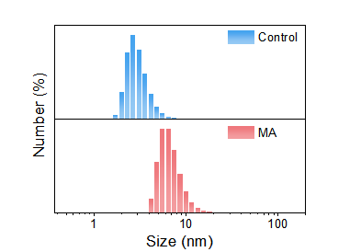
Fig. S4 Colloidal size distribution of precursor solution without and with MA

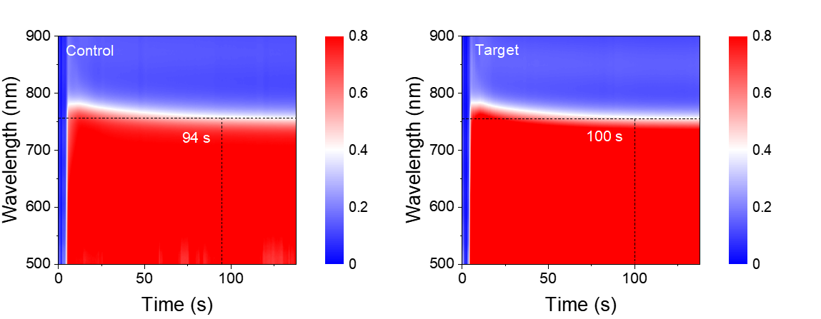
Fig. S5 In situ absorption spectra of control and target perovskite films

Fig. S6 In situ GIWAXS images of the intensity of q integrating with times changes in the control and MA modified films

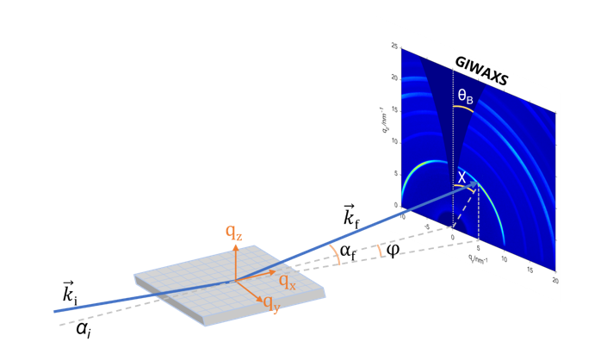
Fig. S7 Schematic diagram of GIWAXS test
Fig. S8 The statistical distribution chart of the peak area from GIWAXS mapping of the flexible perovskite films

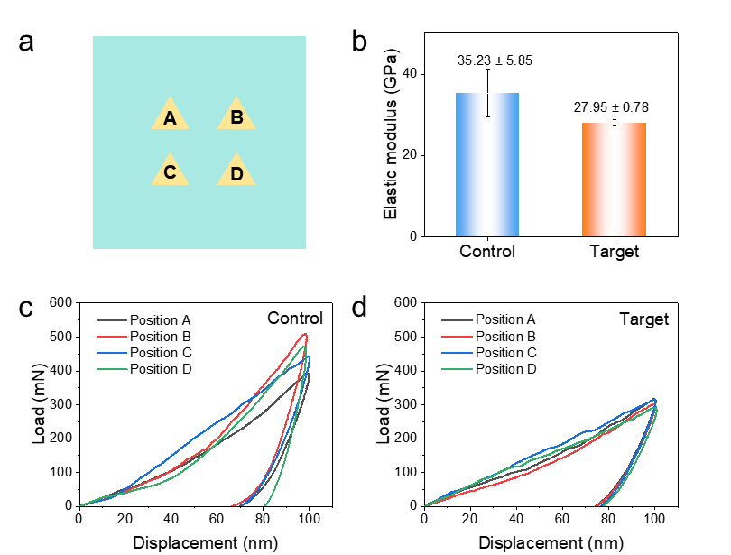
Fig. S9 a Schematic diagram of nanoindentation array. b Elastic modulus of control and MA-modified perovskite film. Representative load-displacement curve of indentation test for c control and d MA-modified perovskite film
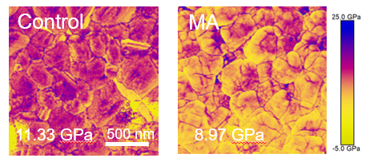
Fig. S10 The Young's modulus diagram of flexible perovskite film

Fig. S11 Surface topography and current of AFM

Fig. S12 a Steady-state PL curves and b TRPL decay curves of control and MA-modified perovskite film
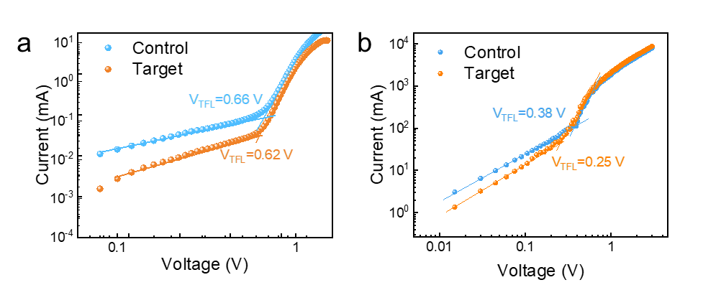
Fig. S13 Current-voltage curves of a hole-only and b electron-only devices via the SCLC method

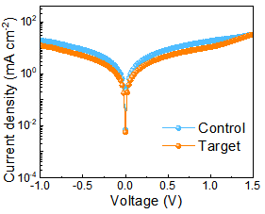
Fig. S14 The dark J-V curves of PSCs

Fig. S15 Transient photovoltage and transient photocurrent decay of the control and target devices
Fig. S16 The surface potential diagram of perovskite film in AFM

Fig. S17 Photovoltaic parameter statistics of control and target FPSCs at different concentration: a V_{OC}; b J_{SC}; c FF; d PCE
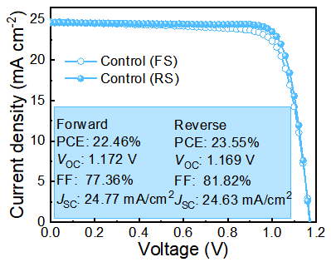
Fig. S18 The J-V curves of control flexible device

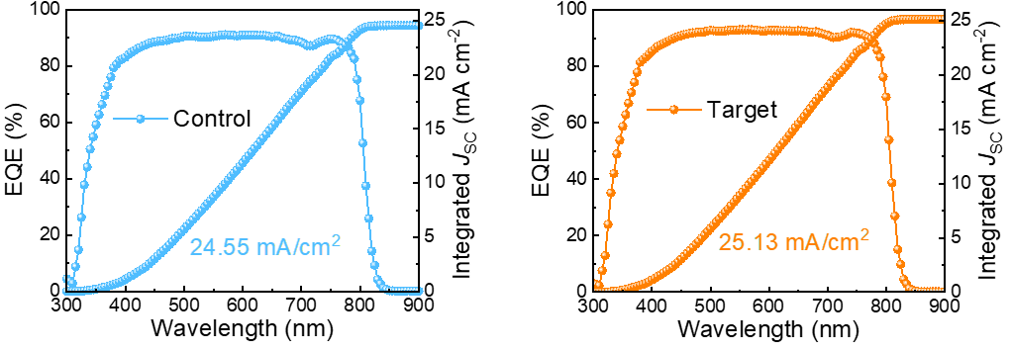
Fig. S19 The EQE spectra and integrated J_{SC} of the control and target FPSCs

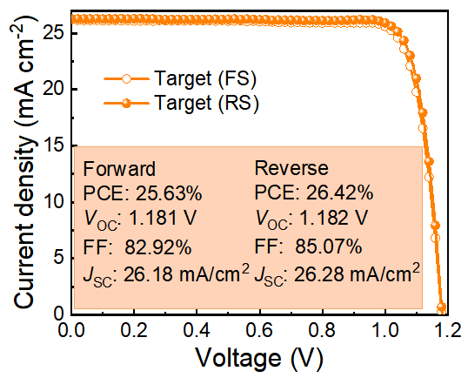
Fig. S20 J-V curves of rigid device
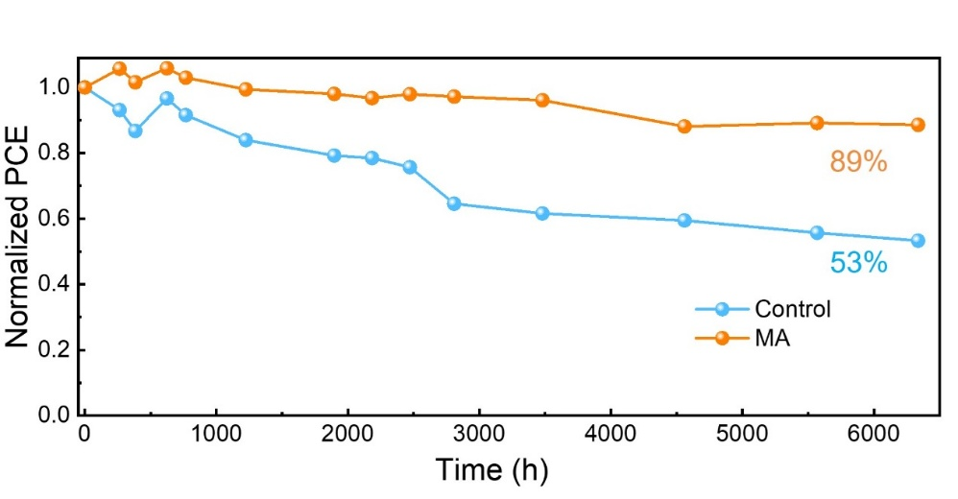
Fig. S21 The stability of FPSCs under the N₂ atmosphere

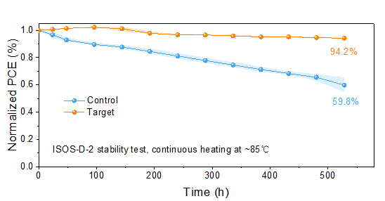
Fig. S22 Normalized PCE of unencapsulated devices aged following the ISOS-D-2 standard

Fig. S23 Normalized PCE for FPSCs after bending at different curvature radii for 1000 cycles
Fig. S24 a Top-view and b Cross-sectional SEM images of control and target perovskite films after bending
Table S1 The fitting parameters for time-resolved PL of the control and PTHM-modified perovskite films on SAM
Sample | τ₁ [ns] | A₁ | τ₂ [ns] | A₂ | τ_{avg} [ns]
Control | 3.64 | 15431.71 | 76.73 | 0.61 | 3.69
With MA | 6.90 | 105.18 | 294.71 | 0.47 | 52.93

$$τ_{ave}=\frac{\sum{A_{i}τ_{i}^{2}}}{\sum{A_{i}τ_{i}}}$$
Fit the time-resolved PL decay curves to a biexponential decay function:
$$f\left(t\right)=A_{1}exp\left(\frac{-t}{τ_{1}}\right)+A_{2}exp\left(\frac{-t}{τ_{2}}\right)+B$$

Table S2 Performance parameters of reported fPSCs
Device structure | Initial PCE (%) | Bending cycles | Bending radius  (mm) | % of initial PCE | Time (h) | % of initial PCE | Refs.
PEN/ITO/MeO-2PACz/perovskite/C₆₀/BCP/Ag | 25.03 | 3000 | 10 | 90.0 | 1850 | 90.0 | This work
PEN/ITO/2PACz/perovskite/C₆₀/BCP/Cu | 25.01 | 3000 | 8 | 90.0 | 1000 | 85.0 | [S1]
PI/ITO//NiOx-SAM/perovskite/C60/BCP/Ag | 25.45 | 20000 | 5 | 97.3 | 1000 | 90.6 | [S2]
PEN/ITO/2PACz/perovskite/C60/BCP/Ag | 25.11 | 5000 | 3 | 92.6 | 1000 | 94 | [S3]
PEN/ITO/NiOx/PTAA/perovskite/PCBM/BCP/Ag | 23.7 | 10000 | 5 | 86 | 800 | 95 | [S4]
PET/ITO/2PACz/perovskite/C₆₀/BCP/Ag | 23.0 | 5000 | 4 | 90.2 | 2000 | 81.3 | [S5]
PEN/ITO/SAM/perovskite/C₆₀/BCP/Ag | 25.1 | 5000 | 5 | 93.0 | 400 | 87.0 | [S6]
PEN/ITO/PTAA/perovskite/C₆₀/BCP/Cu | 23.0 | 10000 | 4 | 87.6 | 1000 | 85.6 | [S7]
PEN/ITO/SnO₂/FAPbI₃/PEAI/HTM/Ag | 24.19 | 4000 | 6 | 95.0 | 100 | 95 | [S8]
PEN/ITO/SnO₂/Perovskite/Spiro-OMeTAD/Au | 24.43 | 10000 | 3 | 94.1 | 1000 | 90.0 | [S9]
PEN/ITO/SnO₂/perovskite/PEAI/spiro-OMeTAD/Ag | 22.1 | 10000 | 2 | 83.0 | 200 | 87.0 | [S10]
PEN/ITO/SnO₂/perovskite/spiro-OMeTAD/Au | 24.2 | 6000 | 5 | 95.6 | 200 | 90 | [S11]
Supplementary References
- Y. Wang, W. Chang, W. You, H. Xue, Y. Zhou et al., Constructing synergistic interactions between multi-hydroxyl molecules and perovskite to alleviate mechanical-thermal mismatch for achieving high-performance flexible solar cells. Angew. Chem. Int. Ed. 64(40), e202512376 (2025). https://doi.org/10.1002/anie.202512376
- W. Cai, J. Wang, X. Zhu, B. Jiao, L. Yang et al., In situ dual-region selective anchoring of zwitterionic gel enables efficient and mechanically durable flexible perovskite solar cell. Adv. Energy Mater. e05869 (2025). https://doi.org/10.1002/aenm.202505869
- X. Sun, J. Gong, Q. Liu, D. Gao, X. Yu et al., Molecular tailoring of self-assembled monolayers via polar ether linker for highly efficient and mechanically robust flexible perovskite solar cells. Adv. Mater. e19365 (2025). https://doi.org/10.1002/adma.202519365
- J. Jin, Z. Zhu, Y. Ming, Y. Zhou, J. Shang et al., Spontaneous bifacial capping of perovskite film for efficient and mechanically stable flexible solar cell. Nat. Commun. 16(1), 90 (2025). https://doi.org/10.1038/s41467-024-55652-6
- S. Zhu, X. Jin, W. Tan, Y. Zhang, G. Zhao et al., Multiple dynamic hydrogen bonding networks boost the mechanical stability of flexible perovskite solar cells. Adv. Funct. Mater. 34(48), 2408487 (2024). https://doi.org/10.1002/adfm.202408487
- X. Tong, L. Xie, J. Li, Z. Pu, S. Du et al., Large orientation angle buried substrate enables efficient flexible perovskite solar cells and modules. Adv. Mater. 36(38), e2407032 (2024). https://doi.org/10.1002/adma.202407032
- H. Zhang, Y. Bi, Y. Wang, C. Liu, N. Chen et al., Manipulating crystallization kinetics of perovskites by acetylsalicylic acid for efficient and stable two-step inverted flexible perovskite solar cells. Chem. Eng. J. 518, 164708 (2025). https://doi.org/10.1016/j.cej.2025.164708
- Z. Yang, J. Wei, Y. Liu, Y. Jiang, L. Liu et al., Radical p-doping spiro-OMeTAD for efficient, stable and self-healing flexible perovskite solar cells. Adv. Mater. 37(27), 2417404 (2025). https://doi.org/10.1002/adma.202417404
- Z. Li, C. Jia, Z. Wan, J. Cao, J. Shi et al., Boosting mechanical durability under high humidity by bioinspired multisite polymer for high-efficiency flexible perovskite solar cells. Nat. Commun. 16(1), 1771 (2025). https://doi.org/10.1038/s41467-025-57102-3
- Q. Sun, X. Meng, G. Liu, S. Duan, D. Hu et al., SnO₂ surface modification and perovskite buried interface passivation by 2, 5-furandicarboxylic acid for flexible perovskite solar cells. Adv. Funct. Mater. 34(45), 2404686 (2024). https://doi.org/10.1002/adfm.202404686
- X. Zhu, Y. Li, Q.-Z. Li, N. Wang, S. Yang et al., Restrictive heterointerfacial delamination in flexible perovskite photovoltaics using a bifacial linker. Adv. Mater. 37(13), e2419329 (2025). https://doi.org/10.1002/adma.202419329

