Supporting Information for
Wafer-Level Self-Assembly and Interface Passivation Patterning Technology for Nanomaterial-Compatible 3D MEMS Sensing Chips
Zheng Zhang¹, Yanlin Zhang¹, Yuanyuan Luo², Guoliang Lv¹, Jianglin Yin¹, Pengwei Tan¹, and Guotao Duan^{1, 3, *}
¹School of Integrated Circuits, Huazhong University of Science and Technology, Wuhan 430074, P. R. China
²Key Laboratory of Materials Physics, Institute of Solid State Physics, HFIPS, Chinese Academy of Sciences, Hefei 230031, P. R. China
³Wuhan National Laboratory for Optoelectronics, Huazhong University of Science and Technology, Wuhan 430074, P. R. China
*Corresponding author. E-mail: duangt@hust.edu.cn (Guotao Duan)
Supplementary Figures and Tables
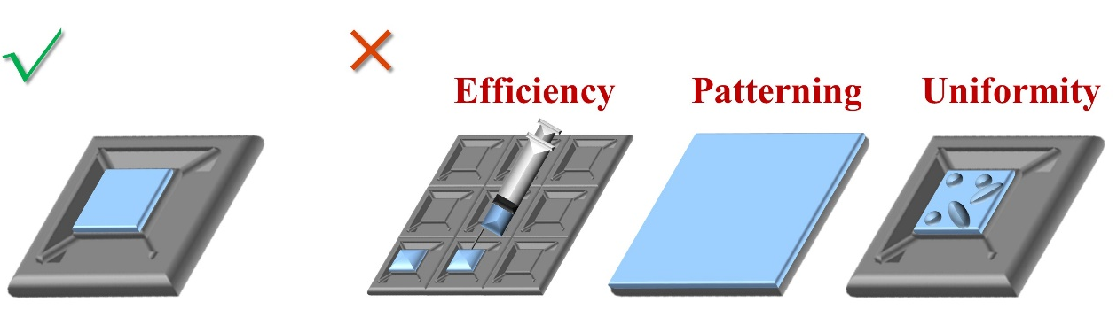
- Schematic diagrams illustrating the expected effects and current challenges in nanomaterials film transfer. Challenges include improve transfer efficiency, thickness uniformity and accurately pattern transfer

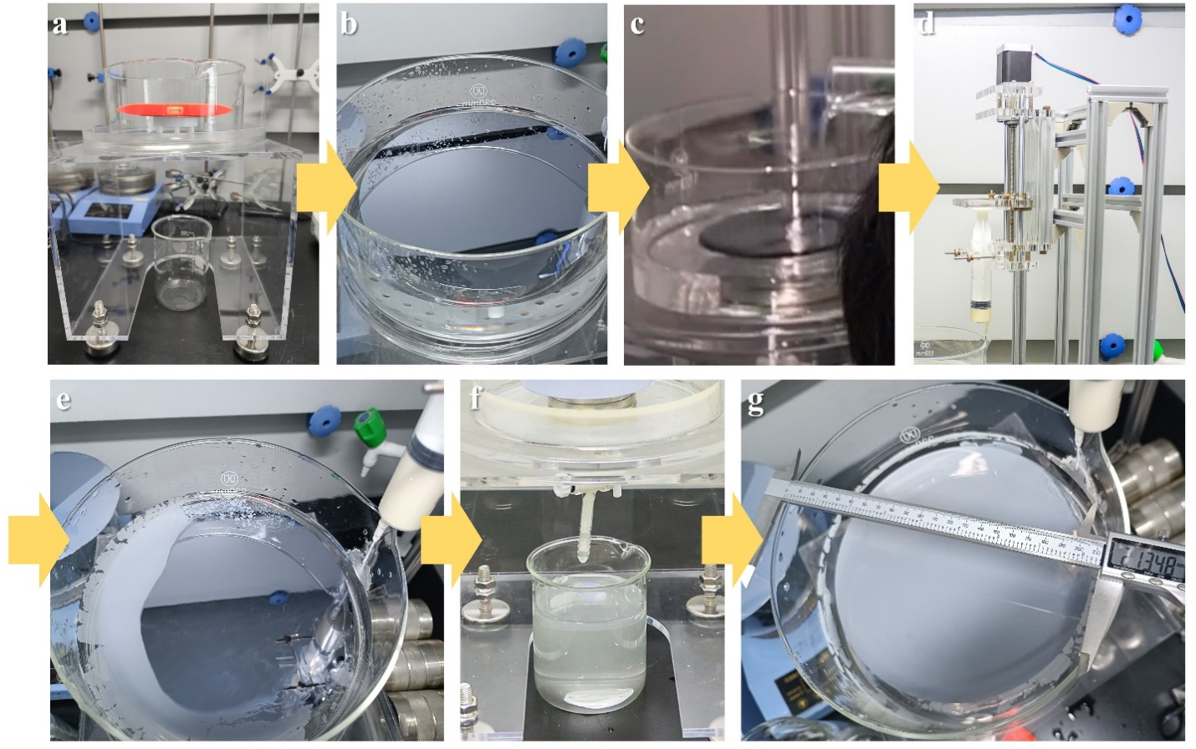
- Operation process of the self-assembly equipment. a Container is adjusted horizontally by the bottom leveling device. b Target wafer is placed in the container. c DI water is added to submerge the entire wafer, with the liquid level 1 cm above the wafer surface. d Automatic syringe is assembled. e Automatic syringe is activated to inject suspension, and the films gradually form on the water surface as shown in Fig. 2c. f Liquid level controlling device is turned on to decrease the liquid level. g Self-assembly monolayer films are transferred onto the wafer surface as the liquid level decreases

- Schematic diagrams of the “film first, cantilever later” wafer-level process flow. Following the IDE deposition step as shown in Fig. 1, the subsequent steps are: (V) The film pattern are defined by lithography. (VI) Self-assembly is performed to form the sensing film. (VII) Unwanted film areas are removed by a lift-off process. (VIII) Cantilever stucture is released via TMAH wet etching
- Self-assembly films prepared on photoresist layers of varying thickness. a SEM images showing the film seperation status. b Thicknesses of photoresist under different spin rates

- Photograph of the self-assembly monolayer SnO₂ films before wet etching, deposited on a SiO₂ substrate
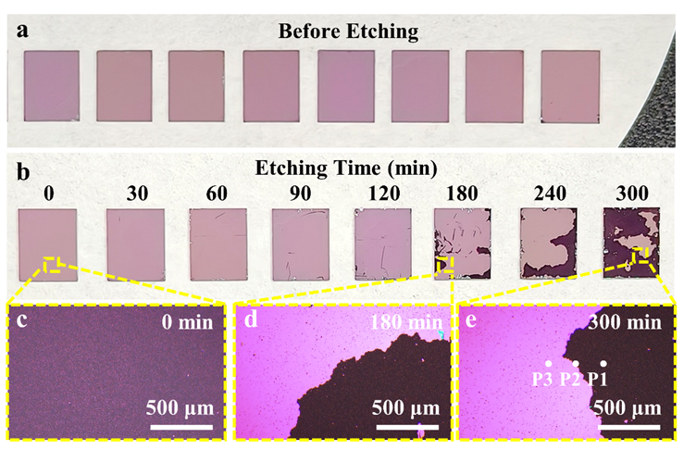
Fig. S6 a-b Photographs and optical microscope images of SnO₂ films on Si₃N₄ substrates before etching and after different etching durations. c-e Enlarged optical images highlighting surface changes corresponding to each etching time

Fig. S7 Raman spectra of the etched SnO₂ films on Si₃N₄ substrates. For the 300-min sample, three spectra represent measurements at distinct positions marked by white dots in Fig. S9e. The spectra of P3 shows the absence of the classic SnO₂ peak
Fig. S8 Adsorption energy (ΔE_{ads}) calculation results for amorphous SiO₂/Si and crystalline HfO₂/SiO₂/Si structure model. a From left to right is the model of amorphous SiO₂/Si structure with single-side interface H passivation, ΔE_{ads} of Si site toward OH species, ΔE_{ads} of Si site toward H₂O molecule, and ΔE_{ads} of O site toward H₂O molecule. b From left to right is the model of crystalline HfO₂/SiO₂/Si structure with single-side interface H passivation, ΔE_{ads} of Hf site toward OH species, ΔE_{ads} of Hf site toward H₂O molecule, and ΔE_{ads} of O site toward H₂O molecule

Fig. S9 Photograph of the self-assembly monolayer SnO₂ films before wet etching, deposited on a HfO₂ substrate
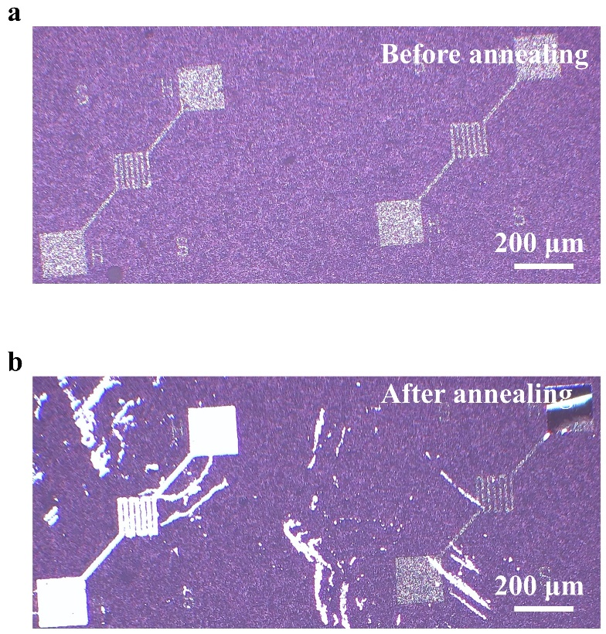
Fig. S10 Optical microscope images of SnO₂ film on Ti/Pt electrodes underwent 800 °C annealing. a Both SnO₂ and metal films are intact before annealing. b Curvature and detachment occurred in the metal film, leading to the breakage of the SnO₂ film
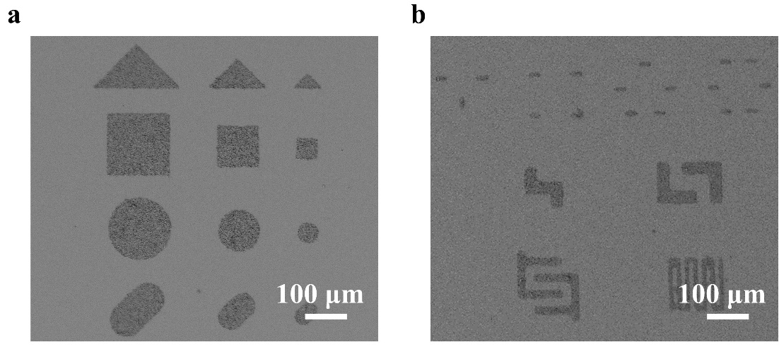
Fig. S11 SEM images of various SnO₂ film patterns. a The regular shapes are suitable for individual MEMS gas sensors. b The irregular shapes can be utilized for MEMS gas sensor arrays structure or more complex sensors structure
Fig. S12 Simulation models and results of MEMS hotplates. a 3D geometry of MEMS hotplate. b Electric field distribution of the heater. c-d Thermal distribution and isotherm explanation of MEMS hotplate. e-f 3D geometry and electric field distribution of array-type MEMS hotplates
Fig. S13 a-b Infrared images of the fabricated MEMS micro hotplate. c Thermal distribution of conventional rectangular range of interest. d Thermal distribution of isothermal-defined range of interest

Fig. S14 a Comparison of photographs and optical microscope images of In₂O₃ films on HfO₂ substrates before and after etching. b Comparison of XRD patterns, both showing the characteristic peaks of In₂O₃

Fig. S15 Comparison of SEM-EDS images of In₂O₃ nanosphere films on HfO₂ substrates. a Before TMAH etching. b After TMAH etching. The In₂O₃ nanospheres film retains intact
Fig. S16 a Comparison of photographs and optical microscope images of ZnO films on HfO₂ substrates before and after etching. b Comparison of XRD patterns, indicating the characteristic peaks of ZnO are absent in the after-etching sample. c Comparison of SEM images, highlighting the detachment caused by the etching effect

Fig. S17 Schematic of the complete wafer-level manufacturing process flow for MEMS gas sensing chips. (i) A SiO₂/Si₃N₄/SiO₂ supporting film is prepared on the Si wafer. (ii) Ti/Pt electrodes are deposited to form the microheaters. (iii) A SiO₂ insulating layer is deposited. (iv) A HfO₂ passivation layer is deposited on the central sensing area of the insulating layer. (v) Bonding pads and etching windows are exposed. (vi) Ti/Pt testing electrodes are prepared. (vii) The self-assembly gas sensing film is transferred aligned with HfO₂. (viii) The suspended cantilever is released by TMAH wet etching, resulting in the final MEMS gas sensing chips
Fig. S18 Response comparison of Pd/SnO₂ sensing chips operating at different temperatures

Fig. S19 Linear fitting curves of the responses of a monolayer Pd/SnO₂ sensor responses to H₂ concentrations ranging from 1 to 500 ppm at 300 °C

Fig. S20 Response time of a monolayer Pd/SnO₂ sensor towards 20 ppm H₂ at 300 °C
Fig. S21 Response variation of 25 monolayer Pd/SnO₂ sensors randomly selected from five different regions of the wafer, with statistical distribution illustrated by box plots
Fig. S22 a Response of monolayer SnO₂ sensors towards 20 ppm H₂. b Response of trilayer Pd/SnO₂ sensors towards 20 ppm H₂

Table S1 Comparison of fabrication capabilities and H₂ sensing performance of MEMS micro hotplate sensors with different film-deposition methods
Sensing materials | Film-deposition methods | Fabrication scale | Film pattern morphology | Concentration Range (ppm) | Response | Response time (s) | Temperature (°C) | Refs.
Au-Pd dual-metal modified In₂O₃ | Dropped by pipette | Single device | Naturally formed | 0.05 ~  100 | 8.35  (10 ppm) | 5.0  (10 ppm) | 245.2 | [S1]
(FeCoNi)_{100−x}O_{x} | Dropped by needle | Single device | Naturally formed | 200 ~  1000 | 8.60  (200 ppm) | \ | 150.0 | [S2]
SnO₂ | Dropped by pipette | Single device | Naturally formed | 0.1 ~ 20 | 2.21  (6 ppm) | 7.0  (6 ppm) | 250.0 | [S3]
Pd NPs/SnO₂ film | Mask-assistant sputtering and ALD | Wafer level (Silicon) | Rectangle | 0.5 ~  500 | 1.52  (20 ppm) | 115.4  (20 ppm) | 150.0 | [S4]
Pd/SnO₂ nanospheres | Lithography-based self-assembly | Wafer level (Silicon) | Customizable | 1 ~  500 | 1.92*  (20 ppm) | 19.7  (20 ppm) | 300.0 | This work
* Sensitivity to different H₂ concentrations at 300 °C: 1.32 (5 ppm), 1.50 (10 ppm), 1.92 (20 ppm), and 4.92 (200 ppm). Sensitivity to 20 ppm H₂ at different temperatures: 1.00 (100 °C), 1.10 (150 °C), 1.34 (200 °C), 1.53 (250 °C), 1.92 (300 °C), 1.46 (350 °C)
Supplementary References
- Z. Yang, Q. Rong, W. Zhang, X. Fan, M. Shao et al., A ZnO packaged MEMS hydrogen sensor for reliable sibo breath analysis with anti-H2S interference. Chem Eng J (Lausanne). 522, 167331 (2025). https://doi.org/10.1016/j.cej.2025.167331
- W. Yan, Y. Liu, Y. Bai, Y. Chen, H. Zhou et al., Intelligent MEMS sensor based on an oxidized medium-entropy alloy (FeCoNi) for H₂ and co recognition. ACS Appl Mater Interfaces. 16(37), 49474-49483 (2024). https://doi.org/10.1021/acsami.4c07782
- N. Luo, C. Wang, D. Zhang, M. Guo, X. Wang et al., Ultralow detection limit MEMS hydrogen sensor based on SnO₂ with oxygen vacancies. Sens Actuators B Chem. 354, 130982 (2022). https://doi.org/10.1016/j.snb.2021.130982
- Z. Zhang, L. Luo, Y. Zhang, G. Lv, Y. Luo et al., Wafer-level manufacturing of MEMS H₂ sensing chips based on Pd nanoparticles modified SnO₂ film patterns. Adv Sci. 10(26), 2302614 (2023). https://doi.org/10.1002/advs.202302614W
ss

