Supporting Information for
Ultra-Light Poly(N-isopropylacrylamide) Hydrogels-Lightweight Water Materials for Passive Thermal Management via Insulation and Cooling
Xueyan Hu^{1,2,†}, Siyuan Dou^{1,†}, Yiming Liu^{1,2}, Yaru Li^{1,2}, Caixia Yu¹, Jin Wang^{1,2,*}
¹ Key Laboratory of Multifunctional Nanomaterials and Smart Systems, Suzhou Institute of Nano-Tech and Nano-Bionics, Chinese Academy of Sciences, Suzhou 215123, P. R. China.
² School of Nano-Tech and Nano-Bionics, University of Science and Technology of China, Hefei 230026, P. R. China
†Xueyan Hu and Siyuan Dou contributed equally to this work.
*Corresponding author. E-mail: jwang2014@sinano.ac.cn (Jin Wang)
Supplementary Figures

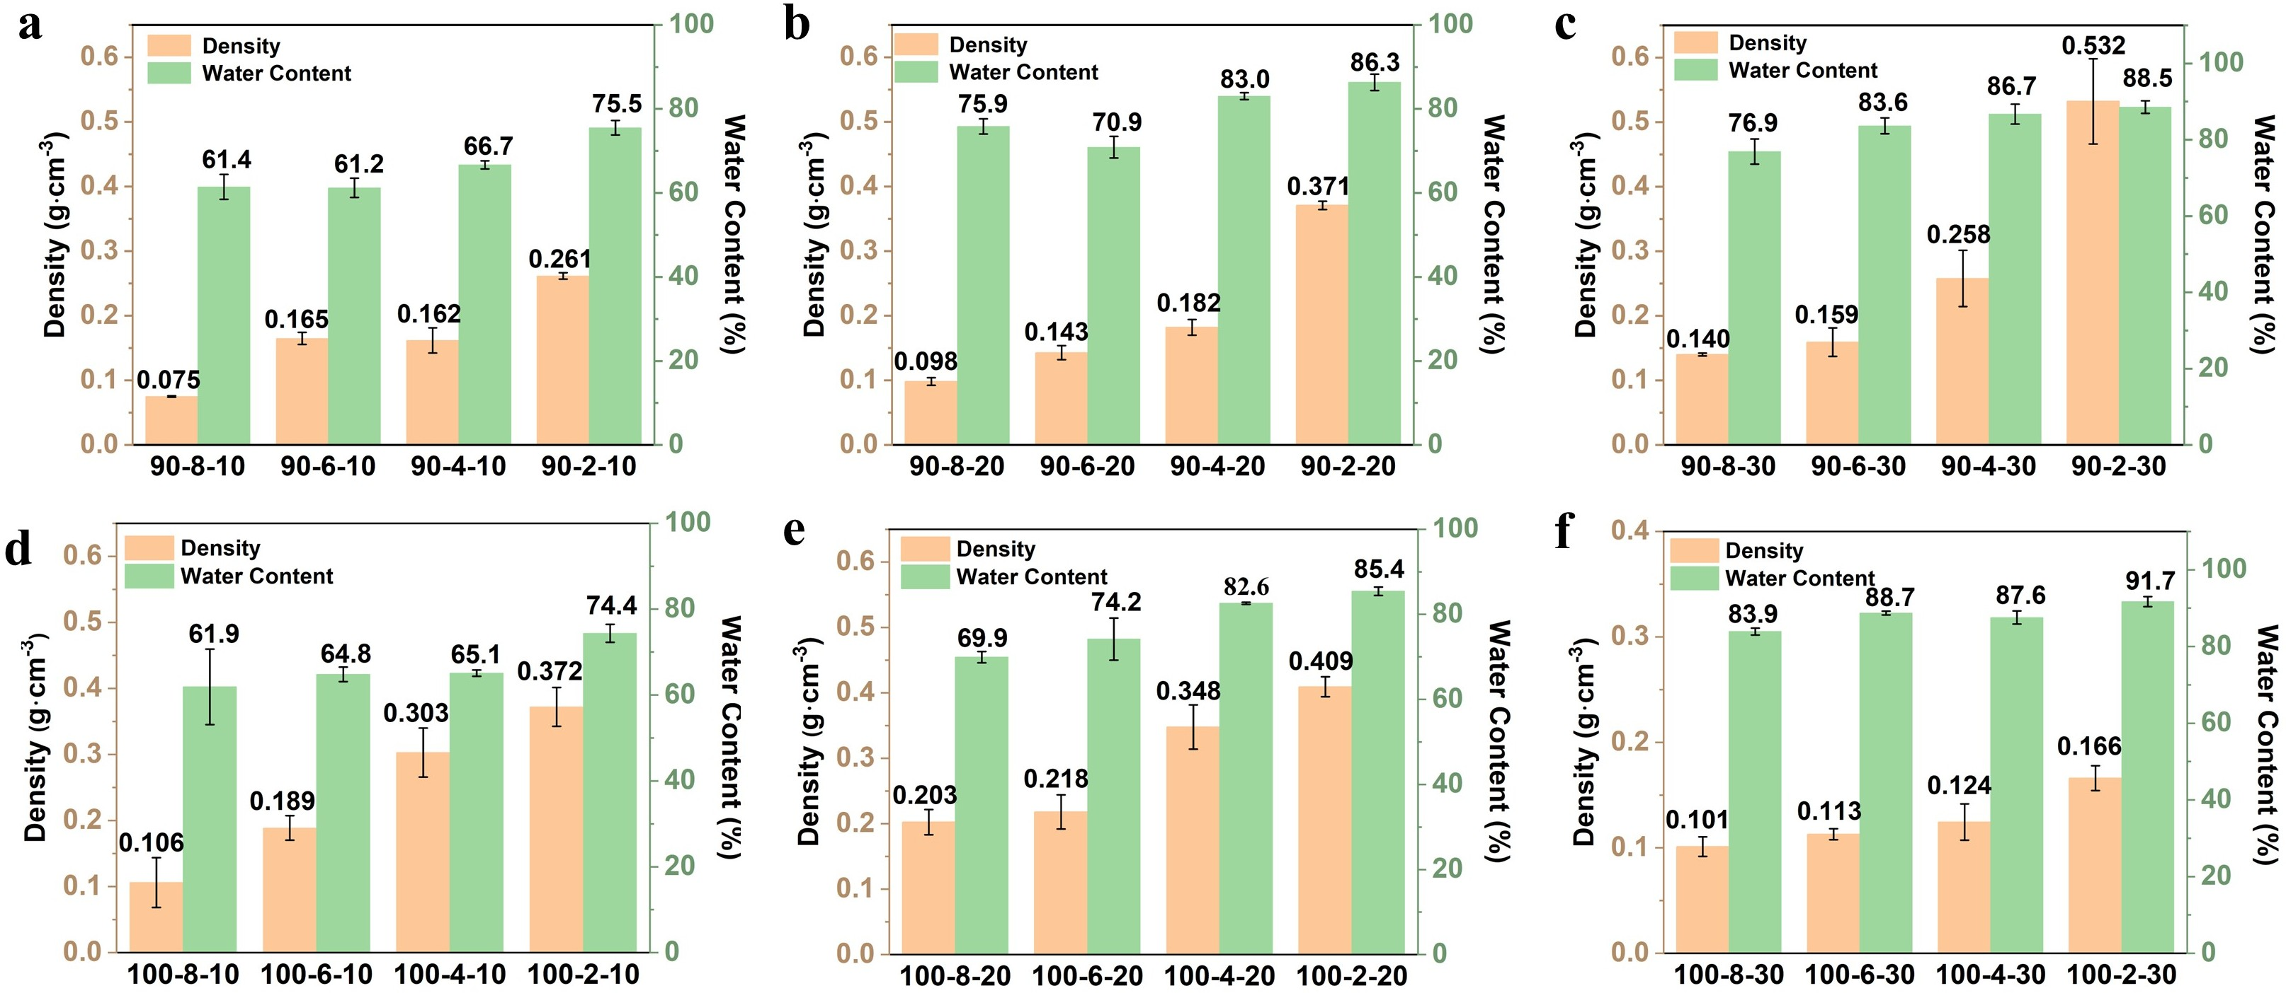
Fig. S1 a–b Density and water content bar charts of the ultra-light hydrogels with crosslinking temperatures of 90 °C and deionised water additions of 10 mL, 20 mL, and 30 mL, respectively. d–f Column charts showing the density and water content of LWMs with 10 mL, 20 mL, and 30 mL of deionised water added at a cross-linking temperature of 100 °C. (The error bars represent the standard deviation obtained from three measurements.)

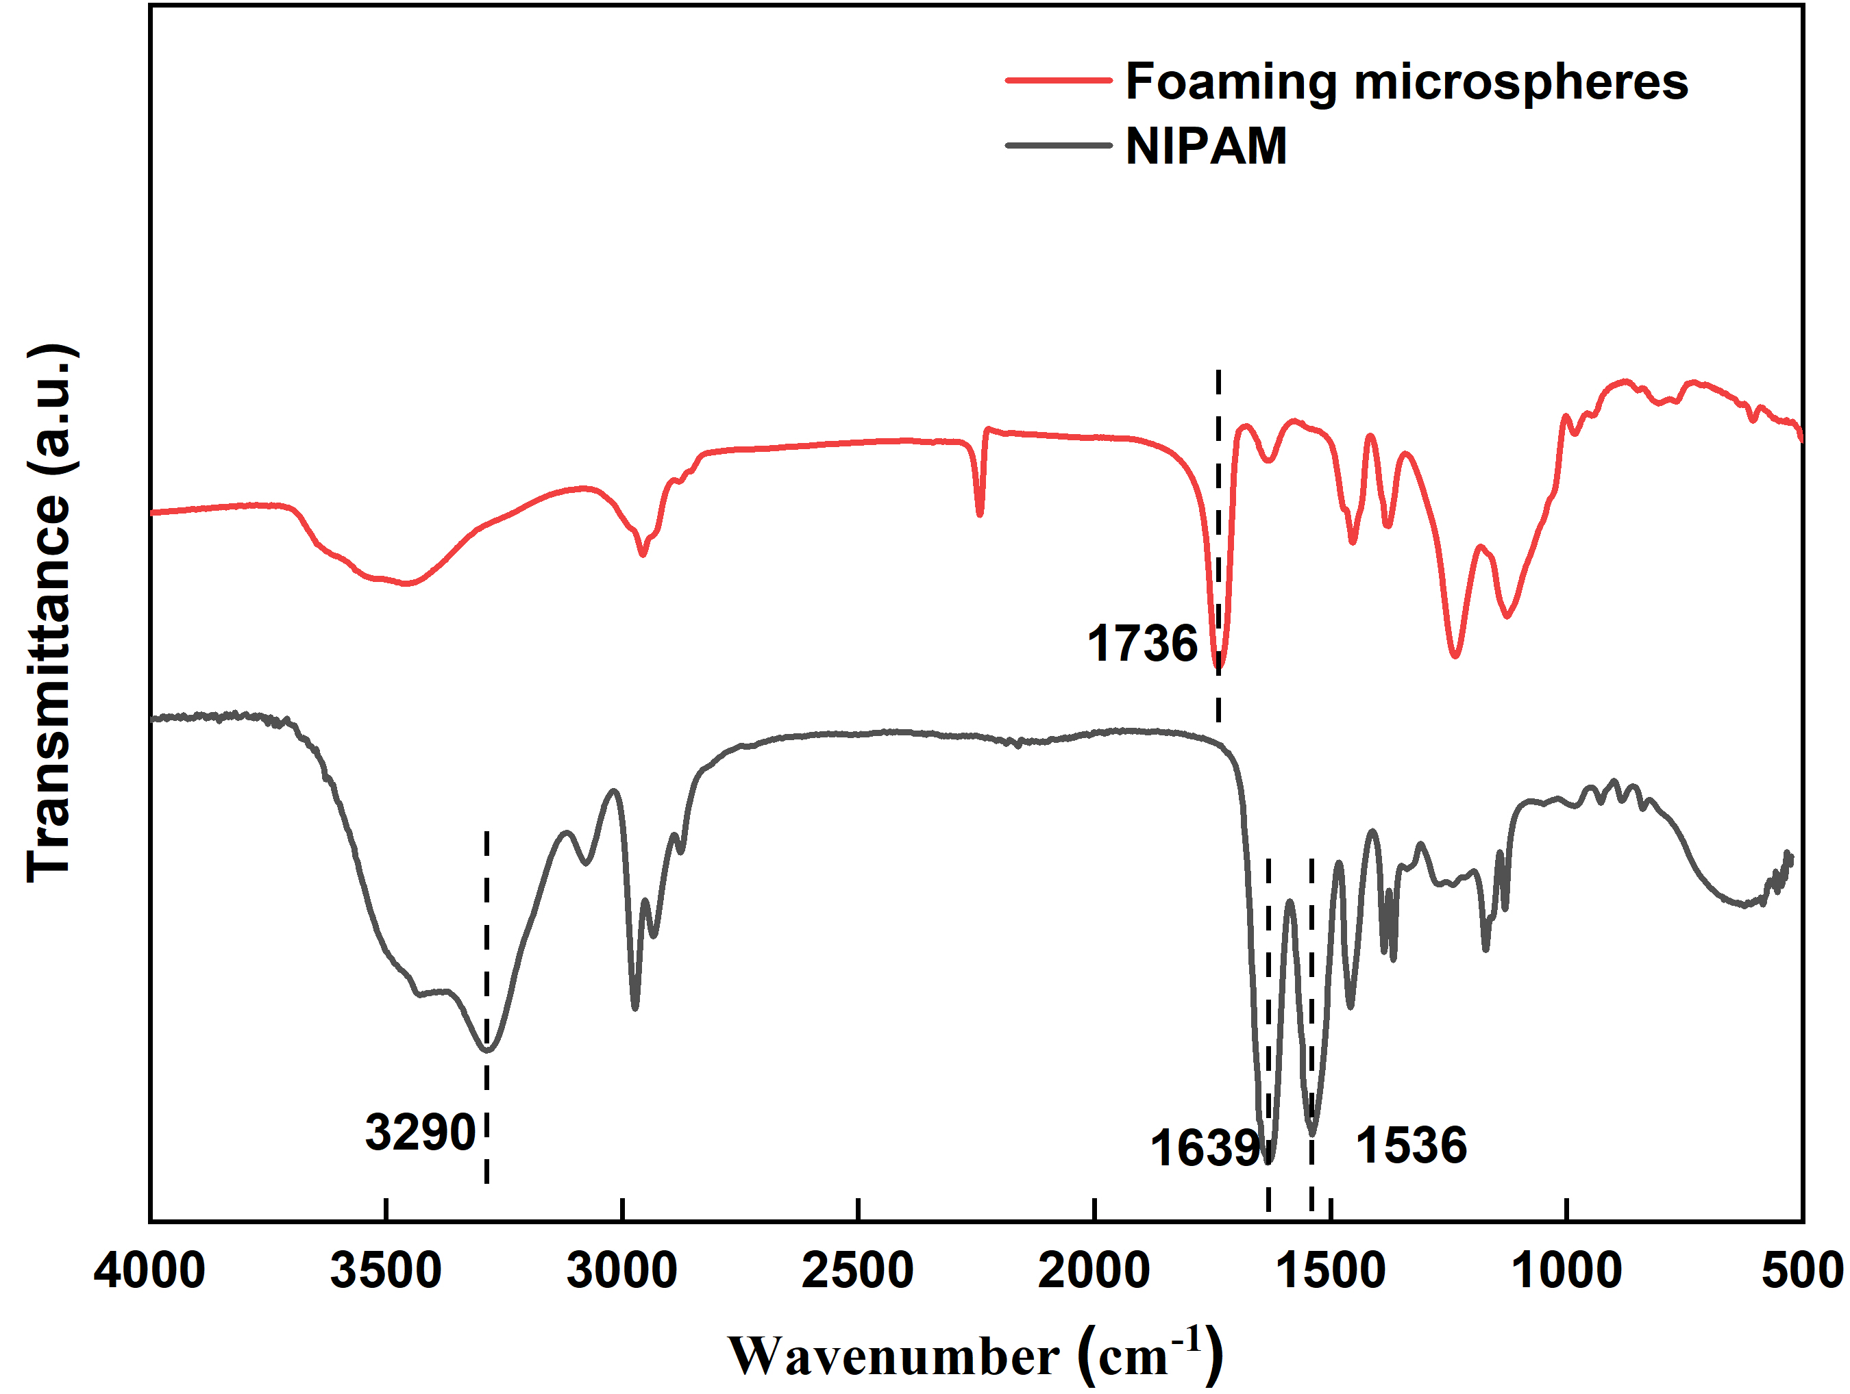
Fig. S2 FT-IR spectroscopy of foaming microsphere and NIPAM

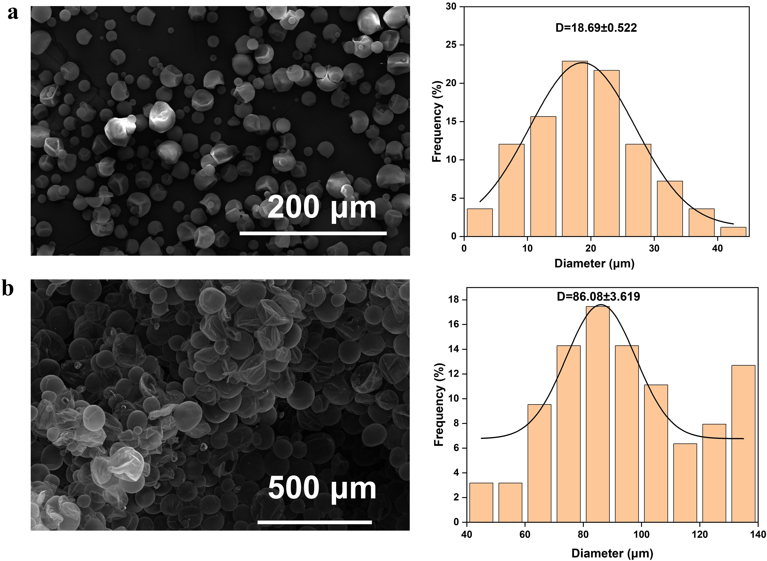
Fig. S3 Scanning electron microscope images of pre-reaction foaming microspheres (a) and post-reaction foaming microspheres (b), and corresponding pore size distribution diagrams
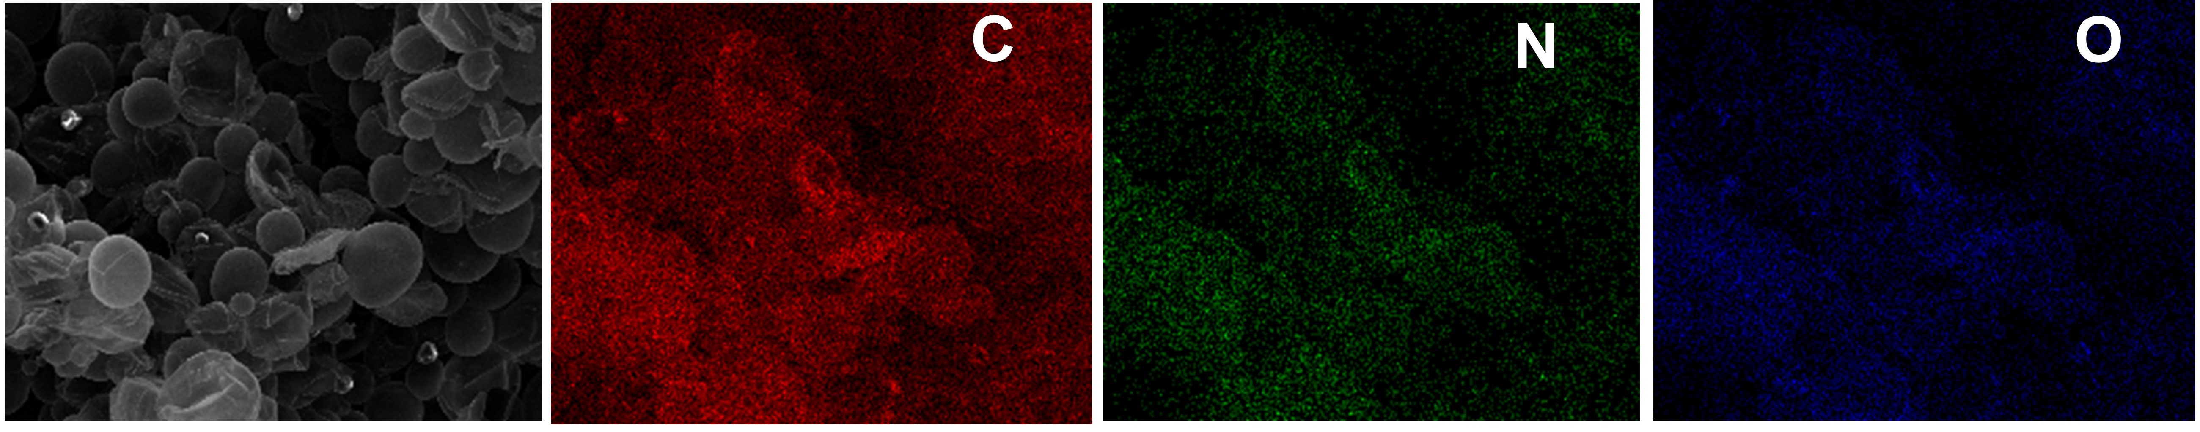
Fig. S4 EDS mapping image corresponding to the SEM image of post-reaction foaming microspheres

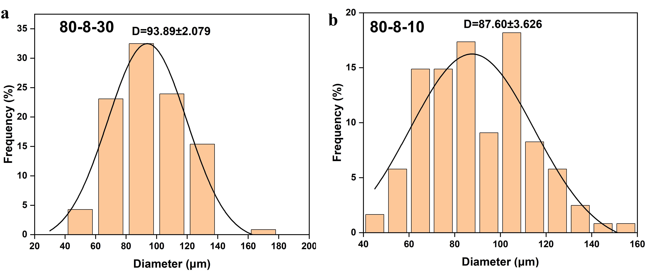
Fig. S5 Pore size distribution diagrams of dry gels LWM80-8-30 and LWM80-8-10

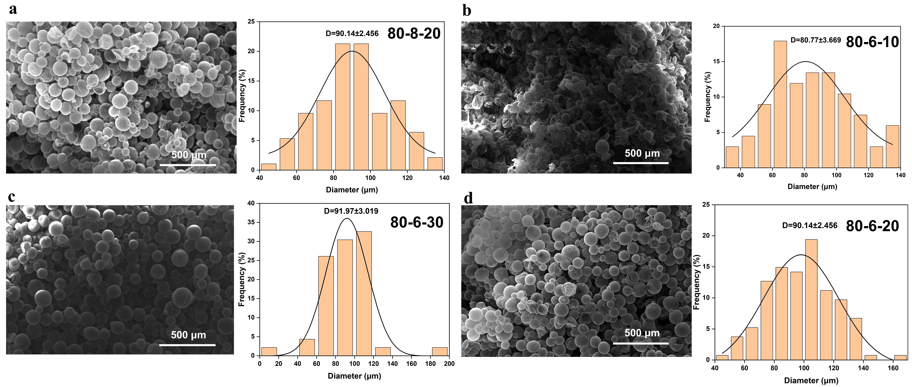
Fig. S6 Scanning electron microscope images of dry gels LWM80-8-20, LWM80-6-10, LWM80-6-30, and LWM80-6-20 and corresponding pore size distribution diagrams

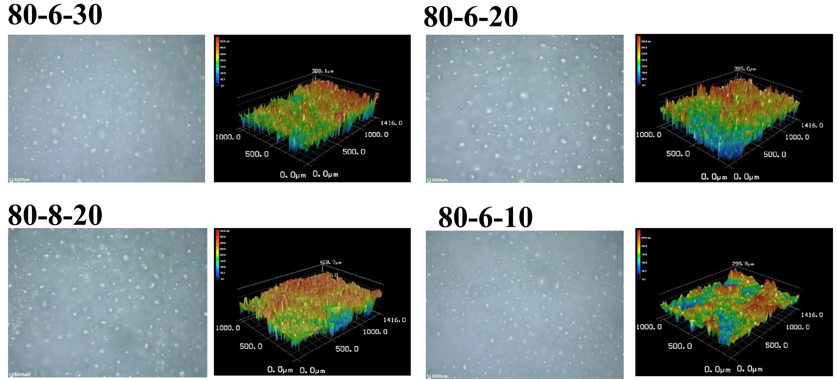
Fig. S7 Three-dimensional surface morphology of hydrogels LWM80-6-30, LWM80-6-20, LWM80-8-20, and LWM80-6-10

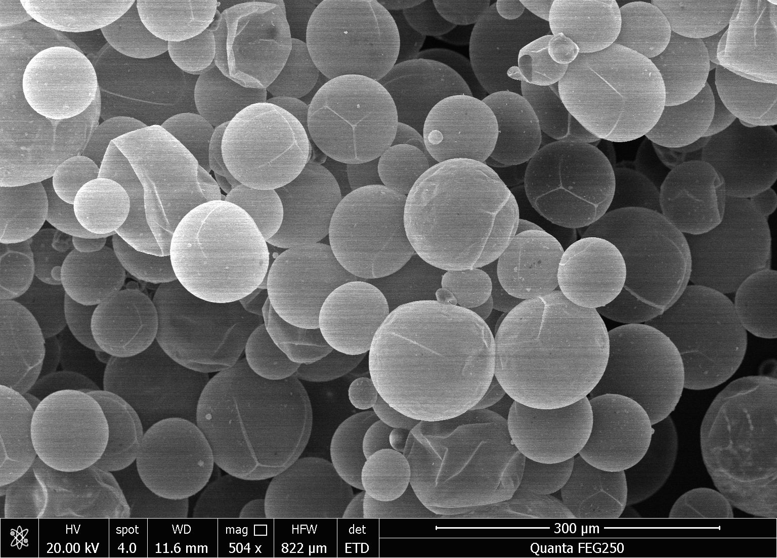
Fig. S8 SEM image of LWM80-8-10 after three thermal cycles (30 min at ambient temperature and 30 min on an 80 °C hot plate; one cycle lasts 1 h)

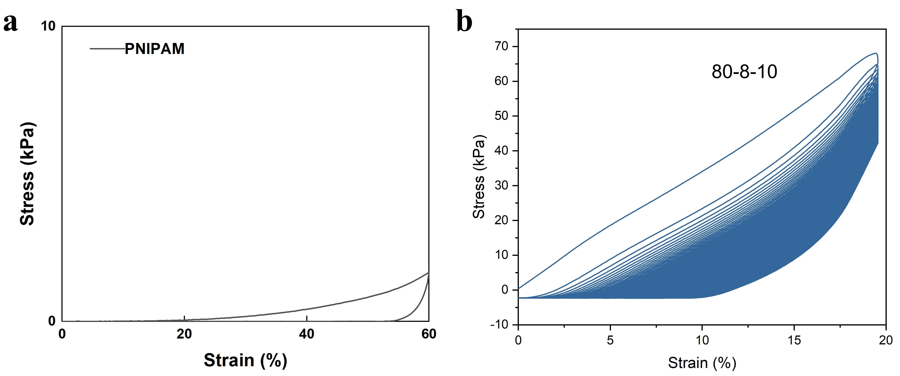
Fig. S9 Stress-strain curve of a loading-unloading cycle of a pure PNIPAM hydrogel
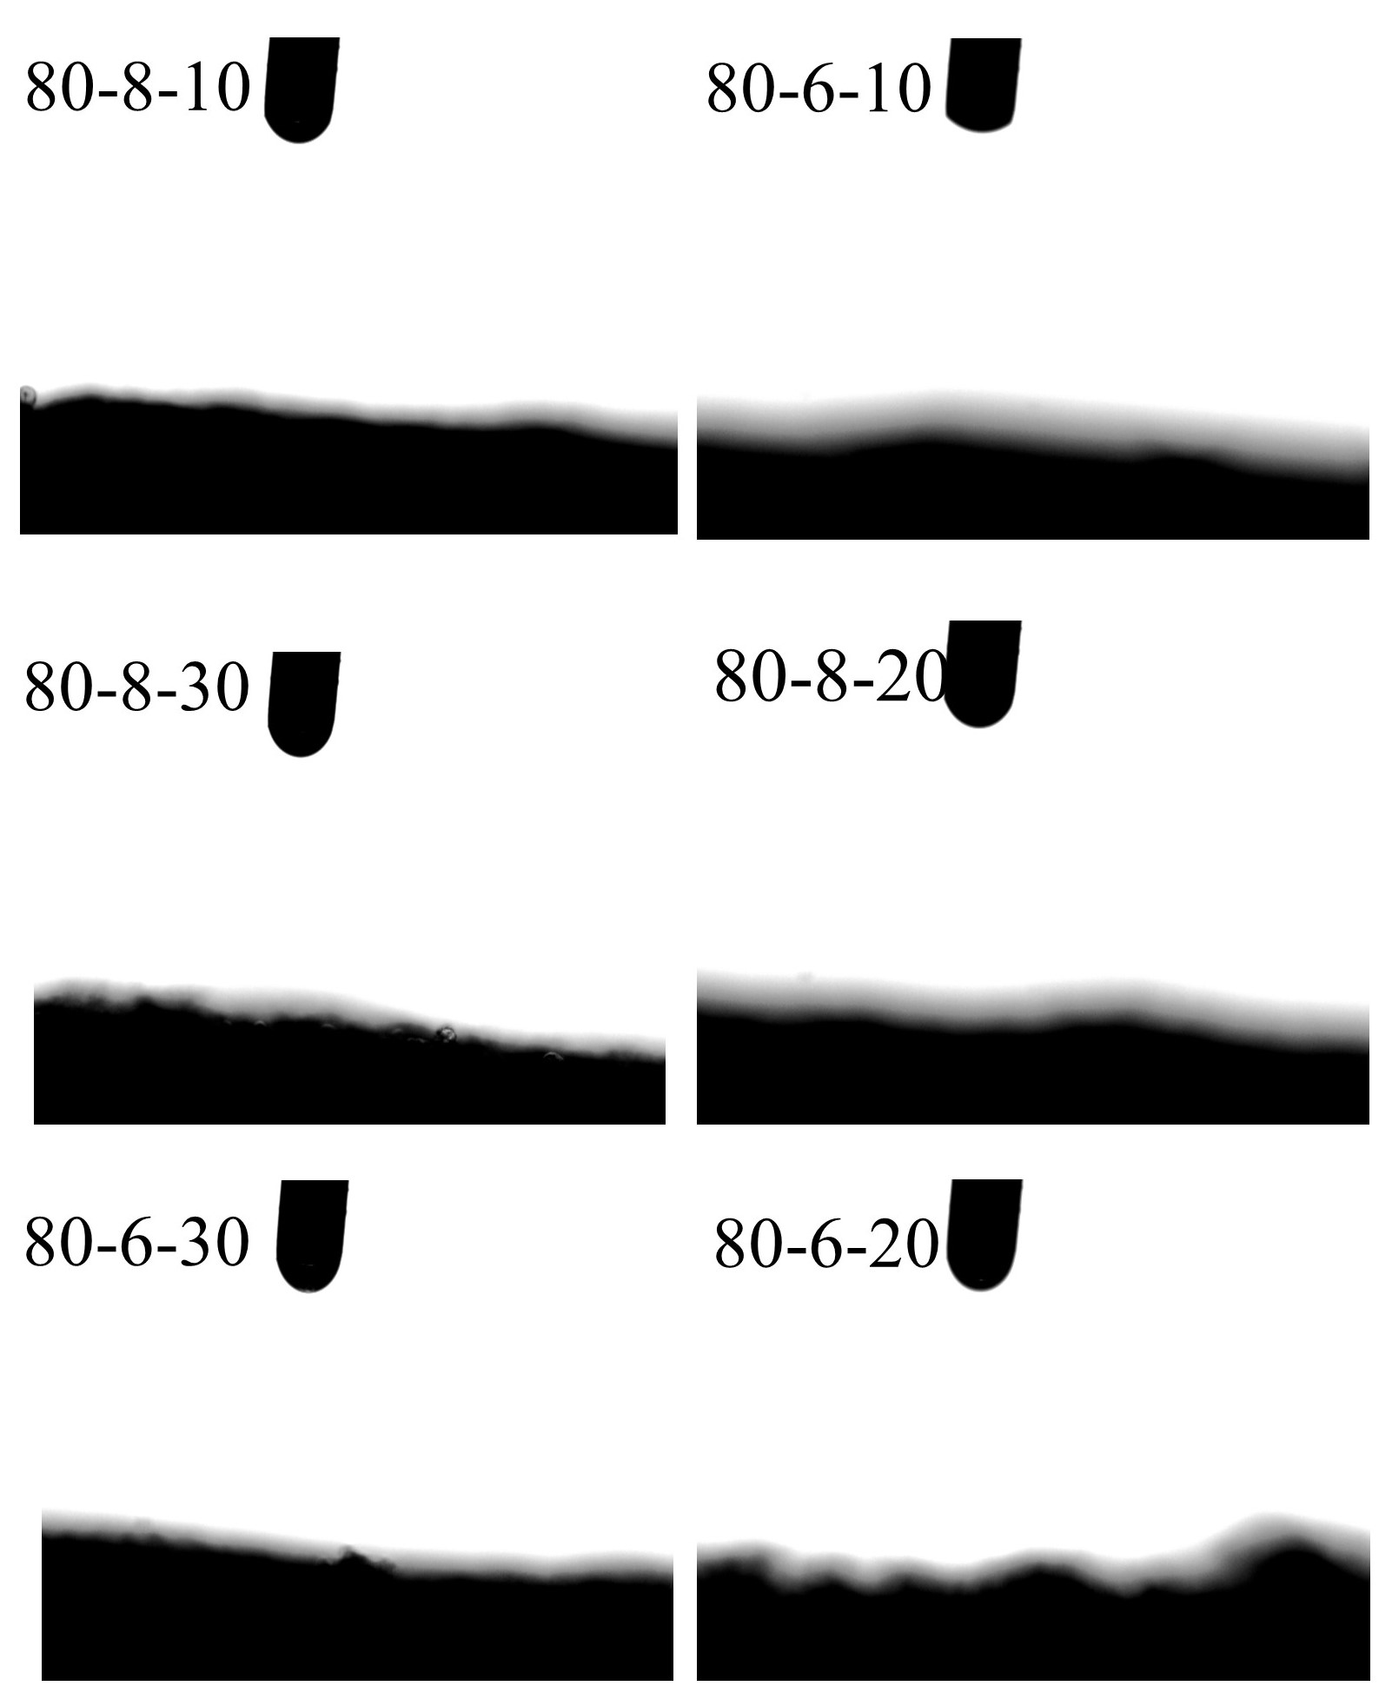
Fig. S10 Contact angle of LWM80-8-10, LWM80-6-10, LWM80-8-30, LWM80-8-20, LWM80-6-30, and LWM80-6-20 hydrogels

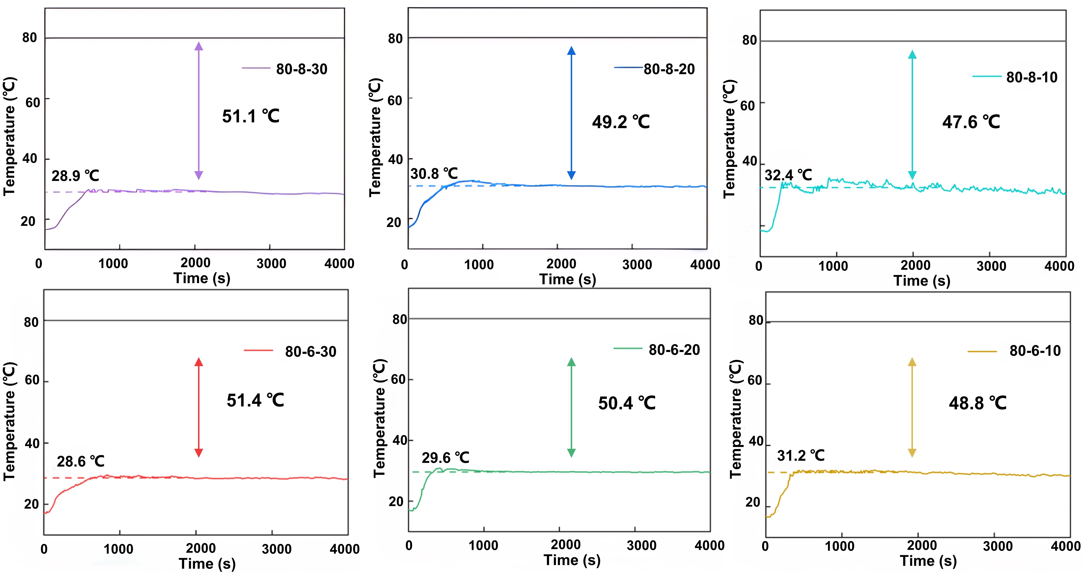
Fig. S11 Temperature-time change curves of hydrogel hot plate experiments at LWM80-8-30, LWM80-8-20, LWM80-8-10, LWM80-6-30, LWM80-6-20, and LWM80-6-10

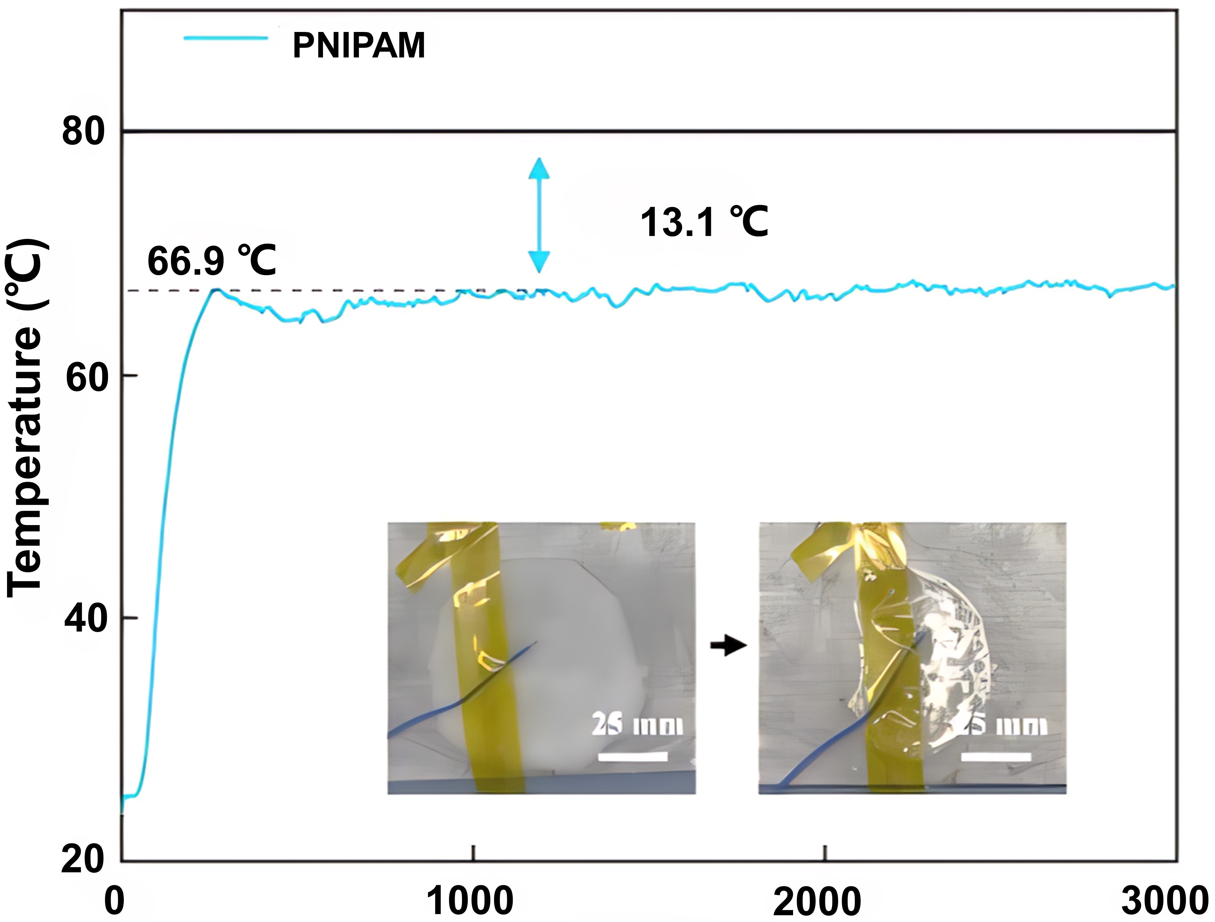
Fig. S12 Temperature-time change curve of PNIPAM hydrogel hot plate experiment

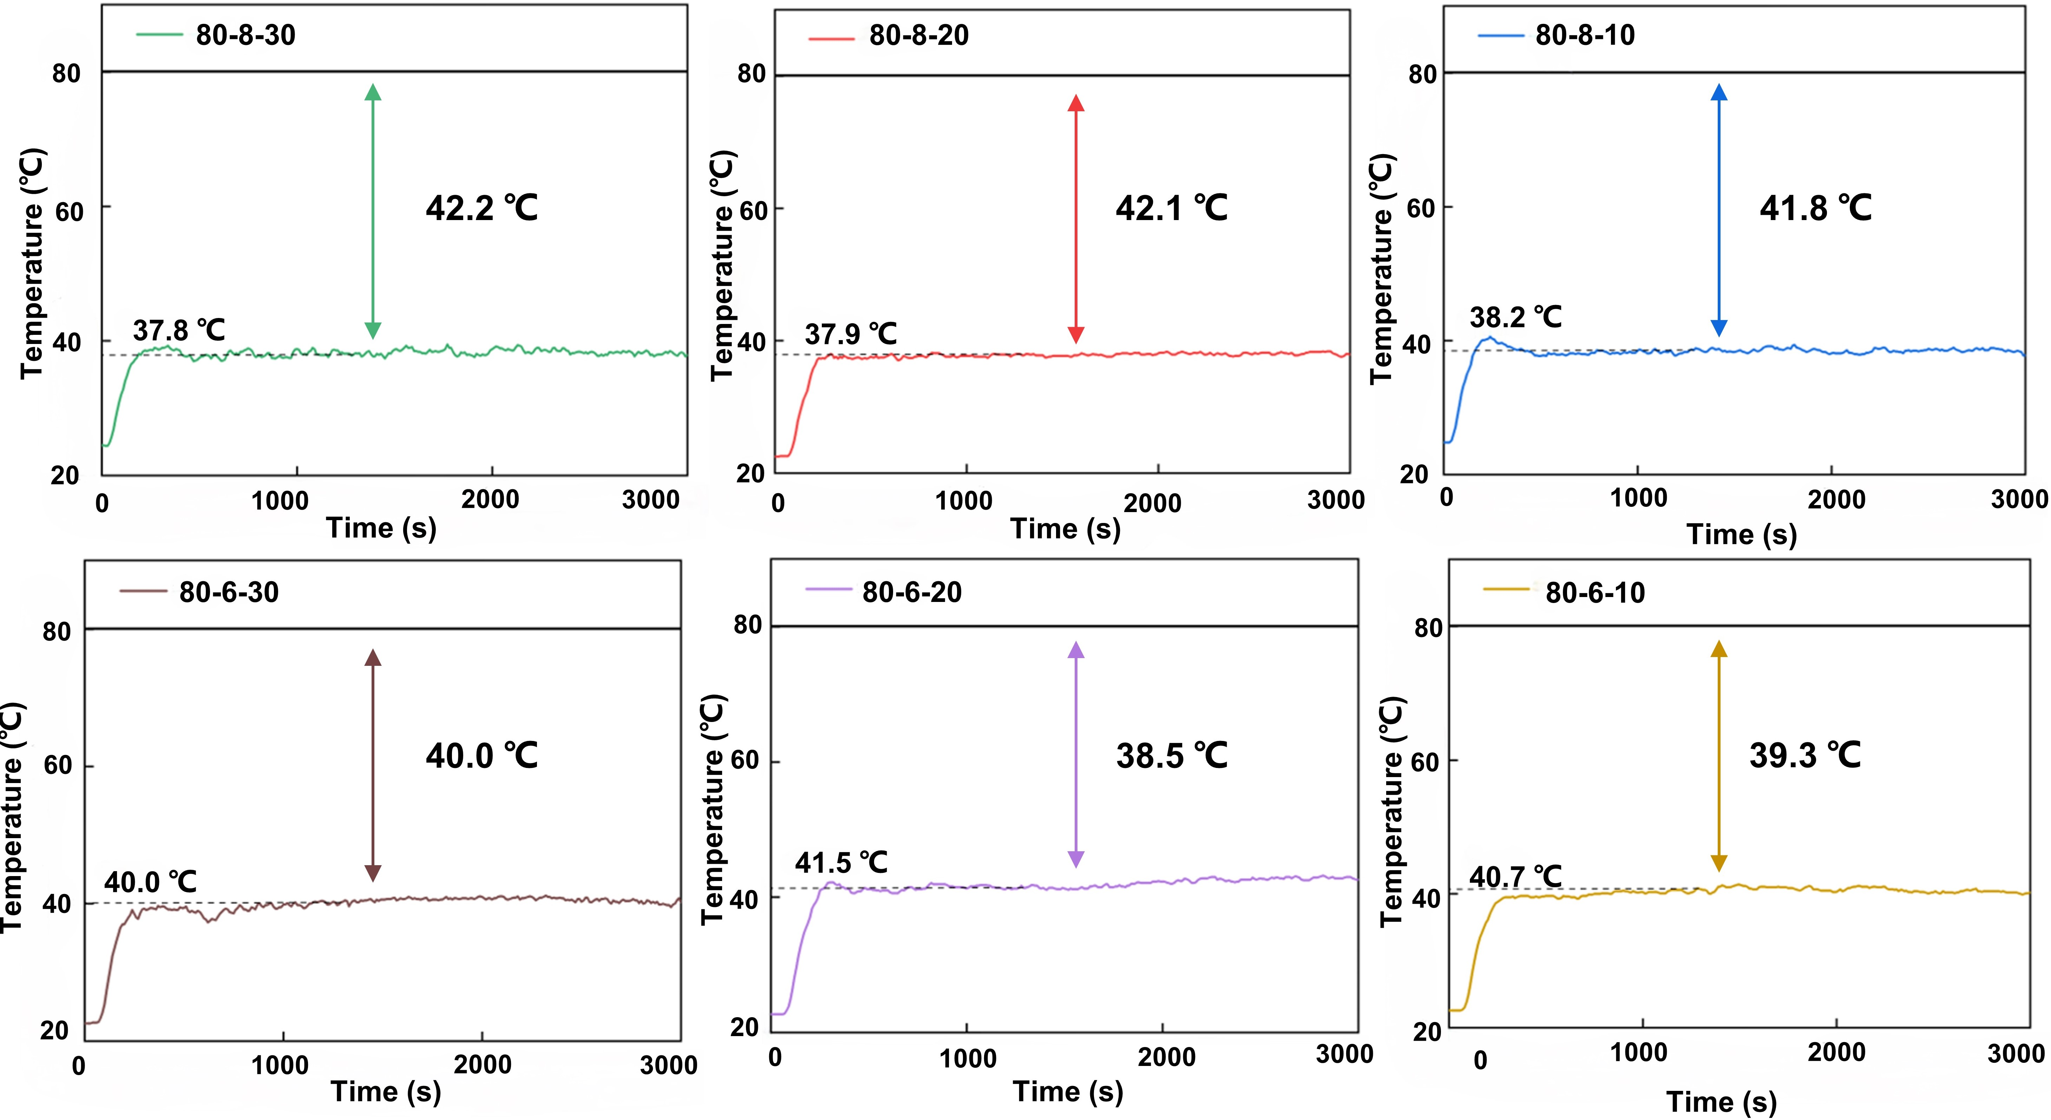
Fig. S13 Temperature-time change curves for dry gel hot plate experiments at LWM80-8-30, LWM80-8-20, LWM80-8-10, LWM80-6-30, LWM80-6-20, and LWM80-6-10

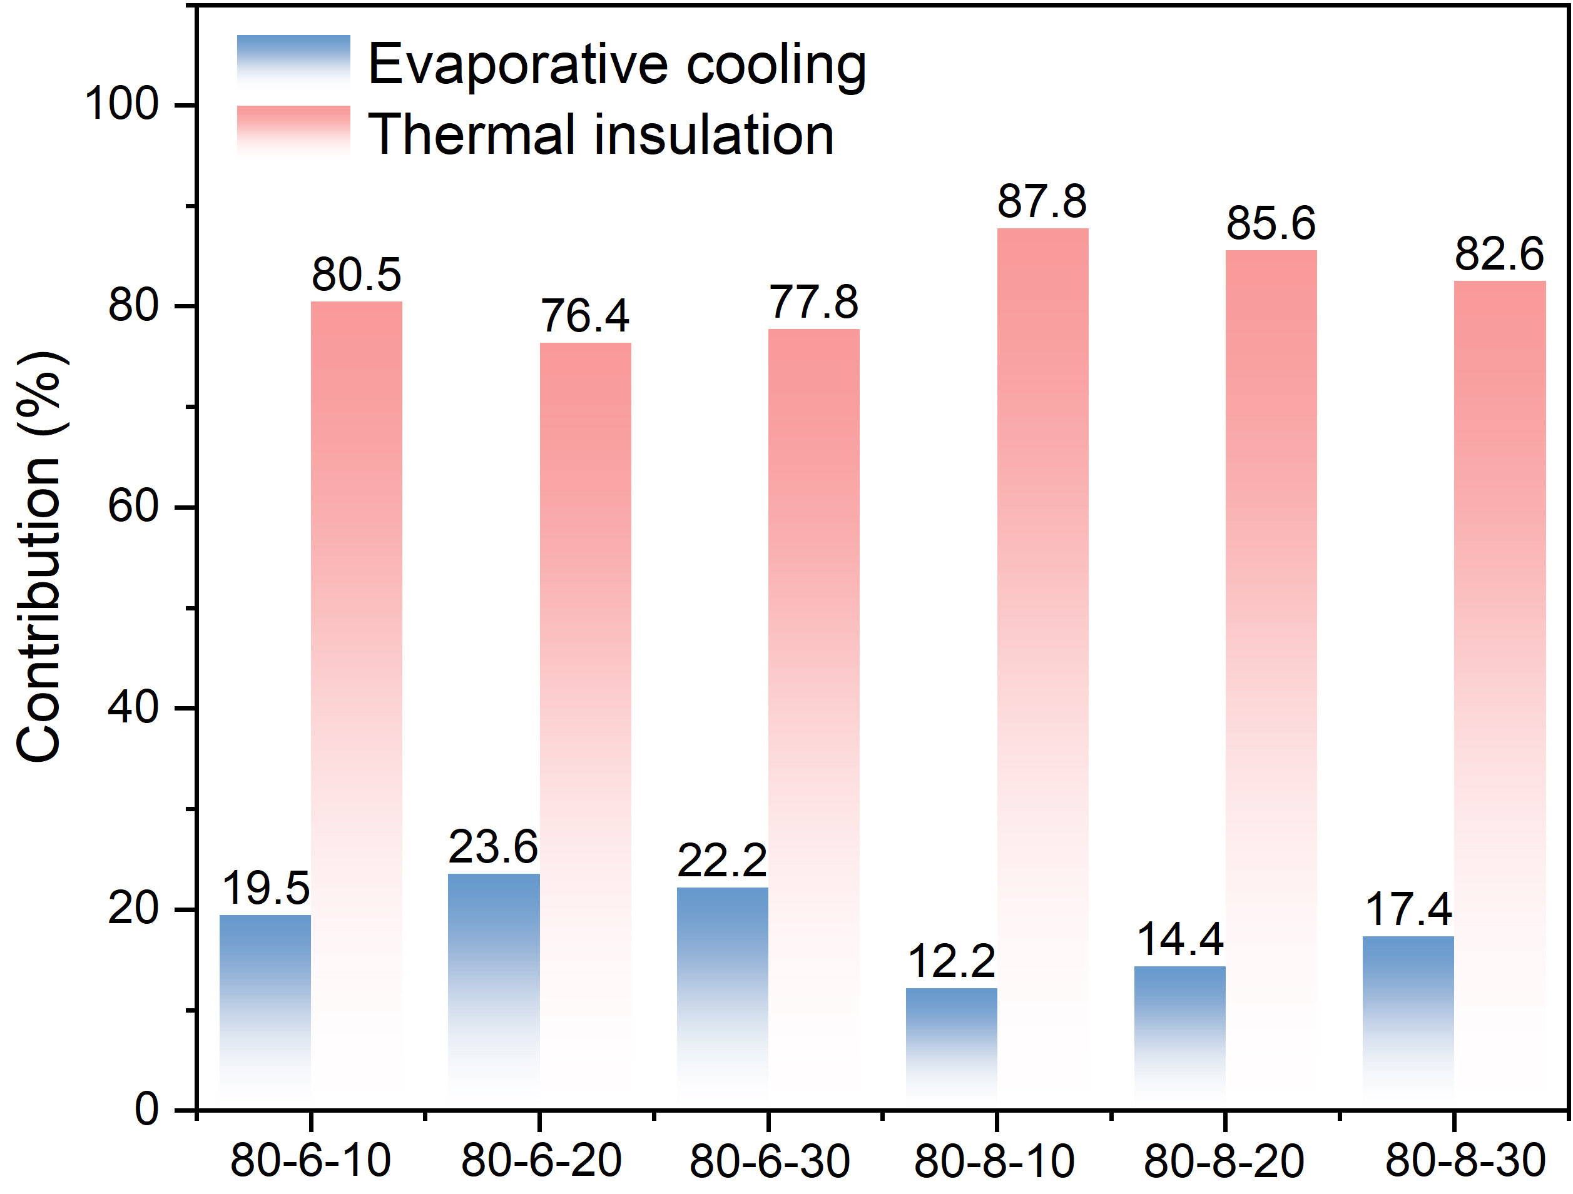
Fig. S14 Percentage of water evaporation and thermal insulation of LWM hydrogels

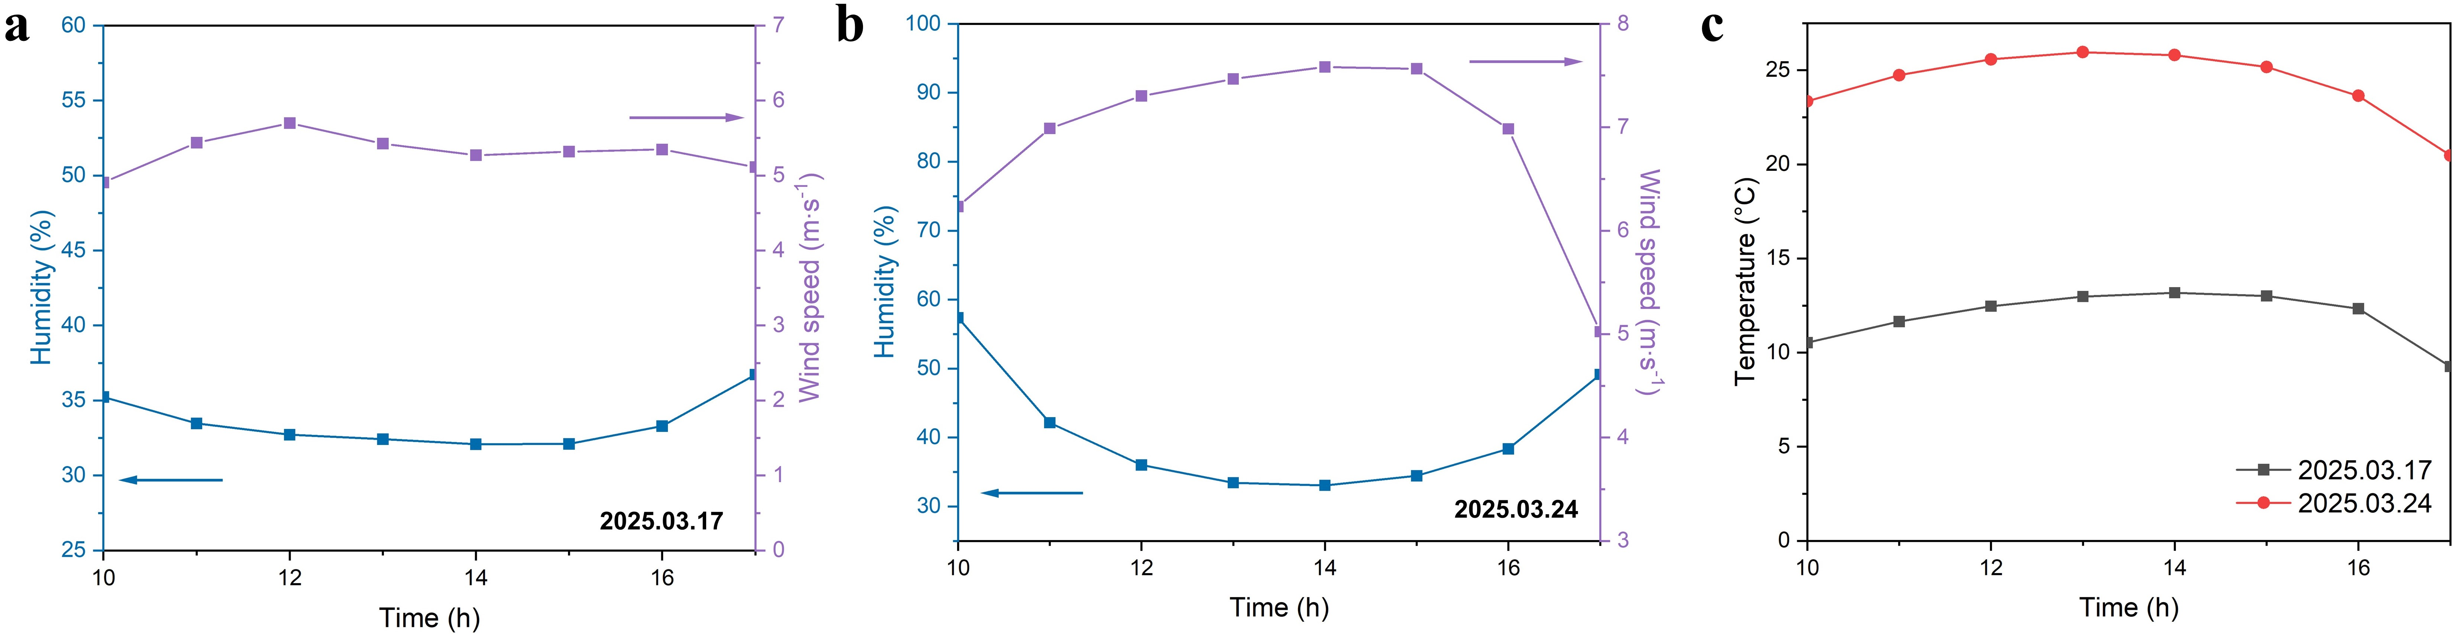
Fig. S15 Humidity, wind speed and meteorological temperature during outdoor testing

