Supporting Information for

Efficient and Pure I-III-VI AIGS Quantum Dot-based Light-Emitting Diodes via Ligand-Reshaped Surface State
Leimeng Xu¹, Jianpeng Zhao¹, Jindi Wang¹, Jisong Yao¹, Shalong Wang¹, Zhi Wu¹, Jizhong Song¹*
¹Key Laboratory of Materials Physics of Ministry of Education, Laboratory of Zhongyuan Light, School of Physics, Zhengzhou University, Daxue Road 75, Zhengzhou 450051, P. R. China
*Corresponding author. E-mail: songjizhong@zzu.edu.cn (Jizhong Song)
S1 Method of density functional theory simulations
DFT calculations [S1, S2] were performed using the Vienna ab initio simulation package (VASP). The generalized gradient approximation (GGA) in the form of Perdew-Burke-Ernzerhof (PBE) [S3] was adopted as the exchange correlation functional. The energy cutoff of 450 eV and the k-point meshes of 1×1×1 were proposed to carry out geometry optimization and electronic structure calculation. During the geometry optimization, the entire system is considered to have successfully converged until the convergence thresholds of maximum force and energy were smaller than 0.05 eV/A and 1.0×10⁻⁵ eV/atom, respectively. The vacuum slab was set as 15Å to avoid interactions between neighboring structures.
S2 Supplementary Figures and Tables
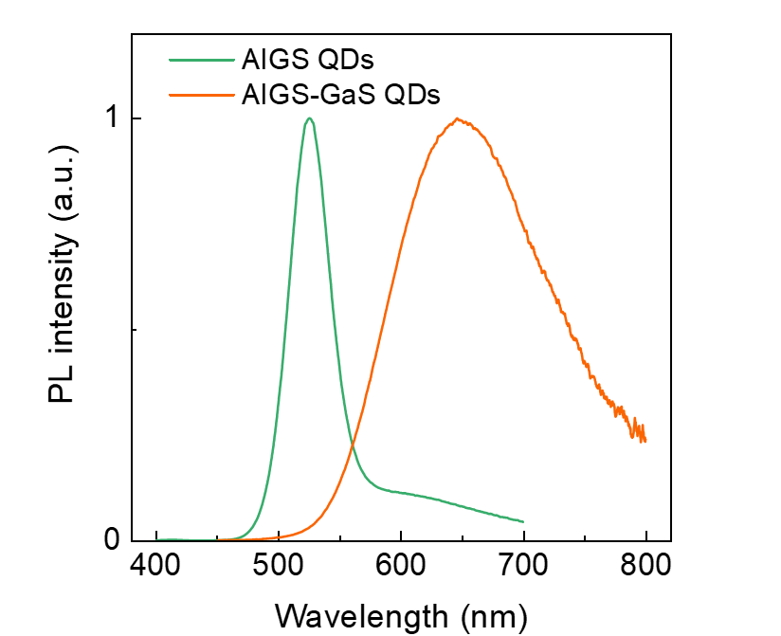
Fig. S1 PL spectra of AIGS QDs before and after GS coating

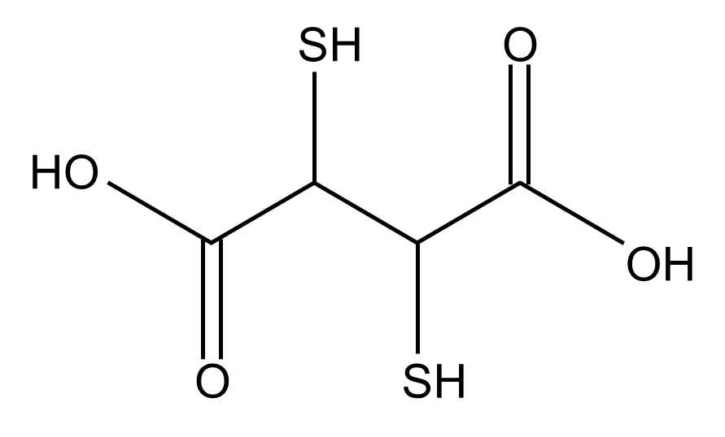
Fig. S2 The molecular structure of DSA

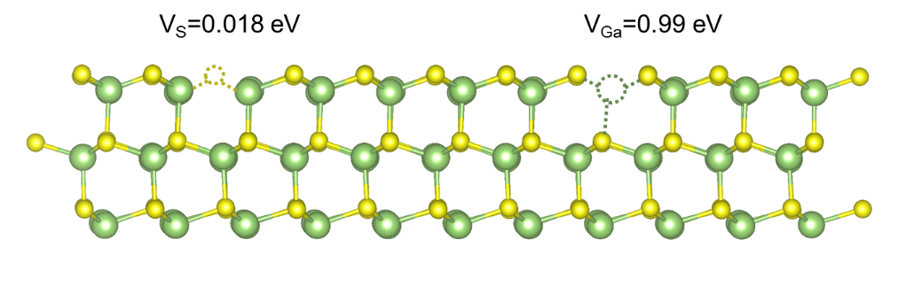
Fig. S3 Schematic diagram of V_{S} and V_{Ga} on GS surface and their corresponding vacancy formation energy

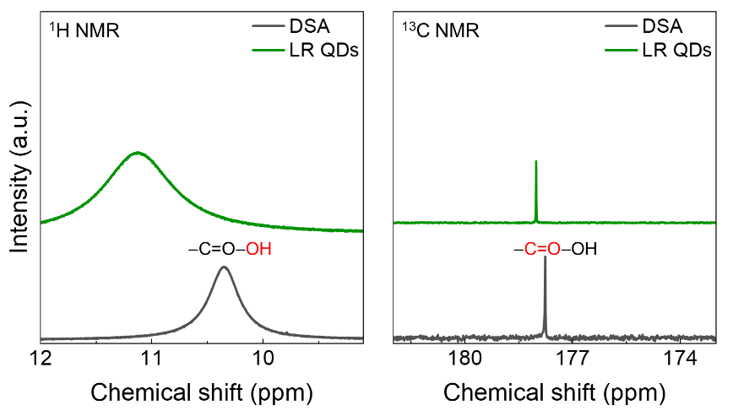
Fig. S4 ¹H and ¹³C NMR spectra of DSA and LR QDs

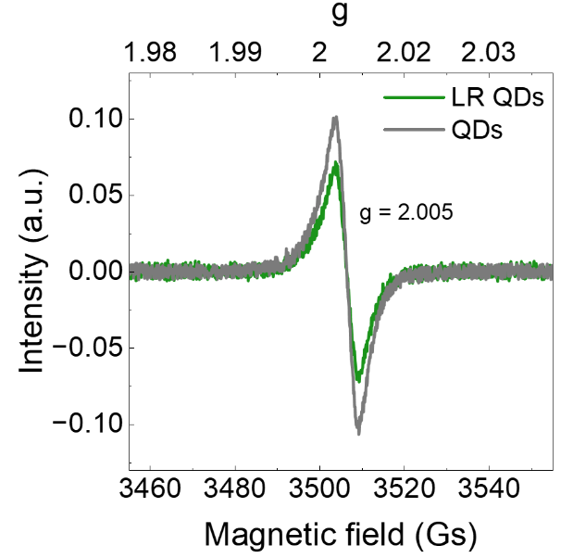
Fig. S5 Electron paramagnetic resonance (EPR) spectra of QDs and LR QDs

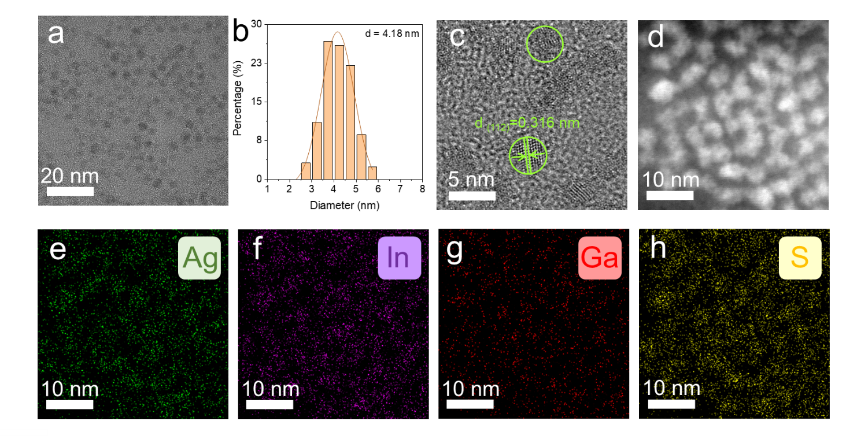
Fig. S6 (a) TEM image, (b) Size distribution histogram, (c) HRTEM image of AIGS QDs before GS coating. (d-h) energy dispersive spectroscopy elemental maps of Ag/In/Ga/S of AIGS QDs before GS coating

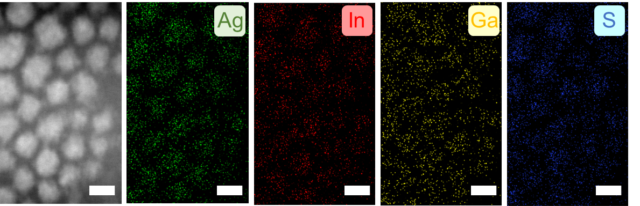
Fig. S7 Energy dispersive spectroscopy elemental maps of Ag/In/Ga/S of control AIGS QDs, the scale bar is 5 nm
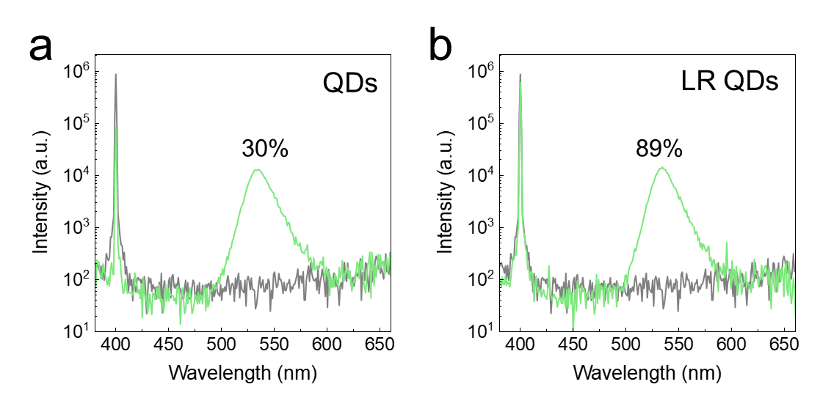
Fig. S8 PLQY spectra of (a) control QDs and (b) LR QDs
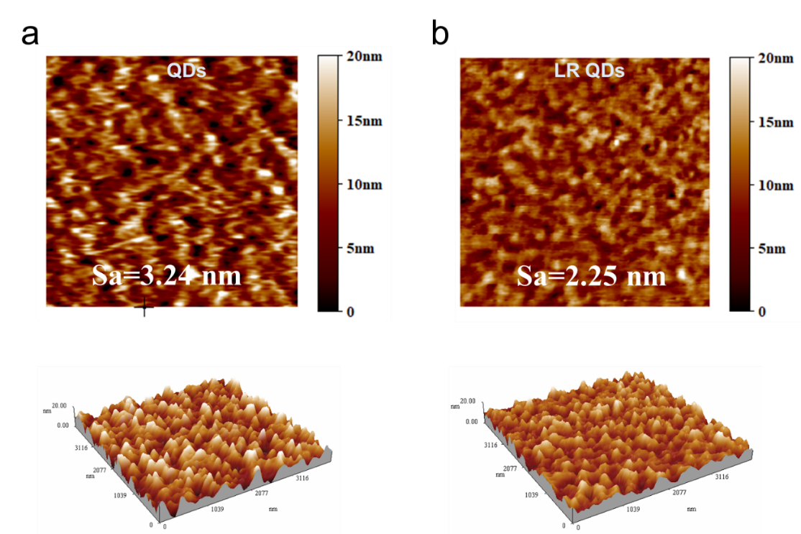
Fig. S9 AFM image and roughness of (a) control QD film and (b) LR QD film

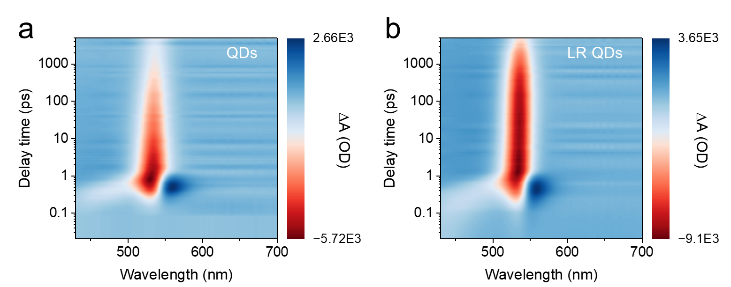
Fig. S10 The fs-TA spectra of (a) control QDs and (b) LR QDs

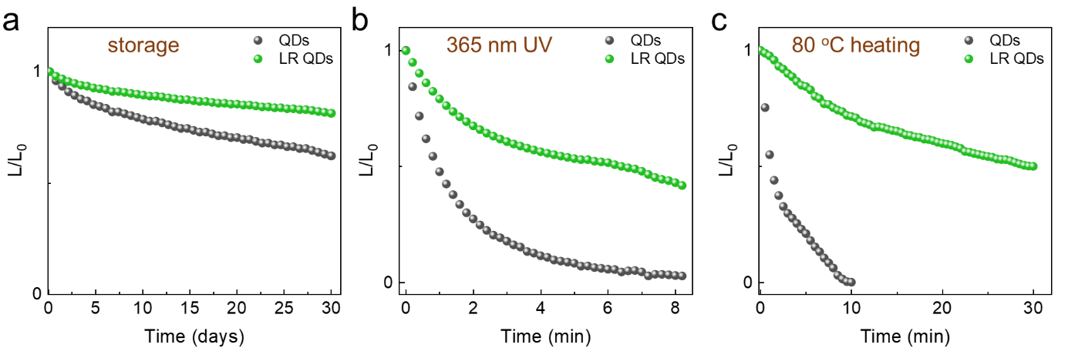
Fig. S11 (a) The PL attenuation curves of colloidal QDs at atmosphere for one month. PL attenuation of QD film (b) under 365 nm UV light irradiation and (c) heating at 80 °C

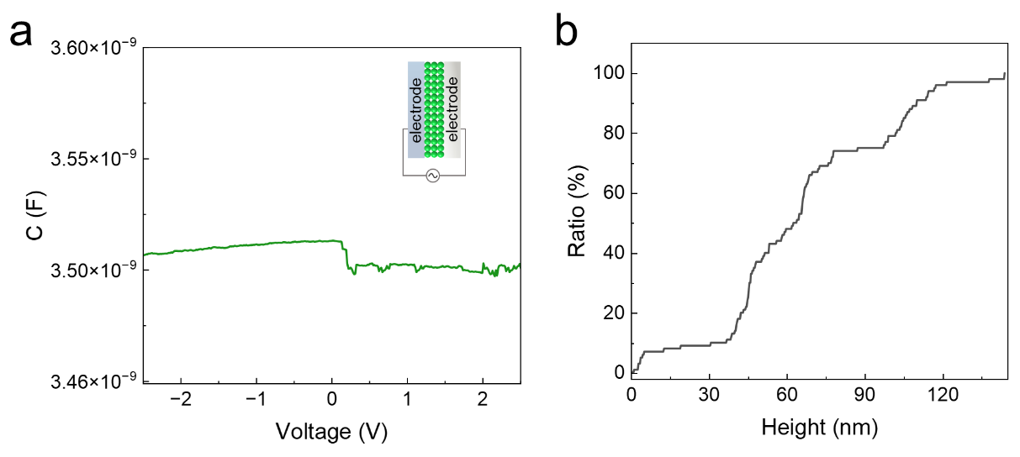
Fig. S12 (a) C-V curve of ITO/QDs/Al tested at 700 KHz. (b) AFM line scanning of QD film
The relative dielectric constant (ε) of AIGS/GS QDs are tested using a flat capacitor with the structure of ITO/QDs/Al, and calculated its relative dielectric constant using the formula . C denotes the maximum capacitance achieved under stable conditions (Fig. S12a); d represents the thickness of the tested sample, which was determined to be approximately 140 nm via AFM measurement (Fig. S12b); A represents the effective electrode area (6 mm²), ε₀ represents the vacuum dielectric constant (8.85×10⁻¹² F/m). Ultimately, the dielectric constant of the QDs, as experimentally determined, was approximately 9.3.

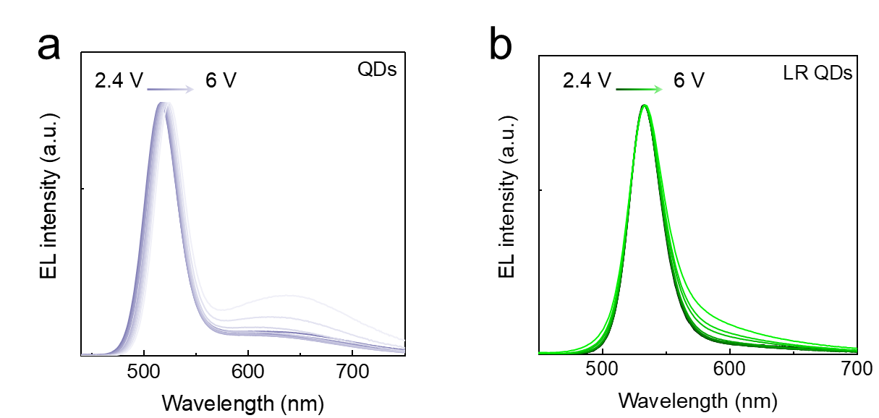
Fig. S13 EL spectra of (a) control QLEDs and (b) LR QLEDs tested from 2.4 V to 6 V

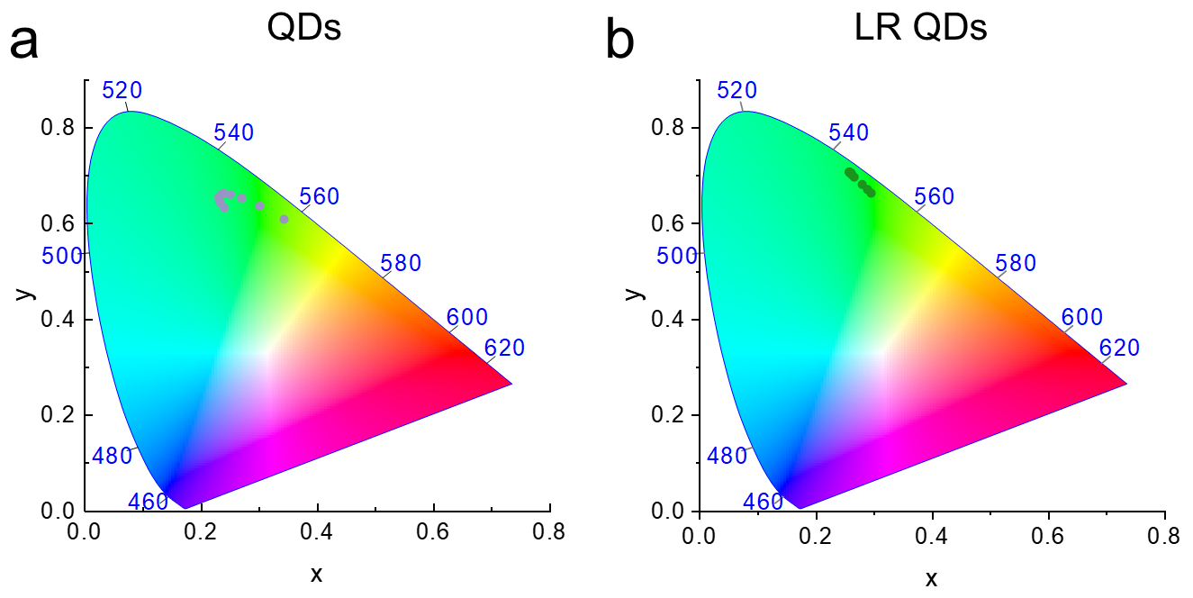
Fig. S14 The CIE chromaticity coordinates of (a) control and (b) LR QLEDs
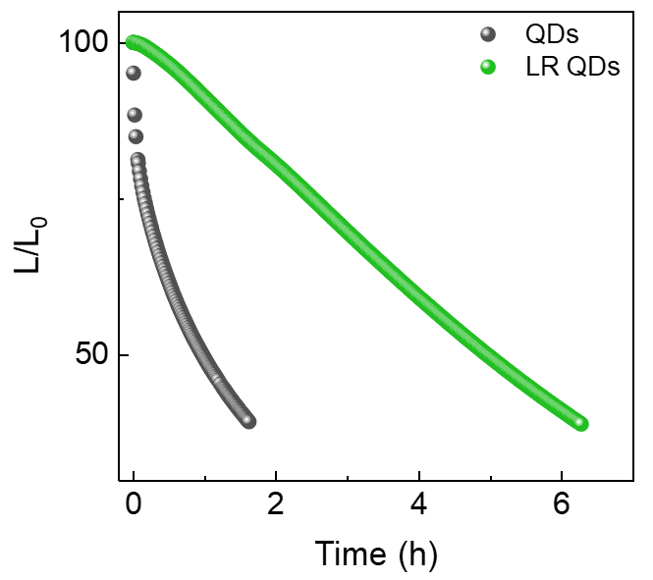
Fig. S15 The operational lifetime of QLEDs tested at initial luminance of 100 cd/m²

Table S1 The atomic ratio of elemental from ICP characterization
 | QDs | LR QDs
Ag | 2.5 | 2.6
In | 0.6 | 0.7
Ga | 1.6 | 1.8
S | 4.1 | 4.5
ratio | 1:0.24:0.64:1.64 | 1:0.26:0.69:1.73

Table S2 Summary of TR-PL decay fitting parameters for control and LR QDs
 | τ₁ (ns) | α₁ | τ₂ (ns) | α₂ | τ₃ (ns) | α₃ | τ_{ave} (ns)
LR QDs | 18.9 | 17.5% | 67.5 | 65.2% | 273.8 | 17.3% | 94.6
QDs | 12.2 | 31% | 64.6 | 43.2% | 289.3 | 25.8% | 106

Table S3 Summary of GSB fitting parameters for control and LR QDs
 | τ₁ (ps) | α₁ | τ₂ (ps) | α₂ | τ₃ (ps) | α₃ | τ_{ave} (ps)
LR QDs | 2.47 | 0.02% | 5099.2 | 99.18% | 308.8 | 0.8% | 94.6
QDs | 1.67 | 0.18% | 64 | 3.16% | 2229.5 | 96.66% | 106
Table S4 Performance summary of reported AIGS QLEDs
Time | Material | PL  (nm) | FWHM  (nm) | PLQY  (%) | EQE  (%) | Luminance  (cd/m²) | References
This work | AIGS@GS | 531 | 31 | 89 | 8.4 | 1219
2024 | AIGS@GS | 524 | 30 | 53 | 5.4 | >1000 | Adv. Phys. Res., 2024, 3, 240042
2024 | AIGS@AGS | 532 | 36 | 45 | 0.75 | 2747 | J. Mater. Chem. C, 2024, 12, 6528
2024 | AIGS@AGS | 532 | 33 | 45 | 0.26 | 1518 | Chinese J. Lumin., 2024, 45, 1849
2024 | AIGZS | 482, 532, 620 | 49, 38, 44 |  | 0.53, 0.13, 0.03 | 405, 184, 196 | Nano Lett., 2024, 24, 9683
2024 | AIGS@ZS | 553 | 44.6 | 16 | 0.1 |  | Chem. Commun., 2024, 5731
2023 | AIGS@GS | 531 | 32 | 32.0 | 1.10 | 175 | ACS Appl. Mater. Interfaces., 2023, 15, 8336
2023 | ZAIGS@IS | 628 | 78 | 86.2 | 5.32 | 218.1 | ACS Appl. Mater. Interfaces., 2023, 15, 50254
2022 | AGZS | 470 | 48 | 16.7 | 0.40 | 123.1 | J. Phys. Chem. Lett., 2022, 13, 11857
2020 | AIS@ZS | 666 | 122 | 72.0 | 1.25 | 1120 | J. Phys. Commun., 2020, 4, 045016
2020 | AIS@GS | 560 | 45 | 70.0 | 0.54 | 120.5 | Appl. Phys. Lett., 2020, 117, 091101

Supplementary References
- P. Hohenberg, W. Kohn, Inhomogeneous electron gas. Phys. Rev. 136(3B), B864 (1964). https://doi.org/10.1103/PhysRev.136.B864
- W. Kohn, L.J. Sham, Self-consistent equations including exchange and correlation effects. Phys. Rev. 140(4A), A1133 (1965). https://doi.org/10.1103/PhysRev.140.A1133
- J.P. Perdew, K. Burke, M. Ernzerhof, Generalized gradient approximation made simple. Phys. Rev. Lett. 77(18), 3865 (1996). https://doi.org/10.1103/PhysRevLett.77.3865

