Supporting Information for
Facilitated Polysulfide Redox Conversion by Delocalized Electrons in MBene Heterointerface for Highly Stable Lithium–Sulfur Batteries
Guifen Wu¹, Yunmiao Fan³, Jiatong Li³, Zhaoxi Shen^{2,}* , Yuxiu Xie¹, Peixun Yang¹, Jun Pu^{1,}*
¹ Key Laboratory of Functional Molecular Solids (Ministry of Education), Anhui Provincial Engineering Laboratory for New-Energy Vehicle Battery Energy-Storage Materials, College of Chemistry and Materials Science, Anhui Normal University, Wuhu 241002, P. R. China
² College of Chemistry and Materials Science, Key Laboratory of Analytical Science and Technology of Hebei Province, Institute of Life Science and Green Development, Hebei University, Baoding 071002, P. R. China
³ State Key Laboratory of Multiphase Complex Systems, Institute of Process Engineering, Chinese Academy of Sciences, Beijing 100190, P. R. China
*Corresponding authors. E-mail: jpu@ahnu.edu.cn (Jun Pu); zhaoxishen@hbu.edu.cn (Zhaoxi Shen)
S1 Experimental Section
Theoretical calculation: The electronic properties and optimize geometries of all the investigated structures in this work were calculated based on density functional theory (DFT). The cambridge sequential total energy package (CASTEP) was employed with a general gradient approximation and Perdew-Burke-Ernzerh of exchange correlation functional [S1, S2]. A plane-wave cutoff energy of 500 eV was employed for the standard norm-conserving pseudopotentials [S3]. The Brillouin zone was sampled with Monkhorst-Pack mesh k-points of 3×3×1 grid. A vacuum slab thickness of 15 Å was set between slabs along the Z-axis. The binding energy (E) between the material and polysulfides was calculated as follows: E = (E_{mat} + E_{ps}) – E_{mat+ps}, where E_{mat}, E_{ps}, and E_{sub+ps}, denoted the energy of the materials, polysulfides and total binding system, respectively [S4].
S2 Supplementary Figures and Tables

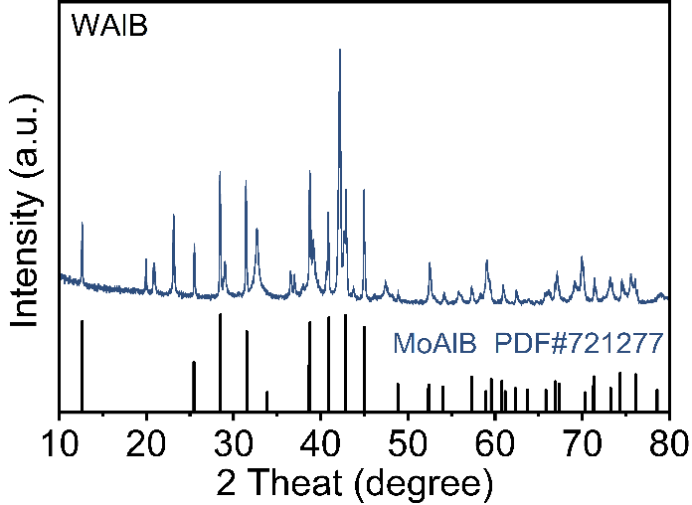
Fig. S1 XRD of WAlB precursor

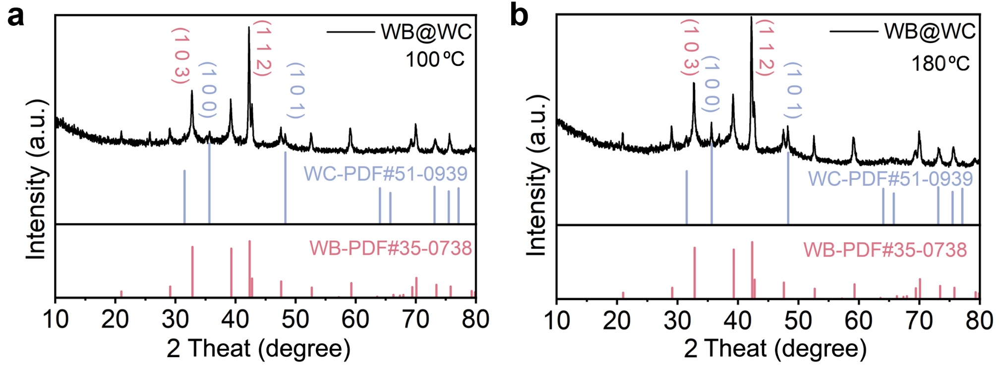
Fig. S2 XRD results of WB@WC samples under different carbonization temperatures: a 100 °C; b 180 °C

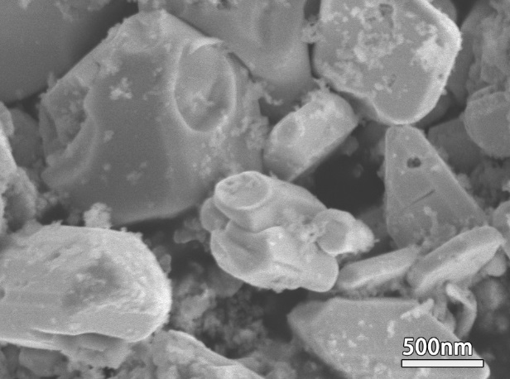
Fig. S3 SEM of WAlB precursor with blocky structure

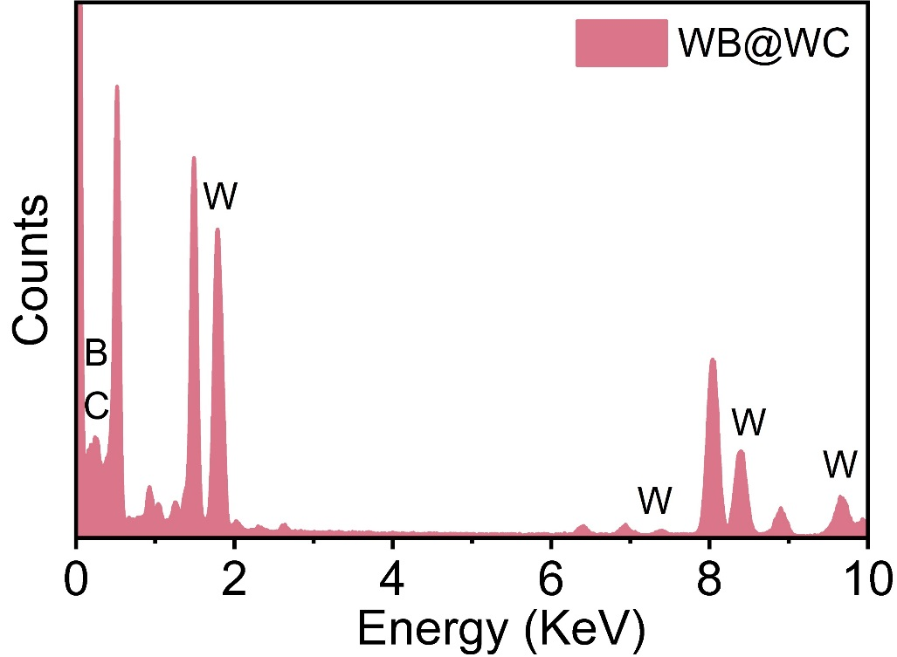
Fig. S4 EDS of WB@WC heterostructures

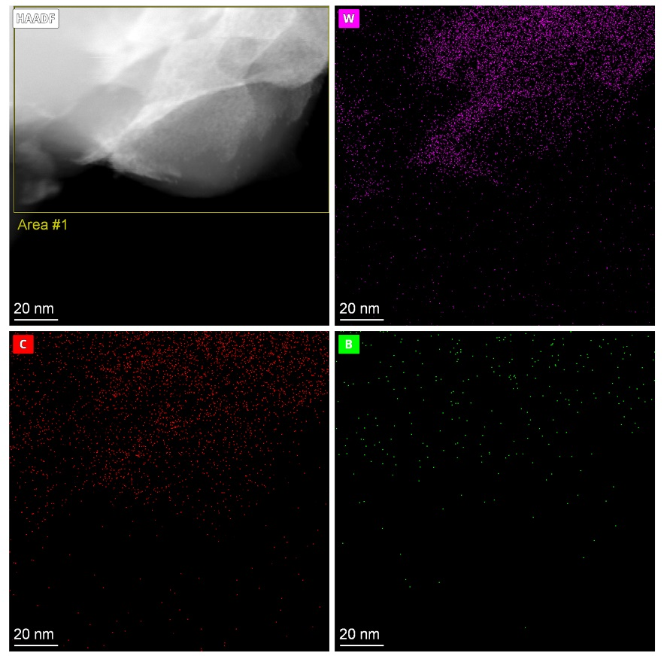
Fig. S5 HAADF-STEM base elemental mapping with further magnification

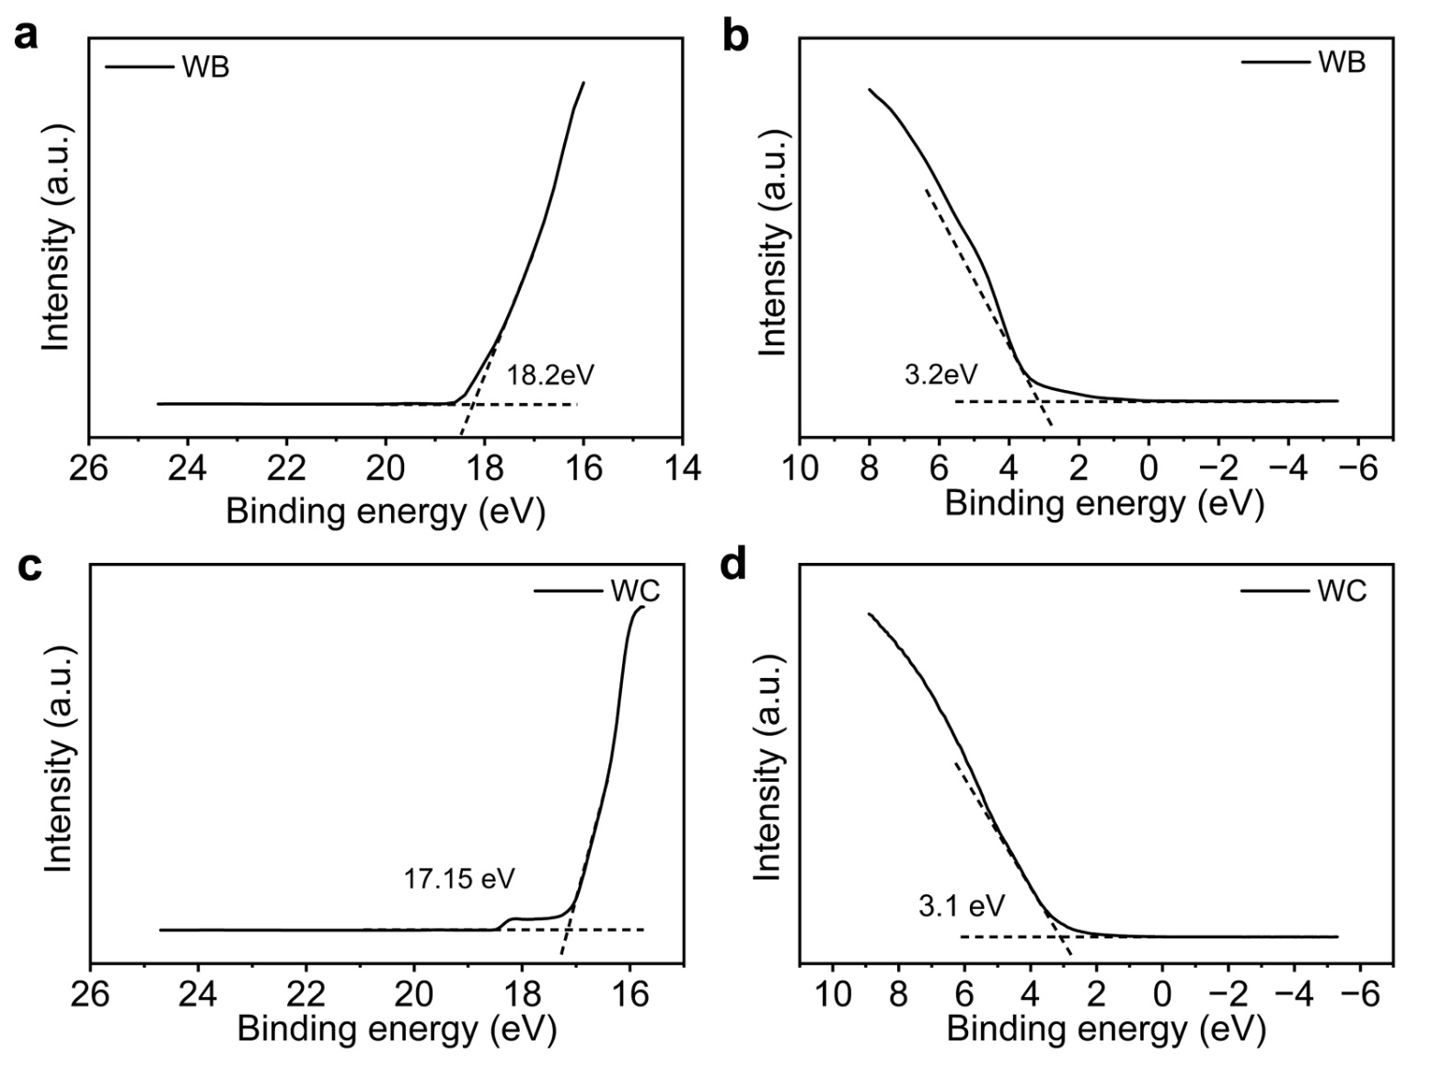
Fig. S6 Ultraviolet photoelectron spectroscopy: a WB, and b WC

WB: Work function (Φ) = 21.2 – 18.2 = 3.0 eV VB/HOMO = 3.2 eV
WC: Work function (Φ) = 21.2 – 17.15 = 4.05 eV VB/HOMO = 3.1 eV

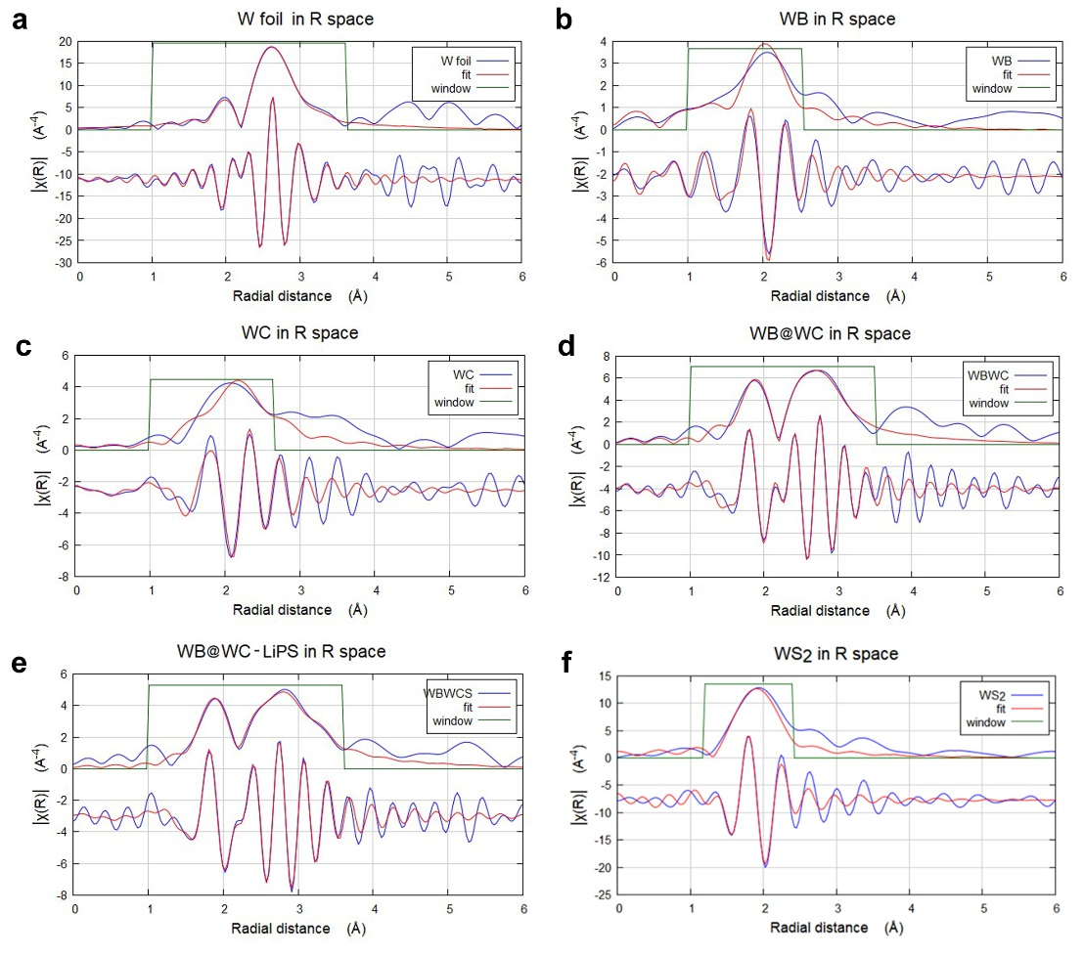
Fig. S7 Fitting results of the XAFS spectra of different samples at k-space and R space: a W foil; b WB; c WC; d WB@WC; e WB@WC-LiPS; f WS₂

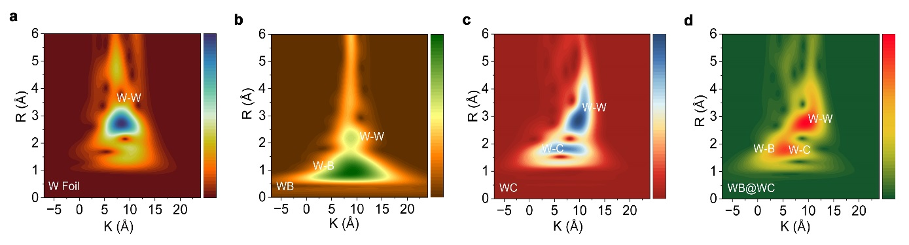
Fig. S8 WT-XAFS of W L-edge for different samples

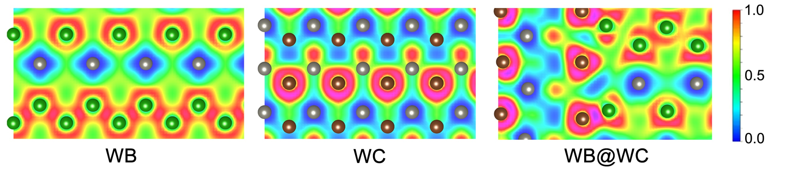
Fig. S9 Calculation of electronic local function of WB, WC and WB@WC

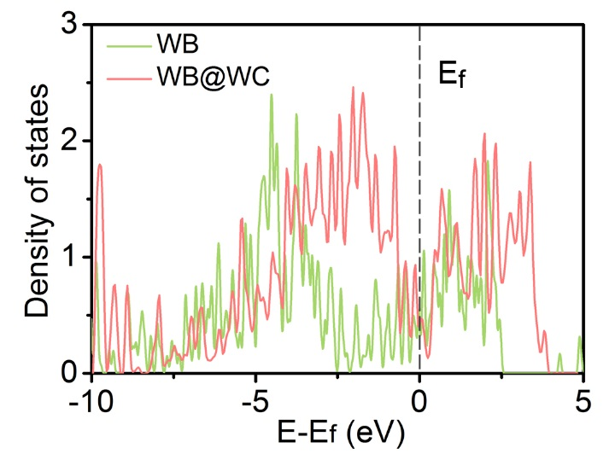
Fig. S10 Density of states of WB and WB@WC

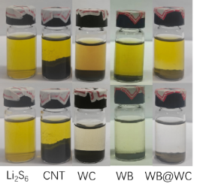
Fig. S11 Associated color change of Li₂S₆ solution before and after adding different materials

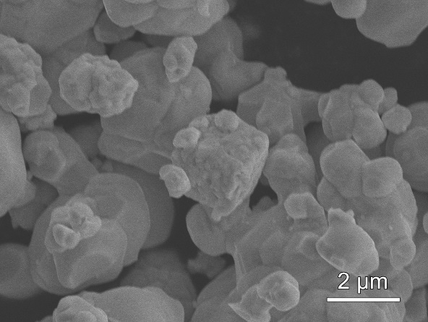
Fig. S12 SEM of WC sample

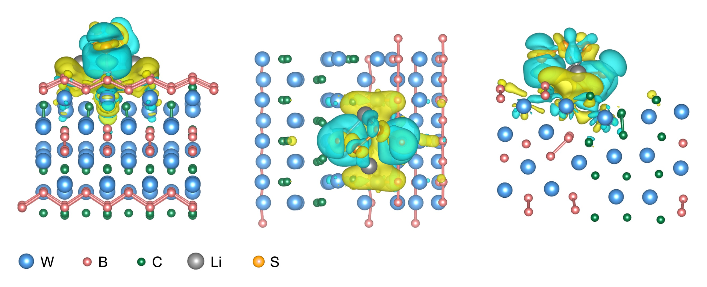
Fig. S13 Bader charge analysis of WB@WC adsorbing LiPS at different angles

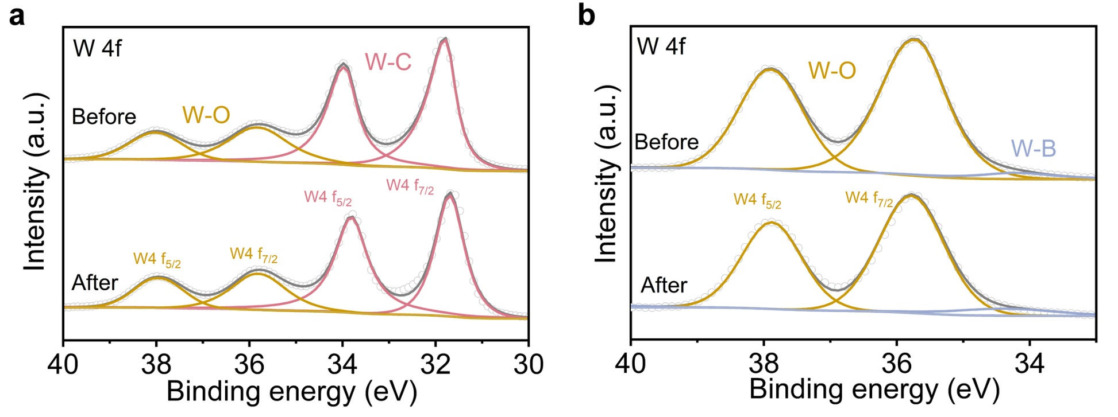
Fig. S14 XPS of W4f before and after LiPSs adsorption

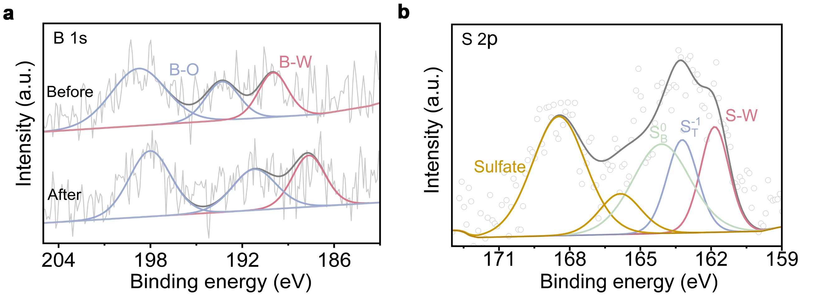
Fig. S15 a XPS comparison of W element in WB@WC before and after adsorption of Li₂S₆. b XPS of S element in WB@WC after adsorption

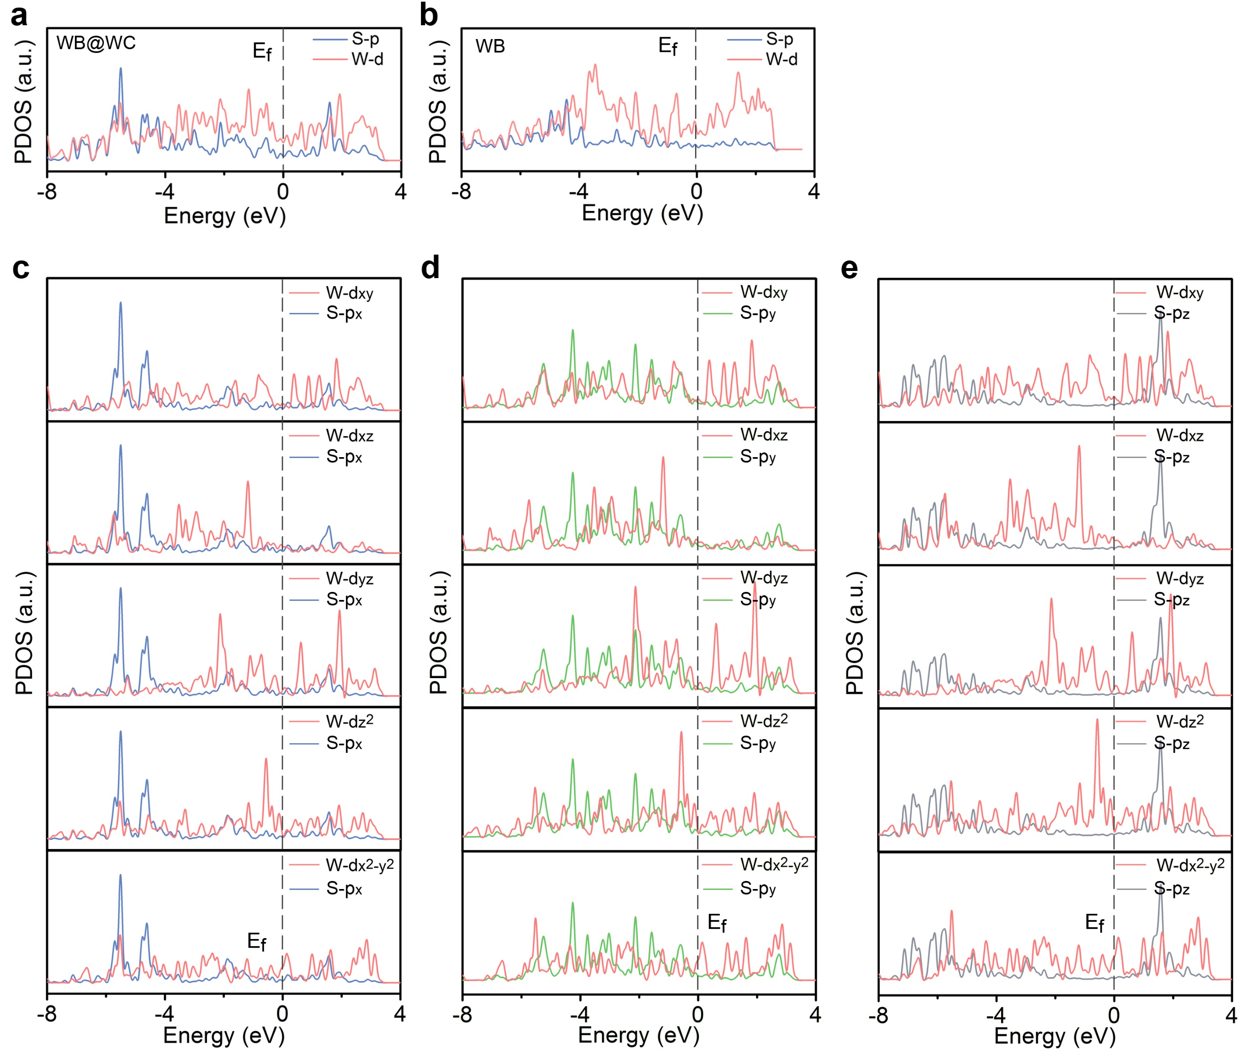
Fig. S16 PDOS of for W-d orbital and S-p orbital the Li₂S₆ adsorbed on different materials: a WB@WC; b WB. Detailed information for the Li₂S₆ adsorbed on WB@WC: c W-d orbital and S-px orbital; d W-d orbital and S-py orbital; e W-d orbital and S-pz orbital

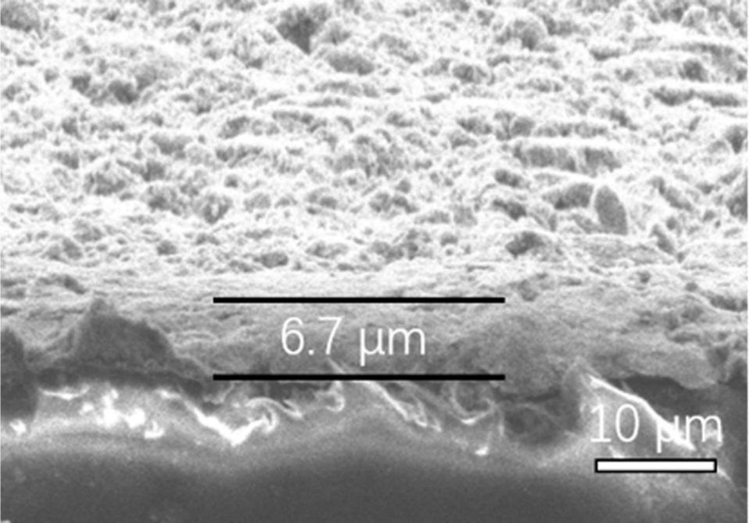
Fig. S17 Cross-sectional SEM image of WB@WC coating layer on PP separator

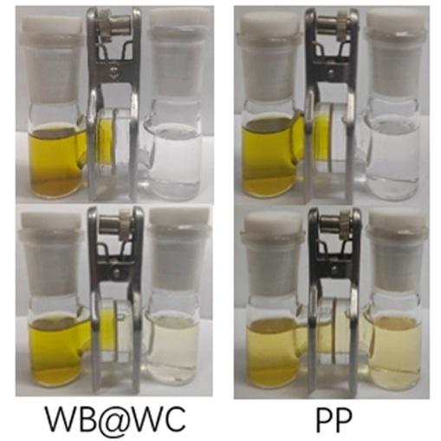
Fig. S18 Visualized soluble Li₂S₄ penetration with H-type electrolytic cell

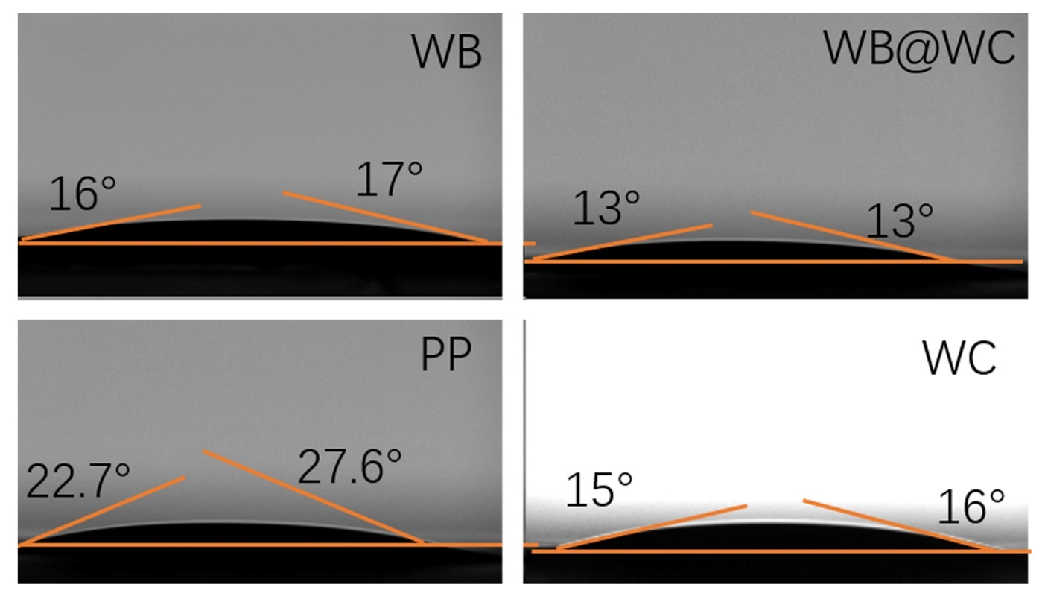
Fig. S19 Optical images of contact angle measurements of Li–S electrolyte on different separators 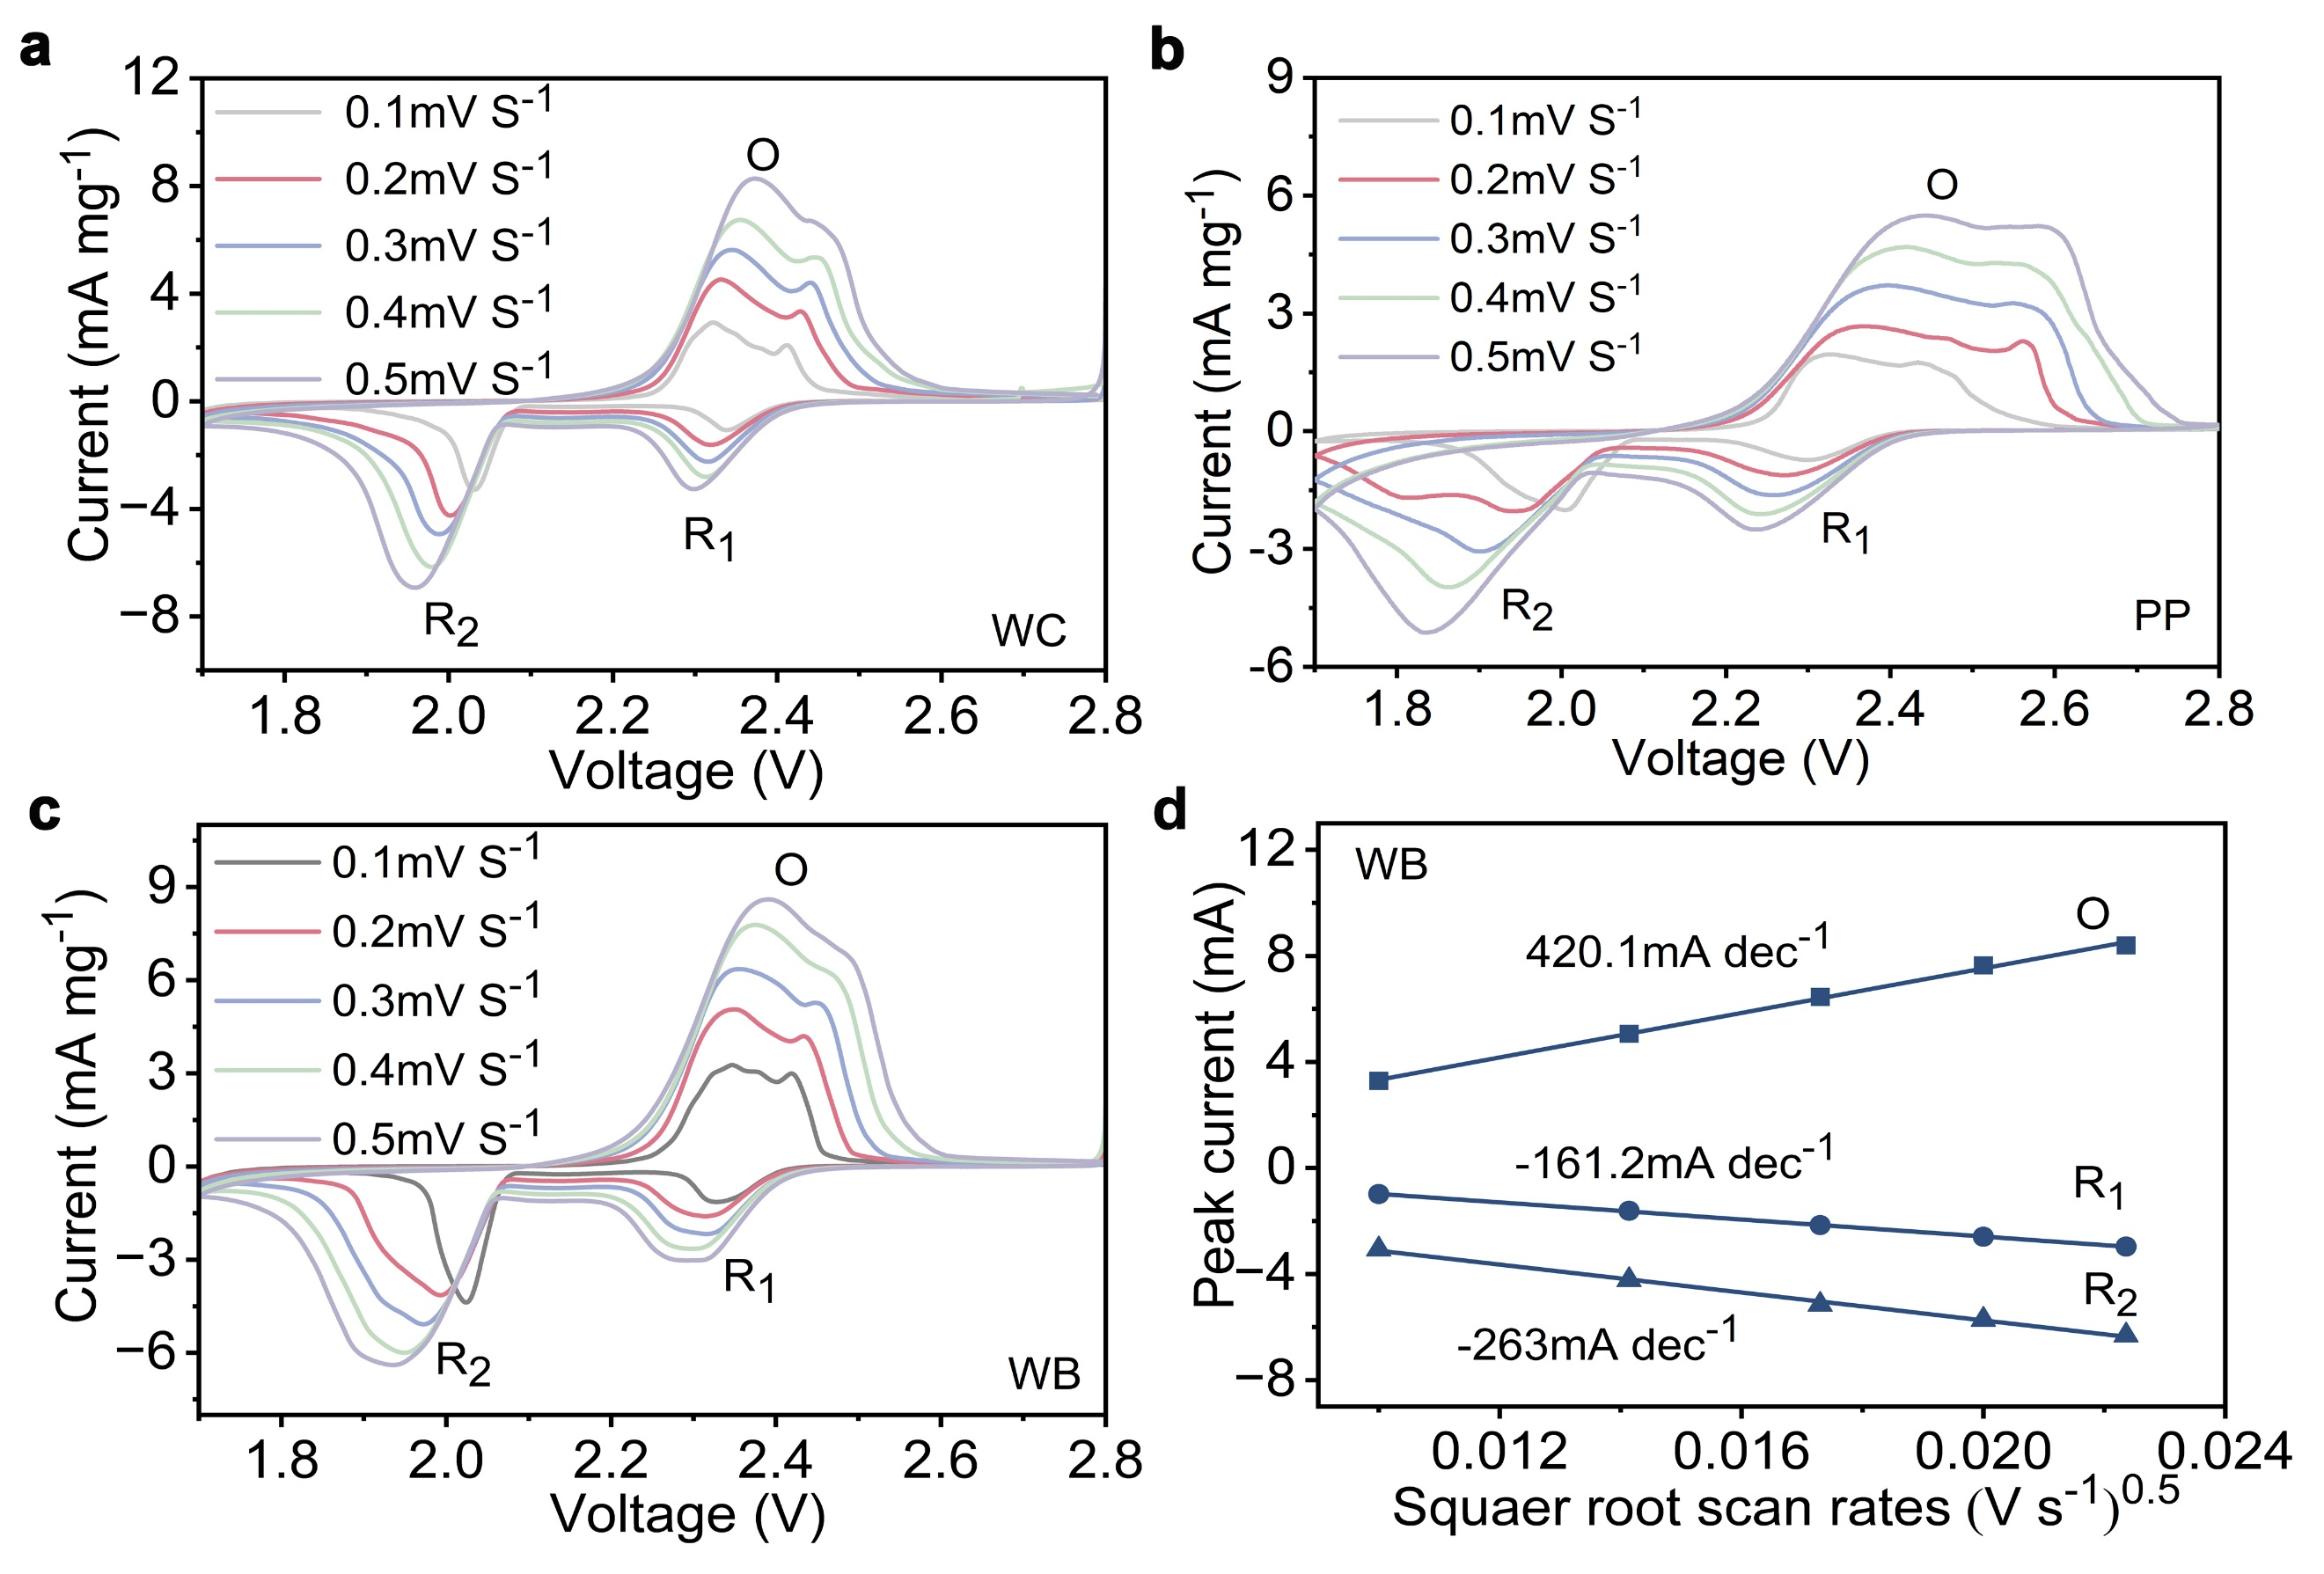

Fig. S20 a–c CV of different separators at various scan rates. d Linear fitting comparison of peak currents in WB based CV curves

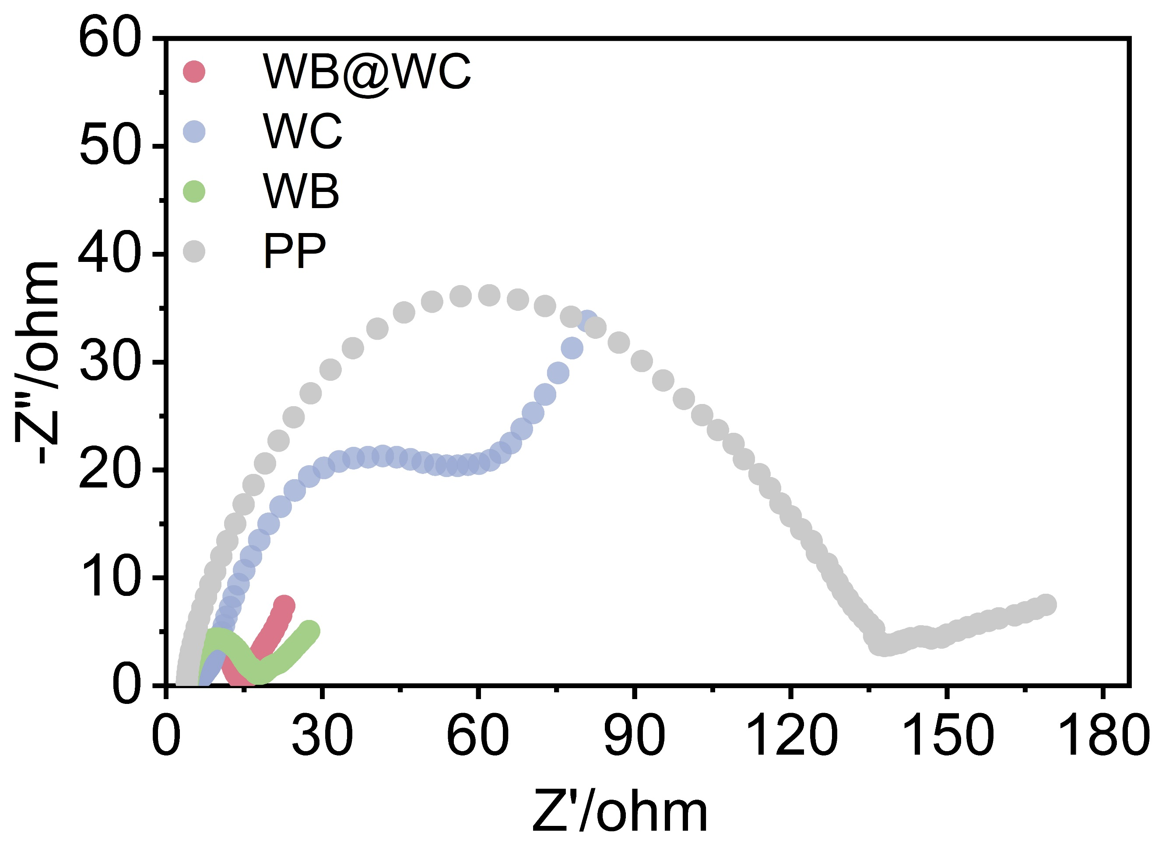
Fig. S21 EIS of different cells

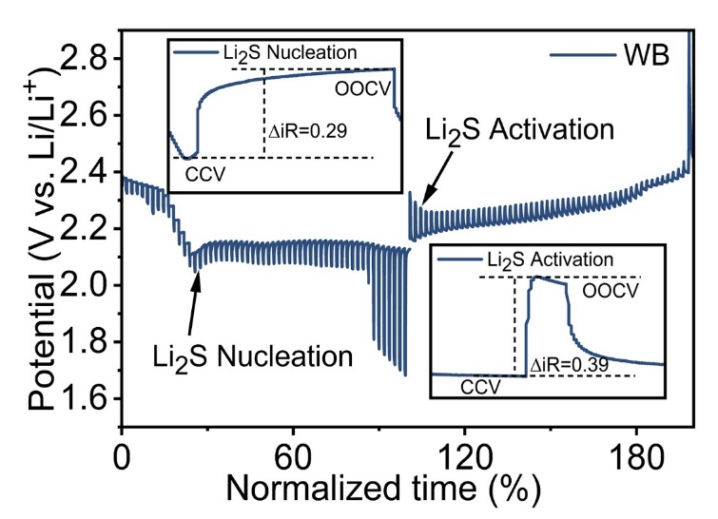
Fig. S22 GITT voltage profiles of PP based cell at 0.1 C
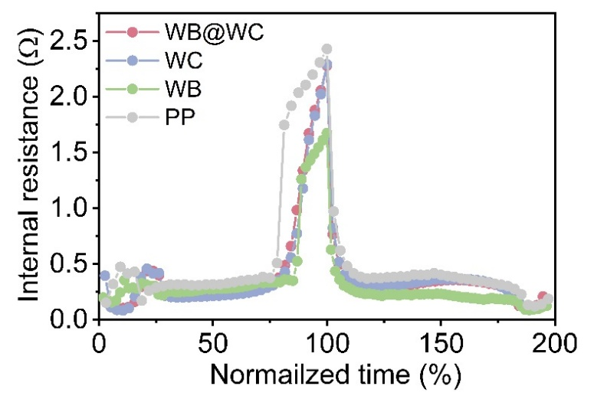
Fig. S23 Internal resistances relative to the normalized discharge-charge time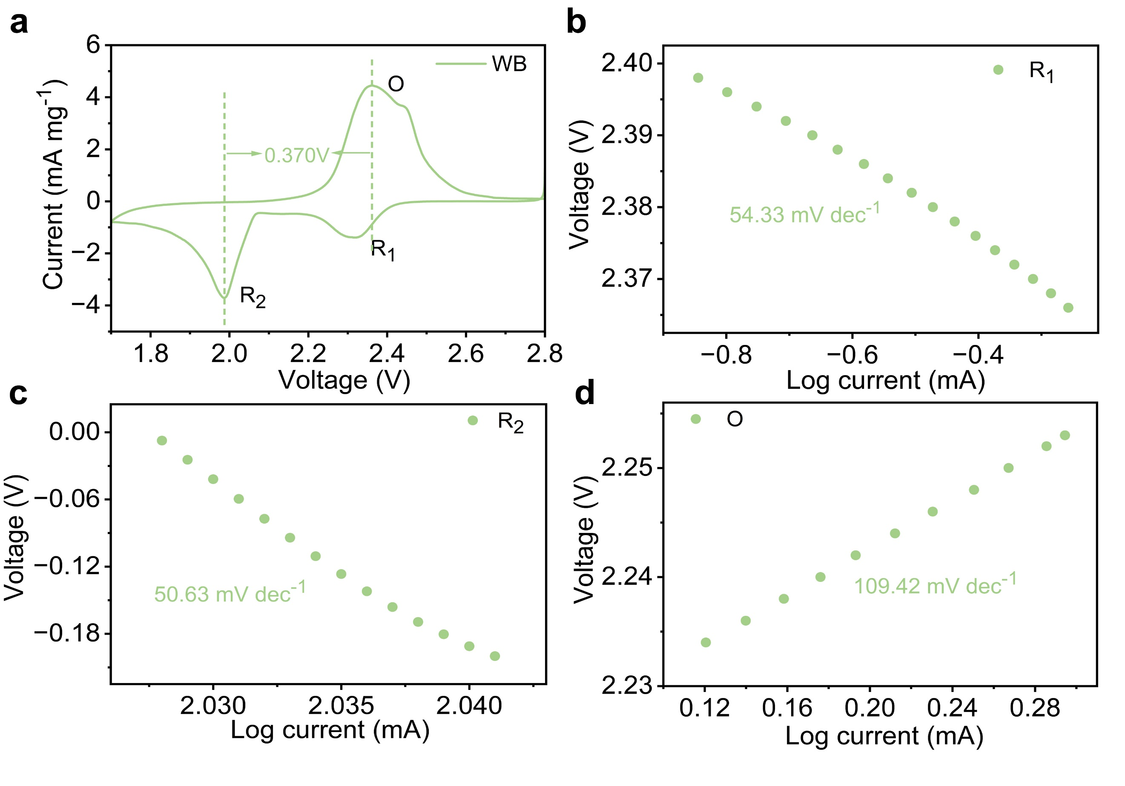
Fig. S24 a CV curve and b–d corresponding Tafel fitted slopes of the WB based cathode at 0.1 mV s⁻¹

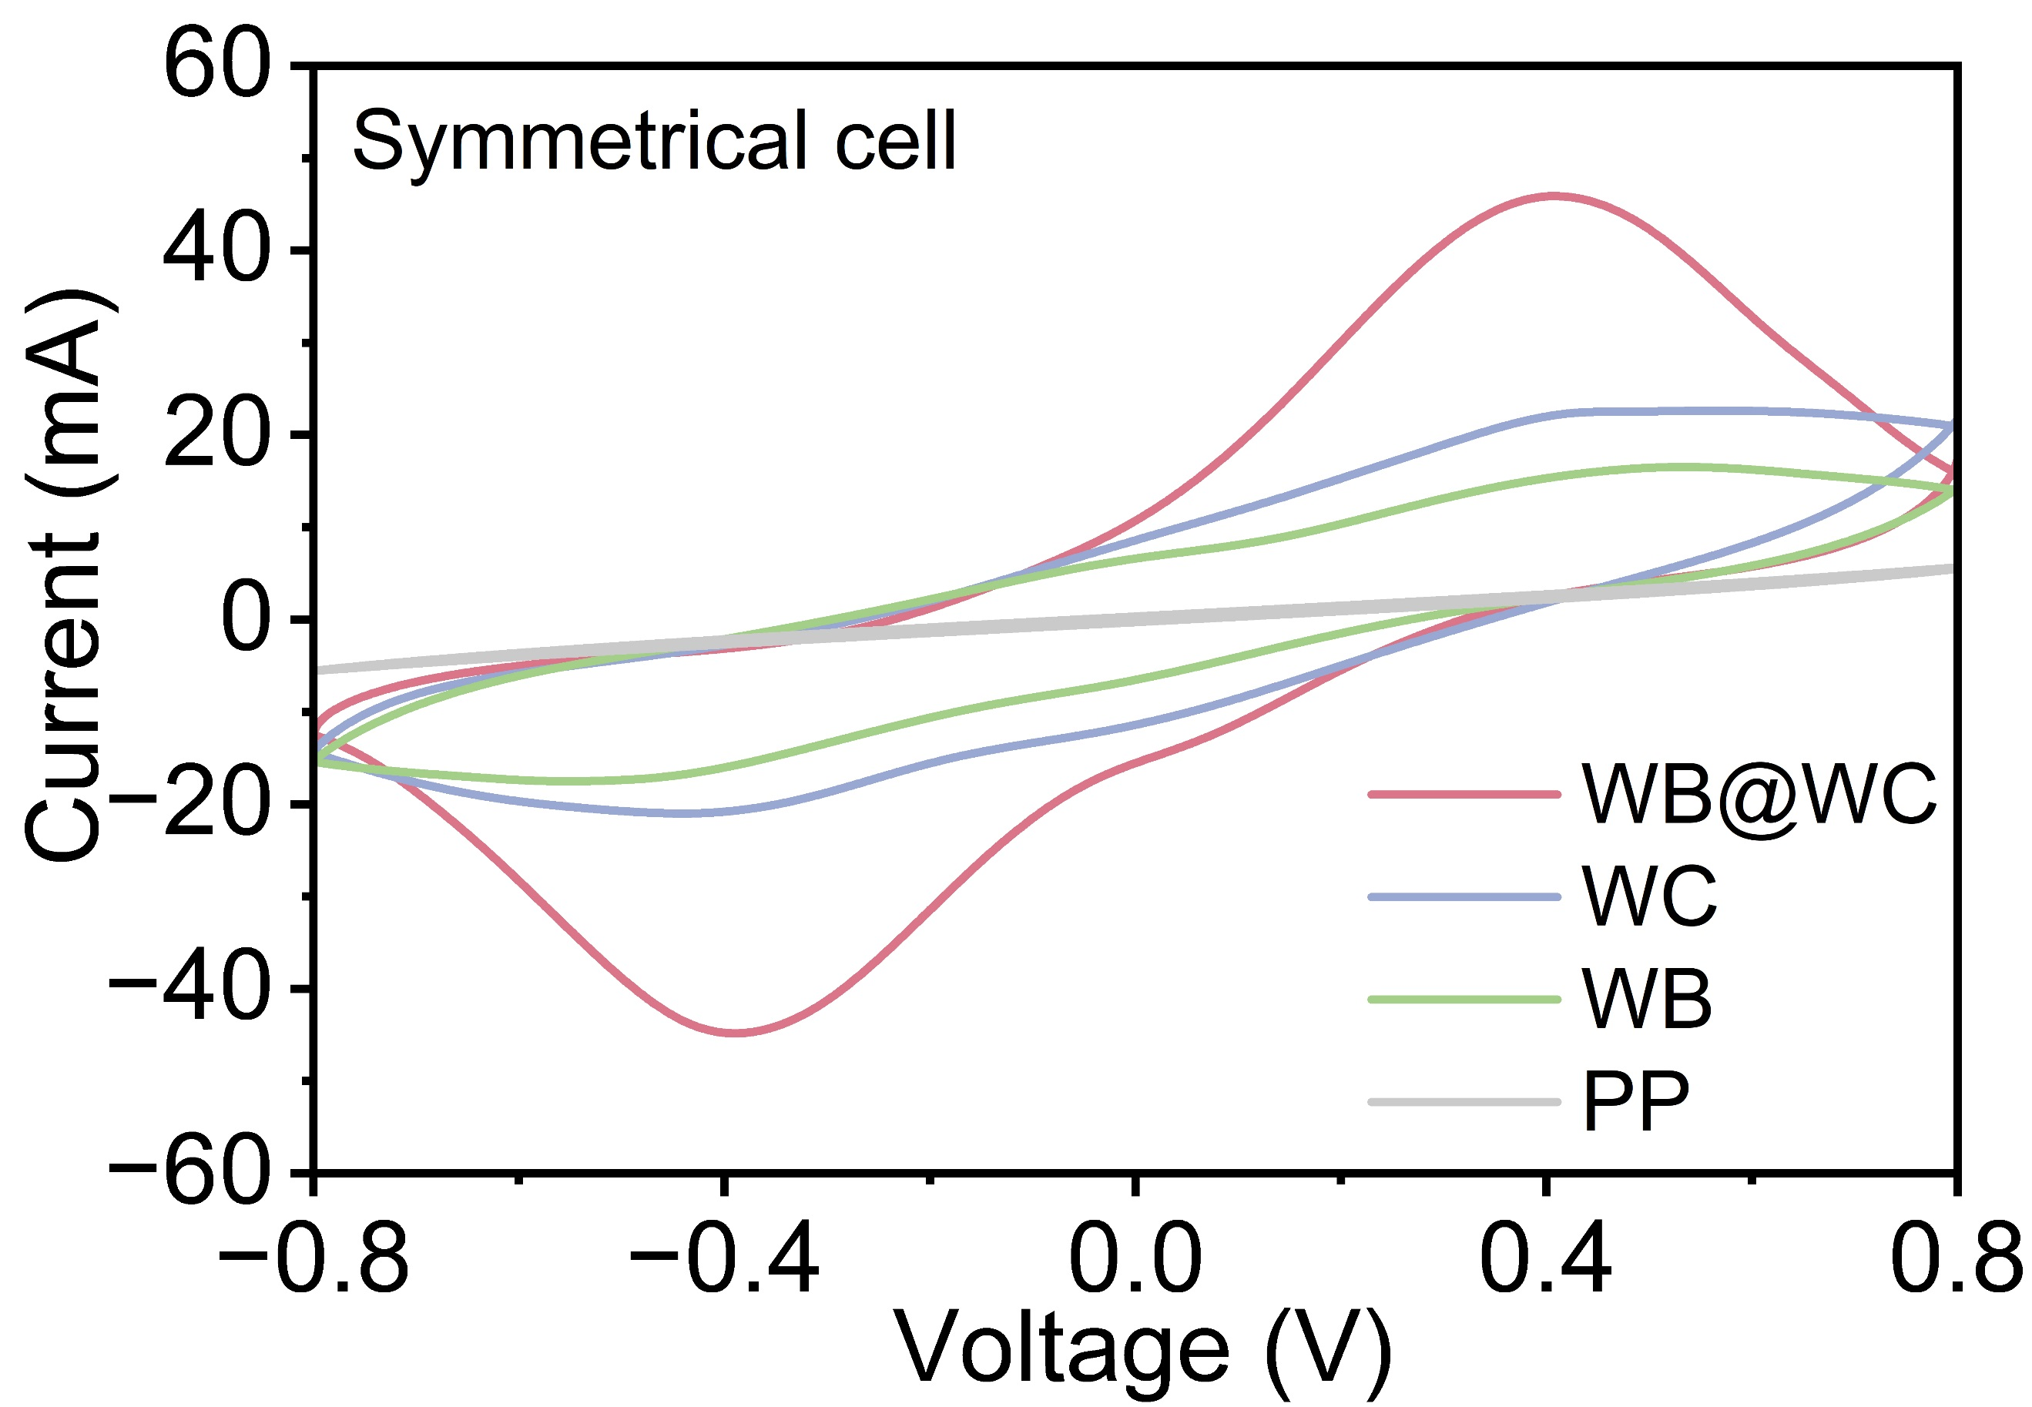
Fig. S25 Symmetrical cell tests at 50 mV s⁻¹

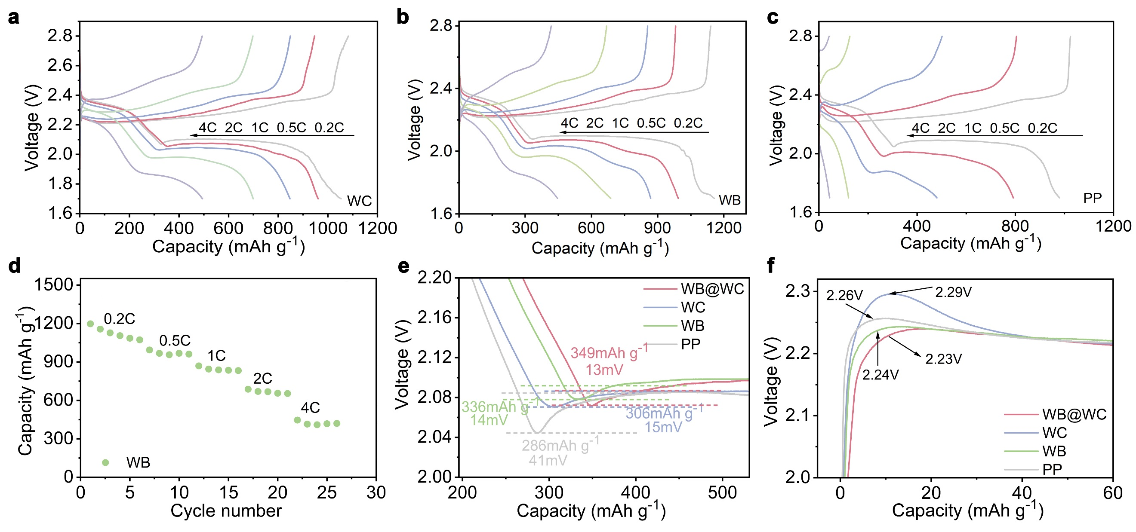
Fig. S26 a–c Voltage profiles of the Li–S cells with different separators at various scan rates. d Rate of WB-based cathode. e, f Partial galvanostatic discharge and charge curves

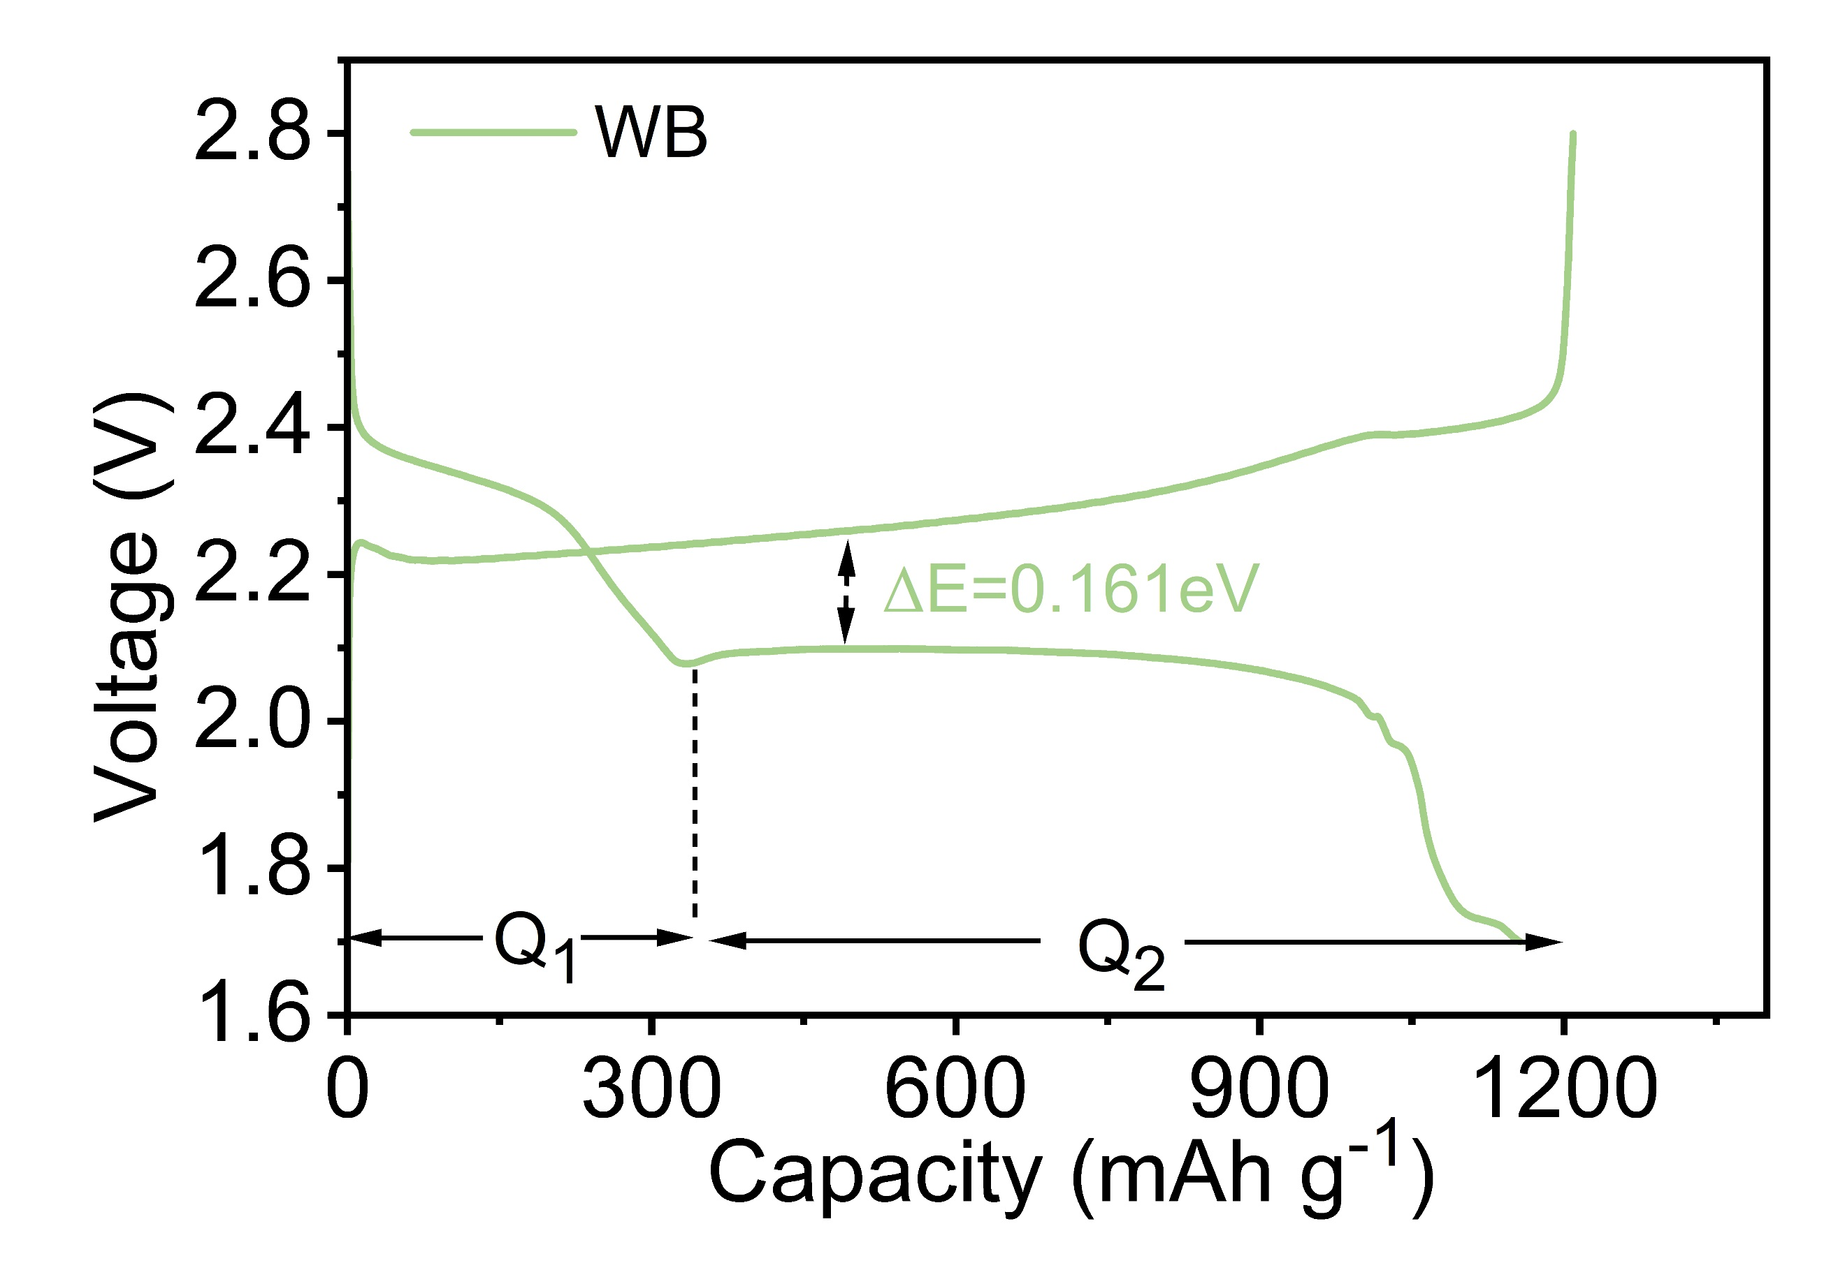
Fig. S27 Galvanostatic charge-discharge profiles based on WB separator at 0.2 C

Fig. S28 The ratio of Q₂ to Q₁

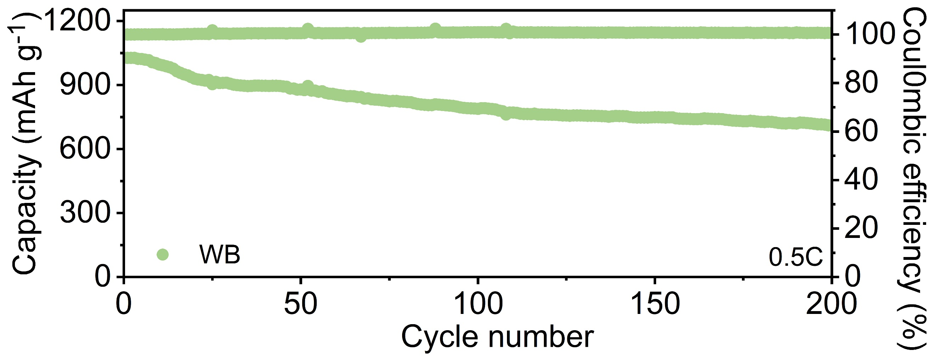
Fig. S29 Cycling performance of cathode with WB-based separator

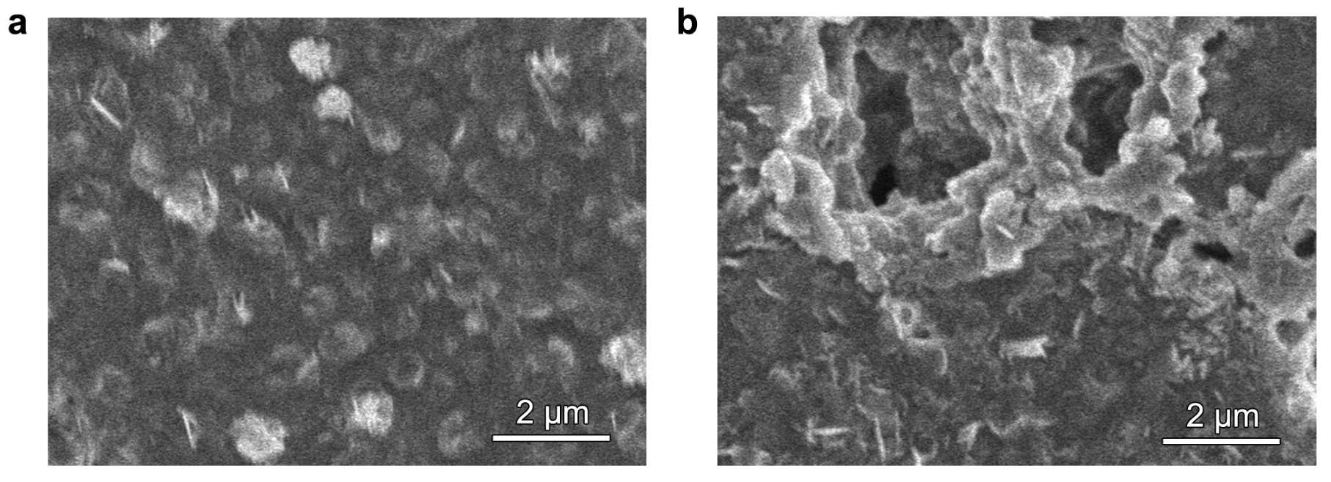
Fig. S30 Post-mortem SEM analysis of cycled Li anodes: a WB@WC modified cell, b ordinary cell with pure PP separator

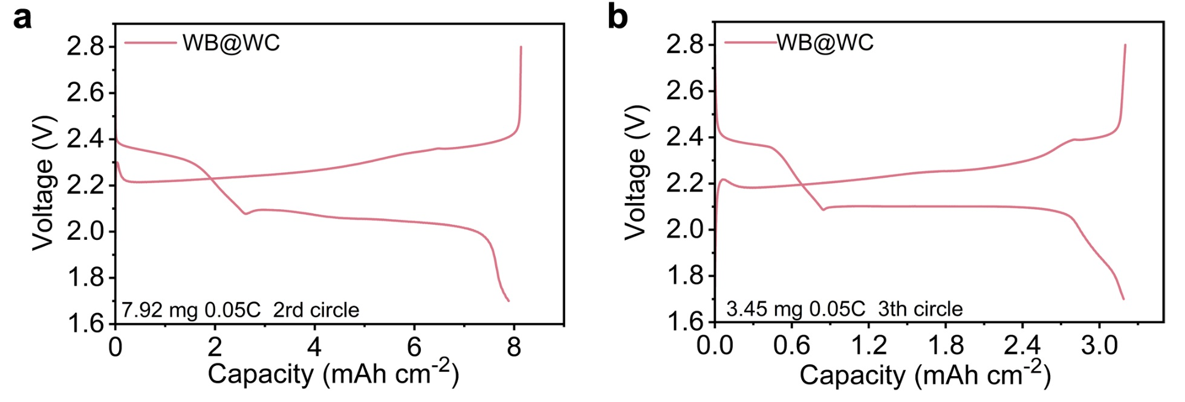
Fig. S31 Charge-discharge curves under different high loads: a 7.92 mg cm⁻²; b 3.45 mg cm⁻²

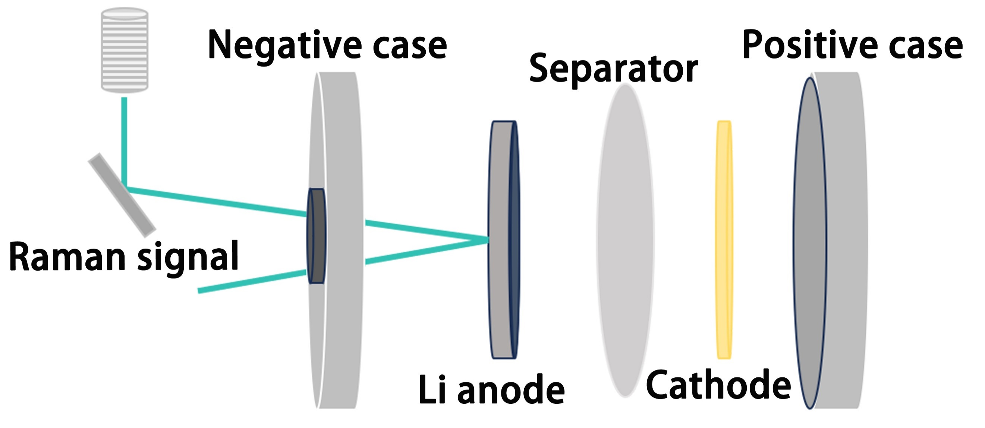
Fig. S32 Schematic diagram of in-situ Raman

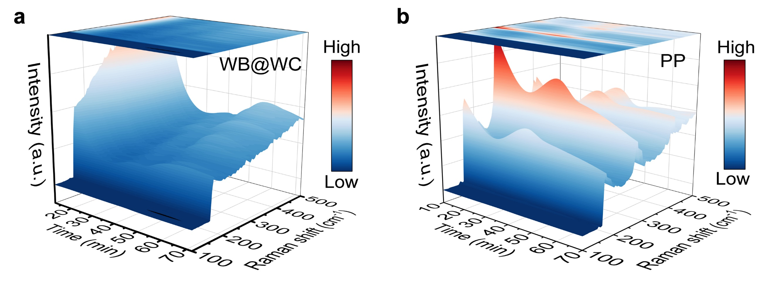
Fig. S33 3D in-situ time-resolved Raman spectra: a WB@WC based cell and b PP based cell

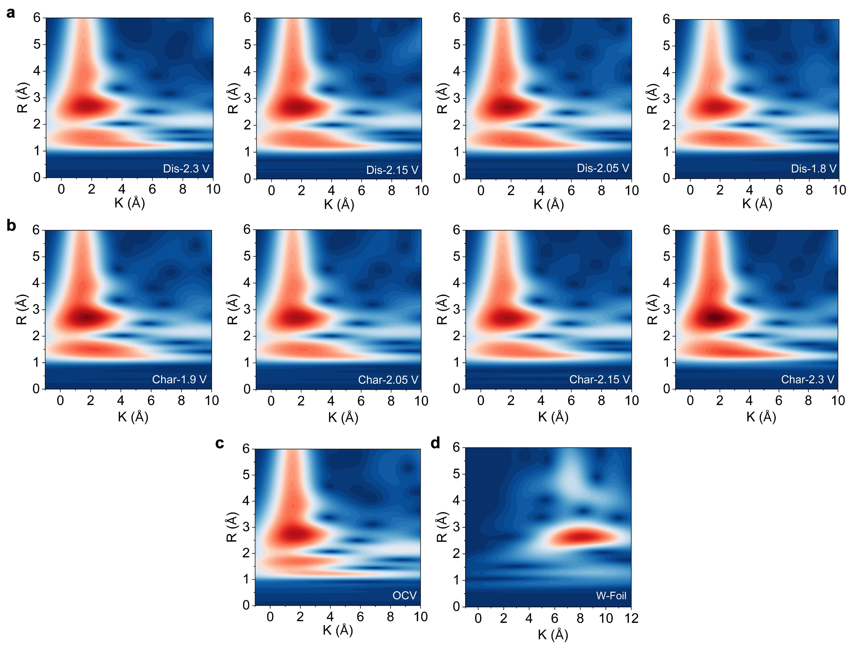
Fig. S34 In-situ WT-XAFS of W L-edge for WB@WC sample

Table S1 XAFS fitting details
Sample | Path | C.N | R(Å) | σ²*10⁻³(Å²) | ΔE(eV) | R factor%
W foil | W-W1  W-W2 | 8*  6* | 2.74  3.16 | 3.0  3.0 | 6.7 | 1.4%
WB | W-B | 8.9 | 2.24 | 3.0 | 9 | 4.6%
WB@WC | W-B1  W-C  W-B2 | 1.1  4.7  5.0 | 3.12  2.85  2.22 | 3.0  3.0  3.0 | 4.4 | 2.0%
WB@WC-LiPS | W-S  W-C  W-B | 0.8  9.6  8.1 | 2.29  2.71  3.00 | 3.0  3.0  3.0 | -6.7 | 1.8%
WC | W-C | 9.1 | 2.06 | 3.0 | -1.8 | 3.8%
WS₂ | W-S | 5.3 | 2.34 | 3.0 | 2.4 | 1.1%
CN: coordination number; R: distance between absorber and backscatter atoms; σ²: Debye-Waller factors; ΔE0: inner potential correction. R-factor: indicative of fitting goodness. The fixed values (*) in the fitting process.

Table S2 Comparison of the improvement of electrochemical performance by W-based materials in Li₋S batteries
W-based nanomaterials | Long cycle capacity | High loading (mg cm⁻²) | Refs.
rGO@WO₃ | 57% (500th) | 5.0 | [S5]
Ni-WS₂@rGO | 47.8% (500th) | 4.5 | [S6]
WS₂-rGO-CNT | 90.7% (100th) | 7.68 | [S7]
e-WS₂ | 64.3% (180th) | / | [S8]
WS₂/MoS₂ | 65.5% (300th) | 3.0 | [S9]
WN-160 | 70.2% (500th) | / | [S10]
WN-CNS | 80% (500th) | 3.0 | [S11]
WCNP@HCPC | 80.5% (500th) | 5.9 | [S12]
3D WB | 60% (200th) | 8.0 | [S13]
meso-WC/rGO | 83% (300th) | 3.0 | [S14]
HC-S + WB₂/PSS-Li | 75% (500th) | 3.8 | [S15]
WO_{x}/W₂C | 73.3% (280th) | 4.0 | [S16]
WS₂/WO₃ | 70% (500th) | 5.0 | [S17]
WO_{3-x}-W₃N₄ | 54.8% (400th) | 11.7 | [S18]
WN | 52.4% (500th) | 1.4 | [S19]
WB@WC | 88% (500th) | 7.92 | This work
Supplementary References
- S. Grimme, Semiempirical GGA-type density functional constructed with a long-range dispersion correction. J. Comput. Chem. 27(15), 1787–1799 (2006). https://doi.org/10.1002/jcc.20495
- J.P. Perdew, K. Burke, M. Ernzerhof, Generalized gradient approximation made simple. Phys. Rev. Lett. 77(18), 3865–3868 (1996). https://doi.org/10.1103/physrevlett.77.3865
- S.J. Clark, M.D. Segall, C.J. Pickard, P.J. Hasnip, M.I.J. Probert et al., First principles methods using CASTEP. Z. Für Kristallogr. Cryst. Mater. 220(5–6), 567–570 (2005). https://doi.org/10.1524/zkri.220.5.567.65075
- Z. Shen, M. Cao, Z. Zhang, J. Pu, C. Zhong et al., Efficient Ni₂Co₄P₃ nanowires catalysts enhance ultrahigh-loading lithium–sulfur conversion in a microreactor-like battery. Adv. Funct. Mater. 30(3), 1906661 (2020). https://doi.org/10.1002/adfm.201906661
- L. Ni, S. Duan, H. Zhang, J. Gu, G. Zhao et al., A 3D Graphene/WO₃ nanowire composite with enhanced capture and polysulfides conversion catalysis for high-performance Li–S batteries. Carbon 182, 335–347 (2021). https://doi.org/10.1016/j.carbon.2021.05.056
- M.A. Al-Tahan, Y. Dong, A.E. Shrshr, X. Liu, R. Zhang et al., Enormous-sulfur-content cathode and excellent electrochemical performance of Li-S battery accouched by surface engineering of Ni-doped WS₂@rGO nanohybrid as a modified separator. J. Colloid Interface Sci. 609, 235–248 (2022). https://doi.org/10.1016/j.jcis.2021.12.035
- S. Huang, Y. Wang, J. Hu, Y. Von Lim, D. Kong et al., Mechanism investigation of high-performance Li–polysulfide batteries enabled by tungsten disulfide nanopetals. ACS Nano 12(9), 9504–9512 (2018). https://doi.org/10.1021/acsnano.8b04857
- A.M. Abraham, S. Ponnurangam, V. Thangadurai, Facet-engineered tungsten disulfide for promoting polysulfide electrocatalysis in lithium–sulfur batteries. Inorg. Chem. 60(17), 12883–12892 (2021). https://doi.org/10.1021/acs.inorgchem.1c01241
- H. Zhao, H. Wu, J. Wu, J. Li, Y. Wang et al., Preparation of MoS₂/WS₂ nanosheets by liquid phase exfoliation with assistance of epigallocatechin gallate and study as an additive for high-performance lithium-sulfur batteries. J. Colloid Interface Sci. 552, 554–562 (2019). https://doi.org/10.1016/j.jcis.2019.05.080
- Z.-D. Huang, Y. Fang, M. Yang, J. Yang, Y. Wang et al., Sulfur in mesoporous tungsten nitride foam blocks: a rational lithium polysulfide confinement experimental design strategy augmented by theoretical predictions. ACS Appl. Mater. Interfaces 11(22), 20013–20021 (2019). https://doi.org/10.1021/acsami.9b04246
- H. Liu, H. Shen, R. Li, S. Liu, A. Turak et al., Tungsten-nitride-coated carbon nanospheres as a sulfur host for high-performance lithium-sulfur batteries. ChemElectroChem 6(7), 2074–2079 (2019). https://doi.org/10.1002/celc.201900139
- J. Zhang, S. Duan, C. You, J. Wang, H. Liu et al., In situ-grown tungsten carbide nanoparticles on nanocarbon as an electrocatalyst to promote the redox reaction kinetics of high-mass loading sulfur cathode for high volumetric performance. J. Mater. Chem. A 8(42), 22240–22250 (2020). https://doi.org/10.1039/d0ta07464k
- Y. Zhao, C. Liu, C. Zha, J. Li, C. Lyu et al., Tailoring WB morphology enables d-band centers to be highly active for high-performance lithium-sulfur battery. Chin. Chem. Lett. 34(11), 108189 (2023). https://doi.org/10.1016/j.cclet.2023.108189
- S.-H. Moon, J.-H. Kim, J.-H. Shin, J.-S. Jang, S.-B. Kim et al., High absorption and fast polysulfides conversion of duel functional separator based on mesoporous-WC/rGO composite for lithium-sulfur batteries. J. Alloys Compd. 904, 164120 (2022). https://doi.org/10.1016/j.jallcom.2022.164120
- T.S. Sahu, V.G. Abhijitha, I. Pal, S. Sau, M. Gautam et al., Regulating polysulfide conversion kinetics using tungsten diboride as additive for high-performance Li-S battery. Small 18(41), e2203222 (2022). https://doi.org/10.1002/smll.202203222
- B. Wang, R. Fang, K. Chen, S. Huang, R. Niu et al., Heterostructured WO_{x}/W₂C nanocatalyst for Li₂S oxidation in lithium-sulfur batteries with high-areal-capacity. Small 20(27), e2310801 (2024). https://doi.org/10.1002/smll.202310801
- B. Zhang, C. Luo, Y. Deng, Z. Huang, G. Zhou et al., Optimized catalytic WS₂–WO₃ heterostructure design for accelerated polysulfide conversion in lithium–sulfur batteries. Adv. Energy Mater. 10(15), 2000091 (2020). https://doi.org/10.1002/aenm.202000091
- D. Zhang, T. Duan, Y. Luo, S. Liu, W. Zhang et al., Oxygen defect-rich WO_{3−x}-W₃N₄ Mott–Schottky heterojunctions enabling bidirectional catalysis for sulfur cathode. Adv. Funct. Mater. 33(42), 2306578 (2023). https://doi.org/10.1002/adfm.202306578
- N. Yan, H. Cui, S. You, J. Shi, Y. Weng et al., Tungsten nitride nanotubes as sulfur host material for high performance Li-S batteries. Inorg. Chem. Commun. 140, 109458 (2022). https://doi.org/10.1016/j.inoche.2022.109458

