Supporting Information for
Electrolyte Engineering in Redox-Enhanced Electrochemical Capacitors with Zn Anodes: The Role of Colorimetric Indicators
Ming Chen¹, Qinglong Luo², Xiaolei Wang³, and Kaiyuan Shi^{1*}
¹ School of Materials Science and Engineering, Institute of Green Chemistry and Molecular Engineering, Sun Yat-Sen University, Guangzhou 510275, P. R. China
² Key Laboratory of Comprehensive and Highly Efficient Utilization of Salt Lake Resources, Qinghai Institute of Salt Lakes, Chinese Academy of Sciences, Xining 810008, P. R. China
³ Department of Chemical and Materials Engineering, University of Alberta, 9211-116 Street NW., Edmonton, Alberta T6G 1H9, Canada
* Corresponding author. E-mail: shiky7@mail.sysu.edu.cn (Kaiyuan Shi)
S1 Theoretical Calculations
The structural properties and molecular dimensions were analyzed using a molecular mechanics approach with InDraw software. The molecular accessible area and solvent-excluded volume were determined using Connolly’s program [S1, S2]. The hydrophobicity of triphenylmethane dyes was estimated by computing the log P value [S3]. The energy levels of the lowest unoccupied molecular orbital (LUMO) and the highest occupied molecular orbital (HOMO) were assessed using the molecular orbital package. The electrostatic potential (ESP) was analyzed by the density functional theory (DFT) method. Besides, the binding energy of triphenylmethane dyes on AC materials was analyzed based on DFT calculations. The calculations were performed using the Quantum Espresso (QE) software based on the pseudopotential plane wave (PPW) method [S4, S5]. The Perdew-Burke-Ernzerhof (PBE) functional was employed to account for the exchange-correlation effects [S6]. Projected augmented wave (PAW) potentials were employed to describe the ionic cores, whereas adsorption energy was calculated using an implicit solvent model [S7, S8]. The plane-wave energy cutoff was set to 400 eV, and a 2×2×1 Monkhorst-Pack k-point grid was used for Brillouin zone sampling. Structural optimization was considered complete when the energy and force thresholds reached 1.0×10⁻⁴ eV and 0.05 eV Å⁻¹, respectively. The adsorption energy (E_{ads}) was calculated by:
$E_{ads}=E_{complex}-E_{substrate}-E_{adsorbate}$ (S1)
Where E_{com}, E_{substrate}, and E_{adsorbate} refer to the total energy of the complex, the substrate surface, and the adsorbate molecule, respectively. Based on it, the charge differential density was calculated through the software Vesta. The Vaspkit was used for the Free-energy corrections over the calculations of ∆G values [S9].
S2 Supplementary Figures

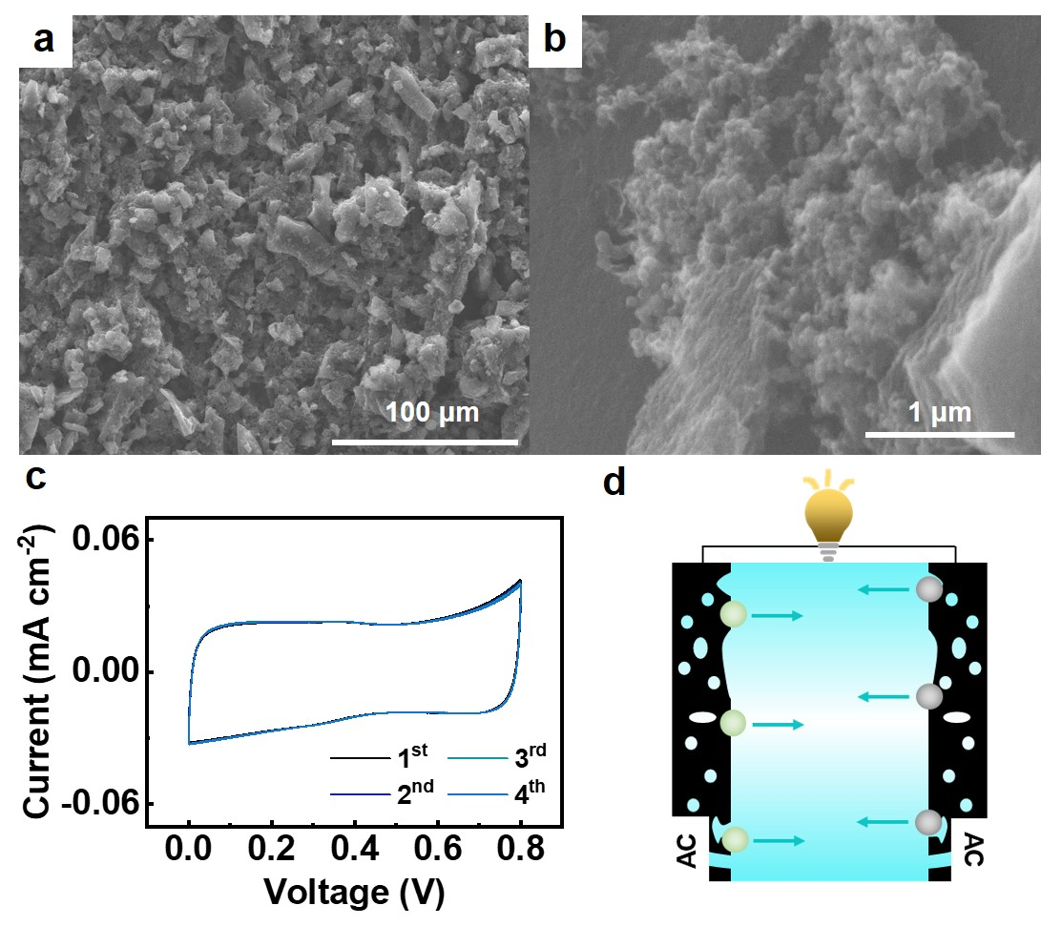
Fig. S1 SEM images of fabricated AC electrodes at (a) low and (b) high magnifications, (c) CV profiles measured in-house at a scan rate of 1 mV s⁻¹ for the first four cycles, and (d) Operational scheme of the symmetric supercapacitor (SC), prepared by AC electrodes
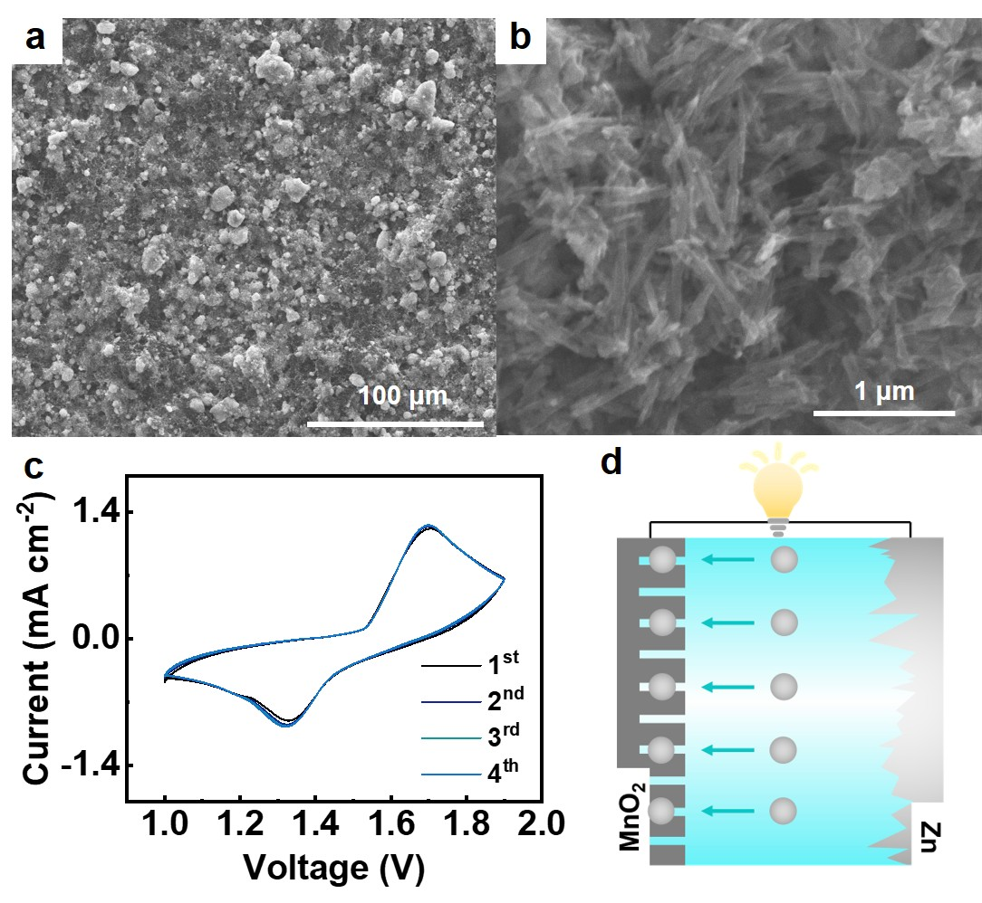
Fig. S2 SEM images of fabricated α-MnO₂ electrodes at (a) low and (b) high magnifications, (c) CV profiles measured in-house at a scan rate of 1 mV s⁻¹ for the first four cycles, and (d) Operational scheme of the zinc-ion battery (ZIB), prepared by α-MnO₂ cathode and Zn anode
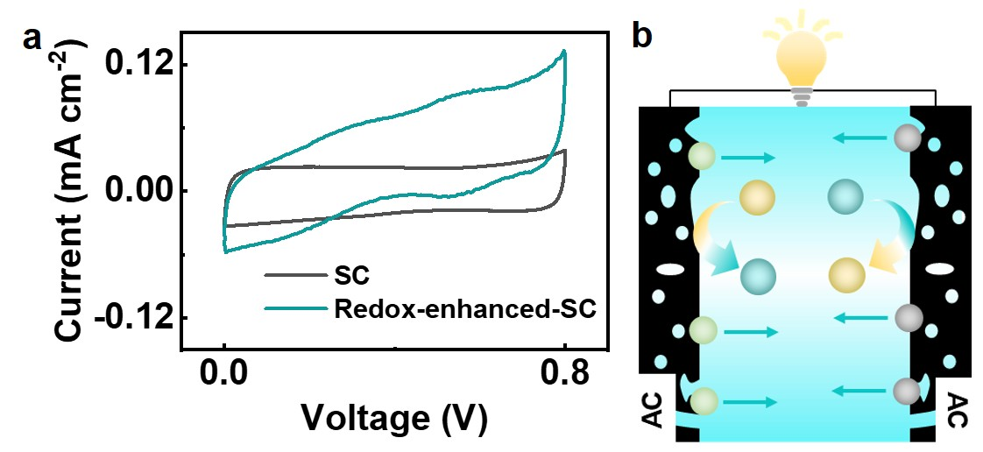
Fig. S3 (a) CV profiles at 1 mV s⁻¹ for the symmetric supercapacitor and redox-enhanced supercapacitor, prepared by the BCP-containing electrolyte. (b) Operational scheme of the redox-enhanced supercapacitor derived from the redox electrolyte
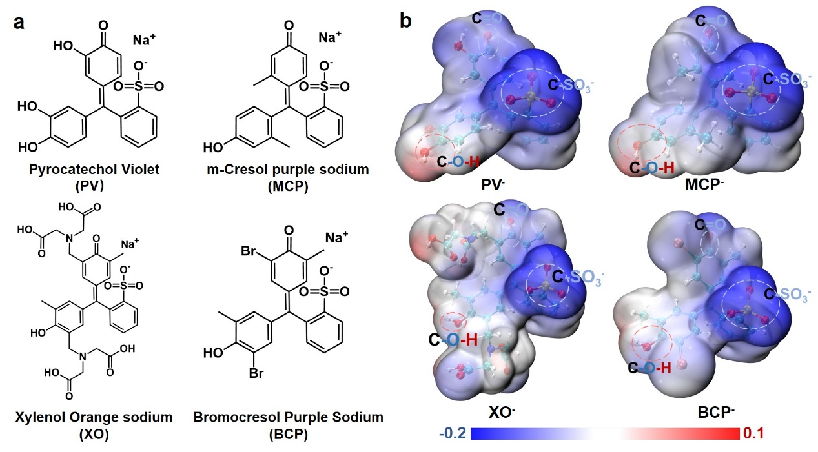
Fig. S4 a) Chemical structures and b) Calculations of ESP distributions for various triphenylmethane dyes
The structures and ESP distributions of triphenylmethane dyes, used as the colorimetric indicators, are presented in Fig. S4. These dyes feature a central triphenylmethane core, where three aromatic rings are conjugated through a central carbon atom. This extended conjugation leads to a delocalized electron cloud, resulting in uniform ESP profiles across the phenyl rings instead of localized polarization [S10]. The ESP mapping demonstrates the regulating effect of substituent groups: the carbonyl (-C=O) groups act as electron-withdrawing sites, lowering the electron density in their vicinity, while sulfonate (-SO₃⁻) and hydroxyl (-OH) groups contribute nucleophilic character and reflect the proton affinity of the molecules [S11]. Our calculations indicate that the -C-OH group introduces more positive ESP in surrounding regions (enhancing electrophilicity), whereas the -C-SO₃⁻ group significantly lowers local negative ESP (enhancing nucleophilicity). It is important to note that the effects of substituents on ESP distributions are primarily due to direct through-space electrostatic interactions rather than π-electron polarization of the conjugated triphenylmethane framework [S12]. The results underscore that substituent groups and molecular architecture can be utilized to modulate proton-electron interactions in aqueous electrochemical systems.

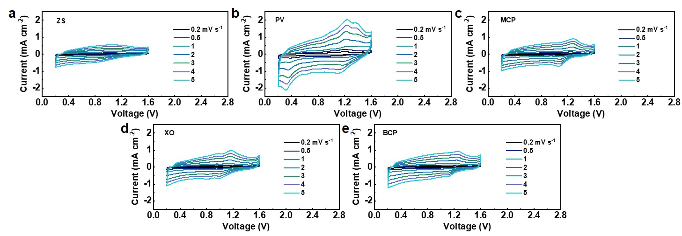
Fig. S5 CV profiles of (a) the baseline ZIC with ZS electrolyte and (b-e) redox-enhanced ZICs (RZICs) incorporating (b) PV, (c) MCP, (d) XO, and (e) BCP dyes at scan rates of 0.2-5 mV s⁻¹

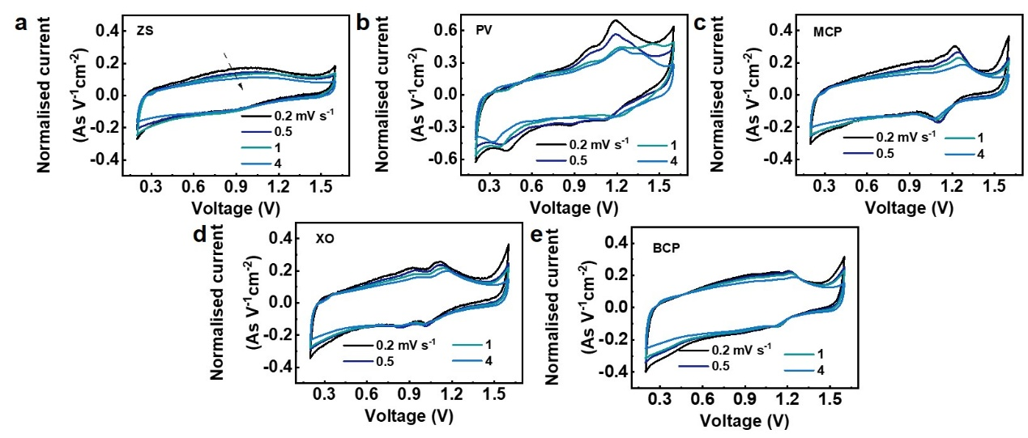
Fig. S6 CV profiles normalized by scan rates for (a) the baseline ZIC with ZS electrolyte and (b-e) RZICs incorporating (b) PV, (c) MCP, (d) XO, and (e) BCP dyes
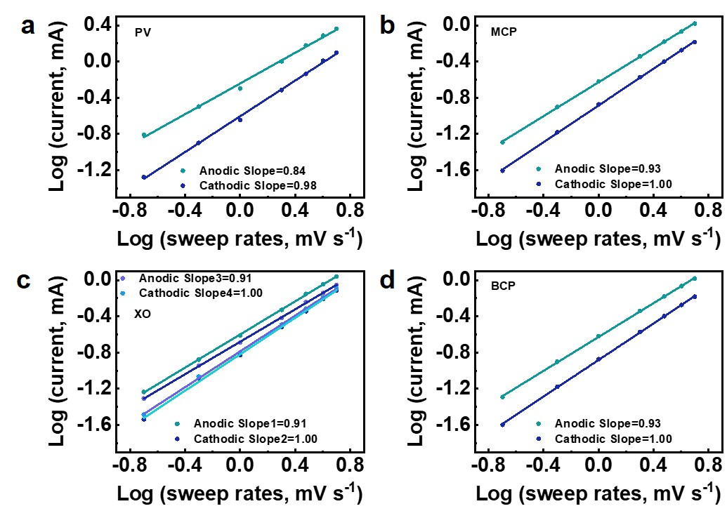
Fig. S7 The peak slopes determined by line-fitting log(i)–log(v) plots from CV data for RZICs prepared by (a) PV, (b) MCP, (c) XO, and (d) BCP-containing electrolytes, calculated based on Fig. S6

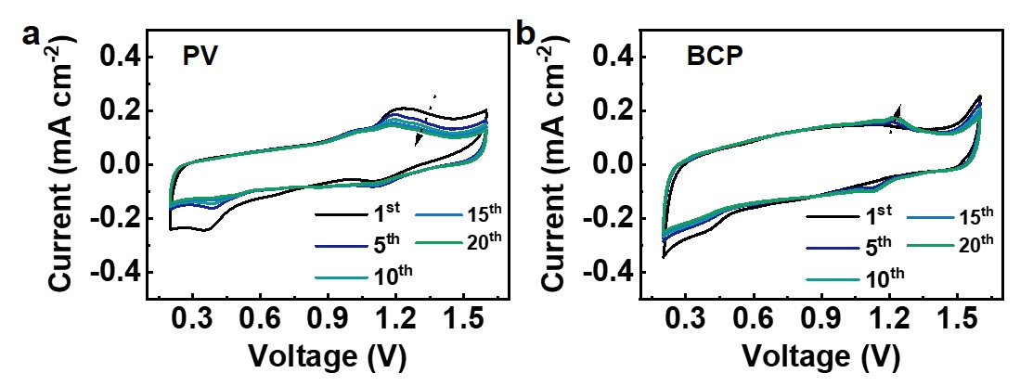
Fig. S8 CV profiles of RZICs, prepared by the (a) PV and (b) BCP-containing electrolytes, measured over different cycles at a scan rate of 1.0 mV s⁻¹
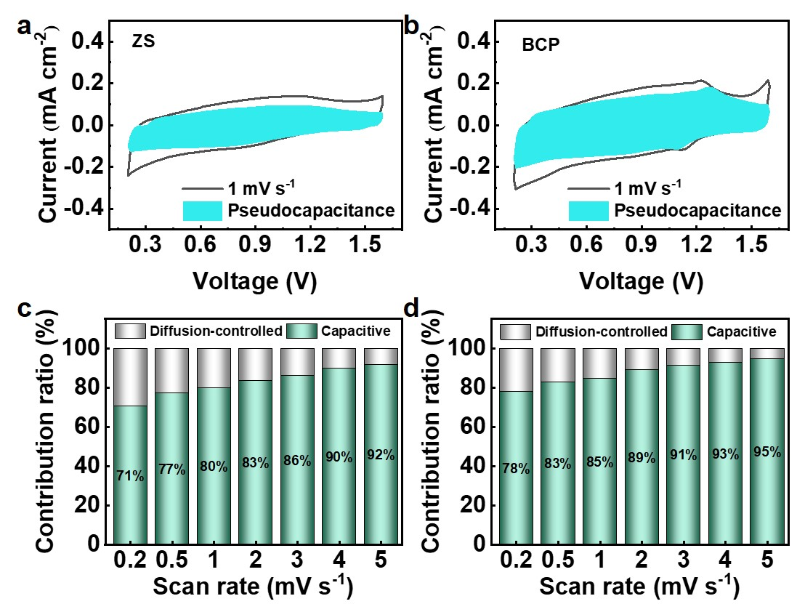
Fig. S9 Separation of the capacitive and diffusion-controlled contributions at 1.0 mV s⁻¹ for (a) the baseline ZIC with ZS electrolyte and (b) the RZIC with BCP-containing electrolyte. Corresponding contribution ratios versus scanning rates calculated using Dunn's method for (c) the baseline ZIC with ZS electrolyte and (d) the RZIC with BCP-containing electrolyte
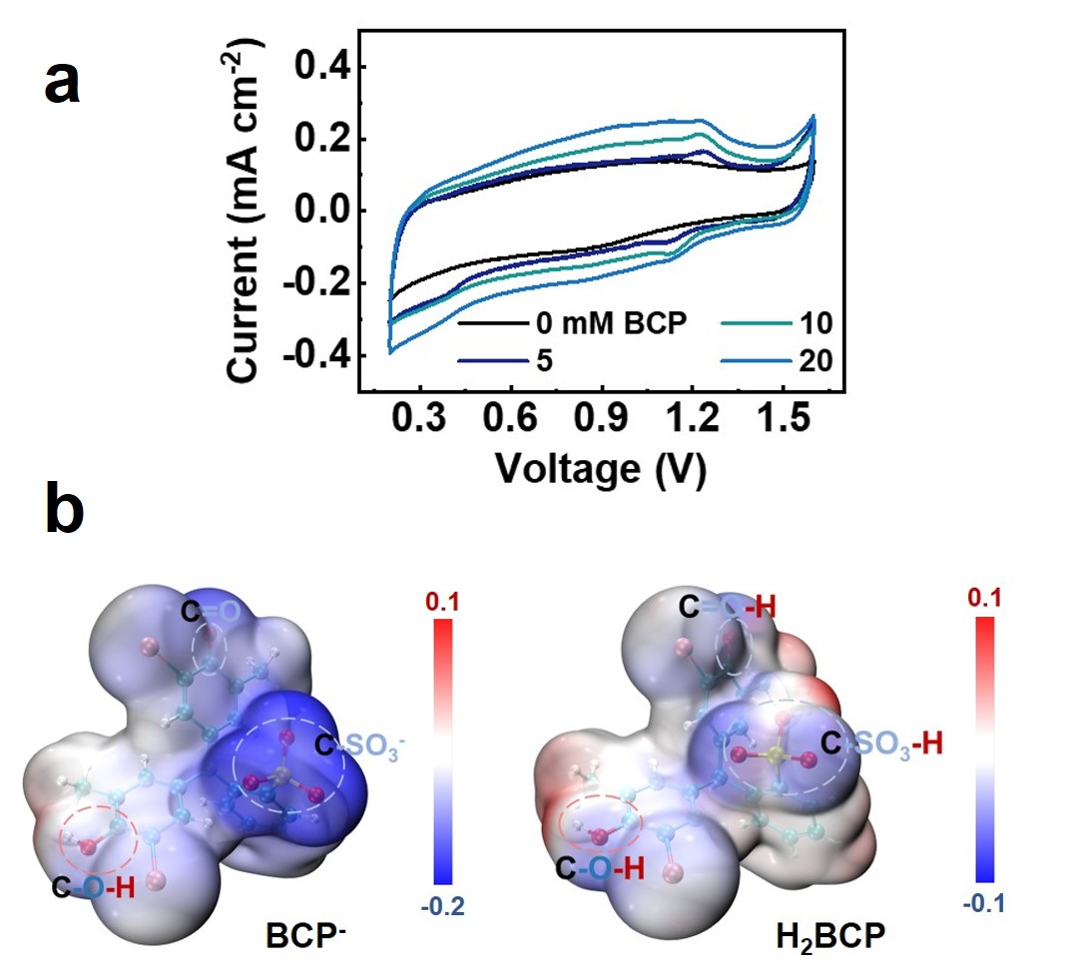
Fig. S10 (a) CV profiles of RZICs at a scan rate of 1.0 mV s⁻¹, prepared by BCP-containing electrolytes with varied dye concentrations. (b) Calculated ESP distributions for BCP molecules in their oxidized (left) and reduced (right) states
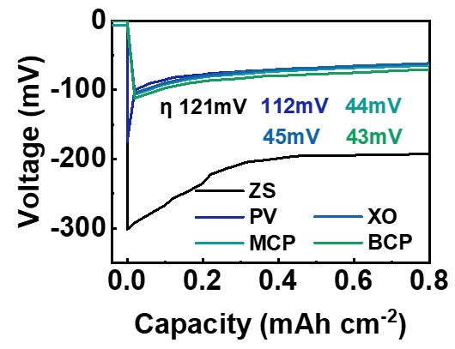
Fig. S11 Chronopotentiometric curves of Zn²⁺ plating at a current density of 2 mA cm⁻² using the ZS electrolyte and triphenylmethane-driven redox electrolytes

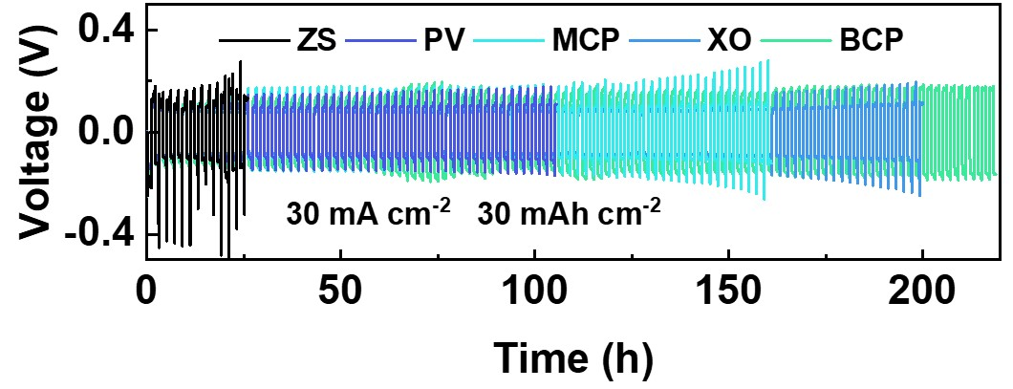
Fig. S12 Cycling behavior of Zn||Zn cells in the ZS and redox electrolytes at 30 mA cm⁻² and 30 mAh cm⁻²
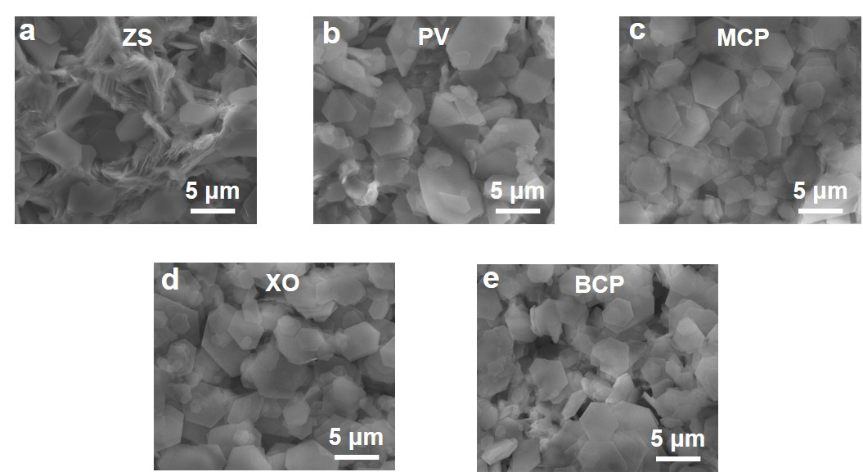
Fig. S13 SEM images of Zn electrodes obtained from Zn||Zn cells at 2 mA cm⁻² and 1 mAh cm⁻² after 200 cycles, using (a) the ZS electrolyte and redox electrolytes prepared by (b) PV, (c) MCP, (d) XO, and (e) BCP dyes.
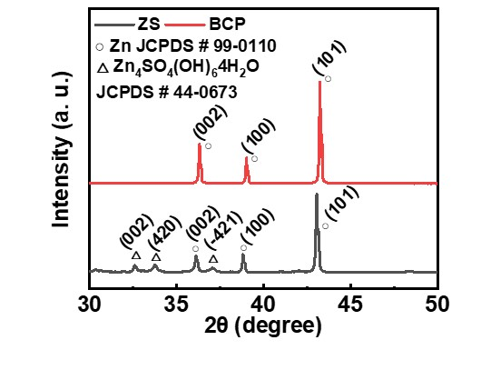
Fig. S14 XRD results of cycled Zn from Zn||Zn cells, prepared by the ZS and BCP-containing electrolytes. The cycling tests were conducted at 2 mA cm⁻² and 1 mAh cm⁻² after 200 cycles
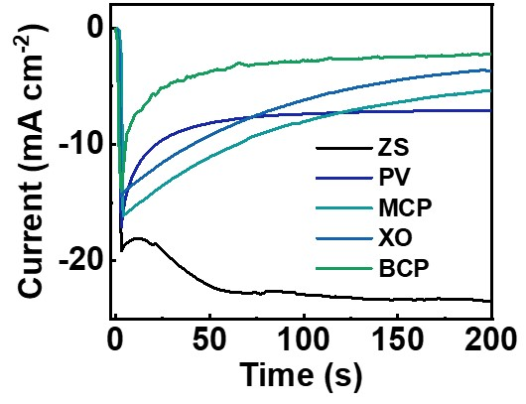
Fig. S15 Chronoamperometric curves of Zn²⁺ plating at an overpotential of −150 mV using ZS electrolyte and triphenylmethane-driven redox electrolytes
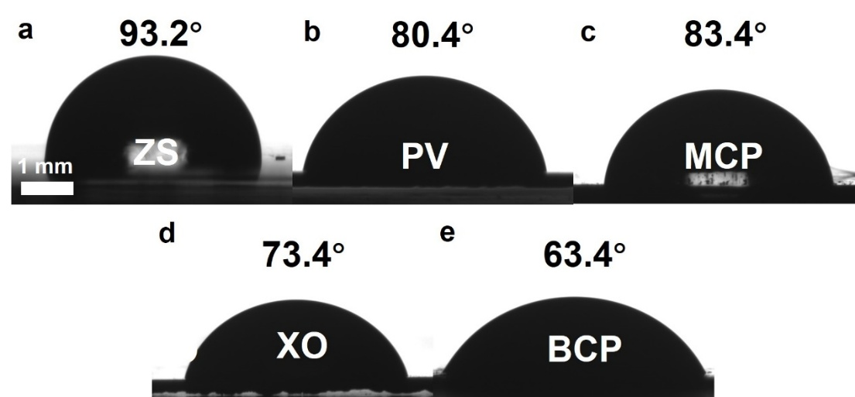
Fig. S16 Contact angle analysis of electrolyte droplets on metallic Zn: (a) the ZS electrolyte and redox electrolytes prepared by (b) PV, (c) MCP, (d) XO, and (e) BCP dyes
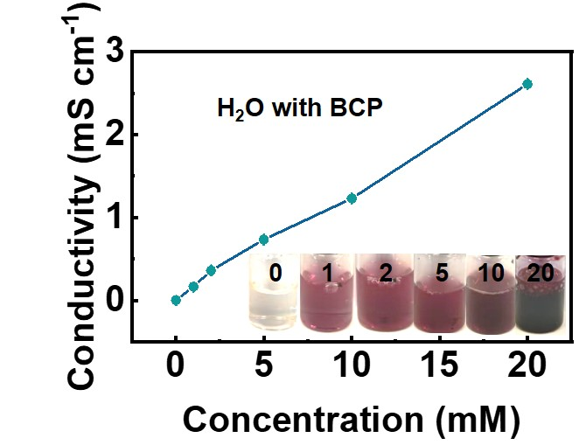
Fig. S17 The conductivity measurement of BCP aqueous solutions with varied dye concentrations, along with their corresponding visual appearances

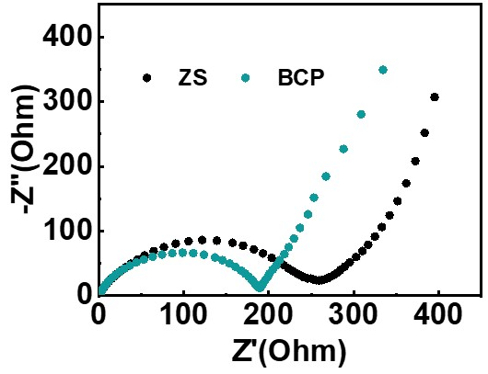
Fig. S18 EIS spectra of Zn||Zn cells, prepared by the ZS and BCP-containing electrolytes.

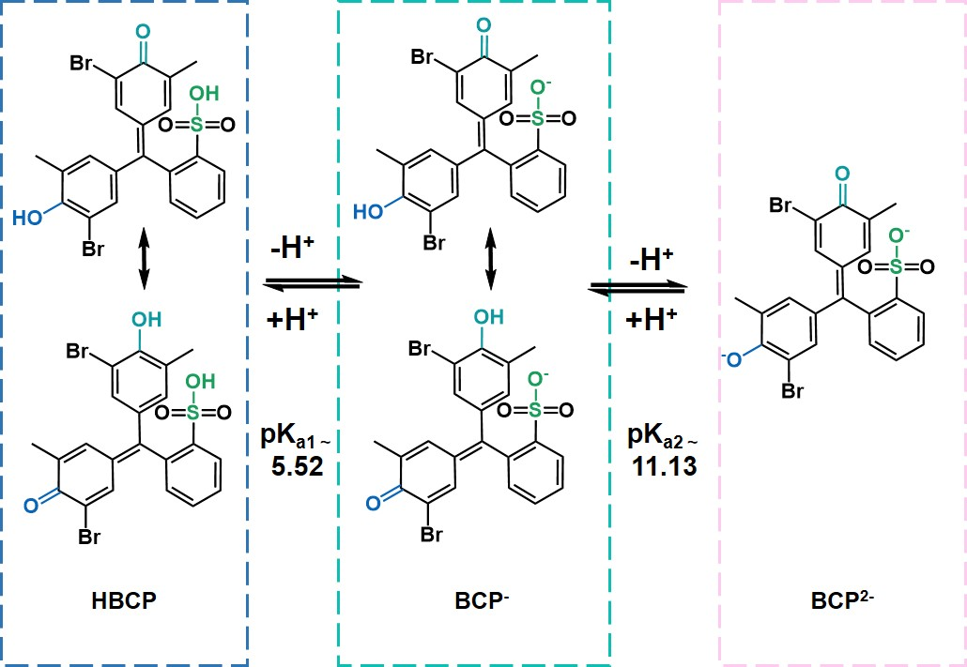
Fig. S19 Potential acid dissociation and tautomeric mechanisms of BCP molecules [S13], illustrating their various protonation states.

Fig. S19A presents the structural evolution of BCP molecules in aqueous environments over the PT process through acid-base equilibria. The BCP exists in three distinct forms depending on the pH: the fully protonated neutral form (HBCP), the singly deprotonated anion (BCP⁻), and the doubly deprotonated dianion (BCP²⁻)[13, 14]. These transformations occur via two acid dissociation steps with well-defined pKa values: pK_{a1} = 5.52 and pK_{a2} = 11.13, as established in previous studies [S13]. Each state features distinct shifts in molecular structure due to the deprotonation of hydroxyl and sulfonic acid groups. This deprotonation influences electron distribution across the molecule and alters its optical properties. Furthermore, the proton association-dissociation equilibria facilitate the buffering of pH fluctuations by neutralizing small amounts of generated acid or base [S15]. Buffered solutions containing redox-active dyes prevent drastic pH fluctuations in aqueous electrochemical systems [S16]. Additionally, the dissociation behavior generates a proton-conducting network according to the Grotthuss mechanism [S17, S18], where the transfer of H⁺ involves the sequential hopping of protons between water molecules via hydrogen bonds, thereby increasing the ionic conductivity of the electrolytes.

The molecular behavior is governed by proton dissociation and tautomerization mechanisms [S19]. At lower pH, HBCP remains stable due to the protonation of both acidic groups. As the pH increases, one proton is removed, resulting in the formation of the monoanionic form BCP⁻, which can exist in resonance or tautomeric forms depending on which acidic proton is lost first (sulfonic vs. phenolic). At even higher pH, a second proton dissociates to form BCP²⁻, fully ionizing the molecule. The equilibrium forms of colorimetric indicators result in distinct UV-vis absorbance. The simultaneous presence of acid-base equilibrium and reversible ET behavior, facilitated by the -C=O group, enables the fabrication of RZICs with enhanced energy performance [S20]. Additionally, the changes in UV-vis characteristics allow BCP to indicate proton activity across a broad pH range, particularly in mildly acidic to basic conditions.

The pK_{a} values serve as key descriptors of BCP’s behavior in aqueous electrolytes [S21]. The Henderson–Hasselbalch equation relates these pK_{a} values to the ratio of protonated and deprotonated forms, providing a framework for understanding the system’s dynamics [S22]. The analysis of ESP distribution is quantitatively correlated with acid-base equilibria, as it reflects electron density that indicates PT ability [S23]. Specifically, low electron density is associated with stronger acids and lower pK_{a} values [S24]. The colorimetric indicators offer a practical and cost-effective method to monitor proton activity in real time. The PT behavior is crucial for ensuring electrochemical stability, enhancing ionic conductivity, and maintaining compatibility with redox-active species in the electrolytes. By leveraging the color transitions and associated equilibrium constants, advanced electrolyte formulations can be developed without complex instrumentation, enhancing the performance of aqueous energy storage devices.

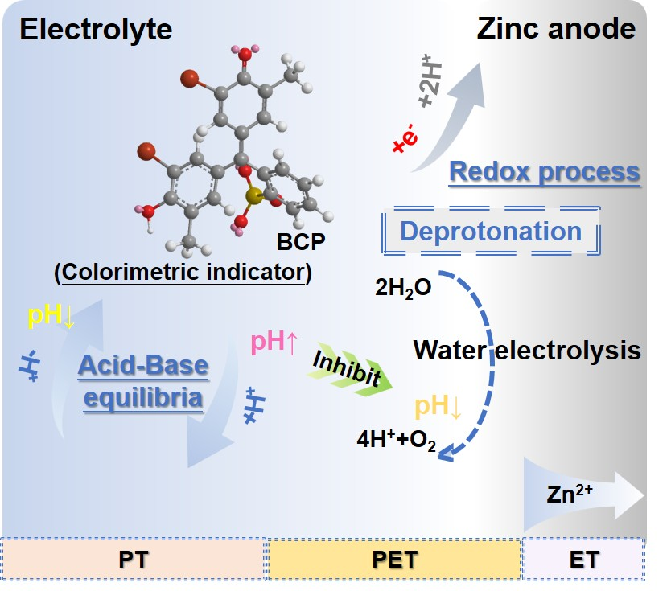
Fig. S20 Scheme of proposed proton transfer (PT) within the electrolyte (left) as well as electron transfer (ET) at the electrode surface (right) of the RZIC, prepared with the BCP-containing electrolyte during the charge process. The structural transformation of the colorimetric indicator is shown in Fig. 3c, while the acid dissociation and tautomeric transformation of the molecule are illustrated in Fig. S19

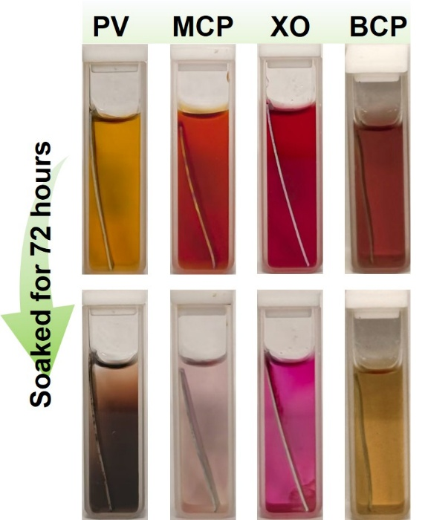
Fig. S21 Photos of aqueous solutions containing PV, MCP, XO, and BCP dyes after soaking metallic Zn in each for 72 hours
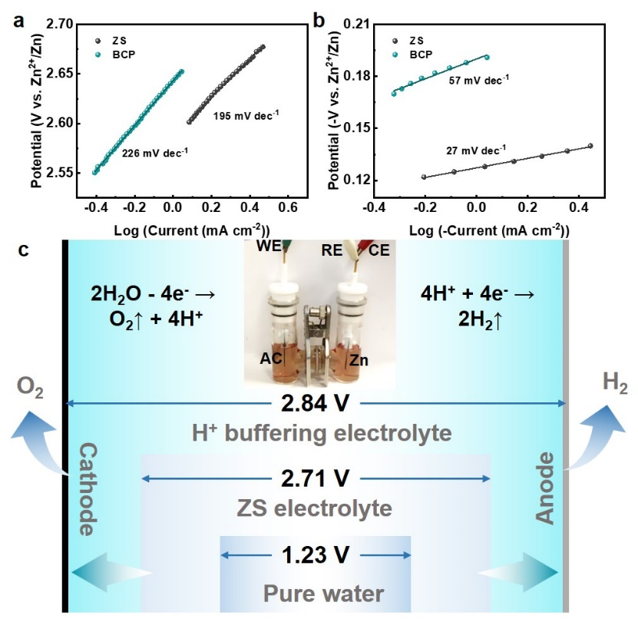
Fig. S22 Tafel slope curves for (a) the OER and (b) the HER processes. (c) The H-cell device and operational scheme for the RZIC prepared with the BCP-containing electrolyte, illustrating the broadening of the voltage window

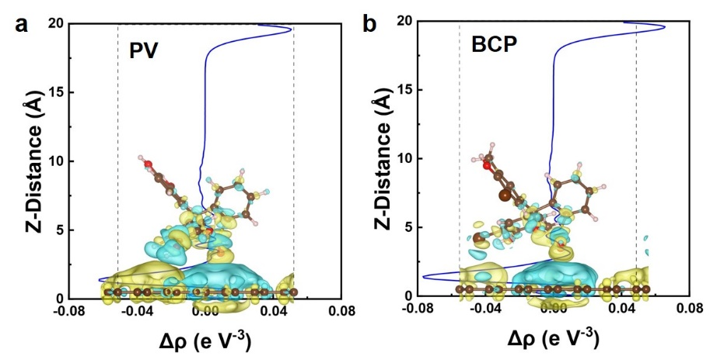
Fig. S23 Differential charge density plots along the Z-axis for (a) PV and (b) BCP dyes on AC materials. The color representation indicates charge density: yellow for charge accumulation and blue for charge depletion

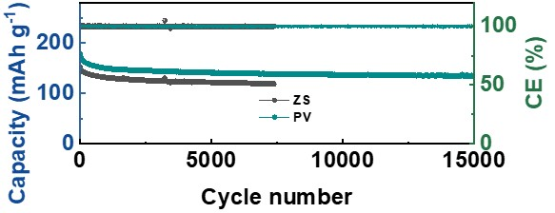
Fig. S24 Cycling performance at 1.0 A g⁻¹ for the baseline ZIC with ZS electrolyte and the RZIC with BCP-containing electrolyte

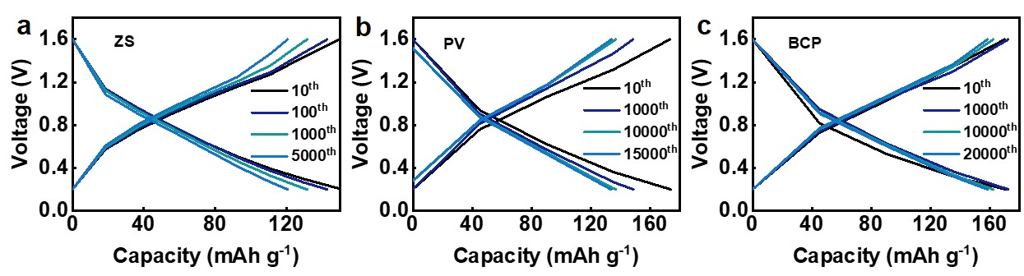
Fig. S25 CD profiles obtained from different cycles of (a) the baseline ZIC with ZS electrolyte and RZICs, prepared by (b) PV and (c) BCP-containing electrolytes

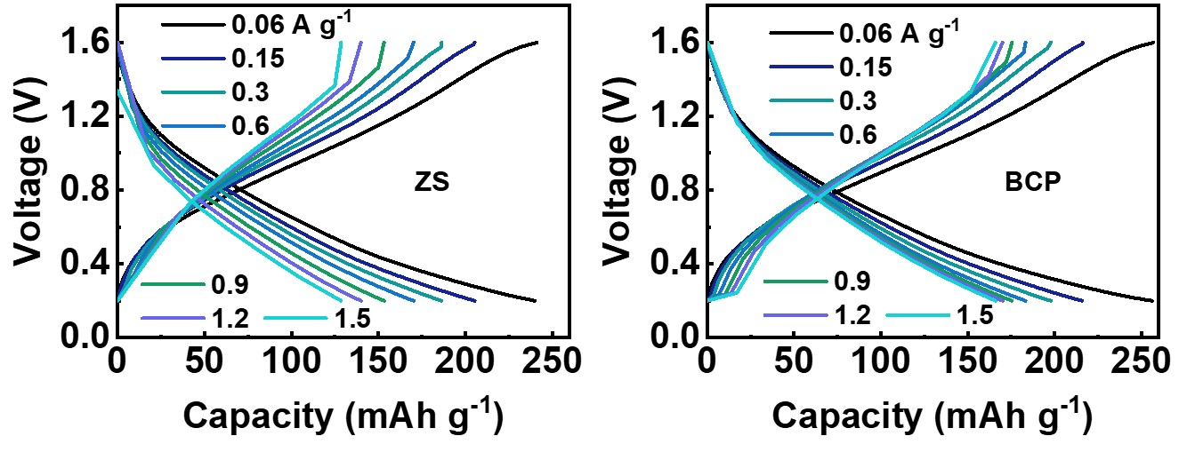
Fig. S26 CD profiles at different current densities for the baseline ZIC with ZS electrolyte and the RZIC with BCP-containing electrolyte
S3 Supplemental Tables
Table S1 The 3D chemical structure and physical-chemical properties of triphenylmethane dyes
Name | Structure | Molecular weight  (g mol⁻¹) | Connolly accessible  Area [S1, S2] (Å²) | Connolly molecular area [S1, S2] (Å²) | Polar surface area [S25](Å²) | Connolly solvent  excluded volume [S2, S26] (Å³) | Log P [S3, S27] (hydrophobicity) | Length (Å) | Width (Å) | Depth (Å) | CAS
Pyrocatechol Violet (PV) | 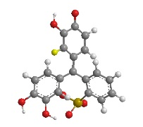 | 385.366 | 519.734 | 285.424 | 134.96 | 264.653 | 2.684 | 12.300 | 11.632 | 7.069 | 115-41-3
M-Cresol Purple Sodium (MCP) | 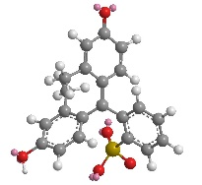 | 381.422 | 532.331 | 297.707 | 94.50 | 299.769 | 3.308 | 12.207 | 11.585 | 7.059 | 62625-31-4
Xylenol Orange Sodium (XO) | 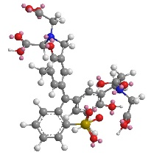 | 671.155 | 809.816 | 490.832 | 250.18 | 539.142 | -0.122 | 16.422 | 12.781 | 11.831 | 63721-83-5
Bromocresol Purple Sodium (BCP) | 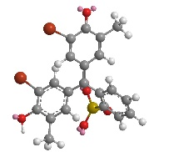 | 539.214 | 618.230 | 351.741 | 94.50 | 335.562 | 4.160 | 12.110 | 12.001 | 8.241 | 62625-30-3

Table S2 Benchmark performance of redox-enhanced ZICs from this study compared to other related works
Cathode | Anode | Electrolyte | ZICs |  |  | Zn||Zn cells |  |  | Refs.
Cathode | Anode | Electrolyte | Voltage window (V) | Current density (A g⁻¹) | Capacity (mAh g⁻¹) | Current density (mA cm⁻²) | Areal capacity (mAh cm⁻²) | Cycling performance (h) | Refs.
AC | Zn | ZnSO₄-BCP | 0.2-1.6 | 1.00 | 152.4 | 2 | 1 | 4000 | This work
AC | Zn | ZnSO₄-AQ | 0.2-1.6 | 0.06 | 195.0 | 2 | 1 | 1600 | [S28]
AC | Zn | ZnSO₄-NQ | 0.2-1.6 | 1.00 | 82.2 | 2 | 1 | 1000 | [S29]
AC | Zn | ZnSO₄-SY | 0.2-1.6 | 0.60 | 113.3 | 2 | 1 | 1600 | [S30]
B/N-AC | Zn | ZnSO₄-HQ | 0.2-1.8 | 2.00 | 168.0 | / | / | / | [S31]
AC | Zn | ZnSO₄-Ce³⁺ | 0.2-1.8 | 1.00 | 60.2 | 2 | 1 | 400 | [S32]
AC | ZVO@Zn | ZnSO₄- VOSO₄ | 0.3-1.9 | 1.00 | 185.3 | / | / | / | [S33]
AC | Zn | ZnSO₄-KI | 0.2-1.8 | 5.00 | 250.0 | 1 | 1 | 1700 | [S34]
AC | Zn | ZnSO₄-KI | 0.2-1.8 | 0.10 | 399.3 | 1 | 1 | 100 | [S35]
N-HNCS-1 | Zn | ZnSO₄-ZnI₂ | 0.2-1.8 | 20.00 | 247.0 | / | / | / | [S36]
PC | Zn | ZnSO₄- KI -HQ | 0.2-1.8 | 2.50 | 731.9 | / | / | / | [S37]
AC | Zn | Zn(CF₃SO₃)₂- ZnBr₂-PEG | 0.0-2.2 | 1.00 | 325.0 | / | / | / | [S38]

Supplementary References
- M.L. Connolly, Computation of molecular volume. J. Am. Chem. Soc. 107(5), 1118–1124 (1985). https://doi.org/10.1021/ja00291a006
- M.L. Connolly, The molecular surface package. J. Mol. Graph. 11(2), 139–141 (1993). https://doi.org/10.1016/0263-7855(93)87010-3 =87007
- A. Leo, P.Y.C. Jow, C. Silipo, C. Hansch, Calculation of hydrophobic constant (log P) from.pi. and f constants. J. Med. Chem. 18(9), 865–868 (1975). https://doi.org/10.1021/jm00243a001
- P. Giannozzi, S. Baroni, N. Bonini, M. Calandra, R. Car et al., QUANTUM ESPRESSO: a modular and open-source software project for quantum simulations of materials. J. Phys. Condens. Matter 21(39), 395502 (2009). https://doi.org/10.1088/0953-8984/21/39/395502
- P. Giannozzi, O. Andreussi, T. Brumme, O. Bunau, M. Buongiorno Nardelli et al., Advanced capabilities for materials modelling with Quantum ESPRESSO. J. Phys. Condens. Matter 29(46), 465901 (2017). https://doi.org/10.1088/1361-648X/aa8f79
- J.P. Perdew, K. Burke, M. Ernzerhof, Generalized gradient approximation made simple. Phys. Rev. Lett. 77(18), 3865–3868 (1996). https://doi.org/10.1103/physrevlett.77.3865
- P. Blöchl, O. Jepsen, O. Andersen, Improved tetrahedron method for Brillouin-zone integrations. Phys. Rev. B 49(23), 16223–16233 (1994). https://doi.org/10.1103/physrevb.49.16223
- P. Blöchl, O. Jepsen, O. Andersen, Improved tetrahedron method for Brillouin-zone integrations. Phys. Rev. B 49(23), 16223–16233 (1994). https://doi.org/10.1103/physrevb.49.16223
- V. Wang, N. Xu, J.-C. Liu, G. Tang, W.-T. Geng, VASPKIT: a user-friendly interface facilitating high-throughput computing and analysis using VASP code. Comput. Phys. Commun. 267, 108033 (2021). https://doi.org/10.1016/j.cpc.2021.108033
- A.S.A. Dena, W.M.I. Hassan, Experimental and quantum mechanical studies on the ion-pair of levocetirizine and bromocresol green in aqueous solutions. Spectrochim. Acta A Mol. Biomol. Spectrosc. 163, 108–114 (2016). https://doi.org/10.1016/j.saa.2016.03.030
- I. Asmaa Abd Aziz, E.-M. El-Sayed Hossani, A.-A. Safaa, Molecular charge-transfer complex between thymol drug and bromocresol purple. World J. Pharmaceutical Sci. 5(2), 156-166 (2017).
- C. Zhang, L. Meng, Z. Fang, Y. Xu, Y. Zhou et al., Experimental and theoretical studies on the adsorption of bromocresol green from aqueous solution using cucumber straw biochar. Molecules 29(19), 4517 (2024). https://doi.org/10.3390/molecules29194517
- S.S. Hemdan, A.M.A.L. Gebali, F.K. Ali, The electrostatic and non-electrostatic interaction affect on acidity constants of bromocresol purple in aqueous ethanolic media. J. Solut. Chem. 53(6), 761–772 (2024). https://doi.org/10.1007/s10953-023-01270-7
- V.M. Ivanov, G.A. Kochelayeva, Pyrocatechol Violet in spectrophotometric and novel optical methods. Russ. Chem. Rev. 75(3), 255–266 (2006). https://doi.org/10.1070/rc2006v075n03abeh003610
- Y. Lyu, J.A. Yuwono, P. Wang, Y. Wang, F. Yang et al., Organic pH buffer for dendrite-free and shuttle-free Zn-I₂ batteries. Angew. Chem. Int. Ed. 62(21), e202303011 (2023). https://doi.org/10.1002/anie.202303011
- L.O. Smith, K.M. Thatcher, O.J. Henderson-Walshe, D.L. Crittenden, Redox behaviour and redox potentials of dyes in aqueous buffers and protic ionic liquids. Chem. 30(48), e202400573 (2024). https://doi.org/10.1002/chem.202400573
- J. Ingenmey, S. Gehrke, B. Kirchner, How to harvest grotthuss diffusion in protic ionic liquid electrolyte systems. ChemSusChem 11(12), 1900–1910 (2018). https://doi.org/10.1002/cssc.201800436
- X. Wu, J.J. Hong, W. Shin, L. Ma, T. Liu et al., Diffusion-free Grotthuss topochemistry for high-rate and long-life proton batteries. Nat. Energy 4(2), 123–130 (2019). https://doi.org/10.1038/s41560-018-0309-7
- A. Steinegger, O.S. Wolfbeis, S.M. Borisov, Optical sensing and imaging of pH values: spectroscopies, materials, and applications. Chem. Rev. 120(22), 12357–12489 (2020). https://doi.org/10.1021/acs.chemrev.0c00451
- Q. Sheng, H. Yu, J. Zheng, Hydrogen peroxide determination by carbon ceramic electrodes modified with pyrocatechol violet. Electrochim. Acta 52(25), 7300–7306 (2007). https://doi.org/10.1016/j.electacta.2007.05.074
- M. Liu, P. Wang, W. Zhang, H. He, G. He et al., Strategies for pH regulation in aqueous zinc ion batteries. Energy Storage Mater. 67, 103248 (2024). https://doi.org/10.1016/j.ensm.2024.103248
- H.P. de Oliveira, Determination of pKa of dyes by electrical impedance spectroscopy. Microchem. J. 88(1), 32–37 (2008). https://doi.org/10.1016/j.microc.2007.09.002
- Y.-F. Wang, Y.-C. Cheng, Molecular electrostatic potential on the proton-donating atom as a theoretical descriptor of excited state acidity. Phys. Chem. Chem. Phys. 20(6), 4351–4359 (2018). https://doi.org/10.1039/c7cp01948c
- S. Liu, L.G. Pedersen, Estimation of molecular acidity via electrostatic potential at the nucleus and valence natural atomic orbitals. J. Phys. Chem. A 113(15), 3648–3655 (2009). https://doi.org/10.1021/jp811250r
- P. Ertl, B. Rohde, P. Selzer, Fast calculation of molecular polar surface area as a sum of fragment-based contributions and its application to the prediction of drug transport properties. J. Med. Chem. 43(20), 3714–3717 (2000). https://doi.org/10.1021/jm000942e
- M.L. Connolly, Solvent-accessible surfaces of proteins and nucleic acids. Science 221(4612), 709–713 (1983). https://doi.org/10.1126/science.6879170
- T. Kim, S. Jeon, Coloration of ultra high molecular weight polyethylene fibers using alkyl-substituted monoazo yellow and red dyes. Fibres. Polym. 14(1), 105–109 (2013). https://doi.org/10.1007/s12221-013-0105-8
- X. Gan, C. Zhang, X. Ye, L. Qie, K. Shi, Unveiling the potential of redox electrolyte additives in enhancing interfacial stability for Zn-ion hybrid capacitors. Energy Storage Mater. 65, 103175 (2024). https://doi.org/10.1016/j.ensm.2024.103175
- J. Wang, M. Chen, D. Shao, I. Zhitomirsky, K. Shi, Zn-Ion hybrid capacitors utilizing redox electrolytes derived from naphthoquinone molecules. Mater. Today Energy 51, 101893 (2025). https://doi.org/10.1016/j.mtener.2025.101893
- M. Chen, L. Gong, I. Zhitomirsky, K. Shi, Unraveling the dynamic transformation of azobenzene-driven redox electrolytes for Zn-ion hybrid capacitors. Energy Environ. Sci. 18(9), 4460–4469 (2025). https://doi.org/10.1039/d4ee05696e
- H. Zhang, Y. Zhang, L. Zhang, X. Wang, Z. Pu et al., Preparation of B/N Co-doped carbon nanosheets and their electrochemical performance in Zn-ion redox capacitors. J. Alloys Compd. 969, 172407 (2023). https://doi.org/10.1016/j.jallcom.2023.172407
- S. Chen, J. Sun, C. Chen, P. Meng, L. Li et al., A Ce^{3+/4+} redox couple-promoted aqueous zinc-ion hybrid capacitor: design strategies and mechanistic insights. Small 21(19), e2411342 (2025). https://doi.org/10.1002/smll.202411342
- Y.-G. Lee, G. Yoo, Y.-R. Jo, H.-R. An, B.-R. Koo et al., Interfacial electrochemical media-engineered tunable vanadium zinc hydrate oxygen defect for enhancing the redox reaction of zinc-ion hybrid supercapacitors. Adv. Energy Mater. 13(24), 2300630 (2023). https://doi.org/10.1002/aenm.202300630
- H. Zhang, N. Wang, Z. Pu, Y. Shen, Y. Li, A novel zinc ion supercapacitor with ultrahigh capacity and ultralong cycling lives enhanced by redox electrolyte. J. Energy Storage 60, 106597 (2023). https://doi.org/10.1016/j.est.2022.106597
- B. Selvaraj, B. Sambandam, S. Kim, V. Mathew, S. Seo et al., A low cost Zn²⁺/I– redox active electrolyte for a high energy and long cycle-life zinc hybrid battery–capacitor. J. Mater. Chem. A 11(44), 24219–24227 (2023). https://doi.org/10.1039/d3ta03912a
- Y. Yang, Y. Zhou, P. Ji, P. Yang, J. Xu et al., Zinc-ion hybrid supercapacitors with hierarchically N-doped porous carbon electrodes and ZnSO₄/ZnI₂ redox electrolyte exhibit boosted energy density. Colloids Surf. A Physicochem. Eng. Aspects 694, 134122 (2024). https://doi.org/10.1016/j.colsurfa.2024.134122
- S. Chen, N. Wang, Y. Ruan, H. Huang, H. Pan et al., Dual redox-active ions enhanced zinc-ion hybrid supercapacitors. J. Energy Storage 131, 117668 (2025). https://doi.org/10.1016/j.est.2025.117668
- L. Wei, Y. Chen, Z. Huang, S. Zheng, X. Guo, Redox-enhanced zinc-ion hybrid capacitors with high energy density enabled by high-voltage active aqueous electrolytes based on low salt concentration. Energy Storage Mater. 58, 30–39 (2023). https://doi.org/10.1016/j.ensm.2023.03.015

