Supporting Information for
Ultrastretchable Anti-Freezing Hydrogel Electrolytes Cross-Linked by Liquid Metal Particle Initiators Toward Soft Energy Storage Devices
Qingshi Zhang¹, Priyanuj Bhuyan², Que Thi Nguyen¹, Xia Sun³, Kunlong Liang¹, Mukesh Singh¹, Subir Kumar Pati¹, Xianglan Li¹, Yeeshu Kumar¹ and Sungjune Park^{1,2*}
¹ School of Chemical Engineering, Sungkyunkwan University (SKKU), Suwon 16419, Republic of Korea
² Wearable Fluidic, Inc, Suwon, 16419, Republic of Korea
³ Sustainable Functional Biomaterials Laboratory, Bioproducts Institute, Department of Wood Science, Faculty of Forestry, University of British Columbia, Vancouver, BC, V6T 1Z4 Canada
*Corresponding author. E-mail: sungjunepark@skku.edu (Sungjune Park)
Supplementary Figures and Tables
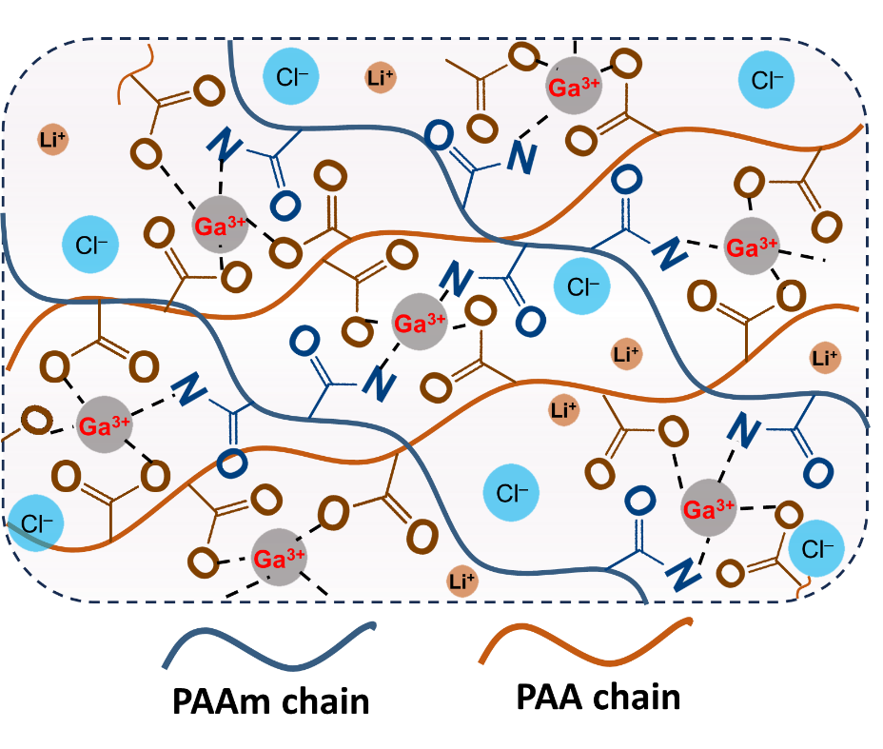
Fig. S1 Schematic illustration of ionic crosslinking between Ga³⁺ ions and carboxylate groups on poly(acrylic acid) chains

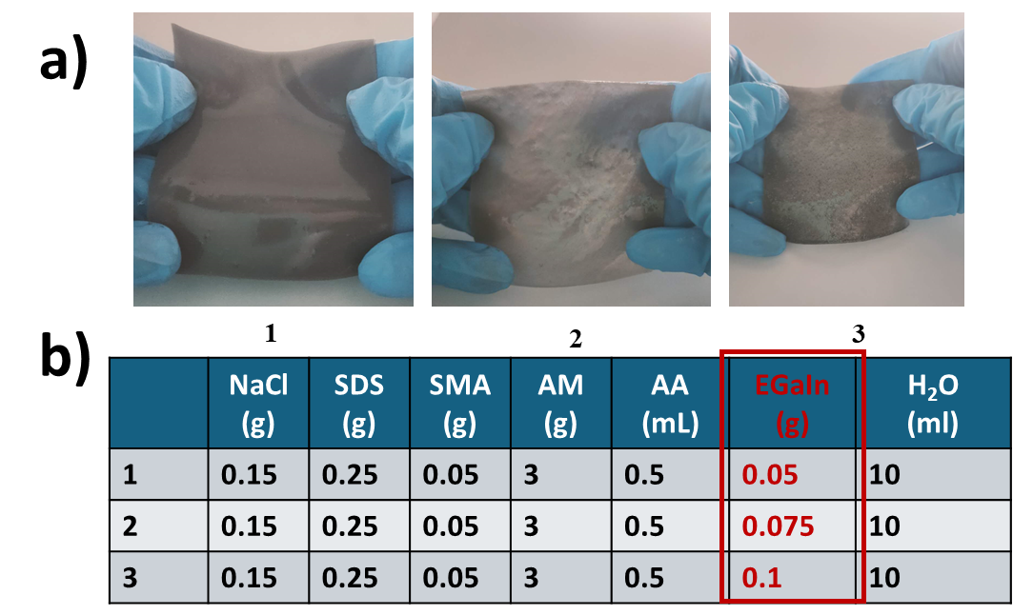
Fig. S2 (a) Photographs of the hydrogels synthesized by using different liquid metal contents (0.05 g, 0.075 g, and 0.1 g). (b) The amount of each component for the hydrogels

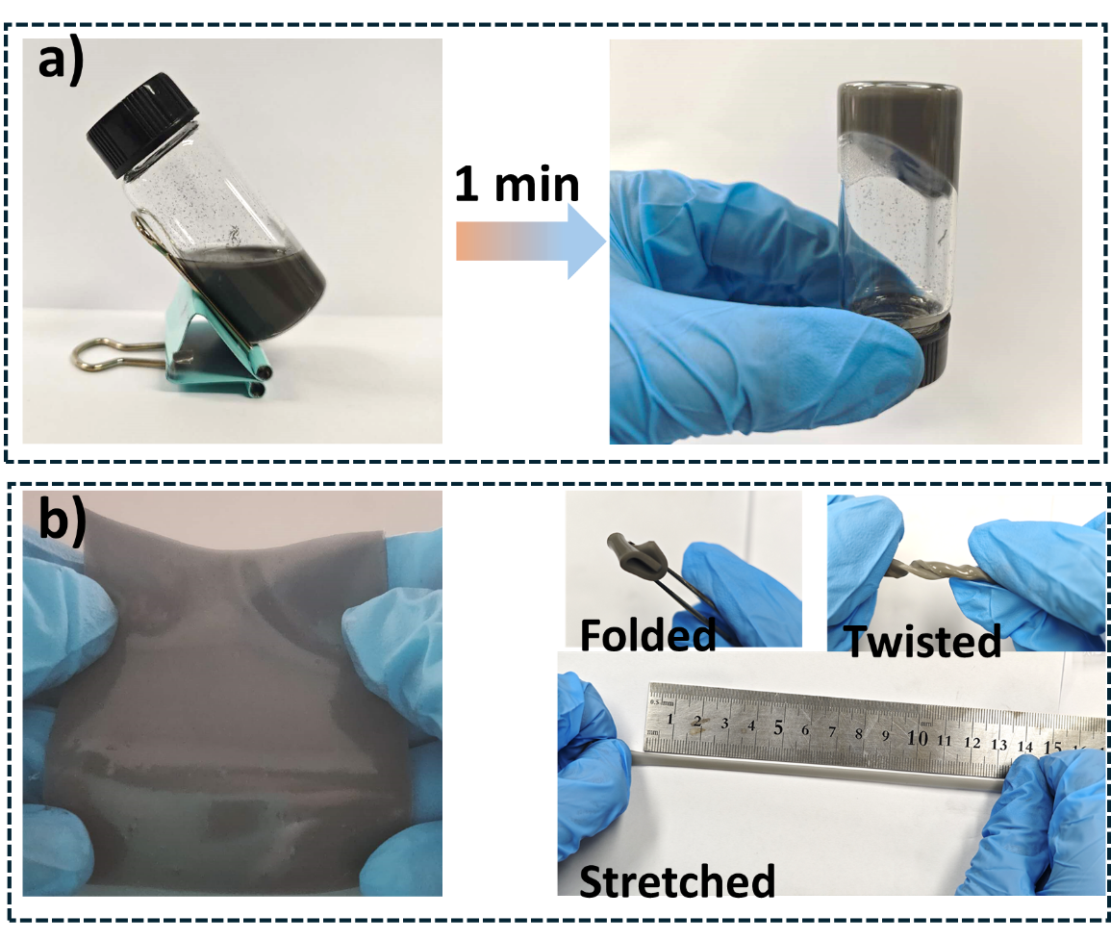
Fig. S3 (a) Photos showing rapid polymerization of PSLM hydrogel. (b) Photos showing deformability of PSLM hydrogel

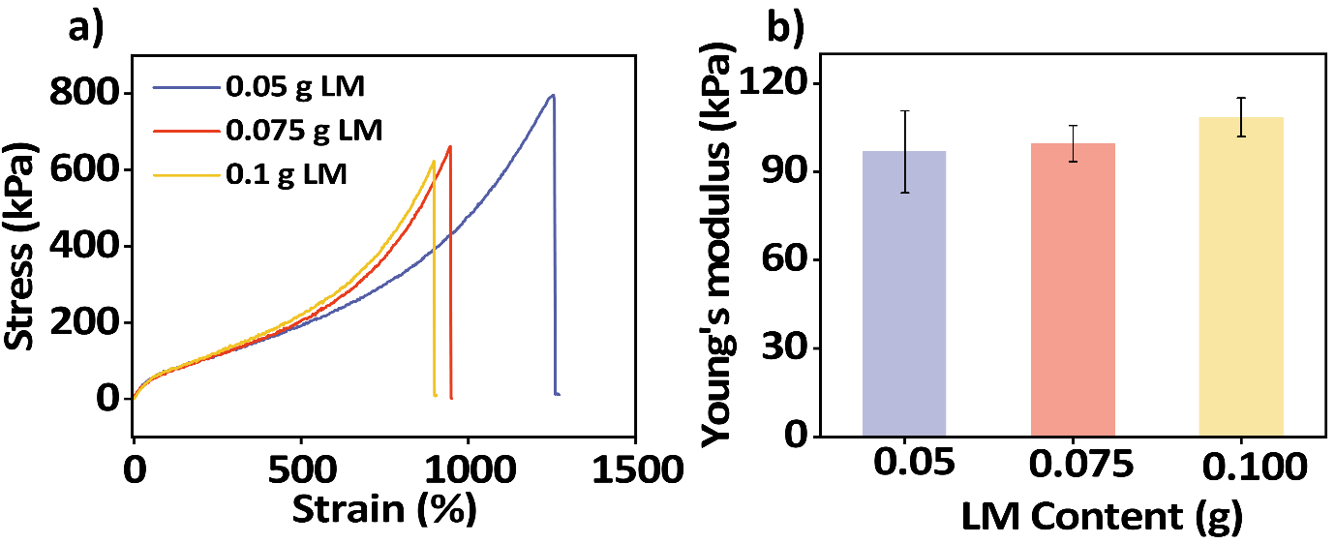
Fig. S4 (a) Tensile stress–strain curves and (b) Young's modulus of hydrogels containing different content of LM
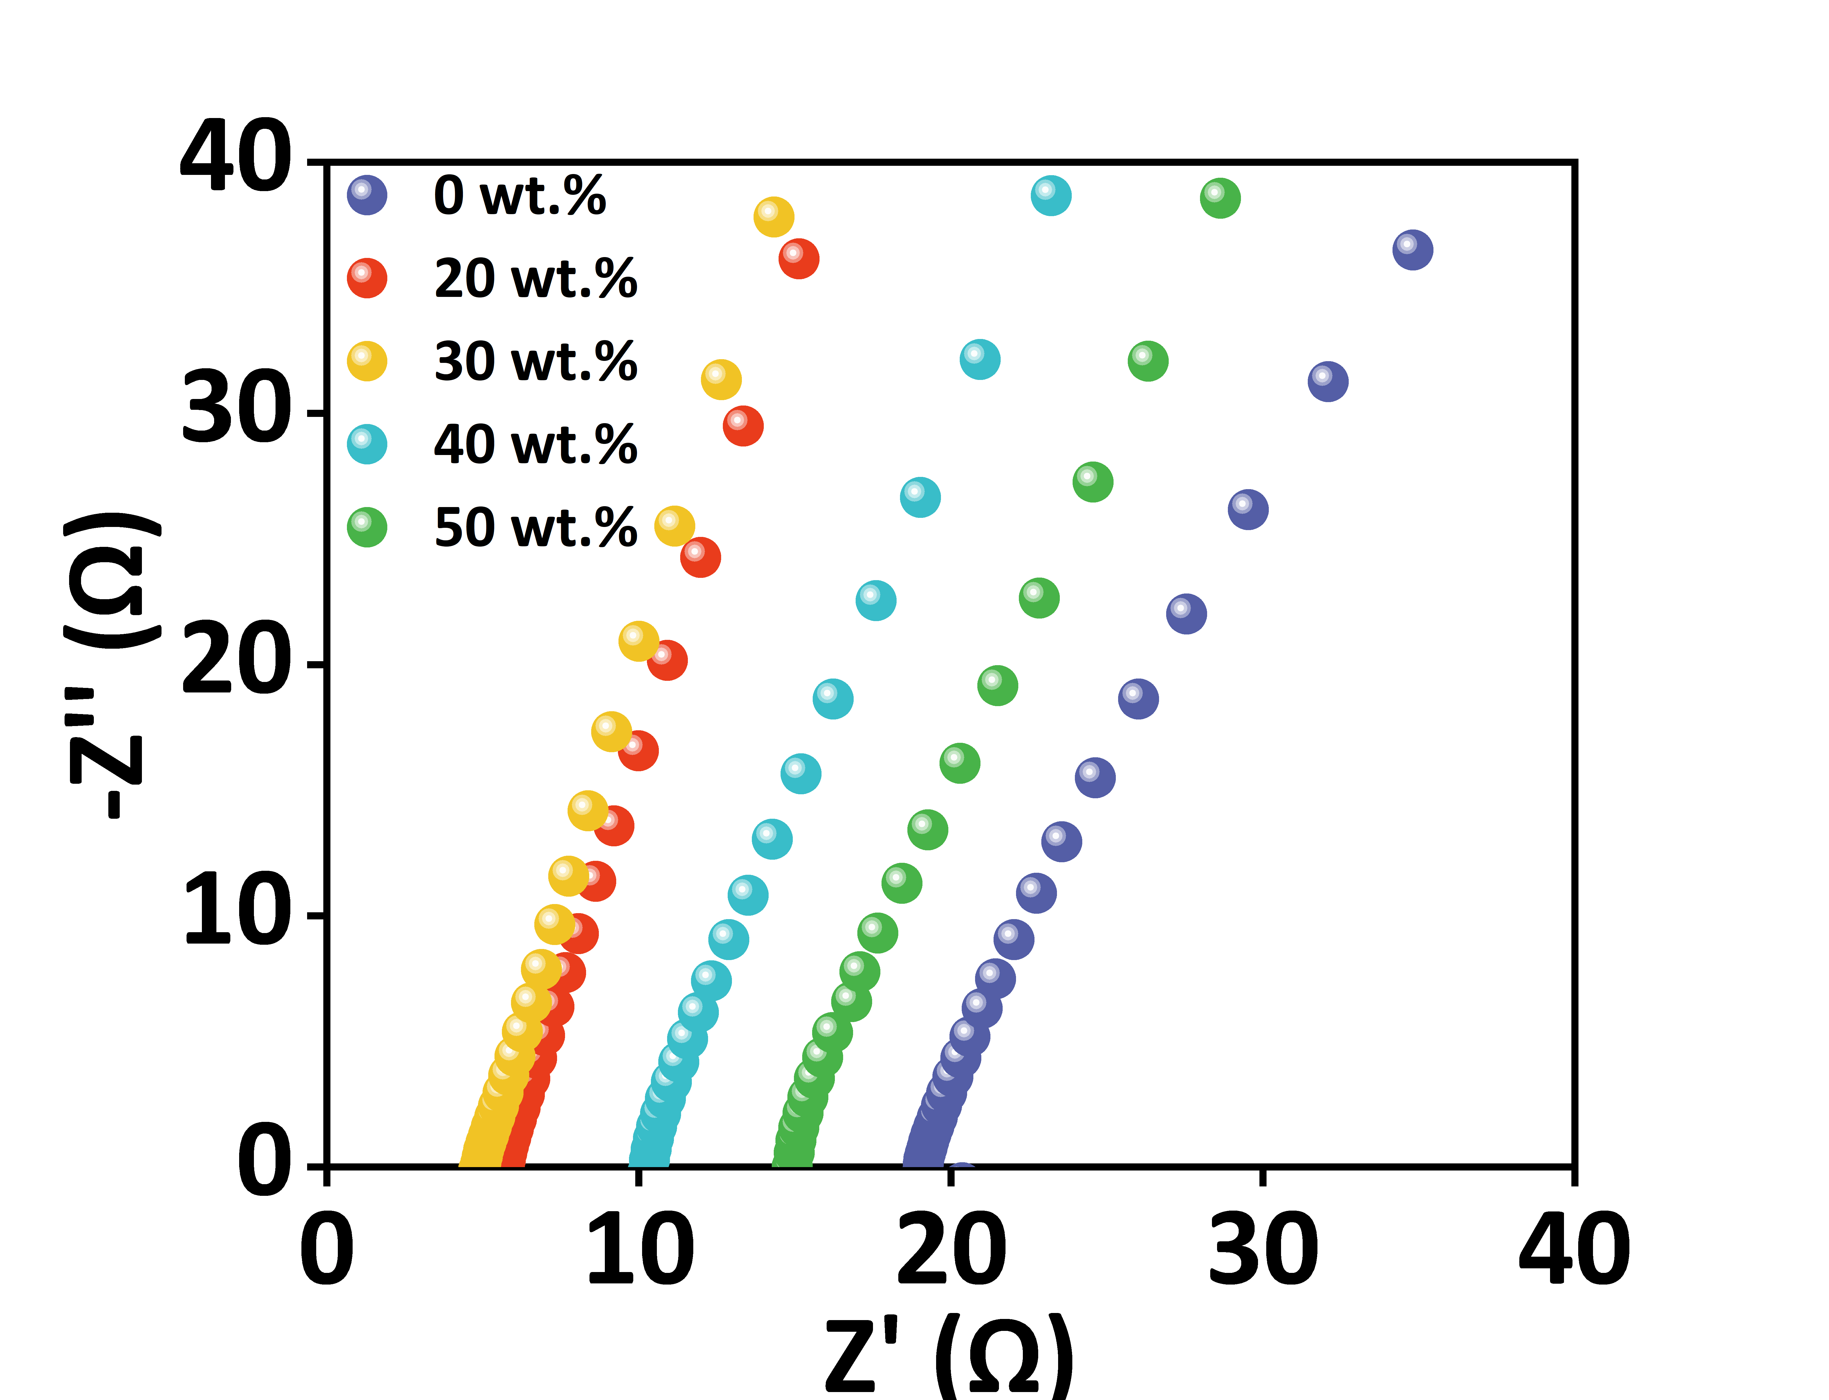
Fig. S5 Nyquist plots of the hydrogel after immersing in DI water containing various concentrations of LiCl
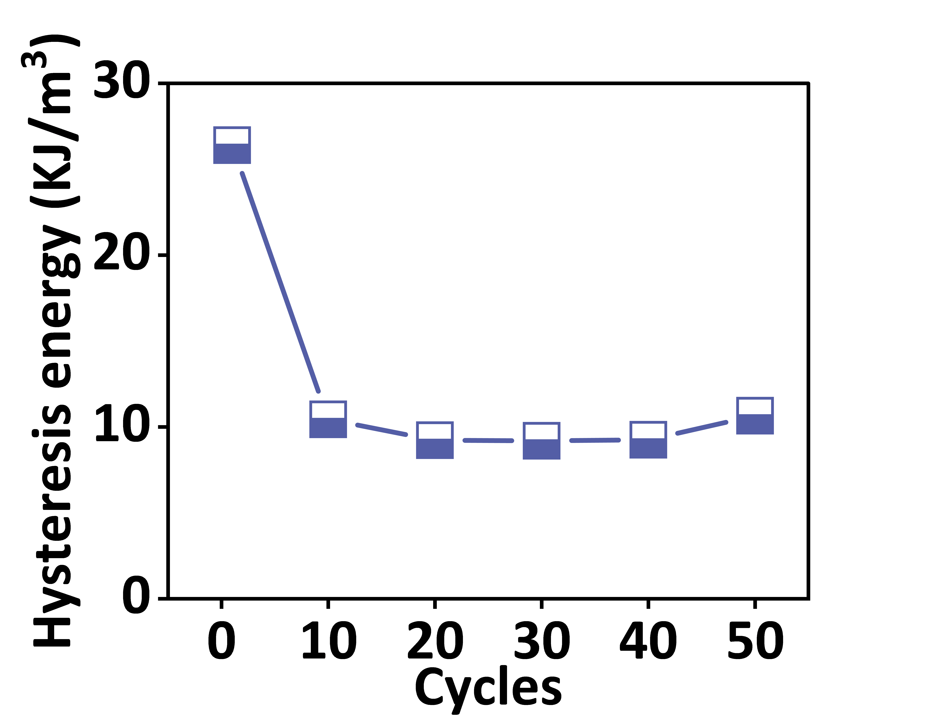
Fig. S6 Hysteresis energy of PSLM/LiCl hydrogels during each cycle of tensile strains with a maximum strain of 200%

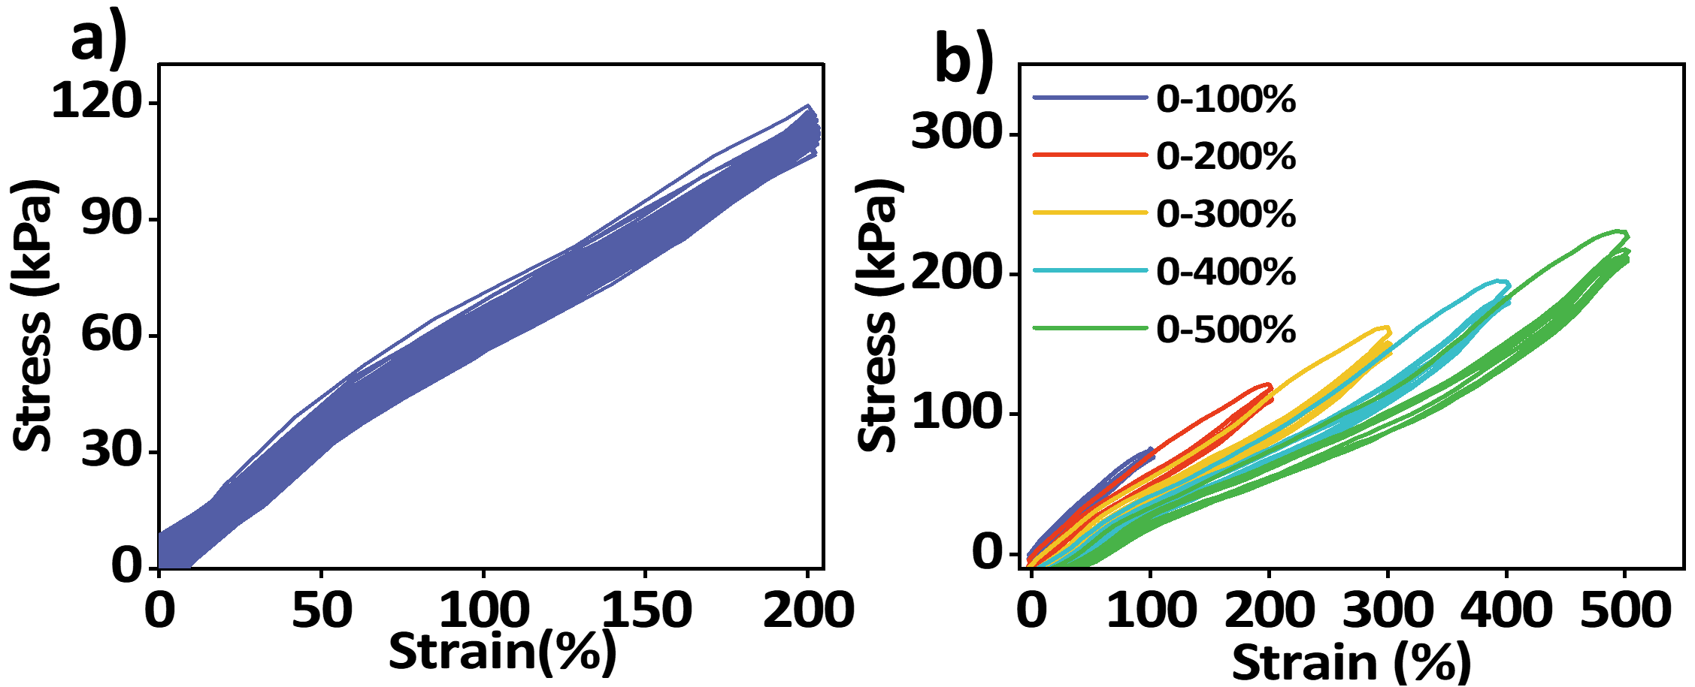
Fig. S7 (a) Stress–strain curves for PSLM/LiCl hydrogel during 50 consecutive tensile strains until a maximum strain of 200% after storage at –20 °C for 12h. (b) Stress–strain curves for PSLM/LiCl hydrogel during 4 cyclic tensile strains until various maximum strains after storage at –20 °C for 12 h

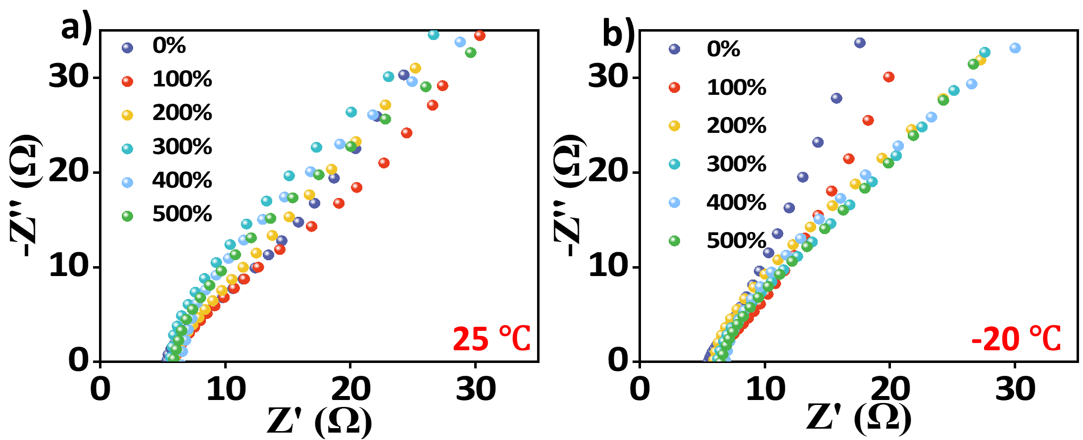
Fig. S8 Nyquist plots of hydrogels in different stretching states after storage at (a) 25 °C and (b) -20 °C
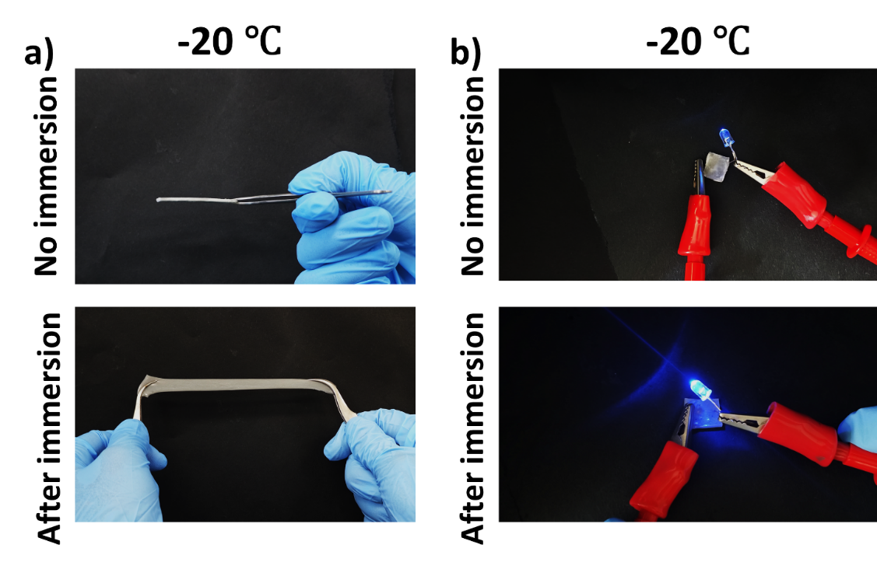
Fig. S9 (a) Photographs of hydrogels immersed and non-immersed in DI water containing 30 wt.% of LiCl after storage at −20 °C for 12 h, respectively. Non-immersed hydrogel exhibits stiff state and immersed hydrogel shows stretchability after storage at −20 °C for 12 h, respectively. (b) LED lighting demonstration using hydrogels immersed and non-immersed in DI water containing 30 wt.% of LiCl after storage at −20 °C for 12 h, serving as ionic conductors
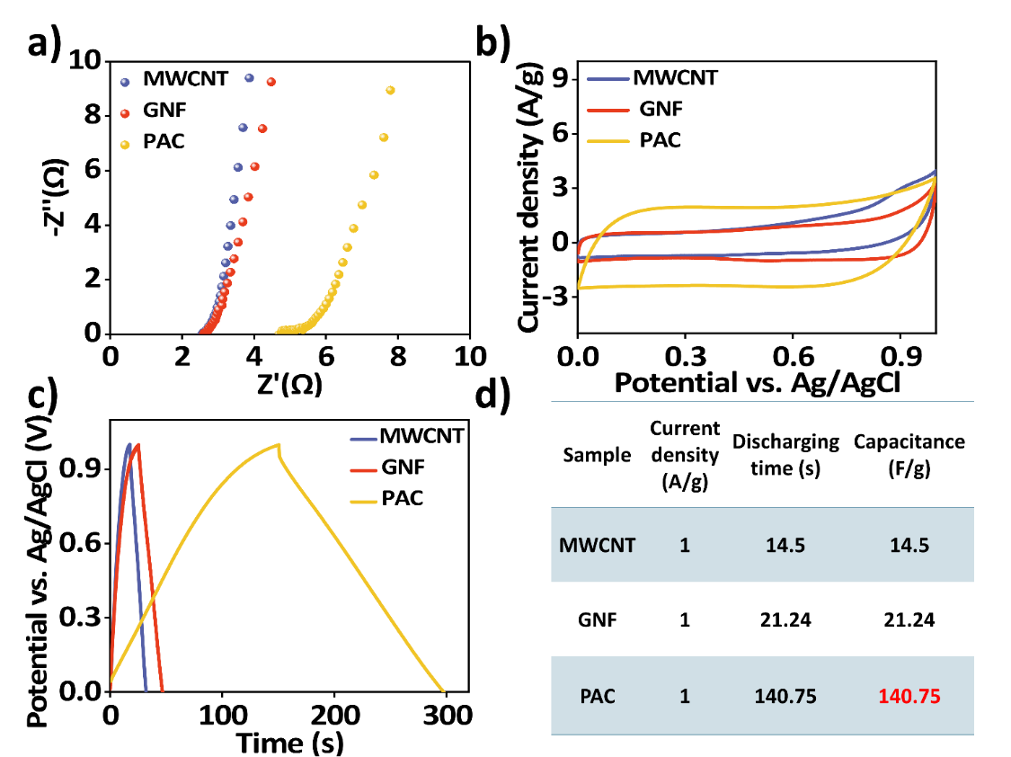
Fig. S10 The electrochemical characteristics of three electrode systems using MWCNT, graphite nanofiber (GNF) and porous activated carbon (PAC) electrodes as a working electrode with PSLM/LiCl hydrogel electrolyte, respectively: (a) Nyquist plots, (b) CV curves measured at 50 mV/s of scan rate, (c) GCD curves measured at 1 A/g of current density and (d) Specific capacitance calculations
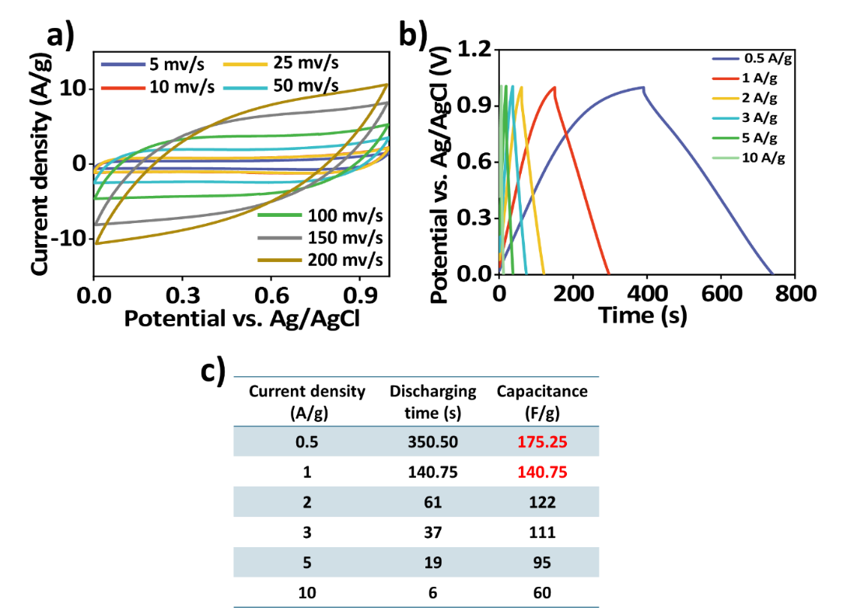
Fig. S11 The performances of three-electrode systems using porous activated carbon electrodes at various conditions: (a) CV curves measured at different scan rates (5 – 200 mV/s), (b) GCD curves measured at different current densities (0.5–10 A/g), and (c) the corresponding specific capacitances calculated viz. GCD results
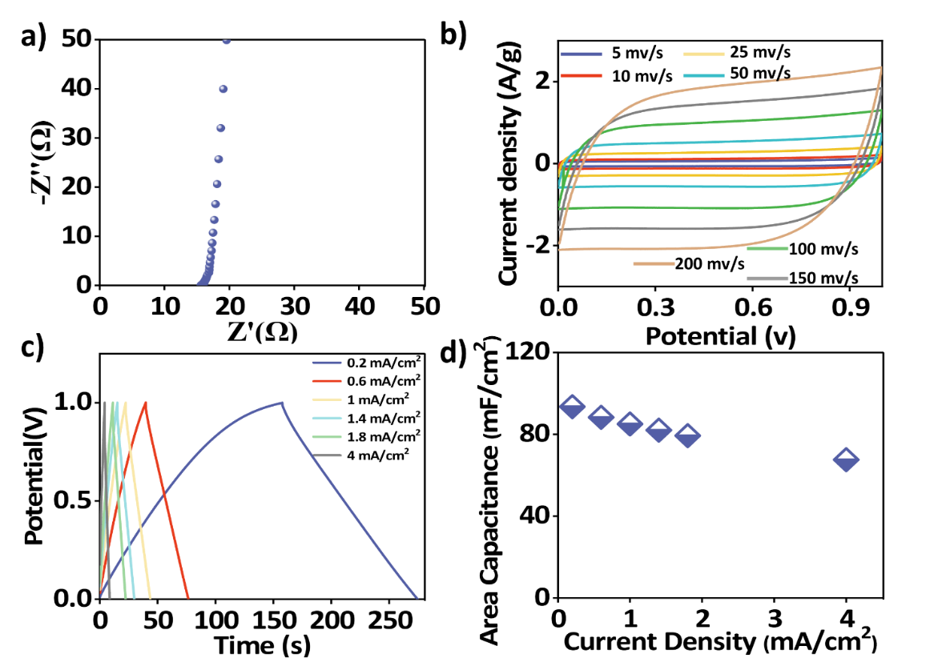
Fig. S12 Performances of supercapacitors with porous activated carbon electrodes and PSLM/LiCl hydrogel electrolyte: (a) Nyquist plots, (b) CV curves measured at different scan rates (5 – 200 mV/s), (c) GCD curves measured at different current densities (0.2 – 4 mA/cm²) and (d) Areal capacitance of the supercapacitor with PSLM/LiCl hydrogel electrolyte at various current densities
Fig. S13 Long-term GCD cycling test of the supercapacitor with PSLM/LiCl hydrogel electrolyte and PAC electrodes conducted at a current density of 4 mA cm⁻² at -20 °C (inset: GCD curves of the 1st and 45,000th cycles)
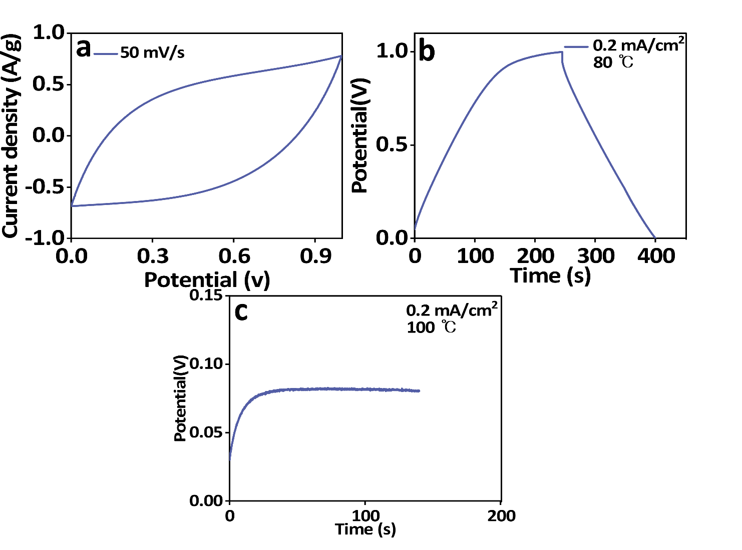
Fig. S14 (a) CV curves measured at 80 °C at a scan rate of 50 mV s⁻¹, (b) GCD curves measured at 80 °C at 0.2mA/cm² and (c) GCD curves measured at 100 °C under the same current density
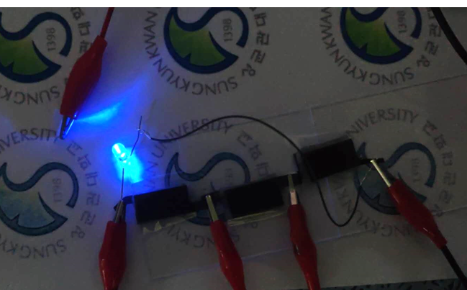
Fig. S15 Photograph of an LED light powered by three supercapacitors connected in series

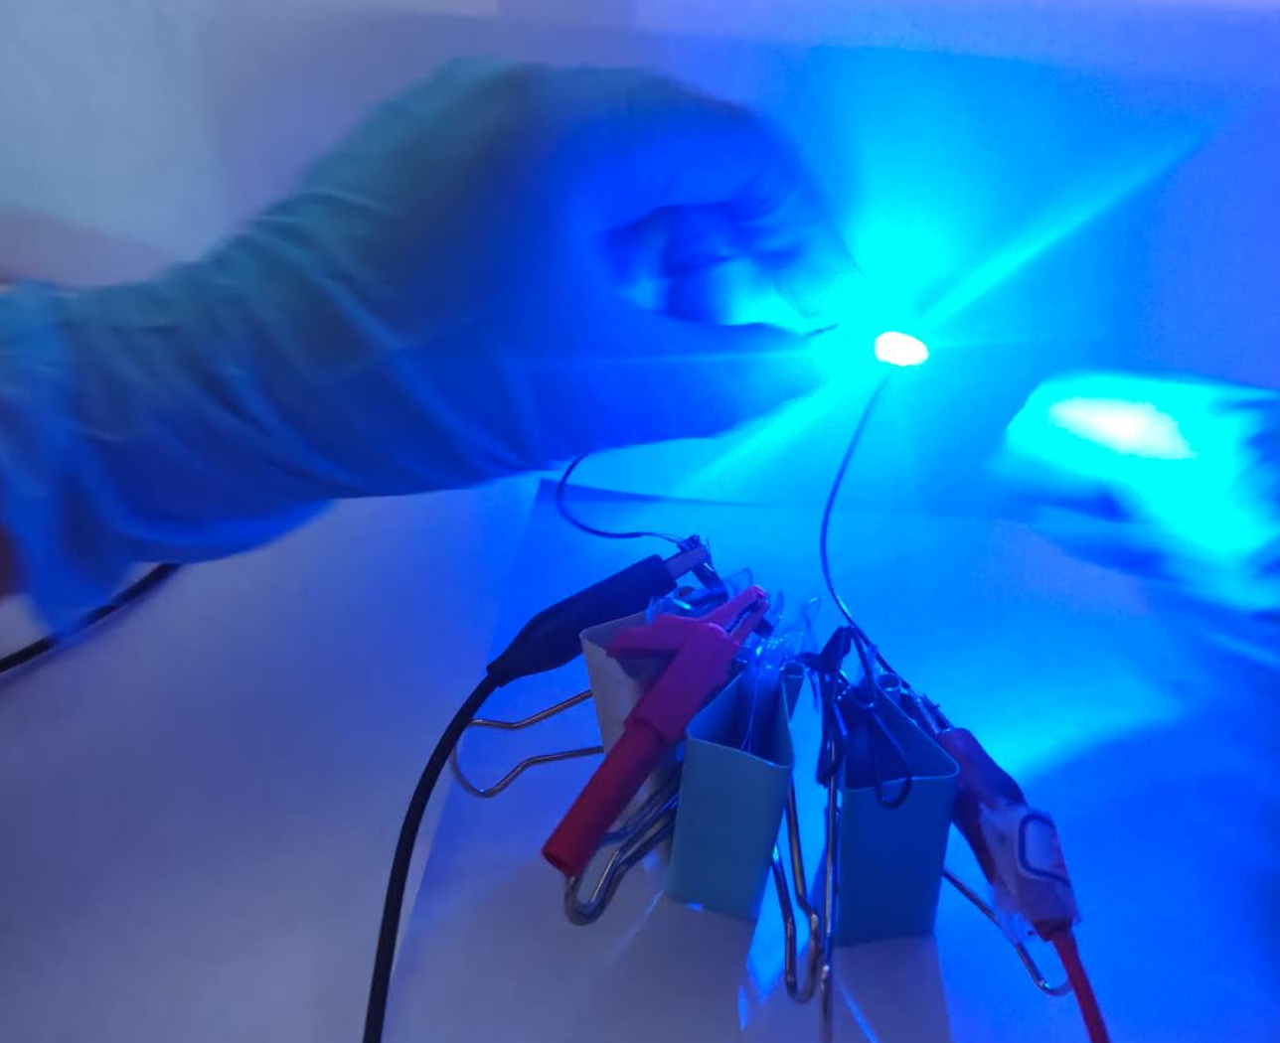
Fig. S16 Photograph of three-connected supercapacitors powering an LED light in 180° bend

