Supporting Information for
Expediting Lithium Electrochemistry via a Bilayer for High-Rate Lithium Metal Batteries
Dongjoo Park¹ and Dong-Wan Kim¹*
¹School of Civil, Environmental, and Architectural Engineering, Korea University, Seoul 02841, South Korea
*Corresponding author. E-mail: dwkim1@korea.ac.kr (Dong-Wan Kim)
Supplementary Table and Figures

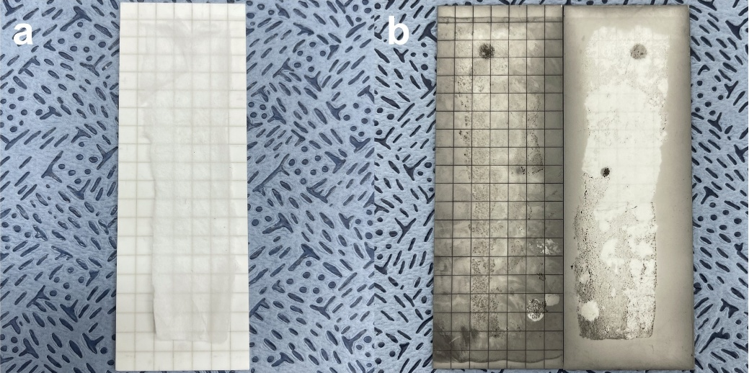
Fig. S1 Photo images of L-layer before heat treatment (a) and after heat treatment (b)

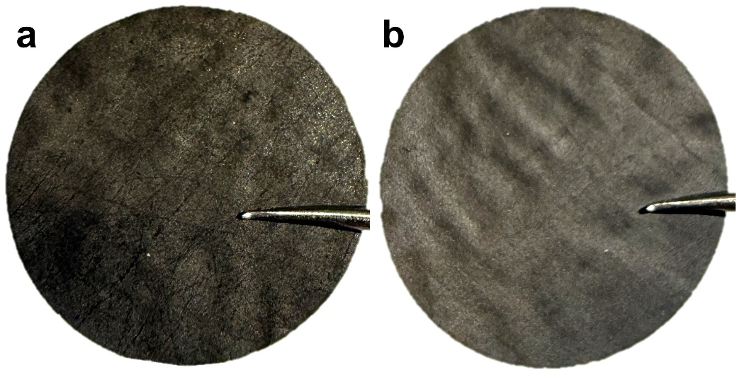
Fig. S2 Photo images of BL-layer, L-layer (a) and C-layer (b)

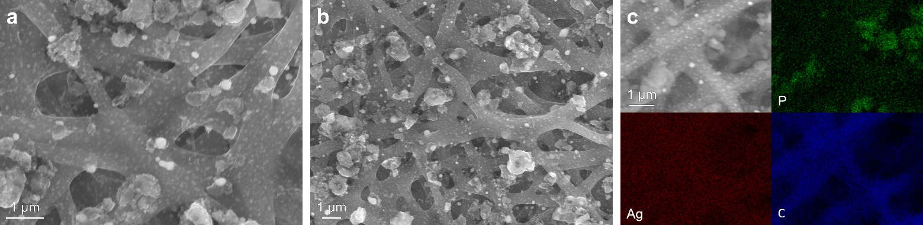
Fig. S3 SEM images (a, b) and EDAX images (c) of L-layer

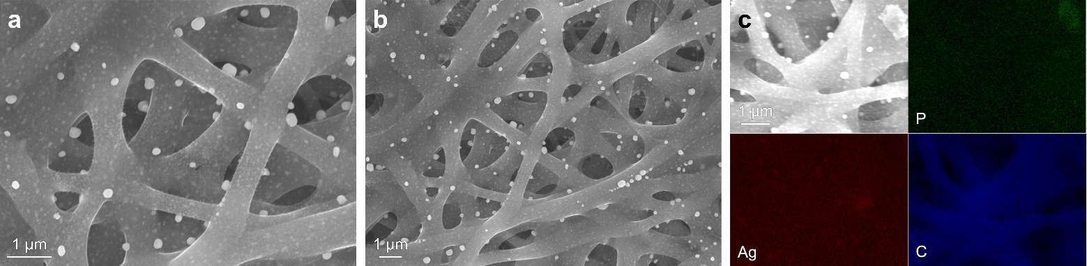
Fig. S4 SEM images (a, b) and EDAX images (c) of C-layer
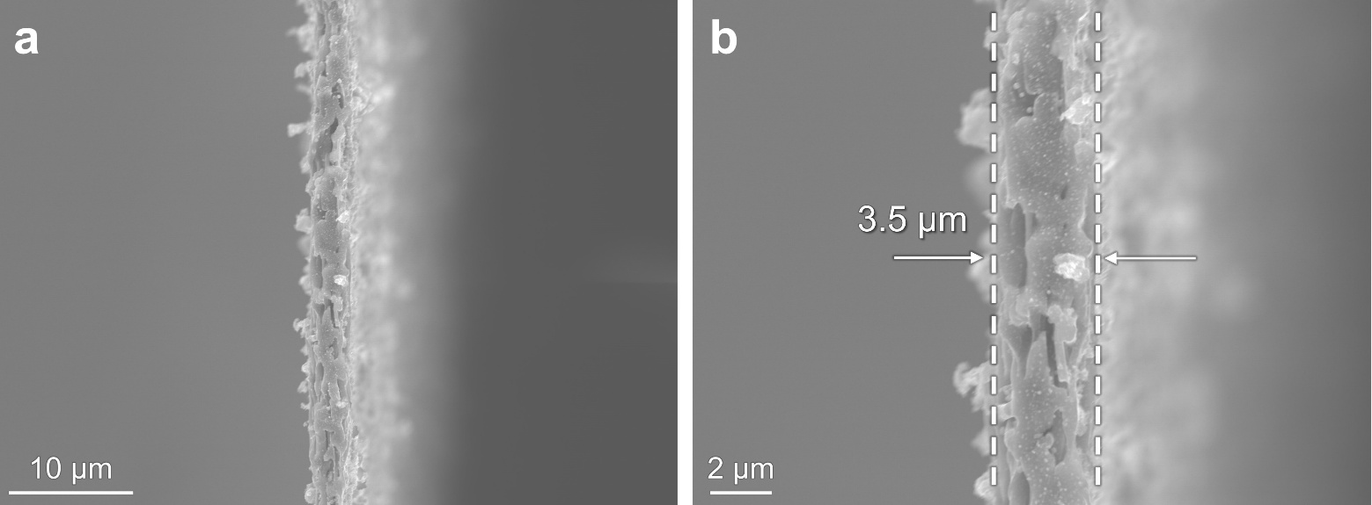
Fig. S5 SEM Cross-sectional image of BL thickness
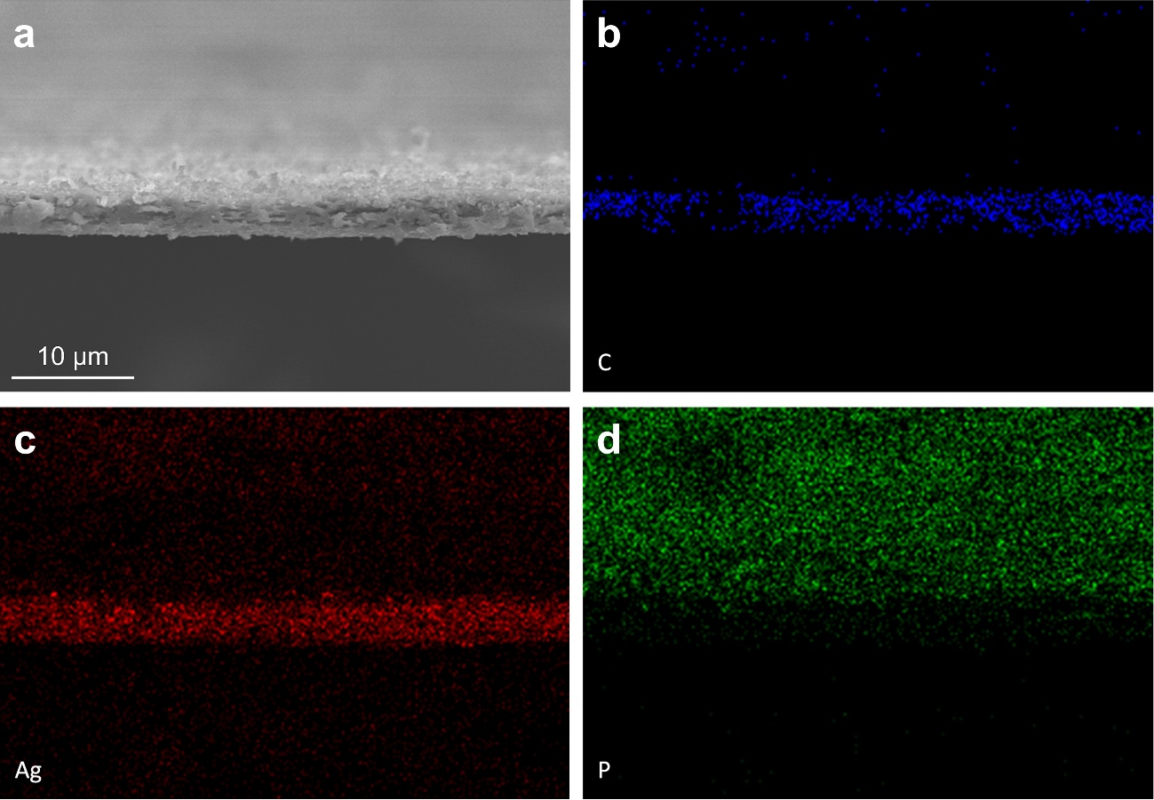
Fig. S6 Cross-sectional SEM image of BL (a) and corresponding EDS elemental maps of C (b), Ag (c), and P (d)
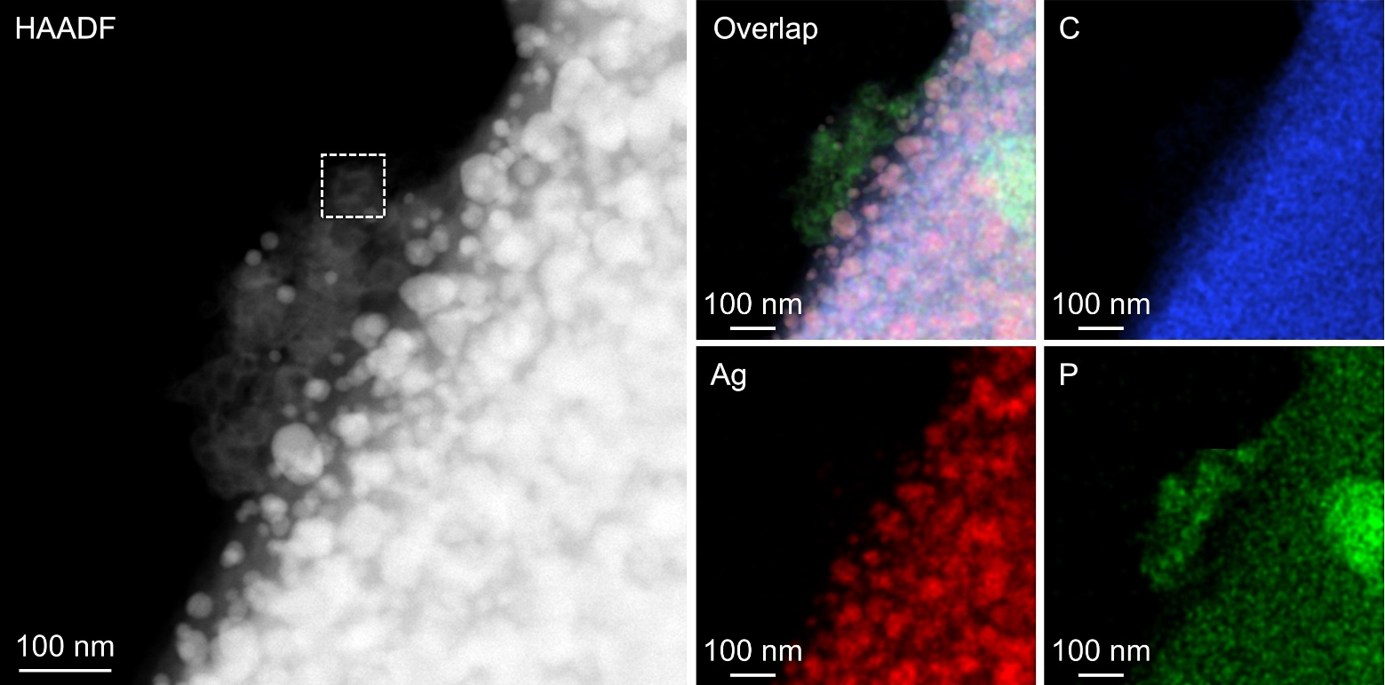
Fig. S7 HAADF-STEM images of BL and corresponding elemental mapping

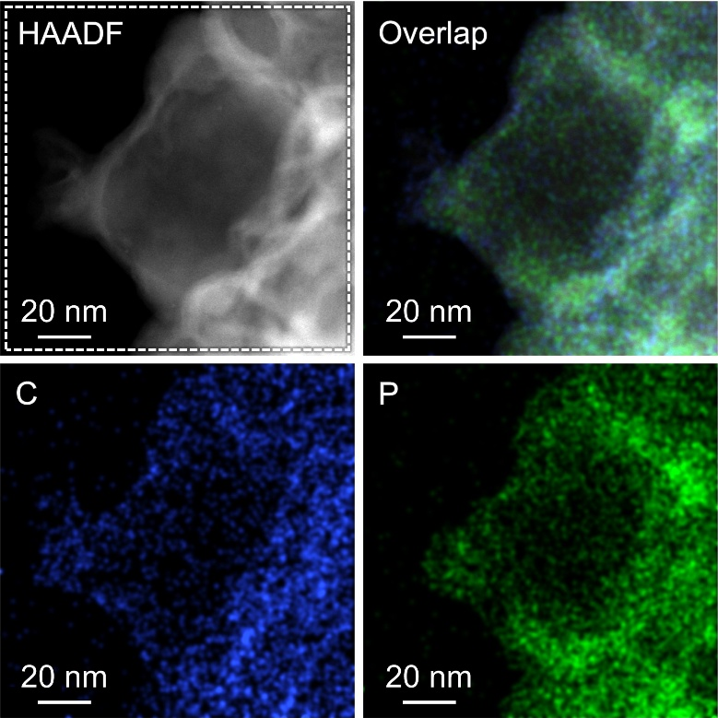
Fig. S8 HAADF-STEM images of surface agglomerates on the BL (noted in Fig.Sx) and corresponding elemental mapping

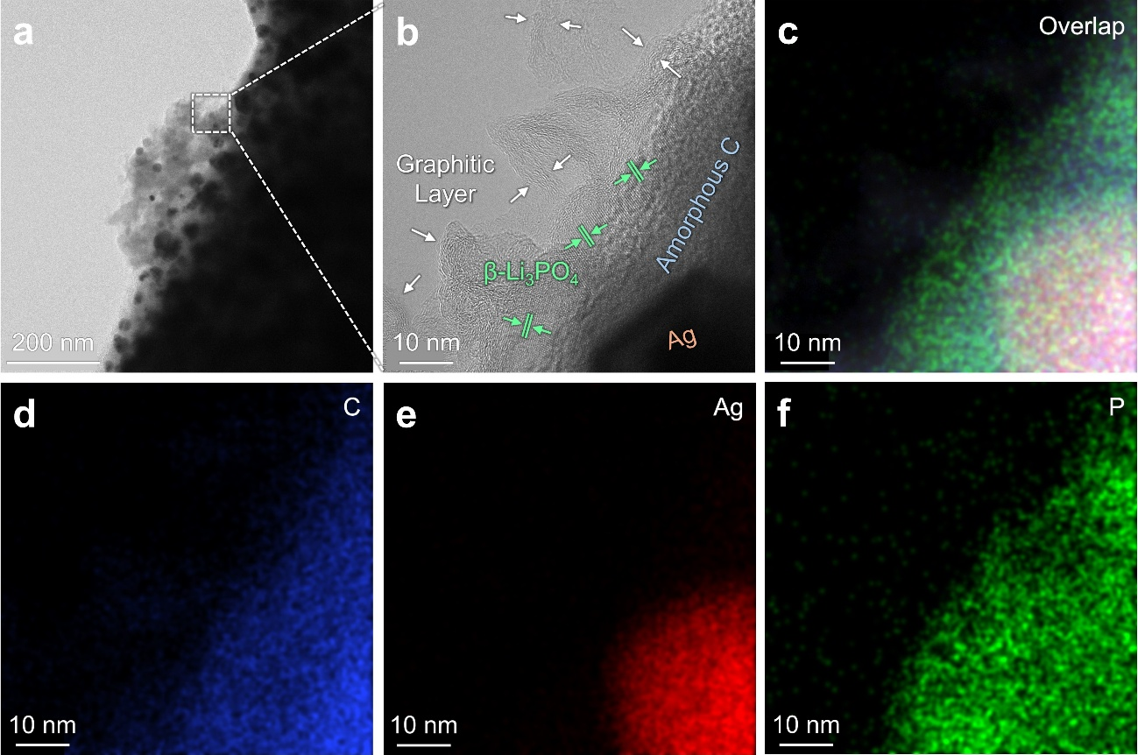
Fig. S9 HAADF-STEM images of BL (a), surface agglomerates on the BL (noted in Fig.S9(a)) (b) and corresponding elemental mapping of overlapping image (c), C (d), Ag (e), and P (f)

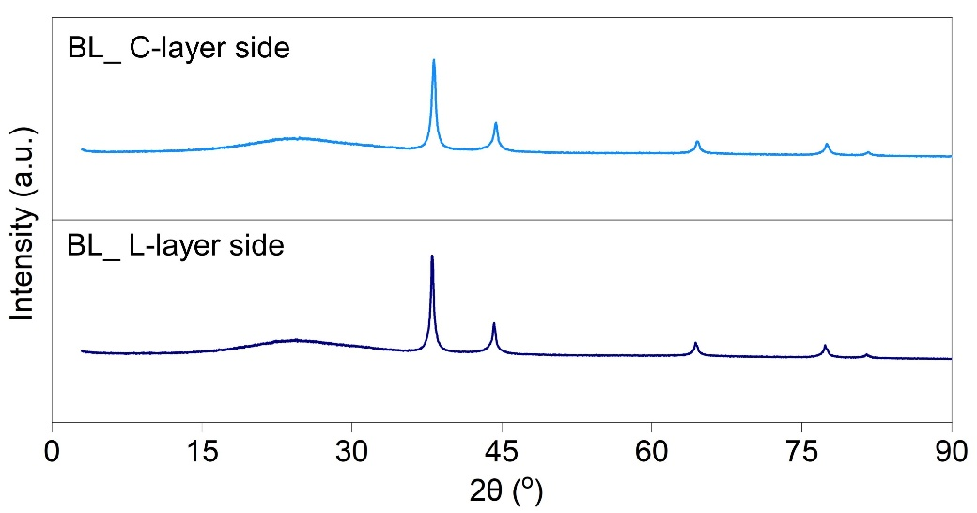
Fig. S10 XRD spectra of BL, C-layer side (upper) and L-layer (lower)

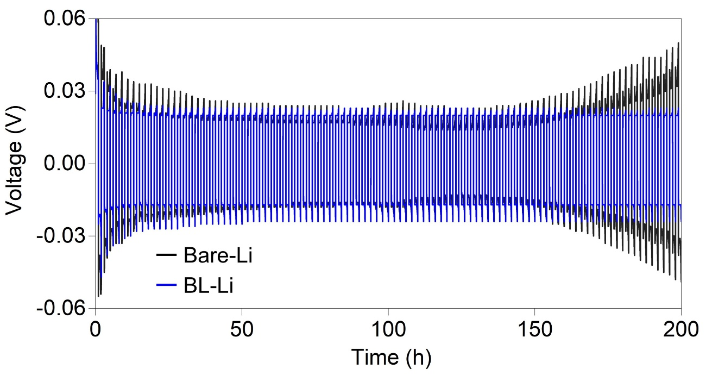
Fig. S11 Li-Li symmetric cell under operating conditions of 1 mA cm⁻² and 1 mAh cm⁻² for 100 cycles

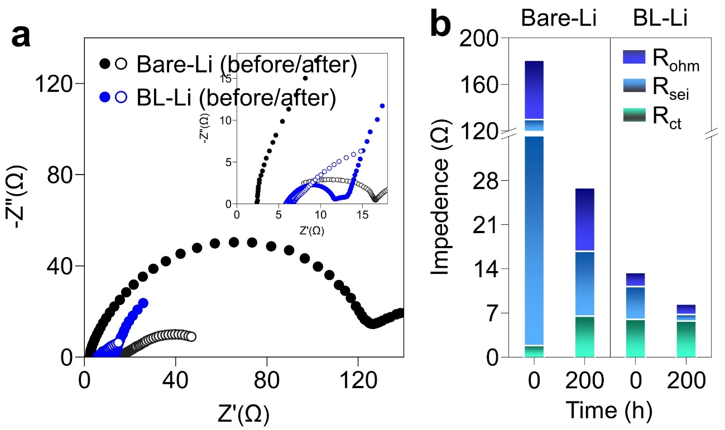
Fig. S12 Comparison of interfacial resistance and overall kinetics before and after at 1 mA cm⁻², 1 mAh cm⁻² for 100 cycles

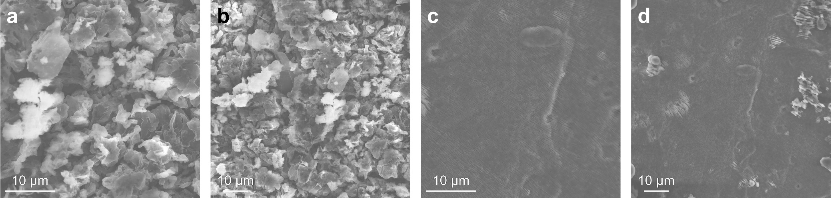
Fig. S13 SEM Top view of after the Li-Li symmetric cells with operating conditions at 1 mA cm⁻², 1 mAh cm⁻² for 100 cycles of Bare-Li (a, b) and BL-Li (c, d)

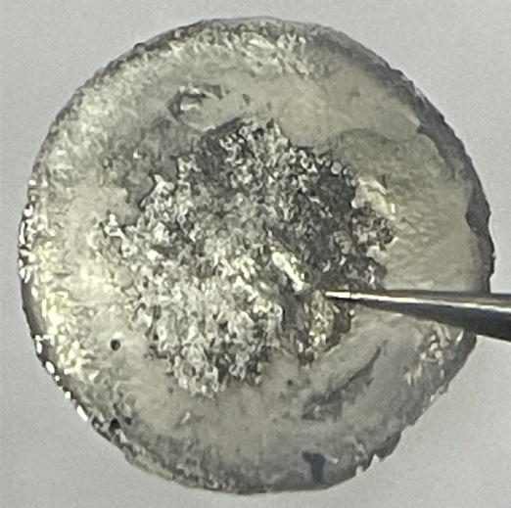
Fig. S14 Photo image of Bare-Li after 100 cycles at 1 mA cm⁻² with a fixed capacity of 1 mAh cm⁻²

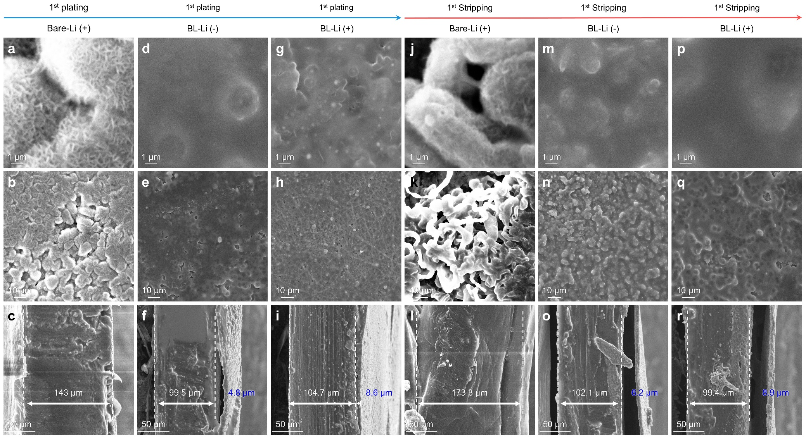
Fig. S15 SEM plane/cross view images

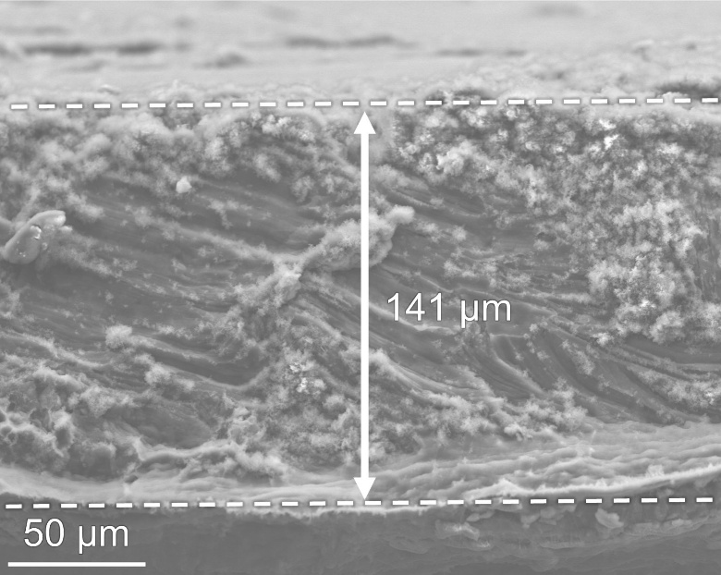
Fig. S16 SEM cross view image of fresh-Li for comparison with Fig. S9

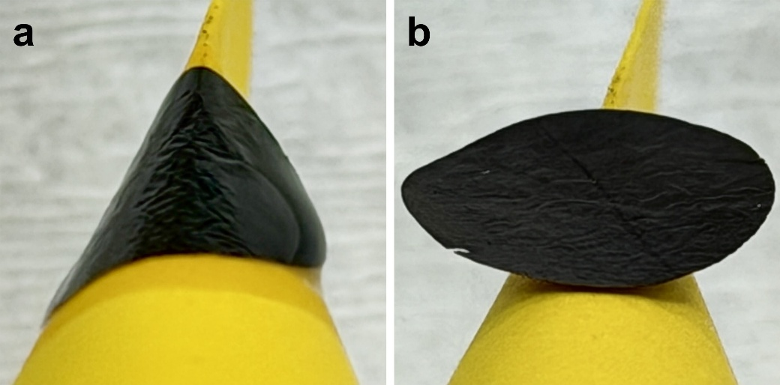
Fig. S17 Optical photographs showing the BL in the wetted (a) and dry (b) states on a bending paper substrate

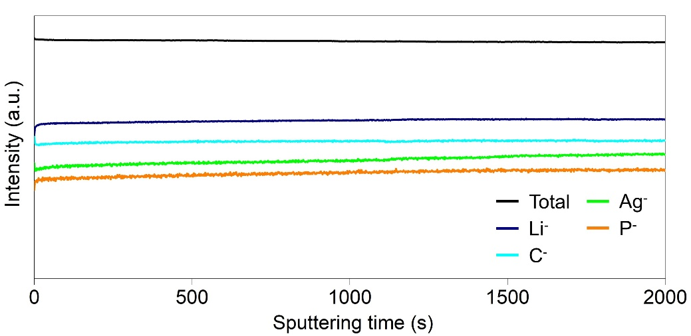
Fig. S18 TOF-SIMS depth profiling of BL-Li cell under operating conditions of 1 mA cm⁻² and 1 mAh cm⁻² for 100 cycles

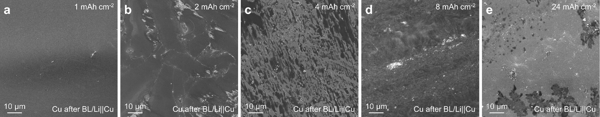
Fig. S19 SEM images of Cu after asymmetric Cu-Li cells under operating conditions of 1, 2, 4, 8, and 24 mAh cm⁻²

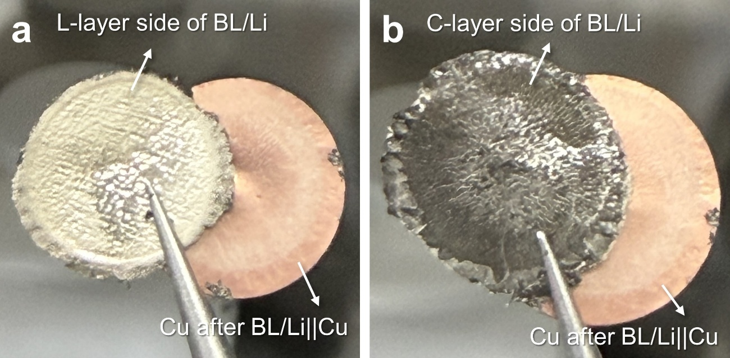
Fig. S20 Photo images of asymmetric Cu-Li cells under operating conditions of 1 mA cm⁻² for 24 h. L-layer side of BL/Li (a) and C-layer side of BL/Li (b)

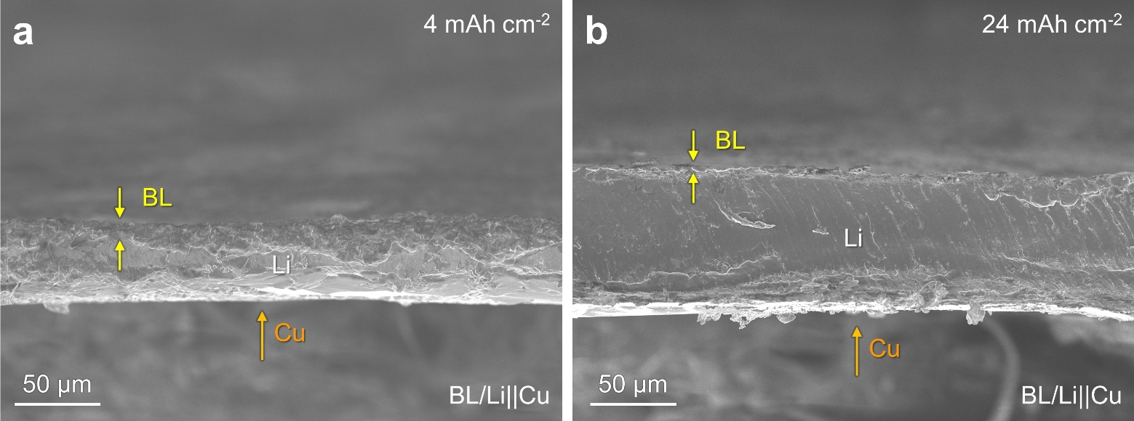
Fig. S21 SEM Cross-sectional image after asymmetric Cu-Li cells under operating conditions of 4 mAh cm⁻² (a) and 24 mAh cm⁻² (b)

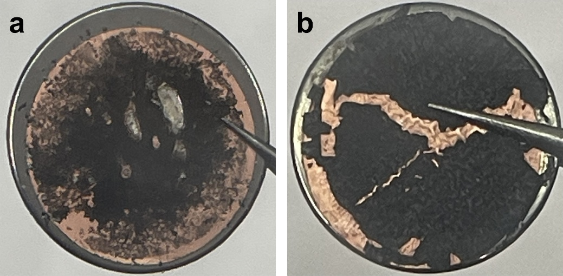
Fig. S22 Cu electrode after 24 mAh cm⁻² plating and 24 mAh cm⁻² stripping

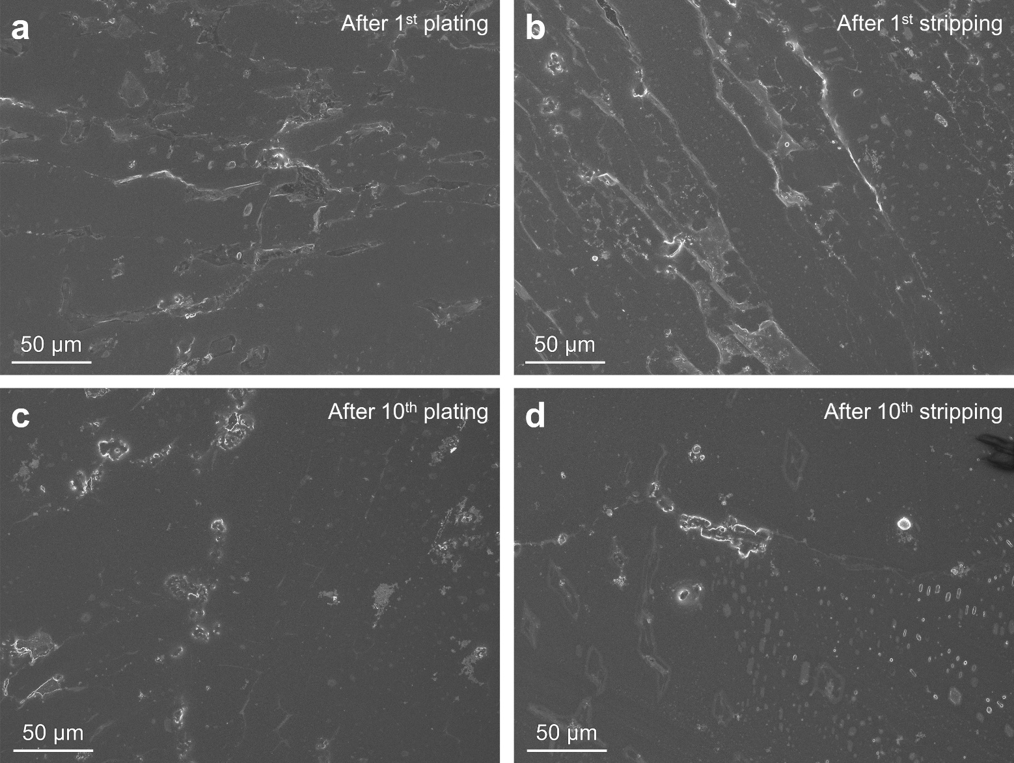
Fig. S23 SEM image of Li after symmetric BL/Li cells under operating conditions of 1 mA cm⁻² at 1 mAh cm⁻² after 1st plating (a), after 1st stripping (b), after 10th plating (c), and after 10th stripping (d)

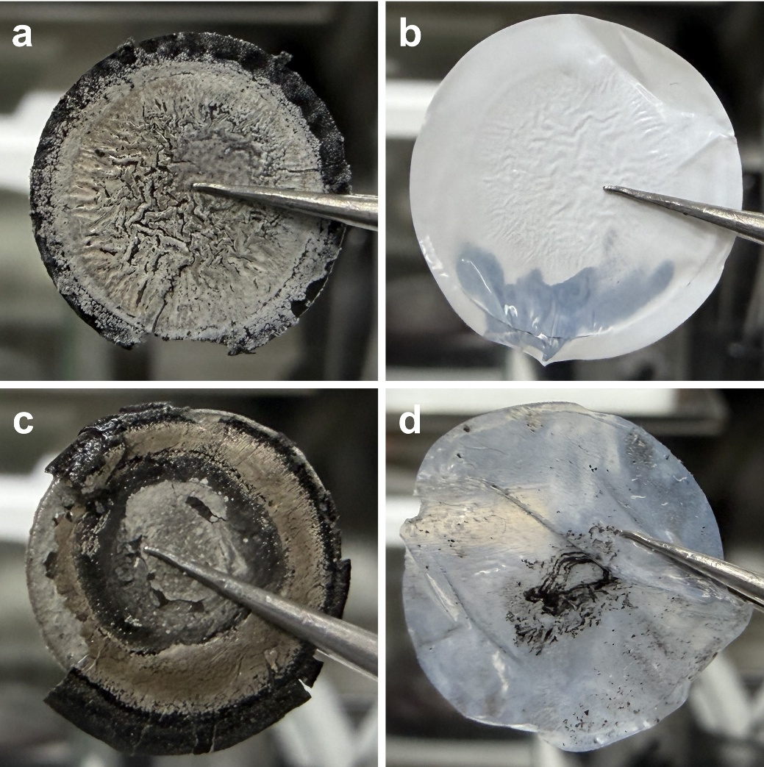
Fig. S24 Optical images of BL/Li electrodes and separators after cell disassembly following Li plating/stripping at 20 mA cm⁻² and 10 mAh cm⁻² for 50 h (a and b) and 320 h (c and d)
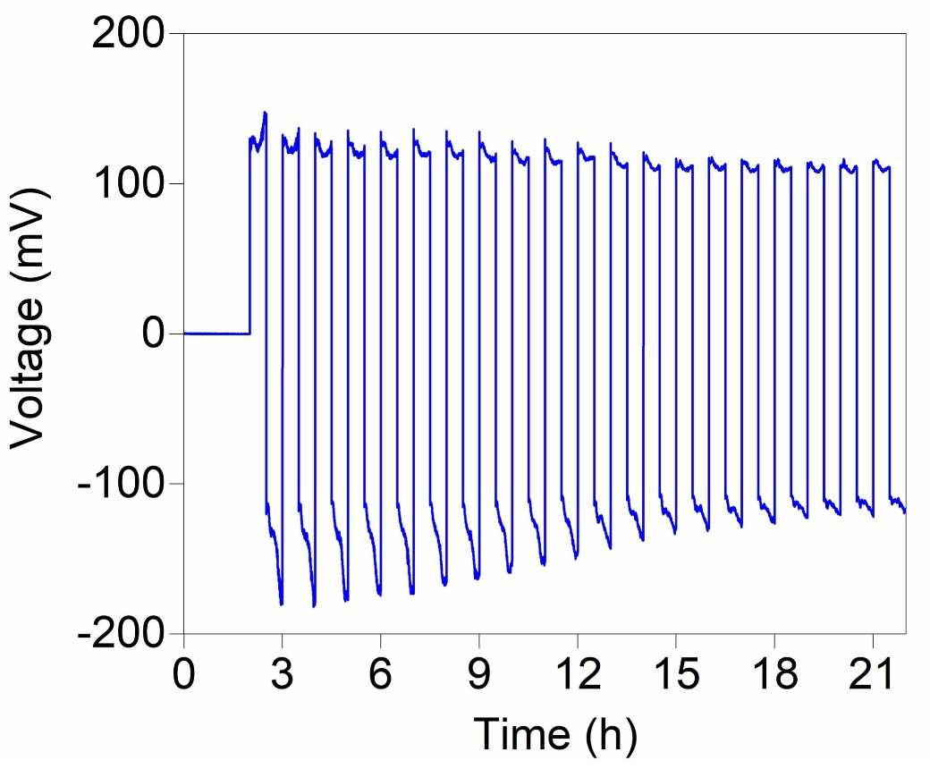
Fig. S25 Galvanostatic charge–discharge voltage profiles of Li–Li symmetric cells with operating conditions at 20 mA cm⁻², 10 mAh cm⁻² for 20 h
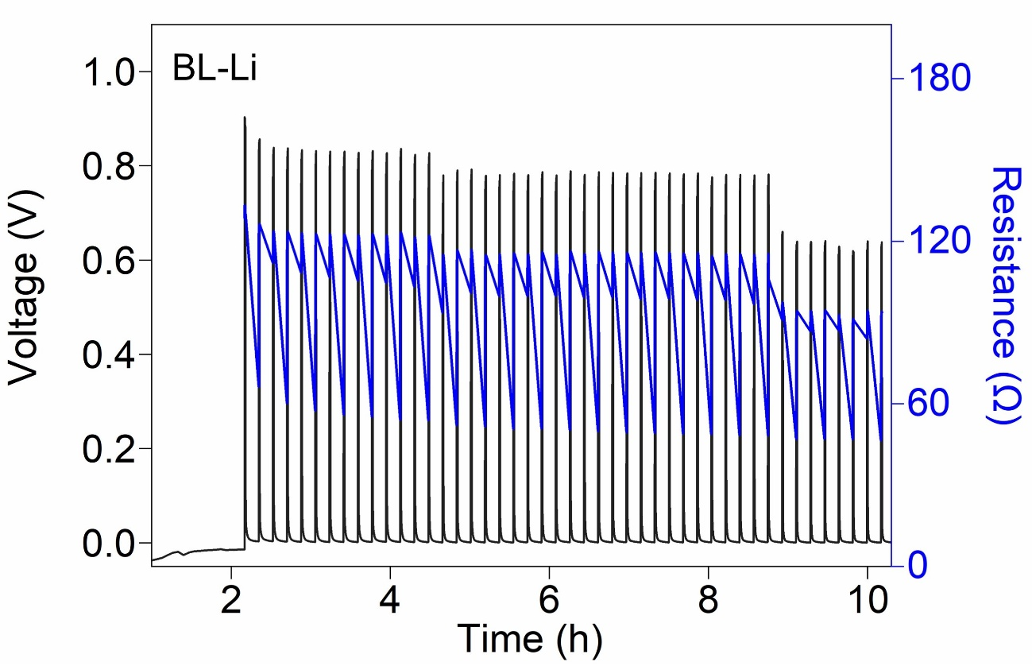
Fig. S26 GITT profiles of a Li symmetric cell during lithium plating using the BL-Li at 20 mA cm⁻², reaching a cumulative areal capacity of 10 mAh cm⁻²

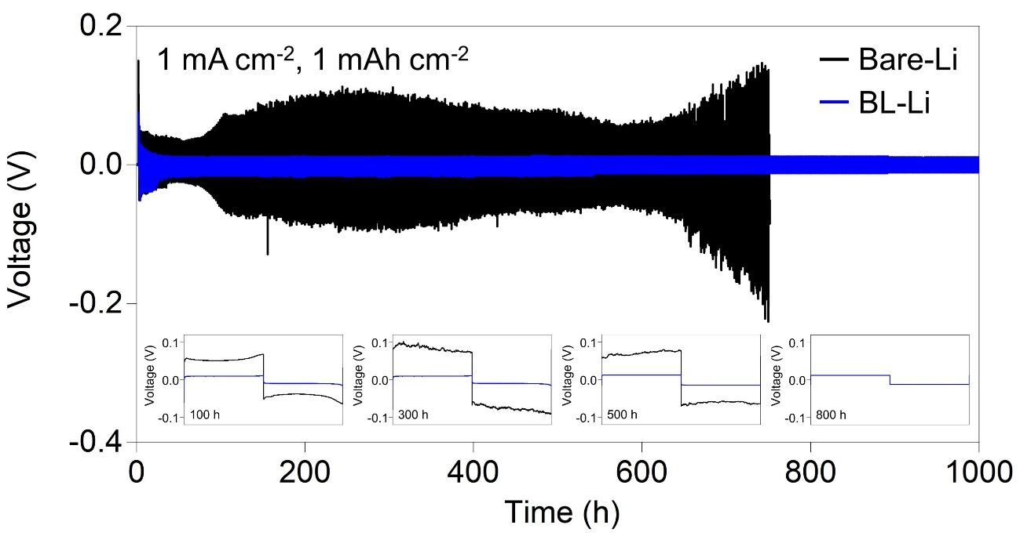
Fig. S27 Galvanostatic charge-discharge voltage profiles of the Li-Li symmetric cells with operating conditions at 1 mA cm⁻², 1 mAh cm⁻² for 1000 h

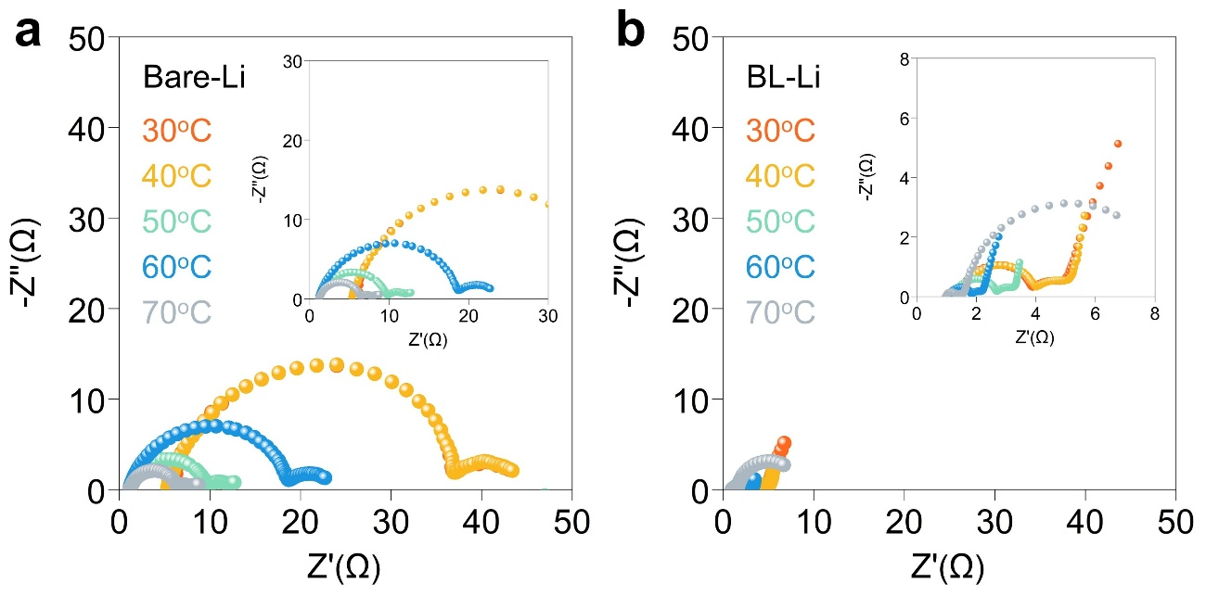
Fig. S28 EIS measurement at different temperature (a and b)

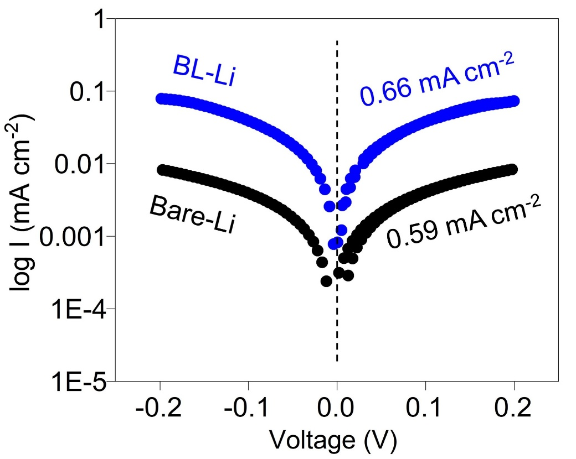
Fig. S29 Tafel plots with scan rate 5 mV s⁻¹ and calculated exchange-current densities (j₀) in the Li symmetric cells

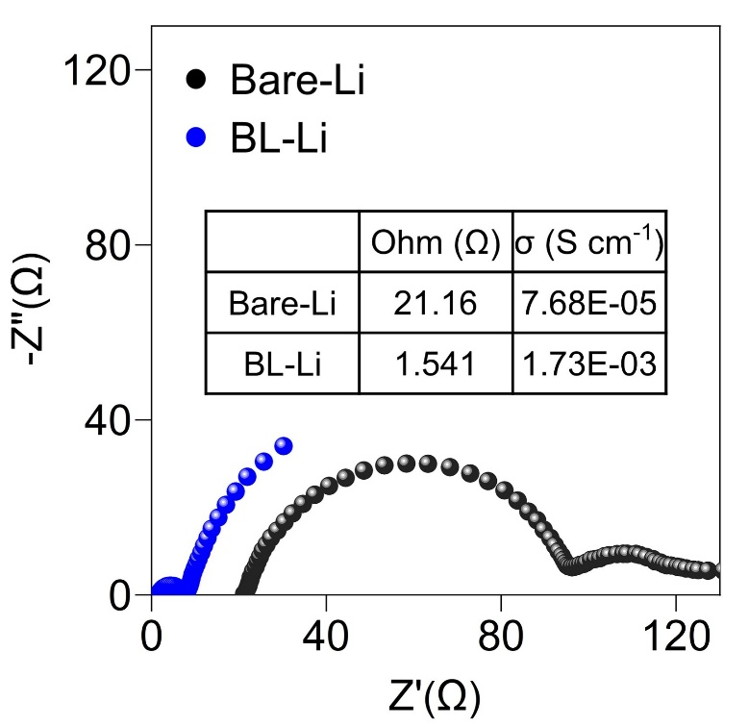
Fig. S30 The Li⁺ ionic conductivity of Bare-Li and BL-Li

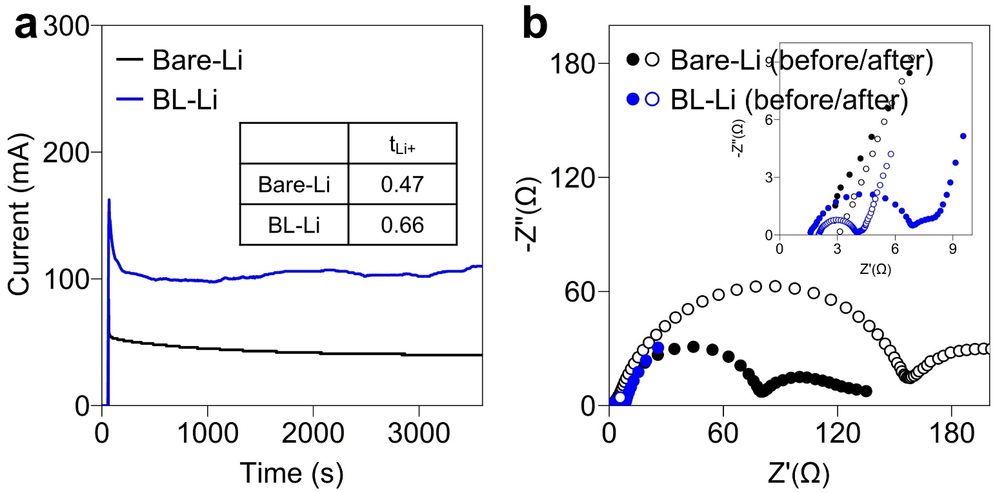
Fig. S31 Chronoamperometry profile and transference number (a) and the EIS plots before and after chronoamperometry collected from a symmetric Bare-Li and BL-Li cells (b)

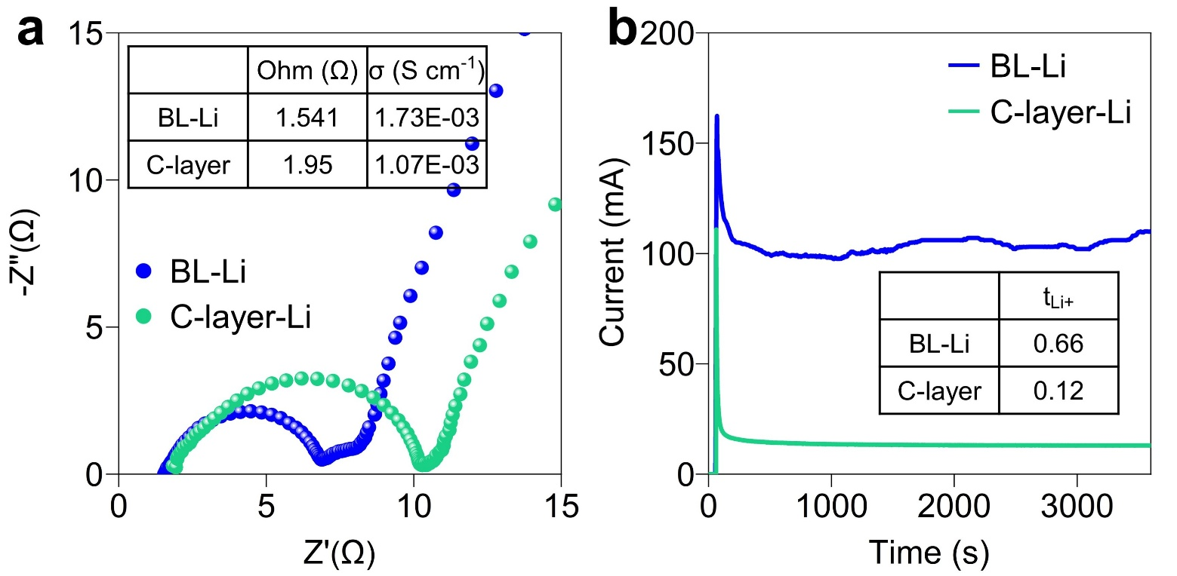
Fig. S32 The Li⁺ ionic conductivity (a) and chronoamperometry profile and transference number (b) of BL-Li and C-layer-Li cells

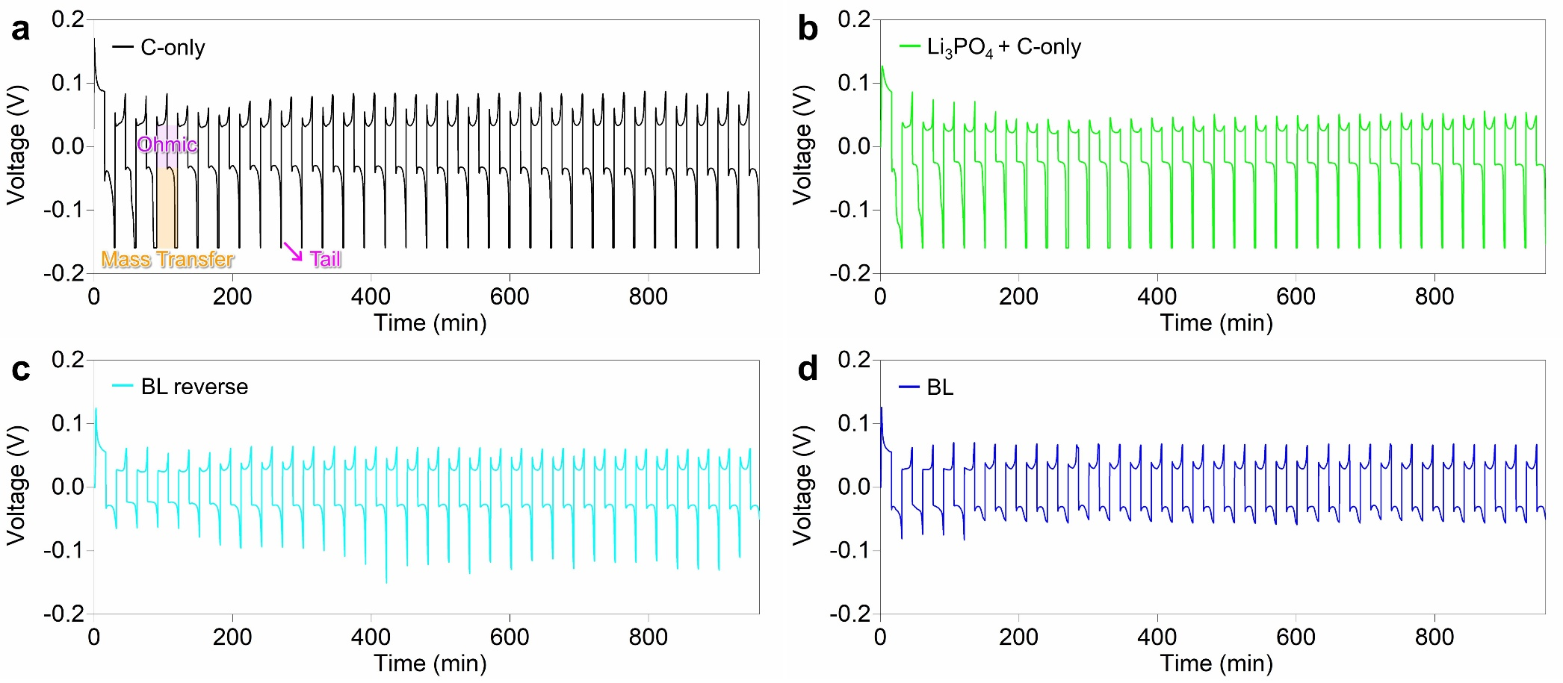
Fig. S33 Voltage–time profiles of Li‖Li symmetric cells with different interfacial configurations at 4 mA cm⁻² with a fixed capacity of 1 mAh cm⁻² : (a) C-only, (b) Li₃PO₄ + C-only, (c) BL reverse, and (d) BL
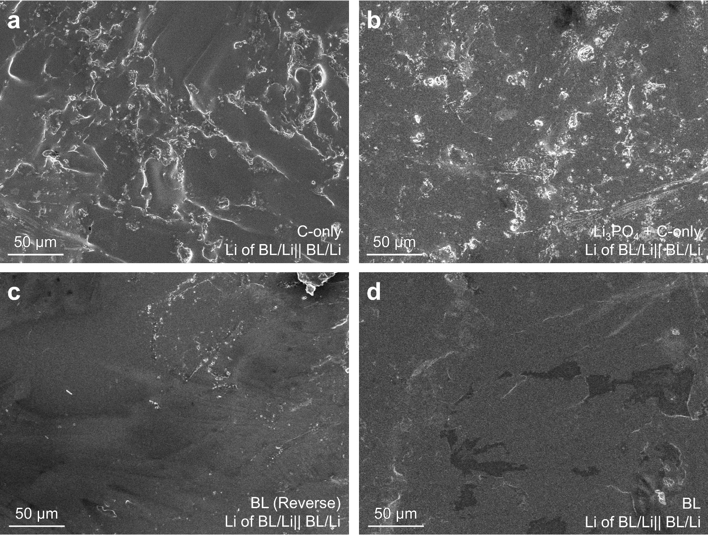
Fig. S34 SEM images for Li after symmetric Li cells of (a) C-layer only, (b) Li₃PO₄ + C-only, (c) BL (reverse), and (d) BL at 4 mA cm⁻² with a fixed capacity of 1 mAh cm⁻² for 50 cycles
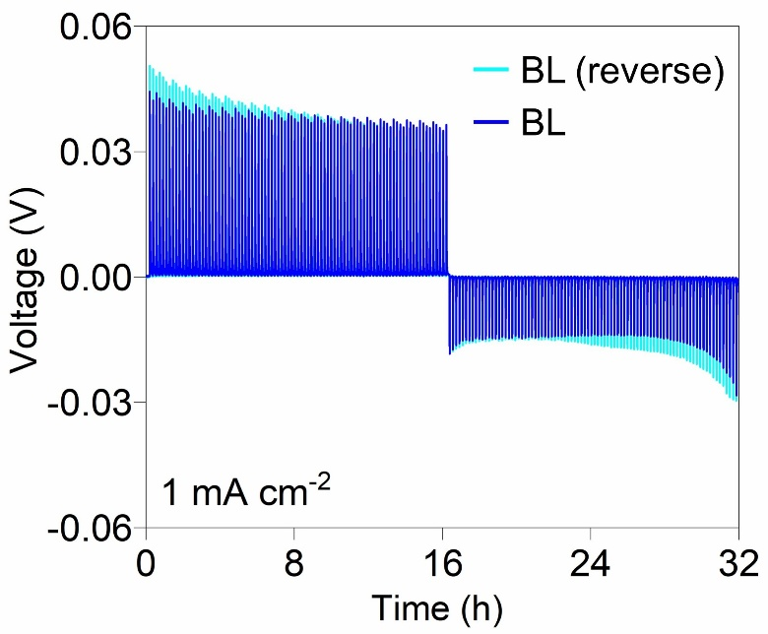
Fig. S35 GITT profiles at 1 mA cm ⁻² of BL (reverse)-Li and BL-Li cells
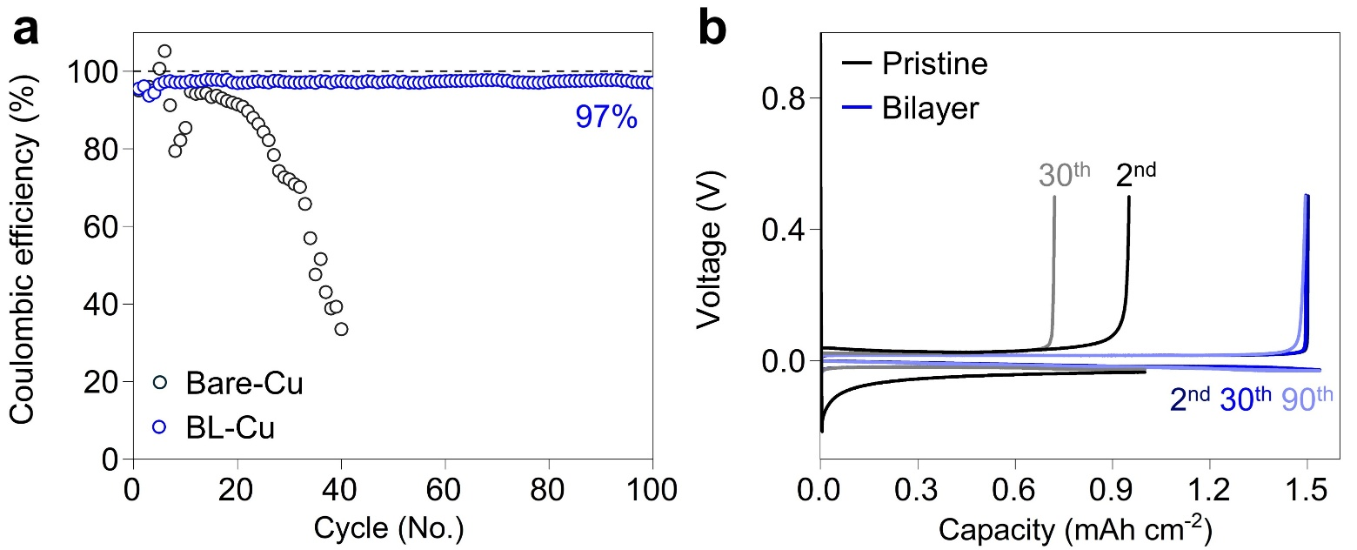
Fig. S36 Comparison of the Coulombic efficiencies of Bare-Cu||Li and BL-Cu||Li cells at 1 mA cm⁻² and 1 mAh cm⁻² (a), and corresponding voltage profiles (b)

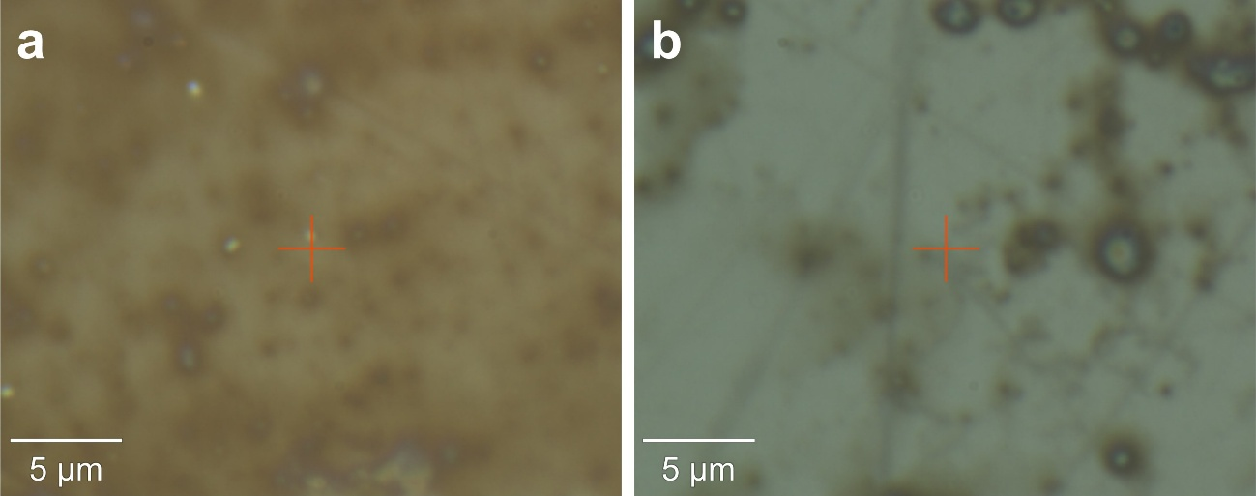
Fig. S37 Optical images during In-situ Raman spectroscopy of Bare-Li (a) and BL-Li (b)

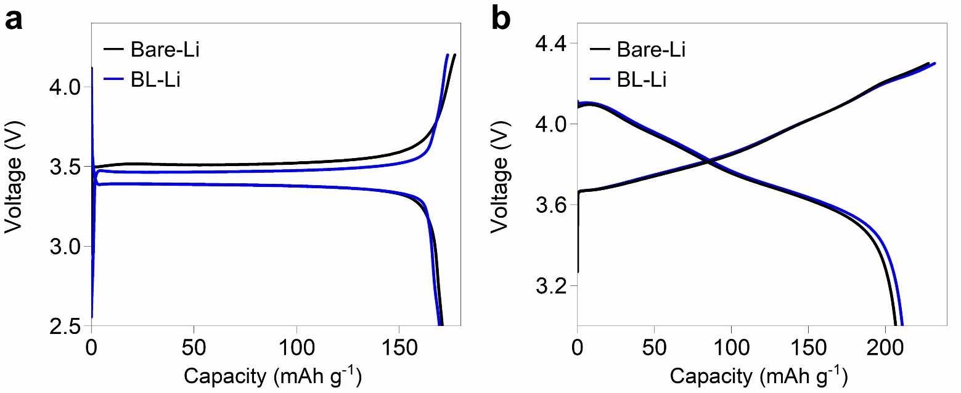
Fig. S38 Galvanostatic charge–discharge curves of Li||LFP and Li||NCM811 at 0.2C

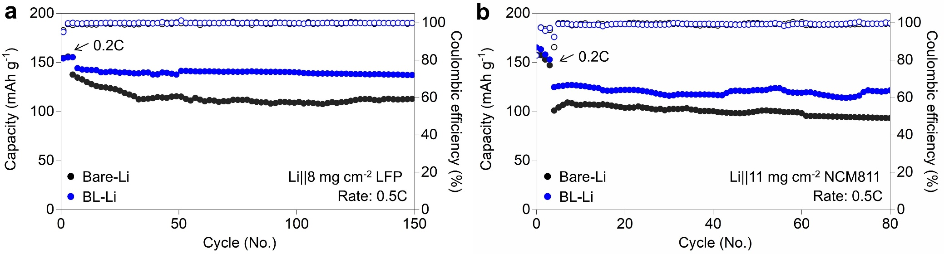
Fig. S39 Cycling performance with higher loading cathodes of LFP and NCM811

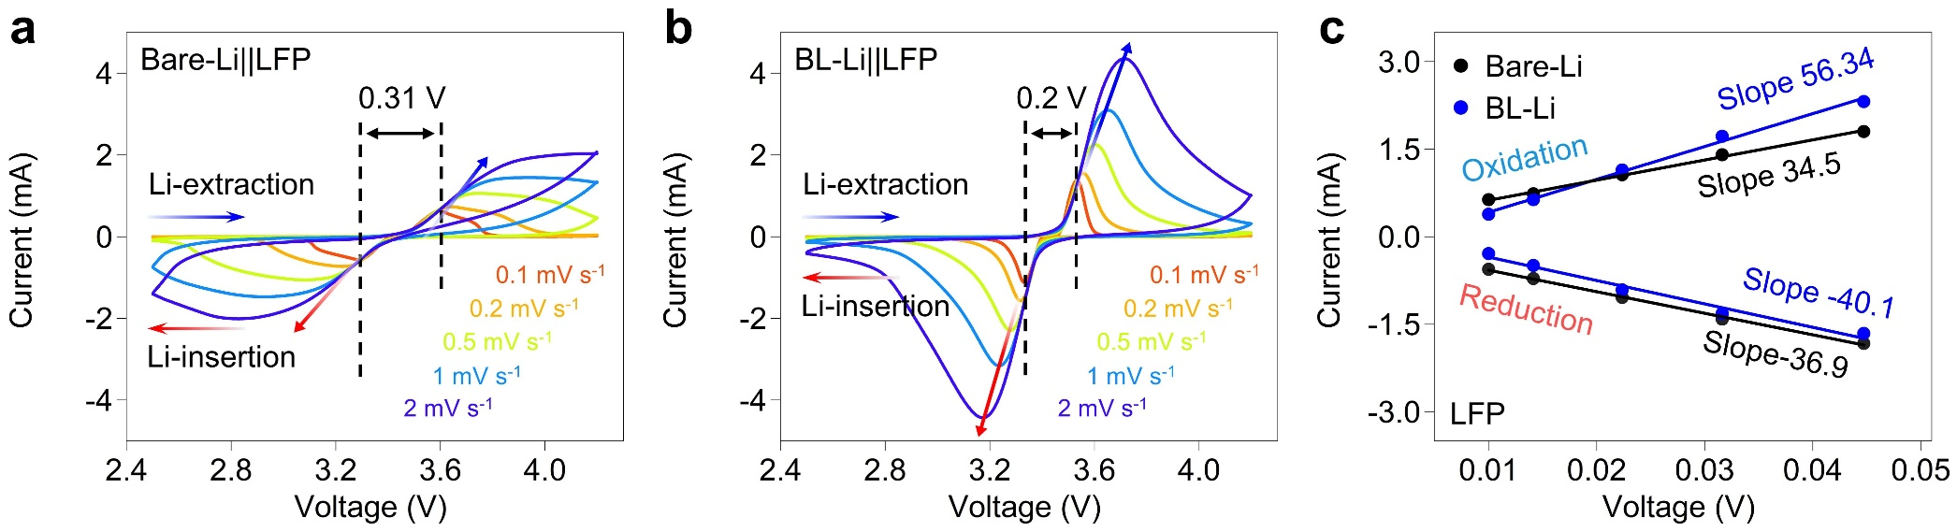
Fig. S40 CV curves of Bare-Li‖LFP cell (a) and BL-Li‖LFP cell at different scan rates from 0.1 to 2 mV s⁻¹ (b) and corresponding linear fitting results of oxidation/reduction peak currents (I_{peak}) against the square root of the scan rates (ν^{0.5}) (c)

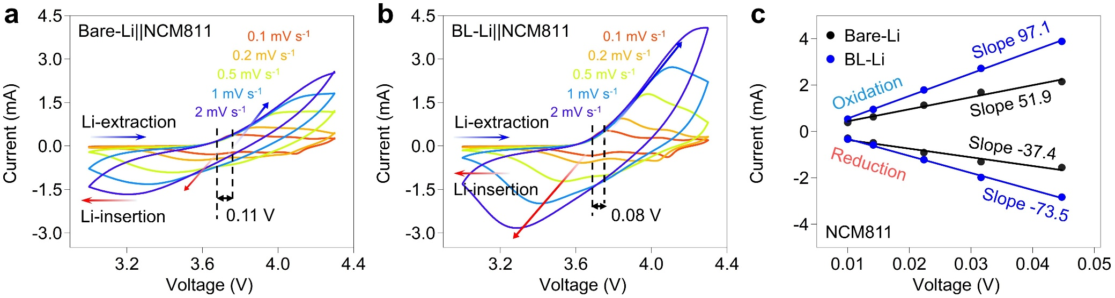
Fig. S41 CV curves of Bare-Li‖NCM811 cell (a) and BL-Li‖NCM811 cell at different scan rates from 0.1 to 1 mV s⁻¹ (b) and corresponding linear fitting results of oxidation/reduction peak currents (I_{peak}) against the square root of the scan rates (ν^{0.5}) (c)

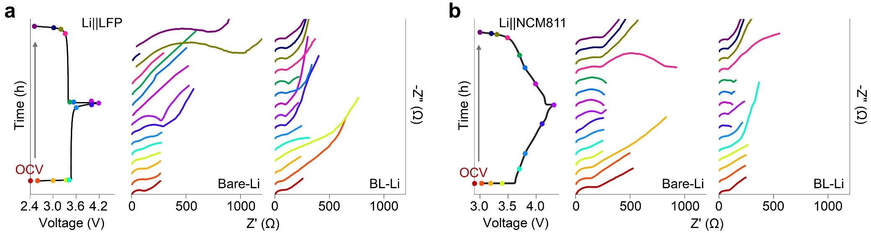
Fig. S42 In-situ EIS results with LFP (a) and NCM811 (b) cycled in Bare-Li and BL-Li anodes during discharge/charge

Table S1 Comparison of R_{ohm}, R_{sei,} R_{ct} in the LFP cells with Bare-Li and BL-Li cells at various voltage stages
 | R_{ohm} (Ω) |  | R_{sei} (Ω) |  | R_{ct} (Ω)
 | Bare-Li | BL-Li | Bare-Li | BL-Li | Bare-Li | BL-Li
1 | 4.621 | 2.589 | 70.78 | 48.63 | 45.84 | 508.7
2 | 5.216 | 3.191 | 60.72 | 38.21 | 16.06 | 145.2
3 | 4.509 | 2.865 | 75.96 | 25.08 | 125.6 | 303
4 | 4.027 | 2.287 | 106.9 | 10.43 | 81.31 | 723.1
5 | 5.642 | 2.484 | 75.87 | 24.77 | 293.1 | 310.4
6 | 1.914 | 1.785 | 56.76 | 22.15 | 443 | 166.3
7 | 4.328 | 2.457 | 68.78 | 69.06 | 233.4 | 73.93
8 | 4.772 | 2.243 | 31.57 | 18.81 | 257.5 | 73
9 | 11.52 | 2.066 | 2305 | 99.96 | 1.108 | 32.89
10 | 11.59 | 2.138 | 337.5 | 38.18 | 14.86 | 86.23
11 | 10.36 | 2.259 | 318.8 | 12.54 | 48.83 | 69.24
12 | 9.848 | 2.108 | 332.4 | 36.23 | 18.97 | 60.29
13 | 32.06 | 2.089 | 533 | 43.77 | 776.1 | 47.84
14 | 10.64 | 2.106 | 335.4 | 37.15 | 23.18 | 47.76
15 | 15.4 | 2.086 | 2156 | 35.52 | 982.7 | 44.04

Table S2 Comparison of R_{ohm}, R_{sei,} R_{ct} in the 811 cells with Bare-Li and BL-Li cells at various voltage stages
 | R_{ohm} (Ω) |  | R_{sei} (Ω) |  | R_{ct} (Ω)
 | Bare-Li | BL-Li | Bare-Li | BL-Li | Bare-Li | BL-Li
1 | 6.604 | 3.149 | 108.8 | 14.95 | 58.45 | 96.4
2 | 4.23 | 3.069 | 109.1 | 42.5 | 266 | 78
3 | 4.01 | 2.273 | 142.1 | 18.99 | 187.1 | 1.076
4 | 4.534 | 2.221 | 46.17 | 36.4 | 45.02 | 263
5 | 3.671 | 2.474 | 113.6 | 36.75 | 402 | 217.8
6 | 2.107 | 2.202 | 42.21 | 24.84 | 767.4 | 4.724
7 | 2.96 | 2.745 | 43.27 | 31.51 | 682.2 | 5.716
8 | 4.099 | 2.664 | 54.96 | 75.24 | 182.4 | 2.485
9 | 4.076 | 1.273 | 31.79 | 58.06 | 219.4 | 2.571
10 | 3.814 | 2.712 | 55.75 | 61.26 | 209.2 | 2.1468
11 | 4.037 | 3.026 | 53.48 | 36.01 | 222.6 | 350
12 | 4.153 | 2.59 | 52.55 | 72.25 | 237.5 | 242.3
13 | 4.06 | 2.738 | 58.95 | 51.71 | 243.7 | 20.73
14 | 4.619 | 2.719 | 65.44 | 51.93 | 220.7 | 22.04
15 | 4.48 | 2.712 | 61.36 | 50.16 | 241.2 | 23.67

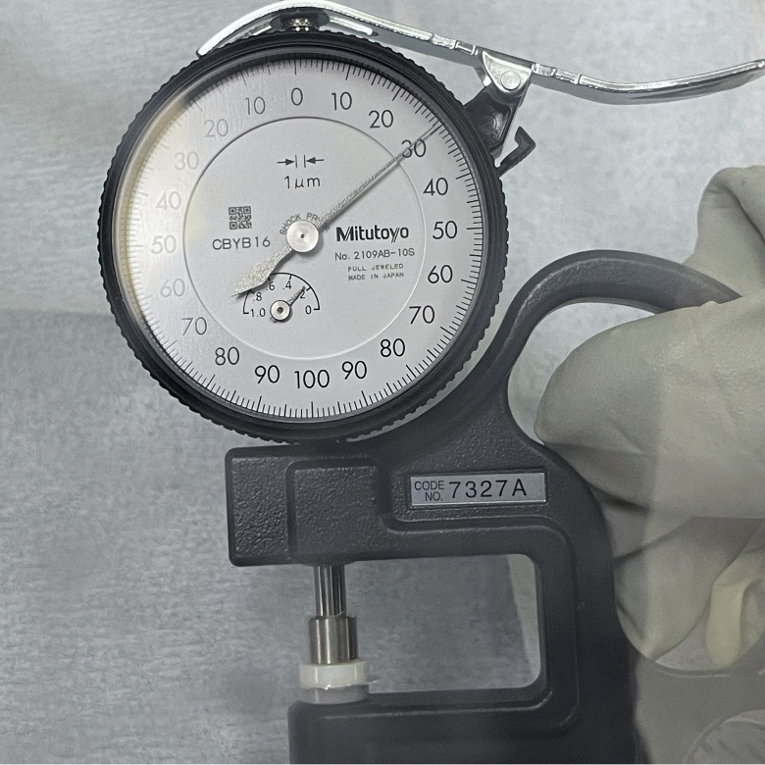
Fig. S43 Photo image of thickness 30 μm lithium metal anode

Table S3 Comparison of the electrochemical performance of modified metal lithium anodes paired with cathodes reported over the past three years in full batteries
 | Cathode | C-rate | Loading mass | Current density | Cycles | Refs.
 | Cathode | C | mg cm⁻² | mA cm⁻² | Cycles | Refs.
This work* | LiFePO₄ | 20 | 1.5 | 5.1 | 6000 | *
1 | LiFePO₄ | 1 | 1.2 | 0.204 | 400 | [S1]
2 | LiFePO₄ | 1 | 2.3 | 0.391 | 1200 | [S2]
3 | LiFePO₄ | 1 | 2.1 | 0.357 | 1500 | [S3]
4 | LiFePO₄ | 1 | 2 | 0.34 | 950 | [S4]
5 | LiFePO₄ | 1 | 4 | 0.68 | 1000 | [S5]
6 | LiFePO₄ | 1 | 11 | 1.87 | 1000 | [S6]
7 | LiFePO₄ | 1 | 2 | 0.34 | 1500 | [S7]
8 | LiFePO₄ | 1 | 3.5 | 0.595 | 600 | [S8]
This work* | LiNi_{0.8}Co_{0.1}Mn_{0.1}O₂ | 3 | 2.5 | 2.00625 | 500 | *
9 | LiNi_{0.8}Co_{0.1}Mn_{0.1}O₂ | 3 | 1.2 | 0.963 | 1500 | [S1]
10 | LiNi_{0.8}Co_{0.1}Mn_{0.1}O₂ | 1 | 1.8 | 0.4815 | 450 | [S9]
11 | LiNi_{0.8}Co_{0.1}Mn_{0.1}O₂ | 0.5 | 3.5 | 0.468125 | 150 | [S10]
Supplementary References
- F. Tao, K. Yan, C. Dong, J. Wang, Q. Pan et al., Electric-dipole coupling ion-dipole engineering induced rational solvation-desolvation behavior for constructing stable solid-state lithium metal batteries. Angew. Chem. Int. Ed. 64(21), e202503037 (2025). https://doi.org/10.1002/anie.202503037
- T. Yang, X. Xu, S. Chen, Y. Yang, F. Li et al., A lithiophilic donor–acceptor polymer modified separator for high-performance lithium metal batteries. Angew. Chem. Int. Ed. 64(9), e202420973 (2025). https://doi.org/10.1002/anie.202420973
- H. Liu, F. Zhen, X. Yin, Y. Wu, K. Yu et al., Ultra-tough dynamic supramolecular ion-conducting elastomer induced uniform Li+ transport and stabilizes interphase ensures dendrite-free lithium metal anodes. Angew. Chem. Int. Ed. 64(2), e202414599 (2025). https://doi.org/10.1002/anie.202414599
- T. Naren, G.-C. Kuang, R. Jiang, P. Qing, H. Yang et al., Reactive polymer as artificial solid electrolyte interface for stable lithium metal batteries. Angew. Chem. Int. Ed. 62(26), e202305287 (2023). https://doi.org/10.1002/anie.202305287
- Y. Zhang, Y. Guo, K. Yong, Q. Wang, M. Yao et al., A large-capacity, superhigh-rate integrated lithium metal anode with top-down composition gradient enabled by polyantimonic acid. Energy Environ. Sci. 17(16), 5819–5832 (2024). https://doi.org/10.1039/d3ee04243j
- F. Zhen, H. Liu, Y. Wu, X. Zhou, W. Li et al., The spontaneous cascade optimization strategy of the double enrichment improves anion-derived solid electrolyte interphases to enable stable lithium-metal batteries. Energy Environ. Sci. 18(10), 4690–4703 (2025). https://doi.org/10.1039/d5ee01352d
- S. Xu, T. Naren, Y. Zhao, Q. Gu, T. Wai Lau et al., Soluble covalent organic frameworks as efficient lithiophilic modulator for high-performance lithium metal batteries. Angew. Chem. Int. Ed. 64(15), e202422040 (2025). https://doi.org/10.1002/anie.202422040
- L. Kong, Y. Li, C. Peng, Z. Zhao, J. Xiao et al., Achieving burst Li⁺ channels via quasi-two-dimensional fluorinated metal-organic framework modulating functionalized interface. Nat. Commun. 16(1), 1885 (2025). https://doi.org/10.1038/s41467-025-57106-z
- S. Duan, L. Zhang, Y. Zheng, Z. Li, Z. Liu et al., “Rigid exterior, soft interior” design enables high-voltage polyether electrolytes for quasi-solid-state batteries. Angew. Chem. Int. Ed. 64(32), e202502728 (2025). https://doi.org/10.1002/anie.202502728
- L. Kong, Y. Li, C. Peng, Z. Zhao, J. Xiao et al., Achieving burst Li⁺ channels via quasi-two-dimensional fluorinated metal-organic framework modulating functionalized interface. Nat. Commun. 16(1), 1885 (2025). https://doi.org/10.1038/s41467-025-57106-z

