Supporting Information for
Confined Synthesis of Axial Chlorine Coordinated Single-Atom Nanozyme within Liposomes for Sensitive Immunoassay
Chenchen Chu^{1, 2†}, Mingyang Jiang^{1†}, Yubei Zhang^{1†}, Kun Feng^{3, 4†}, Chaolei Hua^{1, 2}, Lie Wu⁵, Yijie Chen¹, Ling Ji^{6*}, Xitong Gao⁷, Xue-Feng Yu^{1, 8}, Shengyong Geng^{1*}, and Wenhua Zhou^{1, 8*}
¹ Materials Artificial Intelligence Center, Shenzhen Institutes of Advanced Technology, Chinese Academy of Sciences, Shenzhen 518055, P. R. China
² University of Chinese Academy of Sciences, Beijing 100049, P. R. China
³ Nanjing University, Nanjing 210023, P. R. China
⁴ Shenzhen University of Advanced Technology, Shenzhen 518107, P. R. China
⁵ State Key Laboratory of Advanced Refractories, Wuhan University of Science & Technology, Wuhan 430081, P. R. China
⁶ Department of Laboratory Medicine, Peking University Shenzhen Hospital, Shenzhen 518055, P. R. China
⁷ Research Center for Cloud Computing, Shenzhen Institutes of Advanced Technology, Chinese Academy of Sciences, Shenzhen 518055, P. R. China
⁸ The Key Laboratory of Biomedical Imaging Science and System, Chinese Academy of Sciences, Shenzhen, 518055, P. R. China
† Chenchen Chu, Mingyang Jiang, Yubei Zhang, and Kun Feng contributed equally to this work.
*Corresponding authors. E-mail: jiling@pkuszh.com (Ling Ji); sy.geng@siat.ac.cn (Shengyong Geng); wh.zhou@siat.ac.cn (Wenhua Zhou)
S1 Experimental Section
Materials. 1,2-Dipalmitoyl-sn-glycero-3-phosphocholine (DPPC) and cholesterol (Chol) were sourced from Avanti Polar Lipids. DSPE-PEG₂₀₀₀-COOH was obtained from Ruixi Biological Technology Co., Ltd. (Xi’an, China). The amino-functionalized graphene quantum dots (GQDs) were acquired from XFNANO Materials Tech Co., Ltd. (Nanjing, China). The elemental composition (by mass) of the GQDs is as follows: C: 46.96%, H: 7.17%, N: 18.86%, and O: 27.01%. Acetic acid, trichloromethane, chloroplatinic acid hexahydrate, TMB, N-hydroxysuccinimide (NHS), and N-(3-Dimethylaminopropyl)-N’-eth-ylcarbodiimide hydrochloride (EDC) were purchased from Aladdin Industrial Corporation (Shanghai, China). Carboxyl-modified magnetic beads (MB) were obtained from Ademtech SA (Pessac, France). Sodium acetate trihydrate, o-phenylenediamine (OPD) and 3,3’-Diaminobenzidine (DAB) were purchased from Sinopharm Chemical Reagent Co., Ltd. (Shanghai, China). Mouse monoclonal anti-H1N1 antibodies (catalog no. FLUA-REAB-G1-011 and FLUA-REAB-G1-020), FluB antigen (catalog no. FLUB-SCAG2-001), FluB antibodies (catalog no. FLUB-REAB-G2-011, FLUB-REAB-G2-026), SARS-CoV-2 antigen and antibodies (catalog no. COV19-PSMAb15, COV19-PSMAb19 and ncov-PS-Ag6) were provided by Fapon Biotech Inc. (Shanghai, China). The Infuenza Virus A Rapid Test Kit (Colloidal Gold Immunoassay) was obtained from Zhongshan Bio-Tech Co., LTD. (China). The Nucleic acid extraction and purification reagent and Influenza A Virus Nucleic Acid Detection Kit (Fluorescent PCR) were supplied by Shengxiang Biotechnology Co. Ltd. (China). General reagents, solvents, and laboratory supplies were obtained from Thermo Fisher Scientific or Aladdin Industrial Corporation.
Synthesis of PtSANs@Lipo. DPPC, Chol, and DSPE-PEG₂₀₀₀-COOH were dissolved in 15 mL of chloroform at a molar ratio of 65:31:4. A lipid film was formed on the inner wall of a pear-shaped flask through evaporation at 37 °C under reduced pressure using a rotary evaporator. The lipid film was then rehydrated with 5 mL of H₂PtCl₆ (1 mg/mL) solution containing GQDs at a molar ratio of 3:1, forming a turbid suspension. This suspension was sonicated for 10 minutes to achieve a uniform liposome size distribution. Finally, the H₂PtCl₆-GQDs@liposome solution was stabilized by incubation in a water bath at 55 ºC for 30 minutes.
To prepare PtSANs@Lipo, 5 mL of H₂PtCl₆-GQDs@liposome solution was rapidly frozen at -80 ºC in an ultra-low temperature freezer. Subsequently, the frozen H₂PtCl₆-GQDs@liposome sample was transferred to -20 ºC fridge and immediately irradiated using a UV lamp for 10 min. The power density of the UV light near the ice was measured to be 2 mW/cm² using a radiometer (PL-MW 2000). Following UV irradiation, the frozen sample was allowed to thaw at room temperature. All procedures were conducted in darkness except during UV irradiation. After centrifugation, the collected solution contained the prepared PtSANs@Lipo. The preparation of GQDs-PtSANs followed a similar protocol: H₂PtCl₆ (1 mg/mL) and GQDs solution (in a molar ratio of 3:1) were mixed, the mixture was then subjected to the same freezing and UV irradiation conditions as described for PtSANs@Lipo.
Characterizations. TEM was conducted using a JEM-3200FS microscope (JEOL, Japan) operating at 200 kV. HAADF-STEM images and elemental mapping were acquired using a Titan Themis G2 (FEI, USA). ICP-OES analysis was performed on a PerkinElmer Optima 8300 (PerkinElmer, USA). XPS measurements were carried out on a Thermo Scientific K-Alpha. XRD patterns were collected using a Rigaku SmartLab SE diffractometer (Rigaku, Japan). Particle size distribution data were obtained using a Zetasizer 3000 HAS (Malvern Ltd., UK). UV-Vis absorbance spectra were recorded on a Thermo Fisher A51119600C spectrophotometer. ESR spectra were acquired using an EMXPlus-6/1 spectrometer (Bruker, Germany) at room temperature.
XAFS experiment and data processing. X-ray absorption spectroscopy (XAS) measurements were carried out at the XAS Beamline of the Australian Synchrotron in Melbourne. With the aid of beamline optics, including a Si-coated collimating mirror and an Rh-coated focusing mirror, the harmonic content of the incident X-ray beam was minimized to negligible levels. Data collection was performed in transmission mode, with energy calibration achieved using a Pt foil. Data reduction, analysis, and EXAFS fitting were carried out using the Athena and Artemis programs from the Demeter data analysis packages, which employs the FEFF6 program for EXAFS data fitting. Energy calibration of the sample was conducted using standard and Pt foil as a reference, measured simultaneously. A linear function was subtracted from the pre-edge region, and the edge jump was normalized using Athena software. The χ(k) data were isolated by subtracting a smooth third-order polynomial approximating the absorption background of an isolated atom. The k³-weighted χ(k) data were Fourier transformed after applying a HanFeng window function (Δk = 1.0). For EXAFS modeling, global amplitude EXAFS (CN, R, σ² and ΔE₀) were obtained through nonlinear least-squares refinement of the EXAFS equation to the Fourier-transformed data in R-space using Artemis software. The EXAFS of the Pt foil was fitted, and the resulting amplitude reduction factor S₀² value (0.932) was used in the EXAFS analysis to determine the coordination numbers in sample.
OXD-like activity test. The kinetic interaction between PtSANs@Lipo and TMB substrate was evaluated using a UV-Vis spectrophotometer in kinetic mode to record the time-dependent increase in absorbance at 652 nm (A652). In a typical assay, varying concentrations of TMB (0-800 µM, dissolved in DMSO) were added to a sodium acetate buffer (pH = 4) to maintain a total reaction volume of 200 µL. The initial rate of absorbance increase at A652 was immediately recorded. The V_{m} and K_{m} were determined by plotting the initial rates against substrate concentrations using Microsoft Excel. The curves were fitted to the Michaelis–Menten equation using Origin software. The EPR spectra were acquired using a Bruker A300 spectrometer. The EPR signal was recorded immediately after adding FeSO₄ (2 mM), DMPO (0.1 M), and PtSANs@Lipo (1 mg/mL) or equal doses of PtSANs@Lipo (1 mg/mL) to an HAc/NaAc buffer (pH 4.5).
Theoretical calculation. All the calculations were conducted within the framework of DFT using the projector augmented plane-wave (PAW) method as implemented in the Vienna Ab initio Simulation Package (VASP). The exchange-correlation potential was described using the generalized gradient approximation (GGA) proposed by Perdew, Burke, and Ernzerhof. Long-range van der Waals interaction were accounted by the DFT-D3 approach. A plane-wave cutoff energy of 500 eV was employed, and the energy convergence criterion for solving the Kohn-Sham equations was set to 10⁻⁶ eV. To prevent artificial interactions between periodic images, a vacuum layer of 15 Å was introduced perpendicular to the sheet. The K-point mesh was determined based on a real-space resolution of 0.04 2π/Å. Structural relaxations were performed until the residual forces on the atoms were reduced to below 0.03 eV/Å.
Functionalization of MBs and PtSANs@Lipo. To prepare functionalized MBs and PtSANs@Lipo conjugates, 400 μL of PBS (0.01 M, pH 5.0) containing 50 mM EDC and NHS was incubated at 37 ºC for 30 min. For the preparation of antibody-conjugated MBs, 30 μL of MBs (10 mg/mL) was added to the solution, followed by shaking at 37 ºC for 30 min. The MBs were then magnetically separated and washed with PBS (pH = 7.2). Subsequently, 10 μL of Ab1 (7.24 mg/mL) was added and incubated at 37 ºC for 4 h. Unreacted sites were blocked with 1% BSA, after which the MBs were resuspended in PBS for storage at 4 ºC. For the preparation of PtSANs@Lipo conjugates, 1 mL of activated PtSANs@Lipo was reacted with 30 μL of Ab2 (5.75 mg/mL) at 37 ºC for 4 h. The final product was purified by centrifugation and stored at 4 ºC.
Construction of PtSANs@Lipo immunosensor. The H1N1 antigen solutions, with concentrations ranging from 10⁻¹² to 10⁻² mg/mL, were incubated with 20 μL of MB-Ab1 at 37 ºC and 270 rpm for 5 minutes. Following magnetic separation and washing, PtSANs@Lipo-Ab2 was added, and the system was incubated under the same conditions for another 5 minutes. After enrichment and washing, 100 μL of 1 mg/mL TMB and 100 μL of acetate buffer (pH = 4) were introduced, and absorbance changes at 652 nm were recorded. The system was also tested across a range H1N1 antigen concentrations from10⁻⁸ to 10⁻³ mg/mL, and the results were compared to those obtained using commercial test strips as well as GQDs-PtSANs-Ab2 system (without liposome). Color changes and absorbance variations at 652 nm were observed and analyzed. To evaluate the accuracy, 30 clinical nasopharyngeal swabs were tested with both RT-PCR and PtSANs@Lipo immunosensor. For RT-qPCR, the H1N1 standard dilutions were utilized, with nucleic acids extracted by the Daan Gene Stream SP96 kit and analyzed using the SLAN®-96P automated PCR system. For the PtSANs@Lipo method, H1N1 antigen dilutions without guanidine salts were employed. The detection sensitivity and accuracy were assessed by comparing the results to those obtained from RT-qPCR, with the performance evaluated using the ROC curve.
ResNet-50 deep learning target detection platform. The H1N1 of known concentration (0, 10⁻¹² - 10⁻² mg/ml) are detected by our biosensor. The images of signal generators after detection are recorded along with the correspondence between the RGB information of and H1N1 concentration. The dataset plays a crucial role in the model training process, and the performance of model detection largely depends on the quantity and quality of the dataset. In this study, we prepared a total of 179 images for the database construction.
All the images are comprehensive enough for being closer to the real application scenario, and for the better the performance of the trained model in practice. Then, all these images are divided into 5 major categories: Negative, 0.5 fg/mL-5 pg/mL, 5 pg/mL-5 ng/mL, 5 ng/mL-5 μg/mL, and > 5 μg/mL.
Model training. We divide the well-prepared dataset into a training set and a test set. The test set comprises 35 samples, which are used to test the final performance of the model. The training set, consisting of 144 samples, is randomly split into a new training subset and a validation subset. The new training subset is utilized for model training, while the validation subset serves to evaluate the model performance after each round of training, with the aim of saving the optimal model parameters. We select the ResNet-50 pre-trained on the ImageNet dataset as the initial model. To adapt it to the task of pathogen concentration detection, we adjust the model by modifying the final fully connected layer to have five outputs.
During the data reading stage of the model, we perform data augmentation on the images in the dataset, including common image processing techniques such as resampling to 64×64 pixels, random horizontal flipping, random vertical flipping, color transformation, and random cropping. In the process of model training, we use the Cross Entropy Loss as the loss function to optimize the model parameters and adopt Adam as the optimizer. Meanwhile, we set the learning rate to 0.001 and the batch size to 32. We conduct experiments on one NVIDIA Tesla V100 GPU, with the number of training epochs being 50. For the multi-classification problem, the cross-entropy loss is defined as:
$$Loss=-\frac{1}{N}\sum_{i=1}^{N}{\sum_{j=1}^{C}{y_{ij}log{\hat{y}}_{ij}}}$$
$N$ denotes the total number of samples, $C$ the total number of classes. $y_{ij}$ stands for a one-hot encoding of the true label of sample$i$(being 1 for the correct class and 0 for others), and ${\hat{y}}_{ij}$ is the prediction probability of category $j$ for category $i$.
S2 Supplementary Figures
Fig. S1 The Pt loading capacity in PtSANs@Lipo prepared at different H₂PtCl₆/GQDs molar ratios
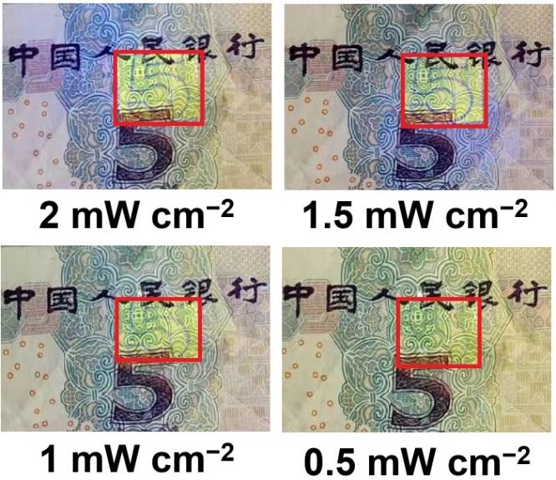
Fig. S2 UV light transmittance measurements through H₂PtCl₆-liposome ice samples with a depth of 0.5 cm. The anti-counterfeiting mark outlined in the red box demonstrates the penetration capability of ultraviolet light.

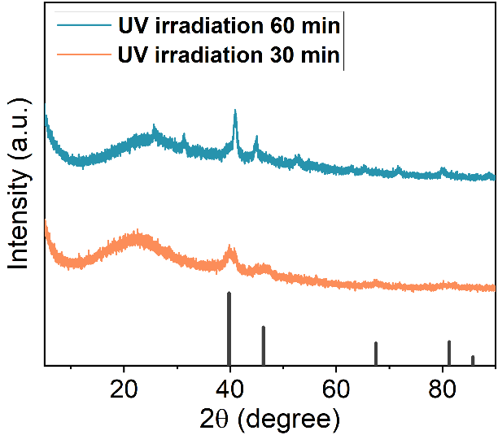
Fig. S3 XRD spectra of PtSANs@Lipo prepared under varying UV exposure times

Fig. S4 Particle sizes of PtSANs@Lipo measured by DLS

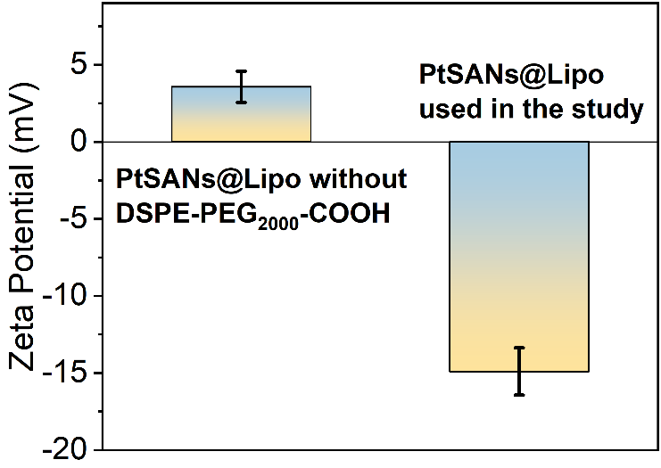
Fig. S5 Zeta potential of PtSANs@Lipo without and with DSPE-PEG₂₀₀₀-COOH modification

Fig. S6 Pt loading capacity measured by ICP

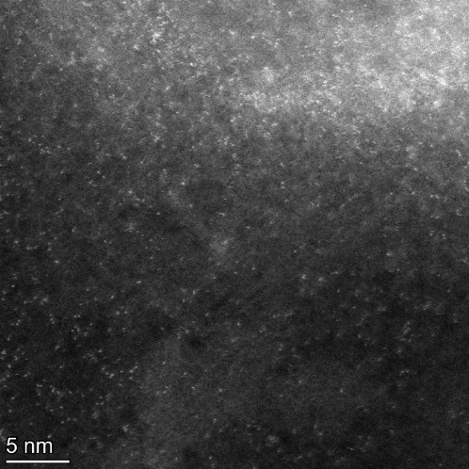
Fig. S7 The HAADF-STEM of GQDs-PtSANs-Lipo

Fig. S8 Size changes of PtSANs@Lipo in PBS (pH 7.4) at 4 ºC
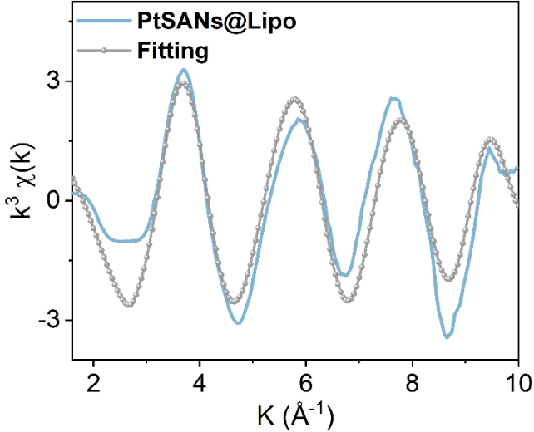
Fig. S9 The EXAFS fitting results of PtSANs@Lipo in K-space

Fig. S10 Comparison of the catalytic activity of PtSANs@Lipo toward TMB under air, N₂, or Ar saturated conditions

Fig. S11 ESR spectra of DMPO-OH adducts in the reaction system under air-saturated and N₂-saturated conditions
Fig. S12 Catalytic stability of PtSANs@Lipo

Fig. S13 Optimal catalytic conditions of PtSANs@Lipo. (a) Optimal temperature verification and (b) Optimal pH value determination

Fig. S14 Comparison of Michaelis-Menten kinetic parameters of PtSANs@Lipo prepared at different H₂PtCl₆/GQDs ratios
Fig. S15 The POD-like activity of PtSANs@Lipo. (a) The plots of initial rate versus H₂O₂ concentrations with the Michaelis-Menten kinetics fitting and (b) the Lineweaver-Burk plots

Fig. S16 Catalytic efficiency of bare GQDs-PtSANs and PtSANs@Lipo at the same concentration against TMB in PBS buffer containing varying serum concentrations

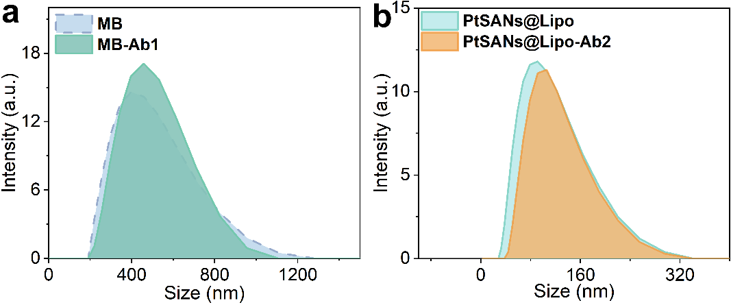
Fig. S17 The hydrodynamic sizes of (a) MB and (b) PtSANs@Lipo before and after antibody conjugation
Fig. S18 The TEM image of PtSANs@Lipo after treatment with 0.5% Triton X-100, clearly showing the disruption of the liposomal structure and the release of GQDs-PtSANs
Fig. S19 Effect of 0.5% Triton X-100 on the oxidation of TMB by PtSANs@Lipo
Fig. S20 Relative cell viability of MCF-7 cells after treatment with different concentrations of PtSANs@Lipo
Fig. S21 HAADF-STEM image of PtSANs@Lipo after incubation in 10% serum for 6 h
Fig. S22 Pt loading capacity of PtSANs@Lipo after incubation in 10% serum for 6 h
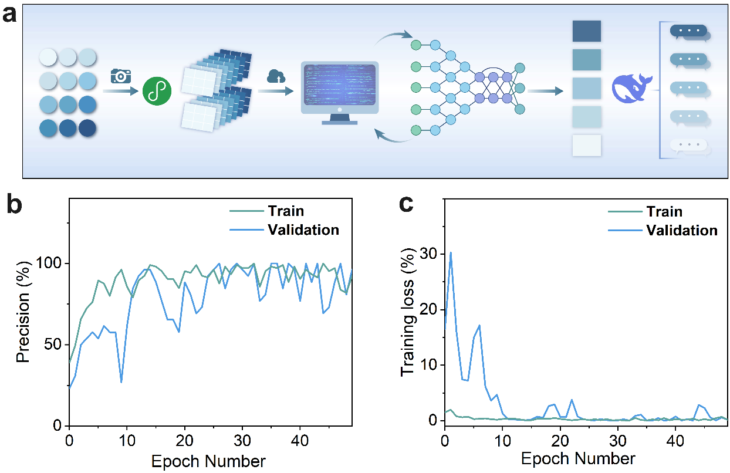
Fig. S23 Machine learning in colorimetric assay of Flu A/H1N1 antigen using PtSANs@Lipo immunosensor. (a) ResNet50 algorithm flowchart. (b) The precision of ResNet50. (c) The training loss of ResNet50. For training, we use a dataset of 144 pathogen color reaction images, with an additional 35 images reserved as the testing set. The training set is further split into training and validation subsets. All images undergo preprocessing, which involves resizing them to 64 × 64 pixels. The model is trained for 50 epochs using a batch size of 32 and a learning rate of 0.001, and finally achieves 100% accuracy on the validation set after 50 epochs, with the training loss converging to nearly zero.
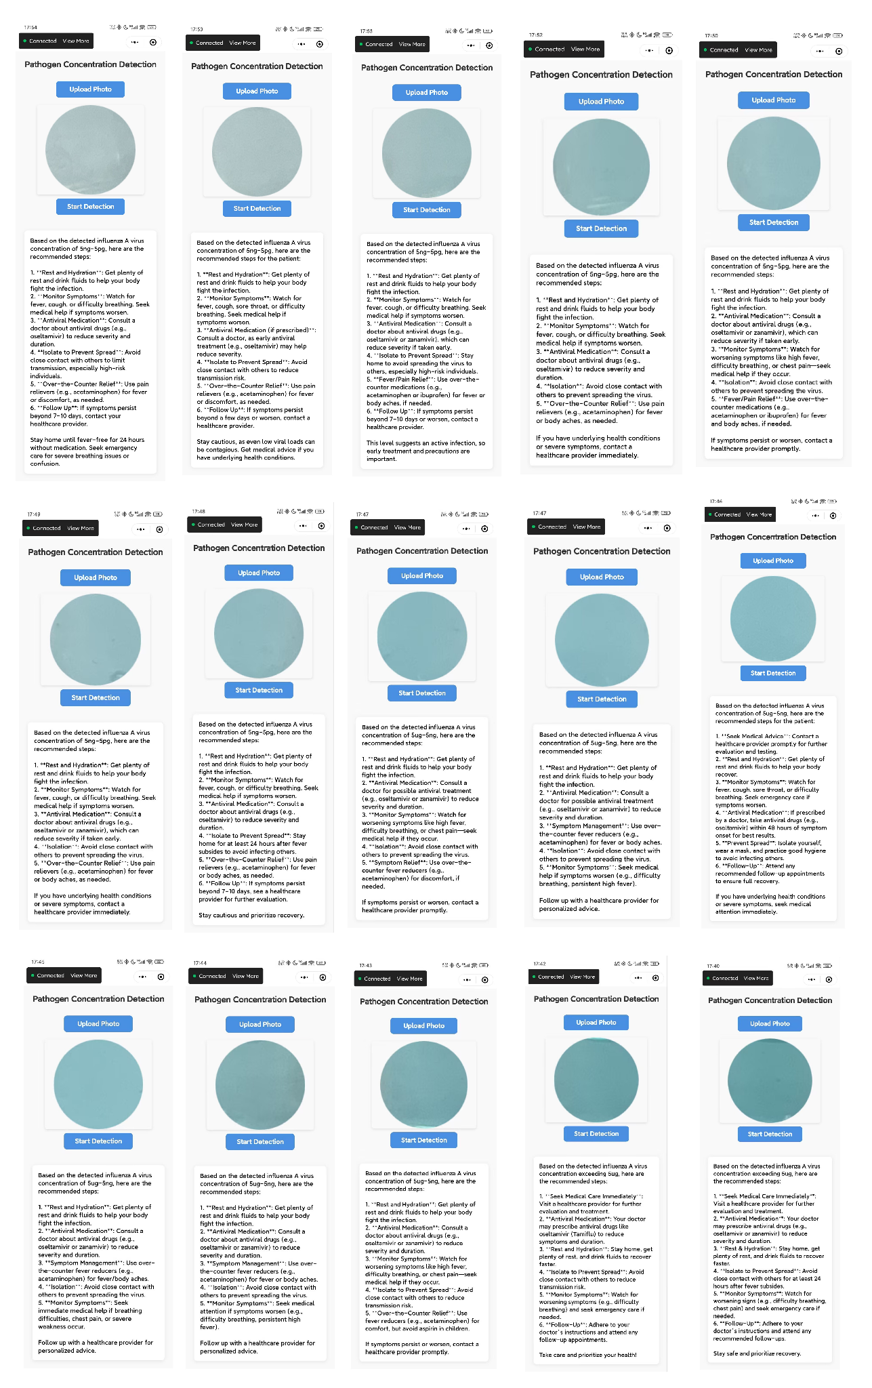
Fig. S24 The analysis results of 15 positive clinical Flu A/H1N1 samples based on the WeChat mini-program
S3 Supplementary Tables
Table S1 Pt K-edge EXAFS curve Fitting Parametersª
Sample | Shell | N | R (Å) | σ² (Å²) | ΔE₀ (eV) | R (%)
Pt foil^{b} | Pt-Pt | 9 | 2.76±0.002 | 0.004±0.0009 | 7.4±0.06 | 0.13
PtO₂^{c} | Pt-O | 4 | 1.99±0.007 | 0.002±0.0007 | 10.1±0.01 | 1.90
PtSANs@Lipo^{d} | Pt-N | 3 | 1.99±0.009 | 0.007±0.0002 | 9.1±0.06 | 0.024
PtSANs@Lipo^{d} | Pt-Cl | 2 | 2.54±0.005 | 0.025±0.0007 | 9.1±0.06 | 0.024
ªN, coordination number; R, distance between absorber and backscatter atoms; σ², Debye-Waller factor to account for both thermal and structural disorders; ΔE₀, inner potential correction; R factor (%) indicates the goodness of the fit. ^{b}Fitting range: 3.0 ≤ k (/Å) ≤ 10.9 and 1 ≤ R (Å) ≤ 3. ^{c}Fitting range: 3.0 ≤ k (/Å) ≤ 14.1 and 1.3 ≤ R (Å) ≤ 2.5. ^{d}Fitting range: 3.0 ≤ k (/Å) ≤ 10.9 and 1 ≤ R (Å) ≤ 3.
Table S2 Comparison of OXD-like activity of PtSANs@Lipo with references
Nanozymes | Substrate | K_{m}  (mM) | V_{max}  (10⁻⁸ M s⁻¹) | K_{cat} (s⁻¹) | K_{cat}/K_{m}  (mM⁻¹ s⁻¹) | Refs.
Au-PtNCs NPs | TMB | 0.36 | 11.36 | --- | --- | [1]
Fe-Pt alloy NPs | TMB | 0.03 | 1.42 | --- | --- | [2]
BSA/Pt-NPs | TMB | 0.217 | 0.154 | --- | --- | [3]
MoS₂-PtAg NPs | TMB | 25.71 | 7.29 | --- | --- | [4]
Fe SAC | TMB | 0.347 | 8.89 | --- | --- | [5]
FeZn SAC | TMB | 0.293 | 10.4 | --- | --- | [5]
FeCoZn SAC | TMB | 0.459 | 22.3 | --- | --- | [5]
PEGylated-Mn SAC | TMB | 0.11 | 42 | --- | --- | [6]
Fe-N₅ SAC | TMB | 0.116 | 11.5 | 0.398 | 3.43 | [7]
Commercial Pt/C | TMB | 0.82 | 10.6 | 0.0007 | 0.0009 | [7]
FeN₅ SAC | TMB | 0.148 | 75.8 | 0.7084 | 4.784 | [8]
Cu₃-C SAC | TMB | 2.89 | 11.5 | 1.474 | 0.510 | [9]
Co-GQD SAC | TMB | 0.66 | 38 | --- | --- | [10]
Fe-N/C SAC | TMB | 0.94 | 59.8 | --- | --- | [11]
Fe SAC | TMB | 0.13 | 22.5 | --- | --- | [12]
Fe-CNG SAC | TMB | 0.324 | 0.207 | --- | --- | [13]
Fe-N-C SAC | TMB | 1.81 | 0.601 | --- | --- | [14]
FeBi-NC SAC | TMB | 0.21 | 0.07 | --- | --- | [15]
Ni-N/C SAC | TMB | 0.284 | 2.45 | 0.056 | 0.197 | [15]
Co-N/C SAC | TMB | 1.17 | 20.8 | 0.307 | 0.262 | [15]
PtSANs@Lipo | TMB | 0.022 | 10.0 | 20.0 | 909 | This work

Table S3 Comparison of sensitivity, linear range, and LOD for detection of respiratory viruses
Method | Virus | Sensitivity | Linear range | LOD | Ref.
Plasma-engineered SERS sensors | SARS-CoV-2 | 0.1 pg/mL | 0.1 pg/mL-  1.0 mg/mL | 0.1 pg/ mL | [16]
LFIA | SARS-CoV-2 | 150 ng/mL | 150-550 ng/mL | 150 ng/mL | [17]
FET-Based biosensor | SARS-CoV-2 | --- | --- | 1 fg/mL | [18]
MIP sensor | SARS-CoV-2 | 2.22 fM | 2.22-111 fM | 15 fM  (~0.69 pg/mL) | [19]
Opto-microfluidic chip | SARS-CoV-2 | --- | --- | 0.08 ng/mL | [20]
All-in-one point-of-care testing device | SARS-CoV-2 | 100 ng/mL | 100-6500 ng/mL | 18 ng/mL | [21]
All-in-one point-of-care testing device | Influenza A | 125 ng/mL | 125-6500 ng/mL | 16 ng/mL | [21]
All-in-one point-of-care testing device | Influenza B | 850 ng/mL | 850-10,000 ng/mL | 635 ng/mL | [21]
All-in-one point-of-care testing device | Adenovirus | 125 ng/mL | 125-6500 ng/mL | 33 ng/mL | [21]
All-in-one point-of-care testing device | RSV | 220 ng/mL | 220-8000 ng/mL | 41 ng/mL | [21]
Dual-drive microfluidic device | RSV | --- | --- | 1.121 ng/mL | [22]
Dual-drive microfluidic device | SARS-CoV-2 | --- | --- | 0.447 ng/mL | [22]
AuNPs-based immunoassay | RSV | 0.05 pg/mL | 0.05-30 pg/mL | 10 fg/mL | [23]
CTAB-caped AuNPs | RSV | 0.1 pg/mL | 0.1-30 pg/mL | 21 fg/mL | [24]
GOx/Mo₂Ti₂C₃T_{x} MXene/SPCEs immunosensor | RSV | 0.01 pg/mL | 0.01 pg/mL-  10 μg/mL | 15 fg/mL | [25]
Fe₃O₄-Au@Pt-based LFA | H1N1 | 0.05 nM | 0.05-10 nM | 50 pM  (~0.73 ng/mL) | [26]
PtSANs@Lipo immunosensor | HIN1  SARS-CoV-2  Influenza B | 1 fg/mL  5 fg/mL  0.5 fg/mL | 10⁻¹²-10⁻² mg/mL  5×10⁻¹²-5×10⁻³ mg/mL  5×10⁻¹³-5×10⁻³ mg/mL | 0.42 fg/mL  2.23 fg/mL  0.36 fg/mL | This work
Supplementary References
- J. Feng, P. Huang, F.-Y. Wu, Gold–platinum bimetallic nanoclusters with enhanced peroxidase-like activity and their integrated agarose hydrogel-based sensing platform for the colorimetric analysis of glucose levels in serum. Analyst 142(21), 4106–4115 (2017). https://doi.org/10.1039/C7AN01343D
- K. Shah, S. Bhagat, D. Varade, S. Singh, Novel synthesis of polyoxyethylene cholesteryl ether coated Fe-Pt nanoalloys: a multifunctional and cytocompatible bimetallic alloy exhibiting intrinsic chemical catalysis and biological enzyme-like activities. Colloids Surf. A Physicochem. Eng. Aspects 553, 50–57 (2018). https://doi.org/10.1016/j.colsurfa.2018.05.034
- L. Chen, N. Wang, X. Wang, S. Ai, Protein-directed in situ synthesis of platinum nanoparticles with superior peroxidase-like activity, and their use for photometric determination of hydrogen peroxide. Microchim. Acta 180(15), 1517–1522 (2013). https://doi.org/10.1007/s00604-013-1068-6
- S. Cai, Q. Han, C. Qi, Z. Lian, X. Jia et al., Pt₇₄Ag26 nanoparticle-decorated ultrathin MoS₂ nanosheets as novel peroxidase mimics for highly selective colorimetric detection of H₂O₂ and glucose. Nanoscale 8(6), 3685–3693 (2016). https://doi.org/10.1039/C5NR08038J
- R. Wu, M. Sun, X. Liu, F. Qin, X. Zhang et al., Oxidase-like ZnCoFe three-atom nanozyme as a colorimetric platform for ascorbic acid sensing. Anal. Chem. 94(41), 14308–14316 (2022). https://doi.org/10.1021/acs.analchem.2c02853
- Y. Zhu, W. Wang, J. Cheng, Y. Qu, Y. Dai et al., Stimuli-responsive manganese single-atom nanozyme for tumor therapy via integrated cascade reactions. Angew. Chem. Int. Ed. 60(17), 9480–9488 (2021). https://doi.org/10.1002/anie.202017152
- T. Chen, D. Zhou, S. Hou, Y. Li, Y. Liu et al., Designing hierarchically porous single atoms of Fe-N5 catalytic sites with high oxidase-like activity for sensitive detection of organophosphorus pesticides. Anal. Chem. 94(44), 15270–15279 (2022). https://doi.org/10.1021/acs.analchem.2c02540
- L. Huang, J. Chen, L. Gan, J. Wang, S. Dong, Single-atom nanozymes. Sci. Adv. 5(5), eaav5490 (2019). https://doi.org/10.1126/sciadv.aav5490
- F. Meng, M. Peng, Y. Chen, X. Cai, F. Huang et al., Defect-rich graphene stabilized atomically dispersed Cu3 clusters with enhanced oxidase-like activity for antibacterial applications. Appl. Catal. B Environ. 301, 120826 (2022). https://doi.org/10.1016/j.apcatb.2021.120826
- N. Li, R. Li, Q. Wang, Y. Yang, X. Sun et al., Colorimetric detection of chlorpyrifos in peach based on cobalt-graphene nanohybrid with excellent oxidase-like activity and reusability. J. Hazard. Mater. 415, 125752 (2021). https://doi.org/10.1016/j.jhazmat.2021.125752
- Q. Chen, S. Li, Y. Liu, X. Zhang, Y. Tang et al., Size-controllable Fe-N/C single-atom nanozyme with exceptional oxidase-like activity for sensitive detection of alkaline phosphatase. Sens. Actuat. B Chem. 305, 127511 (2020). https://doi.org/10.1016/j.snb.2019.127511
- C. Zhao, C. Xiong, X. Liu, M. Qiao, Z. Li et al., Unraveling the enzyme-like activity of heterogeneous single atom catalyst. Chem. Commun. 55(16), 2285–2288 (2019). https://doi.org/10.1039/c9cc00199a
- S. Chu, M. Xia, P. Xu, D. Lin, Y. Jiang et al., Single-atom Fe nanozymes with excellent oxidase-like and laccase-like activity for colorimetric detection of ascorbic acid and hydroquinone. Anal. Bioanal. Chem. 416(27), 6067–6077 (2024). https://doi.org/10.1007/s00216-023-05077-9
- Y. Gu, Z. Cao, M. Zhao, Y. Xu, N. Lu, Single-atom Fe nanozyme with enhanced oxidase-like activity for the colorimetric detection of ascorbic acid and glutathione. Biosensors 13(4), 487 (2023). https://doi.org/10.3390/bios13040487
- Q. Chen, Y. Liu, Y. Lu, Y. Hou, X. Zhang et al., Atomically dispersed Fe/Bi dual active sites single-atom nanozymes for cascade catalysis and peroxymonosulfate activation to degrade dyes. J. Hazard. Mater. 422, 126929 (2022). https://doi.org/10.1016/j.jhazmat.2021.126929
- Y.-J. Yeh, T.-N. Le, W.W. Hsiao, K.-L. Tung, K. Ostrikov et al., Plasmonic nanostructure-enhanced Raman scattering for detection of SARS-CoV-2 nucleocapsid protein and spike protein variants. Anal. Chim. Acta 1239, 340651 (2023). https://doi.org/10.1016/j.aca.2022.340651
- K. Behrouzi, L. Lin, Gold nanoparticle based plasmonic sensing for the detection of SARS-CoV-2 nucleocapsid proteins. Biosens. Bioelectron. 195, 113669 (2022). https://doi.org/10.1016/j.bios.2021.113669
- G. Seo, G. Lee, M.J. Kim, S.-H. Baek, M. Choi et al., Rapid detection of COVID-19 causative virus (SARS-CoV-2) in human nasopharyngeal swab specimens using field-effect transistor-based biosensor. ACS Nano 14(4), 5135–5142 (2020). https://doi.org/10.1021/acsnano.0c02823
- A. Raziq, A. Kidakova, R. Boroznjak, J. Reut, A. Öpik et al., Development of a portable MIP-based electrochemical sensor for detection of SARS-CoV-2 antigen. Biosens. Bioelectron. 178, 113029 (2021). https://doi.org/10.1016/j.bios.2021.113029
- R. Funari, K.-Y. Chu, A.Q. Shen, Detection of antibodies against SARS-CoV-2 spike protein by gold nanospikes in an opto-microfluidic chip. Biosens. Bioelectron. 169, 112578 (2020). https://doi.org/10.1016/j.bios.2020.112578
- W. Teixeira, Y. Pallás-Tamarit, A. Juste-Dolz, A. Sena-Torralba, R. Gozalbo-Rovira et al., An all-in-one point-of-care testing device for multiplexed detection of respiratory infections. Biosens. Bioelectron. 213, 114454 (2022). https://doi.org/10.1016/j.bios.2022.114454
- X. Yang, Y. Li, J.Z. Lee, Y. Sun, X. Tan et al., A highly sensitive dual-drive microfluidic device for multiplexed detection of respiratory virus antigens. Micromachines 15(6), 685 (2024). https://doi.org/10.3390/mi15060685
- L. Zhan, T. Yang, C.M. Li, W.B. Wu, C.Z. Huang, Sensitive immunosensor for respiratory syncytial virus based on dual signal amplification of gold nanopaticle layer-modified plates and catalyzed reporter deposition. Sens. Actuat. B Chem. 255, 1291–1297 (2018). https://doi.org/10.1016/j.snb.2017.08.110
- L. Zhan, W.B. Wu, L. Yang, C.Z. Huang, Sensitive detection of respiratory syncytial virus based on a dual signal amplified plasmonic enzyme-linked immunosorbent assay. Anal. Chim. Acta 962, 73–79 (2017). https://doi.org/10.1016/j.aca.2017.01.023
- A. Rhouati, A. Thakur, B. Anasori, M. Zourob, Investigation of the Mo₂Ti₂C₃Tx MXene in the electrochemical immunosensing of the respiratory syncytial virus (RSV). Nanoscale 17(9), 5161–5170 (2025). https://doi.org/10.1039/D4NR04333B
- K. Wang, D. Yu, X. Liang, W. Lu, X. Jiang et al., Janus Fe₃O₄-Au@Pt nanozymes based lateral flow assay for enhanced-sensitive colorimetric detection of influenza A virus. Microchem. J. 204, 111104 (2024). https://doi.org/10.1016/j.microc.2024.111104

