Exceeding 30% Efficiency of Red Perovskite Quantum Dot Light-Emitting Diodes via Interparticle Energy Dissipation Suppression
Zhiwei Yao^{†1,3,4}, Changsheng Liang^{†1,4}, Chenghao Bi²*, Wenyuan Zhou^{1,4}, Ke Ren², Ming Deng^{1,4}, Shuo Ding^{1,4}*, Chaoyu Xiang^{1,3,4}*
- Laboratory of Advanced Nano-Optoelectronic Materials and Devices, Ningbo Institute of Materials Technology and Engineering, Chinese Academy of Science, Ningbo, Zhejiang, 315201, China.
- College of Physics and Optoelectronic Engineering, Harbin Engineering University, Harbin 150001, China.
- University of Chinese Academy of Sciences, No.1 Yanqihu East Road, Huairou District, Beijing, China.
- Laboratory of Advanced Nano-Optoelectronic Materials and Devices, Qianwan Institute of CNITECH, Ningbo, P. R. China, Ningbo 315300, China.
Email: chenghao.bi@hrbeu.edu.cn; dingshuo@nimte.ac.cn; xiangchaoyu@nimte.ac.cn

Supplementary Figures and Tables
Figure S1. FT-IR spectra of the control and 11-PFHA-treated QDs
Figure S2. XPS results of the control and 11-PFHA-treated QDs
Figure S3. a The PL spectra and b the normalized PL spectra of QDs treated with different dose of 11-PHFA
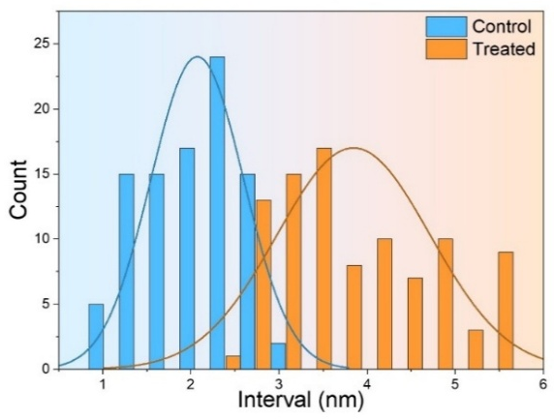
Figure S4. The distribution of the interval of control and treated QDs in TEM measurements
Figure S5. The a UV spectra and b PLE spectra of the control and treated QDs
Figure S6. PL emission spectra of control and treated QDs in solution and film (657 nm)
Figure S7. The structural diagrams of QDs passivated by a alkylamine and b 11-PFHA
Figure S8. Schematic diagram of (the cross-section along the ligand molecule) electron density difference between a, b alkylamine and c, d 11-PFHA (the cross-section perpendicular to the one shown in Figure S3)
Figure S9. The electron potential barriers in QDs passivated with different ligands
Figure S10. The PL Decay measurements of the control and treated QDs
Figure S11. PLQY results of the control and treated QDs emission at a 640 nm and b 657 nm in solution and film state
Figure S12. TA spectra of GSB peaks establishment dynamics process of a control and b treated QDs
Figure S13. The TEM pictures of QDs emission at a 640nm and b 657nm. c The statistic of the size of QDs emission at 640nm and 657nm
Figure S14. Cross-sectional TEM images of LEDs based on CsPbI₃ QD emission at 640nm
Figure S15. The UPS details of the control and treated QDs a, b emission at 640 nm and c, d 657 nm. The energy landscape of the QD emission at e 640 nm and f 657 nm
Figure S16. The current density vs voltage curves of the hole only devices based on control QDs and 11-PFHA QDs emission at a 640 nm and b 657 nm
Figure S17. a EL spectra b Current density vs Voltage vs Luminance curves c EQE vs Current density curve and d EQE vs Luminance curve of 11-PFHA treated QDs measured by the group of Zhang Xiaoyu in Jilin University
Figure S18. a The EL spectra b EQE vs current density and c CE vs current density curve of PeLEDs based on QDs emission at 640nm. d The EL spectra e EQE vs current density and f CE vs current density curve of PeLEDs based on QDs emission at 657nm
Figure S19. The distribution of the peak EQE of the PeLEDs fabricated with control and treated QDs emission at 640nm and 657nm
Figure S20. Comparison of the EQE of devices based on CsPbI₃ in our work with others available from the current literature
Figure S21. The PL spectra at different bias of devices based on a, e control QDs and b, f 11-PFHA treated QDs. The PL spectra before and after T₅₀ tests of devices based on the c, d control and g, h 11-PFHA treated QDs, the normalized EL spectra are embedded in the corresponding EL spectra
Figure S22. a Refractive index n and b extinction coefficient k of each function layer. c Relative ratios of each mode in 657 nm-PeLED without versus ETL (PO-T2T) thickness
As shown in the profile, the light extraction efficiency of our device is 35.5% when the thickness of PO-T2T&TmPyPB is 45nm, which is exactly the thickness of our devices shown in Figure S12
Figure S23. Angular dependent electroluminescence (EL) intensity of red PeLED
Figure S24. The operational lifetime of PeLEDs based on control QDs and treated QDs (640 nm)
Figure S25. The operational lifetime of PeLEDs based on control QDs and treated QDs (657 nm)
Table S1. Fitting data of the PL Decay measurement.

Sample | A₁(%) | τ₁(ns) | A₂(%) | τ₂ (ns) | τ_{ave} (ns)
Control | 100 | 10.15 | - | - | 10.15
Treated | 100 | 13.62 | - | - | 13.62

