Supporting Information for
Electrochemically Enhanced Low-Impedance Ti₃C₂T_{x} MXene Epidermal Electrodes for Accurate Electrophysiological Monitoring
Liubing Fan^{1,2}, Fangfang Gao^{1,2}, Liangxu Xu^{1,2}, Xiaochen Xun^{1,2}, Shuchang Zhao^{1,2}, Bing Yang^{1,2}, Han Bi^{1,2}, Xuan Zhao^{1,2}*, Qingliang Liao^{1,2}*, Yue Zhang^{1,2}*
¹ Academy for Advanced Interdisciplinary Science and Technology, Beijing Advanced Innovation Center for Materials Genome Engineering, University of Science and Technology Beijing, Beijing 100083, P. R. China
² Key Laboratory of Advanced Materials and Devices for Post-Moore Chips, Ministry of Education, Beijing Key Laboratory for Advanced Energy Materials and Technologies, School of Materials Science and Engineering, University of Science and Technology Beijing, Beijing 100083, P. R. China
*Corresponding authors. E-mail: xuanzhao@ustb.edu.cn (Xuan Zhao); liao@ustb.edu.cn (Qingliang Liao); yuezhang@ustb.edu.cn (Yue Zhang)

Note S1 Electrical equivalent circuit models for different electrode-skin interfaces
The dermal and subcutaneous layers can be represented by a resistor (R_{t}), with a capacitor (C_{e}) and a resistor (R_{e}) connected in parallel, both of which simulate the epidermis [S1]. The potential (E_{se}) arises from different ion concentrations across the stratum corneum. At the interface of the electrode and electrolyte, a half-cell potential (E_{hc}) between the electrode and tissue is presented. The double-layer structure of the electrode-skin interface is modeled by a parallel circuit comprising a capacitor C_{d} and a resistor R_{d}, where R_{d} represents the charge transfer resistance across the interfacial layers. For wet gel electrodes employed in commercial products, which utilize electrolyte gels, the equivalent circuit model incorporates the gel resistance (R_{g}). Owing to skin irritation concerns associated with electrolyte gels, dry electrodes have inherent advantages. For non-conformal dry electrodes, there are air gaps between the electrode and skin, which can be modeled by another capacitor (C_{gap}) and resistor (R_{gap}) placed in parallel. This additional parallel RC circuit of air gaps will drastically increase the electrode-skin interfacial impedance [S2].
Note S2 Preparation of diverse Ti₃C₂T_{x} MXene nanosheets
The traditional sonication exfoliation method, when applied to pristine MAX precursors, yielded MXene nanosheets with a mean lateral size of approximately 0.43 μm (denoted as small MXene). In contrast, vortex oscillation exfoliation of the pristine MAX resulted in MXene nanosheets, demonstrating a substantially larger mean lateral dimension of ~4.6 μm (denoted as medium MXene, Fig. S7). Consequently, the shear force method effectively facilitates the delamination of Ti₃C₂T_{x} MXene nanosheets. Notably, when applying vortex oscillation exfoliation to processed MAX precursors, the resultant MXene nanosheets achieved exceptional lateral dimensions averaging ~6.5 μm (denoted as large MXene, Fig. 1d).

Note S3 Oxidation stability of diverse Ti₃C₂T_{x} MXene nanosheets
The UV-vis spectra analysis of Ti₃C₂T_{x} MXene nanosheets with various flake sizes (Fig. S11a) reveals distinct features at 325 nm, showing size-dependent characteristics consistent with electronic structure variations between edge sites and basal plane [S2, S3]. A comparatively gradual decline of normalized UV-vis spectra indicates the slower degradation rate of large Ti₃C₂T_{x} MXene (Fig. 1g), where the points were fitted by an empirical function [S4], $A=A_{unre}+A_{re}e^{-t/τ}$, $τ$ is the time constant (days) and the fitting parameters are provided in Table S2. The $τ$ can be plotted as a function with the mean flake size L (μm) and fitted using the following formula: $τ=5.4×{10}^{0.021L}$ (Fig. S14b), which demonstrates the size effect and proves that degradation initiates at the edges [S3].
Supplementary Figures and Tables
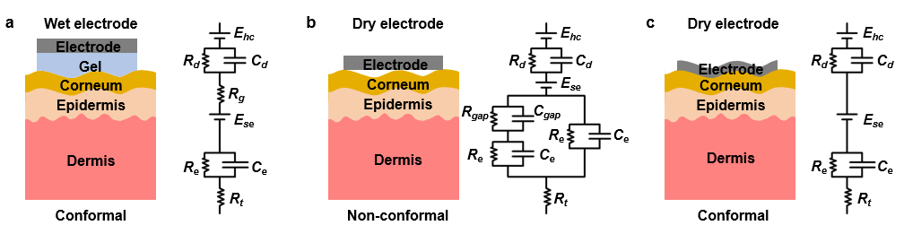
Fig. S1 Schematic and equivalent circuit models of three typical electrode-skin interfaces. (a) Wet gel electrodes. (b) Non-conformal dry electrodes. (c) Conformal dry electrodes

Fig. S2 Schematic of the sedimentation method for large MAX particles. (a) Mathematical model of particle sedimentation. (b) Schematic illustration of different particles in solution

Fig. S3 Particle lateral size statistics of pristine and processed Ti₃AlC₂ MAX phase. (a), (b), and (c) SEM images of pristine Ti₃AlC₂ MAX phase. (d), (e), and (f) SEM images of processed Ti₃AlC₂ MAX phase after sedimentation. Lateral size distribution of (g) pristine Ti₃AlC₂ and (h) processed Ti₃AlC₂ MAX phase

Fig. S4 Synthesis and structural evolution process of large MXene nanosheets. (a) Schematic illustration of the process flow from MAX phase to delaminated nanosheets. (b) SEM images of MAX, multi-layer MXene, and few-layer MXene nanosheet
Fig. S5 TEM analysis and elemental mapping of large Ti₃C₂T_{x} MXene nanosheets. (a), (b) TEM images of large Ti₃C₂T_{x} MXene nanosheets. Elemental mapping of (c) Ti and (d) C

Fig. S6 TEM images of large MXene nanosheets. (a) High-resolution transmission electron microscopy (HRTEM) image and (b) corresponding selected area electron diffraction (SAED) pattern. (c) TEM image showing the MXene layers with an interlayer spacing of 1.2 nm

Fig. S7 AFM image of the large Ti₃C₂T_{x} MXene nanosheet
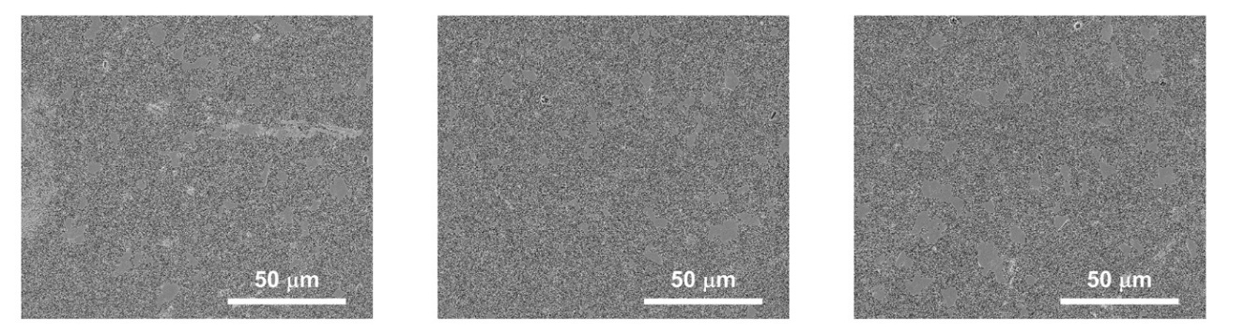

Fig. S8 Multiple SEM images of large MXene nanosheets for statistical analysis of lateral size distributions

Fig. S9 Statistical distribution of the size of various Ti₃C₂T_{x} MXene. (a) The width (y) flake size of large Ti₃C₂T_{x} MXene. (b) Dynamic light scattering (DLS) data of small Ti₃C₂T_{x} MXene. (c), (d) The length (x) and width (y) of medium Ti₃C₂T_{x} MXene

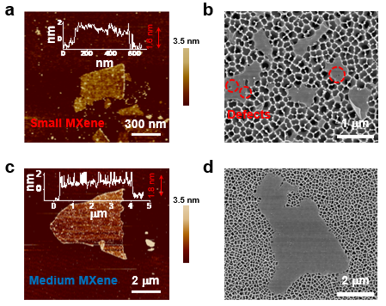
Fig. S10 Morphological characterization of Ti₃C₂T_{x} MXene nanosheets with different flake sizes. (a) AFM image and (b) SEM image of small Ti₃C₂T_{x} MXene nanosheets. (c) AFM image and (d) SEM image of medium Ti₃C₂T_{x} MXene nanosheets.
Based on the AFM images, the thicknesses of small MXene and medium MXene nanosheets are 1.6 and 1.8 nm, respectively. These values exceed the theoretical monolayer thickness of Ti₃C₂, which is due to the existence of H₂O molecules and surface oxidation [S5, S6].
Fig. S11 Chemical composition and structure characterization of Ti₃C₂T_{x} MXene films with various flake sizes. (a) XRD patterns of Ti₃AlC₂ MAX phase and Ti₃C₂T_{x} MXene films with various flake sizes. (b) FTIR and (c) Raman spectra of Ti₃C₂T_{x} MXene films with various flake sizes
The purity of synthesized Ti₃C₂T_{x} MXene nanosheets with various flake sizes was demonstrated by the disappearance of the Ti₃AlC₂ MAX phase peak at 2θ = 39° in the XRD pattern. The chemical structure and composition of Ti₃C₂T_{x} MXene with various flake sizes were confirmed using attenuated total reflection FTIR spectroscopy, Raman spectroscopy, and XPS, which indicated a consistent skeletal Ti-C structure and the presence of surface groups (-O, -OH, and -F) [S7].

Fig. S12 XPS spectra characterization of Ti₃C₂T_{x} MXene films with various flake sizes. (a) XPS survey, (b) C 1s, (c) Ti 2p, (d) O 1s, and (e) F 1s spectra

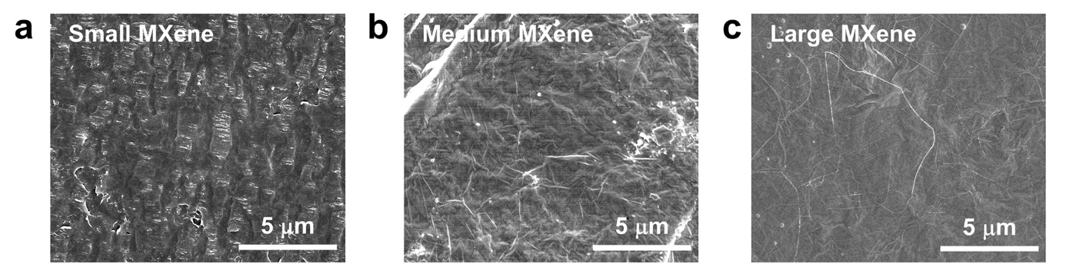
Fig. S13 Morphological characterization of Ti₃C₂T_{x} MXene films with various flake sizes. SEM images of surface morphology for (a) small, (b) medium, and (c) large Ti₃C₂T_{x} MXene films
The Ti₃C₂T_{x} MXene films with various flake sizes demonstrate significant morphological differences. As the flake size increases, the surfaces of Ti₃C₂T_{x} MXene films become progressively flatter.

Fig. S14 UV-vis spectra characterization of Ti₃C₂T_{x} MXene nanosheets with various flake sizes. (a) Normalized UV-vis spectra of Ti₃C₂T_{x} MXene dispersions with various flake sizes (inset is the photograph showing the Tyndall effect of the large Ti₃C₂T_{x} MXene dispersion). (b) The function of $τ$ and flake size, the dotted line shows the fitted results

Fig. S15 Ti 2p XPS spectra of different MXene nanosheets after storage for 10 days. (a) Small MXene. (b) Medium MXene. (c) Large MXene

Fig. S16 The infrared images of MXene and HEC/MXene. (a) Before adding HEC. (b) After adding HEC

Fig. S17 XRD patterns of large MXene and HEC/MXene films with various HEC loadings

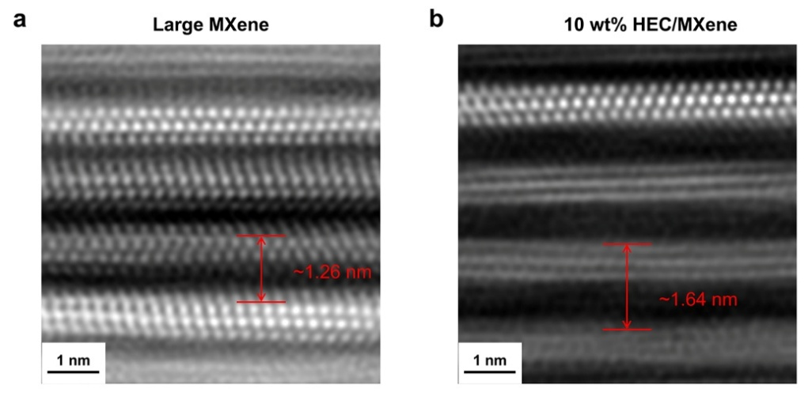
Fig. S18 High-angle annular darkfield (HAADF) scanning transmission electron microscopy (STEM) images of (a) large MXene with an interlayer spacing of 1.26 nm and (b) 10 wt% HEC/MXene with an interlayer spacing of 1.64 nm
Fig. S19 The MXene nanosheets stacking morphology of the cross-sections of films. (a) TEM image of the large MXene film with a disorderly stacking structure. (b) TEM image of 10 wt% HEC/MXene film with orderly stacking structure. (c) Schematic illustration of the stacking structure of large MXene and 10 wt% HEC/MXene film

Fig. S20 XPS survey and Ti 2p spectra of large MXene and HEC/MXene films with various HEC loadings. (a) XPS survey. Ti 2p spectra of (b) Large MXene, (c) 5 wt% HEC/MXene, (d) 10 wt% HEC/MXene, (e) 15 wt% HEC/MXene, and (f) 20 wt% HEC/MXene
Fig. S21 Flexibility and mechanical durability of large MXene and HEC/MXene films. (a) SEM image illustrating an HEC/MXene film folded 180° with a bending radius of ~155 μm. (b) SEM image illustrating a large MXene film folded 180° with a bending radius of ~243 μm. (c) Photos showing an HEC/MXene film (15 mm × 12 mm) during a bending cycle. (d) Electrochemical performance of the HEC/MXene film before and after 500 bending cycles

Fig. S22 Capacitances of large MXene and HEC/MXene films with various HEC loadings

Fig. S23 Electrochemical characterization of small MXene, large MXene, and 10 wt% HEC/MXene films. cyclic voltammetry curves measured in 1× PBS for (a) small MXene, (b) large MXene, and (c) 10 wt% HEC/MXene films in the region of -0.3 ~ -0.1 V with scan rates of 1-6 mV/s

Fig. S24 The 100 stimulation cycles of charge-balanced pulses of 1 mA for 10 wt% HEC/MXene film in 1× PBS
Fig. S25 Cyclic voltammetry (CV) curves of HEC/MXene film with scan rates of 20 mV/s in 1× PBS. (a) CVs exploring the negative voltage limit. (b) CVs exploring the positive voltage limit
Fig. S26 Electrochemical performance of various MXene electrodes in artificial sweat. (a) Cyclic voltammetry curves with scan rates of 20 mV/s. (b) Corresponding capacitances

Fig. S27 Ti/O atomic ratios in 10 wt% HEC/MXene films determined by XPS across different batches. Data are presented as mean ± SD (n = 4).

Fig. S28 Adhesiveness of HEC/MXene epidermal electrodes. (a) The schematic of the 90° peel test. (b) Adhesion forces of HEC/MXene epidermal electrodes on skin

Fig. S29 Fluorescence microscopy images (green: viable cells, red: dead cells) of live/dead human skin fibroblast cells in the control and 10 wt% HEC/MXene film groups after 24 and 48 h immersion

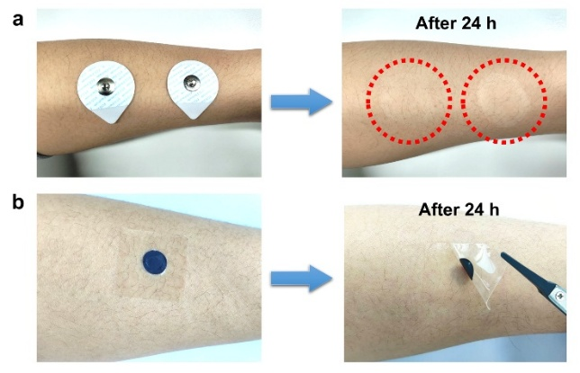
Fig. S30 Irritation comparison between commercial Ag/AgCl gel electrodes and 10 wt% HEC/MXene epidermal electrodes. Photographic images of (a) commercial Ag/AgCl gel electrodes and (b) 10 wt% HEC/MXene epidermal electrodes worn on human skin for 24 h

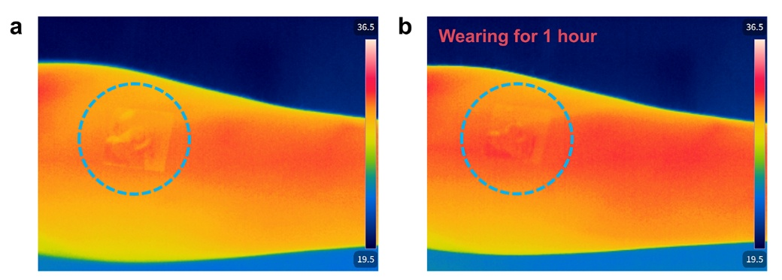
Fig. S31 The infrared images of HEC/MXene epidermal electrode on skin. (a) The start of wear. (b) After wearing for 1 hour

Fig. S32 Electrode-skin interfacial impedance measurement

Fig. S33 Electrode-skin interfacial impedance of small MXene epidermal electrodes Data are presented as mean with shaded regions corresponding to SD (n = 5). Data recorded from N = 1 subject

Fig. S34 Electrode-skin interfacial impedance characteristics. Bode magnitude plots for (a) large MXene and (b) 10 wt% HEC/MXene. The black lines in each plot represent fitted lines. (c) Double-layer capacitance as determined by fitting the impedance data of large MXene and 10 wt% HEC/MXene
Fig. S35 Data acquisition device of portable EMG monitoring system. (a) Data acquisition circuit. (b) PCB diagram
The component housed within the blue enclosure is an adjustable resistor, specifically model 3266W.
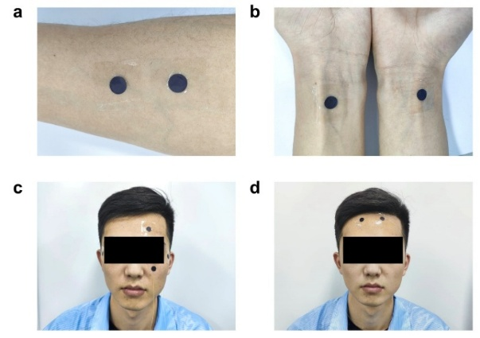
Fig. S36 Photographic images of the experimental setup during electrophysiological monitoring. (a) EMG. (b) ECG. (c) EOG. (d) EEG
Fig. S37 Long-term EMG monitoring performance of the HEC/MXene epidermal electrodes. (a) Evolution of the electrode-skin interfacial impedance over 48 hours. Data are presented as mean ± SD (n = 3). (b) Recorded EMG signals during the 48-hour monitoring period. (c) Corresponding signal-to-noise ratio (SNR) variation over time. Data are presented as mean ± SD (n = 8 trials)

Fig. S38 RMS values of EMG signal amplitudes. The top corresponds to different grip strengths, and the bottom corresponds to different hand gestures. Data are presented as mean ± SD (n = 8 trials)

Fig. S39 ECG signals detected by commercial Ag/AgCl gel electrodes and HEC/MXene epidermal electrodes. (a) Complexes of ECG signals. (b) RQS voltage. Data are presented as mean ± SD (n = 8 trials)
Fig. S40 ECG signals detected by HEC/MXene epidermal electrodes under different temperatures and relative humidity (RH) conditions. (a) Different temperatures conditions. (b) Different RH conditions

Fig. S41 Multi-cycle ECG monitoring performance of the HEC/MXene epidermal electrodes. (a) Evolution of the electrode-skin interfacial impedance over cycles. Data are presented as mean ± SD (n = 3). (b) Variation of QRS voltage observed during multi-cycle ECG monitoring. Data are presented as mean ± SD (n = 8 trials). (c) Variation of RMS noise observed during multi-cycle ECG monitoring with HEC/MXene epidermal electrodes
Fig. S42 EOG signals for commercial Ag/AgCl gel electrodes and 10 wt% HEC/MXene epidermal electrodes. (a) EOG signals during open-close eye movements. (b) Peak-to-peak voltages during varied eye movements. Data are presented as mean ± SD (n = 8 trials)
Fig. S43 Extracted beta wave components during different states. (a) Eyes open states. (b) Eyes closed states

Table S1 Statistical data of various Ti₃C₂T_{x} MXene size distributions
Distributions (μm) |  | Medium Ti₃C₂T_{x} MXene |  | Large Ti₃C₂T_{x} MXene
Bin range | Bin center | x counts | y counts | x counts | y counts
0-1 | 0.5 | 1 | 10 | \ | \
1-2 | 1.5 | 47 | 135 | \ | \
2-3 | 2.5 | 63 | 114 | 6 | 53
3-4 | 3.5 | 83 | 57 | 38 | 74
4-5 | 4.5 | 53 | 26 | 28 | 50
5-6 | 5.5 | 33 | 14 | 46 | 29
6-7 | 6.5 | 24 | 5 | 37 | 16
7-8 | 7.5 | 19 | 3 | 21 | 2
8-9 | 8.5 | 14 | 1 | 11 | 6
9-10 | 9.5 | 10 | 10 | 15 | 1
10-11 | 10.5 | 7 | \ | 10 | \
11-12 | 11.5 | 3 | \ | 7 | \
12-13 | 12.5 | 0 | \ | 7 | \
13-14 | 13.5 | 3 | \ | 3 | \
14-15 | 14.5 | 2 | \ | 2 | \
15-16 | 15.5 | 3 | \ | 1 | \
Total counts |  | 365 | 365 | 232 | 232

Table S2 XPS fitting results for various Ti₃C₂T_{x} MXene
Region | Binding energy (eV) |  |  | Assigned to
Region | small Ti₃C₂T_{x} | Medium Ti₃C₂T_{x} | Large Ti₃C₂T_{x} | Assigned to
Ti 2p_{3/2} (2p1_{/2}) | 454.7 (460.7) | 454.7 (460.7) | 454.7 (460.7) | Ti (I, II or IV)
Ti 2p_{3/2} (2p1_{/2}) | 455.3 (461.3) | 455.3 (461.3) | 455.3 (461.3) | Ti²⁺ (I, II, or IV)
Ti 2p_{3/2} (2p1_{/2}) | 456.2 (462.2) | 456.2 (462.2) | 456.2 (462.2) | Ti³⁺ (I, II, or IV)
Ti 2p_{3/2} (2p1_{/2}) | 459.2 (464.5) | 459.3 (464.6) | 459.2 (464.5) | TiO₂
C 1s | 281.8 | 281.8 | 281.7 | C-Ti-T_{x} (I, II,III, or IV)
C 1s | 284.8 | 284.8 | 284.8 | C-C
O 1s | 529.6 | 529.4 | 529.5 | Ti-O
O 1s | 530.9 | 530.3 | 530.3 | C-Ti-O_{x}
O 1s | 532.6 | 532.6 | 532.6 | C-Ti-(OH)_{x}
F 1s | 684.9 | 684.9 | 685.1 | C-Ti-F_{x}

Table S3 Fitting parameters of Ti₃C₂T_{x} MXene nanosheets with various flake sizes
Size | Time constant ($τ$) | $$A_{unre}$$ | $$A_{re}$$ | $$\frac{A_{re}}{A_{re}+A_{unre}}$$
small | 5.5 | 0.19 | 0.80 | 0.81
medium | 6.9 | 0.19 | 0.81 | 0.81
large | 7.5 | 0.17 | 0.83 | 0.83
*$τ$ is the time constant (days), $A_{unre}$ is the unreactive/stable MXene nanosheets, and $A_{re}$ is the reactive/unstable MXene nanosheets.

Table S4 The thickness of HEC/MXene films with various HEC loadings
HEC content (wt%) | Thickness (μm)
0 | 8.0
5 | 8.3
10 | 8.5
15 | 9.0
20 | 9.6

Table S5 XPS fitting results for large Ti₃C₂T_{x} MXene with various HEC loadings
Region | Binding energy (eV)
Region | Large Ti₃C₂T_{x} | 5 wt% HEC | 10 wt% HEC | 15 wt% HEC | 20 wt% HEC
Ti 2p_{3/2} (2p1_{/2}) | 454.69 (460.69) | 454.85 (460.85) | 454.87 (460.87) | 454.88 (460.88) | 454.89 (460.89)
Ti 2p_{3/2} (2p1_{/2}) | 455.32 (461.32) | 455.49 (461.49) | 455.52 (461.52) | 455.53 (461.53) | 455.54 (461.54)
Ti 2p_{3/2} (2p1_{/2}) | 456.15 (462.15) | 456.34 (462.34) | 456.38 (462.38) | 456.37 (462.37) | 456.38 (462.38)
Ti 2p_{3/2} (2p1_{/2}) | 459.21 (464.51) | 459.3 (464.6) | 459.34 (464.64) | 459.27 (464.57) | 459.32 (464.62)

Table S6 Frequency ranges of various electrophysiological signals
Electrophysiological signals | Frequency (Hz)
EEG | 0.5-150
ECG | 0.01-250
EMG | 15-500
EOG | 0.1-50

Table S7 Reported interfacial impedance values of commercial Ag/AgCl gel electrodes at 10 Hz
Source | Impedance at 10 Hz (kΩ) | Electrode area (cm²) | Normalized impedance at 10 Hz (kΩ cm²)
This work | 217 | 2.01 | 436
[S8] | ≈300 | 10.5 | 3150
[S9] | ≈240 | 7.07 | 1697
[S10] | ≈500 | 2.1 | 1050
[S11] | \ | \ | 460
[S12] | \ | \ | 252

Table S8 Comparison of electrode-skin interface impedance at 10 Hz for different electrodes without skin abrasion
Electrode material |  | Applications | Normalized impedance at 10 Hz (kΩ cm²) | Electrode area (cm²) | Conductivity （S/cm） | Reference
PEDOT:PSS/GO/PEGDMA |  | EMG, EEG | 43 | 0.785 | 2060 | [S13]
MXene/HEC |  | EMG, ECG, EOG, EEG | 53 | 0.785 | 1081 | This work
Epitaxial Graphene |  | EEG | 68 | 1 | \ | [S14]
MXene/MOF |  | ECG, EMG, EOG | 80 | 1 | \ | [S15]
PEDOT:PSS/WPU/D-sorbitol |  | ECG, EMG, EEG | 82 | \ | 380 | [S16]
PEDOT:PSS/PVA/TA |  | ECG, EMG | 100 | \ | 122 | [S17]
AgNWs/TPU |  | ECG | 106 | 1.767 | 4800 | [S18]
LIG/PET |  | ECG | 240 | 4 | \ | [S19]
CNT film |  | ECG | 470 | 0.785 | \ | [S20]
MXene/WPU |  | ECG, EMG, EEG | 480 | 4 | \ | [S21]
 | AgNWs/PU NFs | ECG | 500 | 1.0 | 9190 | [S22]
 | AgNW/HPAN/PU | EMG, ECG | 1400 | 2.0 | 1.5 × 10⁻⁴ | [S23]
 | SWCNT/rGO | ECG | 1570 | 0.785 | \ | [S24]
 | MXene/CNF/PCE | ECG, EMG | 3180 | 7.07 | \ | [S9]

Table S9 Signal-to-noise ratios (SNRs) of EMG signals acquired by HEC/MXene electrodes and Ag/AgCl gel electrodes across different subjects
Subject | Age | Gender | EMG SNR (dB)
Subject | Age | Gender | HEC/MXene electrodes | Ag/AgCl gel electrodes
#1 | 28 | Male | 39 ± 5 | 16 ± 2
#2 | 25 | Male | 40 ± 1 | 21 ± 3
#3 | 24 | Female | 34 ± 2 | 15 ± 2
Supplementary References
- J.G. Webster, A.J. Nimunkar. Medical instrumentation: application and design. 5th edn. (Wiley, Hoboken, N.J, 2020), pp. 268-320.
- C. Backes, R.J. Smith, N. McEvoy, N.C. Berner, D. McCloskey et al., Edge and confinement effects allow in situ measurement of size and thickness of liquid-exfoliated nanosheets. Nat. Commun. 5, 4576 (2014). https://doi.org/10.1038/ncomms5576
- C.J. Zhang, S. Pinilla, N. McEvoy, C.P. Cullen, B. Anasori et al., Oxidation stability of colloidal two-dimensional titanium carbides (MXenes). Chem. Mater. 29(11), 4848–4856 (2017). https://doi.org/10.1021/acs.chemmater.7b00745
- D. Hanlon, C. Backes, E. Doherty, C.S. Cucinotta, N.C. Berner et al., Liquid exfoliation of solvent-stabilized few-layer black phosphorus for applications beyond electronics. Nat. Commun. 6, 8563 (2015). https://doi.org/10.1038/ncomms9563
- Q. Zhang, R. Fan, W. Cheng, P. Ji, J. Sheng et al., Synthesis of large-area MXenes with high yields through power-focused delamination utilizing Vortex kinetic energy. Adv. Sci. 9(28), 2202748 (2022). https://doi.org/10.1002/advs.202202748
- X. Huang, P. Wu, A facile, high-yield, and freeze-and-thaw-assisted approach to fabricate MXene with plentiful wrinkles and its application in on-chip micro-supercapacitors. Adv. Funct. Mater. 30(12), 1910048 (2020). https://doi.org/10.1002/adfm.201910048
- A. Sarycheva, Y. Gogotsi, Raman spectroscopy analysis of the structure and surface chemistry of Ti₃C₂T_{x} MXene. Chem. Mater. 32(8), 3480–3488 (2020). https://doi.org/10.1021/acs.chemmater.0c00359
- Z. Zhang, J. Yang, H. Wang, C. Wang, Y. Gu et al., A 10-micrometer-thick nanomesh-reinforced gas-permeable hydrogel skin sensor for long-term electrophysiological monitoring. Sci. Adv. 10(2), eadj5389 (2024). https://doi.org/10.1126/sciadv.adj5389
- S. Lee, D.H. Ho, J. Jekal, S.Y. Cho, Y.J. Choi et al., Fabric-based Lamina emergent MXene-based electrode for electrophysiological monitoring. Nat. Commun. 15(1), 5974 (2024). https://doi.org/10.1038/s41467-024-49939-x
- S. Ji, C. Wan, T. Wang, Q. Li, G. Chen et al., Water-resistant conformal hybrid electrodes for aquatic endurable electrocardiographic monitoring. Adv. Mater. 32(26), e2001496 (2020). https://doi.org/10.1002/adma.202001496
- Q. Wang, Y. Li, Y. Lin, Y. Sun, C. Bai et al., A generic strategy to create mechanically interlocked nanocomposite/hydrogel hybrid electrodes for epidermal electronics. Nanomicro Lett. 16(1), 87 (2024). https://doi.org/10.1007/s40820-023-01314-z
- M. Asaduzzaman, O. Faruk, A.A. Samad, H. Kim, M.S. Reza et al., A MOFs-derived hydroxyl-functionalized hybrid nanoporous carbon incorporated laser-scribed graphene-based multimodal skin patch for perspiration analysis and electrocardiogram monitoring. Adv. Funct. Mater. 34(40), 2405651 (2024). https://doi.org/10.1002/adfm.202405651
- X. Du, L. Yang, X. Shi, C. Ye, Y. Wang et al., Ultrathin bioelectrode array with improved electrochemical performance for electrophysiological sensing and modulation. ACS Nano 18(51), 34971–34985 (2024). https://doi.org/10.1021/acsnano.4c13325
- S.N. Faisal, M. Amjadipour, K. Izzo, J.A. Singer, A. Bendavid et al., Non-invasive on-skin sensors for brain machine interfaces with epitaxial graphene. J. Neural Eng. 18(6). 066035 (2021). https://doi.org/10.1088/1741-2552/ac4085
- X. Lin, D. Song, T. Shao, T. Xue, W. Hu et al., A multifunctional biosensor via MXene assisted by conductive metal–organic framework for healthcare monitoring. Adv. Funct. Mater. 34(11), 2311637 (2024). https://doi.org/10.1002/adfm.202311637
- L. Zhang, K.S. Kumar, H. He, C.J. Cai, X. He et al., Fully organic compliant dry electrodes self-adhesive to skin for long-term motion-robust epidermal biopotential monitoring. Nat. Commun. 11(1), 4683 (2020). https://doi.org/10.1038/s41467-020-18503-8
- J. Cao, X. Yang, J. Rao, A. Mitriashkin, X. Fan et al., Stretchable and self-adhesive PEDOT: PSS blend with high sweat tolerance as conformal biopotential dry electrodes. ACS Appl. Mater. Interfaces 14(34), 39159–39171 (2022). https://doi.org/10.1021/acsami.2c11921
- Y.J. Fan, P.T. Yu, F. Liang, X. Li, H.Y. Li et al., Highly conductive, stretchable, and breathable epidermal electrode based on hierarchically interactive nano-network. Nanoscale 12(30), 16053–16062 (2020). https://doi.org/10.1039/d0nr03189e
- G. Murastov, E. Bogatova, K. Brazovskiy, I. Amin, A. Lipovka et al., Flexible and water-stable graphene-based electrodes for long-term use in bioelectronics. Biosens. Bioelectron. 166, 112426 (2020). https://doi.org/10.1016/j.bios.2020.112426
- B.M. Li, O. Yildiz, A.C. Mills, T.J. Flewwellin, P.D. Bradford et al., Iron-on carbon nanotube (CNT) thin films for biosensing E-Textile applications. Carbon 168, 673–683 (2020). https://doi.org/10.1016/j.carbon.2020.06.057
- Y. Hao, Q. Yan, H. Liu, X. He, P. Zhang et al., A stretchable, breathable, and self-adhesive electronic skin with multimodal sensing capabilities for human-centered healthcare. Adv. Funct. Mater. 33(44), 2303881 (2023). https://doi.org/10.1002/adfm.202303881
- Z. Jiang, M.O.G. Nayeem, K. Fukuda, S. Ding, H. Jin et al., Highly stretchable metallic nanowire networks reinforced by the underlying randomly distributed elastic polymer nanofibers via interfacial adhesion improvement. Adv. Mater. 31(37), 1903446 (2019). https://doi.org/10.1002/adma.201903446
- X. Yang, S. Wang, M. Liu, L. Li, Y. Zhao et al., All-nanofiber-based Janus epidermal electrode with directional sweat permeability for artifact-free biopotential monitoring. Small 18(12), 2106477 (2022). https://doi.org/10.1002/smll.202106477
- A.V. Kuksin, A.S. Morozova, Y.O. Vasilevskaya, E.M. Eganova, K.D. Popovich et al., Dry electrodes based on carbon nanotubes-graphene hybrid nanostructures for long-term ECG monitoring. Diam. Relat. Mater. 159, 112895 (2025). https://doi.org/10.1016/j.diamond.2025.112895

