Supporting Information for
Dual-Site Functional Orchestration Enables Synergistic Anodic Modulation and Cathodic Mooring for Durable Zinc-Iodine Batteries
Yan Jin¹, Jin Cao^{1,2}*, Can Huang¹, Xin An¹, Shenghan Wang¹, Xuelin Yang²*
¹ College of Materials and Chemical Engineering, China Three Gorges University, Yichang, Hubei 443002, P. R. China
² Institute of Energy Storage Technology, China Three Gorges University, Yichang, Hubei 443002, P. R. China
*Corresponding authors. E-mail: caojin@ctgu.edu.cn (Jin Cao); xlyang@ctgu.edu.cn (Xuelin Yang)

S1 Theoretical calculations
S1.1 DFT calculation
The Density functional theory (DFT) was used to calculate and visualize the electrostatic potential maps, LUMO-HOMO energy level, and binding energy, which was implemented by the Dmol3 program. The structure optimizations and calculations of the electrostatic potential maps and LUMO-HOMO energy level were performed at the BLYP level. Density functional theory (DFT) was carried out to obtain the binding interaction energies for ELA-H₂O, ELA-Zn²⁺, and Zn²⁺-H₂O. The geometry optimization was carried out by using PBE/def2-svp level, and the energy calculations were then calculated by using PBE/def2-tzvp level [S1, S2]. The basis set super position error (BSSE) has been considered [S3, S4]. The ORCA package has been used for all calculations [S5]. The binding energies for ELA and each adsorbed molecule were calculated using the following equation:
ΔE_{B} = ΔE_{cpx} – ΔE_{ELA} −ΔE_{m} (S1)
where ΔE_{B} is the binding energy (kcal/mol), ΔE_{cpx} the complex energy, ΔE_{ELA} is the ELA energy, and ΔE_{m} is the energy of H₂O or Zn²⁺.
S1.2 MD simulation
To investigate the structural and adsorption properties of ELA molecules in the presence of ZnSO₄ and water, classical molecular dynamics (MD) simulations were performed using the DLPOLY 4.10 package [S6]. The initial simulation box had dimensions of 50×50×50 Å³, and simulations were carried out using the Nosé–Hoover ensemble at a temperature of 298 K [S7, S8]. Periodic boundary conditions were applied, and the minimum image convention was used. Short-range interactions were calculated with a cutoff radius of 12 Å, while long-range interactions were treated using the Ewald summation method [S9]. Each simulation system contained 36 ZnSO₄ units and 1000 water molecules, randomly distributed. For equilibration, the system was first simulated under the NPT ensemble for 2 ns with a time step of 1 fs. Production runs were then performed under the NVT ensemble for 20 ns, with trajectories from the last 10 ns used to compute radial distribution functions (RDFs). The interaction of water molecules was modeled using the SPC/E model, in which the bond lengths and angles were fixed [S10, S11]. The DREIDING force field was applied for interactions between all other atom types [S12]. The Lennard-Jones (LJ) parameters for different atom pairs ($σ_{ij}$, $ɛ_{ij}$) were derived from pure component values using the Lorentz-Berthelot mixing rules [S13], as given by:
$σ_{ij}=\frac{σ_{ii}+σ_{jj}}{2}; ɛ_{ij}=\sqrt{ɛ_{ii}ɛ_{jj}}$ (S2)
Partial atomic charges, except for those of water molecules, were obtained from ORCA calculations using the Hartree-Fock method with the 6-31G(d) basis set and electrostatic potential (ESP) fitting via the CHELPG scheme [14].

Supplementary Figures and Tables
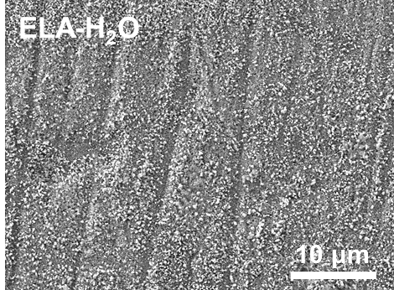
Fig. S1 Surface SEM image of zinc foil after immersion in ELA-H₂O
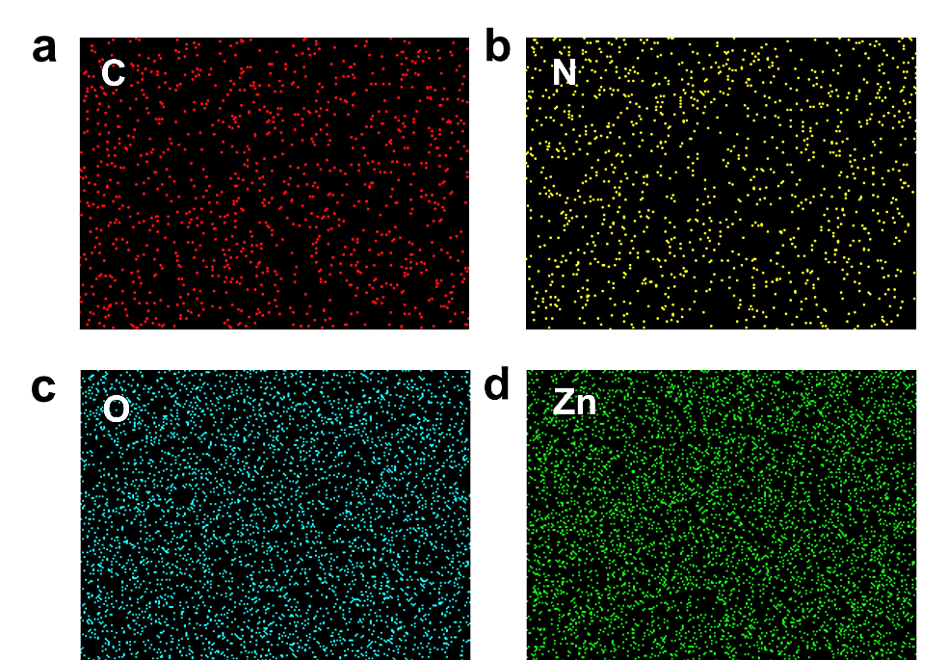
Fig. S2 Elemental mapping of zinc foil surface after immersion in ELA-H₂O
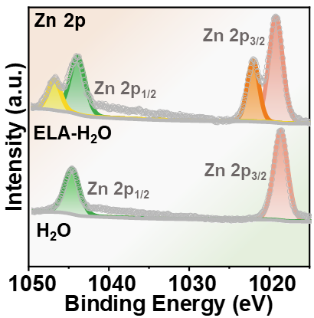
Fig. S3 Zn 2p XPS spectrum of zinc foil surface after immersion in ELA-H₂O
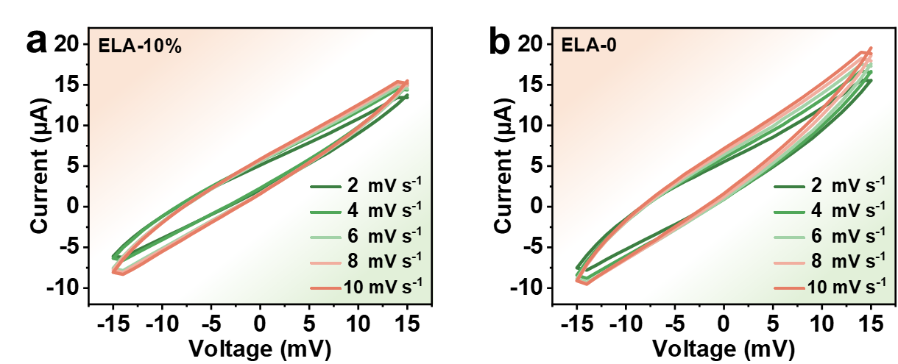
Fig. S4 CV curves of Zn||Zn symmetric cells in (a) ELA-10% and (b) ELA-0 electrolytes at different scan rates in the voltage range of -15 mV to 15 mV

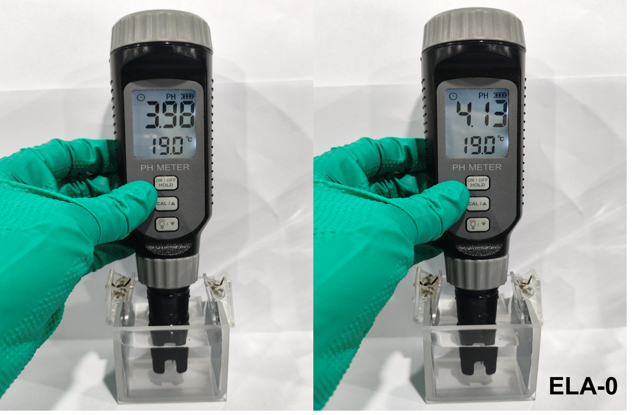
Fig. S5 Digital photographs showing the pH value of the ELA-0 electrolyte before and after cycling in Zn||Zn symmetric cells
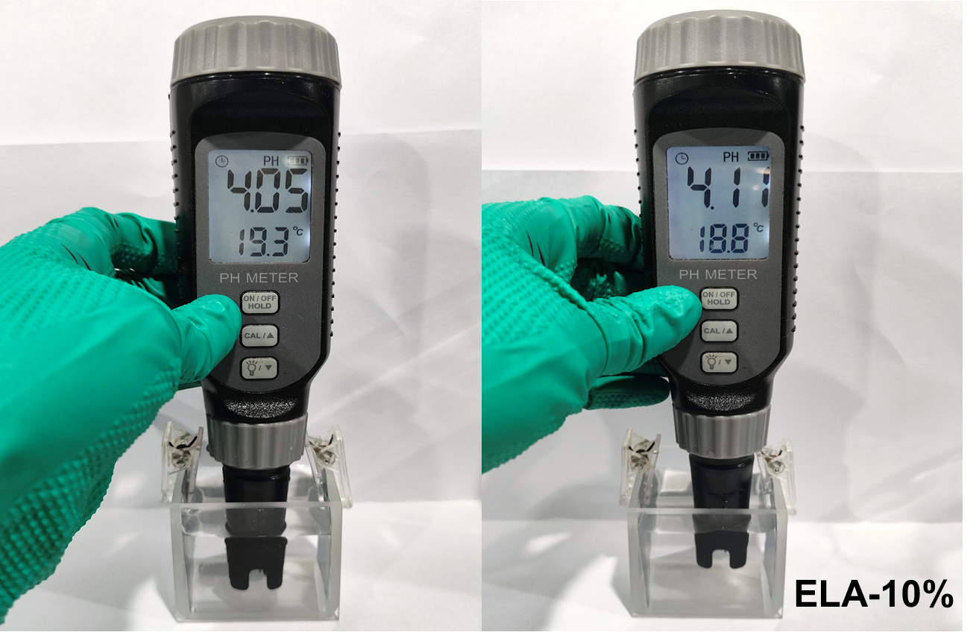
Fig. S6 Digital photographs showing the pH value of the ELA-10% electrolyte before and after cycling in Zn||Zn symmetric cells

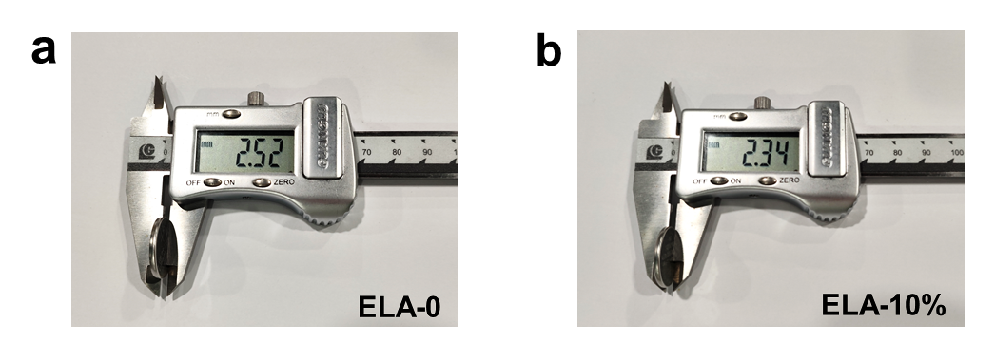
Fig. S7 Post-cycling thickness comparison of symmetric cells assembled with (a) ELA-0 and (b) ELA-10% electrodes at 5 mA cm⁻² (2 mAh cm⁻²)
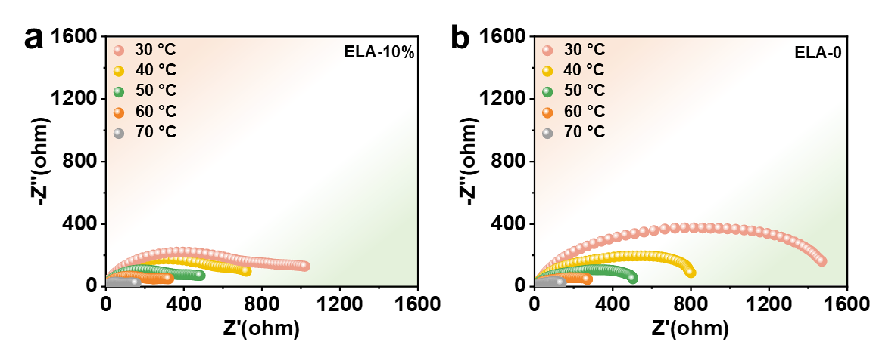
Fig. S8 Electrochemical impedance spectra of symmetric cells based on (a) ELA-10% and (b) ELA-0 at different temperatures

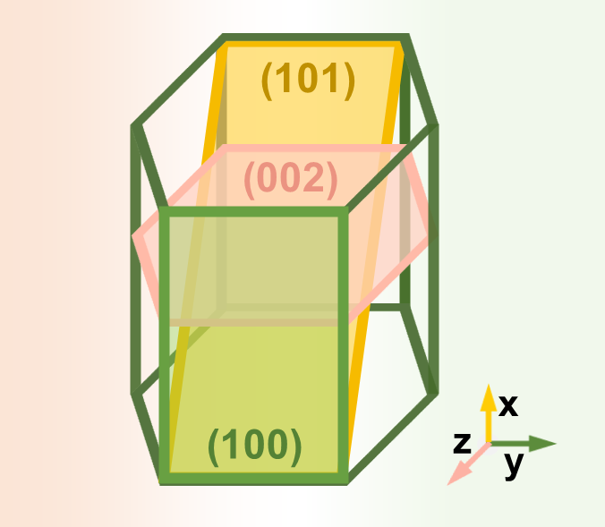
Fig. S9 Hcp structure of Zn

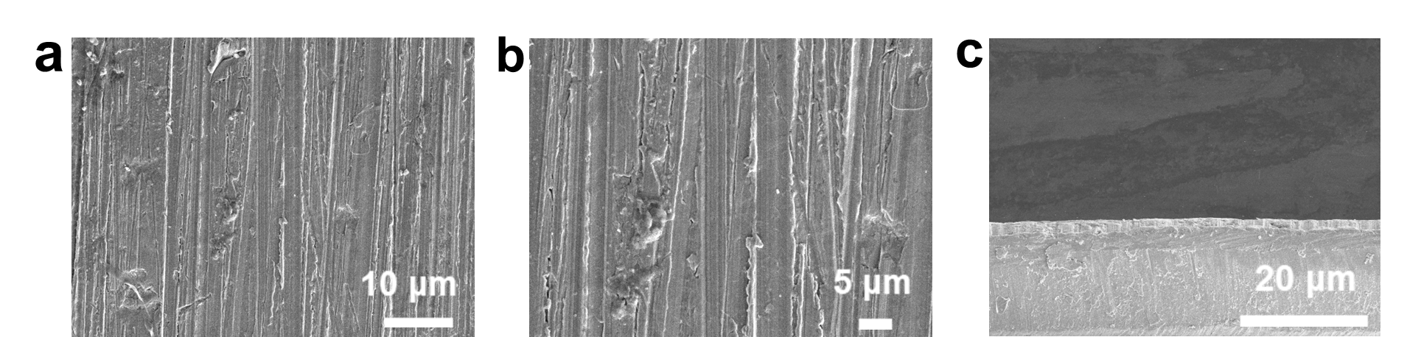
Fig. S10 Morphological observations of pure zinc foil at different magnifications: (a-b) surface and (c) cross-section

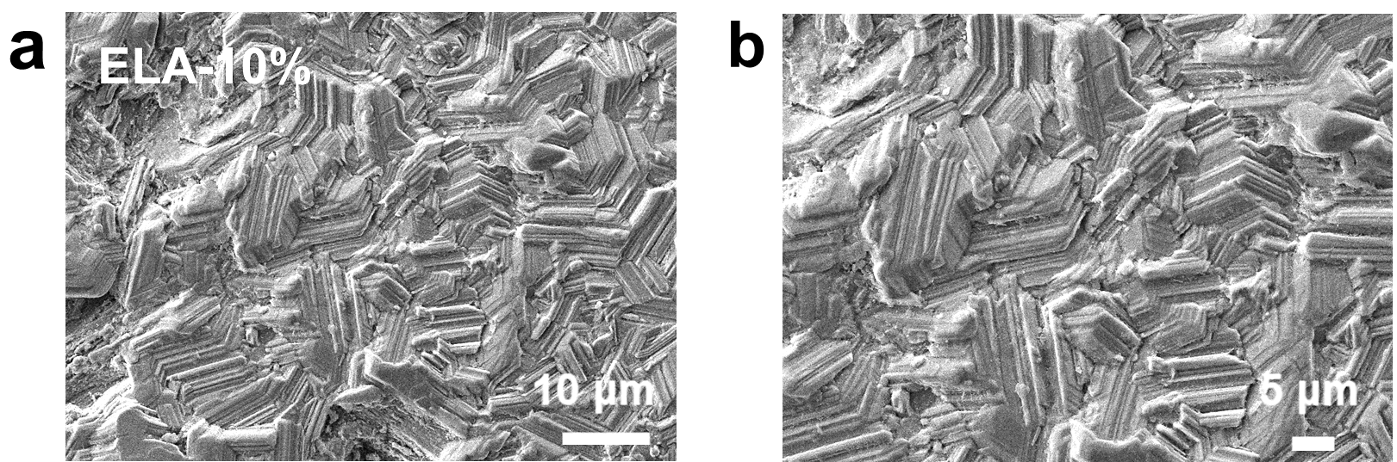
Fig. S11 (a-b) Plan-view SEM images of cycled ELA-10% electrode at different magnifications

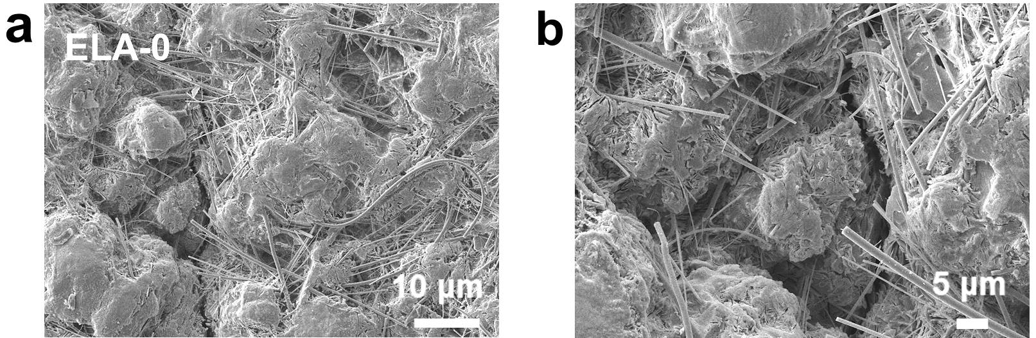
Fig. S12 (a-b) Plan-view SEM images of cycled ELA-0 electrode at different magnifications
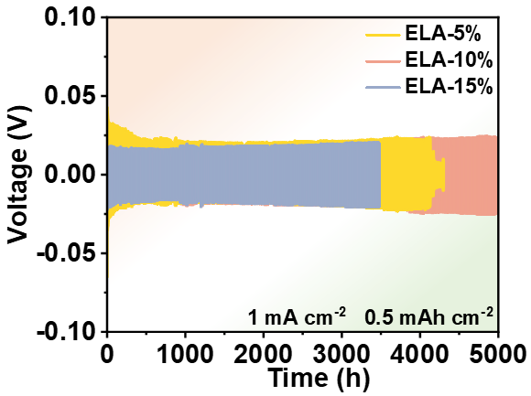
Fig. S13 Cycling performance of symmetric cells with varying ELA concentrations at 1 mA cm⁻² (0.5 mAh cm⁻²)
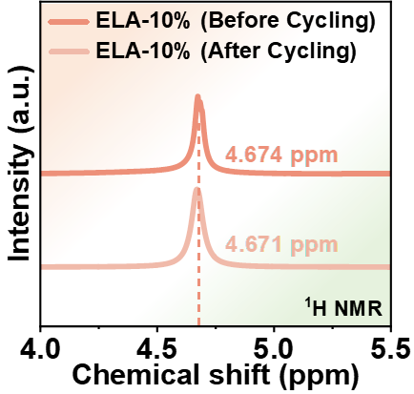
Fig. S14 ¹H NMR spectra of the ELA-10% electrolyte before and after cycling in Zn||Zn symmetric cells
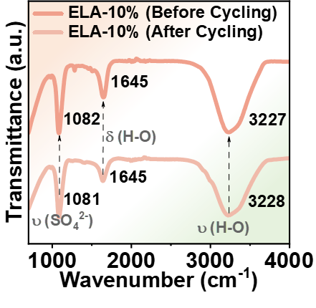
Fig. S15 FTIR spectra of the ELA-10% electrolyte before and after cycling in Zn||Zn symmetric cells
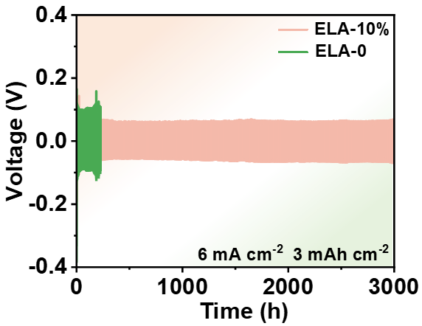
Fig. S16 Cycling performance of symmetric cells with ELA-10% and ELA-0 at 6 mA cm⁻² (3 mAh cm⁻²)
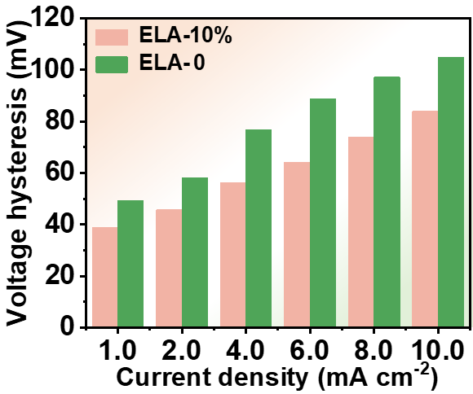
Fig. S17 Bar chart of rate performance

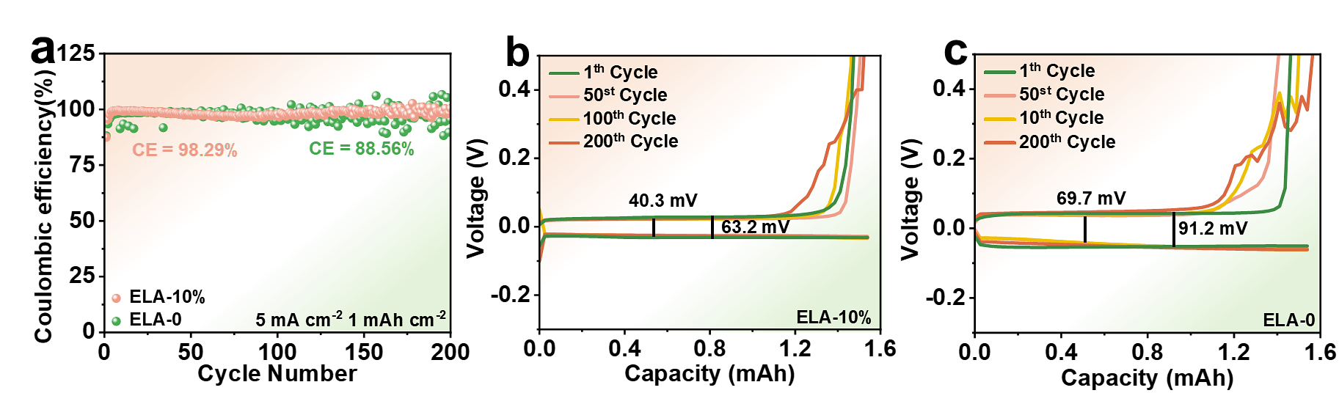
Fig. S18 (a) Coulombic efficiency of Zn||Ti half-cells for ELA-10% and ELA-0 at 5 mA cm⁻² (1 mAh cm⁻²). (b) Voltage-capacity curve of ELA-10% Zn||Ti half-cell. (c) Voltage-capacity curve of ELA-0 Zn||Ti half-cell

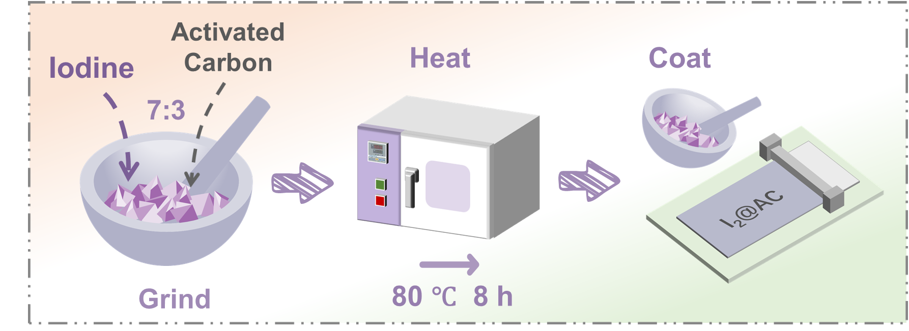
Fig. S19 Preparation process of iodine cathode

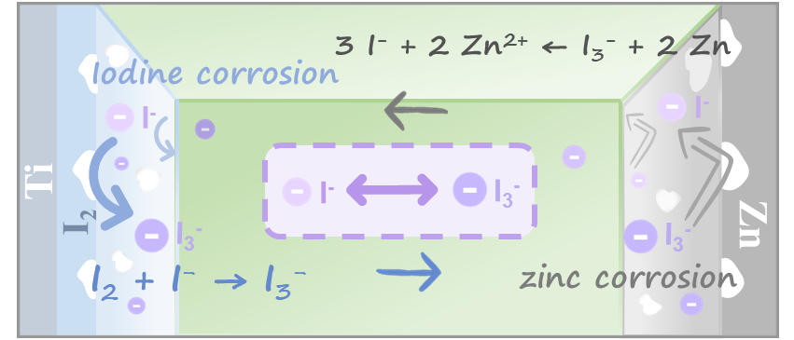
Fig. S20 Cycling schematic of ELA-0 Zn||I₂ full cell

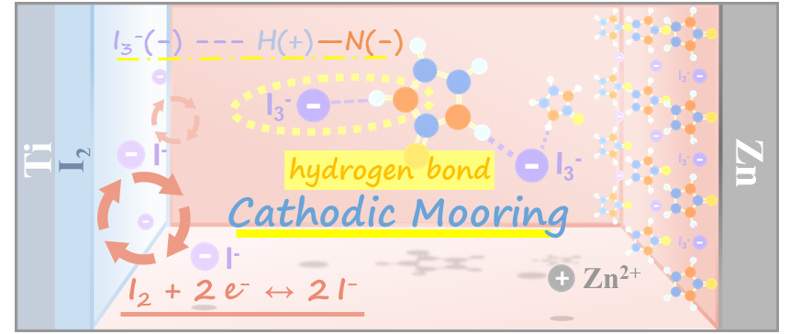
Fig. S21 Cycling schematic of ELA-10% Zn||I₂ full cell
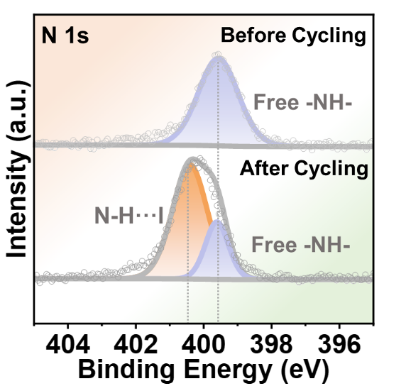
Fig. S22 High-resolution XPS N 1s spectra of the cathode before and after cycling

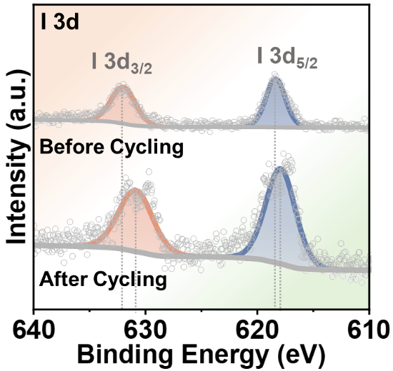
Fig. S23 High-resolution XPS I 3d spectra of the cathode before and after cycling

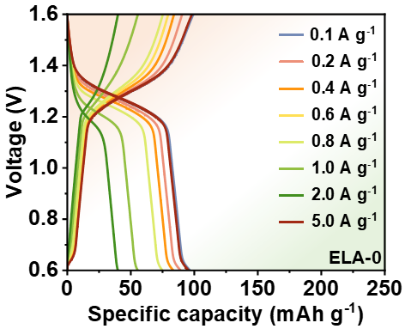
Fig. S24 Galvanostatic charge-discharge curves of ELA-0 full cell
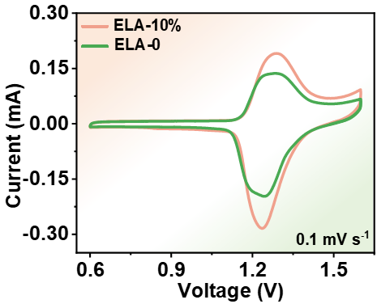
Fig. S25 CV curves of ELA-10% and ELA-0 full cells
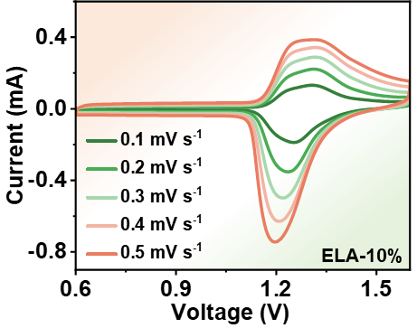
Fig. S26 Variable scan rate CV curves of ELA-10% full cell

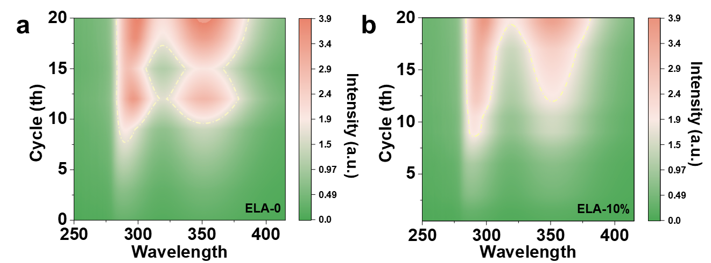
Fig. S27 UV-vis spectra contour plots of iodine dissolution from (a) ELA-0 and (b) ELA-10% electrodes
Table S1 Performance comparison between this work and recently reported imidazole-based additives as well as zinc–iodine batteries
 | Strategy | Current density  (mA cm⁻²) | Capacity  (mAh cm⁻²) | Cycle life | Cumulative capacity  (A h cm⁻²) | Reference
1 | BmBr | 1 | 1 | 2600 | 2.6 | [S15]
2 | IS | 1 | 1 | 1800 | 1.8 | [S16]
2 | IS | 3 | 3 | 400 | 1.2 | [S16]
3 | Bilayer SEI | 2 | 1 | 1600 | 3.2 | [S17]
3 | Bilayer SEI | 10 | 10 | 950 | 9.5 | [S17]
4 | HEI | 1 | 1 | 4200 | 4.2 | [S18]
4 | HEI | 10 | 10 | 250 | 2.5 | [S18]
5 | BM | 4 | 4 | 2000 | 8 | [S19]
6 | DCHE | 1 | 1 | 4800 | 4.8 | [S20]
6 | DCHE | 5 | 5 | 800 | 4 | [S20]
7 | HSL | 2 | 2 | 3800 | 7.6 | [S21]
7 | HSL | 10 | 10 | 400 | 4 | [S21]
8 | TXE | 2 | 2 | 4000 | 8 | [S22]
9 | SP | 5 | 2 | 1200 | 6 | [S23]
10 | PVEMA | 1 | 1 | 3500 | 3.5 | [S24]
10 | PVEMA | 20 | 10 | 450 | 9 | [S24]
11 | ELA | 5 | 2 | 5400 | 27 | this work
11 | ELA | 8 | 1 | 5500 | 44 | this work

Supplementary References
- J. Perdew, K. Burke, M. Ernzerhof, Generalized gradient approximation made simple. Phys. Rev. Lett. 77(18), 3865–3868 (1996). https://doi.org/10.1103/PhysRevLett.77.3865
- J.P. Perdew, A. Ruzsinszky, G.I. Csonka, O.A. Vydrov, G.E. Scuseria et al., Restoring the density-gradient expansion for exchange in solids and surfaces. Phys. Rev. Lett. 100(13), 136406 (2008). https://doi.org/10.1103/PhysRevLett.100.136406
- J.G.C.M. van Duijneveldt-van de Rijdt, F.B. van Duijneveldt, Ab initio potential energy surface for the low-frequency out-of-plane bending motions of the water trimer. Chem. Phys. Lett. 237(5–6), 560–567 (1995). https://doi.org/10.1016/0009-2614(95)00343-3
- P. Hobza, Z. Havlas, Counterpoise-corrected potential energy surfaces of simple H-bonded systems. Theor. Chem. Acc. 99(6), 372–377 (1998). https://doi.org/10.1007/s002140050034
- F. Neese, The ORCA Program system. Wires Comput. Mol. Sci. 2(1), 73–78 (2012). https://doi.org/10.1002/wcms.81
- I.T. Todorov, W. Smith, DL_POLY₃: the CCP5 national UK code for molecular-dynamics simulations. Philos. Trans. A Math. Phys. Eng. Sci. 362(1822), 1835–1852 (2004). https://doi.org/10.1098/rsta.2004.1419
- S.Nosé, A molecular dynamics method for simulations in the canonical ensemble. Mol. Phys. 52(2), 255–268 (1984). https://doi.org/10.1080/00268978400101201
- W. Hoover, Canonical dynamics: Equilibrium phase-space distributions. Phys. Rev. A Gen. Phys. 31(3), 1695–1697 (1985). https://doi.org/10.1103/physreva.31.1695
- P.P. Ewald, Die berechnung optischer und elektrostatischer gitterpotentiale. Ann. Der Phys. 369(3), 253–287 (1921). https://doi.org/10.1002/andp.19213690304
- H.J.C. Berendsen, J.R. Grigera, T.P. Straatsma, The missing term in effective pair potentials. J. Phys. Chem. 91(24), 6269–6271 (1987). https://doi.org/10.1021/j100308a038
- M.P. Allen, D.J. Tildesley, Computer Simulation of Liquids, Oxford University Press, 2017. https://doi.org/10.1093/oso/9780198803195.001.0001
- S.L. Mayo, B.D. Olafson, W.A. Goddard, DREIDING: a generic force field for molecular simulations. J. Phys. Chem. 94(26), 8897–8909 (1990). https://doi.org/10.1021/j100389a010
- H.A. Lorentz, Ueber die Anwendung des Satzes vom Virial in der kinetischen Theorie der Gase. Ann. Der Phys. 248(1), 127–136 (1881). https://doi.org/10.1002/andp.18812480110
- C.M. Breneman, K.B. Wiberg, Determining atom-centered monopoles from molecular electrostatic potentials. The need for high sampling density in formamide conformational analysis. J. Comput. Chem. 11(3), 361–373 (1990). https://doi.org/10.1002/jcc.540110311
- Y. Lv, C. Huang, M. Zhao, M. Fang, Q. Dong et al., Synergistic anion-cation chemistry enables highly stable Zn metal anodes. J. Am. Chem. Soc. 147(10), 8523–8533 (2025). https://doi.org/10.1021/jacs.4c16932
- L. Liu, X. Wang, Z. Hu, X. Wang, Q. Zheng et al., Electric double layer regulator design through a functional group assembly strategy towards long-lasting zinc metal batteries. Angew. Chem. Int. Ed. 63(30), e202405209 (2024). https://doi.org/10.1002/anie.202405209
- Y. Meng, M. Wang, J. Wang, X. Huang, X. Zhou et al., Robust bilayer solid electrolyte interphase for Zn electrode with high utilization and efficiency. Nat. Commun. 15(1), 8431 (2024). https://doi.org/10.1038/s41467-024-52611-z
- J. Chen, G. Ou, P. Liu, W. Fan, B. Li et al., Pyrrolic-nitrogen chemistry in 1-(2-hydroxyethyl)imidazole electrolyte additives toward a 50, 000-cycle-life aqueous zinc-iodine battery. Angew. Chem. Int. Ed. 64(2), e202414166 (2025). https://doi.org/10.1002/anie.202414166
- Y. Wang, Y. Cui, M. Zhao, J. Wang, X. Liu et al., Zwitterion-mediated interface chemistry for practical Zn-iodine batteries. Nat. Commun. 16, 5565 (2025). https://doi.org/10.1038/s41467-025-60488-9
- X. Huang, T. Pan, B. Zhang, J. Wang, T. Hu et al., Functionally segregated ion regulation enables dual confinement effect for highly stable zinc-iodine batteries. Adv. Mater. 37(30), e2500500 (2025). https://doi.org/10.1002/adma.202500500
- T. Yang, T. Su, M. Xu, D. Wang, W. Ren et al., Dienoic-acid coupling effect induced hierarchical interface for high-performance zinc metal batteries. Angew. Chem. Int. Ed. 64(41), e202512780 (2025). https://doi.org/10.1002/anie.202512780
- H. Wu, S.-J. Zhang, J. Vongsvivut, M. Jaroniec, J. Hao et al., Aqueous zinc-iodine batteries with ultra-high loading and advanced performance. Joule 9(7), 102000 (2025). https://doi.org/10.1016/j.joule.2025.102000
- S.-J. Zhang, J. Hao, H. Wu, Q. Chen, C. Ye et al., Protein interfacial gelation toward shuttle-free and dendrite-free Zn-iodine batteries. Adv. Mater. 36(35), e2404011 (2024). https://doi.org/10.1002/adma.202404011
- C. Wu, Y. Pan, Y. Jiao, P. Wu, α-methyl group reinforced amphiphilic poly(ionic liquid) additive for high-performance zinc-iodine batteries. Angew. Chem. Int. Ed. 64(21), e202423326 (2025). https://doi.org/10.1002/anie.202423326

