Supporting Information for
Synergistic sp-C/sp-N Anchoring of Metal Single Atoms on Graphdiyne for Enhanced Microwave Absorption
Yihao Fan ^{1, 2}, Haichuan Cheng ¹, Pengyu Deng ¹, Jianfeng Wu ^{1, 2,※} , Baoliang Zhang ^{1, 3, ※}
¹ School of Chemistry and Chemical Engineering, Northwestern Polytechnical University, Xi’an710072, People’s Republic of China
² Xi’an Key Laboratory of Functional Organic Porous Materials, Northwestern Polytechnical University, Xi’an 710129, People’s Republic of China
³ Shaanxi Engineering and Research Center for Functional Polymers on Adsorption and Separation, Sunresins New Materials Co. Ltd., Xi’an 710072, People’s Republic of China
※Corresponding authors. E-mail: jfwu@nwpu.edu.cn (Jianfeng Wu); blzhang@nwpu.edu.cn (Baoliang Zhang)
S1 Experimental Section
S1.1 Microwave absorption test
The electromagnetic parameters of the powder samples were measured by a vector network analyzer (ZNLE18, Rohde & Schwarz) using the coaxial method. The samples were mixed with paraffin wax, and then coaxial rings with an inner diameter of 3.04 mm and an outer diameter of 7 mm were machined with a mold. The filler content of all the samples was 24%.
Reflection loss (RL) is an important evaluation index of electromagnetic wave absorption performance. According to the transmission line theory, RL can be calculated by Eqs. S1 and S2:
 | $$Z=\left|\frac{Z_{in}}{Z_{O}}\right|=\sqrt{\left|{μ_{r}}/{ε_{r}}\right|} tanh\left[j\left({2πfd}/c\right)\sqrt{μ_{r}ε_{r}}\right]$$ | (S1)

 | $$RL\left(dB\right)=20 \log_{10}\left|\frac{Z_{in}-Z_{0}}{Z_{in}+Z_{0}}\right|$$ | (S2)
According to Debye's theory, the imaginary part of the complex permittivity ($ε^{''}$) can be divided into conduction loss ($ε_{C}^{''}$) and polarisation loss ($ε_{P}^{''}$) by means of Eqs. S3 and S4:
 | $$ε^{''}=\frac{ωτ(ε_{s}-ε_{∞})}{1+ω^{2}τ^{2}}+\frac{σ}{ωε_{0}}=ε_{p}^{''}+ε_{C}^{''}$$ | (S3)
 | $$ε_{C}^{''}=\frac{α}{ωε_{0}}$$ | (S4)
The attenuation constant ($α$) was calculated by Eqs. S5:
 | $$α=\sqrt{\left(μ^{''}ε^{''}-ε^{'}μ^{'}\right)+\sqrt{{(μ^{''}ε^{''}-ε^{'}μ^{'})}^{2}+{(μ^{''}ε^{''}+ε^{'}μ^{'})}^{2}}}$$ | (S5)
S1.2 CST simulation
Radar cross section (RCS) was simulated using CST Studio Suite 2022. Four models were simulated. In the radar cross-section simulation, the model consists of an upper absorbing layer and a lower perfect electrical conductor (PEC) layer with thicknesses of 2.0 mm and 1.0 mm, respectively. In addition, the square model was designed with a side length of 200 mm. A linearly polarized plane wave was defined as the excitation port, with the microwave propagating in the negative direction along the Y-axis and the direction of the magnetic field along the Z-axis. Open boundary conditions were used in this direction. The radar RCS of the simulated sample was represented by the following Eq. S6:
 | $$σ(dBm^{2} )=10log\left[{\frac{4πS}{λ^{2}}\left|\frac{E_{s}}{E_{i}}\right|}^{2}\right]$$ | (S6)
Where $S$ is the area of the simulated plate, $λ$ is the length of the incident microwave, Es is the electric field strength of the transmitted wave, and $Ei$ is the electric field strength of the received wave.
S1.3 DFT calculation
All the DFT calculations were conducted based on the Vienna Ab initio Simulation Package (VASP). The exchange-correlation potential was described by the Perdew−Burke−Ernzerhof (PBE) generalized gradient approach (GGA). The electron-ion interactions were accounted by the projector augmented wave (PAW). All DFT calculations were performed with a cut-off energy of 400 eV, and the 3×3×1 Gamma centered Monkhorst-Pack grids k-points were selected to sample the Brillouin zone integration. The energy and force convergence criteria of the self-consistent iteration were set to 10-4 eV and 0.02 eV Å-1, respectively. DFT-D3 method was used to describe van der Waals (vdW) interactions.

S2 Supplementary Figures and Tables
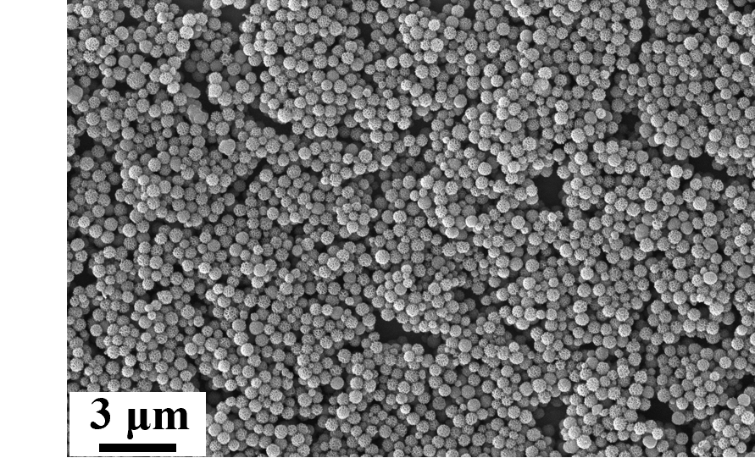
Fig. S1 SEM figure of Cu₂O/GDY
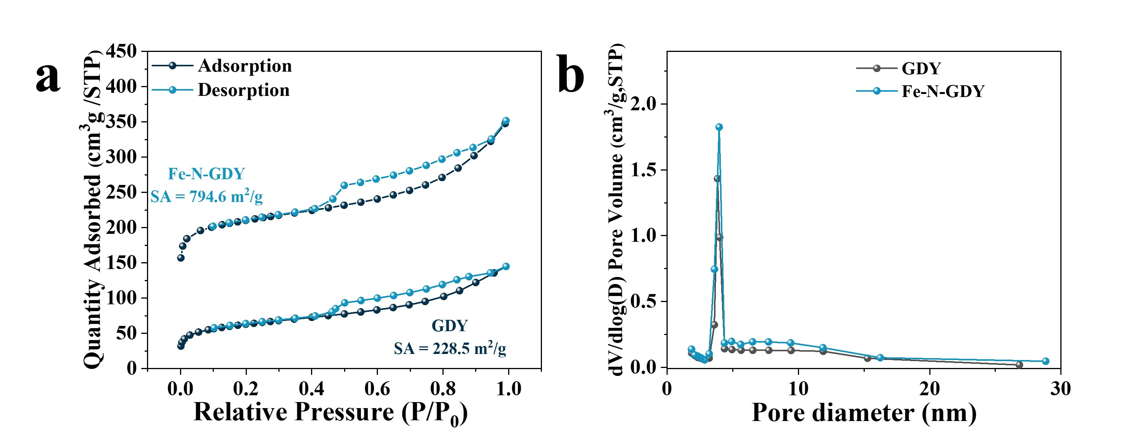
Fig. S2 a Nitrogen adsorption-desorption isotherms and b pore size distribution curves
Fig. S3 FTIR curves of GDY and Fe-N-GDY

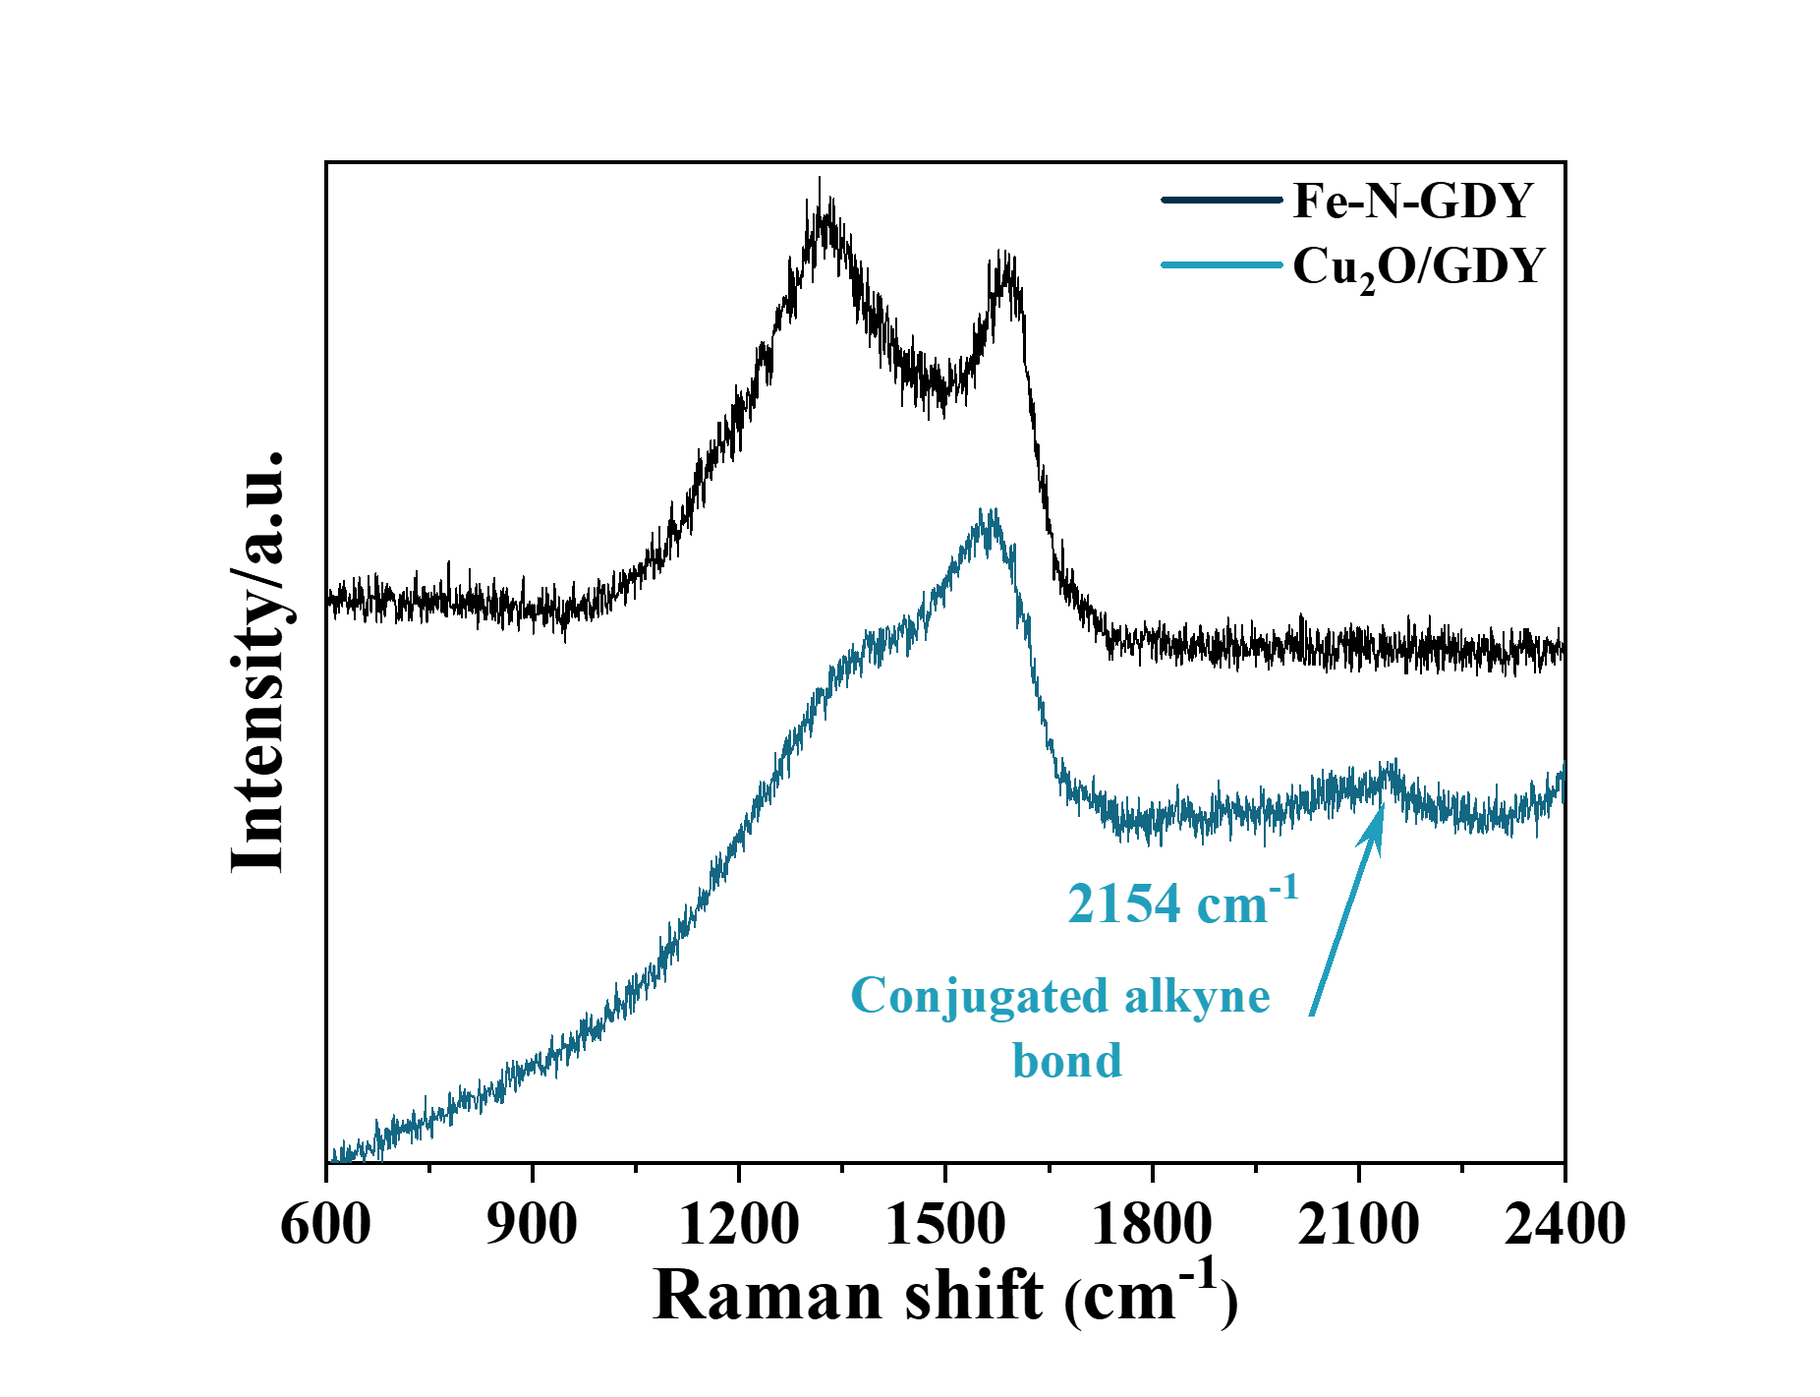
Fig. S4 Raman spectra of Cu₂O/GDY

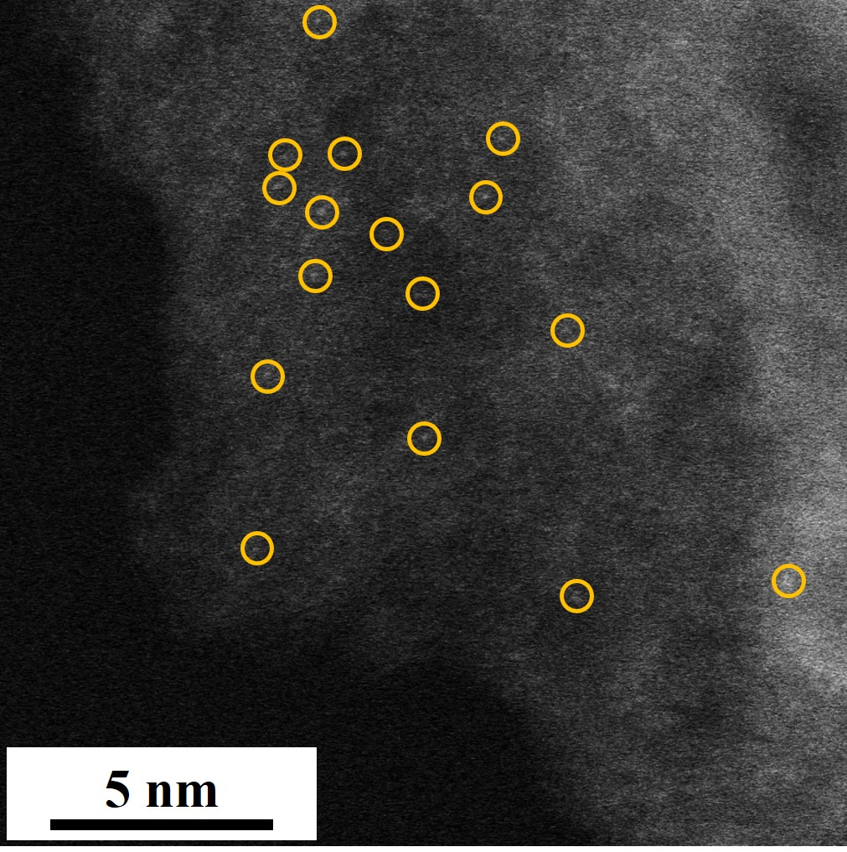
Fig. S5 Double Cs-corrected image of Fe-GDY
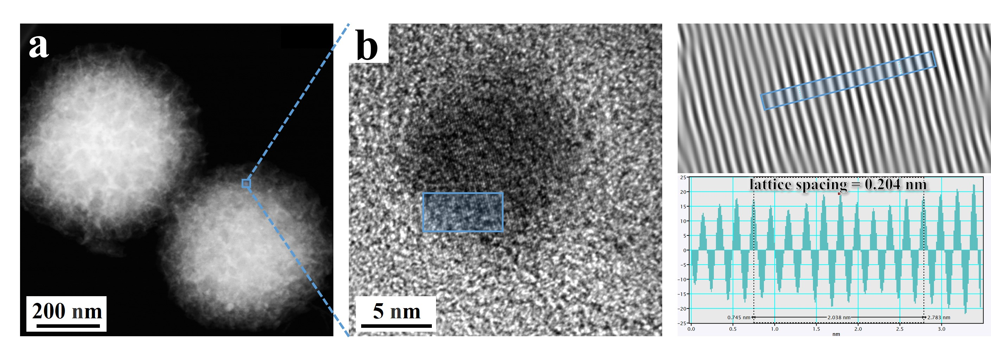
Fig. S6 a HAADF-STEM image and b lattice analysis of Fe NPs/Fe-N-GDY
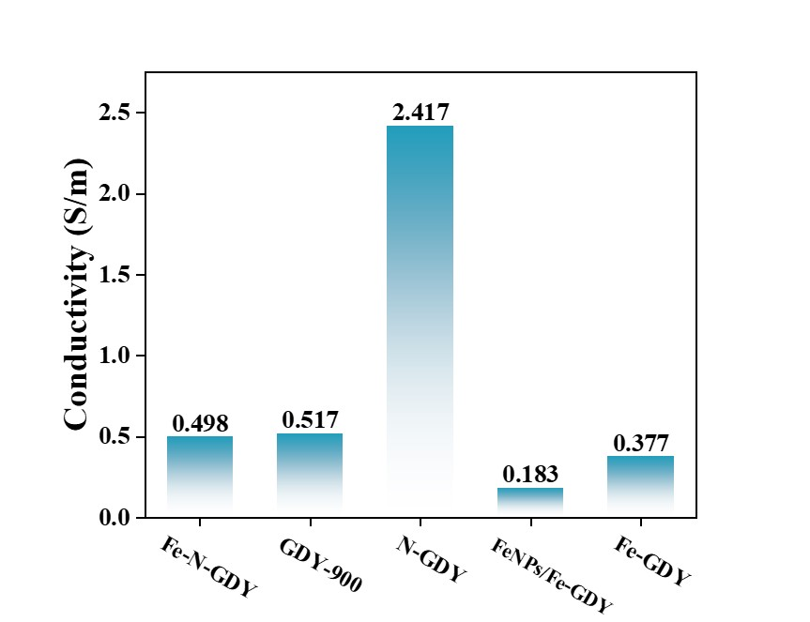
Fig. S7 Electrical conductivity measurement via the four-probe method

Fig. S8 a Real part $ε^{'}$ and b imaginary part $ε''$ of complex permittivity

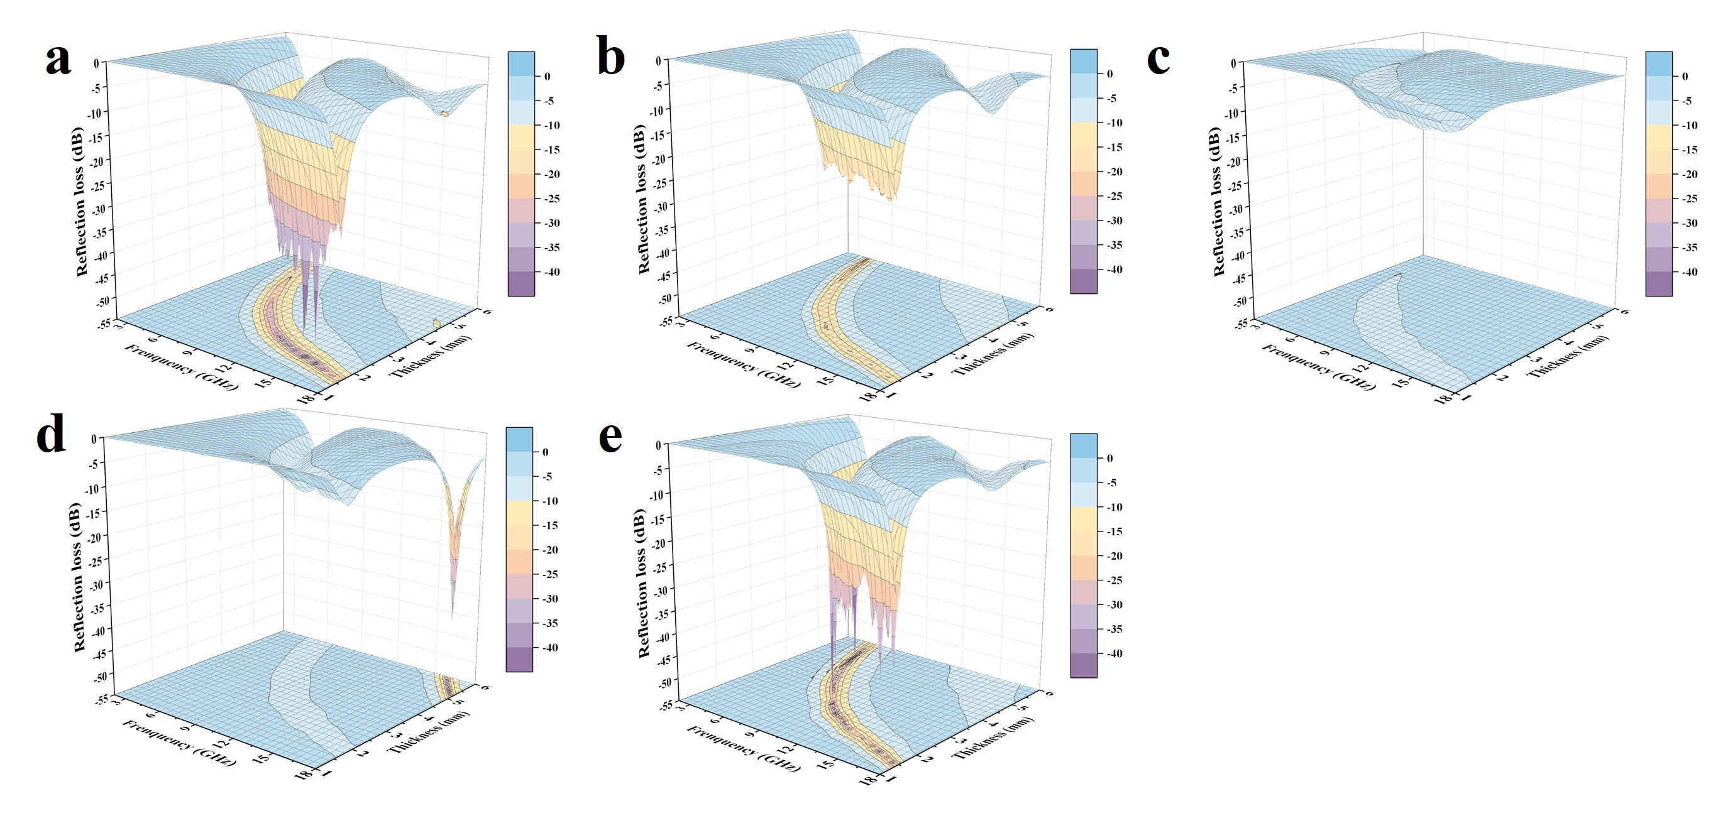
Fig. S9 3D RL-frequency plots of the series of microwave absorbers: a Fe-N-GDY, b GDY-900, c N-GDY, d Fe NPs/Fe-N-GDY, e Fe-GDY
Fig. S10 Plots of reflection losses and λ/4 with frequency of a GDY-900, b Fe-N-GDY and c Fe-G

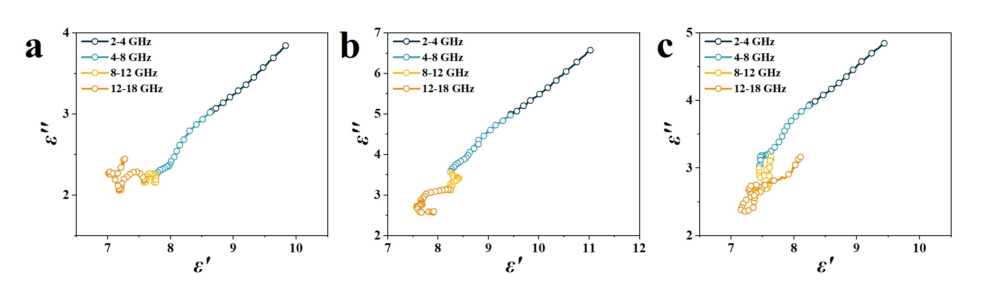
Fig. S11 $ε^{'}-ε''$ curves of a GDY-900, b Fe-N-GDY and c Fe-GDY

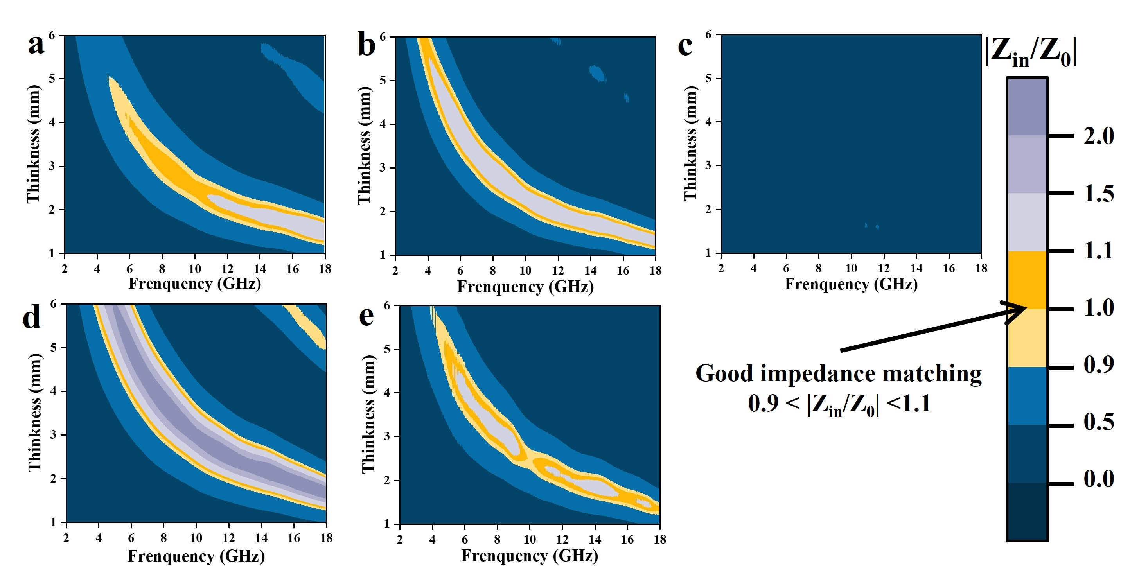
Fig. S12 |Z_{in}/Z₀| two-dimensional contour maps of a Fe-N-GDY, b GDY-900, c N-GDY, d Fe NPs/Fe-N-GDY, e Fe-GDY
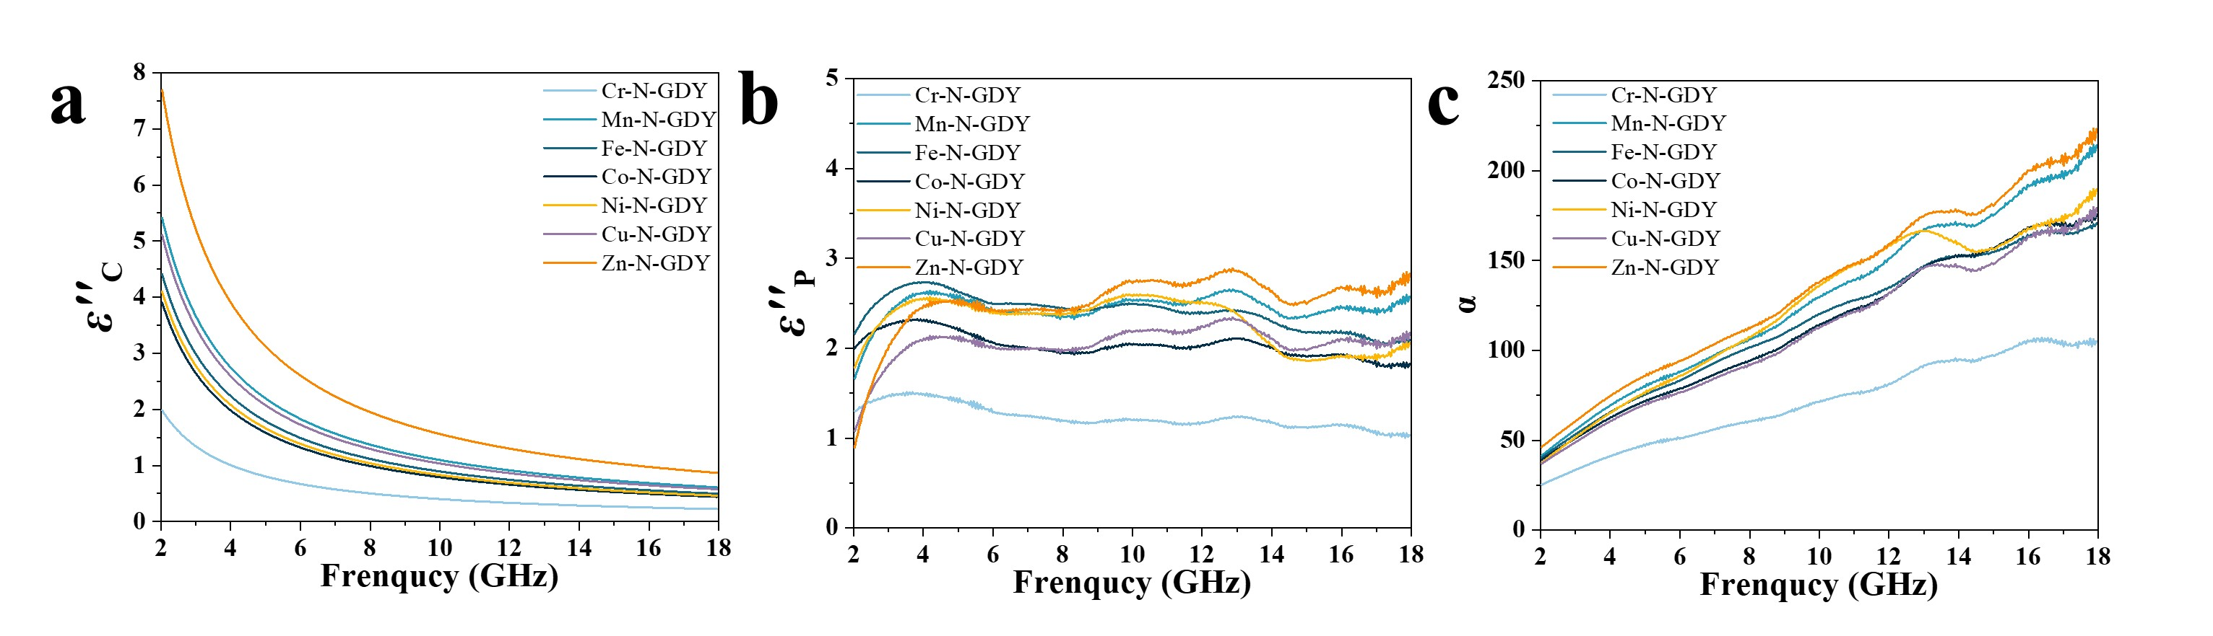
Fig. S13 a ${ε''}_{C}$, b ${ε''}_{P}$, and c $ɑ$ of the samples
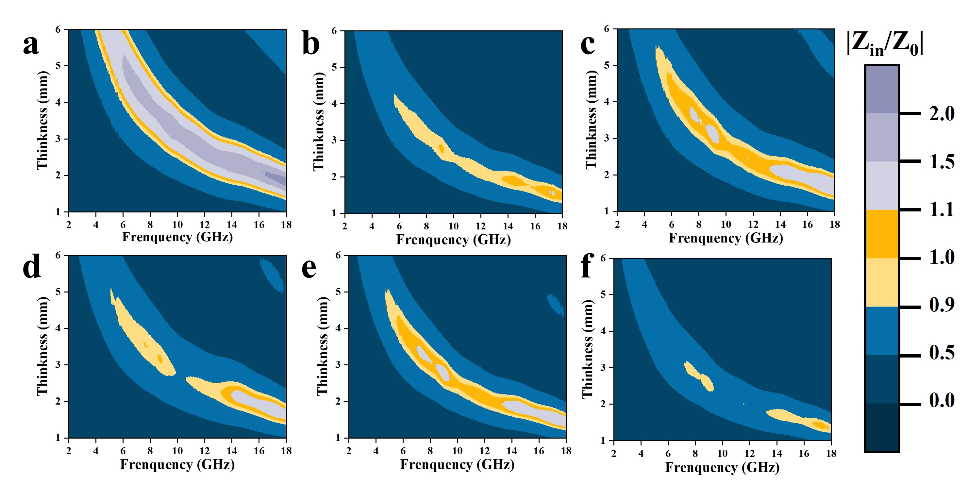
Fig. S14 |Z_{in}/Z₀| two-dimensional contour maps of a Cr-N-GDY, b Mn-N-GDY, c Co-N-GDY, d Ni-N-GDY, e Cu-N-GDY, and f Zn-N-GDY

Fig. S15 Cole-Cole plots of a Cr-N-GDY, b Mn-N-GDY, c Co-N-GDY, d Ni-N-GDY, e Cu-N-GDY, and f Zn-N-GDY

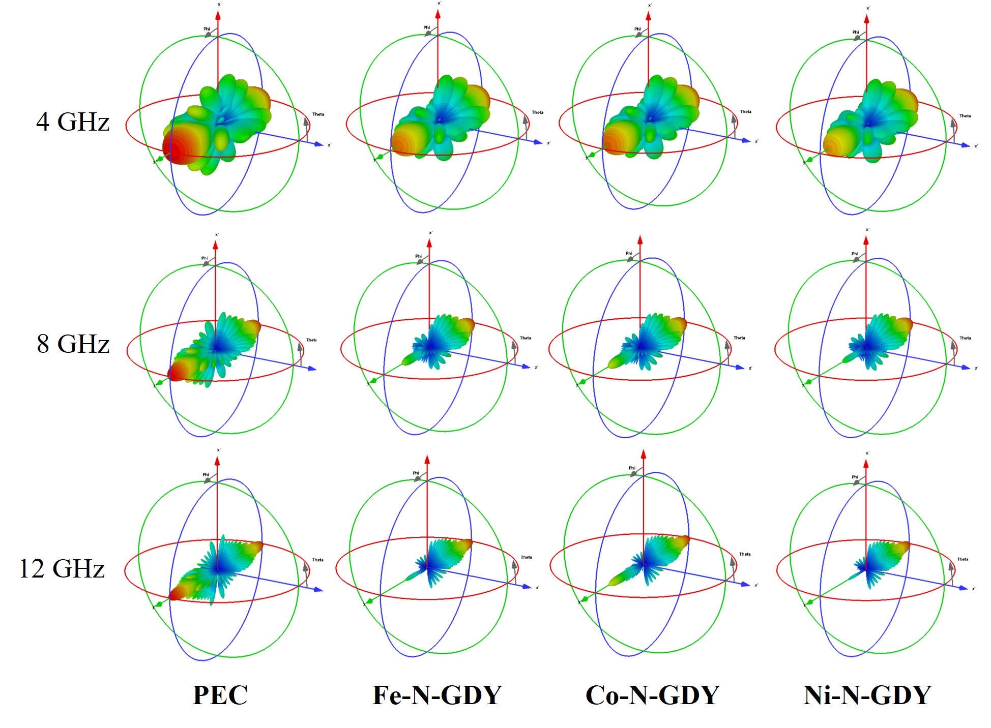
Fig. S16 3D RCS reflection signals of each sample at 4 GHz, 8GHz and 12GHz
Table S1 The elemental contents determined by ICP-MS
Samples | Fe-GDY | Fe-N-GDY | Fe NPs/Fe-N-GDY
Fe wt% | 1.2 | 1.6 | 5.4

Table S2 Curvefit parameters for Fe K-edge EXAFS for Fe-N-GDY
Path | C.N. | R (Å) | σ² (Å²) | ΔE₀ (eV) | R factor
Fe-N | 2 | 1.92±0.04 | 0.012±0.003 | -6.0±2.6 | 0.019
Fe-C | 2 | 2.03±0.04 | 0.012±0.003 | -6.0±2.6 | 0.019
C. N. is the coordination number; R is interatomic distance; σ² is Debye-Waller factor (the Mean Square Relative Displacement (MSRD)); ΔE₀ is inner potential correction. R factor is used to value the goodness of the fitting. Data ranges:2.5≤k≤14 Å,1.0≤R≤3.0 Å. The number of variables is 4.

Table S3 I_{D}/I_{G} of the related samples
Samples | Fe-N-GDY | Fe NPs/Fe-N-GDY | Fe-GDY | N-GDY | GDY-900
I_{D}/I_{G} | 0.88 | 0.95 | 0.90 | 0.81 | 0.84

