Supporting Information for
Constructing Intrinsically Safe Lithium-Ion Battery Energy Storage via Gradient-Laminated Ceramifiable Silicone Foams
Shuilai Qiu^{1,2}, Jingyao Xu ^{1,2}, Congling Shi ³*, Laibin Zhang ^{1,2}
¹ College of Safety and Ocean Engineering, China University of Petroleum-Beijing, 18 Fuxue Road, Beijing 102249, P. R. China
² Key Laboratory of Oil and Gas Safety and Emergency Technology, Ministry of Emergency Management, Beijing 102249, P.R. China
³ Beijing Key Lab of MFPTS, China Academy of Safety Science and Technology, Beijing 100012, P.R. China

*Corresponding author. E-mail: shicl@chinasafety.ac.cn (Congling Shi)

Supplementary Figures and Tables
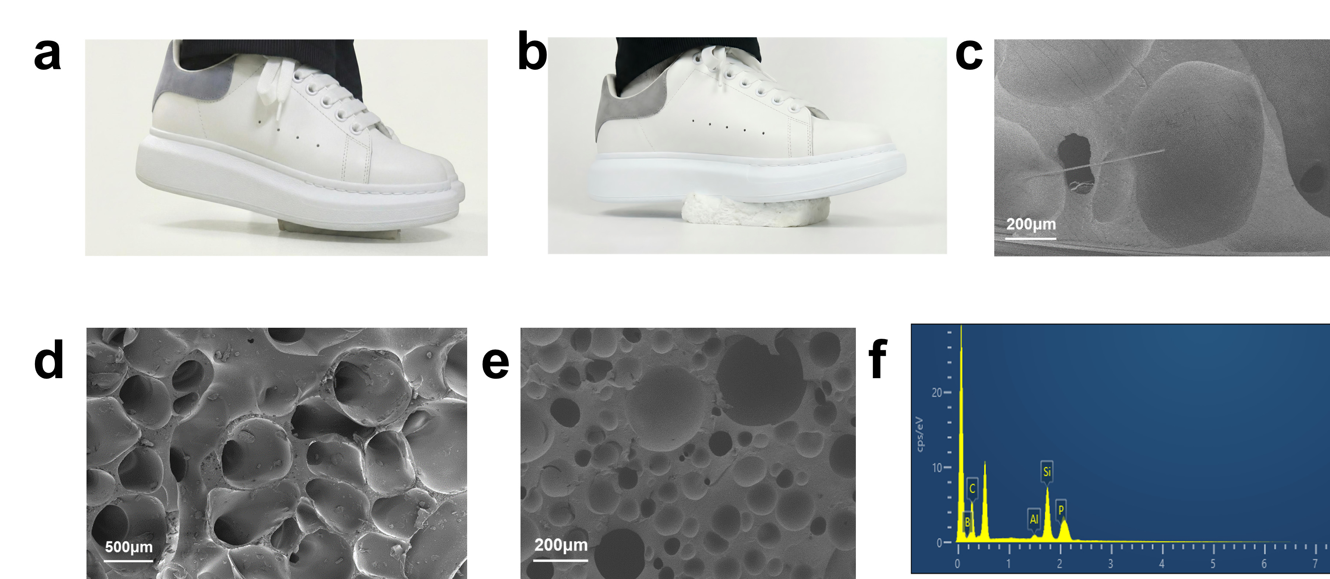
Fig S1 a, b Compressive properties of SF/GFF_{APP-ZB-Aero-Kao}, c Interfacial bonding between SF/GFF_{APP-ZB-Aero-Kao} and glass fiber fabric observed under scanning electron microscopy (SEM), d Foam cell structure, e Microstructure of SF, f Elemental composition distribution within the SF/GFF_{APP-ZB-Aero-Kao}.
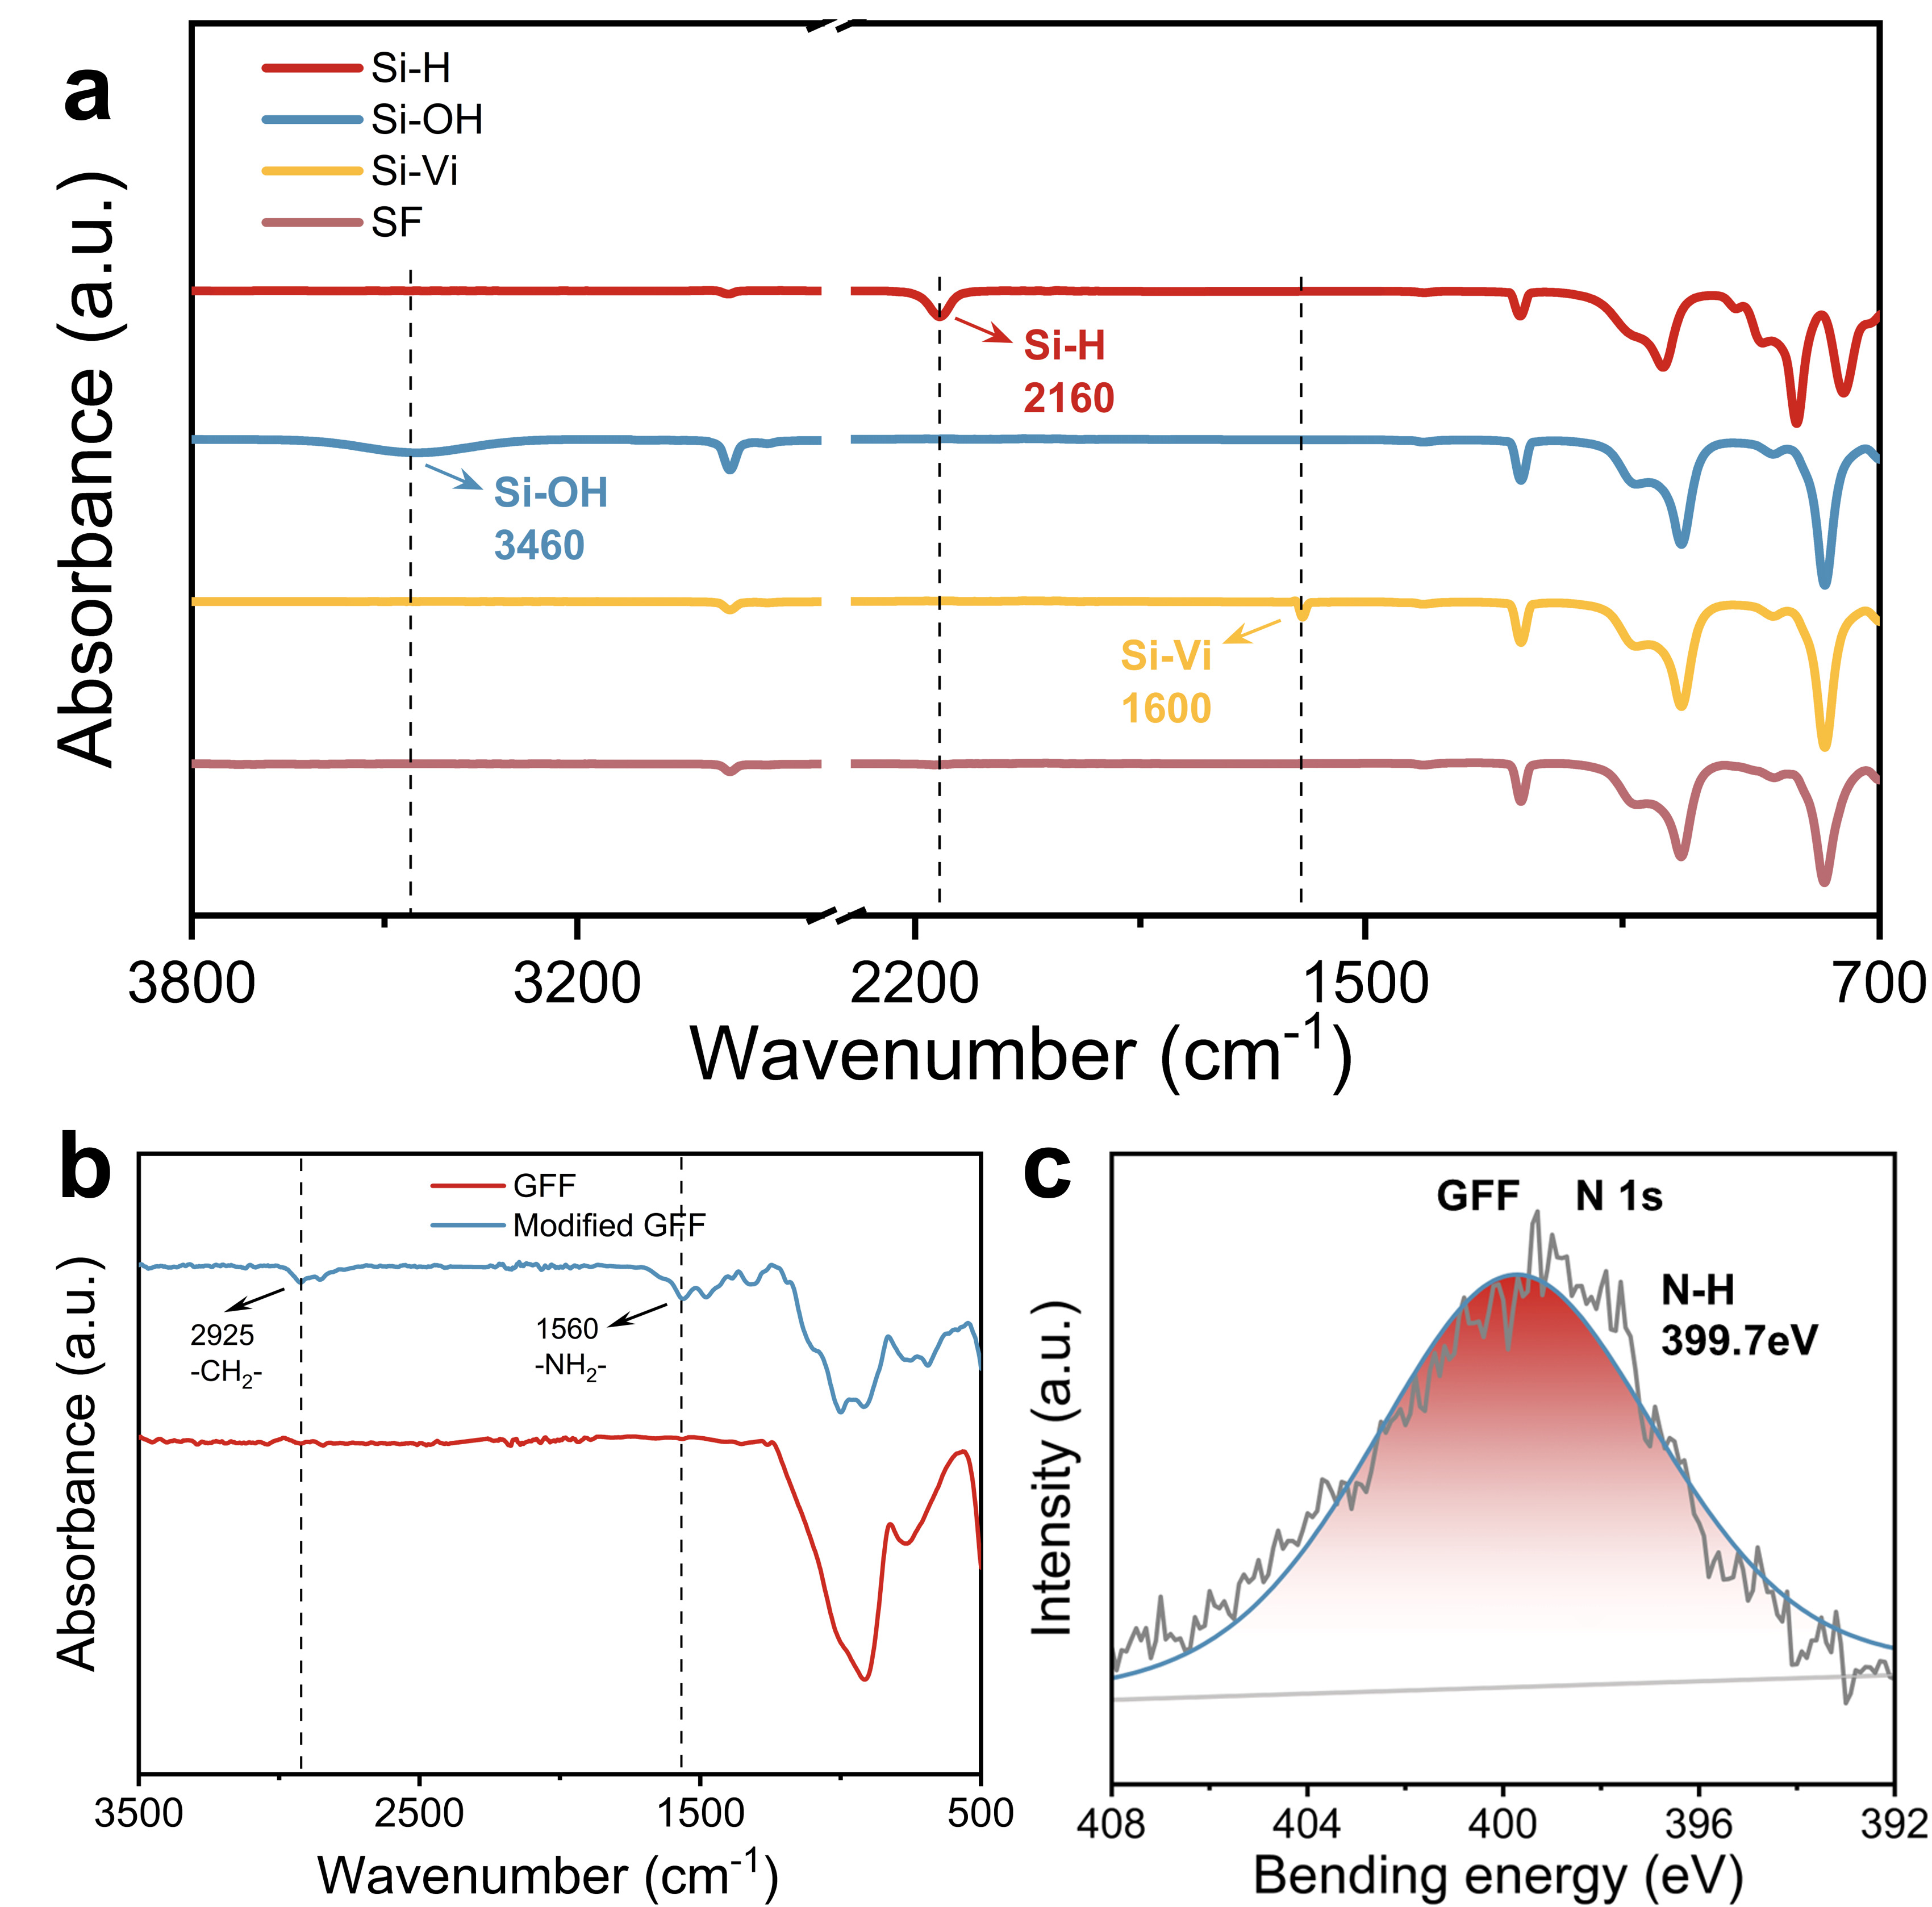
Fig S2 a FT-IR spectra of various prepolymers (OH-PDMS, H-PDMS, Vi-PDMS and SF) and b FT-IR spectra of GFF and modified GFF, c XPS N 1s spectrum of the modified GFF.

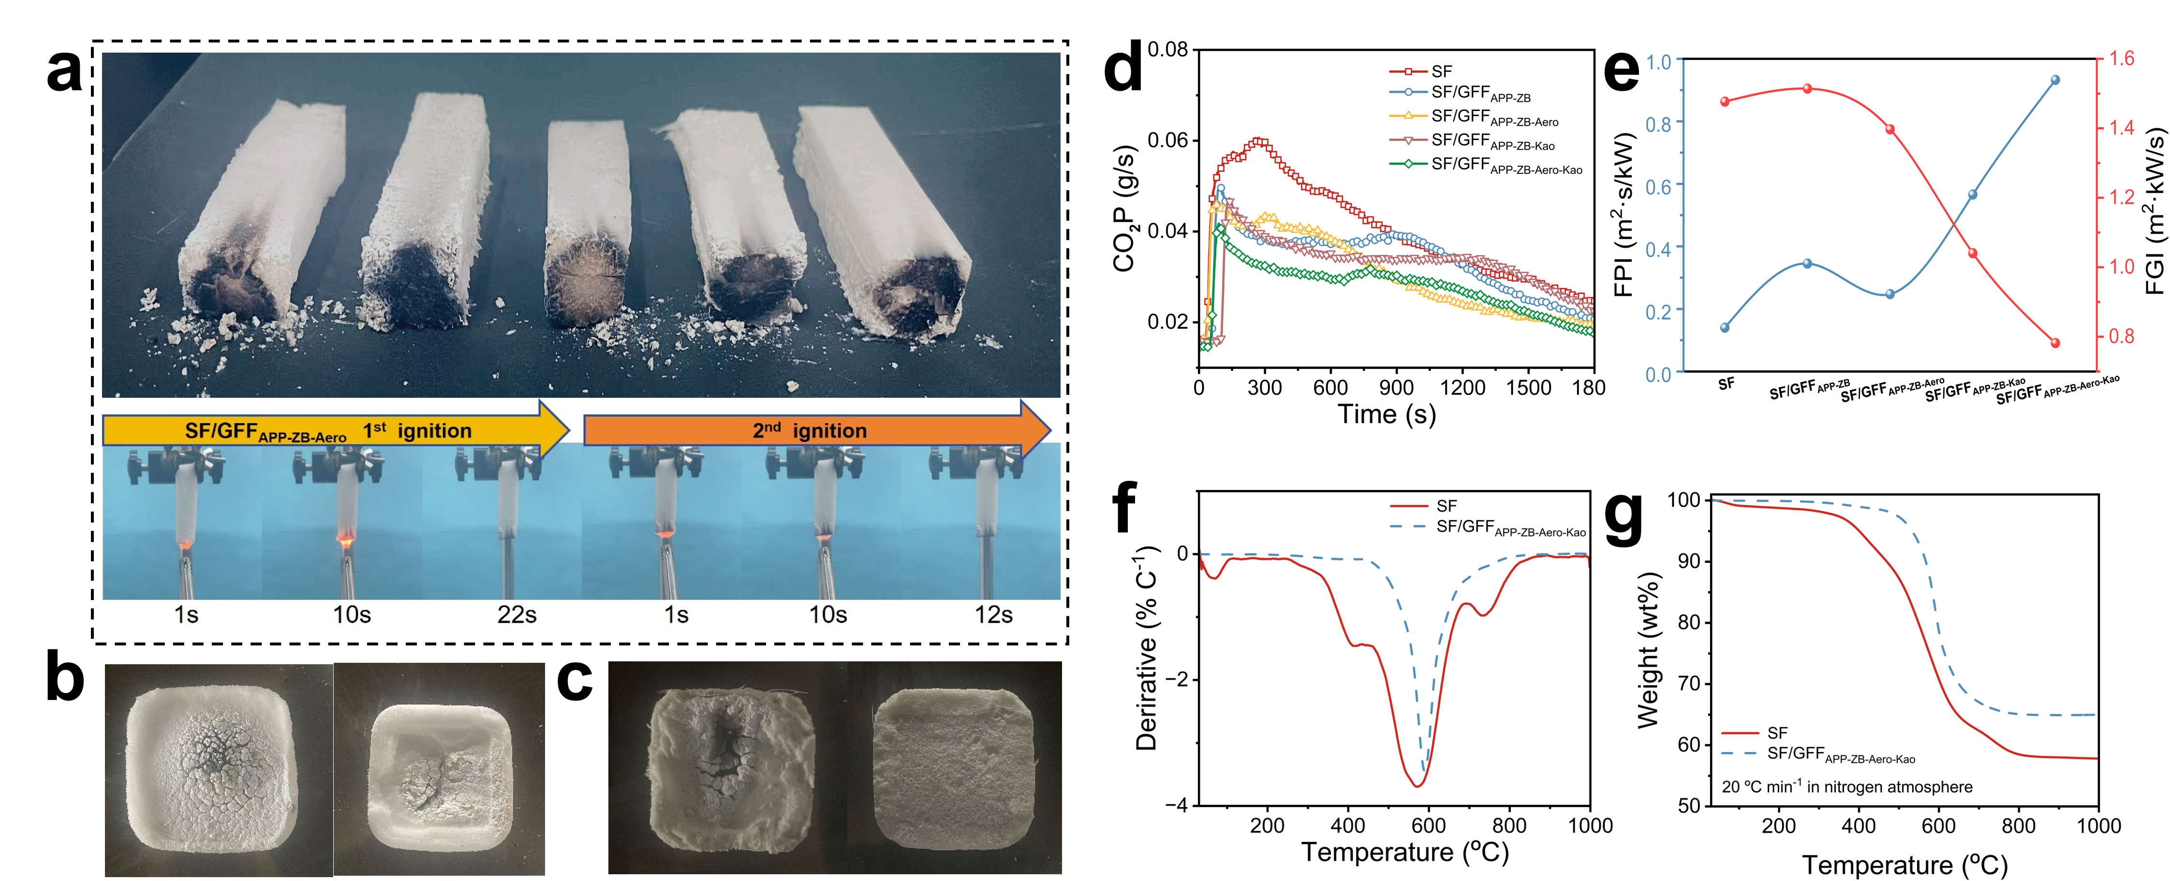
Fig S3 a Char layer morphology at the sample interface post-ignition testing, b Front and rear photographs of SF and c SF/GFF_{APP-ZB-Aero-Kao} following combustion testing, d CO₂P curves derived from cone calorimetry tests and e FPI/FGI performance curves; f, g TG analysis curves for SF and SF/GFF_{APP-ZB-Aero-Kao}.

Fig S4 Fire-resistant properties of SF, SF/GFF_{APP-ZB}, SF/GFF_{APP-ZB-Kao}, and SF/GFF_{APP-ZB-Aero-Kao}.
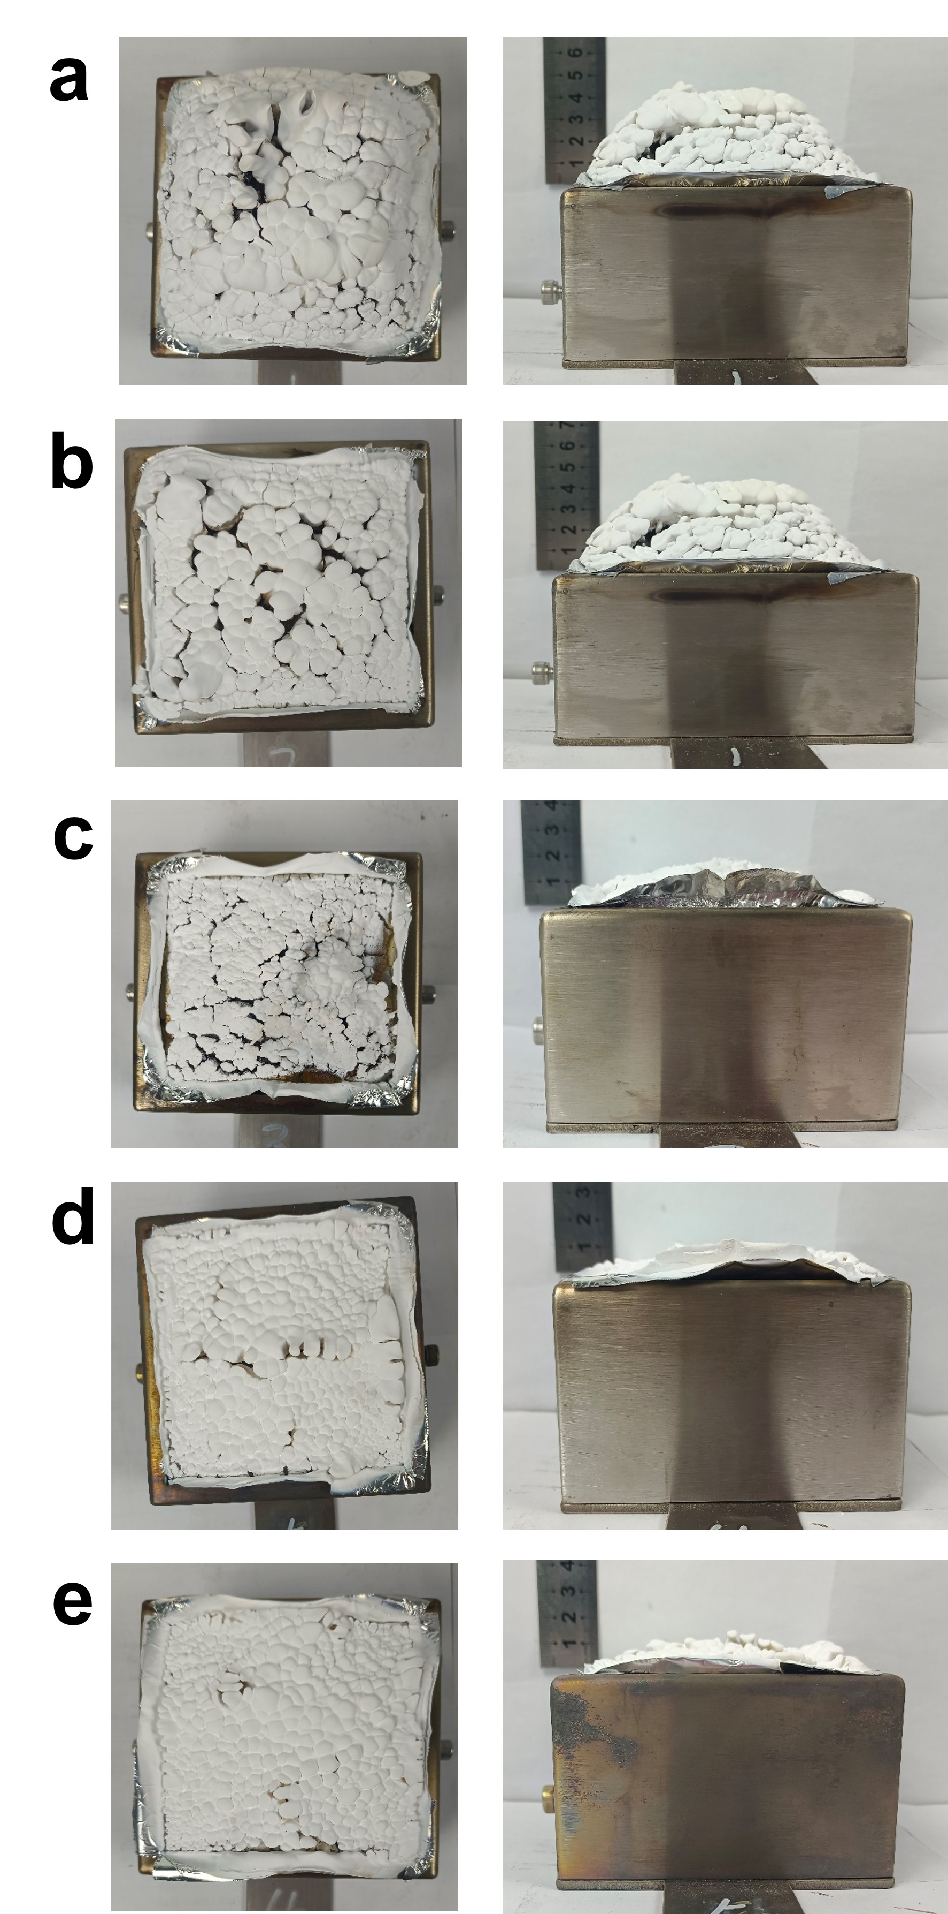
Fig S5 a Post-cone calorimetry testing comparison of SF, b SF/GFF_{APP-ZB}, c SF/GFF_{APP-ZB-Aero}, d SF/GFF_{APP-ZB-Kao},and e SF/GFF_{APP-ZB-Aero-Kao} showing comparative front and side-view images.

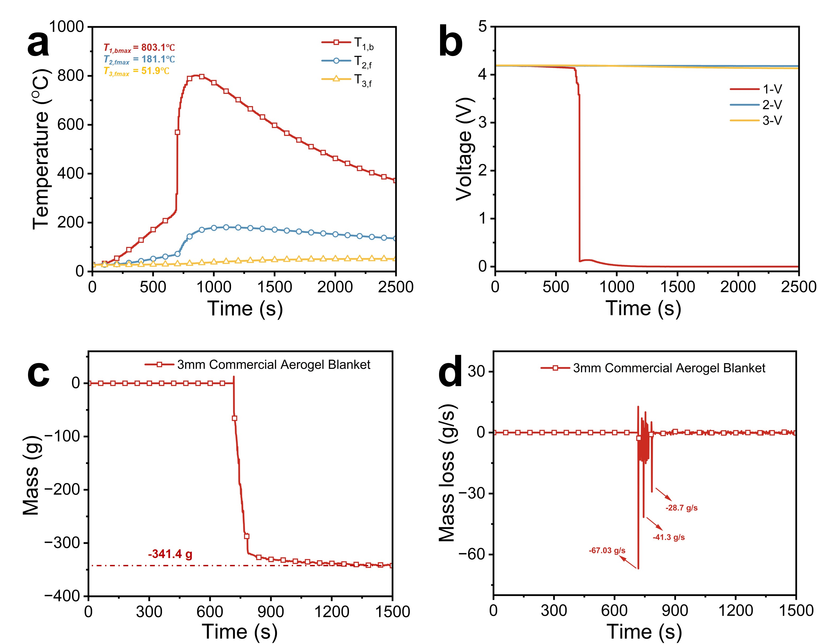
Fig S6 TRP test results of the battery module using a 3 mm commercial aerogel blanket as the thermal barrier. a Temperature evolution curves on the front and rear surfaces of the batteries. b Voltage fluctuation profiles during the test. c Total mass loss curve. d Mass loss rate curve.

Table S1 Thermal conductivity testing data at 25 ℃.
Sample code | SF | SF/GFF | SF/GFF_{APP-ZB-Aero-Kao}
Thermal conductivity (W/m·K) | 0.094 | 0.072 | 0.046
Thermal conductivity of SF, SF/GFF and SF/GFF_{APP-ZB-Aero-Kao} at 25℃, respectively.

Table S2 Vertical burning test data
Sample code | SF | SF/GFF_{APP-ZB} | SF/GFF_{APP-ZB-Kao} | SF/GFF_{APP-ZB-Aero-Kao}
t ₁(s) | 18±3 | 6±1 | 3±1 | 2±1
t₂ (s) | 5±2 | 4±1 | 2±1 | 1±1
t₁+t ₂ (s) | 115 | 50 | 25 | 15
t₂+t ₃(s) | 21±4 | 9±2 | 4±1 | 2±1
Dripping (Y/N) | N | N | N | N
UL-94 ratings | V1 | V0 | V0 | V0
t₁ and t₂ indicate the combustion times of an individual sample after removing the burner.
The aggregate t₁+ t₂ refers to the total burning duration for any condition set for the 5 specimens.
t₂+t₃ measures the total time of flaming and glowing for a single sample following the second flame application.

