Supporting Information for
Unlocking the Synergistic Promoter Role of Phosphorus in Evolving NiFe Phosphides for Enhanced Water Oxidation
Ningning Shi ^{1, 2, 3, #}, Mingcheng Gao ^{1, 2, #}, M. Maneesha ⁴, C. S. Praveen ^{4,} *, Panpan Liu ^{1, 2}, Shengnan Yue ^{1, 2}, Wangjing Xie ^{1, 2}, Dechao Chen ¹, Yu Tang ¹, Yuanqing Wang ^{5,} *, Hua Fan ¹, and Xing Huang ^{1, 2, 3,} *
¹ State Key Laboratory of Green and Efficient Development of Phosphorus Resources, College of Chemistry, Fuzhou University, 350108 Fuzhou, P. R. China
² Electron Microscopy Center, Qingyuan Innovation Laboratory, 362100 Quanzhou, P. R. China
³ School of Chemistry, Chemical Engineering and Materials, Jining University, 273155 Qufu, P. R. China
⁴ International School of Photonics, Cochin University of Science and Technology, 682022 Cochin, India
⁵ Materials Genome Institute, Shanghai University, 200444 Shanghai, P. R. China
# Ningning Shi and Mingcheng Gao contributed equally to this work.
*Corresponding authors. E-mail: praveen@gmail.com (C. S. Praveen); yuanqingwang@shu.edu.cn (Yuanqing Wang); xinghuang@fzu.edu.cn (Xing Huang)
S1 Supplementary Experimental Section
S1.1 Electrochemical measurements
The electrochemical measurements were performed in a single-chamber three-electrode reactor with a CHI660e electrochemical analyzer (CH Instruments, Inc., Shanghai). For high current density durability tests at 500 mAcm⁻², we used the DH7000D analyzer (Donghua Analytical Instruments Co., Ltd., Jiangsu, capable of ±1 A). The catalysts coated on Carbon Fiber Paper (CFP) were used as the working electrode, the Hg/HgO reference electrode was used as the reference electrode, and a graphite rod was used as the counter electrode. The Hg/HgO electrode converted to a reverse hydrogen electrode (RHE) has been calibrated (see Fig. S11). In this study, E(RHE) = E(Hg/HgO) + 0.9153 V. Each catalyst (2 mg) was dispersed with Nafion (20 μL, 5 wt% in a mixture of lower aliphatic alcohol and water in alcohol (180 μL). The mixture was sonicated for 30 min to form a uniform catalyst ink. 50 µL of the dispersion of homogeneous ink was loaded onto a 2×0.5 cm² carbon fiber paper (CFP) electrode with an effective area of 1×0.5 cm² and allowed to dry naturally at room temperature. The loading amount of the electrocatalysts on CFP was calculated to be 1 mg cm⁻².
Cyclic voltammetry with a scan rate of 5 mV s⁻¹ was conducted for 40 cycles to activate the working electrode. The linear sweep voltammetry measurements were conducted with a scan rate of 5 mV s⁻¹ in 1.0 M KOH solution. Before the experiment, the electrolyte solution was bubbled with Ar (99.999%) for 30 minutes to ensure the formation of an inert gas-saturated solution. The electrochemical impedance spectroscopy (EIS) was carried out at 1.56 V vs. RHE in a frequency range from 100 kHz to 10 mHz with an amplitude of 5 mV. All polarization curves were recorded with 100% iR correction. Unless otherwise explicitly stated, all current densities mentioned herein refer to values normalized per geometric area. Tafel plot of the overpotential vs. log (j) was calculated by fitting the linear portion at low overpotential to the Tafel equation (η = a + b log j, where η is the overpotential, j is the anodic current density, and b is the Tafel slope). The electrochemical surface area (ECSA) of the electrode was evaluated from their double-layer electrochemical capacitances (C_{dl}) in a non-faradic region by a simple cyclic voltammetry method. By plotting the capacitive currents (j_{anodic} – j_{cathodic}) / 2 vs. scan rate, the C_{dl} at the solid–liquid interface of materials can be estimated from the slope. The ECSA of a catalyst is proportional to its C_{dl}: ECSA = $\frac{C_{dl}}{C_{s}}$, where C_{s} is assumed to be 0.040 mF cm⁻² [S1]. The stability tests were also performed using a typical three-electrode system. The specific activity values were calculated from the normalized ECSA values. Mass activity values were calculated from the electrocatalyst loading m (1 mg cm⁻²) and the measured current density j at η = 300 mV according to the equation: Mass activity =$\frac{ j}{m}$. The TOF value was calculated by the equation: TOF = $\frac{I}{αFn}$, where I is the current at η = 300 mV, F is Faraday’s constant, α is the number of electrons consumed to form one O₂ molecule from water (4 electrons for OER), and n is the number of active sites (See details from TOF calculation part).
S1.2 DFT calculations
All DFT calculations were performed using the Quantum ESPRESSO package [S2]. A monolayer Ni(OH)₂ was constructed along the [0001] direction, with the interplanar spacing fixed at 7.6 Å to match the experimental observations. The geometries were taken from Sharon Hammes-Schiffer et.al. [S3], and the atomic positions were relaxed at the PBE+U level with ortho-atomic projections and spin polarization, wherein the PBE exchange-correlation functional was augmented with Hubbard U corrections (U = 5.5 eV for Ni 3d and U = 5.3 eV for Fe 3d) to capture correlation of the Ni and Fe 3d electrons. To account for the core electrons, ultrasoft (For Ni, H, and P) and PAW pseudopotentials, (for Fe and O) taken from the SSSP Library were used [S4]. We employed a kinetic energy cutoff of 60 Ry for the wavefunctions and 480 Ry for the charge density. Brillouin zone integrations employed a Γ-centered (2 × 2 × 2) k-point mesh, with Fermi-Dirac smearing of 0.005 Ry. After full structural optimization, the electronic density of states (DOS) was calculated using the screened hybrid HSE functional, incorporating 15% exact exchange. For the HSE calculations, the geometries optimized at the PBE+U level were kept fixed, and optimized norm-conserving Vanderbilt (ONCV) pseudopotentials [S5] were used for all elements to ensure reliable treatment of the nonlocal Fock exchange. The plane-wave cutoff energies were increased to 80 Ry for wavefunctions, and reduced to 320 Ry for charge density, and 160 Ry for the exact exchange, with the same (2 × 2 × 2) k-point mesh. Marzari-Vanderbilt smearing (width 0.001 Ry) was employed, and the Gygi-Baldereschi method was used for the treatment of exact exchange divergence. The Gibbs free energy of the OER intermediates was calculated using the computational hydrogen electrode model [S6] nd is given by G = E_{tot-sys} + E_{ZPE} -TS, where E_{tot-sys} is the DFT energy, E_{ZPE} is the zero point energy, T is the room temperature, and S is the entropy, which is taken as non-zero only for the aqueous and gas phase species. The reaction free energy (∆G) of each intermediate step was found using
$ΔG_{1}=G_{OH}-E_{slab}-G_{H_{2}O}\left(l\right)+0.5×G_{H_{2}}(g)$ (S1)
$ΔG_{2}=G_{O}-G_{OH}+0.5 ×G_{H_{2}}\left(g\right)$ (S2)
$ΔG_{3}=G_{OOH}-G_{O}-G_{H_{2}O }\left(l\right)+0.5 ×G_{H_{2}}\left(g\right)$ (S3)
$ΔG_{4}=G_{O_{2}}\left(g\right)+E_{slab}+0.5 ×G_{H_{2}}\left(g\right)-G_{OOH}$ (S4)
and the theoretical overpotential is calculated as
η = max[∆G_{1,} ∆G_{2,} ∆G_{3,} ∆G₄ ] $-$ U_{eq}, where U_{eq}= 1.23 eV [S6].
Due to the limitations of DFT in accurately predicting the high-spin ground state of the O₂ molecule, its free energy (G_{O2}(g)) is estimated using the relation
$G_{O_{2}}\left(g\right)=2 G_{H_{2}O}\left(l\right)-2G_{H_{2}}\left(g\right)+4.92 eV$ (S5)
where 4.92 eV is the total standard free energy change for the water splitting reaction [S7].
The free energy of gaseous phase H₂O at 0.035 bar was taken as the reference state since at this pressure gas phase H₂O is in equilibrium with liquid water at room temperature [S8].
Table S1 Zero-point energy and entropy at room temperature
 | ZPE (eV) | TS (eV)
*OH | 0.386 | 0.07
*O | 0.084 | 0.05
*OOH | 0.457 | 0.16
H₂O | 0.56 | 0.583
H₂ | 0.27 | 0.404
The entropy and zero-point energy values listed in Table 1 were sourced as follows: gas-phase values were taken from the NIST Computational Chemistry Comparison and Benchmark Database [S9] while values for adsorbed species were taken from a previous study [S10].
Supplementary Figures and Tables
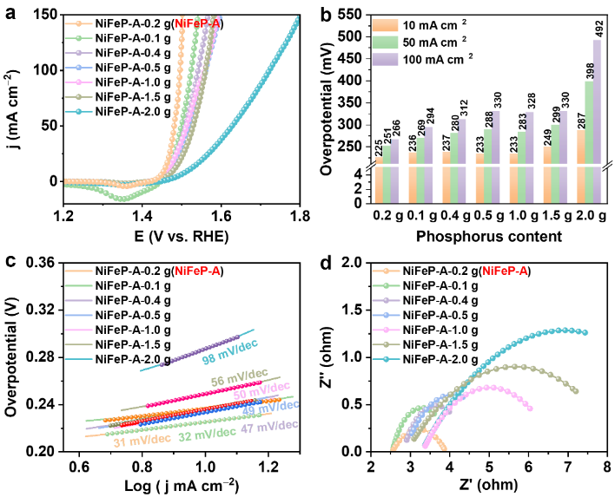
Fig. S1 Catalytic performance evaluation of catalysts obtained using different phosphorus precursor amounts. a Polarization curves (backward-scan profiles) at a scan rate of 5 mV s^{–1}. b Overpotentials at current densities of 10, 50, and 100 mA cm⁻². c Tafel plots. d Nyquist plots.

Discussion on Fig. S1: To quantitatively investigate the correlation between phosphorus content and OER performance, we prepared a series of NiFeP catalysts with varying phosphorus contents by adjusting the amount of P precursor (NaH₂PO₂) from 0.1g to 2.0 g during the phosphidation step. After identical electrochemical activation (CV + LSV), the OER performance was measured and the residual phosphate content in each activated catalyst was determined by STEM-EDX.
As shown in Fig. S1, we observed a clear correlation between use of P precursor amount and OER performance, with the catalyst using 0.2 g of NaH₂PO₂ precursor exhibiting the best performance. Subsequent EDX analysis revealed that the residual phosphorus content in the activated catalysts was roughly proportional to the amount of P precursor used (Table S1). This result suggests that a moderate amount of intercalated PO₄³⁻ is sufficient to achieve the desired redox‑buffering effect (see our DFT calculations) without blocking active sites.

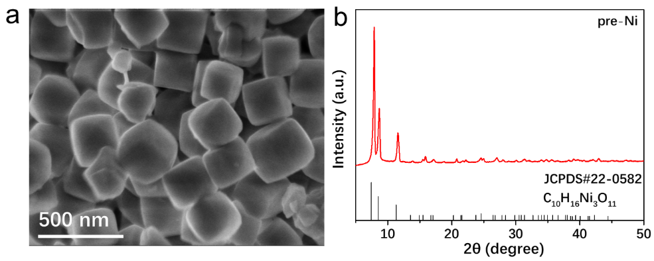
Fig. S2 a SEM image and b XRD patterns of pre-Ni.

Fig. S3 a TEM image, b HAADF-STEM image, and c-f corresponding elemental mappings of the pre-Ni.
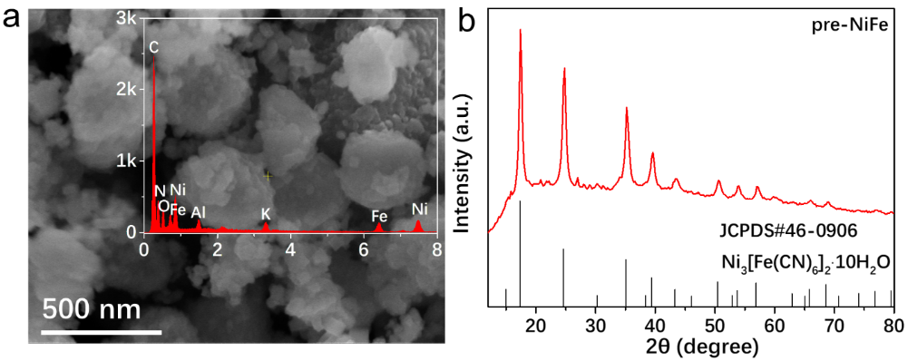
Fig. S4 a SEM image and b XRD patterns of pre-NiFe. Inset is SEM-EDX spectrum of pre-NiFe.

Fig. S5 a TEM image, b HAADF-STEM image, and c-f corresponding elemental mappings of the pre-NiFe.
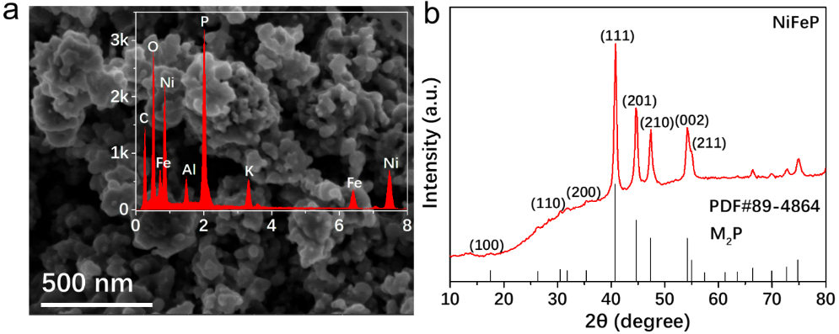
Fig. S6 a SEM image and b XRD patterns of NiFeP. Inset is SEM-EDX spectrum of NiFeP.

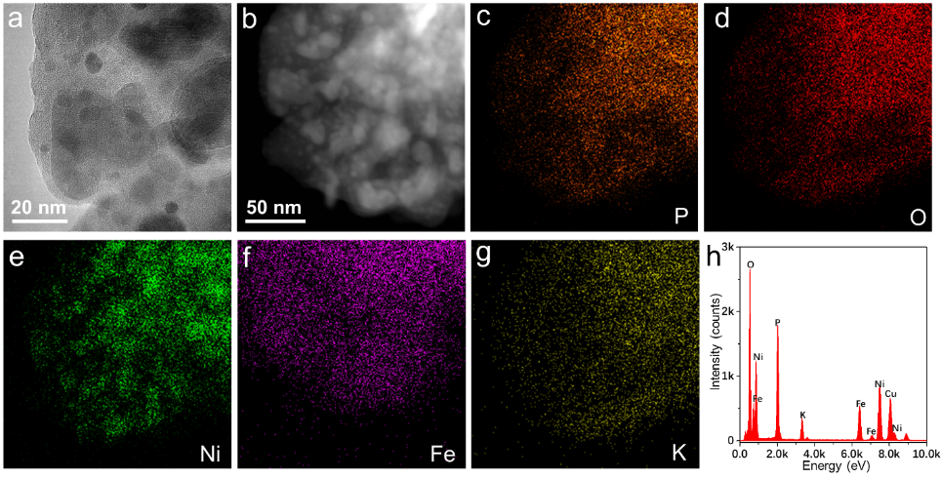
Fig. S7 a TEM image and b HAADF-STEM image of coating layers of as-prepared NiFeP. c-g Corresponding elemental maps and EDX line profiling spectra of NiFeP.
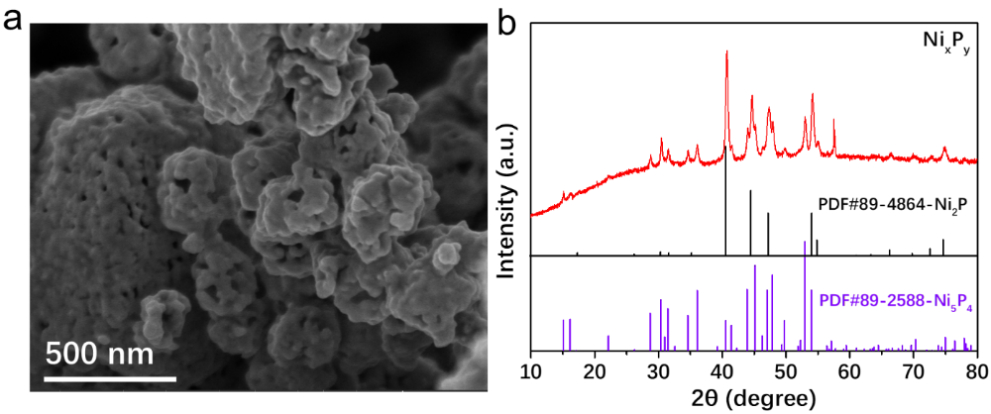
Fig. S8 a SEM image and b XRD patterns of Ni_{x}P_{y}.

Fig. S9 a TEM image, b HAADF-STEM image, and c-f corresponding elemental maps of the Ni_{x}P_{y}.
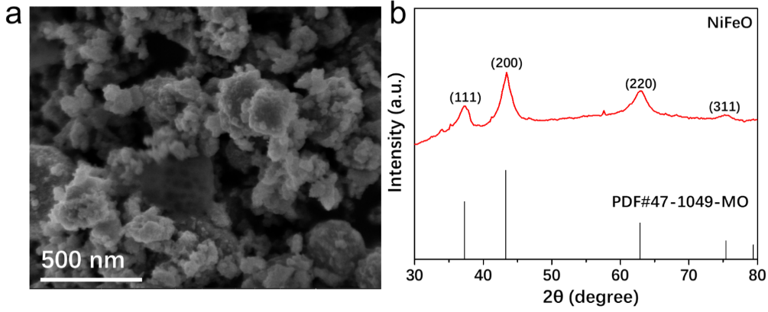
Fig. S10 a SEM image and b XRD patterns of NiFeO.

Fig. S11 a TEM image, b HAADF-STEM image, and c-f corresponding elemental maps of the NiFeO.
Fig. S12 LSV curves of Hg/HgO electrode vs. RHE.
The Hg/HgO reference electrode was calibrated using a standard three-electrode setup in 1.0 M KOH electrolyte, with a platinum counter electrode and a platinum mesh working electrode. Before measurement, the electrolyte was saturated with high-purity hydrogen (99.999%). Linear sweep voltammetry (LSV) was conducted at a scan rate of 2 mV s⁻¹. All measurements were performed in triplicate to ensure reproducibility, as summarized in Fig. S12. The thermodynamic potential for the hydrogen electrode reaction was determined as the electrode potential at zero current. Based on the average of three independent measurements, the conversion relationship was established as E_{(RHE)} = E_{(Hg/HgO)} + 0.9153 V.

Fig. S13 CV curves of the as-synthesized NiFeP and pre-NiFe.
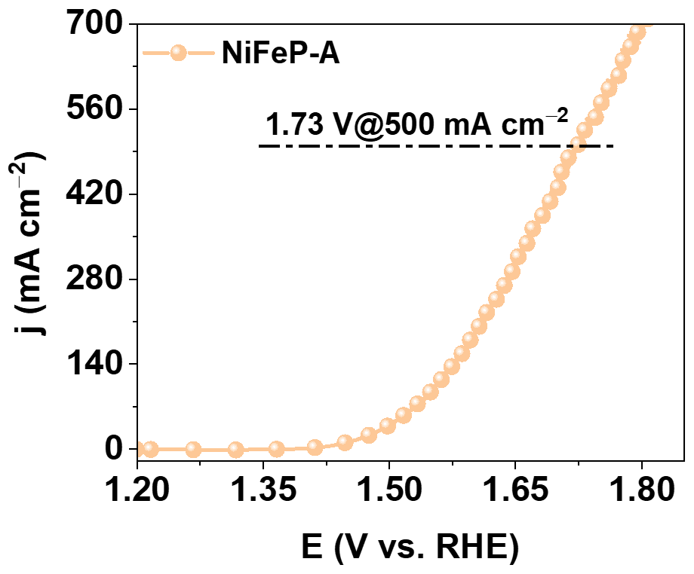
Fig. S14 Polarization curves (backward-scan profiles) of NiFeP-A at the large current densities.
Fig. S15 CV curves of the catalysts recorded in the non-Faradaic regions at scanning rates from 10 mV/s to 100 mV/s. a pre-NiFe-A. b NiFeP-A. c NiFeO-A. d Ni_{x}P_{y}-A. e RuO₂. f Double-layer capacitances (C_{dl}). g ECSA values.
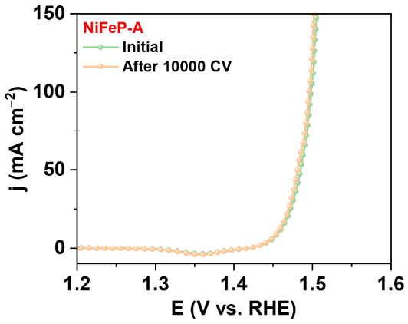
Fig. S16 Polarization curves of NiFeP before and after 10000 cycles.

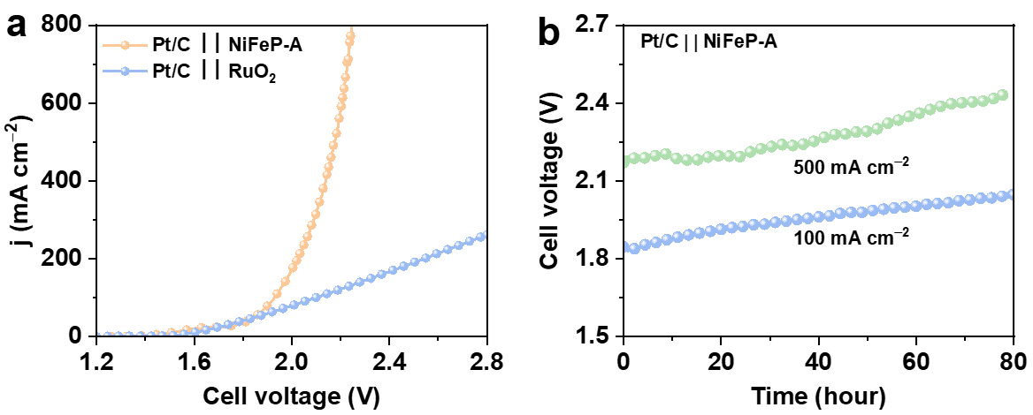
Fig. S17 a LSV curves of the Pt/C || NiFeP-A two electrode system and commercial Pt/C || RuO₂ system in 1 M KOH solution. b Stability tests of the Pt/C || NiFeP-A two electrode system at a current density of 100 mA cm⁻² and 500 mA cm⁻².
TOF calculation
TOF = $\frac{\text{Number of oxygen turnover}}{\text{Number of active sites}}$
Number of oxygen turnover (mol/s) = $\frac{\text{I} }{\text{4F}}$
Thus, TOF can be calculated with the equation:
TOF= $\frac{\text{I}}{\text{4Fn}}$
where I is the current obtained from the LSV tests at the overpotential of 300 mV, F is the Faradaic constant of 96485.3 C / mol.
The number of active sites (n) was determined by the total loading mass, which is in an underestimated way, via equation [S11]
Number of active sites (mol) = $\frac{\text{50 }\text{μ}\text{L*2 mg/200}\text{μ}\text{L}\text{×}{\text{γ}}_{\text{NiFe/NiFePOH}}}{\text{Mw}}$
Where γ_{NiFe/NiFePOH} is the mass ratio of NiFe in NiFeP-A (NiFePOH) (Ni:Fe:P:O = 0.77:0.23:013:2.49), M_{w} is the molecular weight of NiFeP-A.

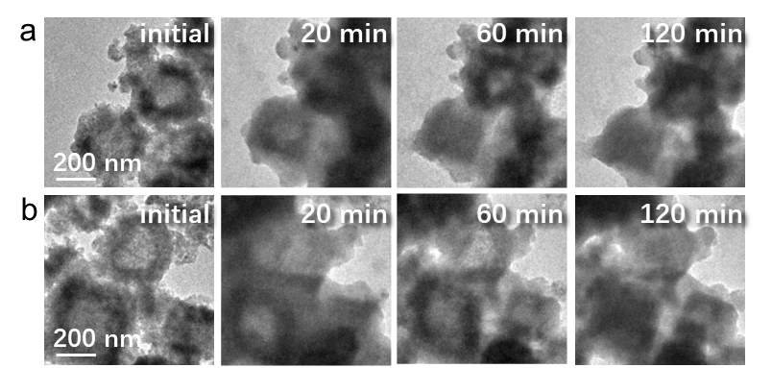
Fig. S18 IL-TEM images of NiFeP before (left) and after 1.82 V_{RHE} for 20 min (middle), 60 min (middle), and 120 min (right) electrolysis in different areas.

Fig. S19. Comparison of Ni and Fe concentrations in fresh and NiFeP-activated alkaline media measured by ICP-MS.
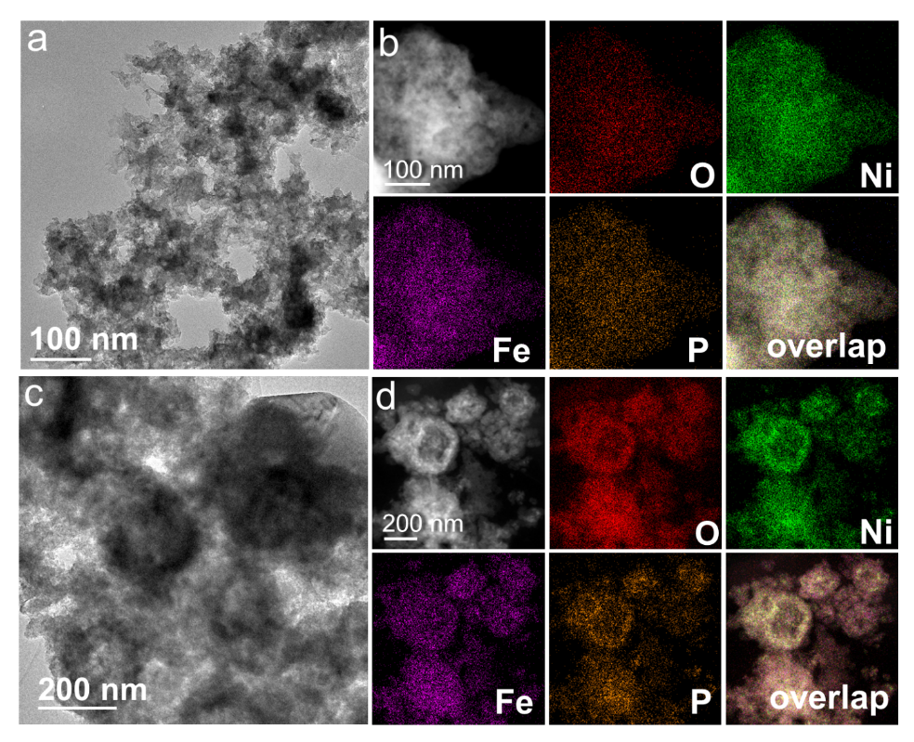
Fig. S20 Morphological and compositional analyses of NiFeP after CV scans. a, c TEM images. b, d HAADF-STEM images and elemental maps.
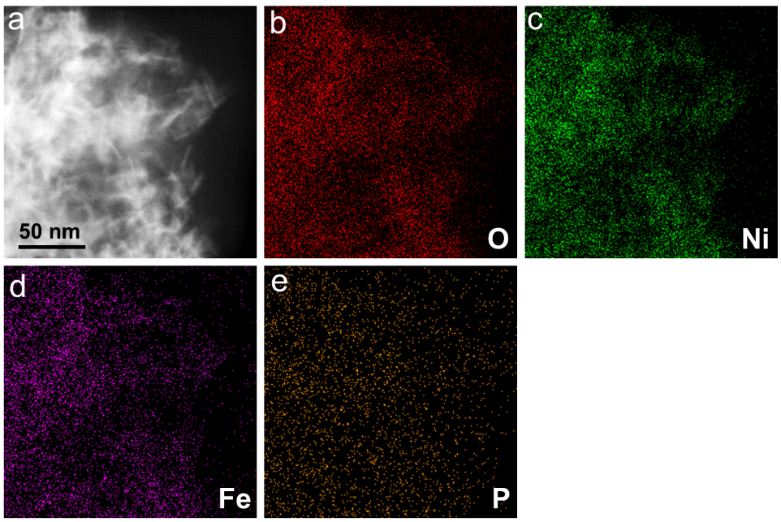
Fig. S21 a HAADF-STEM image and b-e elemental maps of the NiFeP-A catalyst.
Fig. S22 XPS spectra of NiFeP-A and after the durability test.

Fig. S23 EELS analysis of a NiFeP and b NiFeP-A.
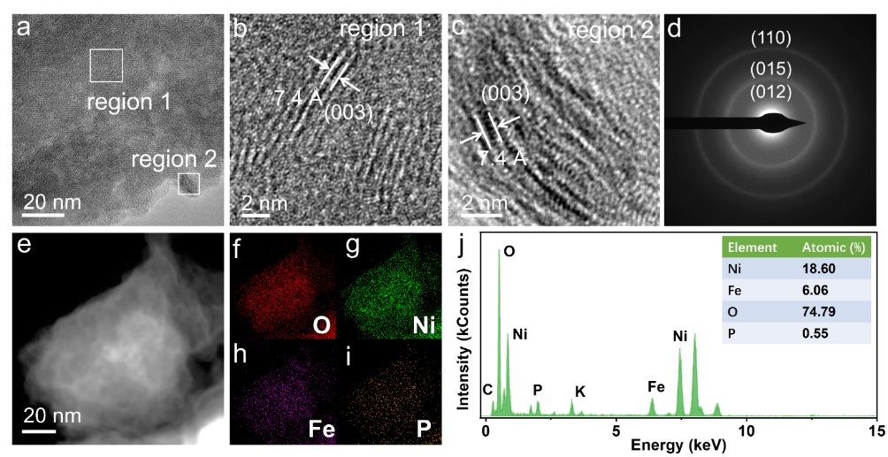
Fig. S24 Structural and chemical analyses of the NiFeP-A after stability test. a HRTEM image. b, c Enlarged HRTEM images from the dotted squares indicated in a. d SAED patterns. e HAADF-STEM image and e-i corresponding elemental mappings. j EDX analysis of NiFeP-A after long-term stability experiments.

Fig. S25 Structural and chemical analyses of the Ni_{x}P_{y}-A. a TEM image. b HRTEM image. c SAED pattern. d-g HAADF-STEM image and corresponding elemental mappings.
Fig. S26 TEM images, SAED patterns, HAADF-STEM images, and corresponding elemental mappings of a-f NiFeO and g-l NiFeO-A.
Fig. S27 Structural analyses of the pre-NiFe-A. a HRTEM image. b, c Enlarged HRTEM images from the dotted squares indicated in a. d-f HAADF-STEM image and corresponding elemental maps. Inset of d shows an EDX spectrum of the sample, which demonstrates the absence of Fe signal in pre-NiFe-A.
Fig. S28 Fe concentrations in basic media (1.0 mol/L KOH) before and after activation of pre-NiFe measured by ICP-MS.
Control Experiment
In order to determine whether iron is lost due to the heating process or the introduction of P, we synthesized pre-NiFe-Ar by heating pre-NiFe in an Ar atmosphere and conducted XRD, TEM, and OER test (see Figs. S29-S31). Pre-NiFe-Ar-A displayed a much inferior OER activity compared with NiFeP-A, indicating that the introduction of P played an important role in promoting electrocatalytic performance. Besides, TEM characterization of pre-NiFe-Ar-A (after CV and LSV activation) revealed that the morphology and structure remained unchanged, while EDX analysis showed that the initial atomic ratio of Ni:Fe (3.8:1) was preserved after activation, further indicating that Fe in pre-NiFe-Ar can be maintained through a heating process. Furthermore, by comparing pre-NiFe-Ar-A with NiFeP-A, we can conclude that the introduction of P could indeed induce the morphology changes.
Synthesis of pre-NiFe-Ar
The whole synthesis process is similar to that of NiFeP, except that Phosphorus sources are not applicable.
Characterizations of pre-NiFe-Ar
The morphology and structure of pre-NiFe-Ar are exhibited in Figs. S29 and S30. XRD patterns (Fig. S29) demonstrate that the crystallographic structure of the pre-NiFe-Ar can be assigned to the mixture of Ni₃Fe (JCPDS 88-1715) and Ni_{1.43}Fe_{1.7}O₄ (JCPDS 80-0072), which is due to the inevitable oxidation (oxygen in bulk pre-NiFe) of the air during the reaction. TEM images imply that pre-NiFe-Ar shows same morphology with pre-NiFe precursor, while EDX shows the Ni/Fe/O atomic ratio in pre-NiFe-Ar is 3.8:1:4.3 (Fig. S30).
Fig. S29 XRD patterns of pre-NiFe-Ar.
Fig. S30 a HAADF-STEM image and b-d corresponding elemental maps of pre-NiFe-Ar.
Fig. S31 a TEM and b HRTEM images. Inset of b shows corresponding FFT image. c HAADF-STEM image and d-f corresponding elemental maps of pre-NiFe-Ar-A.

Fig. S32 OER performance of pre-NiFe-A, pre-NiFe-Ar-A, and NiFeP-A in 1.0 M KOH. a Polarization curves. b Tafel plots. c The Nyquist plots.
Fig. S33 Stability test of pre-NiFe-A at the current density of 10 mA cm⁻² for 100 h.

As shown in Figs. S32 and S33, the pre-NiFe-Ar-A showed a higher overpotential (η₁₀ = 299 mV), a higher Tafel slope (43.0 mV dec⁻¹), and a larger charge-transfer resistance (2.97 ohm) compared to NiFeP-A. These results demonstrated that the pre-NiFe-Ar-A had much inferior OER activity compared with NiFeP-A, indicating that the introduction of P played an important role in electrocatalytic performance. Moreover, TEM showed the morphology and composition of pre-NiFe-Ar-A were preserved after CV and LSV activation (Fig. S31), demonstrating that Fe in pre-NiFe can be retained through heating process other than phosphating process.

Fig. S34 a, b Comparison of Nyquist plots at 1.56 V vs. RHE of pre-Ni in 1.0 M KOH electrolyte with 0.05 M concentrations of PO₄³⁻ under different pretreatments.

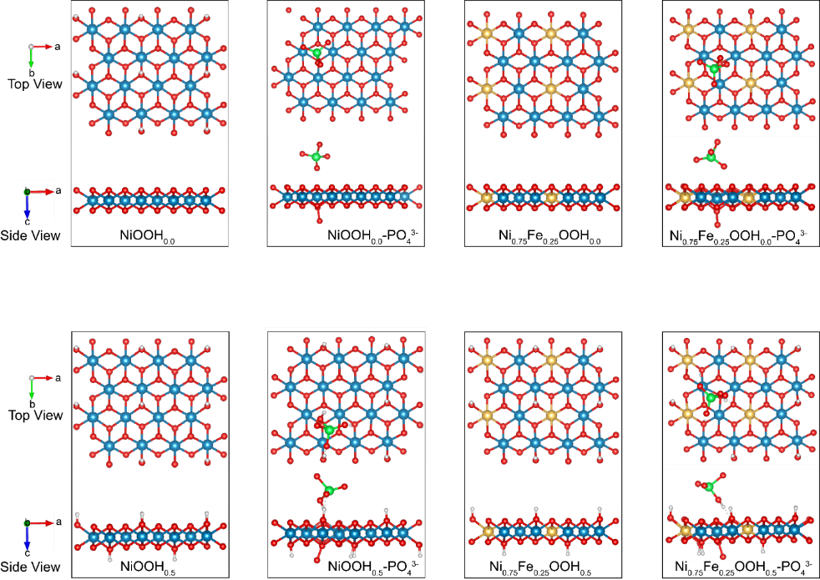
Fig. S35 The optimal atom model. Atom coloring: Ni: blue, Fe: yellow, O: red, H: grey, P: green.

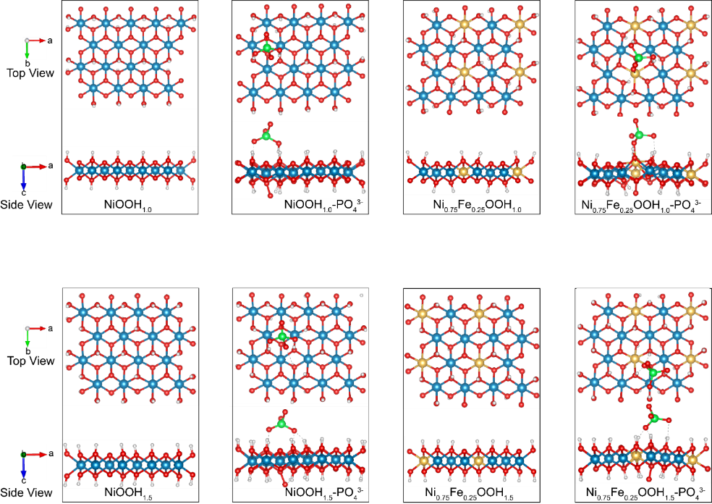
Fig. S36 The optimal atom model. Atom coloring: Ni: blue, Fe: yellow, O: red, H: grey, P: green.
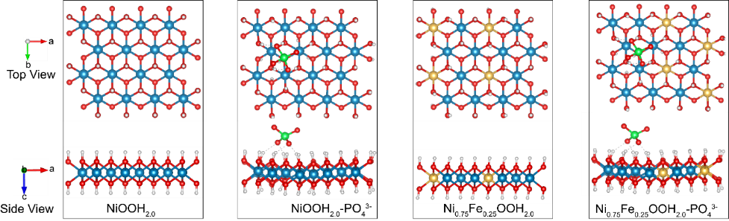
Fig. S37 The optimal atom model. Atom coloring: Ni: blue, Fe: yellow, O: red, H: grey, P: green.

Fig. S38 Projected density of states (pDOS) for Ni_{0.75}Fe_{0.25}OOH-PO₄³⁻.
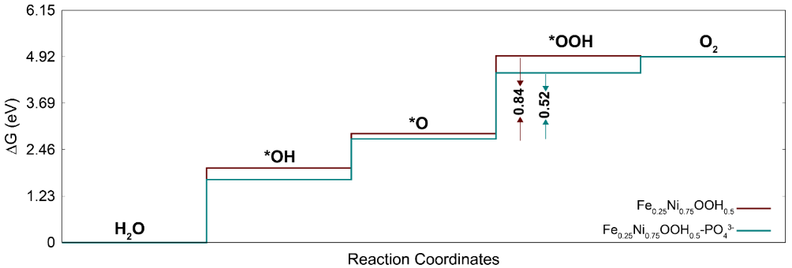
Fig. S39 The free energy profile of Fe_{0.25}Ni_{0.75}OOH_{0.5} and Fe_{0.25}Ni_{0.75}OOH_{0.5}- PO₄³⁻.

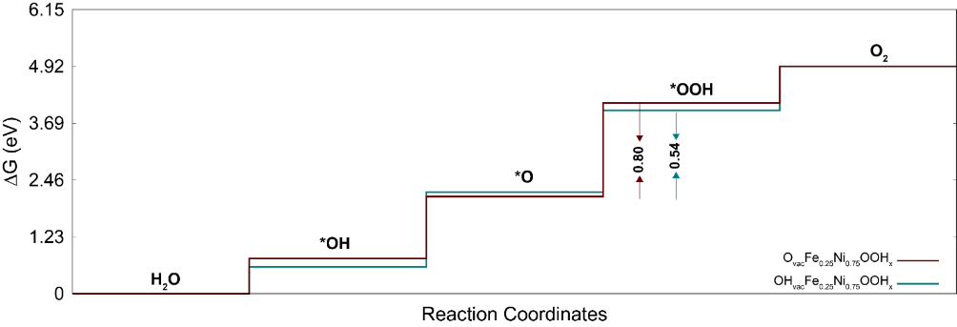
Fig. S40 The free energy profile of OH_{vac} - Fe_{0.25}Ni_{0.75}OOH_{x} and O_{vac} - Fe_{0.25}Ni_{0.75}OOH_{x}.
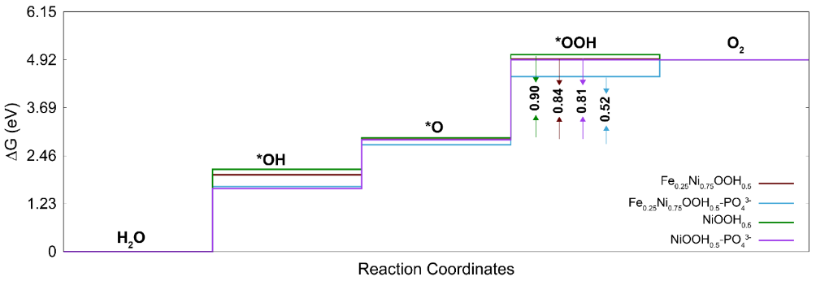
Fig. S41 The free-energy profiles for Fe_{0.25}Ni_{0.75}OOH_{0.5}, Fe_{0.25}Ni_{0.75}OOH_{0.5}-PO₄³⁻, NiOOH_{0.5} and NiOOH_{0.5}-PO₄³⁻.

Table S1 Elemental analysis of catalysts obtained using different amounts of phosphorus precursor (NaH₂PO₂) and after CV+LSV measurements
Catalyst | Ni | Fe | P | O
NiFeP-A-0.2 g (NiFeP-A) | 22.06% | 7.41% | 0.83% | 69.69%
NiFeP-A-0.1 g | 22.73% | 7.36% | 0.15% | 69.76%
NiFeP-A-1.0 g | 25.14% | 8.32% | 1.44% | 65.10%
NiFeP-A-2.0 g | 22.86% | 7.38% | 2.36% | 67.54%

Table S2 ICP-OES of NiFeP
Element | Ni | Fe | P
Mass ratio in NiFeP, % | 33.97% | 10.78% | 24.67%
Molar ratio in NiFeP (normalized to Fe) | 3 | 1 | 4.13

Table S3 Comparison of the overpotential (at 500 mA cm⁻²) of our catalyst with recently reported OER catalysts in 1.0 M KOH
Catalysts | Overpotential @500 mAcm⁻² | Ref.
NiFeP-A | 500 | This work
αβ1-Ni(OH)₂ | 590 | [S12]
NiCo/NF | 507 | [S13]
FeS@Fe₂B/IP | 520 | [S14]
α-Co(OH)₂ | 630 | [S15]
Co-CoO_{x}@NOC-0.1KNO₃ | 612 | [S16]
FeCoNiMoW | 600 | [S17]
FeCoCrNiTi_{0.6} (HEA) | 655 | [S18]
NiS-FeS@IF | 563 | [S19]
CeO₂-NiFeO_{x}H_{y} | 659 | [S20]
POM-CTAB-Co | 770 | [S21]
P-NiO | 560 | [S22]
CD@Ni_{0.6}Fe_{0.4}OOH/CP | 750 | [S23]

Table S4 Comparison of the overpotential (at 10 mA cm⁻²) and the Tafel slope of NiFeP-A with recently reported NiFeP OER catalysts in 1.0 M KOH
Catalysts | Overpotential  (10 Ma cm⁻²) | Tafel slope  (mV/dec) | Ref.
NiFeP-A | 225 | 32 | (This work)
NiFeP/g-C₃N₄ | 232 | 103 | [S24]
NiFeP/FP-2 | 235 | 114.26 | [S25]
NiFeP-Sn/NM | 239 | 52.1 | [S26]
(Ni_{0.75}Fe_{0.25})₂P@MXene | 240 | 65.5 | [S27]
NiFeP/NPC OHS | 243 | 57 | [S28]
YRO@D-NiFeP/Ru | 260 | 42.4 | [S29]
La_{0.3}-NiFeP | 271 | 78 | [S30]
NiFeP/CoP | 274 | 70 | [S31]
NiFeP@FPs | 282 | 63.41 | [S32]
NiFeP/MXene | 286 | 35 | [S33]
NiFeP/NiS-A | 295 | 52.3 | [S34]

Table S5 Fitting parameters of the electrochemical impedance spectra of as-prepared catalysts for OER measured at an overpotential of 330 mV
Catalysts | η (mV) | R_{s} (ohm) | R_{ct} (ohm)
pre-NiFe-A | 330 | 3.21 | 3.80
NiFeP-A | 330 | 2.54 | 1.36
NiFeO-A | 330 | 2.97 | 2.09
Ni_{x}P_{y}-A | 330 | 2.41 | 3.55
RuO₂ | 330 | 2.71 | 9.05
ƞ: overpotential
R_{s}: The solution and electrode resistance
R_{ct}: The charge transfer resistance

Table S6 TOFs of pre-NiFe-A, NiFeP-A, NiFeO-A, Ni_{x}P_{y}-A, and RuO₂
Catalysts | Molecular formula | Molecular weight | Mass ratio | n (mol) | j (mA) | TOF (s⁻¹)
pre-NiFe-A | Ni₁O_{2.91} | 105.25 | 0.56 | 2.66×10⁻⁶ | 1.701 | 0.0017
NiFeP-A | Ni_{0.77}Fe_{0.23}P_{0.13}O_{2.49} | 101.90 | 0.57 | 2.80×10⁻⁶ | 153.4 | 0.14
NiFeO-A | Ni_{0.76}Fe_{0.24}O₁ | 74.01 | 0.78 | 5.27×10⁻⁶ | 5.254 | 0.0026
Ni_{x}P_{y}-A | Ni₁P_{0.17}O_{2.64} | 106.19 | 0.55 | 2.59×10⁻⁶ | 5.675 | 0.0057
RuO₂ | RuO₂ | 133.10 | 0.76 | 2.86×10⁻⁶ | 7.935 | 0.0072

Table S7 Comparison of TOF between NiFeP-A and recently reported OER catalysts in 1.0 M KOH.
Catalysts (1.0 M KOH) | Overpotential (mV) | TOF | Ref.
NiFeP-A | 300 | 0.14 | This work
RuO₂ | 300 | 0.0072 | This work
NiFe-OH/NiFeP/NF | 250 | 0.036 | [S35]
NiFeP@OCC | 400 | 0.018 | [S36]
H-CoS_{x}@NiFe LDH/NF | 280 | 0.067 | [S37]
Ni₃V₁Fe₁-LDH | 300 | 0.0528 | [S38]
Ni_{0.75}V_{0.25}-LDH | 350 | 0.054 | [S39]
RuNi₇FeO_{x}(OH)_{y} @NCA | 278 | 0.107 | [S40]
Ru@Fe-Ni (OH)₂/NF | 300 | 0.062 | [S41]
Fe₃O₄-NF | 300 | 0.00312 | [S42]
Co_{0.5}V_{0.5}@COF-SO₃ | 300 | 0.098 | [S43]
Cu-ZIF-400 | 342 | 0.0021 | [S44]
Co₃O₄-TiO₂ | 370 | 0.034 | [S45]
Table S8 Comparison of cell voltages at 10 mAcm⁻² with state-of-the-art overall water splitting electrocatalysts in 1.0 M KOH
Catalysts | Cell voltage | Ref.
Pt/C || NiFeP-A | 1.51 V | This work.
Pt/C || RuO₂ | 1.56 V | This work.
MoP/NiFeP/CP || MoP/NiFeP/CP | 1.51 V | [S46]
NiP/NiFeP/C || NiP/NiFeP/C | 1.53 V | [S47]
CC-NC-NiFeP || CC-NC-NiFeP | 1.54 V | [S48]
Mo-NiFeP/NIF-2 || Mo-NiFeP/NIF | 1.55 V | [S49]
Pt/C || Mo₅₁Ni₄₀Fe₉ | 1.56 V | [S50]
Ni_{0.8}Fe_{0.2}P-C/NF || Ni_{0.8}Fe_{0.2}P-C/NF | 1.56 V | [S51]
CoP-NC@NFP || CoP-NC@NFP | 1.57 V | [S52]
NiFeP/CC|| NiFeP/CC | 1.57 V | [S53]
NiFeP/NFF || NiFeP/NFF | 1.58 V | [S54]
Pt/C || NiFeP/MXene | 1.61 V | [S33]
NiFeP/Zn || NiFeP/Zn | 1.65 V | [S55]
Pt/C || Fe-NiCoP | 1.71 V | [S56]
Table S9 ICP-OES of NiFeP-A
Element | Ni | Fe | P
Metallic mass ratio in NiFeP-A, % | 15.41% | 4.35% | 1.16%
Metallic molar ratio in NiFeP-A (normalized to Fe) | 3.37 | 1 | 0.48

Table S10 The EXAFS fitting data of NiFeP and NiFeP-A at the Ni K-edge
Sample | Path | CN | R(Å) | σ²(×10⁻³Å²) | ΔE₀ (eV) | R-factor
Ni foil | Ni−Ni | 12* | 2.48±0.03 | 5.9±0.3 | 7.1±0.4 | 0.0022
NiO | Ni−O | 7.9±1.3 | 2.08±0.02 | 6.1±2.4 | -2.9±0.9 | 0.0084
NiO | Ni−Ni | 17.2±2.1 | 2.95±0.01 | 7.0±0.9 | -2.9±0.9 | 0.0084
NiFeP | Ni−P | 7.1±0.6 | 2.24±0.01 | 10.1±1.3 | -6.2±1.2 | 0.0066
NiFeP-A | Ni−O | 7.3±0.4 | 2.02±0.08 | 10.1±1.1 | -6.2±0.7 | 0.0047
NiFeP-A | Ni−(O) −M | 4.1±0.2 | 3.04±0.08 | 4.4±3.5 | -6.1±0.7 | 0.0047
CN, coordination number. R, the distance to the neighboring atom. σ², Debye-Waller factors. ΔE₀, inner potential correction. The R-factor indicates the goodness of the fit. S₀² was fixed to 0.75 according to the experimental EXAFS fit of Ni foil by fixing CN as the known crystallographic value. * This value was fixed during EXAFS fitting.
Fitting range: 3.0 ≤ k (/Å) ≤ 12.5 and 1.0 ≤ R (Å) ≤ 3.0 (Ni foil).
3.0 ≤ k (/Å) ≤ 12.4 and 1.0 ≤ R (Å) ≤ 3.0 (NiO).
3.0 ≤ k (/Å) ≤ 12.4 and 1.2 ≤ R (Å) ≤ 2.5 (NiFeP).
3.0 ≤ k (/Å) ≤ 12.3 and 1.0 ≤ R (Å) ≤ 3.5 (NiFeP-A).
A reasonable range of EXAFS fitting parameters: 0.700 < S₀² < 1.000; CN > 0; σ² > 0 Å²; |ΔE₀| < 10 eV; R-factor < 0.02.
Table S11 Calculated Gibbs free energies and overpotential of OER on NiOOH_{0.5} and NiOOH_{0.5}- PO₄³⁻
Structure | Reaction step | ∆G (eV) | Overpotential (V)
Ni₄O₈H₂ | *+H₂O(l) → *OH + (H⁺ + e⁻) | 2.11 | 0.90
Ni₄O₈H₂ | *OH → *O + (H⁺ + e⁻) | 0.81 | 0.90
Ni₄O₈H₂ | *O + H₂O(l) → *OOH + (H⁺ + e⁻) | 2.13 | 0.90
Ni₄O₈H₂ | *OOH → * + O₂ + (H⁺ + e⁻) | -0.13 | 0.90
Ni₄O₈H₂ - PO₄³⁻ | *+H₂O → *OH + (H⁺ + e⁻) | 1.62 | 0.81
Ni₄O₈H₂ - PO₄³⁻ | *OH → *O + (H⁺ + e⁻) | 1.25 | 0.81
Ni₄O₈H₂ - PO₄³⁻ | *O + H₂O(l) → *OOH + (H⁺ + e⁻) | 2.04 | 0.81
Ni₄O₈H₂ - PO₄³⁻ | *OOH → * + O₂ + (H⁺ + e⁻) | 0.01 | 0.81
*Bold digits indicate ∆G _{max.}

Table S12 Calculated Gibbs free energies and overpotential, η (V) of OER on Fe doped NiOOH_{0.5} and defective Fe doped NiOOH_{0.5}
Structure | Reaction step |  | ∆G (eV) |  | Overpotential (V)
Fe_{0.25}Ni_{0.75}OOH_{0.5} |  | *+H₂O(l) → *OH + (H⁺ + e⁻) |  | 1.97 |  | 0.84
 |  | *OH → *O + (H⁺ + e⁻) |  | 0.91 |  | 0.84
 |  | *O + H₂O(l) → *OOH + (H⁺ + e⁻) |  | 2.07 |  | 0.84
 |  | *OOH → * + O₂ + (H⁺ + e⁻) |  | -0.02 |  | 0.84
Fe_{0.25}Ni_{0.75}OOH_{0.5}- PO₄³⁻ |  | *+H₂O(l) → *OH + (H⁺ + e⁻) |  | 1.67 |  | 0.52
 |  | *OH → *O + (H⁺ + e⁻) |  | 1.07 |  | 0.52
 |  | *O + H₂O(l) → *OOH + (H⁺ + e⁻) |  | 1.75 |  | 0.52
 |  | *OOH → * + O₂ + (H⁺ + e⁻) |  | 0.43 |  | 0.52
OH_{vac}- Fe_{0.25}Ni_{0.75}OOH_{x} |  | *+H₂O(l) → *OH + (H⁺ + e⁻) |  | 0.58 |  | 0.54
 |  | *OH → *O + (H⁺ + e⁻) |  | 1.62 |  | 0.54
 |  | *O + H₂O(l) → *OOH + (H⁺ + e⁻) |  | 1.77 |  | 0.54
 |  | *OOH → * + O₂ + (H⁺ + e⁻) |  | 0.95 |  | 0.54
O_{vac} - Fe_{0.25}Ni_{0.75}OOH_{x}. |  | *+H₂O(l) → *OH + (H⁺ + e⁻) |  | 0.76 |  | 0.80
 |  | *OH → *O + (H⁺ + e⁻) |  | 1.34 |  | 0.80
 |  | *O + H₂O(l) → *OOH + (H⁺ + e⁻) |  | 2.03 |  | 0.80
 |  | *OOH → * + O₂ + (H⁺ + e⁻) |  | 0.79 |  | 0.80
*Bold digits indicate ∆G _{max.}
Supplementary References
- C.C.L. McCrory, S. Jung, J.C. Peters, T.F. Jaramillo, Benchmarking heterogeneous electrocatalysts for the oxygen evolution reaction. J. Am. Chem. Soc. 135(45), 16977–16987 (2013). https://doi.org/10.1021/ja407115p
- P. Giannozzi, S. Baroni, N. Bonini, M. Calandra, R. Car et al., QUANTUM ESPRESSO: a modular and open-source software project for quantum. J. Phys. Condens. Matter 21(39), 395502 (2009). https://doi.org/10.1088/0953-8984/21/39/395502
- Z.K. Goldsmith, A.K. Harshan, J.B. Gerken, M. Vörös, G. Galli et al., Characterization of NiFe oxyhydroxide electrocatalysts by integrated electronic structure calculations and spectroelectrochemistry. Proc. Natl. Acad. Sci. USA 114(12), 3050–3055 (2017). https://doi.org/10.1073/pnas.1702081114
- G. Prandini, A. Marrazzo, I.E. Castelli, N. Mounet, E. Passaro, et al., A Standard Solid State Pseudopotentials (SSSP) library optimized for p recision and efficiency, Materials Cloud Archive, 65 (2023). https://doi.org/10.24435/materialscloud:f3-ym
- D.R. Hamann, Optimized norm-conserving Vanderbilt pseudopotentials. Phys. Rev. B 88(8), 085117 (2013). https://doi.org/10.1103/physrevb.88.085117
- J.K. Nørskov, J. Rossmeisl, A. Logadottir, L. Lindqvist, J.R. Kitchin et al., Origin of the overpotential for oxygen reduction at a fuel-cell cathode. J. Phys. Chem. B 108(46), 17886–17892 (2004). https://doi.org/10.1021/jp047349j
- H. Xu, D. Cheng, D. Cao, X.C. Zeng, Revisiting the universal principle for the rational design of single-atom electrocatalysts. Nat. Catal. 7(2), 207–218 (2024). https://doi.org/10.1038/s41929-023-01106-z
- J. Rossmeisl, A. Logadottir, J.K. Nørskov, Electrolysis of water on (oxidized) metal surfaces. Chem. Phys. 319(1–3), 178–184 (2005). https://doi.org/10.1016/j.chemphys.2005.05.038
- R.D.J. III, NIST Computational Chemistry Comparison and Benchmark Database, NIST Standard Reference Database, 101 (2022). http://cccbdb.nist.gov/
- M. Li, L. Zhang, Q. Xu, J. Niu, Z. Xia, N-doped graphene as catalysts for oxygen reduction and oxygen evolution reactions: Theoretical considerations. J. Catal. 314, 66–72 (2014). https://doi.org/10.1016/j.jcat.2014.03.011
- P. Su, W. Pei, X. Wang, Y. Ma, Q. Jiang et al., Exceptional electrochemical HER performance with enhanced electron transfer between Ru nanoparticles and single atoms dispersed on a carbon substrate. Angew. Chem. Int. Ed. 60(29), 16044–16050 (2021). https://doi.org/10.1002/anie.202103557
- W. Zitzmann, A.S. Nair, B. Paulus, A. Rafferty, X. Yi et al., The role of nickel hydroxide phases in wastewater electrolysis for sustainable green hydrogen production. Nanoscale (2026). http://doi.org/10.1039/D5NR05037E
- H.-S. Hu, Y. Li, Y.-R. Shao, K.-X. Li, G. Deng et al., NiCoP nanorod arrays as high-performance bifunctional electrocatalyst for overall water splitting at high current densities. J. Power Sources 484, 229269 (2021). https://doi.org/10.1016/j.jpowsour.2020.229269
- L. Yang, J. Lang, W. Jiang, Y. Ma, X. Chu et al., Interfacial engineering for the construction of iron sulfide/boride nanosheets heterostructure bifunctional electrocatalysts for high-efficiency overall water splitting. J. Alloys Compd. 1006, 176344 (2024). https://doi.org/10.1016/j.jallcom.2024.176344
- H. Ma, Y. Jin, X. Zhou, Y. Cui, Y. Zhao et al., Chloride-induced easier phase transformation and catalytic synergy for enhanced seawater splitting. Chem. Sci. (2026). http://doi.org/10.1039/D5SC09403H
- A. Li, X. Qian, M. Han, Z. Li, X. He et al., Pyrolysis of ZIF-Co assisted by a small amount of KNO₃: Tuning of Co-CoOx@N, O Co-doped carbon hybrid nanostructures for accelerating water splitting. Fuel 371, 131969 (2024). https://doi.org/10.1016/j.fuel.2024.131969
- L. Li, D. Liu, Z. Yu, Y. Cao, C. Zhong et al., Dynamic evolution of high-valence metals in high-entropy systems enabling highly enhanced oxygen evolution reaction. J. Energy Chem. 115, 595–605 (2026). https://doi.org/10.1016/j.jechem.2025.12.008
- T. Li, Z. Wang, Y. Wang, X. He, J. Luo et al., Anodized bulk FeCoCrNiTi_{0.6} high-entropy alloy electrocatalysts for long-term industrial-scale oxygen evolution reaction. J. Colloid Interface Sci. 703, 139232 (2026). https://doi.org/10.1016/j.jcis.2025.139232
- J. Fan, X. Ma, J. Xia, L. Zhang, Q. Bi et al., Corrosion resistance and earth-abundance FeS-based heterojunction catalyst for seawater splitting at industrial grade density. J. Colloid Interface Sci. 657, 393–401 (2024). https://doi.org/10.1016/j.jcis.2023.12.001
- L. Li, L. Qiao, D. Liu, Z. Yu, K. An et al., High-valence metals accelerate the reaction kinetics for boosting water oxidation. Small 21(6), 2403992 (2025). https://doi.org/10.1002/smll.202403992
- R.-Z. Sun, X. Ma, K. Chen, J.-B. Yang, Y.-X. Liu et al., Self-assembled polyoxometalate supramolecular nanosheets for efficient and durable water oxidation. Angew. Chem. Int. Ed. 64(40), e202513915 (2025). https://doi.org/10.1002/anie.202513915
- S. Haghverdi Khamene, M. Creatore, M.N. Tsampas, 3D electrode surface engineering via atomic layer deposition of nickel oxide for improved water oxidation performance. Chem. Eng. J. Adv. 22, 100723 (2025). https://doi.org/10.1016/j.ceja.2025.100723
- H. Shin, J. Lee, D. Jang, Y. Kim, H. Jeong et al., Enhanced oxygen evolution reaction and durability of carbon dot-anchored nickel-iron oxyhydroxide electrodes for alkaline water electrolysis at high current densities. Mater. Today Adv. 25, 100560 (2025). https://doi.org/10.1016/j.mtadv.2025.100560
- J. Xiang, F. Zhou, X. Ma, J. Wu, C. Guo et al., Spherical cluster heterojunction engineering of NiFeP/g-C₃N₄ for efficient oxygen evolution reaction in alkaline solution. J. Colloid Interface Sci. 674, 266–278 (2024). https://doi.org/10.1016/j.jcis.2024.06.042
- B. Kan, M. Wei, Y. Zhang, W. Feng, C. Si et al., Crystalline-amorphous NiFeP alloy as an efficient bifunctional self-supporting electrode for alkaline overall water splitting. J. Alloys Compd. 1060, 187350 (2026). https://doi.org/10.1016/j.jallcom.2026.187350
- Y. Zhou, J. Chen, Q. Chen, X. Dong, X. Yang et al., Sn-mediated amorphous NiFeP electroless plating on nickel mesh for stable high-current oxygen evolution reaction. ACS Appl. Mater. Interfaces 18(10), 15144–15155 (2026). https://doi.org/10.1021/acsami.5c24462
- X. Zhang, D. Lin, R. Wan, Y. Wang, Q. Pan et al., Hierarchical NiFeP nanoflowers on the MXene film as a self-standing bifunctional electrode toward superior overall water electrolysis. ACS Appl. Nano Mater. 7(7), 7684–7693 (2024). https://doi.org/10.1021/acsanm.4c00379
- M. Vinu, K.-Y. Chiang, Highly efficient oxygen carrier NiFeP (oxy) hydroxides nanoparticle embedded in N-doped porous carbon derived from bio-waste for bifunctional electrocatalysts. Chemosphere 366, 143486 (2024). https://doi.org/10.1016/j.chemosphere.2024.143486
- E. Jang, J. Kim, J. Cho, J. Lee, J. Kim, Defect modulation and in-situ exsolution in Y₂Ru₂O₇@NiFeP/Ru heterostructure for enhanced oxygen evolution reaction. Rare Met. 44(2), 1014–1023 (2025). https://doi.org/10.1007/s12598-024-03006-y
- L. Yang, L. Li, Atomic-level La-modulated NiFeP bifunctional electrocatalysts for high efficiency overall water splitting. Chemistry 31(46), e01525 (2025). https://doi.org/10.1002/chem.202501525
- G.-L. Li, Y.-Y. Miao, F. Deng, S. Wang, R.-X. Wang et al., Highly-dispersed 2D NiFeP/CoP heterojunction trifunctional catalyst for efficient electrolysis of water and urea. J. Colloid Interface Sci. 667, 543–552 (2024). https://doi.org/10.1016/j.jcis.2024.04.059
- H. Chen, B. Hui, Flexible NiFeP@filter paper electrode for alkaline overall water electrosplitting. Int. J. Hydrog. Energy 51, 615–623 (2024). https://doi.org/10.1016/j.ijhydene.2023.08.279
- J. Chen, Q. Long, K. Xiao, T. Ouyang, N. Li et al., Vertically-interlaced NiFeP/MXene electrocatalyst with tunable electronic structure for high-efficiency oxygen evolution reaction. Sci. Bull. 66(11), 1063–1072 (2021). https://doi.org/10.1016/j.scib.2021.02.033
- M. Han, H. Wang, J. Zhou, K. Liu, N. Wang et al., Introducing lewis base-phosphate to boost neutral seawater splitting in anion exchange membrane electrolyzer. Adv. Funct. Mater. 35(6), 2415143 (2025). https://doi.org/10.1002/adfm.202415143
- H. Liang, A.N. Gandi, C. Xia, M.N. Hedhili, D.H. Anjum et al., Amorphous NiFe-OH/NiFeP electrocatalyst fabricated at low temperature for water oxidation applications. ACS Energy Lett. 2(5), 1035–1042 (2017). https://doi.org/10.1021/acsenergylett.7b00206
- A. Kafle, M. Kumar, D. Gupta, T.C. Nagaiah, The activation-free electroless deposition of NiFe over carbon cloth as a self-standing flexible electrode towards overall water splitting. J. Mater. Chem. A 9(43), 24299–24307 (2021). http://doi.org/10.1039/D1TA03244E
- Y.J. Lee, S.-K. Park, Metal-organic framework-derived hollow CoS_{x} nanoarray coupled with NiFe layered double hydroxides as efficient bifunctional electrocatalyst for overall water splitting. Small 18(16), e2200586 (2022). https://doi.org/10.1002/smll.202200586
- Z. Wang, W. Liu, Y. Hu, L. Xu, M. Guan et al., An Fe-doped NiV LDH ultrathin nanosheet as a highly efficient electrocatalyst for efficient water oxidation. Inorg. Chem. Front. 6(7), 1890–1896 (2019). http://doi.org/10.1039/C9QI00404A
- K. Fan, H. Chen, Y. Ji, H. Huang, P.M. Claesson et al., Nickel-vanadium monolayer double hydroxide for efficient electrochemical water oxidation. Nat. Commun. 7, 11981 (2016). https://doi.org/10.1038/ncomms11981
- S. Huang, J. Lu, X. Wu, H. Zhu, X. Shen et al., Ru-promoted NiFe oxyhydroxide anchored on the hierarchical porous N-doped carbon aerogel: Electronic structures modulation for much enhanced OER/HER dual-functional characteristics. Appl. Catal. A Gen. 664, 119331 (2023). https://doi.org/10.1016/j.apcata.2023.119331
- F. Liu, Z. Feng, X. Zhang, L. Cui, J. Liu, One-step achievement of Fe-doped and interfacial Ru nanoclusters co-engineered Ni(OH)₂ electrocatalyst on Ni foam for promoted oxygen evolution reaction. J. Colloid Interface Sci. 638, 498–505 (2023). https://doi.org/10.1016/j.jcis.2023.01.037
- A.A. Pawar, H.A. Bandal, H. Kim, Spinel type Fe₃O₄ polyhedron supported on nickel foam as an electrocatalyst for water oxidation reaction. J. Alloys Compd. 863, 158742 (2021). https://doi.org/10.1016/j.jallcom.2021.158742
- Z. Gao, Z. Yu, Y. Huang, X. He, X. Su et al., Flexible and robust bimetallic covalent organic frameworks for the reversible switching of electrocatalytic oxygen evolution activity. J. Mater. Chem. A 8(12), 5907–5912 (2020). http://doi.org/10.1039/C9TA14023A
- Y. Zhang, X. Zhou, F. Zhang, T. Tian, Y. Ding et al., Design and synthesis of Cu modified cobalt oxides with hollow polyhedral nanocages as efficient electrocatalytic and photocatalytic water oxidation catalysts. J. Catal. 352, 246–255 (2017). https://doi.org/10.1016/j.jcat.2017.05.020
- M.S. Amer, M.A. Ghanem, P. Arunachalam, A.M. Al-Mayouf, S.M. Hadadi, Bifunctional electrocatalyst of low-symmetry mesoporous titanium dioxide modified with cobalt oxide for oxygen evolution and reduction reactions. Catalysts 9(10): 836. (2019). https://doi.org/10.3390/catal9100836
- L. Lin, M. Chen, L. Wu, Hierarchical MoP/NiFeP hybrid hollow spheres as highly efficient bifunctional electrocatalysts for overall water splitting. Mater. Chem. Front. 5(1), 375–385 (2021). http://doi.org/10.1039/D0QM00635A
- B. Weng, X. Wang, C.R. Grice, F. Xu, Y. Yan, A new metal–organic open framework enabling facile synthesis of carbon encapsulated transition metal phosphide/sulfide nanoparticle electrocatalysts. J. Mater. Chem. A 7(12), 7168–7178 (2019). http://doi.org/10.1039/C9TA00404A
- S. Wang, J. Cai, C. Lv, C. Hu, H. Guan et al., General and scalable preparation of Prussian blue analogues on arbitrary conductive substrates and their derived metal phosphides as highly efficient and ultra-long-life bifunctional electrocatalysts for overall water splitting. Chem. Eng. J. 420, 129972 (2021). https://doi.org/10.1016/j.cej.2021.129972
- Y. Wang, P. Yang, Y. Gong, D. Liu, S. Liu et al., Amorphous high-valence Mo-doped NiFeP nanospheres as efficient electrocatalysts for overall water-splitting under large-current density. Chem. Eng. J. 468, 143833 (2023). https://doi.org/10.1016/j.cej.2023.143833
- X. Luo, Q. Shao, Y. Pi, X. Huang, Trimetallic molybdate nanobelts as active and stable electrocatalysts for the oxygen evolution reaction. ACS Catal. 9(2), 1013–1018 (2019). https://doi.org/10.1021/acscatal.8b04521
- X. Zhang, X.-R. Shi, P. Wang, Z. Bao, M. Huang et al., Bio-inspired design of NiFeP nanoparticles embedded in (N, P) Co-doped carbon for boosting overall water splitting. Dalton Trans. 52(20), 6860–6869 (2023). http://doi.org/10.1039/D3DT00583F
- E. Vijayakumar, S. Ramakrishnan, C. Sathiskumar, D.J. Yoo, J. Balamurugan et al., MOF-derived CoP-nitrogen-doped carbon@NiFeP nanoflakes as an efficient and durable electrocatalyst with multiple catalytically active sites for OER, HER, ORR and rechargeable zinc-air batteries. Chem. Eng. J. 428, 131115 (2022). https://doi.org/10.1016/j.cej.2021.131115
- J. Bian, Z. Song, X. Li, Y. Zhang, C. Cheng, Nickel iron phosphide ultrathin nanosheets anchored on nitrogen-doped carbon nanoflake arrays as a bifunctional catalyst for efficient overall water splitting. Nanoscale 12(15), 8443–8452 (2020). http://doi.org/10.1039/C9NR10471B
- X. Yu, X. He, R. Li, X. Gou, One-step synthesis of amorphous nickel iron phosphide hierarchical nanostructures for water electrolysis with superb stability at high current density. Dalton Trans. 50(23), 8102–8110 (2021). http://doi.org/10.1039/D1DT00852H
- J.O. Silva, S. Cartagena, J.A. Calderón, Novel electrodeposited NiFeP/Zn bifunctional catalytic coating for alkaline water splitting. Electrochim. Acta 451, 142299 (2023). https://doi.org/10.1016/j.electacta.2023.142299
- Y. Liu, P. Ge, Y. Li, X. Zhai, K. Lu et al., Prussian blue analogues derived Fe-NiCoP reveals the cooperation of Fe doping and phosphating for enhancing OER activity. Appl. Surf. Sci. 615, 156378 (2023). https://doi.org/10.1016/j.apsusc.2023.156378

