Supporting Information for
CuS-bridged MXene-based Photoresponsive Phase Change Materials Enabling Thermoelectric Cogeneration and Microwave Absorption
Yuhao Feng^{1,} †, Jindi Zhao^{1, †}, Keke Chen¹, Yang Li^{2,} *, Jiao Liu³, Huitao Yu⁴, Mulin Qin², Kaihang Jia², Haiwei Han², Zhenghui Shen², Mingliang Ma^{3,} *, and Xiao Chen^{1,} *
¹ School of Physics and Astronomy, Beijing Normal University, Beijing 100875, China
² School of Materials Science and Engineering, Peking University, Beijing 100871, China
³ School of Civil Engineering, Qingdao University of Technology, Qingdao, 266033, China
⁴ School of Materials Science and Engineering, Inner Mongolia University of Science and Technology, Inner Mongolia 014010, China
† These authors contributed equally to this work.
*Corresponding author. E-mail: younglee@pku.edu.cn, mamingliang@qut.edu.cn, xiaochen@bnu.edu.cn

S1 Supplementary Calculation Formula
S1.1 Thermal Storage Calculation Formula
The calculation formula of impregnation ratio (R), are as follows.
$$\begin{aligned}R=\frac{H_{m, PCMs}}{H_{m,PEG}} \#\left(1\right)\end{aligned}$$
where H_{m, PCMs} represent the melting and freezing enthalpy of composite PCMs, respectively. Similarly, H_{m, PEG} represent the melting and freezing enthalpy of PEG.
S1.2 Photothermal Conversion Calculation Formula
The photothermal conversion efficiency (η) was calculated according to the equation as follows:
$$\begin{aligned}η=\frac{mΔH_{m}}{PS\left(t_{2}-t_{1}\right)}\#\left(2\right)\end{aligned}$$
Where m and S denote mass and surface area of PEG-MXene@CuS composite PCMs, respectively; P represents the solar irradiance; and t₁ and t₂ signify the onset and termination times of the phase transition.
S1.3 Microwave Absorption Calculation Formula
S1.3.1 Electromagnetic Parameters
Electromagnetic parameters are crucial for evaluating the electromagnetic performance of electromagnetic wave absorbing materials. The dielectric and magnetic properties of materials can be characterized by the complex permittivity (ε_{r}) and complex permeability (μ_{r}):
$$\begin{aligned}ε_{r}=ε_{r}^{'}-jε_{r}^{''}\#\left(3\right)\end{aligned}$$
$$\begin{aligned}μ_{r}=μ_{r}^{'}-jμ_{r}^{''}\#\left(4\right)\end{aligned}$$
where ε_{r}' denotes the real part of the complex permittivity, ε_{r}'' denotes the imaginary part of the complex permittivity, μ_{r}' denotes the real part of the complex permeability, and μ_{r}'' denotes the imaginary part of the complex permeability. The real parts represent the ability to store electrical and magnetic energy, while the imaginary parts represent the ability to dissipate electrical and magnetic energy. For electromagnetic wave absorbing materials, larger values of the imaginary parts of ε_{r} and μ_{r} imply greater attenuation of incident electromagnetic wave, thereby indicating better electromagnetic wave absorption performance. Typically, the degree of electromagnetic wave loss is characterized by the dielectric loss tangent (tanδ_{ε}) and magnetic loss tangent (tanδ_{μ}):
$$\begin{aligned}\tan{δ_{ε}}=\frac{ε^{''}}{ε^{'}}\#\left(5\right)\end{aligned}$$
$$\begin{aligned}\tan{δ_{μ}}=\frac{μ^{''}}{μ^{'}}\#\left(6\right)\end{aligned}$$
where ε describes the phase lag of a material's internal electric induction field (D) relative to the external field, μ describes the phase lag of its magnetic induction field (B) relative to the external field. The loss tangent represents the ability of a material to absorb electromagnetic wave energy and convert it into heat. A higher value of the loss tangent indicates a stronger ability of the material to absorb electromagnetic wave.
S1.3.2 Cole-Cole Semicircle
When the frequency of the alternating electric field increases to a certain extent, the polarization process cannot synchronize with the electric field, resulting in a phase difference between the electric field and polarization. As the frequency of the alternating electric field further rises to a specific level, it leads to the loss of electric field energy, namely the polarization relaxation phenomenon. The relaxation of dipole polarization can be described by Debye theory, and the real and imaginary parts of the complex permittivity can be expressed by Debye theory as follows:
$$\begin{aligned}ε^{'}=ε_{∞}+\frac{ε_{s}-ε_{∞}}{1+ω^{2}τ^{2}}\#\left(7\right)\end{aligned}$$
$$\begin{aligned}ε^{''}=\frac{\left(ε_{s}-ε_{∞}\right)ωτ}{1+ω^{2}τ^{2}}\#\left(8\right)\end{aligned}$$
$$\begin{aligned}\tan{δ_{ε}}=\frac{ε^{'}}{ε^{''}}=\frac{\left(ε_{s}-ε_{∞}\right)ωτ}{ε_{s}+{ε_{∞}ω}^{2}τ^{2}}\#\left(9\right)\end{aligned}$$
where ε_{s} denotes the static permittivity, ε∞ represents the high-frequency (optical) permittivity, ω is the angular frequency, and τ stands for the relaxation time. According to the above formula, the real part of the permittivity decreases with increasing frequency, while the imaginary part reaches a peak when ωτ = 1. This phenomenon of frequency-dependent permittivity is referred to as dielectric dispersion. When plotting the real part of the permittivity on the horizontal axis and the imaginary part on the vertical axis (Cole-Cole plot), the above equation can be rearranged to obtain:
$$\begin{aligned}{{\left(ε^{'}-\frac{ε_{s}+ε_{∞}}{2}\right)}^{2}+\left(ε^{''}\right)}^{2}={\left(\frac{ε_{s}-ε_{∞}}{2}\right)}^{2}\#\left(10\right)\end{aligned}$$
The simplified form is obtained as follows:
$$\begin{aligned}ε^{'}=ε_{∞}+\frac{1}{τ}\left(\frac{ε^{''}}{ω}\right)\#\left(11\right)\end{aligned}$$
It can be inferred that the dielectric polarization process manifests as semicircles in the Cole-Cole plot.
S1.3.3 Impedance Matching Property
The surface impedance of the material is jointly determined by the complex permittivity and complex permeability, which can be expressed as Z. The impedance matching characteristic serves to evaluate the ability of electromagnetic wave to penetrate into absorbing materials, which essentially reflects the matching relationship between the absorption and reflection of electromagnetic wave. The impedance matching property is typically denoted by "Z". It is jointly determined by the complex permittivity and complex permeability, and can be quantified by calculating the ratio |Z_{in}/Z₀|. The specific calculation formula is as follows:
$$\begin{aligned}Z=\frac{Z_{in}}{Z_{0}}=\sqrt{\frac{μ_{r}}{ε_{r}}\tan{h\left(j\frac{2πfd}{c}\sqrt{μ_{r}ε_{r}}\right)}} \#\left(12\right)\end{aligned}$$
where Z_{in} represents the input characteristic impedance, and Z₀ denotes the free space impedance. f is the frequency of electromagnetic wave, d is the thickness of the absorbing material, and c is the speed of light. RL stands for reflection loss. μ₀ is the magnetic permeability in vacuum, with a value of 4π × 10⁻⁷ H/m, and ε₀ is the dielectric constant in vacuum, with a value of 8.854 × 10⁻¹² F/m. μ_{r} represents the relative magnetic permeability (µ_{r}), and ε_{r} represents the relative dielectric constant (ε_{r}).
S1.3.4 Reflection Loss
Reflection loss (RL) is a widely adopted metric for assessing the electromagnetic wave absorption performance of materials. Leveraging the transmission line theory and the measured electromagnetic parameters, and in conjunction with the specified sample thickness, the RL value of the material can be computed. The detailed calculation formula is presented as follows:
$$\begin{aligned}RL=20\lg\left|\frac{Z_{in}-Z_{0}}{Z_{in}+Z_{0}}\right| \#\left(13\right)\end{aligned}$$
$$\begin{aligned}Z_{in}=Z_{0}\sqrt{\frac{μ_{r}}{ε_{r}}\tan{h\left(j\frac{2πfd}{c}\sqrt{μ_{r}ε_{r}}\right)}}\#\left(14\right)\end{aligned}$$
RL value of -10 dB implies that the absorbing material has absorbed 90% of the incident electromagnetic wave. When the RL value reaches -20 dB, it means that the material can achieve an electromagnetic wave loss rate of up to 99%. Evidently, as the RL value decreases, the loss rate of the material for electromagnetic wave increases correspondingly. Conventionally, a RL below -10 dB is defined as effective absorption, and the width of the corresponding frequency range is called the effective absorption bandwidth (EAB).

S1.3.5 Characteristic Impedance
In the frequency bands with a large attenuation constant, when the impedance matching coefficient Z=|Z_{in}/Z₀| is equal to or close to 1 (i.e., the two impedance values of the electromagnetic wave absorbing material are similar), the material can achieve ideal impedance matching and exhibit the optimal electromagnetic wave absorption performance.
S1.3.6 Dielectric Loss
The dielectric loss of electromagnetic wave absorbing materials includes conduction loss ($ε_{c}^{''}$) and polarization loss ($ε_{p}^{''}$), which can be simulated by connecting resistors and capacitors in series and parallel circuits. The $ε_{c}^{''}$ and $ε_{p}^{''}$ are calculated according to the formula:
$$\begin{aligned}ε^{''}=ε_{p}^{''}+ε_{c}^{''}=\frac{2πfτ\left(ε_{s}-ε_{∞}\right)}{1+{\left(2πf\right)}^{2}τ^{2}}+\frac{σ}{2πfε_{0}}\#\left(15\right)\end{aligned}$$
$$\begin{aligned}ε_{c}^{''}=\frac{σ}{2πfε_{0}}\#\left(16\right)\end{aligned}$$
where $σ$ is the conductivity, τ represents the polarization relaxation time, and ε₀ (8.85 × 10⁻¹² F/m) denotes the vacuum permittivity.
S1.4 Radar Cross Section Simulation
The radar cross section (RCS) simulations were performed in CST software based on the far-field response. The simulation model consists of an upper wave-absorbing layer and a lower perfect electrical conductor (PEC) layer. The model was placed in the XOY plane, and a plane wave was incident along the negative Z direction. Open boundary conditions were applied to simulate the free-space environment. The RCS performance of the samples was evaluated by the following equation:
$$\begin{aligned}RCS\left(dBm^{2}\right)=10log\left(\frac{4πS}{λ^{2}}{\left|\frac{E_{S}}{E_{i}}\right|}^{2}\right)\#\left(17\right)\end{aligned}$$
where S is the area of the layer of the simulated plate, and λ is the electromagnetic wave wavelength. E_{s} and E_{i} represent the electric field intensity of scattered electromagnetic wave and incident electromagnetic wave, respectively.
S2 Supplementary Detail
S2.1 RCS simulation
The simulation model consisted of a 180 mm × 180 mm square absorbing layer deposited on a perfect electric conductor (PEC) substrate of the same lateral dimensions. The thicknesses of the PEG-MXene@CuS absorbing layer and the PEC substrate were 1.88 mm and 1.0 mm, respectively. The simulations were performed using the Integral Equation (IE) Solver in CST Studio Suite 2024. A plane wave was used as the excitation source under open boundary conditions. The azimuth angle was fixed at 90°, and the incident angle (θ) was varied from -60° to 60°. The simulations were conducted at a representative frequency of 14.9 GHz using the experimentally measured complex permittivity and permeability obtained by the coaxial-line method.
S2.2 DFT calculation
All the density-functional theory (DFT) computations were performed using the Cambridge Sequential Total Energy Package (CASTEP)^{[1]} based on the pseudopotential plane wave (PPW) method. Electron-ion interactions were described using the ultrasoft (USP) potentials^{[2]}. A plane-wave basis set was employed to expand the wave functions with a cutoff kinetic energy of 400 eV. For the electron-electron exchange and correlation interactions, the functional parametrized by Perdew-Burke-Ernzerhof (PBE)^{[3]}, a form of the general gradient approximation (GGA), was used throughout with the Hubbard U values of Cu is 4.5 eV and 2.5 eV for Ti. The vander Waals interaction was described using the DFT-D2 method that proposed by Grimme^{[4]}.
During the geometry optimizations, all the atom position were allowed to relax. In this work, the Brillouin-zone integrations were conducted using Monkhorst-Pack (MP) grids^{[5]} of special points with the separation of 0.05 Å⁻¹ for the model cell. The convergence criterion for the electronic self-consistent field (SCF) loop was set to 1×10⁻⁶ eV/atom. The atomic structures were optimized until the residual forces were below 0.03 eVÅ⁻¹.

S3 Supplementary Figure

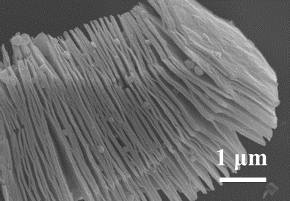
Fig. S1 SEM image of MXene

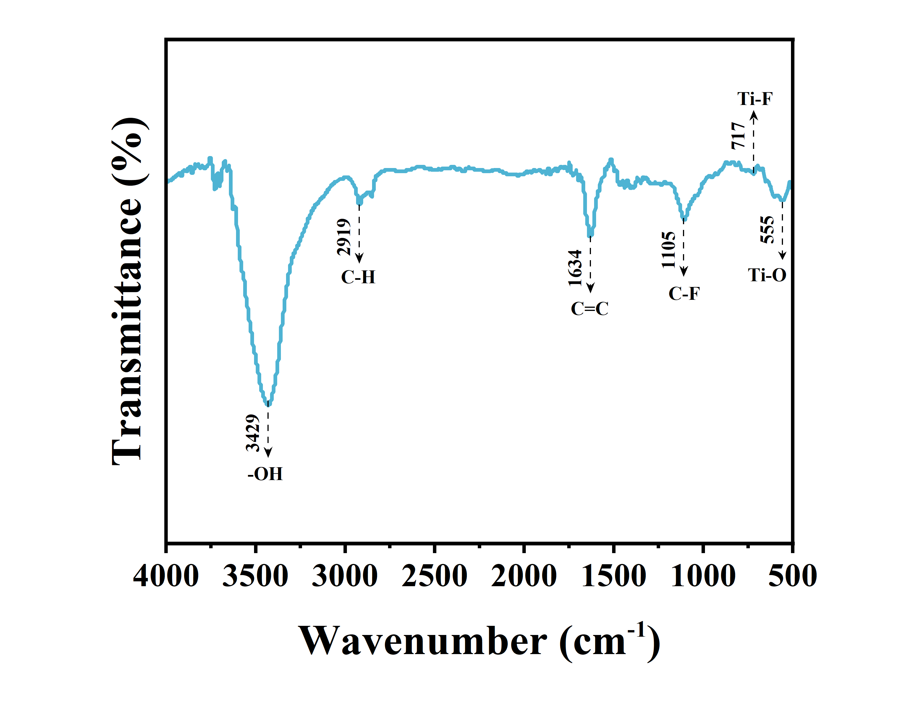
Fig. S2 FT-IR spectra of MXene^{[6]}
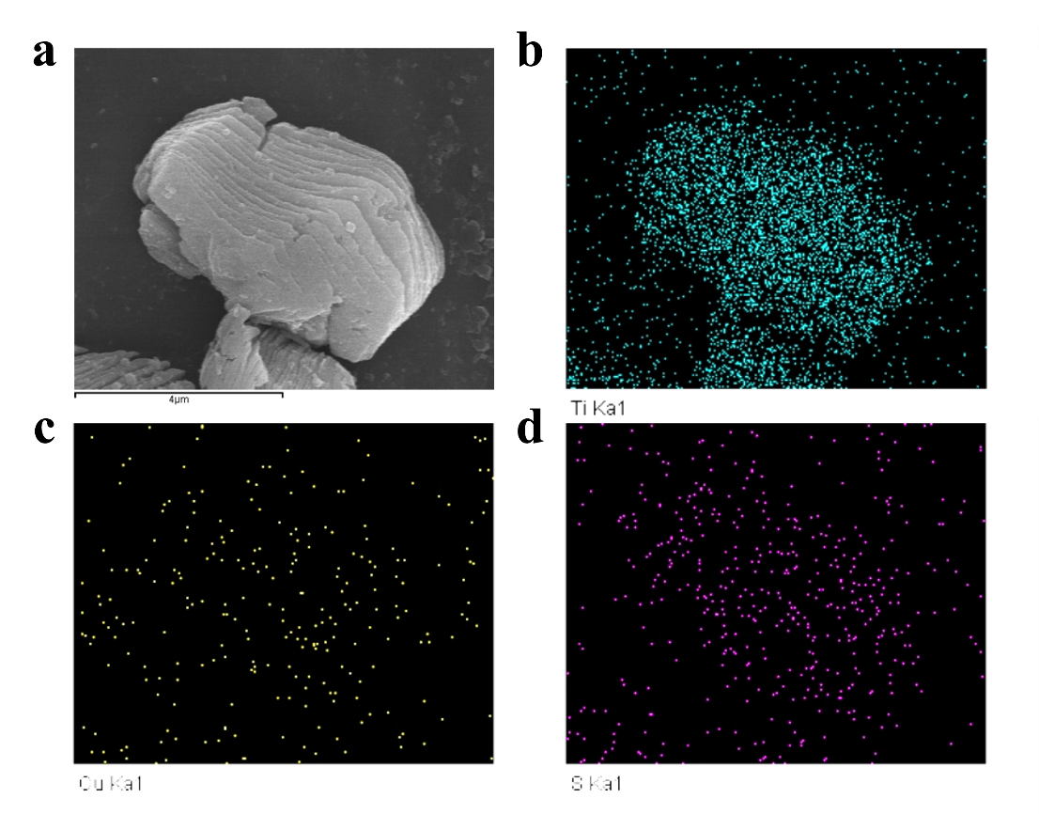
Fig. S3 EDS elemental mapping of MXene@CuS-1

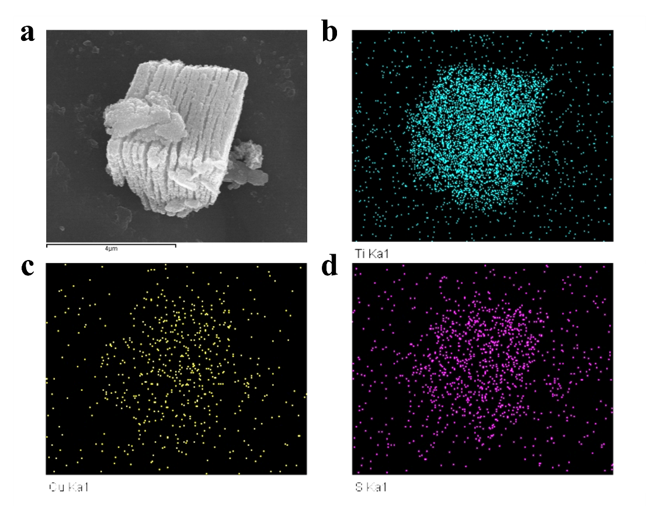
Fig. S4 EDS elemental mapping of MXene@CuS-2
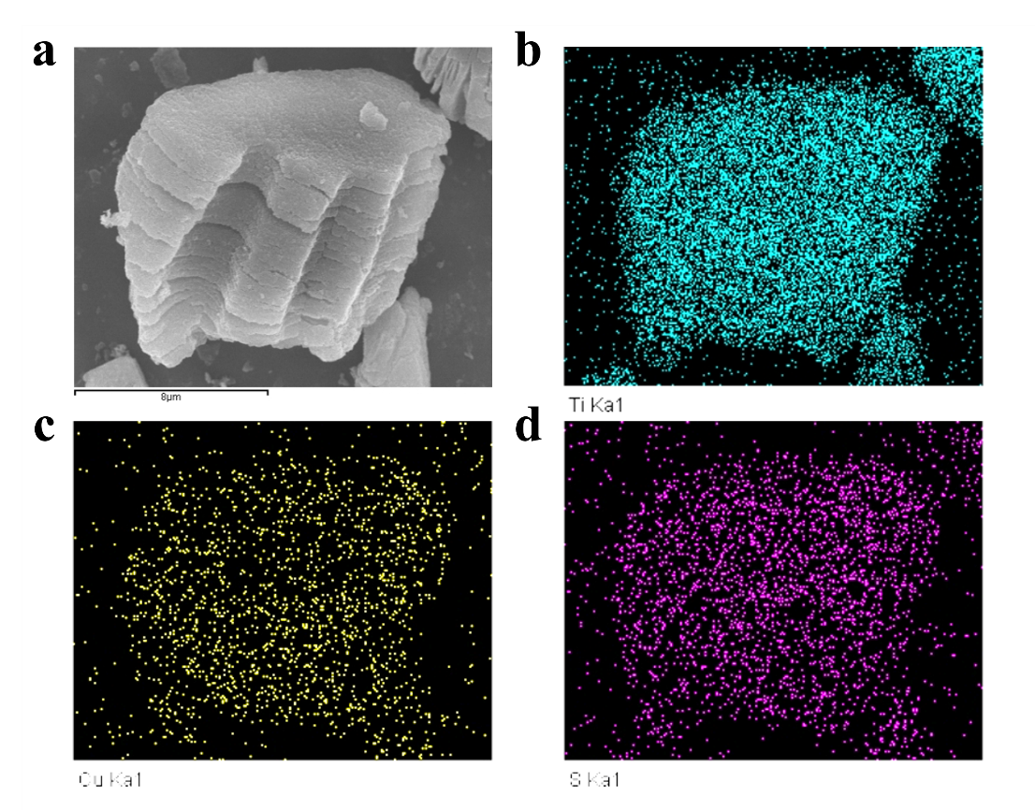
Fig. S5 EDS elemental mapping of MXene@CuS-3

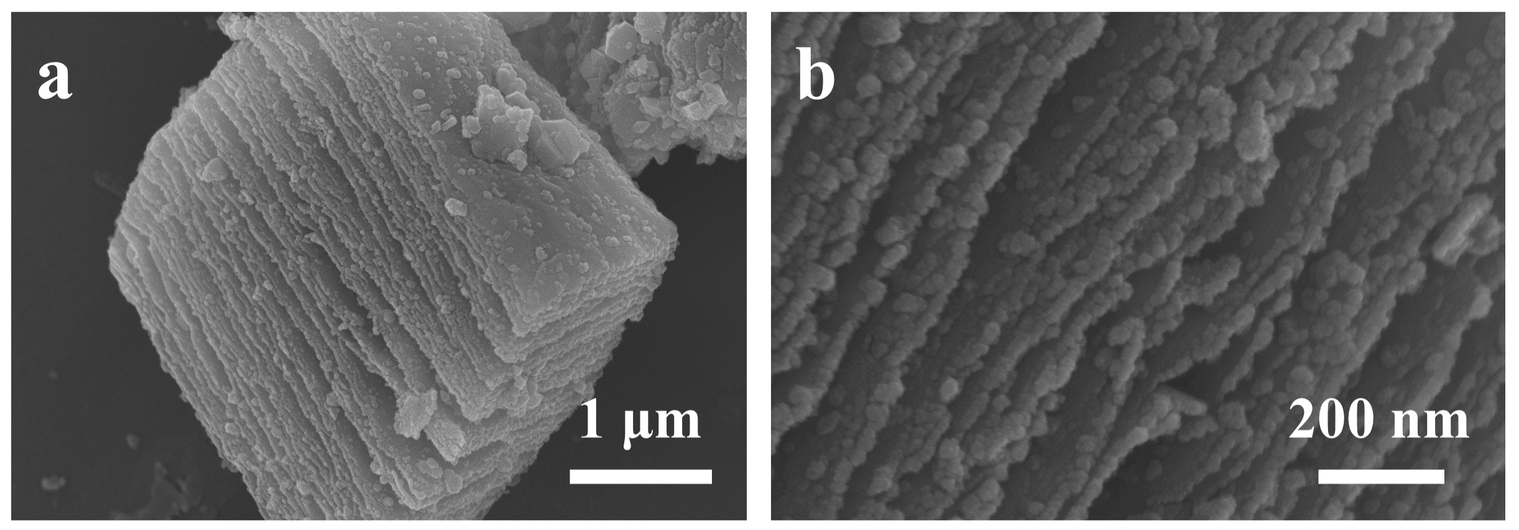
Fig. S6 SEM images of MXene@CuS-1

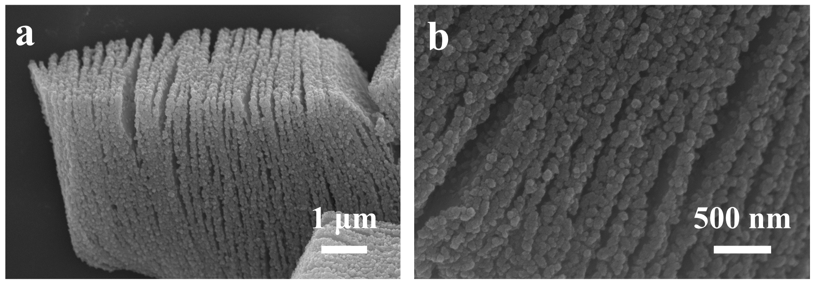
Fig. S7 SEM images of MXene@CuS-2

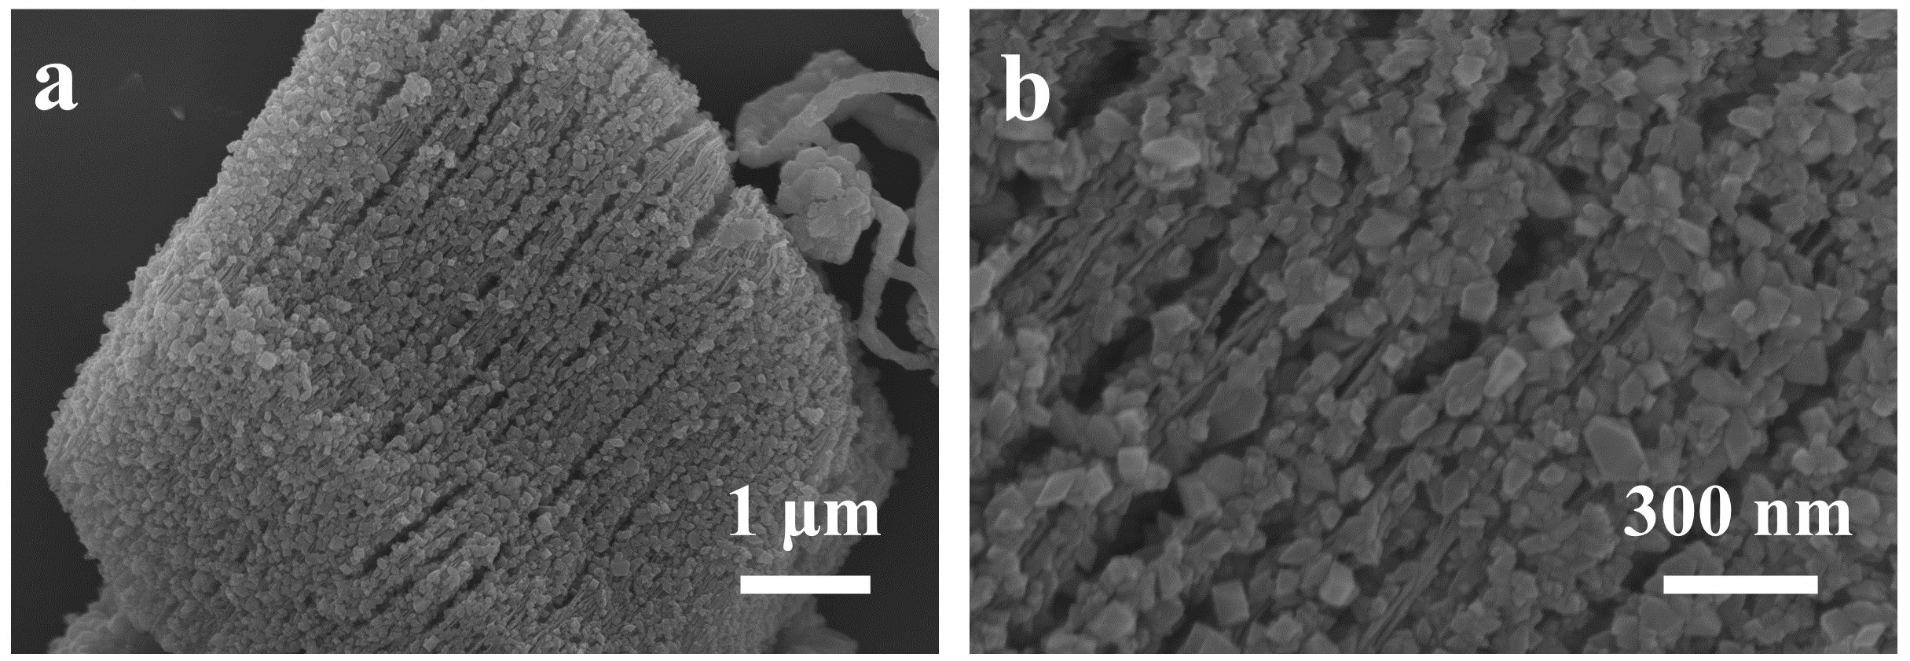
Fig. S8 SEM images of MXene@CuS-3

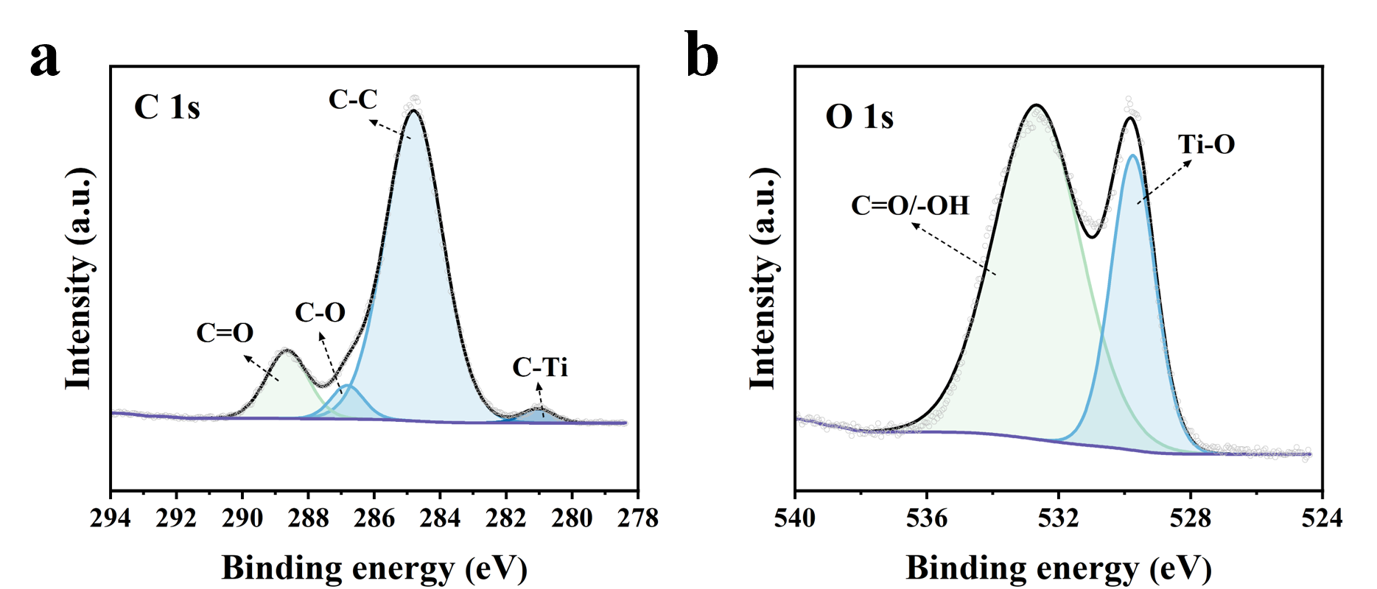
Fig. S9 XPS spectra of MXene@CuS: a C 1s, b O 1s

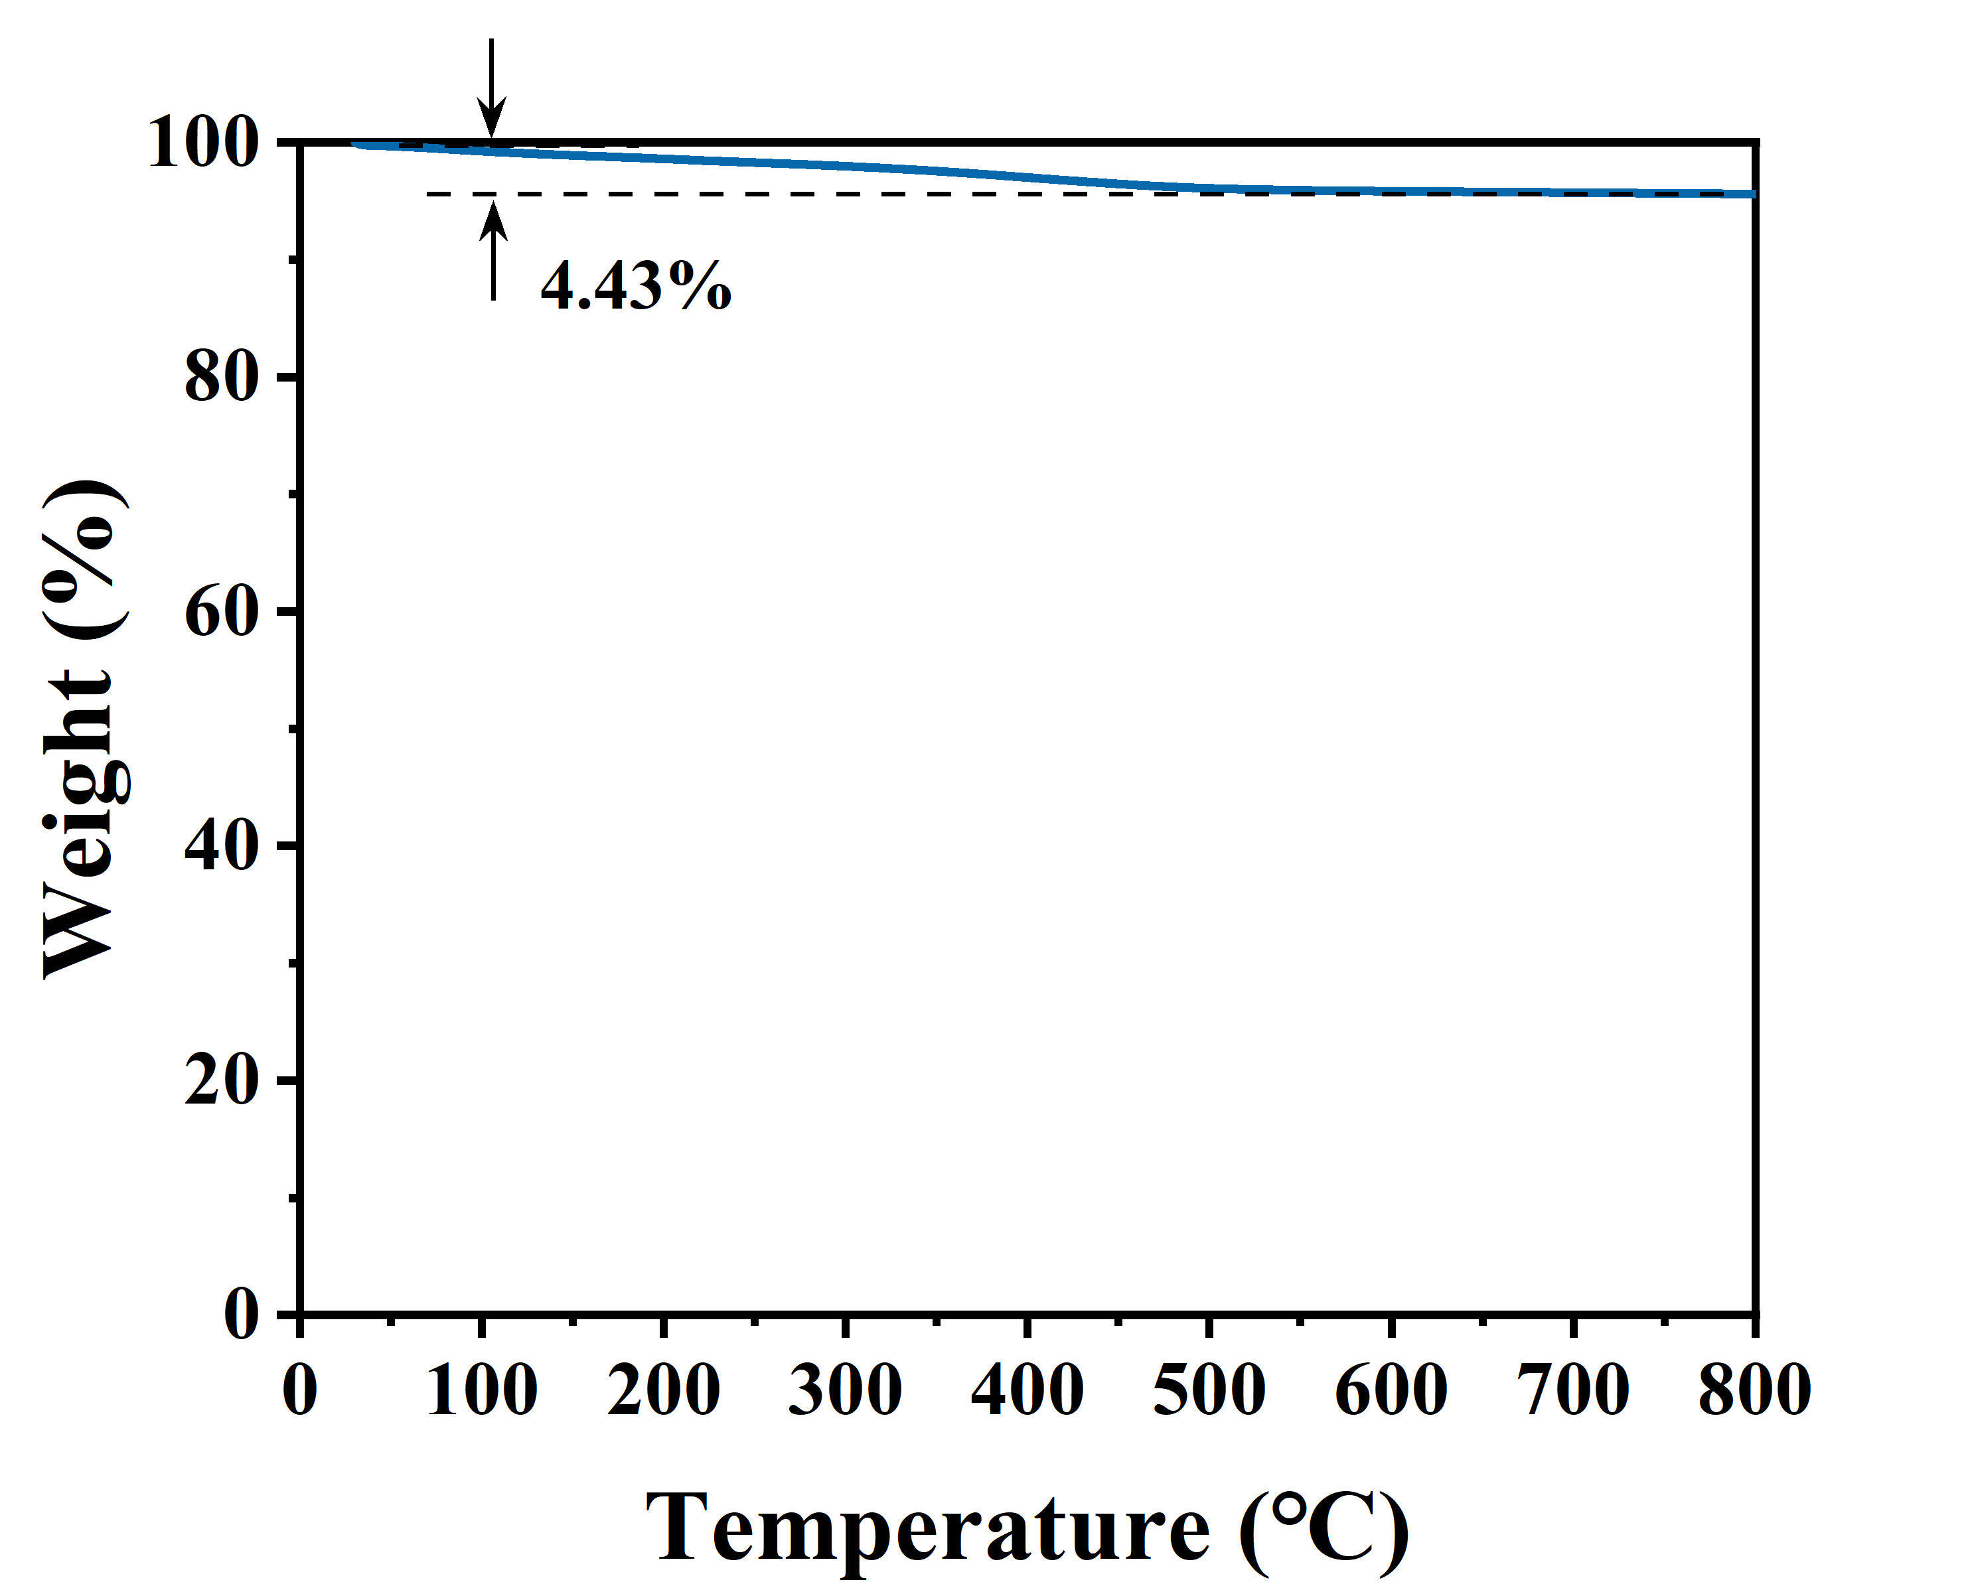
Fig. S10 TGA curves of MXene@CuS

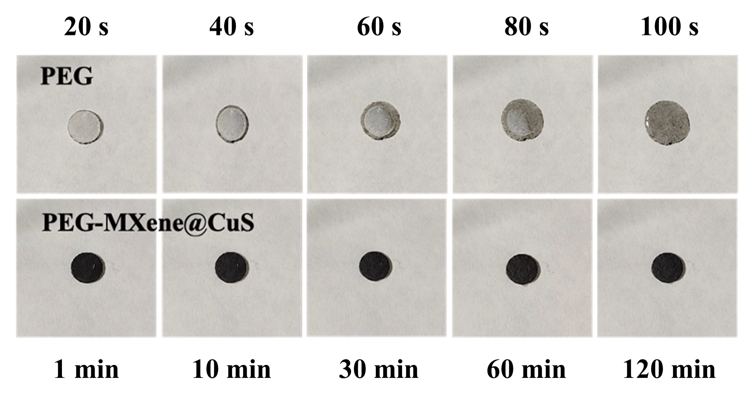
Fig. S11 Leakage test experiment of PEG and PEG-MXene@CuS

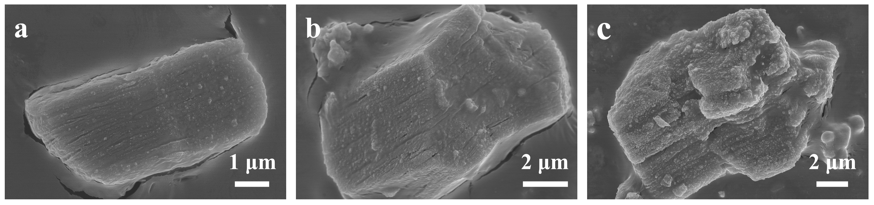
Fig. S12 SEM images of a PEG-MXene@CuS-1, b PEG-MXene@CuS-2, and c PEG-MXene@CuS-3

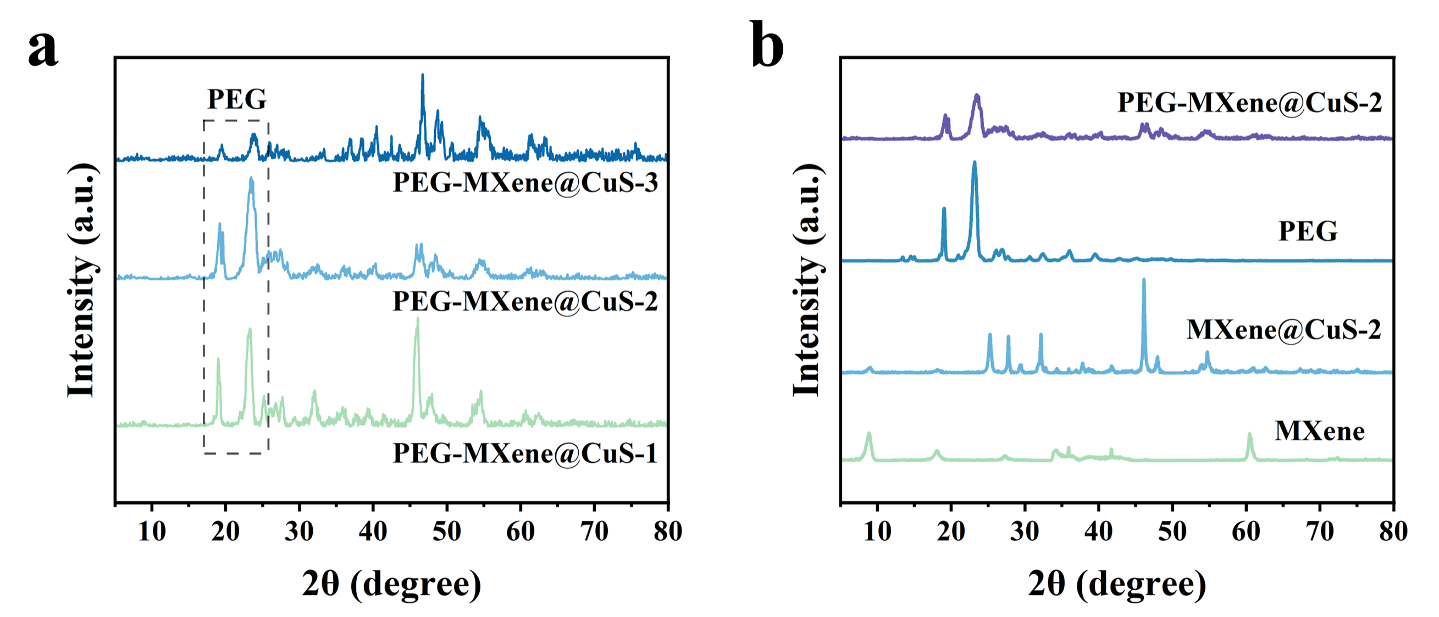
Fig. S13 a XRD patterns of PEG-MXene@CuS. b XRD patterns of MXene, MXene@CuS-2, PEG, and PEG-MXene@CuS-2
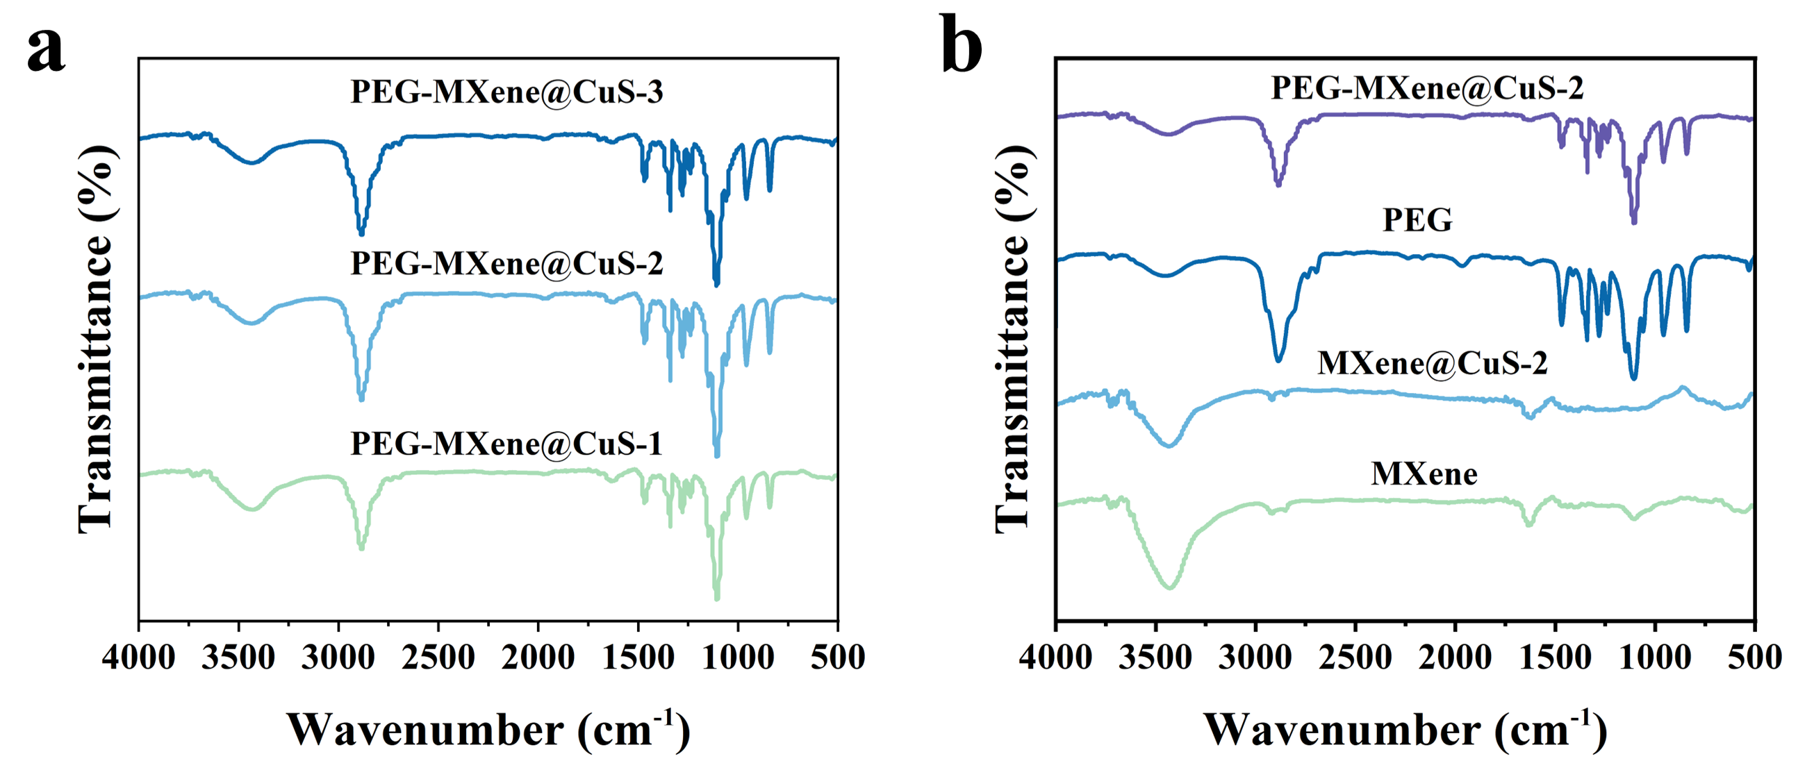
Fig. S14 a FT-IR spectra of PEG-MXene@CuS. b FT-IR spectra of MXene, MXene@CuS-2, PEG, and PEG-MXene@CuS-2

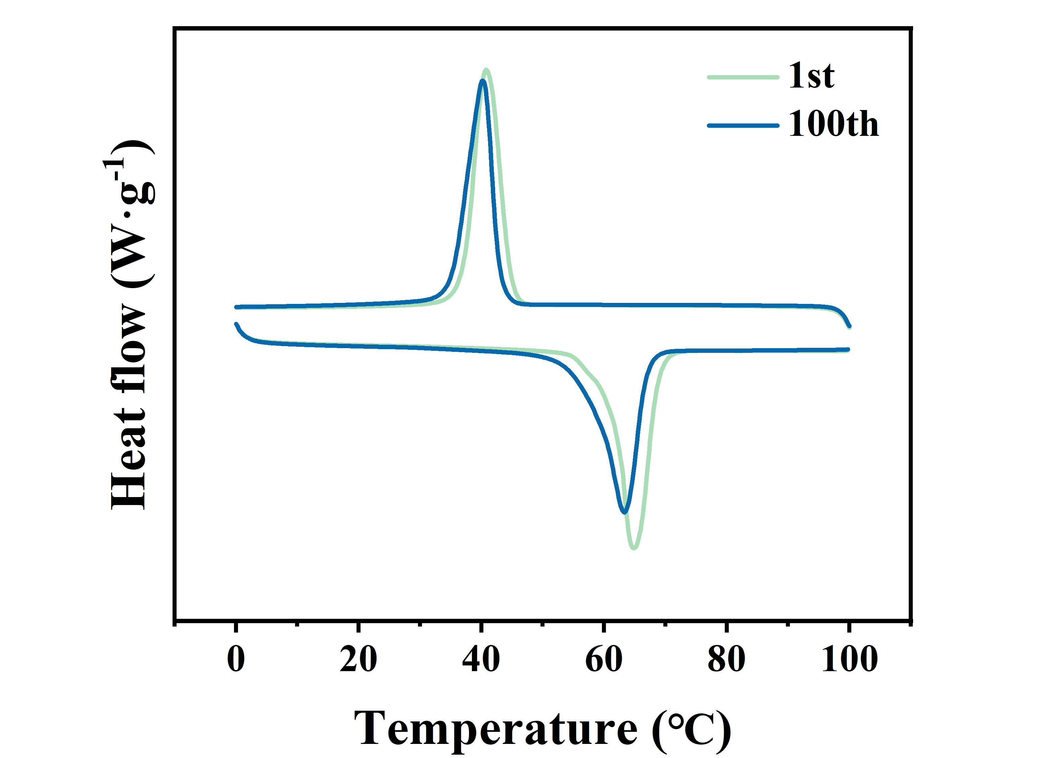
Fig. S15 DSC curve of PEG-MXene@CuS-2 for the 1st and the 100th cycles

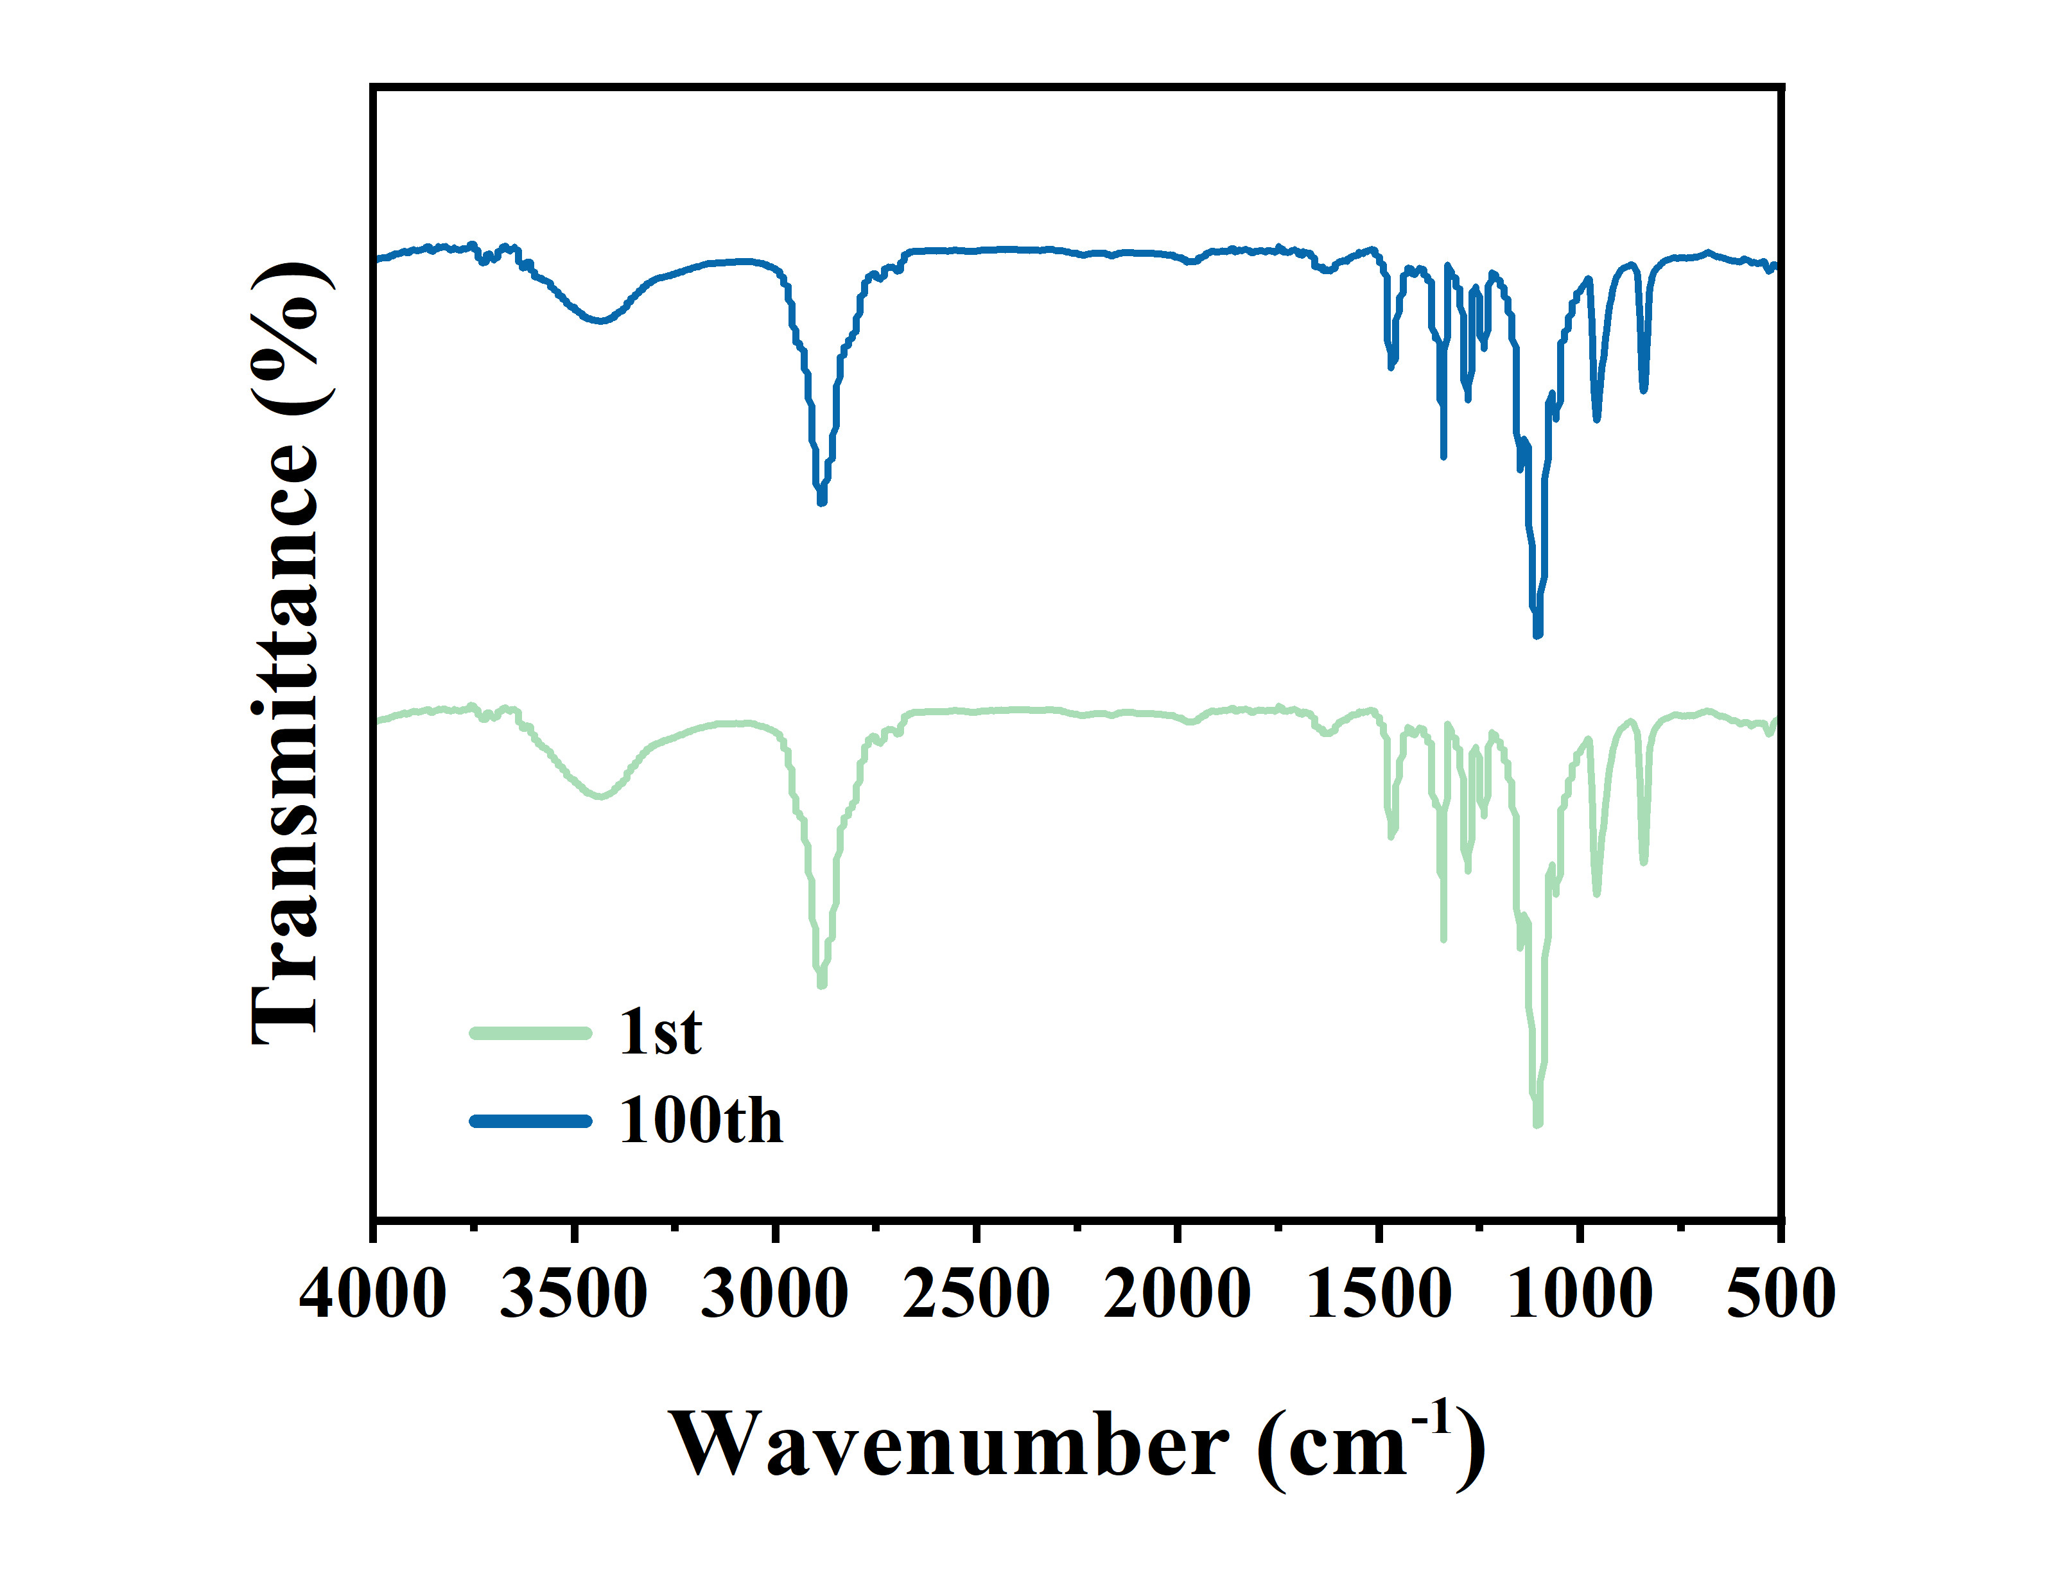
Fig. S16 FT-IR spectra of PEG-MXene@CuS-2 for the 1st and the 100th cycles
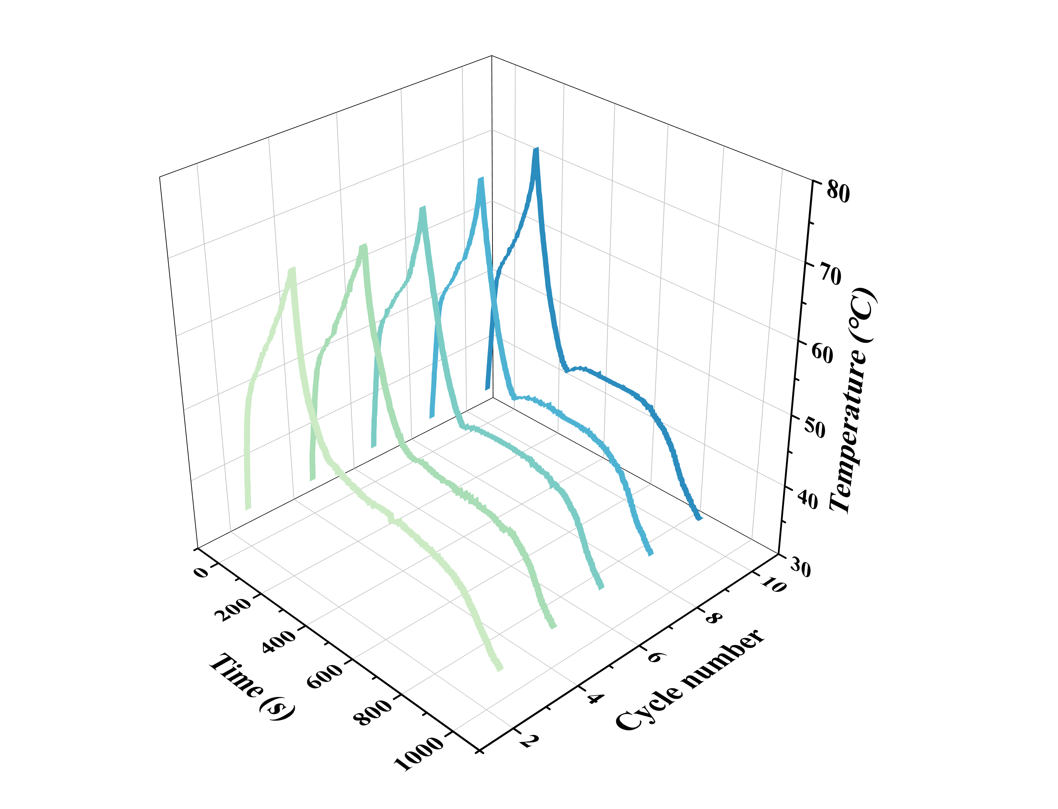
Fig. S17 Cyclic photothermal conversion curves of PEG-MXene@CuS-2
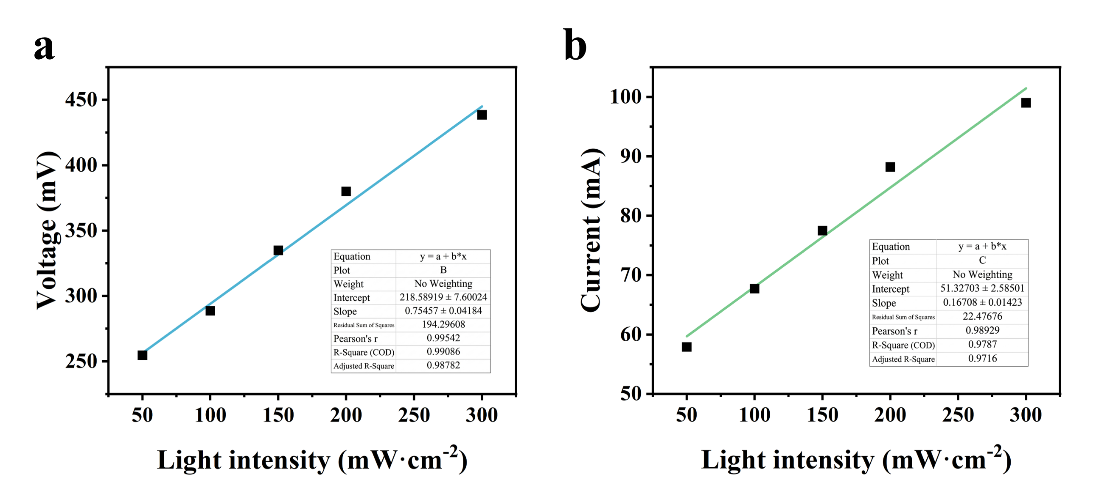
Fig. S18 Fitting curves of the output voltage and current of PEG-MXene@CuS-2 varying irradiation intensities

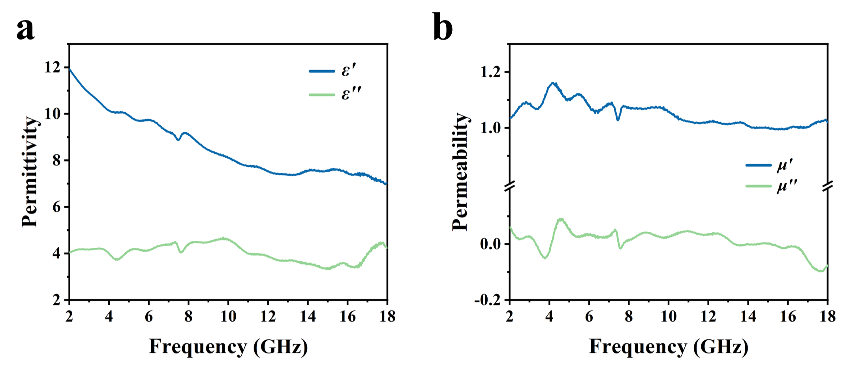
Fig. S19 Electromagnetic parameters a εʹ, εʺ and b μʹ, μʺ of PEG-MXene@CuS-2
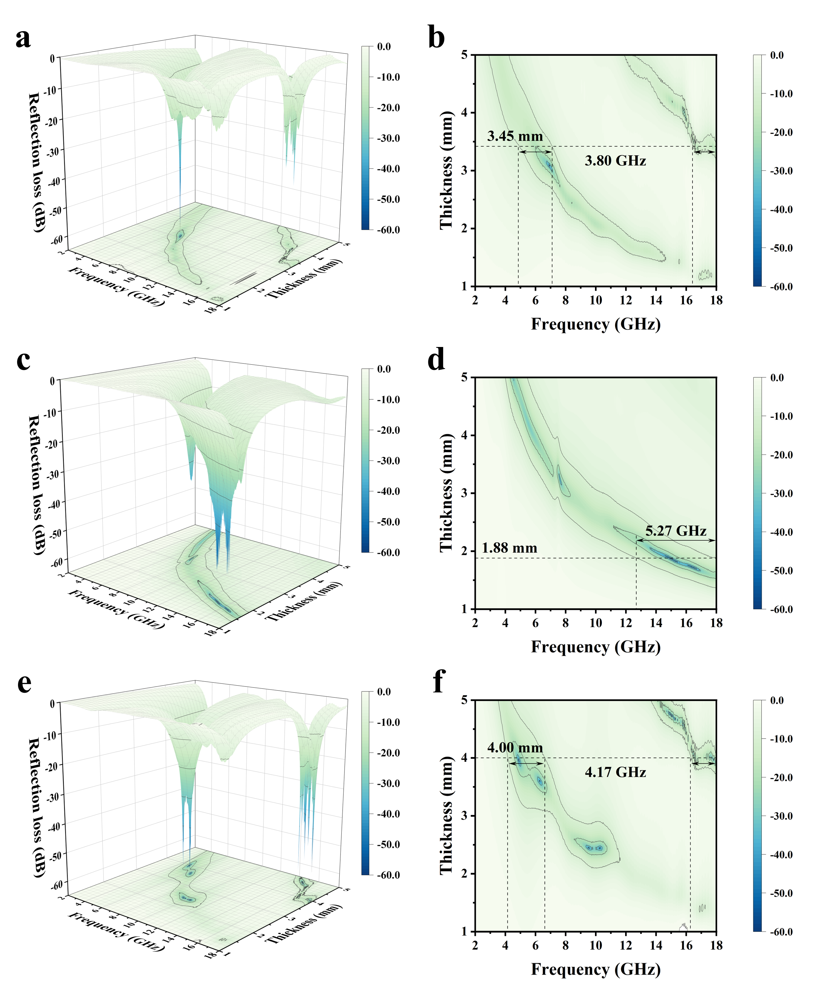
Fig. S20 3D representations and 2D projection graphics of the RL value for a, b PEG-MXene@CuS-1; c, d PEG-MXene@CuS-2; e, f PEG-MXene@CuS-3

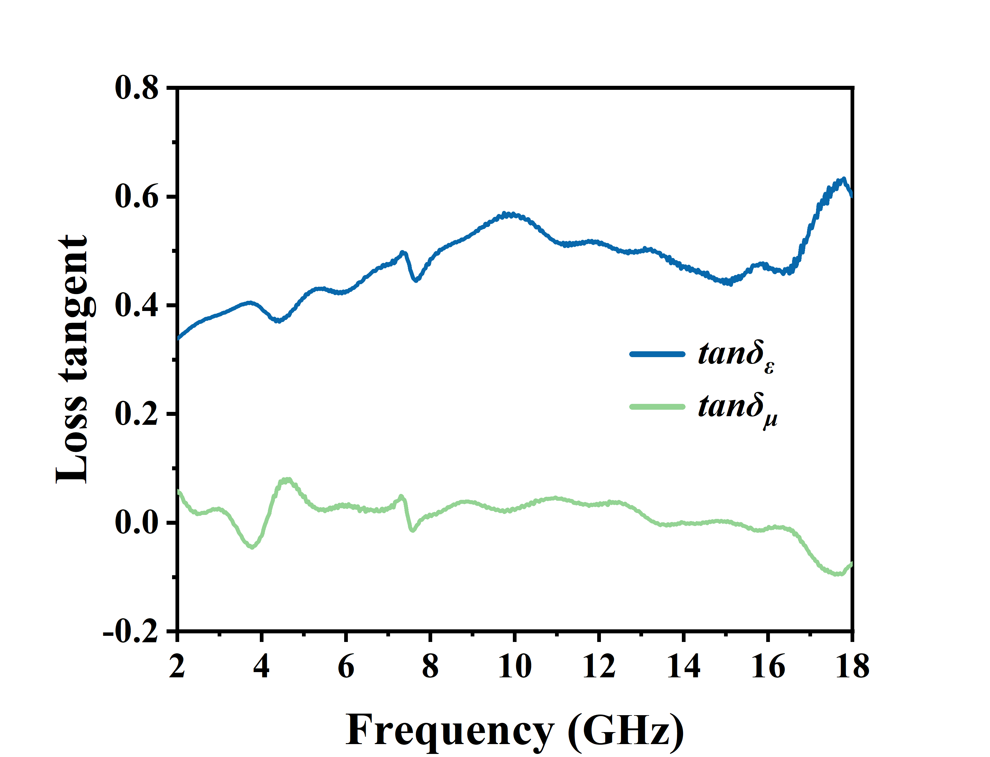
Fig. S21 tanδ_{ε} and tanδ_{μ} of PEG-MXene@CuS-2
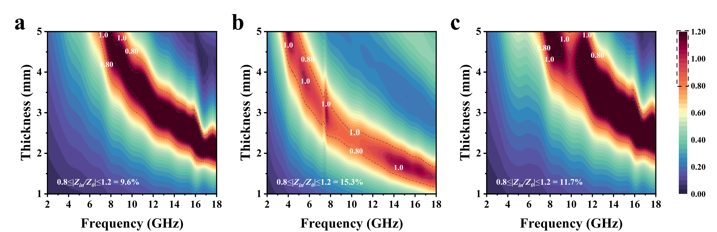
Fig. S22 Impedance matching diagram of a PEG-MXene@CuS-1, b PEG-MXene@CuS-2, c PEG-MXene@CuS-3
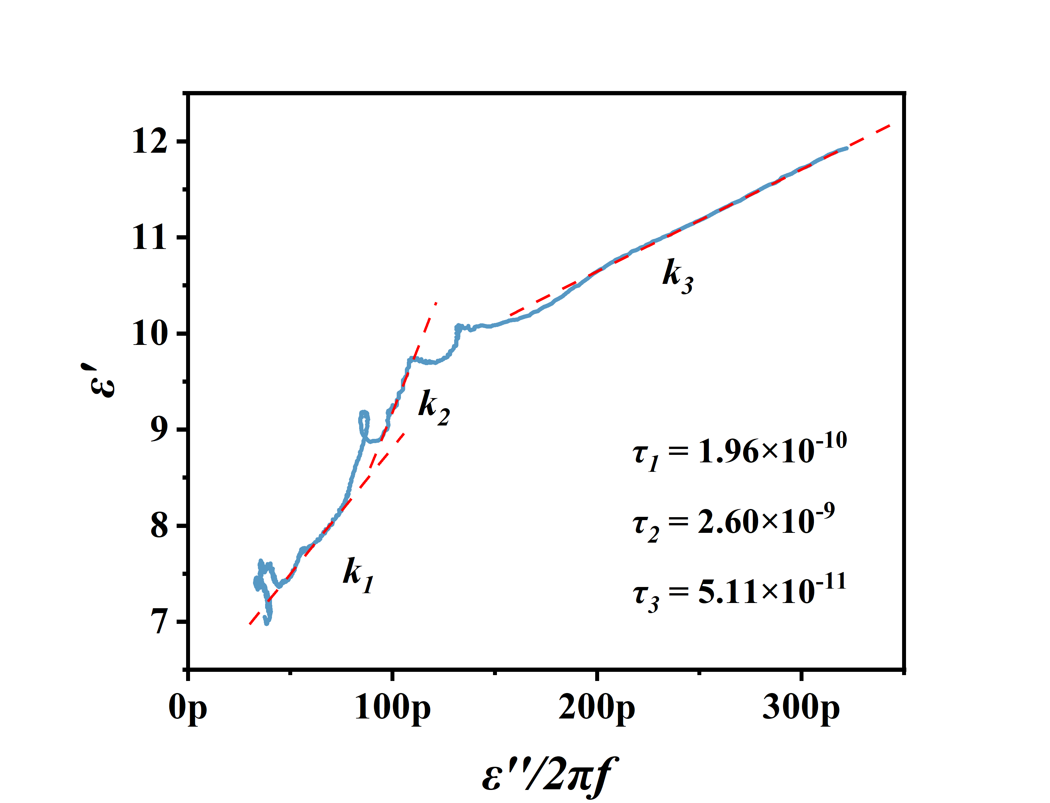
Fig. S23 Linear fitting of ε' versus εʹ/2πf based on the Debye relaxation model

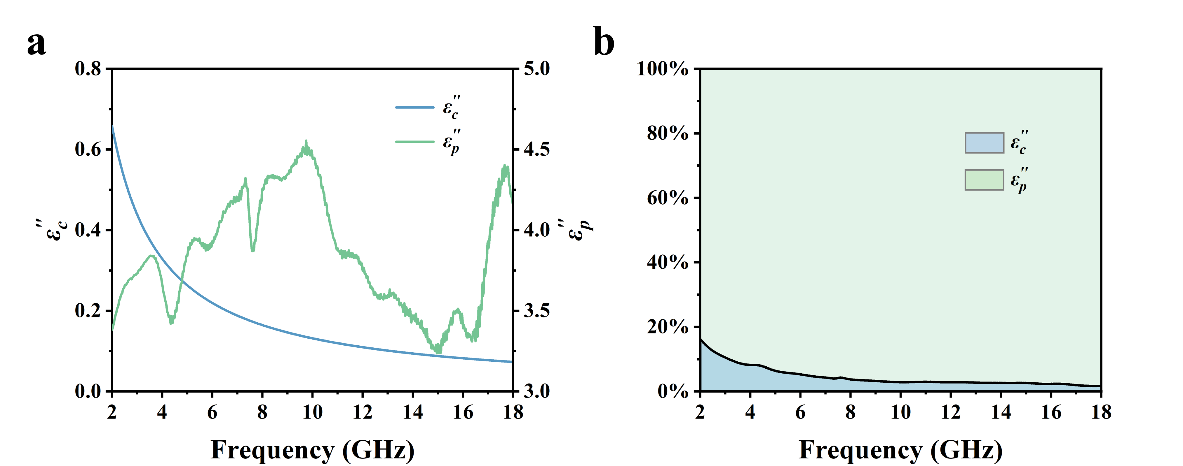
Fig. S24 a Conduction loss and polarization loss of PEG-MXene@CuS-2. b Ratio of conduction loss and polarization loss

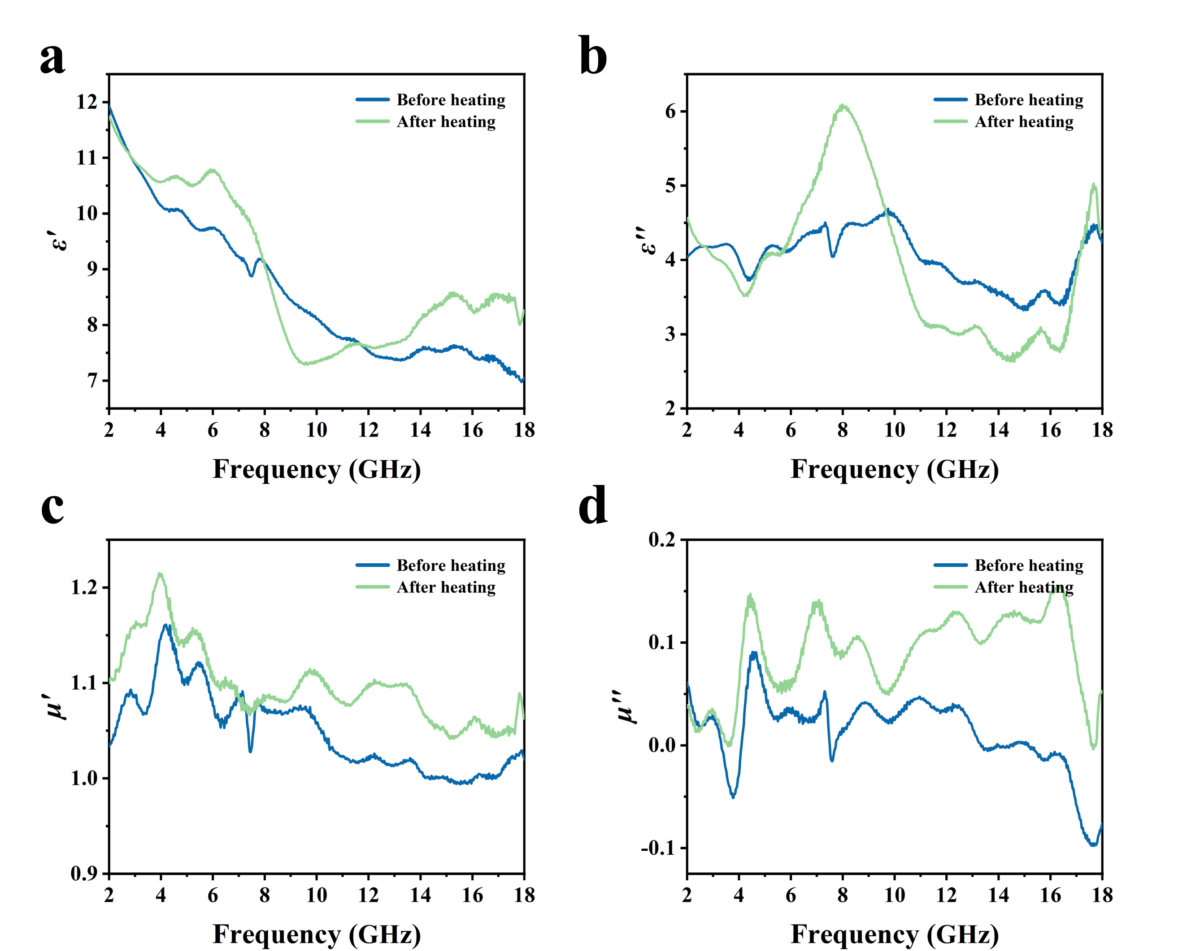
Fig. S25 Electromagnetic parameters a εʹ, b εʺ, c μʹ, and d μʺ of PEG-MXene@CuS-2 before and after heating

S4 Supplementary Table
Table S1 Elemental composition (Atomic %) of MXene@CuS samples
Sample | C | Ti | Cu | S
MXene@CuS-1 | 73.12% | 20.45% | 3.46% | 2.97%
MXene@CuS-2 | 65.46% | 25.57% | 4.89% | 4.09%
MXene@CuS-3 | 50.70% | 32.23% | 8.85% | 8.22%

Table S2 Thermal characteristics of PEG and composite PCMs
Sample | Melting process |  | Crystallization process
Sample | T_{m} (℃) | H_{m} (J·g⁻¹) | T_{c} (℃) | H_{c} (J·g⁻¹)
PEG | 61.1 | 152.83 | 44.6 | 140.07
PEG-MXene@CuS-1 | 61.6 | 100.74 | 45.4 | 99.57
PEG-MXene@CuS-2 | 60.2 | 99.06 | 45.2 | 99.36
PEG-MXene@CuS-3 | 60.2 | 98.10 | 46.2 | 97.41

Table S3 Thermal conductivity
Sample | Thermal conductivity (W·m⁻¹·K⁻¹)
PEG | 0.25
PEG-MXene | 0.41
PEG-MXene@CuS-1 | 0.56
PEG-MXene@CuS-2 | 0.68
PEG-MXene@CuS-3 | 0.62

Table S4 Photothermal conversion efficiency of PEG-MXene@CuS
Sample | Photothermal conversion efficiency
PEG-MXene@CuS-1 | 89.6%
PEG-MXene@CuS-2 | 94.5%
PEG-MXene@CuS-3 | 91.1%

Table S5 Comparison of output voltage and photothermal efficiency for composite PCMs
Sample | Output voltage (mV) | Photothermal efficiency | Light intensity (mW·cm⁻²) | Refs.
TRIS/EG | 93.1 | 87.0% | 47.7 | S7
PW-CNT/rGO | 150.0 | 90.3% | 150 | S8
SA-BC/graphene | 151.9 | 90.8% | 200 | S9
TD-ACW/Fe₃O₄ | 196.6 | 89.8% | 150 | S10
PEG-PI/KNF/CoFe₂O₄/PPy | 259.7 | 84.8% | 200 | S11
PEG-PPy | 318.0 | 86.0% | 250 | S12
PW-PVP/GO/AgNPs | 200.5 | 92.6% | 100 | S13
PEG-PU/NR/MXene | 410.0 | 92.0% | 200 | S14
PEG-MoS₂/Mt | 458.0 | 96.5% | 200 | S15
PEG-PVA/HNT/PPy | 587.0 | 90.4% | 300 | S16
PEG-BC/MoS₂/CuS | 157.0 | 93.6% | 100 | S17
PEG-CKF@Co/C | 309.0 | 94.4% | 100 | S18
PEG-MXene@CuS | 288.6 | 94.5% | 100 | This work

Table S6 Photoresponsive thermoelectric performance of PEG-MXene@CuS-2
Irradiation (mW·cm⁻²) | Output voltage (mV) | Output current (mA) | Power density (W·m⁻²)
50 | 254.6 | 57.9 | 16.3
100 | 288.6 | 67.7 | 21.7
150 | 334.9 | 77.5 | 28.8
200 | 380.0 | 88.2 | 37.2
300 | 438.5 | 99.0 | 48.2

Table S7 Comparison of microwave absorption performance for composite PCMs
Sample | EAB  (GHz) | RL_{min}  (dB) | Thickness  (mm) | Filler mass ratio (%) | Refs.
LA-CKF@Fe₃O₄ | 1.7 | -17.3 | 5.5 | 9.5% | S19
PEG-CMF/rGO/MoS₂ | 4.8 | -32.5 | 2.4 | 7.9% | S20
PW-CMF@Co/NC | 3.8 | -57.9 | 3.0 | 39.8% | S21
PW-MXene/CoNi-C | 3.1 | -49.3 | 4.5 | 28.0% | S22
PW-MoS₂@CNTs | 4.3 | -28.0 | 2.0 | 50.3% | S23
PW-C-LDH@MXene | 3.9 | -20.9 | 2.0 | 30.4% | S24
PEG-SWCNT/PDMS | 2.5 | -51.7 | 1.8 | 36.5% | S25
PEG-PI/Graphene/Fe₃O₄ | 2.6 | -38.5 | 2.8 | 15.8% | S26
PW-MXene/CNF@MoS₂ | 4.3 | -61.3 | 1.4 | 33.5% | S27
PW-Co-MnS/CF@MoS₂ | 6.2 | -63.2 | 1.9 | 34.2% | S28
PEG@FGA | 5.8 | 48.7 | 2.1 | 8.6% | S29
ADGW/PEG | 4.9 | -41.4 | 2.5 | 16.7% | S30
PI/PPy-CNTs@PEG | 2.6 | -42.0 | 5.5 | 10.8% | S31
PEG-MXene@CuS | 5.3 | -55.5 | 1.9 | 33.0% | This work

Supplementary References
[S1] S. J. Clark, M. D. Segall, C. J. Pickard, P. J. Hasnip, M. I. J. Probert, et al., First principles methods using castep. 220(5–6), 567–570 (2005). https://doi.org/10.1524/zkri.220.5.567.65075
[S2] D. Vanderbilt, Soft self-consistent pseudopotentials in a generalized eigenvalue formalism. Phys. Rev. B 41(11), 7892–7895 (1990). https://doi.org/10.1103/PhysRevB.41.7892
[S3] J. P. Perdew, K. Burke, M. Ernzerhof, Generalized gradient approximation made simple. Phys. Rev. Lett. 77(18), 3865–3868 (1996). https://doi.org/10.1103/PhysRevLett.77.3865
[S4] S. Grimme, Semiempirical GGA‐type density functional constructed with a long‐range dispersion correction. J. Comput. Chem. 27(15), 1787–1799 (2006). https://doi.org/10.1002/jcc.20495
[S5] H. J. Monkhorst, J. D. Pack, Special points for Brillouin-zone integrations. Phys. Rev. B 13(12), 5188–5192 (1976). https://doi.org/10.1103/PhysRevB.13.5188
[S6] T. Parker, D. Zhang, D. Bugallo, K. Shevchuk, M. Downes, et al., Fourier-transform infrared spectral library of MXenes. Chem. Mater. 36(17), 8437–8446 (2024). https://doi.org/10.1021/acs.chemmater.4c01536
[S7] S. Song, H. Ai, W. Zhu, L. Lv, R. Feng, et al., Carbon aerogel based composite phase change material derived from kapok fiber: Exceptional microwave absorbility and efficient solar/magnetic to thermal energy storage performance. Compos. Part B Eng. 226, 109330 (2021). https://doi.org/10.1016/j.compositesb.2021.109330
[S8] Z. Hu, M. Jiang, Y. Zou, L. Sun, F. Xu, et al., MoS₂-decorated carbonized melamine foam/reduced graphene oxide network for constructing polyethylene-glycol-based multifunctional phase change materials toward multiple energy harvesting and microwave absorbing applications. Chem. Eng. J. 461, 141923 (2023). https://doi.org/10.1016/j.cej.2023.141923
[S9] Y. Li, X. Diao, P. Li, P. Liu, Y. Gao, et al., Advanced multifunctional Co/N co-doped carbon foam-based phase change materials for wearable thermal management. Chem. Eng. J. 485, 149858 (2024). https://doi.org/10.1016/j.cej.2024.149858
[S10] Y. Gao, X. Chen, X. Jin, C. Zhang, X. Zhang, et al., Multifunction integration within magnetic CNT-bridged MXene/CoNi based phase change materials. eScience 4(6), 100292 (2024). https://doi.org/10.1016/j.esci.2024.100292
[S11] P. Liu, Y. Li, Z. Tang, J. Lv, P. Cheng, et al., Integrating thermal energy storage and microwave absorption in phase change material-encapsulated core-sheath MoS₂@CNTs. J. Energy Chem. 84, 41–49 (2023). https://doi.org/10.1016/j.jechem.2023.04.048
[S12] Y. Gao, J. Lin, X. Chen, Z. Tang, G. Qin, et al., Engineering 2D MXene and LDH into 3D hollow framework for boosting photothermal energy storage and microwave absorption. Small 19(49), 2303113 (2023). https://doi.org/10.1002/smll.202303113
[S13] X. Ge, G. Tay, Y. Hou, Y. Zhao, P. J. Sugumaran, et al., Flexible and leakage-proof phase change composite for microwave attenuation and thermal management. Carbon 210, 118084 (2023). https://doi.org/10.1016/j.carbon.2023.118084
[S14] T. Shi, Z. Zheng, H. Liu, D. Wu, X. Wang, Configuration of multifunctional Polyimide/Graphene/Fe₃O₄ hybrid aerogel-based phase-change composite films for electromagnetic and infrared bi-stealth. Nanomaterials 11(11), 3038 (2021). https://doi.org/10.3390/nano11113038
[S15] Y. Feng, G. Hai, G. Sun, K. Chen, X. Wang, et al., Dual-functional phase change composites integrating thermal buffering and electromagnetic wave absorption via multi-interfacial engineering. Adv. Fiber Mater. 7(6), 1873–1887 (2025). https://doi.org/10.1007/s42765-025-00585-y
[S16] Y. Feng, M. Qin, J. Qin, Z. Shen, X. Chen, et al., Synergistic thermal management and electromagnetic wave absorption in core-sheath phase change composites. Adv. Funct. Mater. 36(24), e23075 (2026). https://doi.org/10.1002/adfm.202523075
[S17] J. Zha, D. Feng, M. Zhang, X. Zhang, W. Li, et al., Graphene aerogel based/polyethylene glycol composite thermal storage materials with high enthalpy and low thermal conductivity for space thermal protection. J. Energy Storage 120, 116456 (2025). https://doi.org/10.1016/j.est.2025.116456
[S18] L. Bai, S. Zhang, Z. Ma, L. Dou, J. Li, Bio-inspired multifunctional composite phase change films for synergistic thermal management and microwave absorption. Nano Res. 19(5), 94908229 (2026). https://doi.org/10.26599/NR.2025.94908229
[S19] Y. Cao, Z. Zhao, X. Zeng, J. Teng, J. Huang, et al., High-performance Polyimide/Polypyrrole-CNTs@PEG composites for integrated thermal management and enhanced electromagnetic wave absorption. Adv. Compos. Hybrid Mater. 8(1), 104 (2025). https://doi.org/10.1007/s42114-024-01202-z
[S20] Z. Dai, Y. Gao, C. Wang, D. Wu, Z. Jiang, et al., Oriented high thermal conductivity solid–solid phase change materials for mid-temperature solar-thermal energy storage. ACS Appl. Mater. Interfaces 15(22), 26863–26871 (2023). https://doi.org/10.1021/acsami.3c04429
[S21] Y. Chen, Q. Ma, L. Chen, X. Wang, X. Zhao, et al., Enhanced light-to-thermal conversion performance of self-assembly carbon nanotube/graphene-interconnected phase change materials for thermal-electric device. J. Energy Storage 72, 108387 (2023). https://doi.org/10.1016/j.est.2023.108387
[S22] G. Wu, N. Bing, Y. Li, H. Xie, W. Yu, Three-dimensional directional cellulose-based carbon aerogels composite phase change materials with enhanced broadband absorption for light-thermal-electric conversion. Energy Convers. Manage. 256, 115361 (2022). https://doi.org/10.1016/j.enconman.2022.115361
[S23] H. Fang, Y. Heng, G. Teng, D. Hu, Advanced 3D-architected carbon-based photothermoelectric energy harvesters for self-powered and responsive magnetic and UV sensing. Ind. Crops Prod. 205, 117483 (2023). https://doi.org/10.1016/j.indcrop.2023.117483
[S24] T. Shi, H. Liu, X. Wang, Unidirectionally structured magnetic phase-change composite based on carbonized Polyimide/Kevlar nanofiber complex aerogel for boosting solar-thermo-electric energy conversion. ACS Appl. Mater. Interfaces 16(8), 10180–10195 (2024). https://doi.org/10.1021/acsami.3c18523
[S25] S. Han, F. Xiong, M. Qin, Z. Shen, H. Han, et al., Polyethylene glycol/polypyrrole aerogel shape-stabilized phase change material for solar-thermal energy storage and thermoelectric power generation. Sol. Energy Mater. Sol. Cells 268, 112745 (2024). https://doi.org/10.1016/j.solmat.2024.112745
[S26] M. He, J. Lu, C. Shi, X. Qian, L. Yin, et al., Multi-stimuli-responsive aerogels composed of ag nanoparticle-coated graphene nanosheets for energy storage and conversion. ACS Appl. Nano Mater. 6(18), 16503–16514 (2023). https://doi.org/10.1021/acsanm.3c02622
[S27] Y.-C. Zhou, J. Yang, L. Bai, R.-Y. Bao, M.-B. Yang, et al., Super-flexible phase change materials with a dual-supporting effect for solar thermoelectric conversion in the ocean environment. J. Mater. Chem. A 11(1), 341–351 (2023). https://doi.org/10.1039/D2TA07885F
[S28] Q. Guo, H. Yi, F. Jia, S. Song, Novel MoS₂/montmorillonite hybrid aerogel encapsulated PEG as composite phase change materials with superior solar-thermal energy harvesting and storage. J. Colloid Interface Sci. 667, 269–281 (2024). https://doi.org/10.1016/j.jcis.2024.04.107
[S29] S. Li, N. Zhang, H. Chen, Z. Zhang, Y. Zhao, et al., Encapsulating phase change materials into melamine formaldehyde sponge assembled with polypyrrole modified halloysite nanotube for effective solar-thermal energy storage and solar-thermal-electric conversion. J. Colloid Interface Sci. 682, 423–435 (2025). https://doi.org/10.1016/j.jcis.2024.11.226
[S30] Y. Li, X. Wang, K. Chen, Y. Feng, P. Liu, et al., Hierarchical MoS₂/CuS photonic nanostructure accelerating photothermoelectric conversion of bacterial cellulose based phase change materials. J. Colloid Interface Sci. 702, 138863 (2026). https://doi.org/10.1016/j.jcis.2025.138863
[S31] Y. Li, Y. Feng, M. Qin, K. Chen, Y. An, et al., Co-anchored hollow carbonized kapok fiber encapsulated phase change materials for upgrading photothermal utilization. Small 21(21), 2500479 (2025). https://doi.org/10.1002/smll.202500479

