Supporting Information for
On-Site Periodontitis Diagnosis via Room-Temperature Oral Exhalation H₂S Sensor Based on Yb-Doped Bi₂S₃ Nanoribbon
Ping Guo ¹, Kai Wang ², Xuyang An ¹, Xuanyu Ren ³, Xinxin He ¹, Yinhua Hu ¹, Lijie Zhou ⁴, Guohua Cai ⁵, Lifeng Wang ⁶, Tiezhu Liu ¹*, Wenyu Ge ²*, Jia Zhang^{1, 7}*
¹ State Key Laboratory of Robotics and System, Harbin Institute of Technology, Harbin 150080, P. R. China
² Department of Stomatology Center, Heilongjiang Provincial Hospital, Harbin 150036, P. R. China
³ Key Laboratory of Bio-Based Material Science and Technology of the Ministry of Education, Northeast Forestry University, Harbin150040, P. R. China
⁴ School of Mechanical and Power Engineering, Harbin University of Science and Technology, Harbin, 150080, P. R. China
⁵ The Second Affiliated Hospital of Harbin Medical University, Harbin, 150081, P. R. China
⁶ School of Science, City Campus Australia, RMIT University, 124 La Trobe Street, Melbourne VIC 3000, Australia
⁷Key Laboratory of Micro-Systems and Micro-Structures Manufacturing, Ministry of Education, Harbin Institute of Technology, Harbin 150080, P. R. China
*Corresponding authors. E-mail: zhangjia@hit.edu.cn (Jia Zhang); liutiezhu@hit.edu.cn (Tiezhu Liu); gwysci@163.com (Wenyu Ge)
Supplementary Figures and Tables
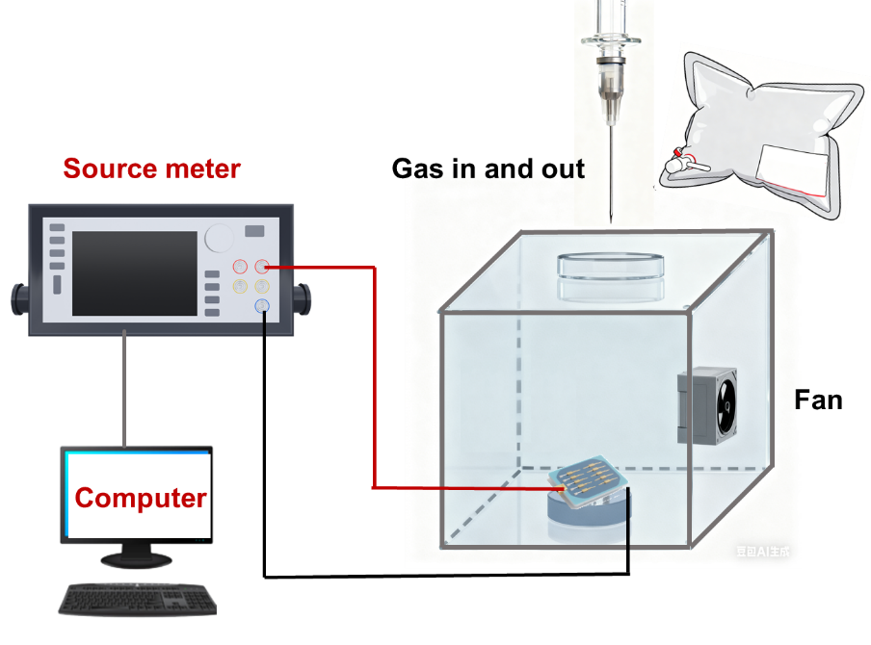
Fig. S1 Schematic diagram of the gas sensing test system.

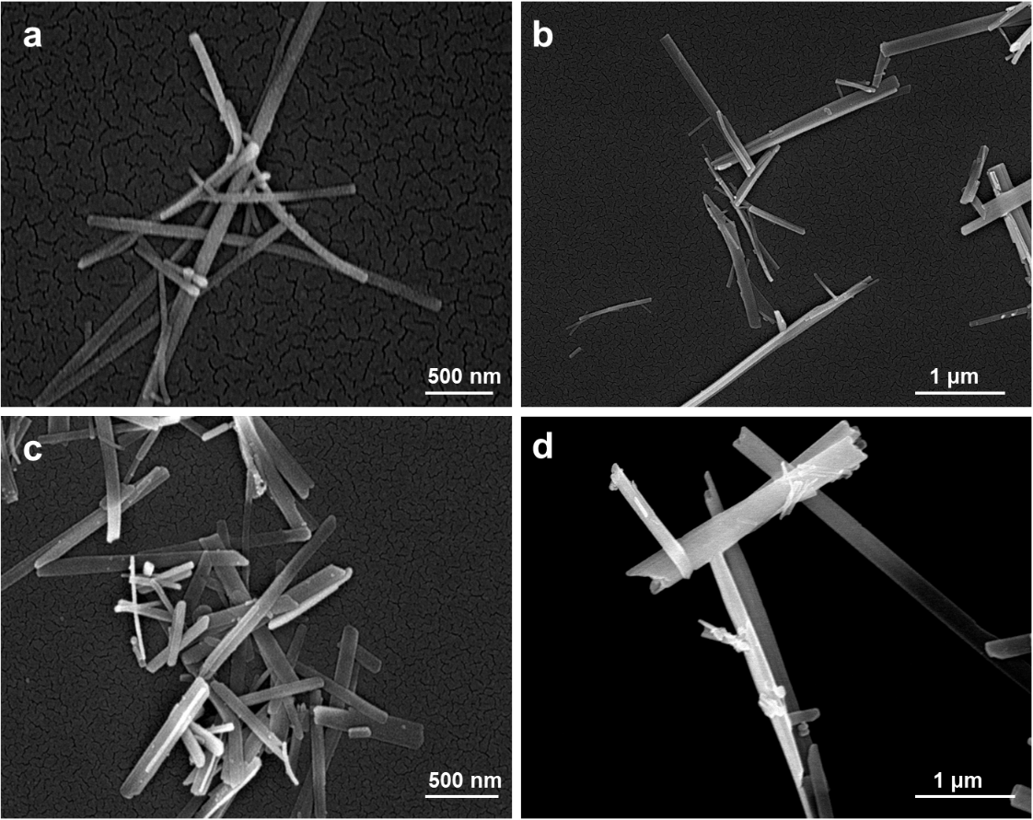
Fig. S2 SEM images of (a) Yb-Bi₂S₃-0.2%, (b) Yb-Bi₂S₃-0.5%, (c) Yb-Bi₂S₃-1.0 %, (d) Yb-Bi₂S₃-2.0%.

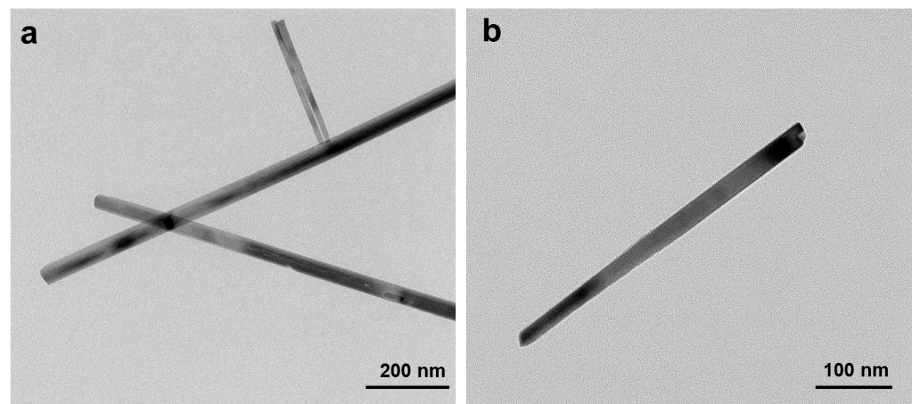
Fig. S3 TEM images of Yb-Bi₂S₃-1.5%.

Fig.S4 Comparison of high-resolution C 1s spectra between Yb-Bi₂S₃ derived from CAU-17 and Yb-Bi₂S₃ synthesized by a conventional one-step hydrothermal method.
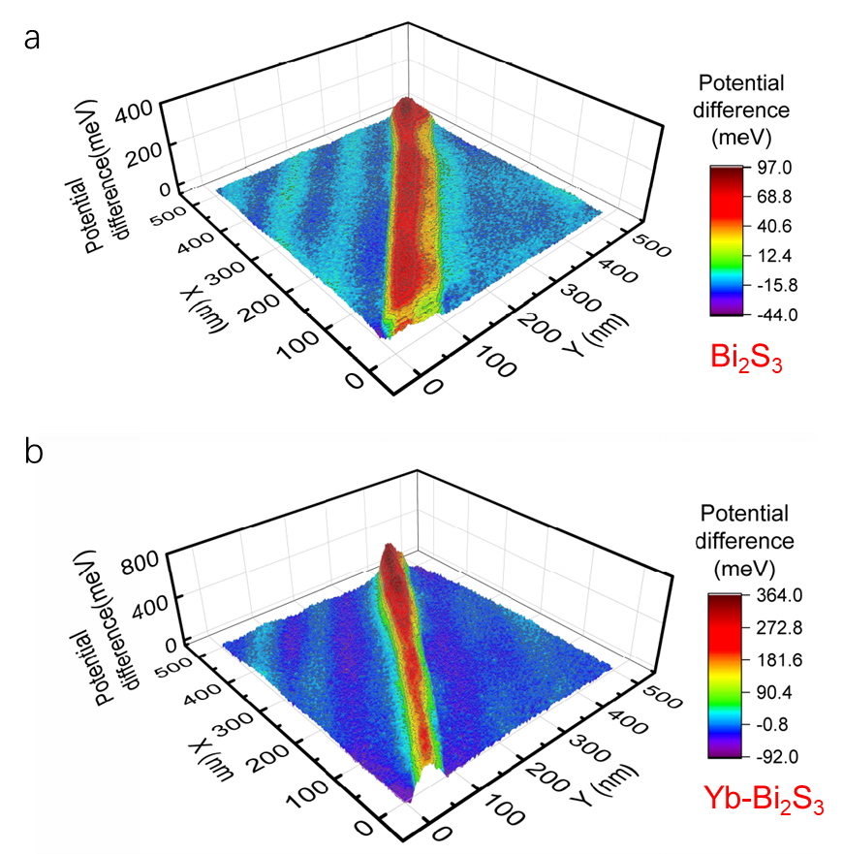
Fig. S5 Work functions measured by Kelvin probe force microscopy (KPFM). (The relationship between the contact potential difference (CPD) and the work function (Φ) is given by CPD _{sample} =CPD _{Au}+(Φ _{Au}−Φ _{sample}), where CPD _{Au}=−0.18, and Φ _{Au}=5.10 eV. The measured CPD values for the Bi₂S₃ and Yb-Bi₂S₃ were approximately 0.08 eV and 0.34 eV, yielding corresponding work functions of 4.84 eV and 4.59 eV, respectively.)
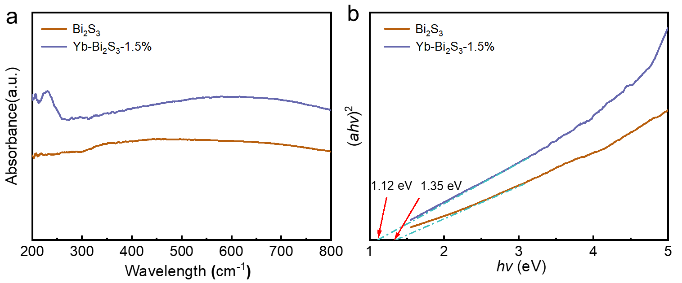
Fig.S6 The optical properties of BS and Yb-Bi₂S₃-1.5%. (a) UV–vis spectra. (b) the calculated band gap.
Fig. S7 The response curve of Yb-Bi₂S₃-1.5% to 5 ppb H₂S.
Fig. S8 A single-range fitting of the response as a function of concentration within the range of 0.005–5 ppm.

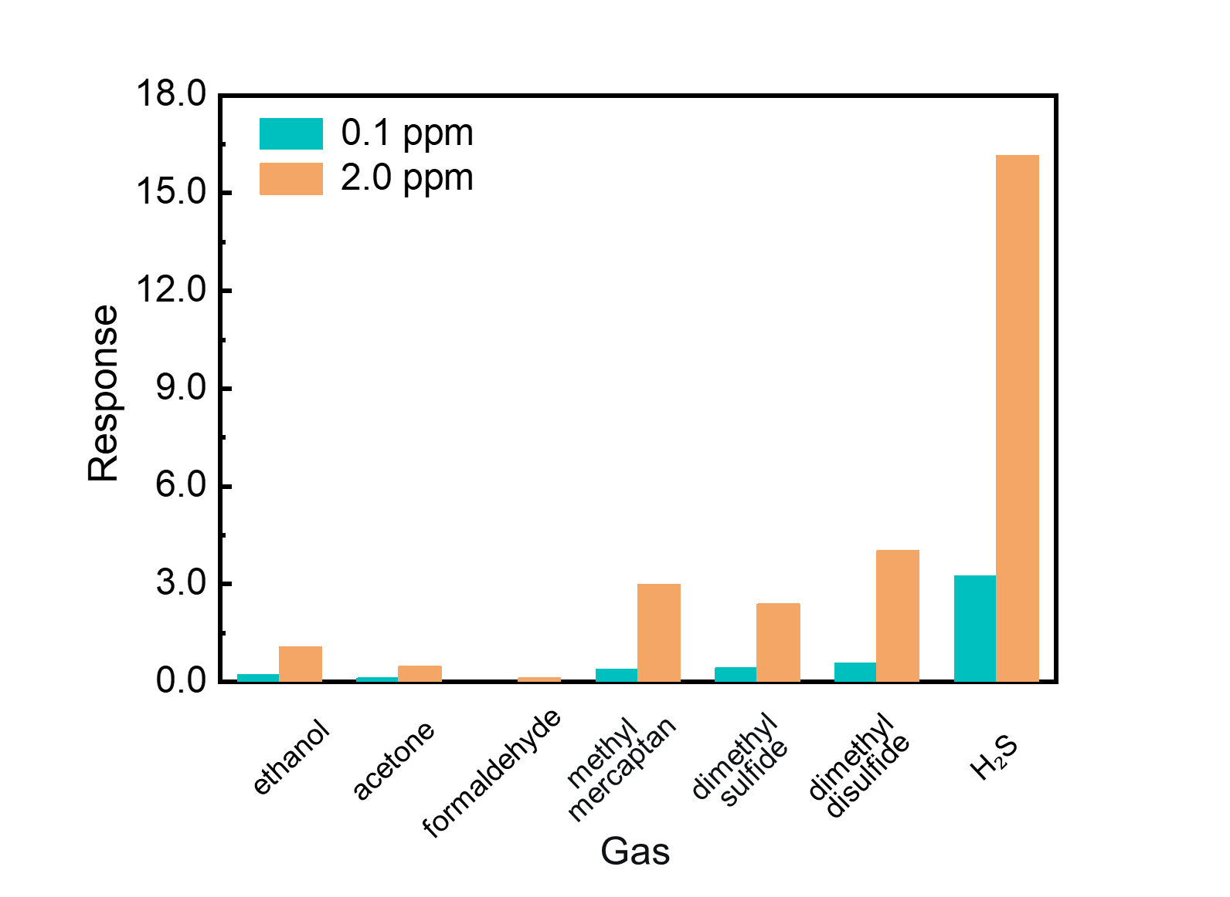
Fig. S9 Selective response of Yb-doped Bi₂S₃ sensor toward VOCs and VSCs

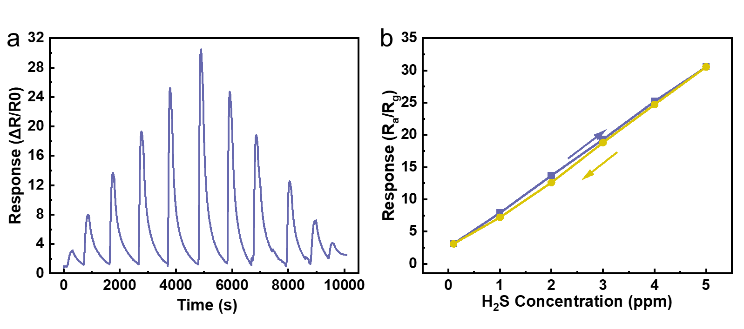
Fig. S10 Hysteresis characteristic of Yb-Bi₂S₃-1.5% in the range of 0.1-5 ppm.

Fig. S11 Repeatability test of Yb-Bi₂S₃-1.5% for Repeated exhalation exposure. (A specific volume of H₂S standard gas was mixed with high-humidity air to prepare simulated oral breath containing 100 ppb H₂S for testing. A dynamic testing method was employed: the gas in the sample bag was first dried to eliminate humidity interference. A small pump connected to a three-way valve at the outlet of the drying tube dynamically delivered gas from the gas bag to a 200-mL detection chamber for gas sensing.)

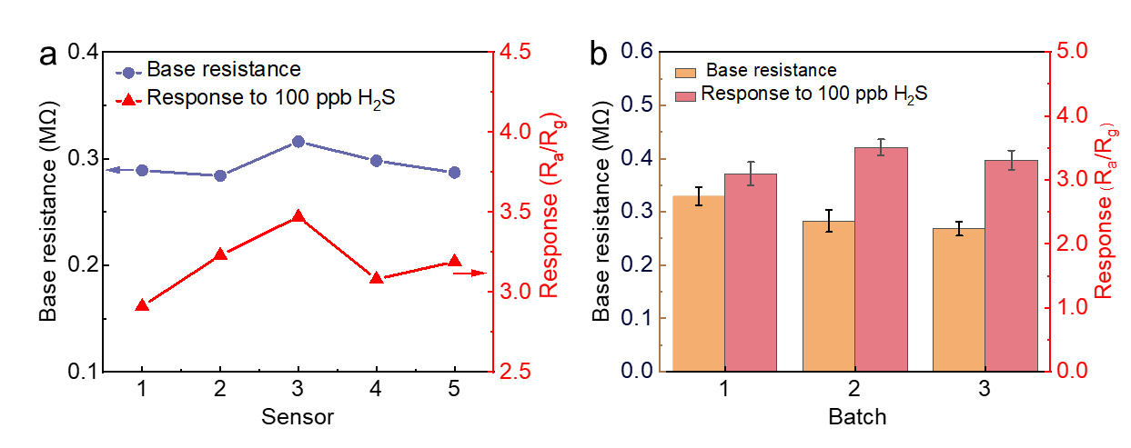
Fig. S12 (a) Baseline resistance and response to 100 ppb H₂S for five sensors from the same batch; (b) baseline resistance and response to 100 ppb H₂S for sensors from different batches

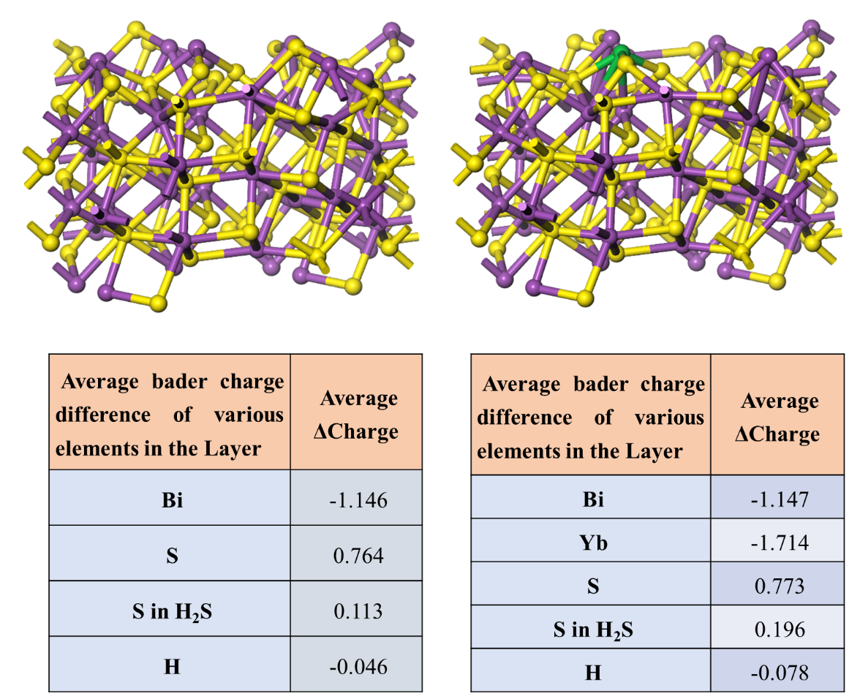
Fig. S13 Bader charge of H₂S adsorption on the surface of BS and Yb-Bi₂S₃-1.5%, respectively.

Fig. S14 H₂S concentration curves in oral exhalation of periodontitis patients (post-dental prophylaxis).

Table S1 A comparative table of latest representative H₂S sensor based on different sensitive material
Materials | Operating temperature | Detection limit(ppb) | Response | t_{res}/t_{rec} | Detection  range | Humidity  tolerance | Selectivity | Sensor Integration | Ref.
Metal Oxides and Heterojunctions
Amorphous a-SnO₂ | 100 ℃ | 210 ppb | 2.4 (1ppm） | 9 min/- | 400 ppb ~ 1.5 ppm | ~20% reduction | - | no | [1]
Rh₂O₃/ WO₃ | 157℃ | 250 ppb | ~5.2 (1 ppm) | 12/64 s | 0.25-100 ppm | ~75% reduction | > 22 | no | [2]
Bi₂MoO₆–CuO | 180 °C | 5 ppb | 4.9 (0.1 ppm) | 213s/1069s | 5-250 ppb |  | > 7 | yes | [3]
α-Fe₂O₃/SnO₂ | 250 °C | 1 ppm | 4.3 (10 ppm) | 13s/104s | 2–10 ppm | - | >3 | no | [4]
Co₃O₄/β-CoMoO₄ | 160 °C | 10 ppb | 1.25 (10 ppb) | 288/731 s | 0.01–20 ppm | - | > 2 | yes | [5]
Cu₂O/NiO | RT | 10 ppm | 1.39 (20 ppm) | ~100 s | 10–100 ppm | - | >10 | no | [6]
In₂O₃/SnO₂ | RT | 100 ppb | ~5.2 (0.1 ppm) | 600/181 s | 0.1-70 ppm | ~53% reduction | > 15 | yes | [7]
WO₃/CuO | 150℃ | 0.5 ppm | 0.68 (5ppm） | 24 s / 78 s | 0.5–50 ppm | - | >6 | no | [8]
Fe₂O_{3/}Ti₃C₂ | RT | 10 ppb | 1.18 (20 ppm) | 10s/15s | 0.01–500 ppm | ~28% reduction | >6 | no | [9]
Transition Metal Sulfides and Heterojunctions
WS₂ | RT | 53 ppb | 0.15 (27 ppm) | 175 s/- | 53 ppb-27 ppm | ~400% increase | > 10 | no | [10]
Bi₂S₃ | RT | 0.5 ppm | 2.03 (10 ppm) | 27 s/21 s | 0.5–50 ppm | - | > 10 | no | [11]
MoSe₂/ZnO | 150 ℃ | 200 ppb | 2.8 (6 ppm) | 690 s/665 s | 200 ppb–6.1 ppm | - | ~2 | no | [12]
MoS₂/rGO | RT | 1 ppm | 1.18 (1ppm) | 0.85/12.1 s | 1-100 ppm | ~46% reduction | >5 | no | [13]
WS₂- ZnO | 250 °C | 0.1 ppm | 0.33 (1ppm) | ~120s/ | 0.1-5 ppm | - | >8 | no | [14]
ZIF-L/SnS₂ | 125 ℃ | 3.6 ppb | 1.11 (1 ppm) | 413s/2276s | 1-50 ppm | - | >10 | no | [15]
Other material systems
Cs₂AgBiCl₆ | RT | 5 ppb | 0.16 (0.08pm) | 99.6/94.2s | 5 ppb-10 ppm | - | >40 | yes | [16]
Co₃(HITP)₂/Ti₃C₂ | RT | 92 ppb | 2.41(10 ppm) | ~200 s/- | 0.1–200 ppm | ~12% reduction | >2 | no | [17]
CsPbBr₃ | RT | <200 ppb | 1.21 (0.2 ppm) | 73/275 s | 0.2-5 ppm | <5% | >10 | no | [18]
This work
Yb-Doped Bi₂S₃ | RT | 5 ppb | 9.13 (1 ppm) | 11 s/141 s | 5 ppb-5 ppm | ~27% reduction | > 20 | yes | -

Supplementary References
- V. Paolucci, J. De Santis, V. Ricci, L. Lozzi, G. Giorgi et al., Bidimensional engineered amorphous a-SnO₂ interfaces: synthesis and gas sensing response to H₂S and humidity. ACS Sens. 7(7), 2058–2068 (2022). https://doi.org/10.1021/acssensors.2c00887
- D. Xu, R. Li, X. Duan, B. Sun, X. Gong et al., In-situ construction of highly sensitive H₂S gas sensor based on Rh₂O₃-loaded WO₃ composites derived from WSe₂ flower-like structure. Sens. Actuat. B Chem. 460, 139938 (2026). https://doi.org/10.1016/j.snb.2026.139938
- Q. Jing, C. Gong, W. Bian, Q. Tian, Y. Zhang et al., Ultrasensitive chemiresistive gas sensor can diagnose asthma and monitor its severity by analyzing its biomarker H₂S: an experimental, clinical, and theoretical study. ACS Sens. 7(8), 2243–2252 (2022). https://doi.org/10.1021/acssensors.2c00737
- X.-Y. Miao, L.-Y. Zhu, X.-Y. Wu, L.-W. Mao, X.-H. Jin et al., Precise preparation of α-Fe₂O₃/SnO₂ core-shell nanowires via atomic layer deposition for selective MEMS-based H₂S gas sensor. Sens. Actuat. B Chem. 378, 133111 (2023). https://doi.org/10.1016/j.snb.2022.133111
- S. Cao, Z. Song, Y. Bing, X. Xu, T. Zhou et al., Metal–organic-framework derived co–Mo multimetal oxide semiconductors: selective trace-level hydrogen sulfide detection. ACS Sens. 9(6), 2979–2988 (2024). https://doi.org/10.1021/acssensors.4c00144
- H. Sun, M. Cao, P. Zhang, X. Tian, M. Lu et al., Magnetic-field-enhanced H₂S sensitivity of Cu₂O/NiO heterostructure ordered nanoarrays. ACS Sens. 7(7), 1903–1911 (2022). https://doi.org/10.1021/acssensors.2c00495
- Y. Sun, K. Qian, J. Yue, X. Zhang, X. Li et al., High-response In₂O₃/SnO₂ heterojunction sensor for detection of food spoilage gas H₂S in refrigerators. Sens. Actuat. B Chem. 451, 139341 (2026). https://doi.org/10.1016/j.snb.2025.139341
- C. Qiu, L. Zhu, Q. Li et al., One-step electrospun WO₃/CuO p–n heterojunction nanocomposites for ultrasensitive and rapid H₂S detection. ACS Sens. 10(9), 6869–6877 (2025). https://doi.org/10.1021/acssensors.5c01761
- D. Zhang, X. Huang, W. Meng, J. Yuan, F. Guo et al., Room-temperature flexible CNT/Fe₂O₃ film sensor for ppb-level H₂S detection. ACS Sens. 9(10), 5197–5205 (2024). https://doi.org/10.1021/acssensors.4c01342
- S. Kundu, G. Gorthala, R. Ghosh, Room temperature detection of H₂S by two dimensional WS₂ based chemiresistive sensors. Sens. Actuat. B Chem. 416, 136018 (2024). https://doi.org/10.1016/j.snb.2024.136018
- C. Li, S. Ramadan, H. Kan, L. Wang, Light-activated room temperature surface acoustic wave H₂S sensor based on Bi₂S₃ nanoribbons. Sensors 25(4), (2025). https://doi.org/10.3390/s25041122
- R.K. Jha, A. Nanda, A. Yadav, R. Sai, N. Bhat, 2D-MoSe₂/0D-ZnO nanocomposite for improved H₂S gas sensing in dry air ambience. J. Alloys Compd. 926, 166825 (2022). https://doi.org/10.1016/j.jallcom.2022.166825
- G.M. Hingangavkar, S.A. Kadam, Y.-R. Ma, M. Selvaraj, R.N. Mulik et al., On the behavior of MoS₂-rGO nanocomposites for chemiresistive H₂S detection at room temperature. Sens. Actuat. B Chem. 399, 134843 (2024). https://doi.org/10.1016/j.snb.2023.134843
- N. Sakhuja, R.K. Jha, R. Sai, N. Bhat, ZnO nanorods grown on WS₂ nanosheets for chemiresistive H₂S sensing. ACS Appl. Nano Mater. 5(7), 9241–9251 (2022). https://doi.org/10.1021/acsanm.2c01580
- S.M. Lee, Y.J. Kim, S.J. Park, W.S. Cheon, J. Kim et al., In-situ growth of 2D MOFs as a molecular sieving layer on SnS₂Nanoflakes for realizing ultraselective H₂S detection. Adv. Funct. Mater. 35(12), 2417019 (2025). https://doi.org/10.1002/adfm.202417019
- M. Li, S. University, W. Ye, S. University, et al., Lead-free halide double perovskite Cs₂AgBiCl₆ for H₂S trace detection at room temperature. ACS Sens. 10(3), 2224–2233 (2025). https://doi.org/10.1021/acssensors.4c03532
- Y. Sun, W. Guo, B. Wang, Y. Hou, W. Wang et al., Construction of a Co₃(HITP)₂/Ti3C2 MXene heterojunction for selective sensing of H₂S with high resistance to humidity. Sens. Actuat. B Chem. 450, 139224 (2026). https://doi.org/10.1016/j.snb.2025.139224
- K. Zhou, H. Yang, Z. Du, Y. Yang, C. Zhu et al., Ultrahigh selectivity H₂S gas sensor based CsPbBr₃ perovskites via Pb–S bonding interaction. ACS Sens. 10(1), 517–525 (2025). https://doi.org/10.1021/acssensors.4c02980

