Supporting Information for
Ion Compensation-Assisted Photolithography Enables High-Resolution Electrolytes for Neuromorphic Transistors
Wenjing Zhang¹, Xiaoci Liang¹, Sixing Chen¹, Xiuquan Ma⁴, Chen Chen^{3,} *, Songjia Han^{2,} *, and Chuan Liu^{1,} *
¹ State Key Laboratory of Optoelectronic Materials and Technologies and Guangdong Province Key Laboratory of Display Material and Technology, School of Electronics and Information Technology, Sun Yat-Sen University, Guangzhou 510275, P. R. China
² College of Artificial Intelligence and Low-Altitude Technology, South China Agricultural University, Guangzhou 510642, P. R. China
³ Science and Technology on Advanced Ceramic Fibers and Composites Laboratory, College of Aerospace Science and Engineering, National University of Defense Technology, Changsha 410073, P. R. China
⁴ Guangdong HUST Industrial Technology Research Institute, Guangdong Provincial Key Laboratory of Digital Manufacturing Equipment, Dongguan 523000, P. R. China
* Corresponding authors. E-mail: liuchuan5@mail.sysu.edu.cn (Chuan Liu); hansongjia@scau.edu.cn (Songjia Han); angela_chen@nudt.edu.cn (Chen Chen)
Supporting Figures
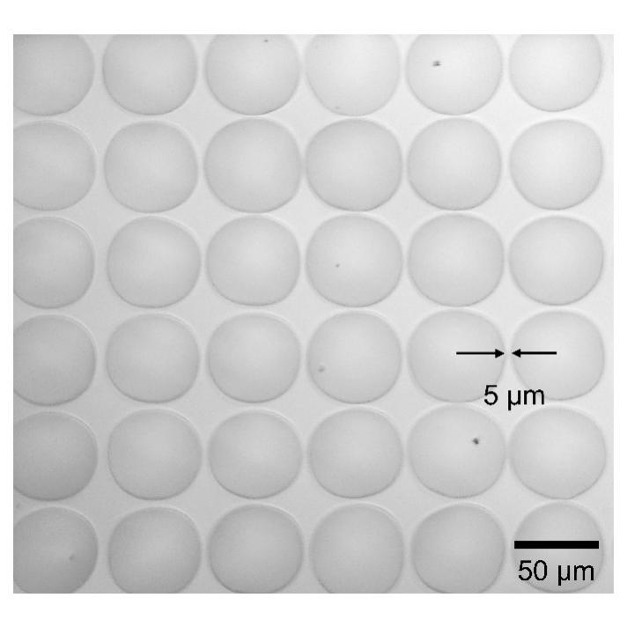
Fig. S1 Optical microscopy images of the PLE with the resolution interval down to 5 μm. Note the minimum feature of 2 μm is shown in the main text (Fig. 2a)

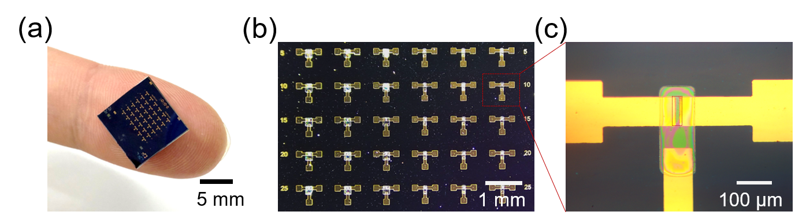

Fig. S2 Array-level demonstration of ICAP-patterned OECTs with various channel lengths (e.g., 5 μm, 10 μm, 15 μm, 20 μm, 25 μm): (a) Photograph of the photolithographically patterned WO₃-OECT array; (b) Optical image of the WO₃-OECT array; (c) Enlarged optical microscopy image of an individual WO₃-OECT, with the dashed region indicating the photolithographically patterned WO₃
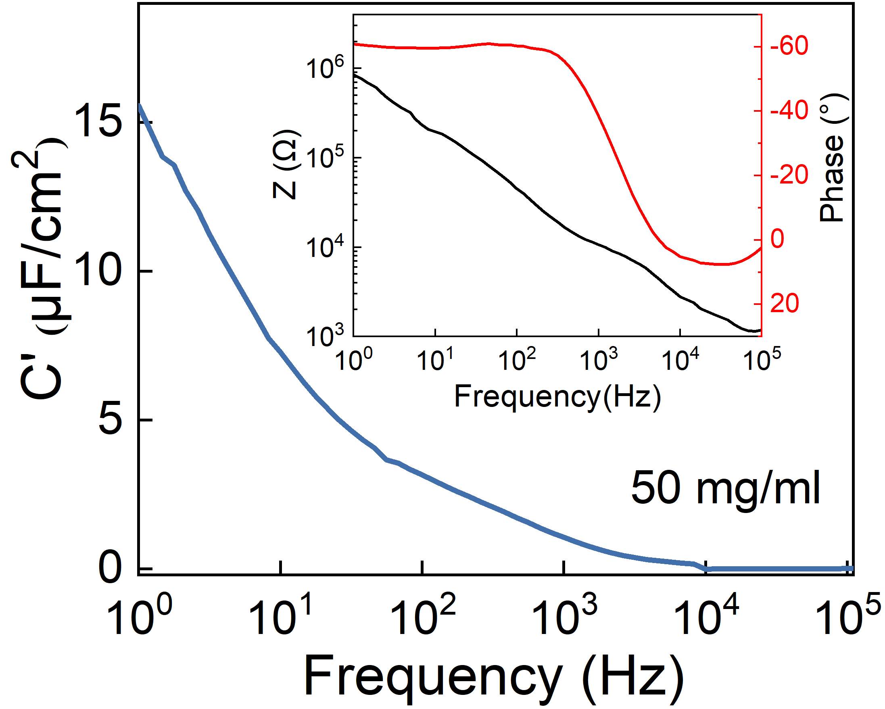
Fig. S3 Frequency-dependent capacitance of the PLE in 50 mg/mL LiCl solution

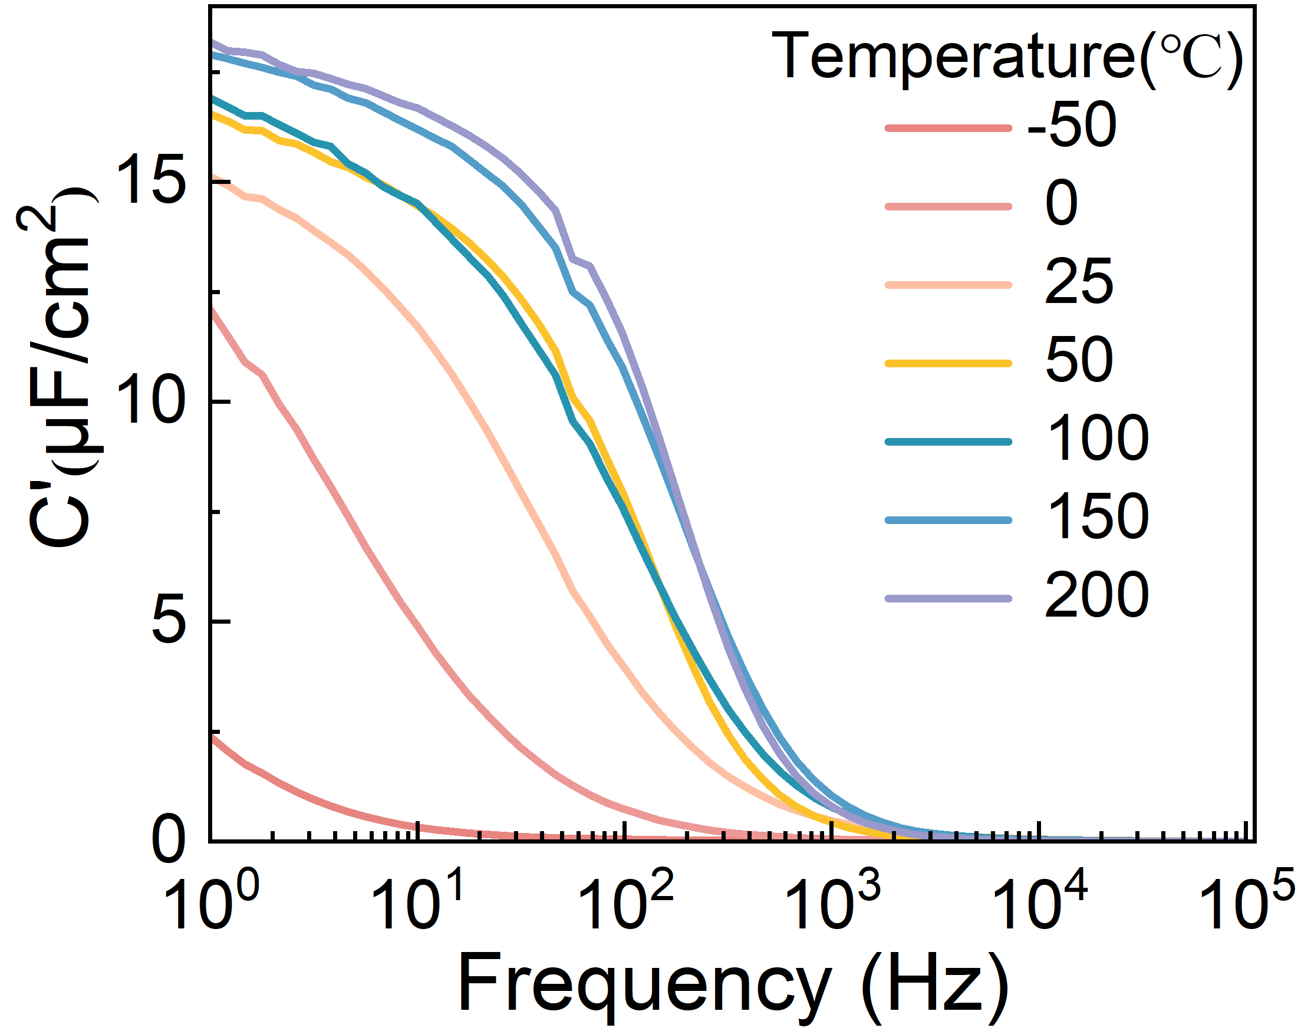
Fig. S4 Capacitance-frequency response of the PLE at different temperatures
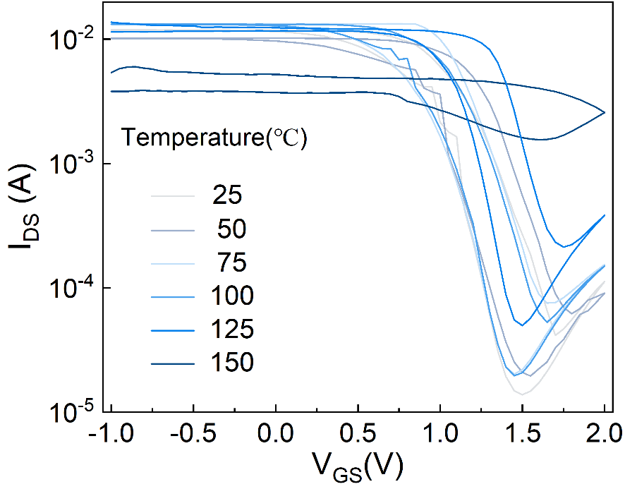
Fig. S5 Thermal validation of PEDOT:PSS-OECTs with ICAP-patterned electrolyte
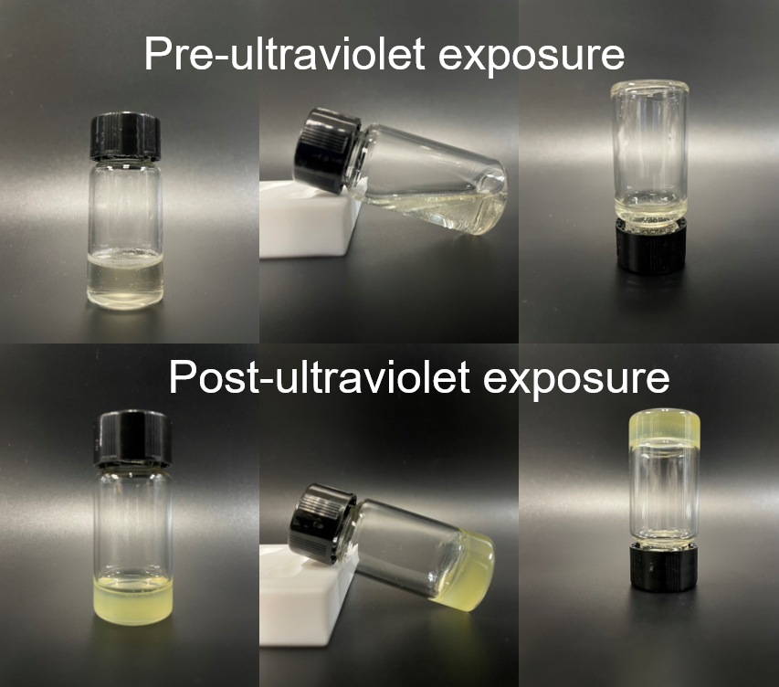
Fig. S6 Images of the PLE sol-gel transition under ultraviolet radiation
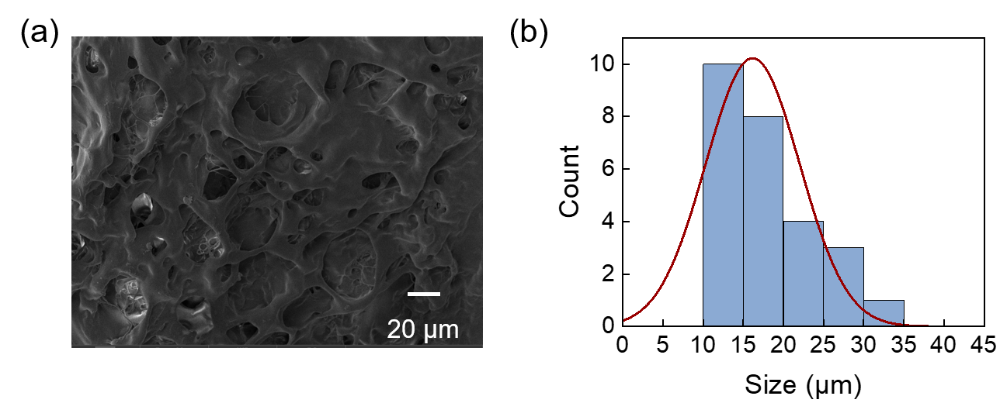
Fig. S7 Surface morphology of the HPC-gel framework: (a) Representative SEM image of HPC-gel; (b) Statistical analysis of pore/free-volume features extracted from SEM images
Fig. S8 XPS O1s spectrum of HPC and PLE

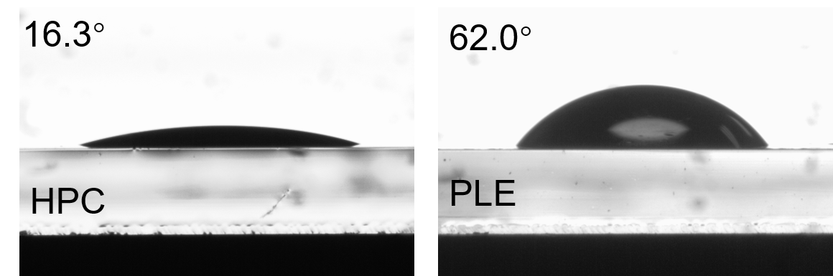
Fig. S9 Comparison of contact angles for HPC and PLE
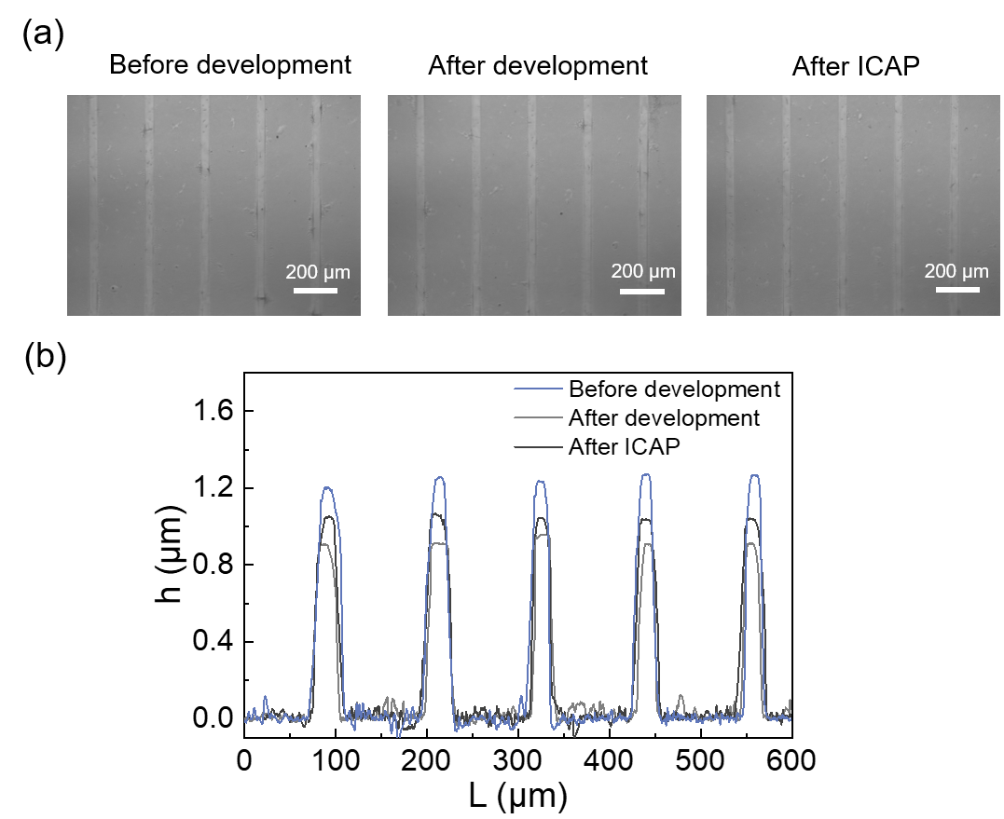
Fig. S10 Stability of patterned ICAP electrolyte during development and ion compensation. (a) Optical images of line-patterned electrolyte arrays before development, after development, and after ICAP treatment; (b) Profilometer height profiles of the line-patterned electrolyte arrays
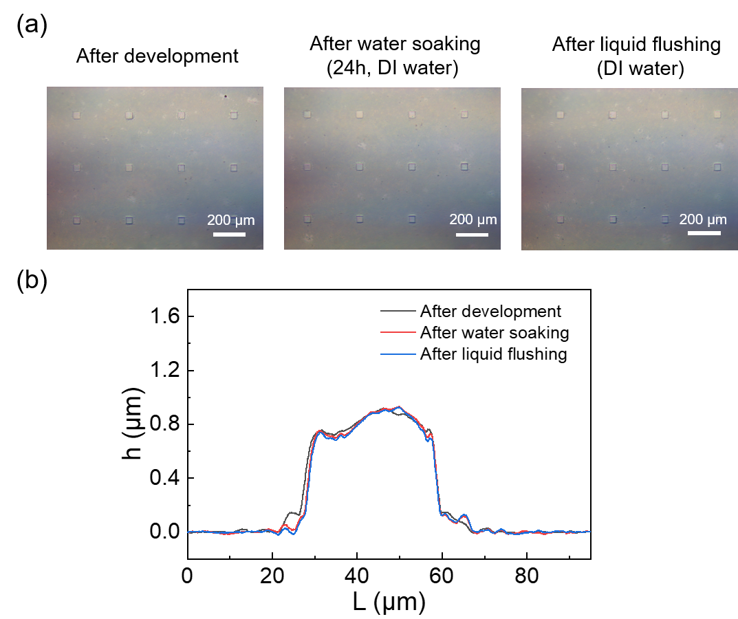
Fig. S11 Stability of the patterned electrolyte under prolonged water immersion: (a) Optical images of patterned electrolyte after development, after 24 h soaking in DI water, and after DI-water flushing; (b) Profilometer height/thickness profiles of a single electrolyte pattern after development, after 24 h DI-water soaking, and after DI-water flushing
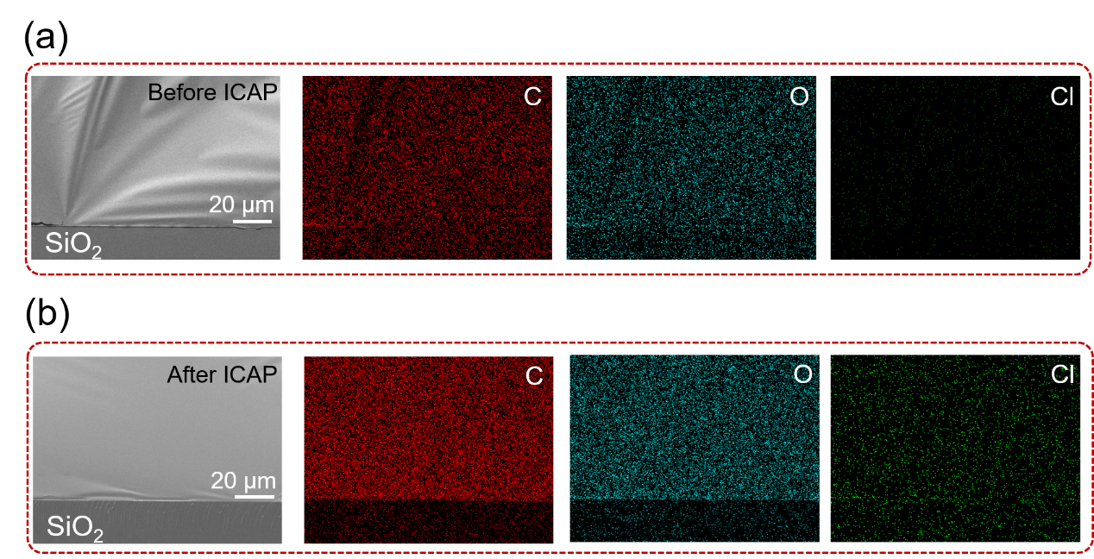
Fig. S12 Cryo-fractured cross-sectional SEM images and corresponding C, O, and Cl elemental mapping of ICAP electrolyte films on SiO₂ substrates before (a) and after (b) ICAP treatment

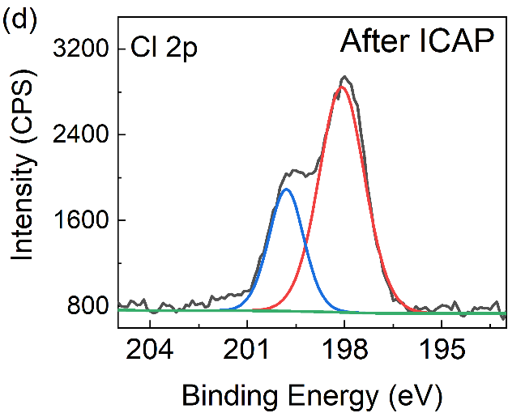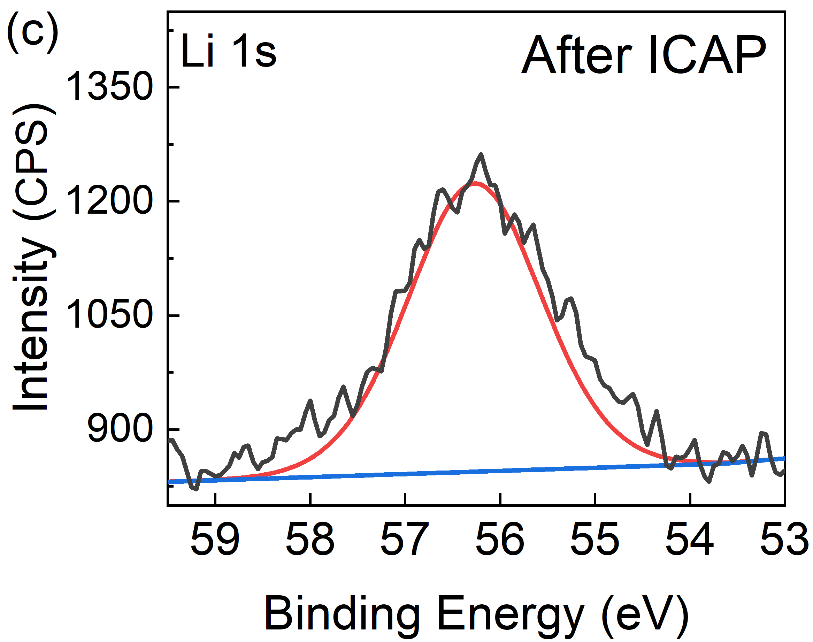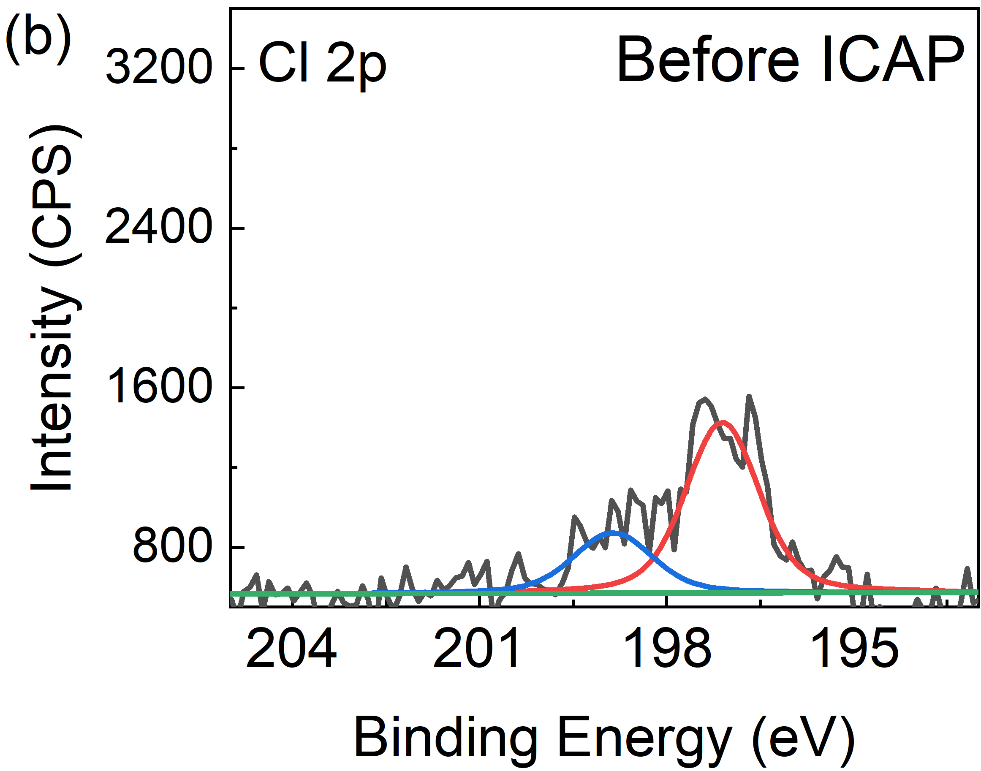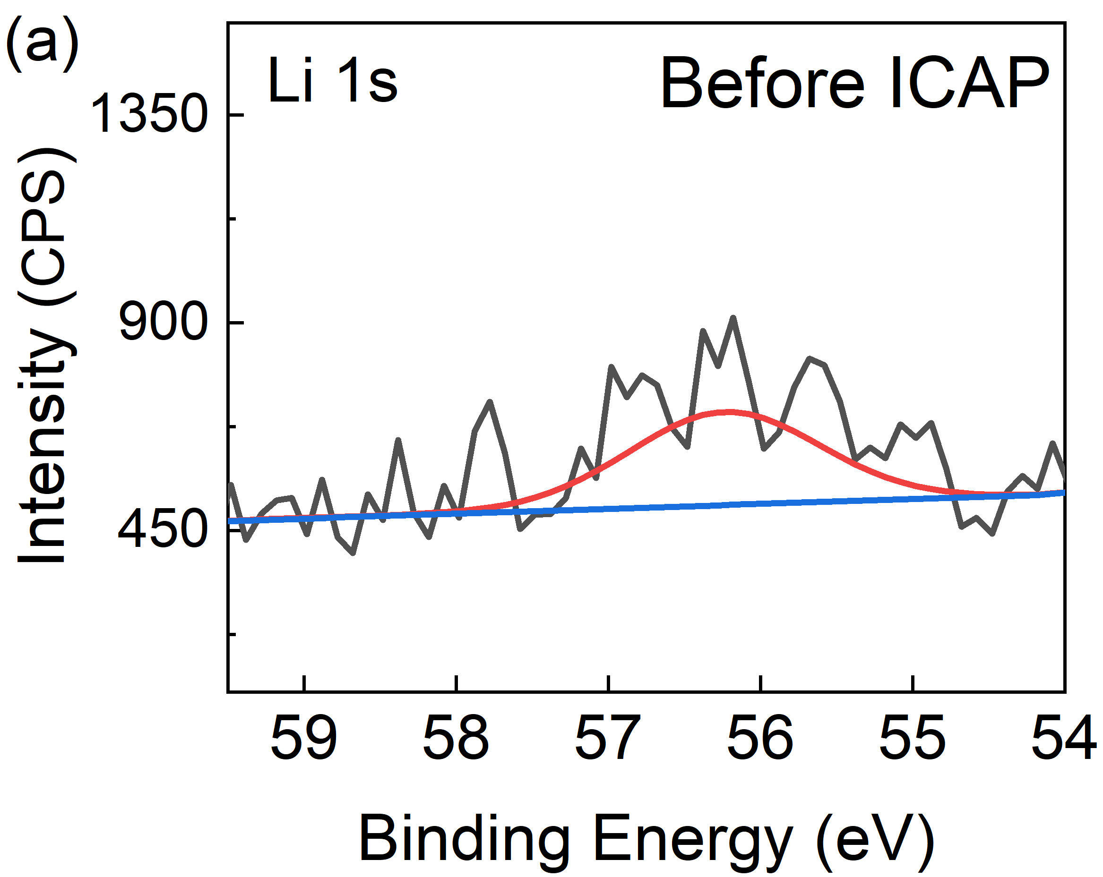
Fig. S13 XPS Li 1s and Cl 2p spectra of the PLE before and after immersion in LiCl solution

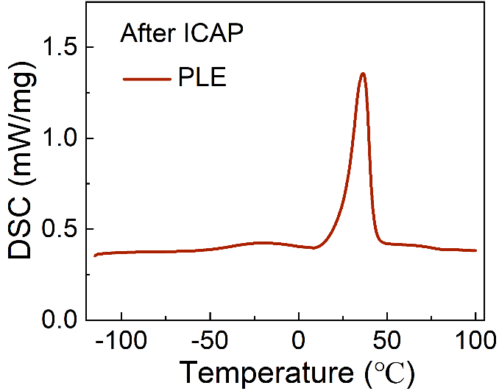
Fig. S14 Differential scanning calorimetry (DSC) thermogram of the PLE

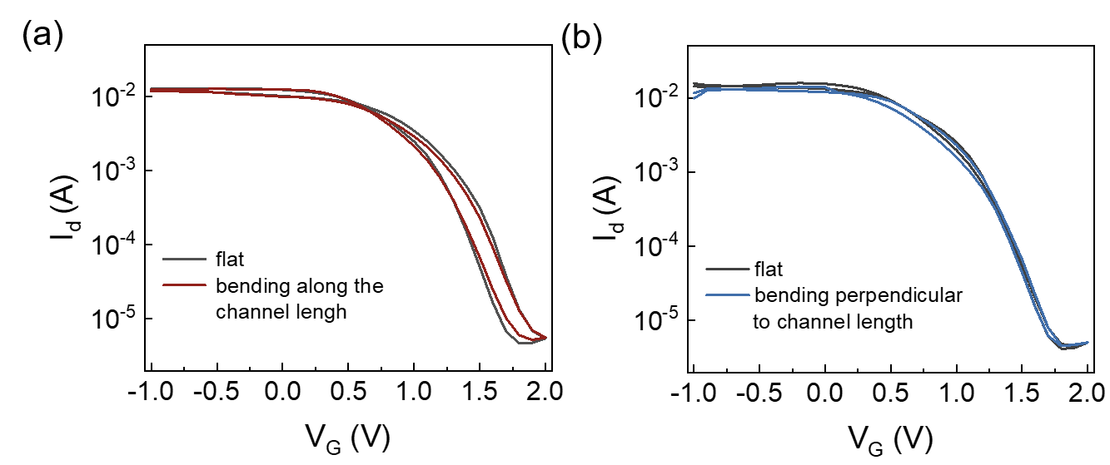
Fig. S15 Transfer curves of PEDOT-OECTs measured in the initial flat state and after 200 bending cycles: (a) bending parallel to the channel-length. (b) bending perpendicular to the channel-length

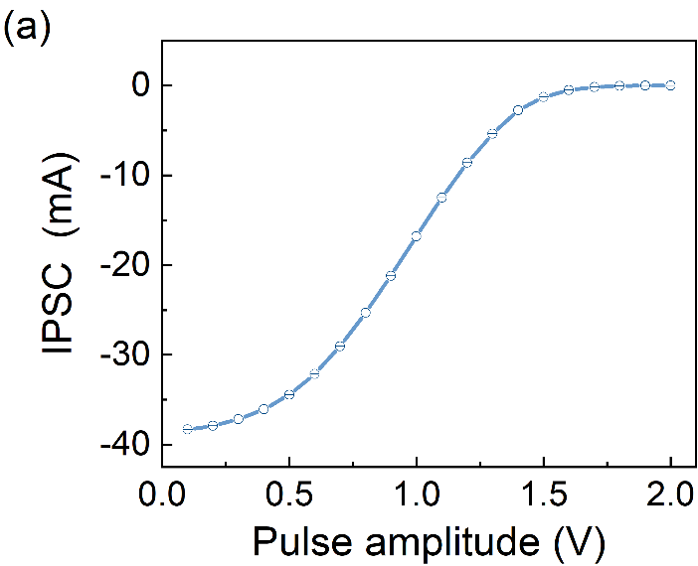
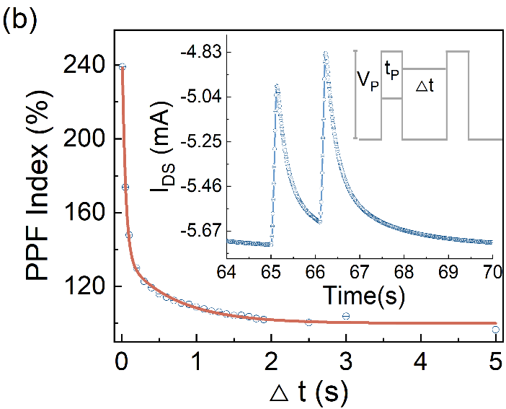
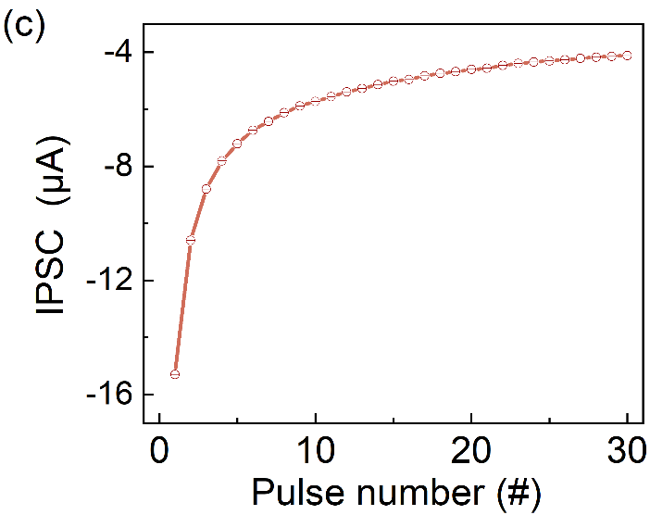
Fig. S16 (a) IPSC response of PEDOT-OECT under voltage stimulation with varying intensities. (b) Paired-pulse facilitation (PPF) effect and synaptic weight change at V_{D}=−0.6V, V_{P}=1.5V, and t_{P}=100 ms. (c) Long-term plasticity (LTP) under 50 ms repetitive stimulations at V_{D}=−0.6V, V_{P}=1V, and Δt=150 ms

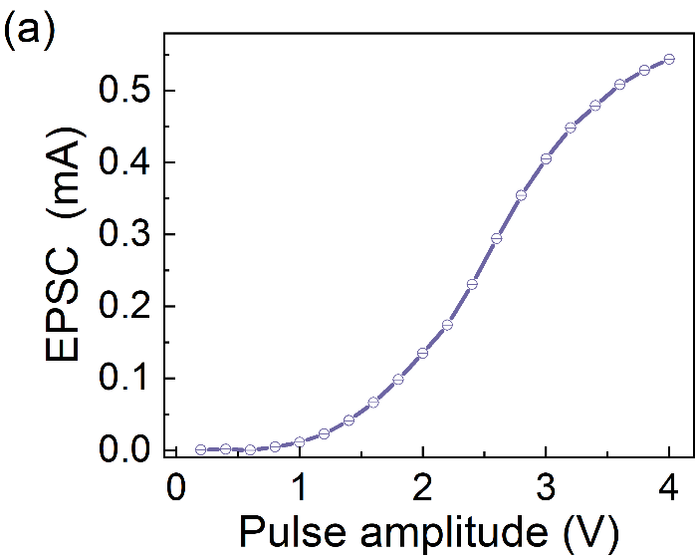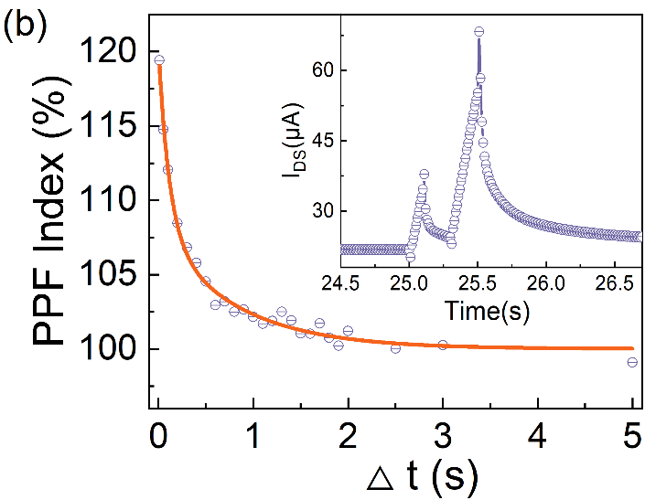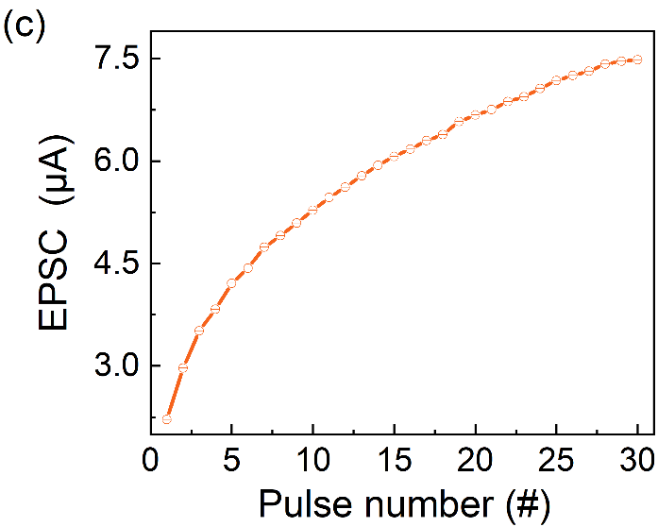
Fig. S17 (a) EPSC response of BBL-OECT under voltage stimulation with various pulse intensities. (b) PPF and synaptic weight change at V_{D}=0.6V, V_{P}=2V, and t_{P}=100 ms. (c) LTP under 50 ms repetitive stimulation at V_{D}=0.6V, V_{P}=2V, and Δt=100 ms

Fig. S18 Transmission spectra of WO₃-OECT at various gate voltages
Fig. S19 Conductance response of WO₃-OECT at various pulse numbers (V_{D} = 0.5 V, t_{P} = 0.75 s, Δt = 2 s)
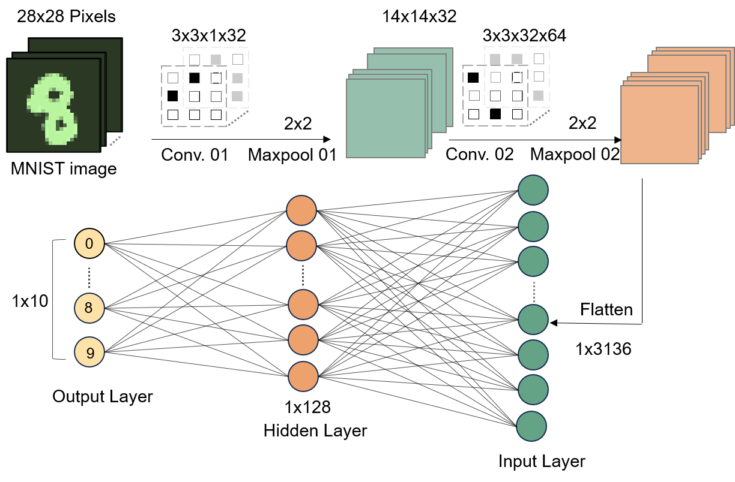
Fig. S20 Schematic of ANN simulations with device conductance mapped as synaptic weights

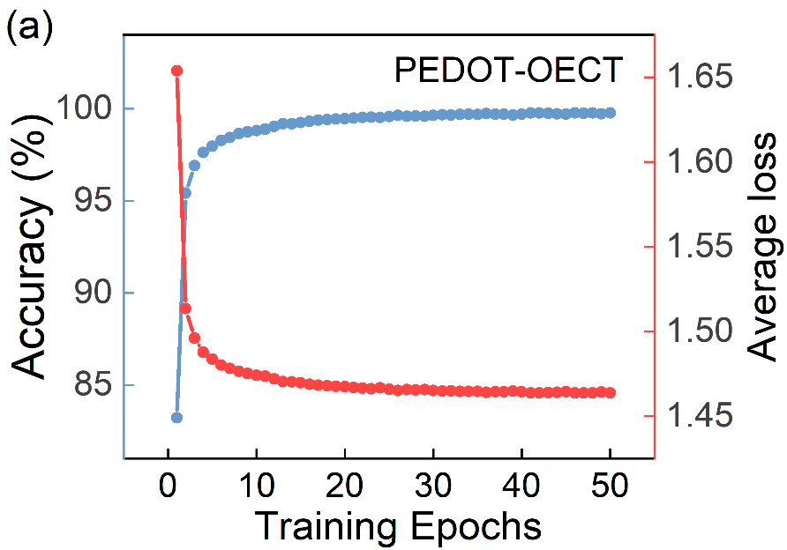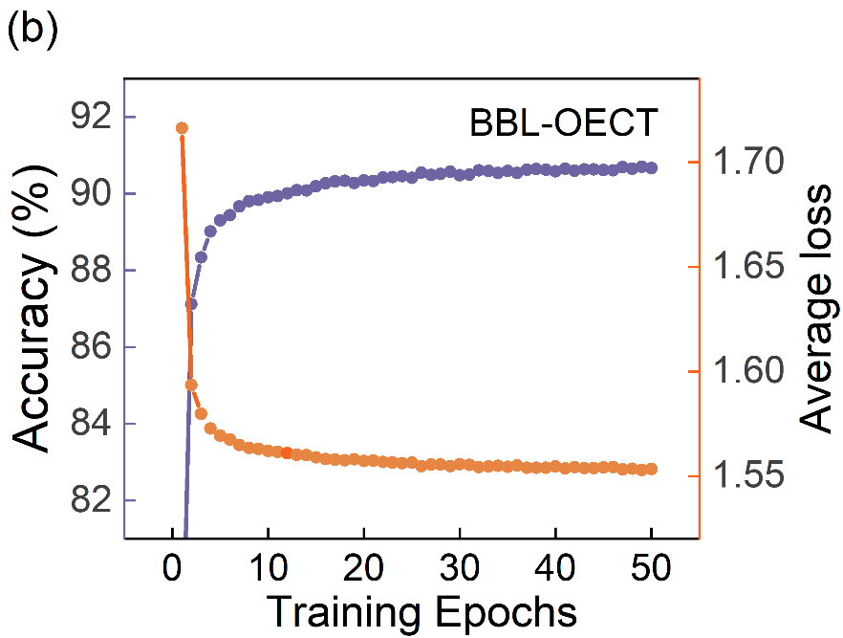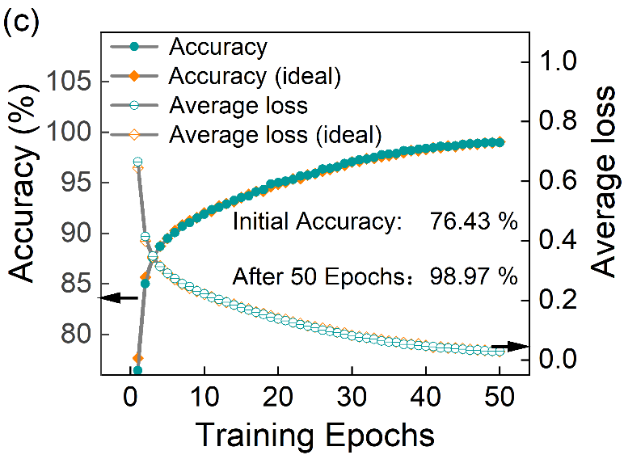
Fig. S21 (a) Recognition accuracy and average loss for the PEDOT-OECT over 50 training epochs on hand-written digits (MNIST). (b) Recognition accuracy and average loss for the BBL-OECT over 50 training epochs on MNIST. (c) Recognition accuracy and average loss for the WO₃-OECT over 50 training epochs on MNIST

Supplementary Tables
Table S1 Comparison of patterning resolution, capacitance, and ionic conductivity of ICAP-fabricated electrolytes with reported electrolytes
Year | Material | Pattern Size | Technique | Capacitance  (μF/cm²) | Conductivity  (mS/cm) | Ref.
2018 | PDA | 100 μm | electrospinning | N/A | 2 | [S1]
2018 | PEGDA | 50 μm | photolithography | N/A | 0.047 | [S2]
2019 | PVDF-HFP | 40 μm | printing | 5 | 1.1 | [S3]
2020 | PMMA | 5 μm | tape-casting | N/A | N/A | [S4]
2020 | PTFE | 0.5 mm | inkjet printing | N/A | N/A | [S5]
2021 | Nafion | 50 μm | imprint lithography | N/A | N/A | [S6]
2022 | 8YSZ | 125 μm | mesh pressing | N/A | N/A | [S7]
2022 | BCZYYb | 39.5 μm | soft lithography | 0.003 | 5 | [S8]
2022 | Nafion/PDMS | 5 μm | soft lithography | N/A | 43.06 | [S9]
2022 | NIPAM | 10 μm | photolithography | N/A | 24 | [S10]
2023 | PAN | 16 μm | electrospinning | N/A | 0.367 | [S11]
2023 | PVA/PAAM | 400 μm | photolithography | 1.6 | 0.03 | [S12]
2023 | 8YSZ | 100 μm | 3D printing | N/A | 36.6 | [S13]
2024 | HACC | 20 μm | photolithography | 1.6 | 4×10⁻⁴ | [S14]
2025 | PEGDMA | 15 μm | photolithography | N/A | 10 | [S15]
2025 | CS-PHEA | 300–400 μm | photolithography | N/A | 0.258 | [S16]
2025 | pDADMAC | 25 μm | photolithography | N/A | N/A | [S17]
2025 | NBR/LiTFSI | 200 μm | photolithography | 10 | 1.95×10⁻⁴ | [S18]
2026 | SU-8 | 25 μm | photolithography | N/A | 17.1 | [S19]
2026 | PVA/PAAm | 66.2 μm | inkjet printing | N/A | N/A | [S20]
2026 | HPC | 2 μm | photolithography | 15.6 | 6.7 | This work

Table S2 Semi-quantitative EDS elemental composition of electrolyte film surfaces before and after ICAP treatment
Sample | C  Atomic % | O  Atomic % | Cl  Atomic % | C  Weight % | O  Weight % | Cl  Weight %
Before ICAP | 58.06 | 41.87 | 0.08 | 50.90 | 48.90 | 0.20
After  ICAP | 56.85 | 38.27 | 4.89 | 46.50 | 41.70 | 11.80

Table S3 Semi-quantitative EDS elemental composition of cryo-fractured cross-sections of electrolyte films before and after ICAP treatment

Sample | C  Atomic % | O  Atomic % | Cl  Atomic % | C  Weight % | O  Weight % | Cl  Weight %
Before ICAP | 2.08 | 97.92 | 0.00 | 1.57 | 98.43 | 0.00
After  ICAP | 2.99 | 90.79 | 6.22 | 2.10 | 84.99 | 12.91

Table S4 The parameters used in the simulations of a transistor
Symbol | Value | Unit | Description
t_{elec} | 100 | nm | Thickness of the electrolyte layer
t_{semi} | 70 | nm | Thickness of the semiconductor layer
t_{ox} | 100 | nm | Thickness of the insulating layer
W | 400 | μm | Width of the channel
L | 1-10 | μm | Length of the channel
c₊₀ | 10²⁰ | cm⁻³ | Initial cation concentration in electrolyte
c₋₀ | 10²⁰ | cm⁻³ | Initial anion concentration in electrolyte
$$D_{ie}$$ | 6.67e-6 | cm²/s | Diffusion coefficient in electrolyte layer
$$D_{is}$$ | 6.67e-8 | cm²/s | Diffusion coefficient in semiconductor layer
ε_{e} | 3.9 | / | Relative dielectric constant of the electrolyte layer
ε_{s} | 10 | / | Relative dielectric constant of the semiconductor layer
E_{g} | 3.7 | eV | The bandgap of the semiconductor
W_{F} | 4.17 | eV | Workfunction of source/drain electrodes
φ_{s} | 4.16 | eV | Affinity of the semiconductor
μ_{semi} | 15 | cm²/Vs | Mobility of the semiconductor

Table S5 Compared with reported electrolyte-gated transistor in prior studies
Channel | Material  type | Electrolyte | on/off ratio | g_{m}  (mS) | μC*  (F cm⁻¹V⁻¹s⁻¹) | Stability | Ref.
PEDOT:PSS | p | 0.1 M NaCl | 10² | 20.2 | N/A | N/A | [S21]
PEDOT:PSS | p | PVA-hydrogel | 1.5 × 10³ | 54 | 91 ± 19 | 1000 | [S22]
PEDOT:PSS | p | LiClO₄ | 0.3 × 10³ | 0.416 | 0.35 | N/A | [S23]
g2T-T | p | 0.1 M NaCl | 10⁴ | 12.29 | 288.9 | 1000 | [S24]
g2T-S | p | 0.1 M NaCl | 10⁴ | 14.45 | 332.7 | 1000 | [S24]
g2T-SVS | p | 0.1 M NaCl | 10⁵ | 10.33 | 285.0 | 1000 | [S24]
pgBTTT | p | E300-RISE | 1.6 × 10⁴ | 0.32 | 15 | 7200 | [S25]
p(g3C2T2-T) | p | PBS | 5.4 × 10³ | 29.7 | 800 | 360 | [S26]
BBL-H | n | 0.1 M KCl | 1.59 × 10⁴ | 10.8 | 9.27 ± 0.03 | 100 | [S27]
BBL-L | n | 0.1 M KCl | 1.23 × 10⁴ | 0.41 | 0.28 ± 0.01 | 100 | [S27]
Cl₂-BAL | n | 0.1 M NaCl | 10⁵ | 0.45 | 6.20 ± 1.25 | 50000 | [S28]
f-BTI2g-TVTF | n | 0.1 M NaCl | 10⁵ | 1.062 | 90.2 ± 10.5 | 100 | [S29]
PDPPODT-TT | n | AuCl₃ | 2.34 × 10⁵ | 1.51 × 10⁻² | 0.21 | N/A | [S30]
gNDI-EDBT | n | 0.1 M NaCl | 10³ | 5.2 × 10⁻² | 0.02 ± 0.01 | 360 | [S31]
gNDI-BT | n | 0.1 M NaCl | 10⁴ | 0.3 | 0.09 ± 0.01 | 360 | [S31]
gNDI-FBT | n | 0.1 M NaCl | 10⁴ | 0.8 | 0.12 ± 0.02 | 360 | [S31]
p(NDI-T2-L2) | n | 0.1 M NaCl | 2.2 × 10² | 2.4 × 10⁻³ | 0.0023 | 100 | [S32]
BBL | n | 0.1 M NaCl | 1.6 × 10³ | 6.51 × 10⁻² | 1.99 | N/A | [S33]
BBL₁₅ | n | 0.1 M NaCl | 2.9 × 10³ | 2.47 × 10⁻³ | 1.94 ± 0.05 | 1000 | [S34]
BBL₆₀ | n | 0.1 M NaCl | 8.3 × 10⁴ | 7.68 × 10⁻³ | 4.90 ± 0.16 | 1000 | [S34]
BBL₉₈ | n | 0.1 M NaCl | 2.0 × 10⁵ | 1.62 × 10⁻² | 10.2 ± 0.4 | 1000 | [S34]
BBL₁₅₂ | n | 0.1 M NaCl | 4.4 × 10⁵ | 4.44 × 10⁻² | 25.9 ± 0.9 | 1000 | [S34]
Li_{x}TiO₂ | Metal oxide | LiClO₄/PEO | 1.7 | 7.5 × 10⁻² | 66.7 | 1000 | [S35]
LiCoO₂ | Metal oxide | Li3PO_{x}Se_{x} | 19.3 | 4.06 × 10⁻⁵ | 0.02 | 720 | [S36]
W-InO_{x} | Metal oxide | AlO_{x} | 10⁴ | N/A | N/A | N/A | [S37]
In₂O₃ | Metal oxide | SiO₂ | 10³ | 1.77 | N/A | N/A | [S38]
WO₃ | Metal oxide | HfO_{x} | 679 | 5.8 × 10⁻⁴ | 4.5 | 1000 | [S39]
WO_{3-x} | Metal oxide | HfO₂ | 112 | 5.6 × 10⁻³ | 3.8 | 2000 | [S40]
WO₃ | Metal oxide | ZrO₂ | 20 | N/A | N/A | 10⁷ | [S41]
WO₃ | Metal oxide | Nafion | 10⁵ | N/A | N/A | N/A | [S42]
PEDOT:PSS | p | ICAP-electrolyte | 10⁴ | 16.5 | 23.8 | 10000 | This work
BBL | n | ICAP-electrolyte | 10⁵ | 4 × 10⁻² | 0.282 | 5000 | This work
WO₃ | Metal oxide | ICAP-electrolyte | 10⁵ | 3.4 | 60.7 | 3000 | This work
Supplementary References
- G.H. Kim, H. Nam, W. Choi, T. An, G. Lim, Electrospinning nanofiber on an insulating surface with a patterned functional electrolyte electrode. Adv. Mater. Interfaces 5(5), 1701204 (2018). https://doi.org/10.1002/admi.201701204
- Y. Zhong, G.T.M. Nguyen, C. Plesse, F. Vidal, E.W.H. Jager, Highly conductive, photolithographically patternable ionogels for flexible and stretchable electrochemical devices. ACS Appl. Mater. Interfaces 10(25), 21601–21611 (2018). https://doi.org/10.1021/acsami.8b03537
- J.H. Lee, Y.S. Park, S. Cho, I.S. Kang, J.K. Kim et al., Output voltage modulation in triboelectric nanogenerator by printed ion gel capacitors. Nano Energy 54, 367–374 (2018). https://doi.org/10.1016/j.nanoen.2018.10.016
- C. Lee, S.S. Shin, J. Choi, J. Kim, J.-W. Son et al., A micro-patterned electrode/electrolyte interface fabricated by soft-lithography for facile oxygen reduction in solid oxide fuel cells. J. Mater. Chem. A 8(32), 16534–16541 (2020). https://doi.org/10.1039/D0TA03997G
- I. Bae, B. Kim, D.-Y. Kim, H. Kim, K.-H. Oh, In-plane 2-D patterning of microporous layer by inkjet printing for water management of polymer electrolyte fuel cell. Renew. Energy 146, 960–967 (2020). https://doi.org/10.1016/j.renene.2019.07.003
- R. Umezaki, J. Murata, Electrochemical imprint lithography on Si surface using a patterned polymer electrolyte membrane. Mater. Chem. Phys. 259, 124081 (2021). https://doi.org/10.1016/j.matchemphys.2020.124081
- C. Timurkutluk, T. Altan, S. Onbilgin, F. Yildirim, M. Yagiz et al., Mesh patterned electrolyte supports for high-performance solid oxide fuel cells. Int. J. Energy Res. 46(8), 10689–10703 (2022). https://doi.org/10.1002/er.7872
- C. Lee, S.S. Shin, J. Kim, J. Choi, M. Choi et al., Tailoring an interface microstructure for high-performance reversible protonic ceramic electrochemical cells via soft lithography. ACS Appl. Mater. Interfaces 14(28), 32124–32133 (2022). https://doi.org/10.1021/acsami.2c08918
- H. Lee, H. Seo, S.K. Kim, I. Bae, Aligned proton transport highway of hierarchically structured proton-exchange membranes constructed via capillary force lithography. ACS Appl. Energy Mater. 5(5), 6256–6264 (2022). https://doi.org/10.1021/acsaem.2c00622
- A. Weissbach, L.M. Bongartz, M. Cucchi, H. Tseng, K. Leo et al., Photopatternable solid electrolyte for integrable organic electrochemical transistors: operation and hysteresis. J. Mater. Chem. C 10(7), 2656–2662 (2022). https://doi.org/10.1039/d1tc04230k
- Q. Kang, Z. Zhuang, Y. Liu, Z. Liu, Y. Li et al., Engineering the structural uniformity of gel polymer electrolytes via pattern-guided alignment for durable, safe solid-state lithium metal batteries. Adv. Mater. 35(38), 2303460 (2023). https://doi.org/10.1002/adma.202303460
- J. Kang, K.Y. Kim, S. Kim, H. Hong, B.-S. Bae et al., A conformable microneedle sensor with photopatternable skin adhesive and gel electrolyte for continuous glucose monitoring. Device 1(4), 100112 (2023). https://doi.org/10.1016/j.device.2023.100112
- L. Zheng, R. Xu, J. Zhang, F. Yu, C. Li et al., Enhanced electrochemical performance by structural design of electrolyte surface combining 3D printing technology with multi-physical modelling. Chem. Eng. J. 451, 139038 (2023). https://doi.org/10.1016/j.cej.2022.139038
- L. Yuan, T. Zhao, J. Dai, L. Xue, X. Zhang et al., High-density, crosstalk-free, flexible electrolyte-gated synaptic transistors array via all-photolithography for multimodal neuromorphic computing. Adv. Funct. Mater. 35(13), 2418052 (2025). https://doi.org/10.1002/adfm.202418052
- M. Xiong, C.-Y. Yang, J. Ji, A.S. Caravaca, Q. Guo et al., A photo-patternable solid-state electrolyte for high-performance, miniaturized, and implantable organic electrochemical transistor-based circuits. Adv. Mater. 37(44), e09314 (2025). https://doi.org/10.1002/adma.202509314
- L. Tang, X. Zheng, M. Sun, X. Ren, W. Huang et al., Photopatternable gel electrolytes for stretchable solid-state organic electrochemical transistors. Sci. China Mater. 68(9), 3212–3218 (2025). https://doi.org/10.1007/s40843-025-3429-x
- T. Li, Z. Qu, J. Si, Y. Lee, V.K. Bandari et al., Monolithically integrated solid-state vertical organic electrochemical transistors switching between neuromorphic and logic functions. Sci. Adv. 11(11), eadt5186 (2025). https://doi.org/10.1126/sciadv.adt5186
- Q.-G. Chen, W.-T. Liao, R.-Y. Li, I. Sanjuán, N.-C. Hsiao et al., Organic solid-state electrolyte synaptic transistors with photoinduced thiol–ene cross-linked polymer electrolytes for deep neural networks. ACS Materials Lett. 7(2), 682–691 (2025). https://doi.org/10.1021/acsmaterialslett.4c02511
- Y.J. Jo, Y.-S. Ye, S. Choi, J.H. Shin, J.U. Kim et al., Choline ionic liquid for long-term stable organic electrochemical transistors. Adv. Mater. 38(4), e12163 (2026). https://doi.org/10.1002/adma.202512163
- M. Li, W. Zhang, X. Lv, X. Liang, M. Wang et al., Regionally controlled ion-doping of organic electrochemical transistors for computing-memory co-integrated neuromorphic systems. npj Flex. Electron. 10, 11 (2026). https://doi.org/10.1038/s41528-025-00511-7
- Q. Xu, J. Chen, Y. Li, J. Qiu, X. Liu et al., Fully printed dual-gate organic electrochemical synaptic transistor with neurotransmitter-mediated plasticity. IEEE Electron Device Lett. 45(1), 104–107 (2024). https://doi.org/10.1109/LED.2023.3335970
- J. Ko, X. Wu, A. Surendran, B.T. Muhammad, W.L. Leong, Self-healable organic electrochemical transistor with high transconductance, fast response, and long-term stability. ACS Appl. Mater. Interfaces 12(30), 33979–33988 (2020). https://doi.org/10.1021/acsami.0c07913
- B. Sun, S.F. Wan Muhamad Hatta, N. Soin, M.F.Z. Bin Abdul Kadir, F.A. Md Rezali et al., Development of screen-printed biodegradable flexible organic electrochemical transistors enabled by poly(3, 4-ethylenedioxythiophene) polystyrene sulfonate and a solid-state chitosan polymer electrolyte. ACS Appl. Electron. Mater. 6(4), 2336–2348 (2024). https://doi.org/10.1021/acsaelm.3c01823
- M. Li, W. Feng, Y. Lan, Y. Sun, P. Li et al., Effects of selenium incorporation on the performance of polythiophene based organic electrochemical transistors. J. Mater. Chem. C 12(22), 7935–7942 (2024). https://doi.org/10.1039/D4TC01226G
- A. Makhinia, L. Bynens, A. Goossens, J. Deckers, L. Lutsen et al., Toward sustainability in all-printed accumulation mode organic electrochemical transistors. Adv. Funct. Mater. 34(28), 2314857 (2024). https://doi.org/10.1002/adfm.202314857
- Y. Zhong, P.D. Nayak, S. Wustoni, J. Surgailis, J.Z. Parrado Agudelo et al., Ionic liquid gated organic electrochemical transistors with broadened bandwidth. ACS Appl. Mater. Interfaces 16(45), 61457–61466 (2024). https://doi.org/10.1021/acsami.3c11214
- J. Guo, L.Q. Flagg, D.K. Tran, S.E. Chen, R. Li et al., Hydration of a side-chain-free n-type semiconducting ladder polymer driven by electrochemical doping. J. Am. Chem. Soc. 145(3), 1866–1876 (2023). https://doi.org/10.1021/jacs.2c11468
- X. Wu, Q. He, Z. Zhou, T.L.D. Tam, C. Tang et al., Stable n-type perylene derivative ladder polymer with antiambipolarity for electrically reconfigurable organic logic gates. Adv. Mater. 36(31), e2308823 (2024). https://doi.org/10.1002/adma.202308823
- W. Yang, K. Feng, S. Ma, B. Liu, Y. Wang et al., High-performance n-type polymeric mixed ionic-electronic conductors: the impacts of halogen functionalization. Adv. Mater. 36(4), 2305416 (2024). https://doi.org/10.1002/adma.202305416
- I.C. Kwak, Y. Lee, M.J. Kim, Y.J. Choi, D.G. Roe et al., Solid-state homojunction electrochemical transistors and logic gates on plastic. Adv. Funct. Mater. 33(13), 2211740 (2023). https://doi.org/10.1002/adfm.202211740
- S. Cong, J. Chen, L. Wang, L. Lan, Y. Wang et al., Donor functionalization tuning the N-type performance of donor–acceptor copolymers for aqueous-based electrochemical devices. Adv. Funct. Mater. 32(29), 2201821 (2022). https://doi.org/10.1002/adfm.202201821
- A.F. Paterson, H. Faber, A. Savva, G. Nikiforidis, M. Gedda et al., On the role of contact resistance and electrode modification in organic electrochemical transistors. Adv. Mater. 31(37), 1902291 (2019). https://doi.org/10.1002/adma.201902291
- J. Surgailis, A. Savva, V. Druet, B.D. Paulsen, R. Wu et al., Mixed conduction in an N-type organic semiconductor in the absence of hydrophilic side-chains. Adv. Funct. Mater. 31(21), 2010165 (2021). https://doi.org/10.1002/adfm.202010165
- H.-Y. Wu, C.-Y. Yang, Q. Li, N.B. Kolhe, X. Strakosas et al., Influence of molecular weight on the organic electrochemical transistor performance of ladder-type conjugated polymers. Adv. Mater. 34(4), 2106235 (2022). https://doi.org/10.1002/adma.202106235
- Y. Li, E.J. Fuller, S. Asapu, S. Agarwal, T. Kurita et al., Low-voltage, CMOS-free synaptic memory based on LiXTiO₂ redox transistors. ACS Appl. Mater. Interfaces 11(42), 38982–38992 (2019). https://doi.org/10.1021/acsami.9b14338
- R.D. Nikam, M. Kwak, J. Lee, K.G. Rajput, W. Banerjee et al., Near ideal synaptic functionalities in Li ion synaptic transistor using Li3POxSex electrolyte with high ionic conductivity. Sci. Rep. 9, 18883 (2019). https://doi.org/10.1038/s41598-019-55310-8
- D. Xie, X. Liang, D. Geng, Q. Wu, C. Liu, An enhanced synaptic plasticity of electrolyte-gated transistors through the tungsten doping of an oxide semiconductor. Electronics 13(8), 1485 (2024). https://doi.org/10.3390/electronics13081485
- J.H. Park, Y.S. Rim, Liquid–solid interface engineering of ultrathin and solution-processed indium oxide-based electrolyte-gated transistors by gallium doping. ACS Appl. Electron. Mater. 6(2), 1181–1188 (2024). https://doi.org/10.1021/acsaelm.3c01563
- H. Kwak, C. Lee, C. Lee, K. Noh, S. Kim, Experimental measurement of ungated channel region conductance in a multi-terminal, metal oxide-based ECRAM. Semicond. Sci. Technol. 36(11), 114002 (2021). https://doi.org/10.1088/1361-6641/ac25c8
- Y. Jeong, H. Lee, D.G. Ryu, S.H. Cho, G. Lee et al., Elucidating ionic programming dynamics of metal-oxide electrochemical memory for neuromorphic computing. Adv. Electron. Mater. 7(8), 2170034 (2021). https://doi.org/10.1002/aelm.202170034
- J. Cui, F. An, J. Qian, Y. Wu, L.L. Sloan et al., CMOS-compatible electrochemical synaptic transistor arrays for deep learning accelerators. Nat. Electron. 6(4), 292–300 (2023). https://doi.org/10.1038/s41928-023-00939-7
- L. Zhang, S. Chen, S. Fu, S. Han, L. Zhang et al., Wet etching-based WO₃ patterning for high-performance neuromorphic electrochemical transistors. Electronics 14(6) , 1183 (2025). https://doi.org/10.3390/electronics14061183

