Supplementary Information for
Air-Processed and Water-Stable Perovskite Solar Cells Enabled by a Fishing-Net-Inspired Interfacial Network
Muh Fadhil Albab^{1,2}, Muhammad Jahandar¹, Ah Ra Kim¹, Jinhee Heo³, Yong Hyun Kim², Youngkyoo Kim^{4,5}, Gi-Hwan Kim⁶, Ji-Youn Seo⁷, Shinuk Cho⁸, Soyeon Kim^{1*}, and Dong Chan Lim^{1,5*}
¹Energy and Environment Materials Research Division, Korea Institute of Materials Science (KIMS); Changwon 51508, Republic of Korea
²Department of Smart Green Technology Engineering, Pukyong National University; Busan 48513, Republic of Korea
³Materials Testing & Reliability Division, Korea Institute of Materials Science (KIMS); Changwon 51508, Republic of Korea
⁴Organic Nanoelectronics Laboratory and KNU Institute for Nanophotonics Applications (KINPA) Department of Chemical Engineering Kyungpook National University; Daegu 41566, Republic of Korea
⁵Semiconductor Unit, Institute for Advanced Technology Convergence, Kyungpook National University; Daegu 41566, Republic of Korea
⁶School of Materials Science and Engineering, Gyeongsang National University; Jinju 52828, Republic of Korea
⁷Department of Nano Fusion Technology, Pusan National University; Busan 46241, Republic of Korea
⁸Department of Semiconductor Physics & Engineering and Energy Harvest Storage Research Center, University of Ulsan; Ulsan, 44610, Republic of Korea
*Corresponding authors. E-mail: dclim@kims.re.kr (Dong Chan Lim); kimso1965@kims.re.kr (Soyeon Kim)
Supplementary Figures and Tables
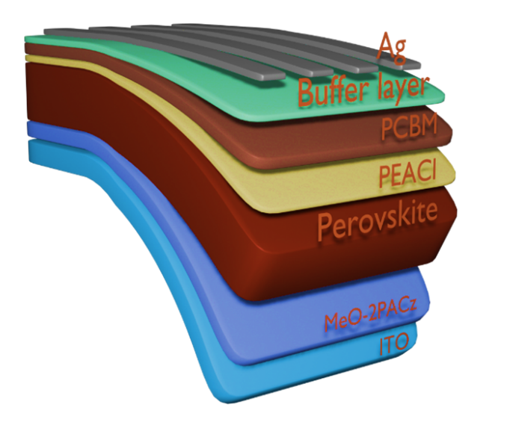
Fig. S1 A schematic of the perovskite structure (p-i-n), layers, and configuration
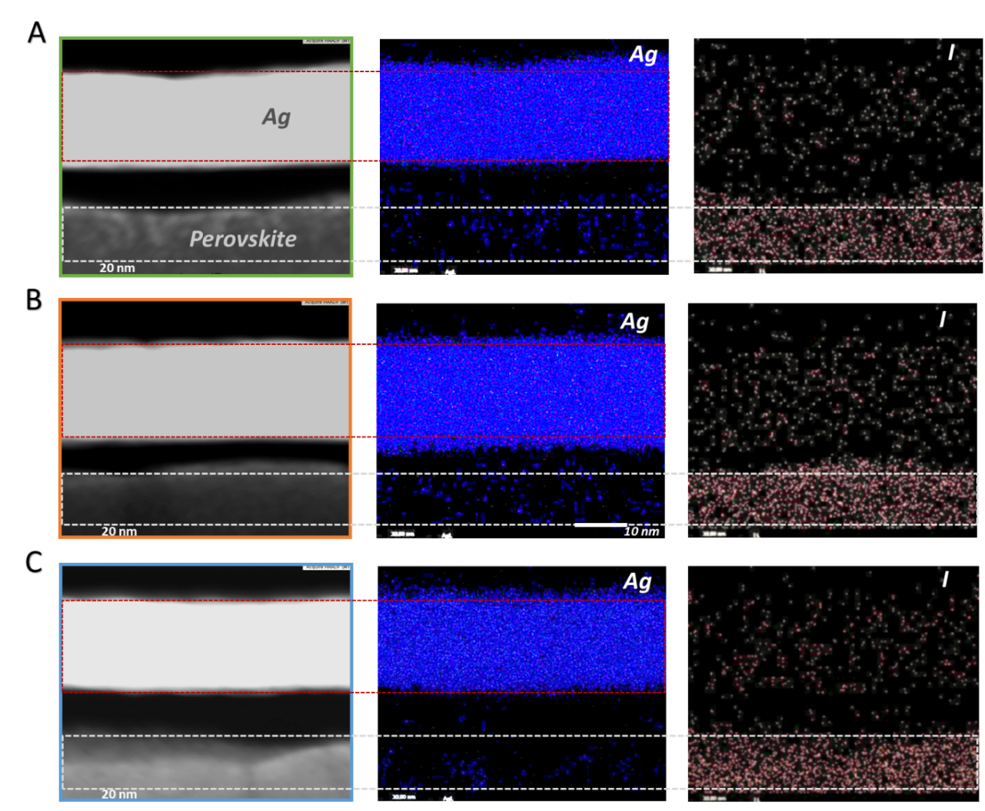
Fig. S2 High-angle annular dark-field scanning transmission electron microscopy (HAADF-STEM) images and the energy dispersive X-ray spectroscopy (EDX) maps of Ag and I elements after ageing at 100 °C for 48h in ambient air. (a) perovskite solar cells without a buffer layer and with (b) BCP and (c) Cu(BCP)(PEIE) interlayer.
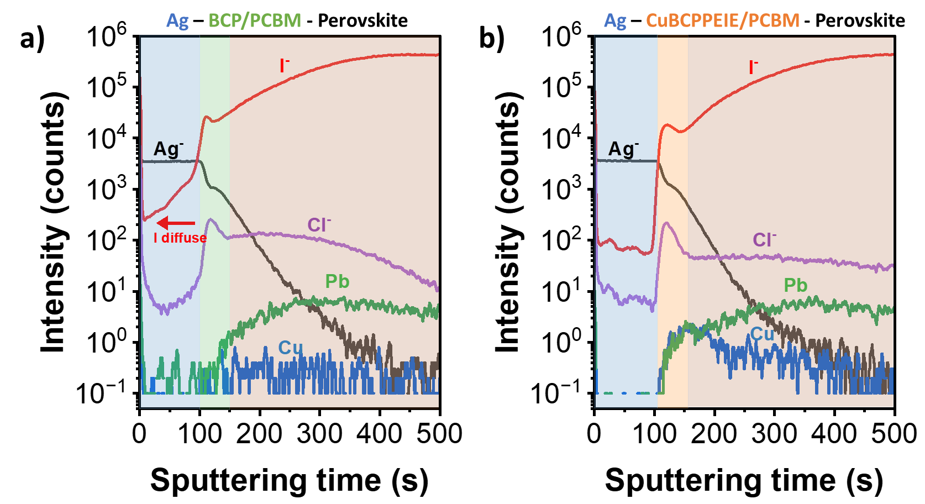
Fig. S3 The in-depth profile of ToF-SIMS of (a) BCP-based and (b) Cu(BCP)(PEIE)-based device after thermally aged at 100 ºC for 48h.

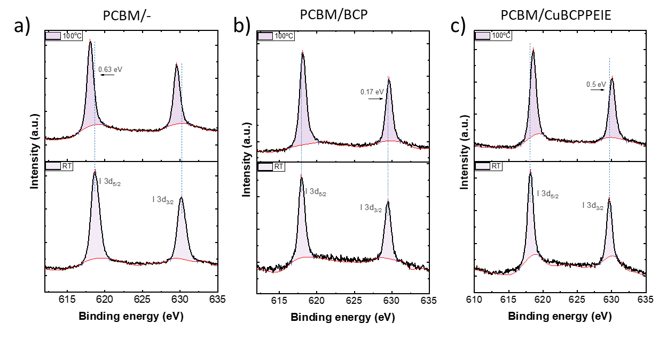
Fig. S4 XPS spectra of FA_{0.88}Cs_{0.12}PbI_{2.64}Br_{0.36}/PCBM/with or without buffer layer/5nm Ag, after degradation test for 48 hours at RT and 100 ºC. a-c the I 3d XPS peak of PCBM, PCBM with BCP, and PCBM with Cu(BCP)(PEIE), respectively.

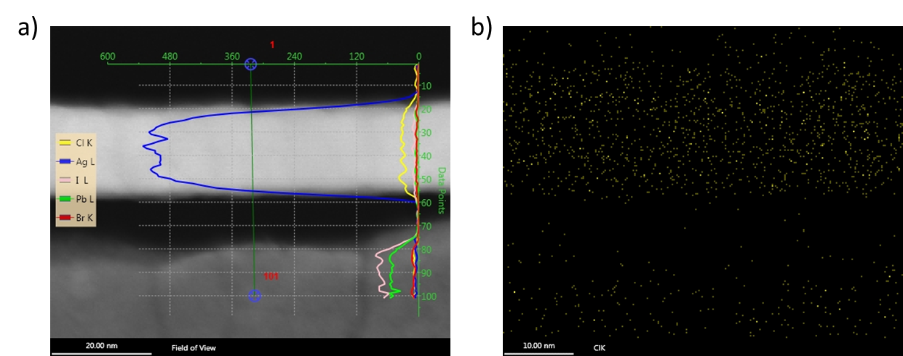
Fig. S5 a) HAADF-STEM and EDX elemental maps of perovskite solar cells and corresponding line profile. b) EDX elemental maps of Cl element after ageing at 100 °C for 48h in ambient air.

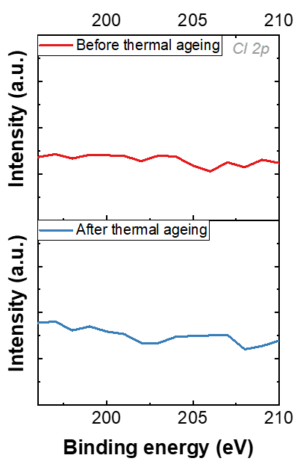
Fig. S6 The XPS of Cl 2p before and after thermal ageing (100 ºC, 48h in ambient air).

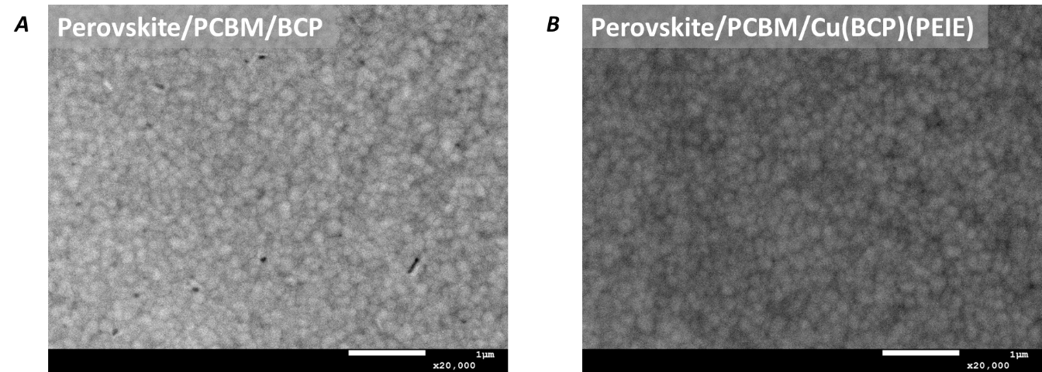
Fig. S7 SEM images of Perovskite/PCBM. a) BCP and b) Cu(BCP)(PEIE) buffer layer

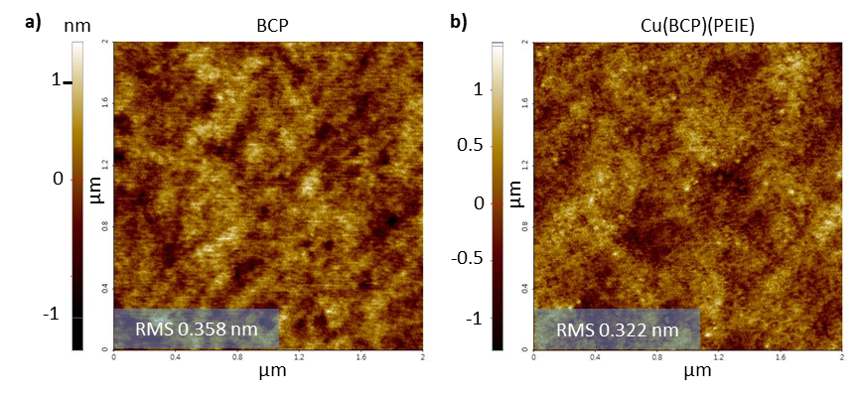
Fig. S8 AFM images of PCBM with a) BCP and b) Cu(BCP)(PEIE) buffer layer

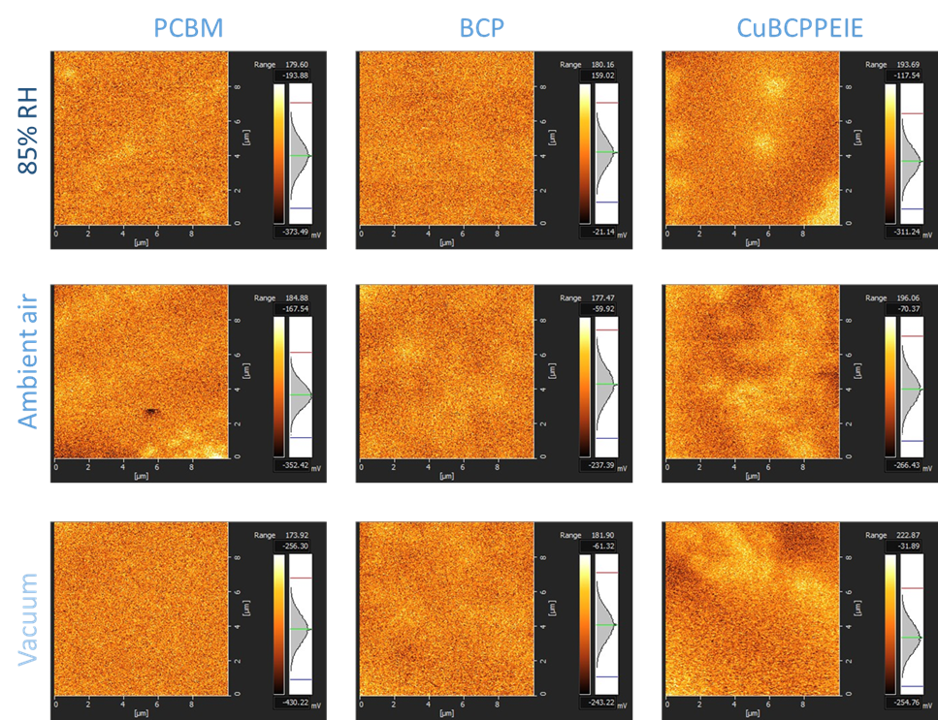
Fig. S9 Surface potential of different buffer layers with humidity level
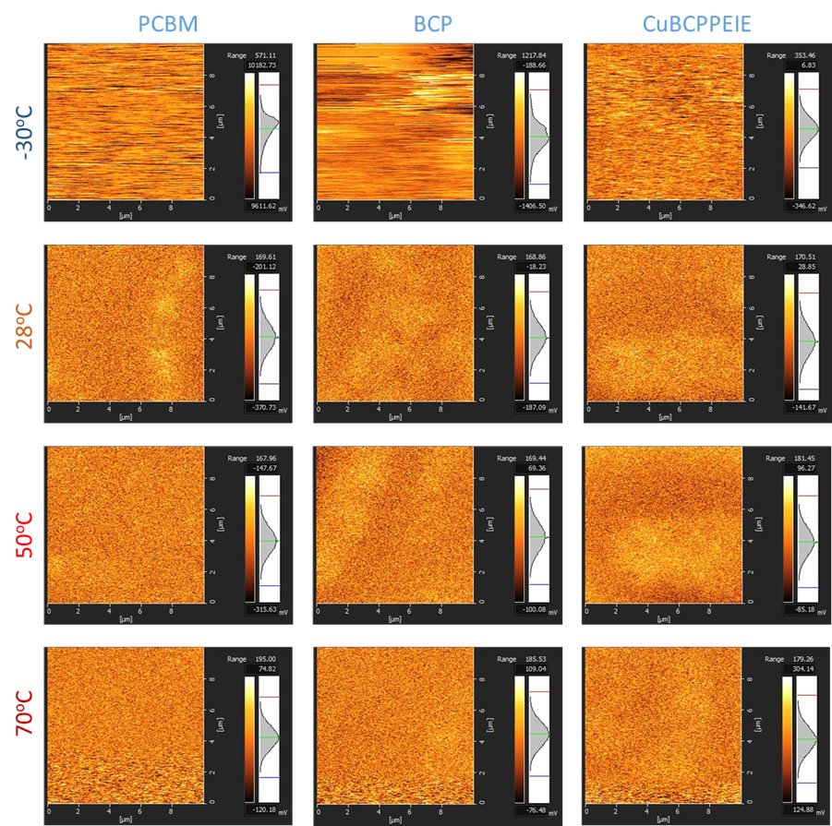
Fig. S10 Surface potential of different buffer layers with temperature
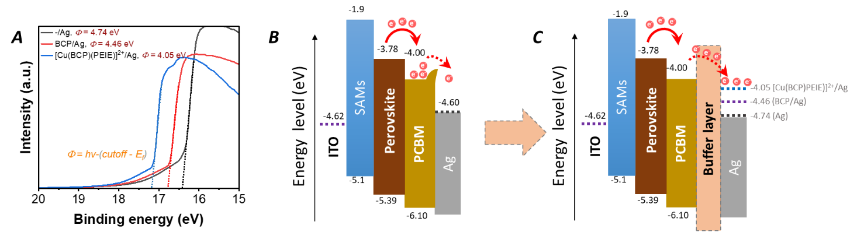
Fig. S11 UPS measurement results of different buffer layer. a) The UPS plot of Ag without and with different cathode buffer layers indicates a progressive reduction in the silver (Ag) work function of 0.7 eV, which aligns with the formation of a strong interfacial dipole. Such a dipole is attributed to amine and ethoxy groups in polyethylenimine ethoxylated (PEIE) and copper-nitrogen (Cu–N) coordination, both of which orient positive charge toward the metal. A schematic illustration of Ag energy level alignment without b) cathode buffer layer and c) with BCP and Cu(BCP)(PEIE) buffer layer.
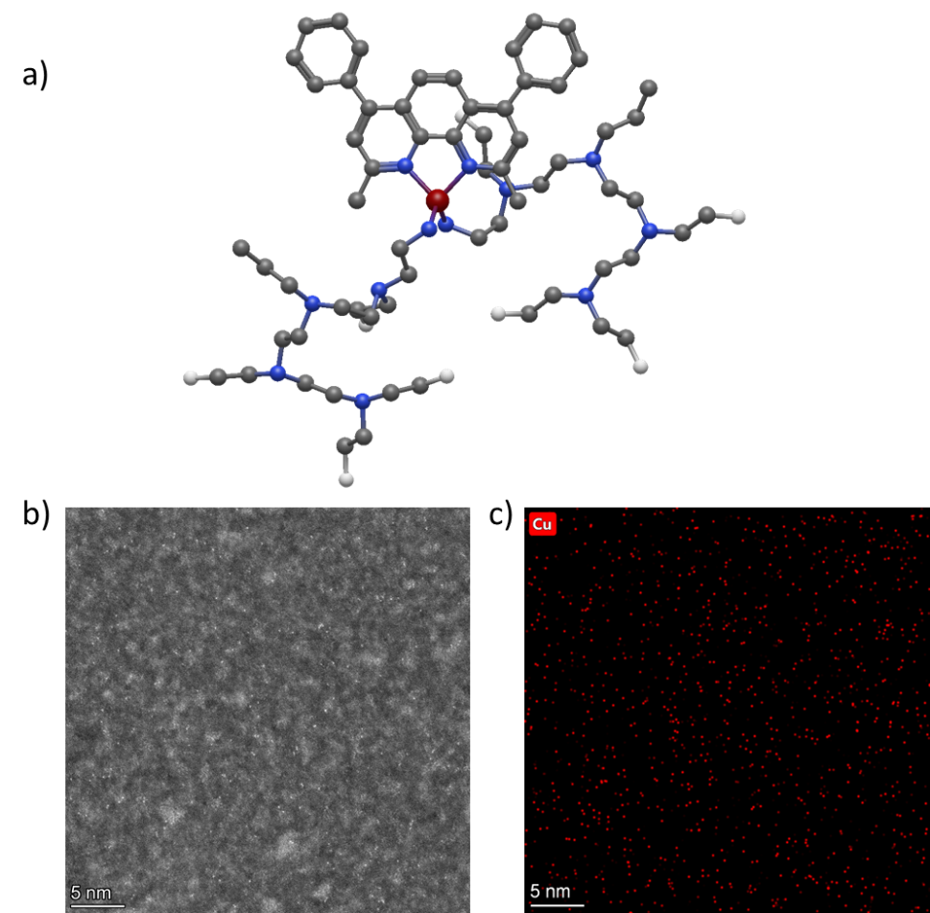
Fig. S12 a) Molecular geometry optimization of the Cu(BCP)(PEIE) ternary complex (85 atoms; Avogadro energy minimization) reveals a Cu–N coordination node bridging the rigid BCP scaffold and flexible PEIE sub-chains. b) High-angle annular dark-field scanning transmission electron microscopy (HAADF-STEM) image of Cu(BCP)(PEIE) plane view. c) EDX elemental analysis of Cu(BCP)(PEIE) indicating the present of metal-anchored (Cu) on the surface.
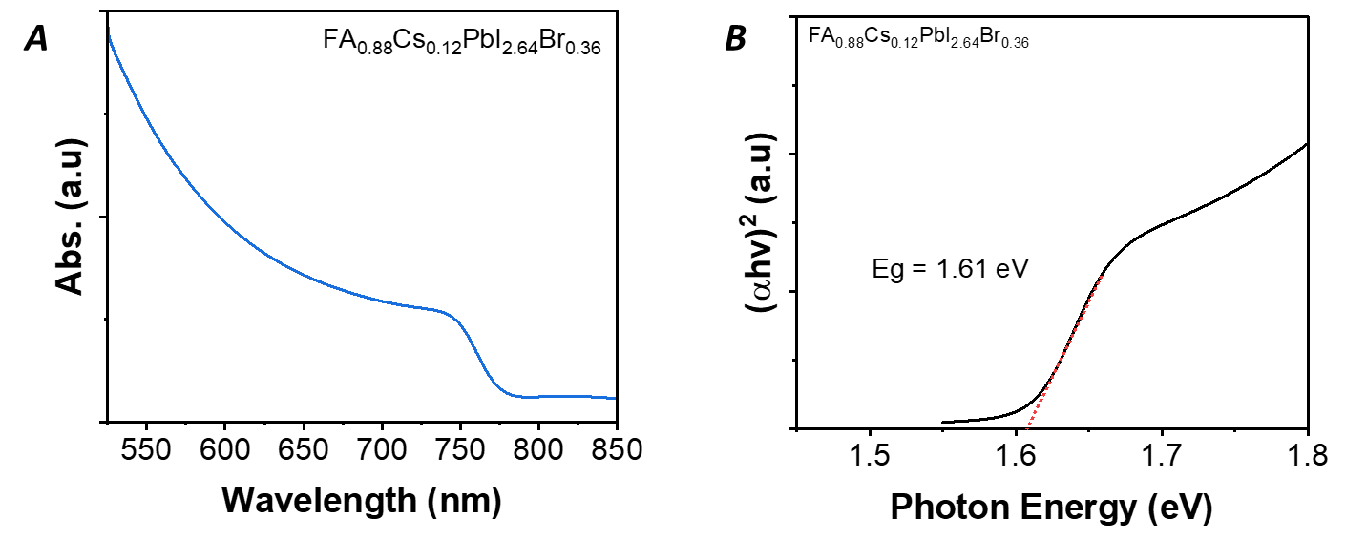
Fig. S13 Absorbance and bandgap calculation. (A) Absorbance spectra with the absorption edge and (B) band-gap derived from tauc plot of triple cation mixed halides perovskite used mainly in this study
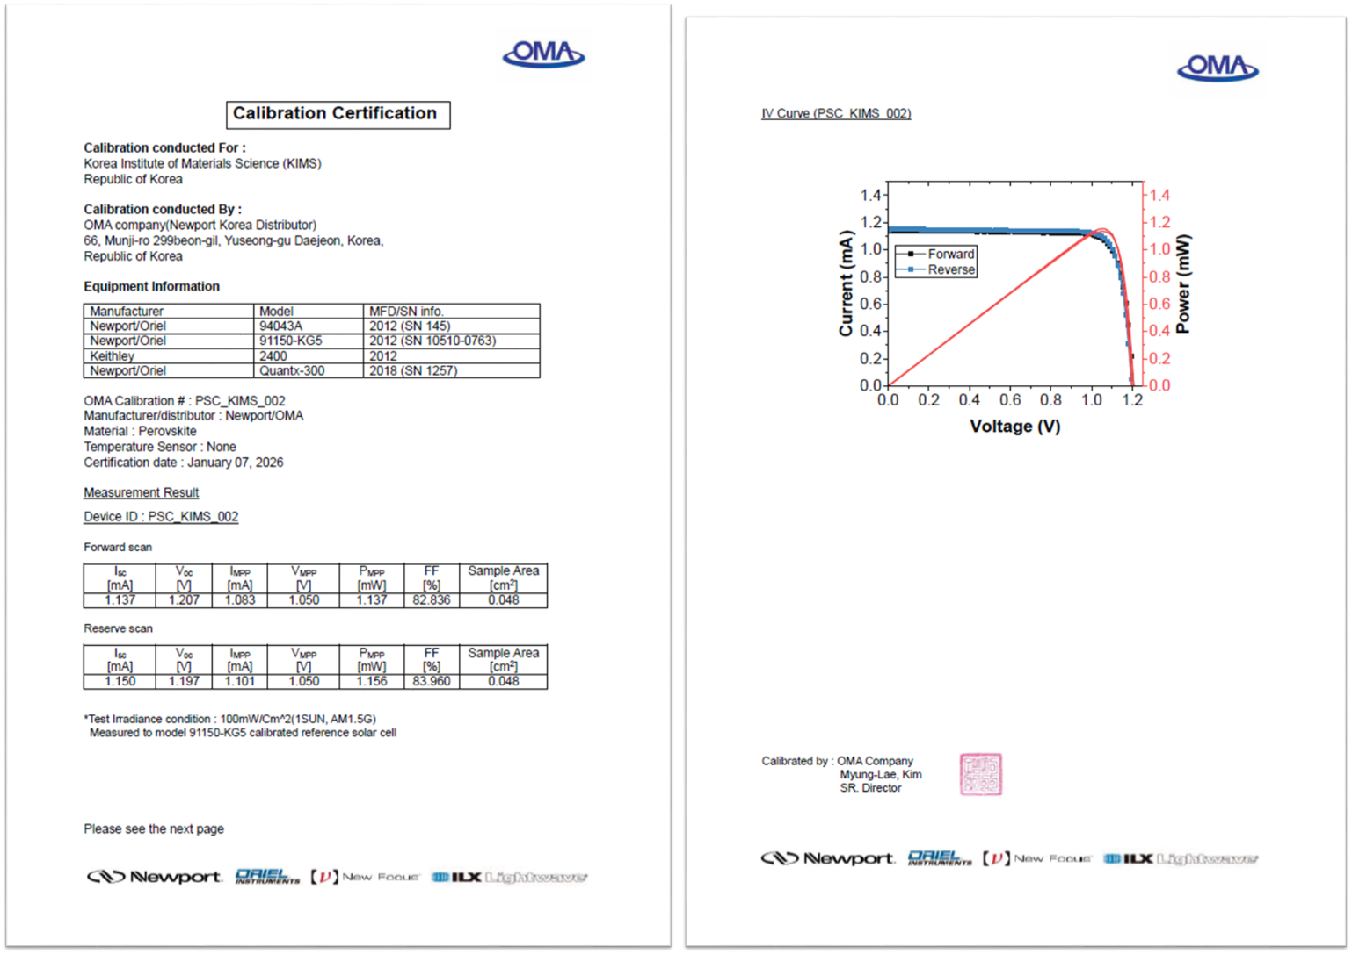
Fig. S14 Certified PV performance for the 1.61-eV perovskite cells with 0.048 cm² aperture area from an accredited photovoltaic certification laboratory (OMA company, Korea). The certificated efficiency is 24.07%.
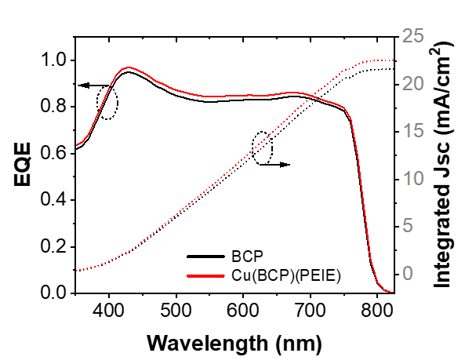
Fig. S15 External quantum efficiency (EQE) and integrated Jsc value from the control (BCP) and target (Cu(BCP)(PEIE)) device.
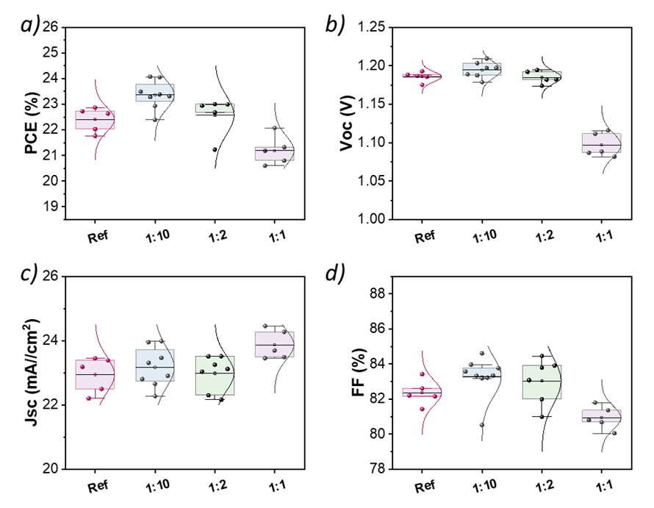
Fig. S16 Device performance of PSCs with different CuCl₂:BCP v/v ratio. (A) PCE, (B) Voc, (C) Jsc, and (D) FF.
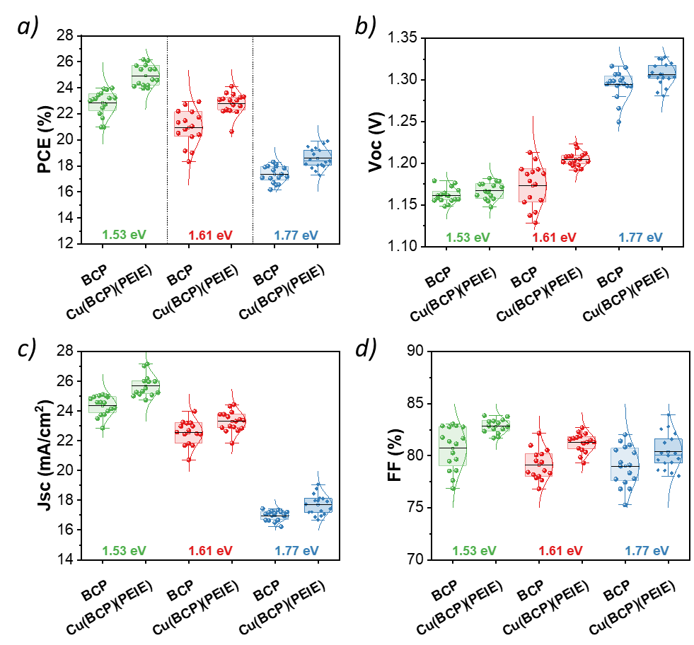
Fig. S17 Performance metrics statistic of rigid PSCs with different bandgap. a) PCE, b) Voc, c) Jsc, and d) FF. Extracted from 15 different device.
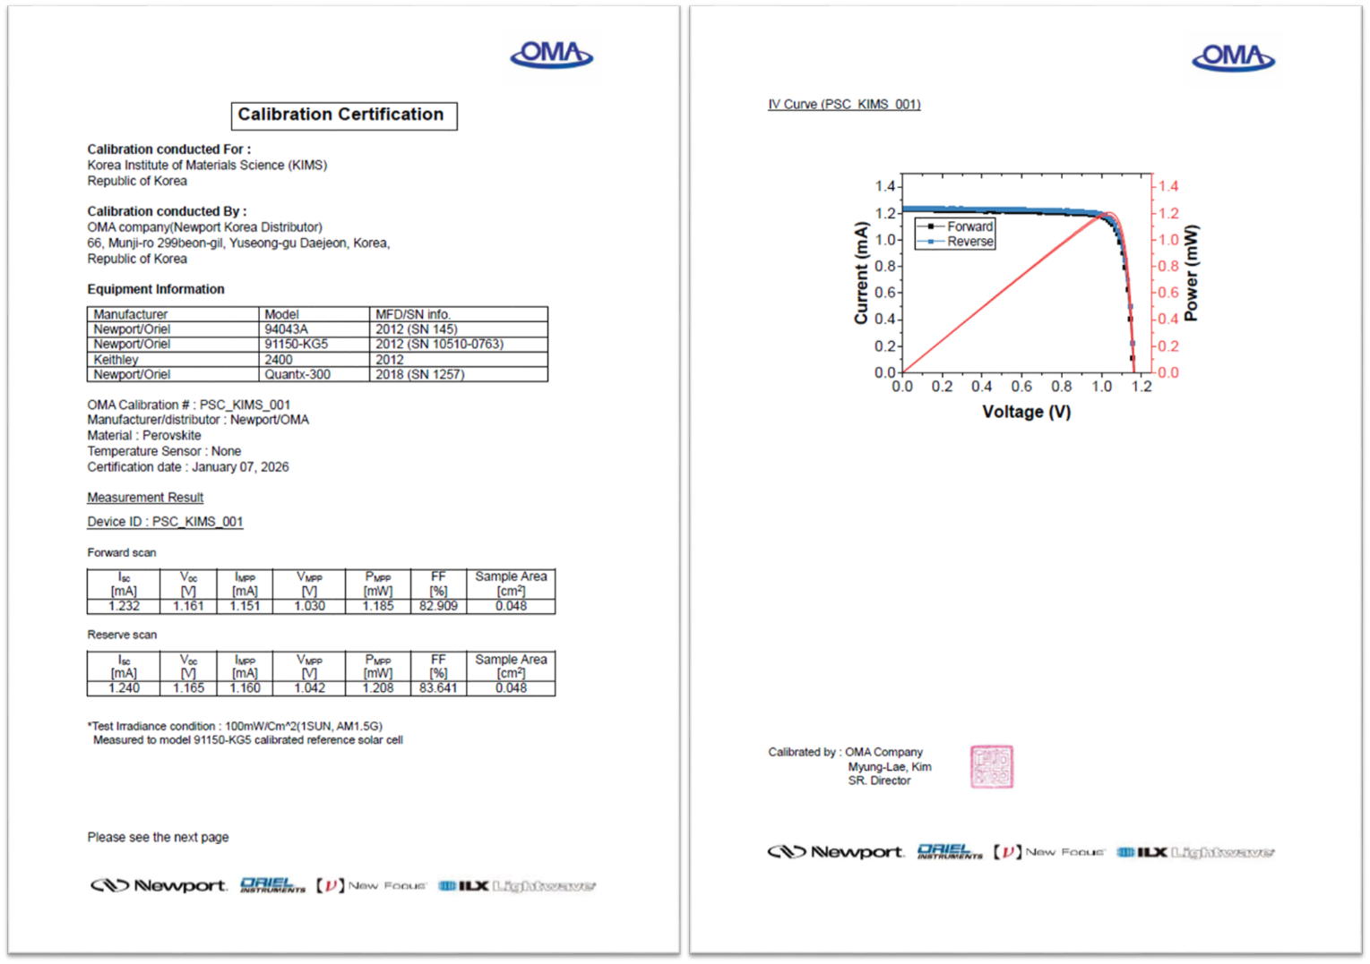
Fig. S18 Certified PV performance for the 1.53-eV perovskite cells with 0.048 cm² aperture area from an accredited photovoltaic certification laboratory (OMA company, Korea). The certificated efficiency is 25.18%.

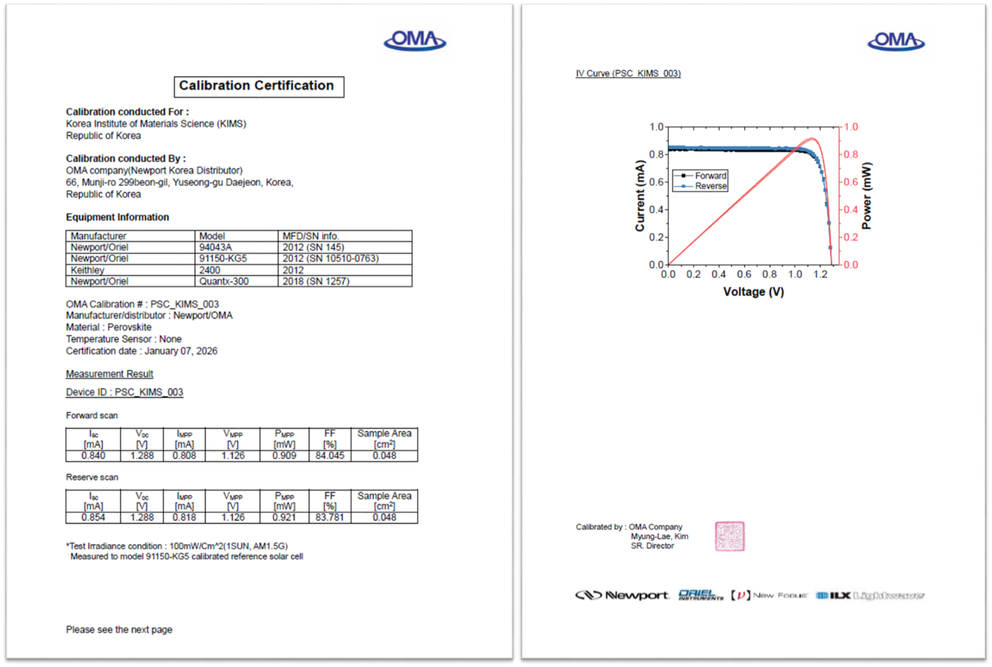
Fig. S19 Certified PV performance for the 1.77-eV perovskite cells with 0.048 cm² aperture area from an accredited photovoltaic certification laboratory (OMA company, Korea). The certificated efficiency is 19.19%.

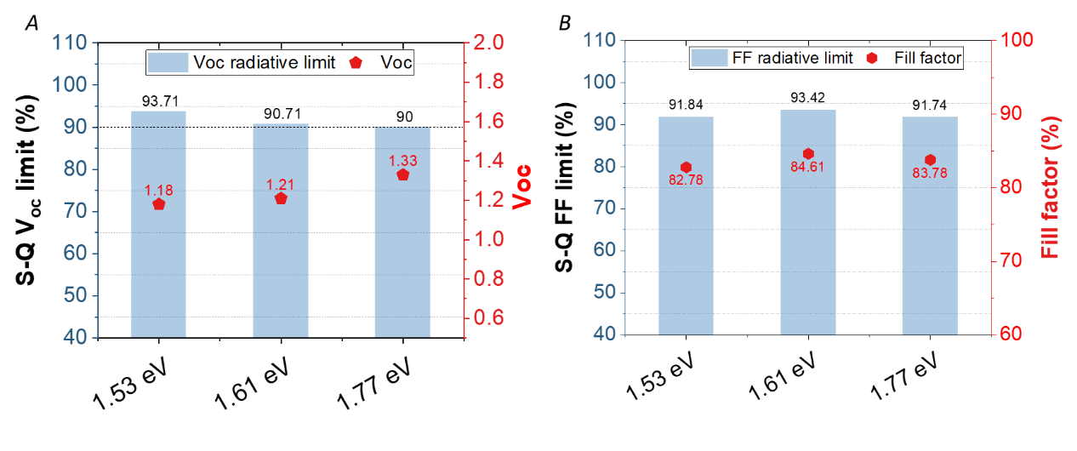
Fig. S20 Percentage of the radiative limit and values of the champion device. (A) V_{oc} and (b) FF for target devices with different bandgaps.
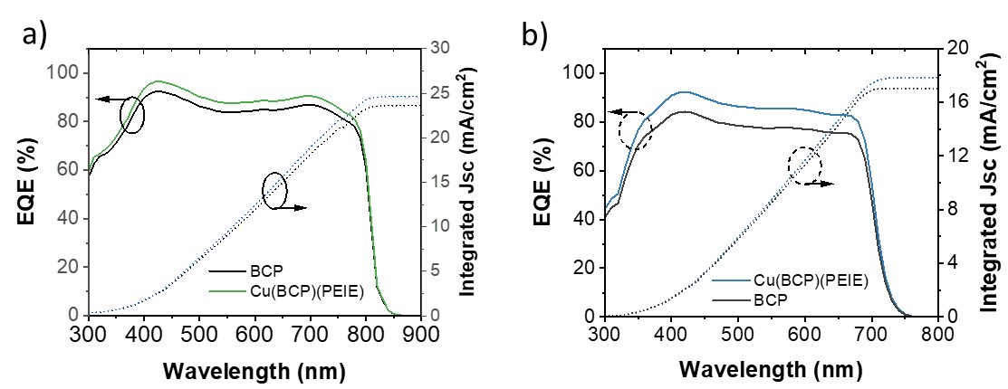
Fig. S21 External quantum efficiency (EQE) and integrated Jsc value from the control (BCP) and target (Cu(BCP)(PEIE)) device for a) 1.53-eV bandgap perovskite and b) 1.77-eV bandgap perovskite

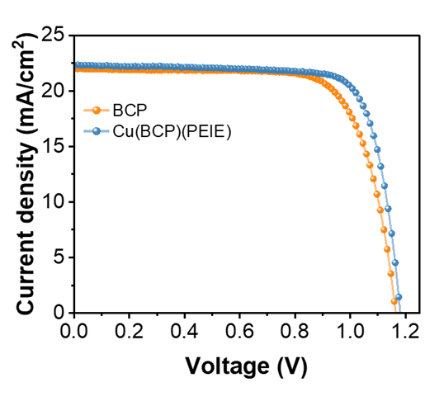
Fig. S22 Device performance of air-processed (>25% RH) 1 cm² area rigid PSCs with different buffer layer

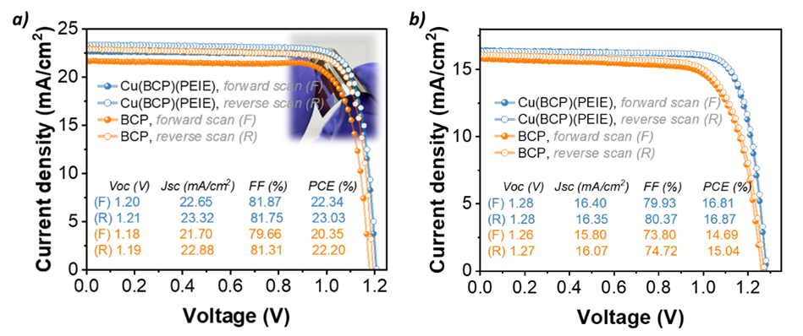
Fig. S23 J–V characteristics of air-processed flexible perovskite solar cells (f-PSCs). (A) 1.61-eV perovskite. (B) 1.77-eV perovskite with BCP and Cu(BCP)(PEIE) buffer layers under AM 1.5G illumination, along with their corresponding performance parameters. The relative humidity during fabrication was over 45 %RH.

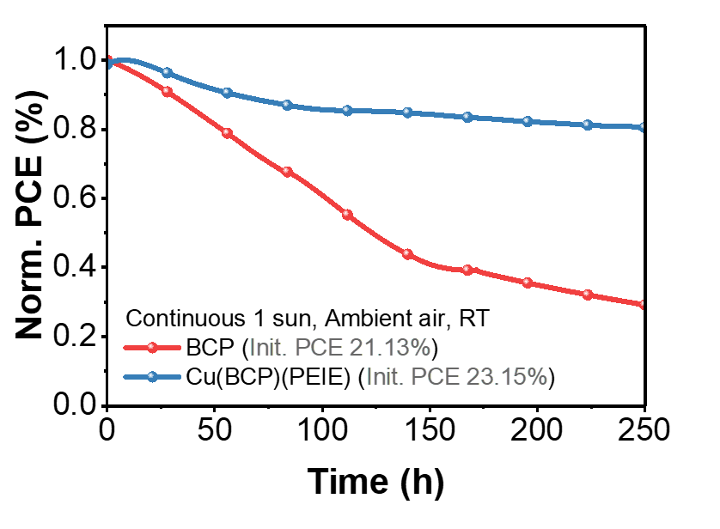
Fig. S24 Maximum power point tracking (MPPT) test of BCP- and Cu(BCP)(PEIE)-based perovskite in ambient air, room temperature (RT) with continuous 1-sun illumination.

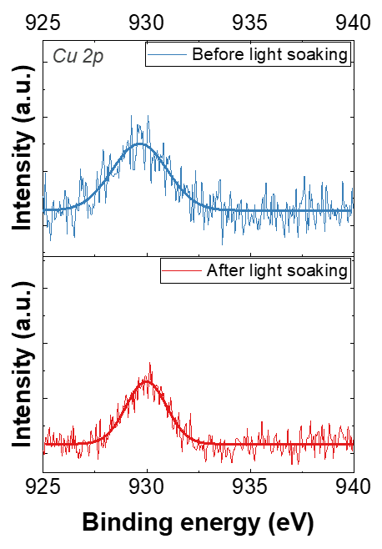

Fig. S25 XPS Cu 2p spectrum of Cu(BCP)(PEIE) confirming the presence of Cu element before and after light-soaking for 200 h.

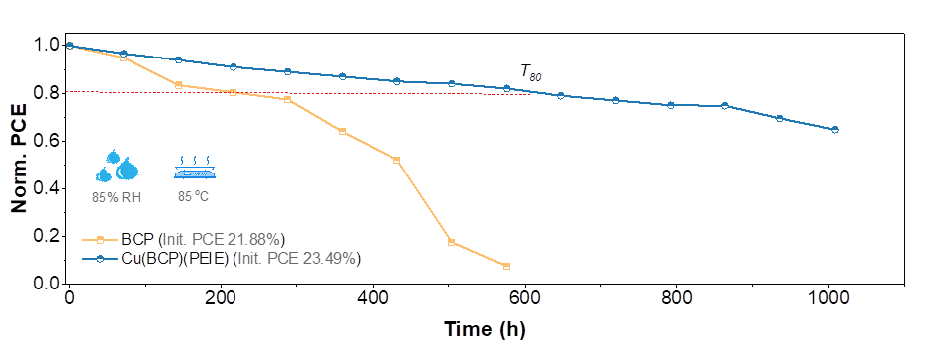
Fig. S26 Thermal and moisture stability (85 ºC / 85 %RH) of encapsulated perovskite solar cells with different buffer layers.
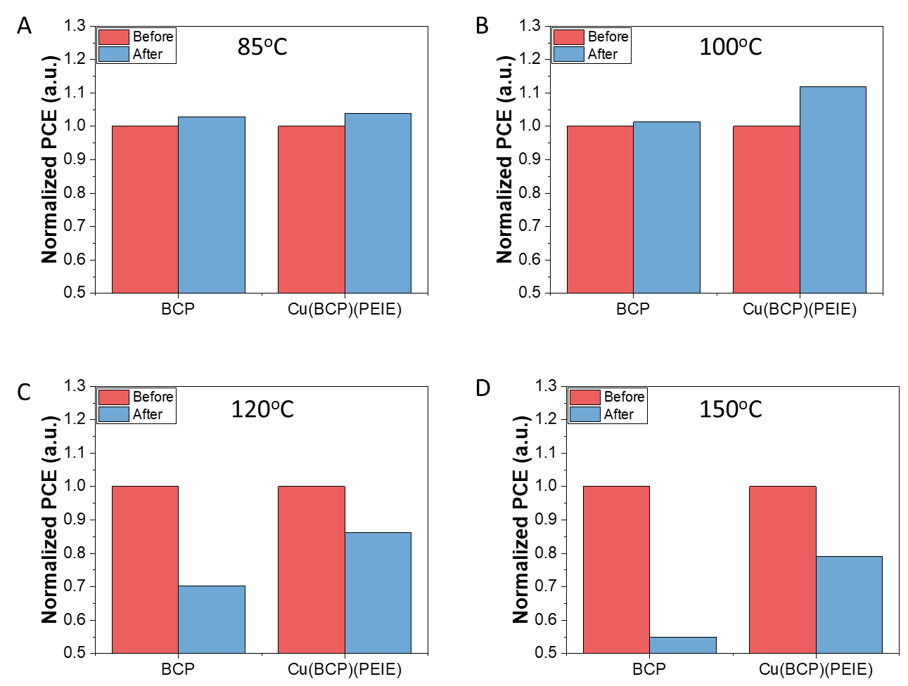
Fig. S27 Post-thermal treatment of perovskite solar cells at different temperatures. (A) 85 ºC, (B) 100 ºC, (C) 120 ºC and (D) 150 ºC. Humidity during testing is ~55 % RH. Thermal treatment duration was 10 minutes.
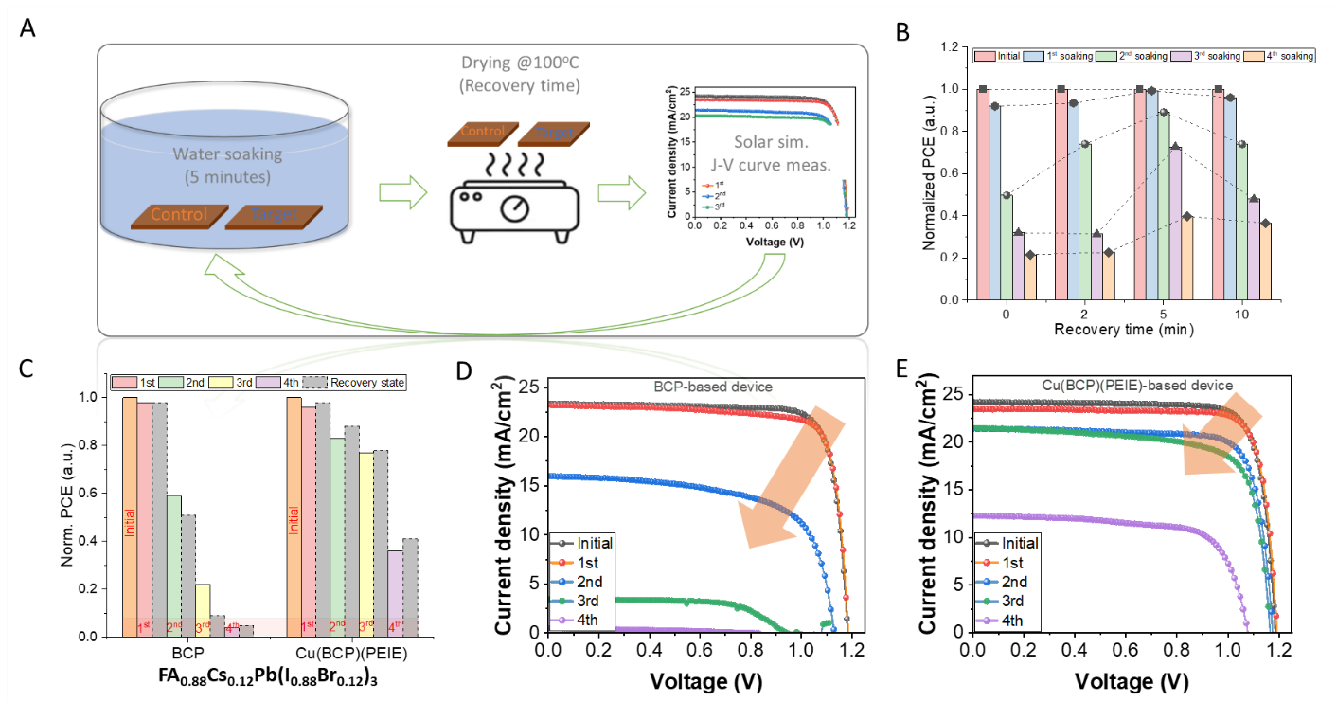
Fig. S28 Water immersion test of perovskite solar cells. (A) a schematic representation of the water immersion test sequence and corresponding conditions. The water temperature during the test was kept at 22-25 ºC. (B) Normalized power conversion efficiency (PCE) of 1.61 eV perovskite solar cells after 5 min of water immersion followed by different durations of post-immersion thermal treatment. In this manuscript, this thermal-treatment period is referred to as the “restoration time”. (C) Normalized PCE evolution during repetitive water immersion tests of FA₀.₈₈Cs₀.₁₂Pb(I₀.₈₈Br₀.₁₂)₃ perovskite solar cells incorporating either the control (BCP) or target (Cu(BCP)(PEIE)) interlayer, together with the corresponding absolute PCE values measured after 5 min of recovery (post-immersion thermal treatment). The detailed photovoltaic parameters is summarized in Table S10-S11. After thermal treatment, the Cu(BCP)(PEIE)-based devices exhibit a markedly superior performance recovery compared with BCP-based control devices. This recovery behavior is attributed to the reversible hydration–dehydration process of the perovskite absorber and the enhanced moisture-blocking capability and interfacial defect passivation provided by the Cu(BCP)(PEIE) interlayer, which suppresses irreversible decomposition and facilitates efficient charge extraction after water exposure. (D-E) J-V curve evolution of recovered devices for BCP- and Cu(BCP)(PEIE)-based cells, respectively, after each # immersion cycles. Devices incorporating the target interlayer exhibit significantly improved resistance to water exposure compared with control devices, demonstrating enhanced interfacial robustness against moisture ingress.

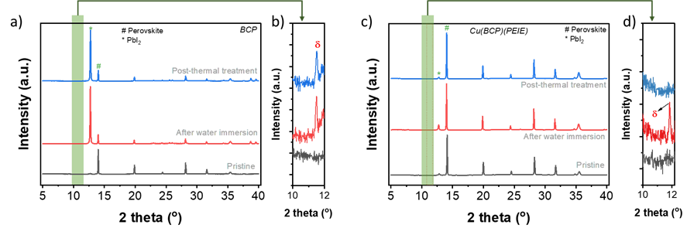
Fig. S29 Crystallographic evidence of moisture-driven α-to-δ phase conversion and thermally assisted partial recovery in perovskite films across three stages (pristine, after water immersion, and after thermal treatment at 100 °C for 10 min). a) full-range XRD patterns of BCP-based films, b) enlarged 2θ region (10–12°) of BCP-based films confirming the non-perovskite δ-FAPbI₃ phase (δ), c) full-range XRD patterns of Cu(BCP)(PEIE)-based films, and d) enlarged 2θ region (10–12°) of Cu(BCP)(PEIE)-based films showing differential suppression of the δ-phase upon annealing.

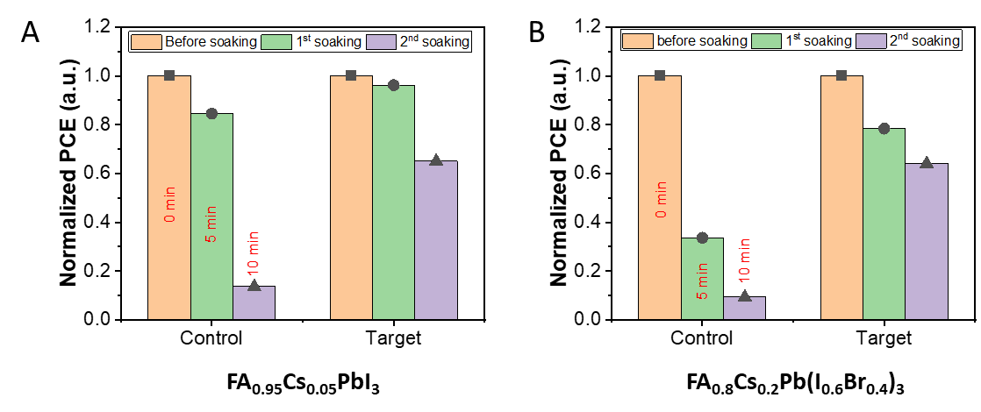
Fig. S30 Normalized PCEs after 5 minutes of water immersion, followed by 5 min of thermal treatment (recovery) with different perovskite bandgap for both control (BCP) and target (Cu(BCP)(PEIE))-based cells. a) FA_{0.95}Cs_{0.05}PbI₃ and b) FA_{0.8}Cs_{0.2}Pb(I_{0.6}Br_{0.4})₃.

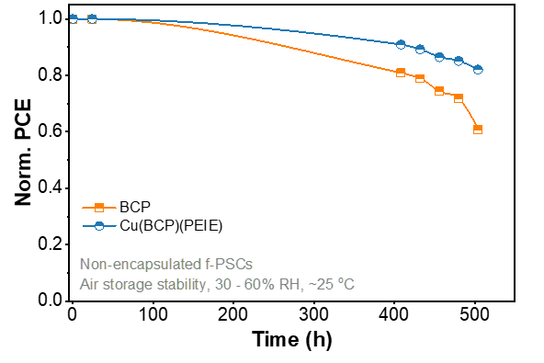
Fig. S31 Air‑storage stability of non‑encapsulated flexible perovskite solar cells (f‑PSCs) employing BCP and Cu(BCP)(PEIE) showing the evolution of normalized PCE as a function of storage time under ambient conditions (30–60% relative humidity, ~25 ℃)

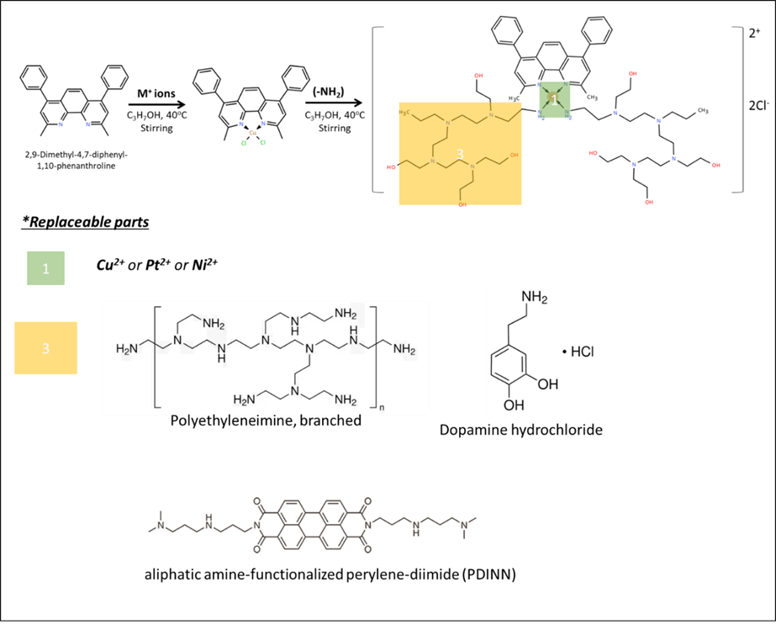
Fig. S32 Illustration of replaceable parts in M(BCP)(-NH2-) molecular inter-net concept using various metal ions and amine-functionalized organic compound.

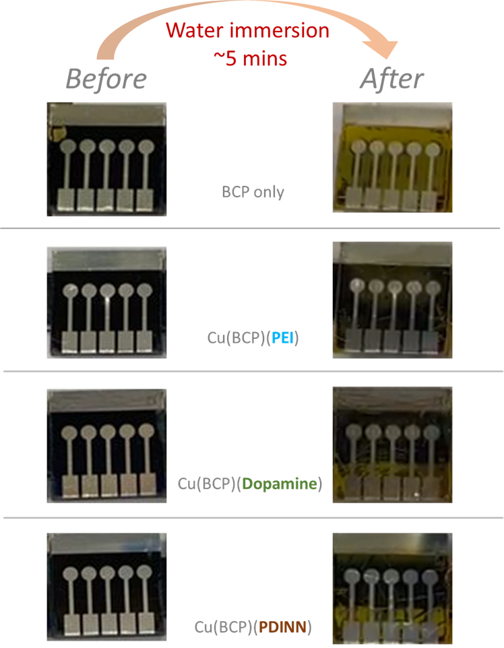
Fig. S33 Water-immersion stability (5 minutes of dipping time) of inverted perovskite solar cells with different buffer layers.

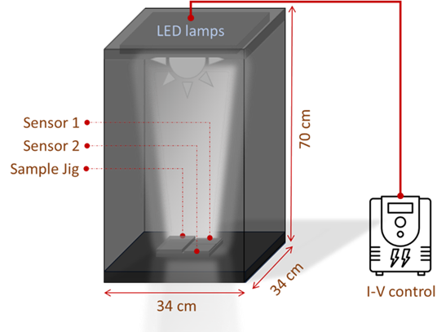
Fig. S34 Indoor light measurement setup
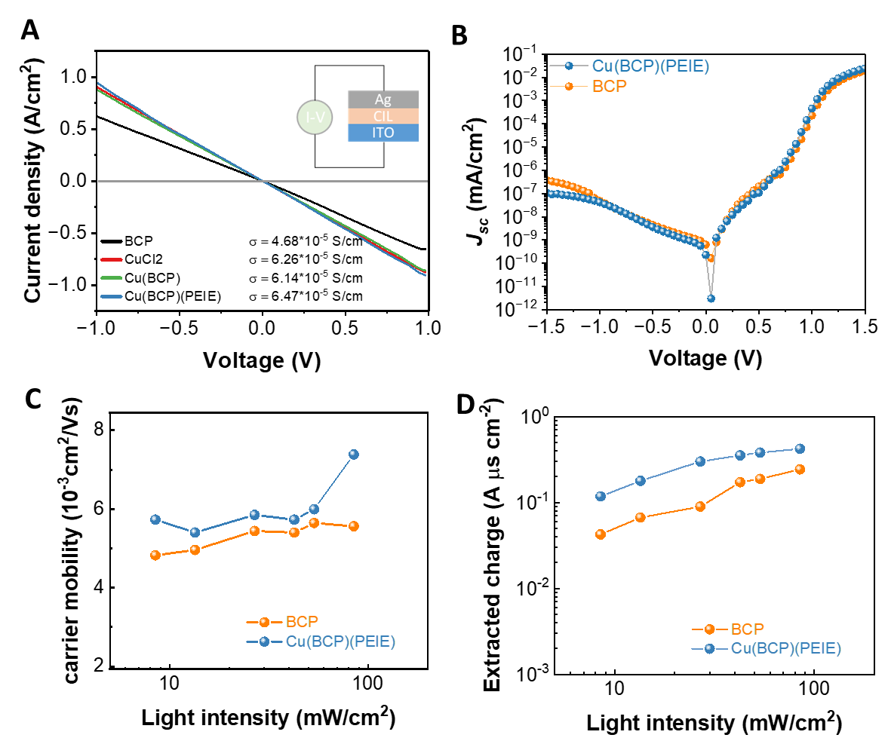
Fig. S35 Electrical characterization and recombination analysis. a) I-V curves of different cathode interlayer materials. b) Measured J-V curve under dark conditions. c) Carrier mobility and d) extracted charge values (Qext) from light-dependent photo-CELIV curves.
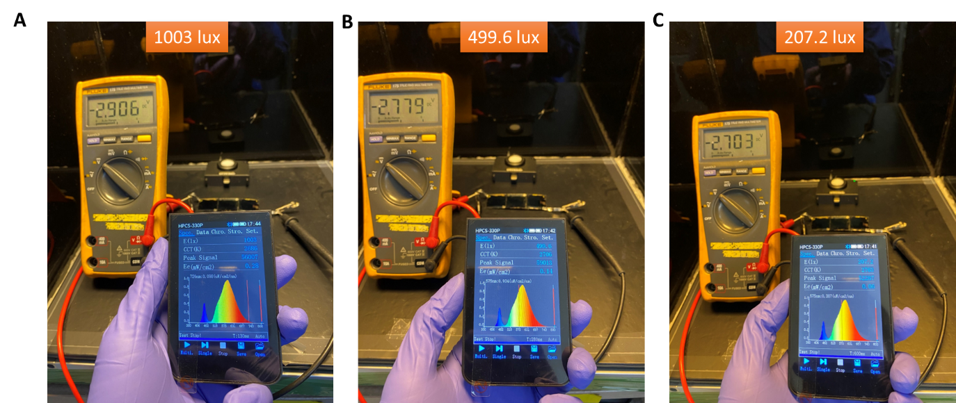
Fig. S36 Voltage output generated from 3-connected devices under different low light intensities. a) 1003 lux, b) 499.6 lux, and c) 207.2 lux

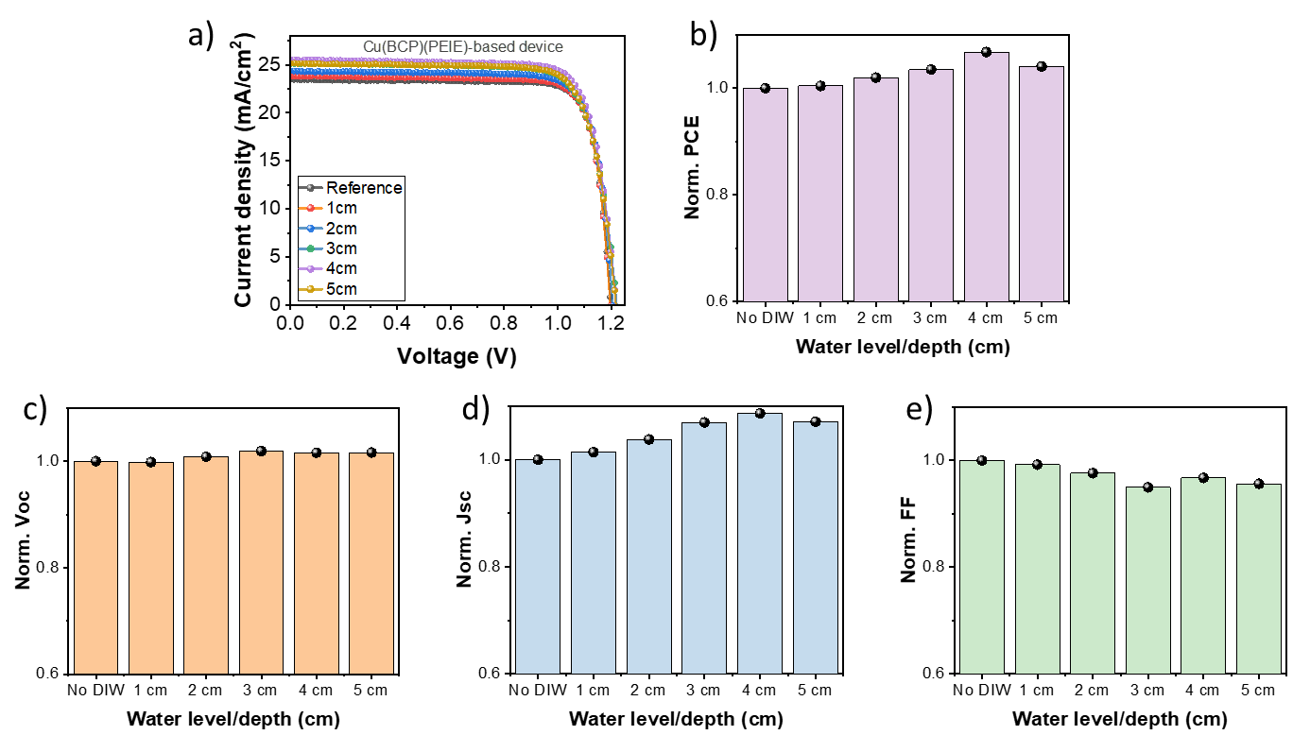
Fig. S37 Water immersion test of perovskite solar cells with different water depth level. a) J-V curve, b) PCE, c) Voc, d) Jsc, and e) FF.

Fig. S38 ICP-MS analysis of Pb²⁺ and Cs⁺ concentrations in water after immersion of perovskite solar cells with no buffer layer, BCP, and Cu(BCP)(PEIE) interlayers.

Table S1 The integrated area and full-width at half maximum (FWHM) of Pb 4f peaks from XPS spectra with different cathode interlayer
Device | Aging temperature | FWHM |  | Integrated Area
 |  | Pb 4f_{7/2} | Pb 4f_{5/2} | Pb 4f_{7/2} | Pb 4f_{5/2}
No buffer layer | RT | 1.21 | 1.24 | 8858 | 7250
 | 100ºC | 1.51 | 1.52 | 10874 | 8631
BCP | RT | 1.50 | 1.57 | 25437 | 21304
 | 100ºC | - | - | - | -
Cu(BCP)(PEIE) | RT | 1.13 | 1.16 | 6398 | 4997
 | 100ºC | - | - | - | -

Table S2 The integrated area and full-width at half maximum (FWHM) of I 3d peaks from XPS spectra with different cathode interlayer
Device | Aging temperature | FWHM |  | Integrated Area
 |  | I 3d_{5/2} | I 3d_{3/2} | I 3d_{5/2} | I 3d_{3/2}
No buffer layer | RT | 1.04 | 1.03 | 84985 | 54743
 | 100ºC | 1.30 | 1.33 | 93932 | 66255
BCP | RT | 0.98 | 0.97 | 22651 | 15208
 | 100ºC | 1.02 | 0.97 | 63819 | 39050
Cu(BCP)(PEIE) | RT | 0.95 | 0.89 | 30282 | 18655
 | 100ºC | 1.02 | 1.06 | 64178 | 46217
Table S3 Comparison of photovoltaic performance of representative perovskite solar cells with bandgaps >1.6 eV reported in the literature and in this work
Bandgap  (eV) | Voc  (V) | Jsc  (mA/cm²) | Fill factor  (%) | PCE  (%) | References
1.6 | 1.22 | 22.3 | 83.4 | 22.6 | Science 2024, 384, 767.
1.61 | 1.164 | 23.19 | 85.7 | 23.13 | InfoMat. 2023;5:e12379
1.61 | 1.21 | 23.51 | 84.61 | 24.11 | This work
1.65 | 1.206 | 22.42 | 81.55 | 22.05 | Nat. Energy 2024, 9, 536.
1.66 | 1.241 | 20.89 | 83.89 | 21.62 | Nano Energy 2024, 121, 109162.
1.67 | 1.26 | 19.5 | 84 | 20.6 | Science 2024, 384, 767.
1.68 | 1.282 | 22.43 | 81.2 | 23.35 | Energy Environ. Sci. 2024, 17, 5866.
1.7 | 1.26 | 20.84 | 82.82 | 21.85 | Energy Environ. Sci. 2025, 18, 1232.
1.72 | 1.321 | 19.32 | 76.1 | 19.42 | Nat. Commun. 2024, 15, 882.
1.73 | 1.27 | 19.15 | 81.89 | 19.97 | Science 2024, 383, 524.
1.75 | 1.32 | 18.81 | 83.59 | 20.8 | Nat. Commun. 2024, 15, 8899.
1.77 | 1.36 | 18.3 | 82.3 | 20.5 | Nature 2024, 635, 867.
1.77 | 1.32 | 18.73 | 81.46 | 20.00 | This work
1.78 | 1.311 | 18.3 | 83.1 | 19.9 | Joule 2025, 101801.
1.79 | 1.332 | 17.37 | 82.9 | 19.59 | Nat. Energy 2024, 9, 298.
1.8 | 1.274 | 17.4 | 79.6 | 17.6 | Chem. Eng. J. 2024, 482, 148638.
1.81 | 1.351 | 17.52 | 82.74 | 19.58 | Nat. Energy 2024, 9, 411.
1.82 | 1.305 | 17.36 | 84.82 | 19.22 | Adv. Energy Mater. 2024, 2404366.
1.83 | 1.32 | 17.06 | 84.21 | 18.96 | Nat. Energy 2024, 9, 592.
1.85 | 1.258 | 14.3 | 71.8 | 12.9 | ACS Energy Lett. 2024, 9, 1666.
1.86 | 1.366 | 16.1 | 84.2 | 18.52 | Joule 2024, 8, 2554.
1.88 | 1.36 | 16.1 | 83.8 | 18.1 | Nature 2024, 635, 860.
1.91 | 1.31 | 14.78 | 77.9 | 15.25 | Nat. Energy 2023, 9, 70.
1.93 | 1.422 | 14.18 | 93.79 | 16.9 | Nature 2024, 628, 306.
1.96 | 1.33 | 13.05 | 76.7 | 13.4 | Adv. Mater. 2024, 36, 2311595.
1.97 | 1.44 | 12.8 | 0.83 | 15.3 | Nat. Energy 2023, 9, 70.
1.99 | 1.17 | 11.13 | 66.3 | 8.63 | Angew. Chem., Int. Ed. 2024, 64, 202415966.
2.1 | 1.316 | 11.79 | 73.6 | 11.42 | Nat. Energy 2023, 9, 70.

Table S4 Device performance of perovskite solar cells with different buffer layers
Condition | Voc  (V) | Jsc  (mA/cm²) | FF  (%) | PCE  (%)
BCP | 1.19 | 23.18 | 82.15 | 22.72
CuCl2 | 1.05 | 20.99 | 54.04 | 11.88
Cu(BCP) | 1.17 | 23.82 | 80.86 | 22.54
Cu(BCP)(PEIE) | 1.21 | 23.51 | 84.61 | 24.11

Table S5 Different Cu:BCP ratio effect in device performance
Condition | Voc  (V) | Jsc  (mA/cm²) | FF  (%) | PCE  (%)
Control (BCP only) | 1.19 | 23.18 | 82.15 | 22.72
Cu:BCP  1:10 v/v ratio | 1.21 | 23.51 | 84.61 | 24.11
1:2 v/v ratio | 1.17 | 22.91 | 83.22 | 22.39
1:1 v/v ratio | 1.12 | 23.13 | 76.38 | 19.77

Table S6 Device performance of perovskite solar cells with BCP and different PEIE concentrations
Condition | Voc  (V) | Jsc  (mA/cm²) | FF  (%) | PCE  (%)
Control (BCP only). ~6 nm | 1.17 | 23.34 | 81.86 | 22.36
Cu(BCP)(0.01 wt% PEIE). ~7 nm | 1.18 | 22.27 | 83.34 | 21.88
Cu(BCP)(0.025 wt% PEIE). ~9 nm | 1.20 | 23.31 | 83.76 | 23.49
Cu(BCP)(0.05 wt% PEIE). ≥14 nm | 1.19 | 23.98 | 80.52 | 22.93
Table S7 Device performance of perovskite solar cells with BCP and different PEIE concentrations
Cu(BCP)(PEIE) coating speed | Voc  (V) | Jsc  (mA/cm²) | FF  (%) | PCE  (%)
2000 rpm. ~11 nm | 1.21 | 23.62 | 80.71 | 23.05
4000 rpm. ~9 nm | 1.21 | 23.92 | 81.30 | 23.50
6000 rpm. ~6 nm | 1.17 | 23.59 | 78.99 | 21.86

Table S8 Device performance of 0.048 cm² and 1 cm² rigid perovskite solar cells (1.61 eV bandgap)
Condition | Active area (cm²) | Voc  (V) | Jsc  (mA/cm²) | FF  (%) | PCE  (%) | Ratio of PCE loss cells to 1cm²
Control (BCP only) | 0.048 (small) | 1.17 | 23.34 | 81.86 | 22.72 | ~15.7%
 | 1 (large) | 1.17 | 22.29 | 73.45 | 19.15 | ~15.7%
Cu(BCP)(PEIE) | 0.048 (small) | 1.20 | 23.95 | 83.96 | 24.07 | ~7.8%
 | 1 (large) | 1.19 | 22.88 | 81.31 | 22.20 | ~7.8%

Table S9 Device performance of air-processed large area (1 cm²) rigid perovskite solar cells (RH >45%)
Condition | Scan direction | Voc  (V) | Jsc  (mA/cm²) | FF  (%) | PCE  (%)
Control (BCP only) | Forward | 1.18 | 22.80 | 75.02 | 18.57
 | Reverse | 1.16 | 21.97 | 73.43 | 18.80
Cu(BCP)(PEIE) | Forward | 1.19 | 22.71 | 73.82 | 20.02
 | Reverse | 1.18 | 22.29 | 77.56 | 20.42

Table S10 Comparison of photovoltaic performance parameters of air-processed flexible PSCs
Device architecture | Active area  (cm²) | Bandgap  (eV) | Fabrication  conditions | FF  (%) | PCE (%) | Refs.
PET/ITO/SnO₂/perovskite/  spiro-OMeTAD/Au | 0.09 | 1.55 | Ambient air | 79.9 | 23.01 | Energy Environ. Sci. 2024, 17, 7069-7080.
PET/ITO/MeO-2PACz: PEACl/  perovskite/PEACl/PCBM/BCP/Ag | 0.14 | 1.61 | Ambient air | 72.11 | 19.20 | Chem. Eng. J. 2025, 518, 164371.
PEN/ITO/SnO₂/perovskite/PEDOT: PSS/carbon | 0.062 | 1.55 | Ambient air | 80 | 19.70 | Adv. Funct. Mater. 2024, 34, 2406354.
PET/ITO/SnO₂/perovskite+AES/  spiro-OMeTAD/Au | 0.05 | 1.53 | 30-40% RH | 76 | 20.1 | Small 2024, 20, 2401456.
PET/ITO/PEDOT:PSS/perovskite+PDLLA/PCBM/BCP/Ag | 0.06 | 1.55 | 20-25 °C  <40 % RH | 74.5 | 16.61 | J. Mater. Sci. 2022, 57, 20654-20671.
PET/ITO/SnO₂-PTACl/  perovskite/spiro-OMeTAD/Au | 1 | 1.55 | Ambient air | 80 | 17.6 | Sol. RRL 2024, 8, 2301013.
PET/ITO/SnO₂/perovskite/spiro-OMeTAD/Au | 0.09 | 1.53 | 25% RH | 77.2 | 19.38 | Adv. Funct. Mater. 2019, 29, 1902974.
PEN/ITO/SnO₂/perovskite+chitin/  spiro-OMeTAD/Au | 0.09 | 1.55 | 15-25% RH | 78.73 | 22.84 | Adv. Mater. 2025, 37, 2411982.
PEN/ITO/SnO₂-DAC-AA/perovskite  /spiro-OMeTAD/MoO_{x}/Ag | 0.092 | 1.54-1.55 | 20-25 °C, 30-40% RH | 81.45 | 23.87 | Adv. Mater. 2025, 37, 2418791.
PET/ITO/NiOx/MeO-4PACz/Perovskite/PEAI/PCBM/PEIE-CuBCP/BCP | 0.048 | 1.61 | 18-22 °C,  >45% RH | 81.75 | 23.03 | This work

Table S11 The photovoltaics parameters evolution of the BCP-based device after #cycle of water immersion and corresponding results after thermal treatment after immersion (recovery period)
Water immersion cycling | Thermal-treatment (TA)  (5 min @100ºC) | Voc  (V) | Jsc  (mA/cm²) | FF  (FF) | PCE  (%) | Retained PCE  (%)
Initial | - | 1.18 | 23.30 | 81.78 | 22.53 | 100
1st soaking | before | 1.18 | 23.05 | 81.19 | 22.08 | 98.4
1st soaking | After TA | 1.18 | 23.20 | 80.60 | 22.15 | 98.9
2nd soaking | before | 1.10 | 16.32 | 74.17 | 13.3 | 59
2nd soaking | After TA | 1.13 | 15.95 | 64.73 | 11.66 | 51.8
3rd soaking | before | 1.00 | 9.63 | 53.45 | 5.13 | 22.8
3rd soaking | After TA | 0.94 | 3.43 | 65.29 | 2.11 | 9.4
4th soaking | before | 0.18 | 13.27 | 44.67 | 1.08 | 4.8
4th soaking | After TA | 0.77 | 0.46 | 32.90 | 0.12 | 0.5

Table S12 The photovoltaics parameters evolution of Cu(BCP)(PEIE)-based device after #cycle of water immersion and corresponding results after thermal treatment after immersion (recovery period)
Water immersion cycling | Thermal-treatment (TA)  (5 min @100ºC) | Voc  (V) | Jsc  (mA/cm²) | FF  (FF) | PCE  (%) | Retained PCE  (%)
Initial | - | 1.19 | 24.22 | 81.56 | 23.4 | 100
1st soaking | before | 1.18 | 23.58 | 81.35 | 22.58 | 96.5
1st soaking | After TA | 1.19 | 23.45 | 82.62 | 23.09 | 98.7
2nd soaking | before | 1.18 | 20.23 | 81.57 | 19.48 | 83.2
2nd soaking | After TA | 1.17 | 21.40 | 79.68 | 20.03 | 88.7
3rd soaking | before | 1.17 | 21.47 | 72.23 | 18.18 | 77.7
3rd soaking | After TA | 1.16 | 21.46 | 73.91 | 18.47 | 78.9
4th soaking | before | 1.07 | 14.75 | 54.10 | 8.57 | 36.6
4th soaking | After TA | 1.08 | 12.27 | 70.43 | 9.31 | 39.8

Table S13 Comparison of indoor performance for air-processed PSCs (1.61 eV perovskite)
Intensity (Lux) | Device | V_{OC}  (V) | J_{SC}  (μA/cm²) | FF  (%) | PCE  (%)
1000 | BCP | 0.97 | 113.83 | 82.10 | 32.84
1000 | Cu(BCP)(PEIE) | 0.97 | 123.05 | 84.05 | 36.00
500 | BCP | 0.94 | 57.35 | 82.56 | 31.96
500 | Cu(BCP)(PEIE) | 0.96 | 61.13 | 83.21 | 35.40
200 | BCP | 0.92 | 22.30 | 80.69 | 30.02
200 | Cu(BCP)(PEIE) | 0.93 | 25.36 | 83.37 | 35.02

Table S14 Reported low indoor light performance (≤ 500 lux intensities) of perovskite solar cells
Year | Color  temperature | Lux | Power input  (uW/cm²) | Light  source | structure | Voc  (V) | Jsc  (uA/cm²) | FF  (%) | PCE  (%) | Ref
2025 | 2700K | 500 | 137.95 | Warm LED light | P-I-N | 0.96 | 61.13 | 83.21 | 35.40 | This work
2025 | 2700K | 200 | 56.14 | Warm LED light | P-I-N | 0.93 | 25.36 | 83.37 | 35.02 | This work
2025 | 4000K | 200 |  | White LED | N-I-P | 0.86 | 21.7 | 74.48 | 23.1 | Solar RRL, 2025; 9:e2500195
2024 | 4000K | 400 | 98.8 | WLED | P-I-N | 1.07 | 49.1 | 81.8 | 39.6 | Small 2025, 21, 2408271
2024 | 4000K | 200 | 49.5 | WLED | P-I-N | 1.06 | 25.1 | 81.9 | 39.7 | Small 2025, 21, 2408271
2023 |  | 400 |  | LED | P-I-N | 0.86 | 46.36 | 81 | 26.91 | Chem. Eng. J 454 (2023) 140284
2023 | 3000K | 500 | 138 | LED | N-I-P | 0.93 | 72 | 80.92 | 39.31 | Adv. Mater. 2024, 36, 2306870
2023 | 3000K | 200 | 56 | LED | N-I-P | 0.89 | 32 | 74.59 | 38.31 | Adv. Mater. 2024, 36, 2306870
2021 | 2700K | 500 | 169.8 | Warm-white LED | N-I-P | 0.92 | 83.15 | 77.26 | 34.64 | Adv. Mat. 33(27):2100770
2021 | 2700K | 200 | 71.1 | Warm-white LED | N-I-P | 0.88 | 37.74 | 71.07 | 33.27 | Adv. Mat. 33(27):2100770
2021 | 5000K | 200 | 60 | LED, BLD 1000 | N-I-P |  | 21.0 |  | 34.2 | Adv. Funct. Mater., 31 (2021), p. 2103614
2021 | - | 200 | 52.8 | LED, PBA-0822-CW-04A | N-I-P | 0.90 | 30.41 | 65.2 | 33.85 | Adv. Funct. Mater., 31 (2021), p. 2008908
2022 |  | 150 |  | LED | N-I-P | 0.9 | 106 | 78.89 | 20.63 | ACS Appl. Energy Mater. 2022, 5, 12, 14669–14679
2022 |  | 200 |  | Halogen | P-I-N | 0.86 | 106.89 | 79 | 33.68 | ACS Appl. Energy Mater. 2022, 5, 11, 13234–13242
2022 |  | 400 |  | Halogen | P-I-N | 0.88 | 205.15 | 78 | 33.95 | ACS Appl. Energy Mater. 2022, 5, 11, 13234–13242
2024 | 3000K | 400 | 120.8 | LED | P-I-N | 0.98 | 29.05 | 79.37 | 37.45 | Energy Environ. Sci., 2024,17, 1637-1644
2024 | 3000K | 200 | 60.4 | LED | P-I-N | 0.98 | 28.74 | 75.35 | 35.50 | Energy Environ. Sci., 2024,17, 1637-1644

Table S15 Extracted charge (Q_{ext}) and carrier mobility of perovskite solar cells with different buffer layers
Qext | Light intensity (mA/cm²) | BCP | Cu(BCP)(PEIE) | Carrier mobility  (10⁻³cm²/Vs) | BCP | Cu(BCP)(PEIE)
Qext | 84.8 | 0.244 | 0.423 | Carrier mobility  (10⁻³cm²/Vs) | 5.561 | 7.387
Qext | 53.5 | 0.189 | 0.382 | Carrier mobility  (10⁻³cm²/Vs) | 5.644 | 5.994
Qext | 42.5 | 0.173 | 0.355 | Carrier mobility  (10⁻³cm²/Vs) | 5.401 | 5.728
Qext | 26.8 | 0.09 | 0.301 | Carrier mobility  (10⁻³cm²/Vs) | 5.44 | 5.85
Qext | 13.4 | 0.067 | 0.179 | Carrier mobility  (10⁻³cm²/Vs) | 4.96 | 5.401
Qext | 8.4 | 0.043 | 0.118 | Carrier mobility  (10⁻³cm²/Vs) | 4.825 | 5.728

