Supporting Information for
Decoupling Ion-Dipole Interactions via Competitive Coordination for Durable Dendrite-free Zinc Metal Batteries
Bixian Chen^{1, 4#}, Xiaomin Cheng^{1, 8#}, Xiang Li⁵, Qinghua Guan¹, Hao Li^{2, 3}, Yongzheng Zhang⁶, Shuang Cheng¹, Huihua Li^{2, 3}, Yunjian Liu^{4,} *, Jing Zhang⁷, Hongzhen Lin^{1,} *, Jian Wang^{2, 3,} *
¹ i-Lab & CAS Key Laboratory of Nanophotonic Materials and Devices, Suzhou Institute of Nano-Tech and Nano-Bionics, Chinese Academy of Sciences, Suzhou 215123, P. R. China
² Helmholtz Institute Ulm (HIU), Ulm D89081, Germany
³ Karlsruhe Institute of Technology (KIT), Karlsruhe D76021, Germany
⁴ School of Materials Science and Engineering, Jiangsu University, Zhenjiang 212013, P. R. China
⁵ Anhui Provincial Key Laboratory of Green Carbon Chemistry, Fuyang Normal University, Fuyang 236037, P. R. China
⁶ School of Textile & Clothing, Nantong University, Nantong 226019, P. R. China
⁷ School of Materials Science and Engineering, Xi’an University of Technology, Xi’an 710048, P. R. China
⁸ Guangdong Institute of Semiconductor Micro-Nano Manufacturing Technology, Guangdong 518103, P. R. China
# Bixian Chen and Xiaomin Cheng contributed equally to this work.
*Corresponding authors. E-mail: lyjian122331@ujs.edu.cn (Yunjian Liu); hzlin2010@sinano.ac.cn (Hongzhen Lin); wangjian2014@sinano.ac.cn or jian.wang@kit.edu (Jian Wang)
S1 Supplementary Figures
Fig. S1 Schematic diagram of the L-CN molecular structure.

Fig. S2 a Radial distribution functions of Zn²⁺-O (H₂O) in BE. b The 3D snapshot of the BE obtained from MD simulations.

Fig. S3 MSD of Zn²⁺ in different electrolytes.

Fig. S4 Fitted Raman spectra of ν-OH in a 0 mmol L⁻¹ L-CN, b 5 mmol L⁻¹ L-CN, c 10 mmol L⁻¹ L-CN, d 20 mmol L⁻¹ L-CN, and e 50 mmol L⁻¹ L-CN. f The summary proportions of strong, medium, and weak H-bonds in the systems.

Fig. S5 Fitted Raman spectra of ν-OSO₃ in a 0 mmol L⁻¹ L-CN, b 5 mmol L⁻¹ L-CN, c 10 mmol L⁻¹ L-CN, d 20 mmol L⁻¹ L-CN, and e 50 mmol L⁻¹ L-CN.
Fig. S6 The long-term cycling performance with L-CN under various concentrations (0-50 mmol L⁻¹).

Fig. S7 Ionic conductivity test with L-CN under different concentrations (0-50 mmol L⁻¹).
The ionic conductivities (σ) were tested by two blocking electrodes (SS) and calculated according to equation S1:
$σ=\frac{L}{RS}$ (S1)
where L represents the diffusion thickness (1.624 mm), and S is the contact area (0.503 cm⁻²) between SS and electrolyte, R₀=5.709 Ω, R₅=5.857 Ω, R₁₀=5.901 Ω, R₂₀=6.175 Ω, R₅₀=6.437 Ω.

Fig. S8 Nyquist plots of symmetric cells employed with a BE and b BE-LCN in at different temperatures. c Charge transfer activation energies based on EIS impedance. d Equivalent circuit diagram used for EIS fitting.
The charge transfer activation energies (E_{a}) were calculated by fitting to the Arrhenius equation:
$\frac{1}{R_{ct}}=\operatorname{Aexp}\left(-\right.\frac{E_{a}}{RT})$ (S2)
Where R_{ct} represents the charge-transfer resistance, E_{a} denotes the activation energy, R is the ideal gas constant, and T represents the temperature in Kelvin.

Fig. S9 The Zn²⁺ transference number (t_{Zn}²⁺) of a BE and b BE-LCN. c The t_{Zn}²⁺ of various electrolytes.
The t_{Zn}²⁺ is evaluated by the equation S3:
$t_{{Zn}^{2+}}=\frac{I_{s}(∆V-I_{0}R_{0})}{I_{0}(∆V-I_{s}R_{s})}$ (S3)
Where ΔV is the applied voltage (20 mV), I₀ and I_{s} are the initial and final current, R₀ and R_{s} are the initial and final resistance.

Fig. S10 Contact angle measurements of a BE and b BE-LCN electrolytes on the Zn anode.

Fig. S11 Cyclic voltammetry (CV) tests at different scan rates in a BE and b BE-LCN.
The EDL capacitance was calculated through the equation S4:
$C=\frac{i_{c}}{v}$ (S4)
Where i_{c} represents the double-layer current and v denotes the scan rate. The linear relationship between i_{c} and v allows for the calculation of capacitance, with C derived from the slope of the i_{c} versus v plot. Specifically, i_{c} is calculated as i_{c} =(i₀⁺-i₀⁻)/2, which is the average of the current difference between the forward and reverse scans at 0 V.

Fig. S12 Operando EIS evolution and corresponding analysis of DRT during galvanostatic plating in a BE and b BE-LCN. EIS evolutions during plating at 1 mA cm⁻² in c BE and d BE-LCN symmetric cells.
The EIS measurements were performed after Zn was deposited at 1 mA cm⁻² for 6 min, followed by a 1 min rest period. The total Zn deposition time is 60 min.

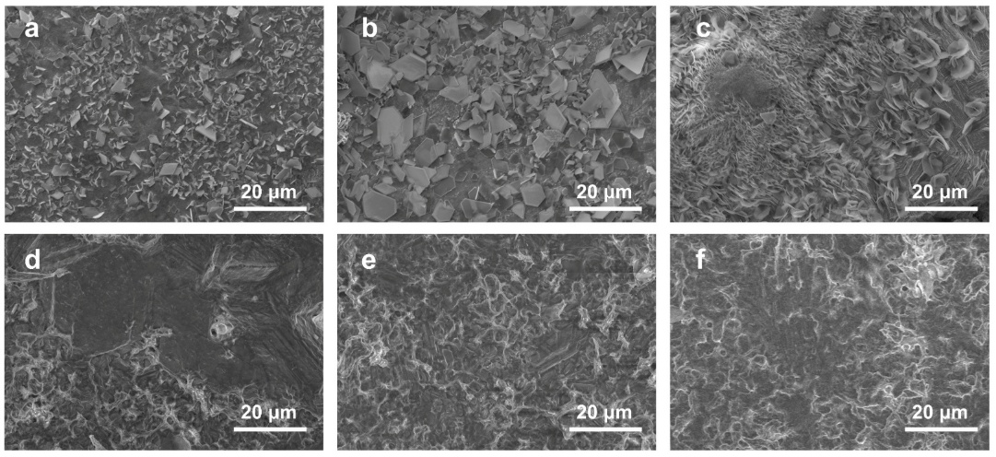
Fig. S13 The SEM images of Zn anodes after plating at first cycle with different current densities and 1 mAh cm⁻²: a 1 mA cm⁻², b 2 mA cm⁻² and c 5 mA cm⁻² in BE; d 1 mA cm⁻², e 2 mA cm⁻² and f 5 mA cm⁻² in BE-LCN.

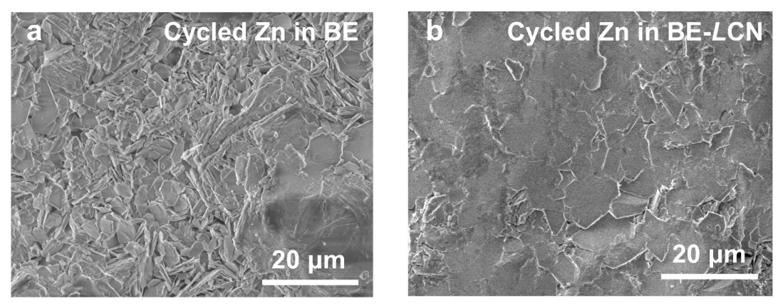
Fig. S14 The SEM images of the cycled Zn foils in a BE and b BE-LCN.

Fig. S15 XRD results of Zn foil after 20 cycles at 1 mA cm⁻², 1 mAh cm⁻².

Fig. S16 pH value of BE and BE-LCN electrolytes.

Fig. S17 Intensity comparison of ZnO⁻, OH⁻ and SO₃⁻ species on cycled Zn in BE and BE-LCN.
Fig. S18 Capacity-voltage curves of a BE and b BE-LCN under different cycles.
Fig. S19 a Coulombic efficiency (CE) values of Zn//Cu cells in BE and BE-LCN with a cut-off voltage of 0.8 V at 1 mA cm⁻². Capacity-voltage curves of b BE and c BE-LCN under different cycles.

Fig. S20 a CE values of Zn//Cu cells in BE and BE-LCN with a cut-off voltage of 0.8 V at 5 mA cm⁻². Capacity-voltage curves of b BE and c BE-LCN under different cycles.

Fig. S21 GITT profiles of symmetric cells in BE and BE-LCN at 1 mA cm⁻² for 3 min and a rest of 3 min.
Fig. S22 Resting-cycle cycling stability of symmetric cells in BE and BE-LCN at 1 mA cm⁻².

Fig. S23 EIS evolution of Zn//Zn symmetric cells during 50 cycles with a BE and b BE-LCN electrolytes at 1 mA cm⁻².

Fig. S24 Rate performances of symmetric cells in BE and BE-LCN.

Fig. S25 Galvanostatic cycling performance at 11.7 mA cm⁻², 11.7 mAh cm⁻² under a high depth of discharge (40%) condition (Zn foil thickness: 50 μm).
The high depth of discharge (DOD) is the percentage of the capacity involved in the electrode reaction relative to the overall capacity of the Zn metal anode:
$DOD=\frac{y}{C_{Zn}*x×{10}^{-4}}*100\%$ (S6)
where C_{Zn} is the theoretical volume capacity of Zn (5855 mAh cm⁻³), x (μm) is the thickness of the Zn foil and y (mAh cm⁻²) represents the Zn areal capacity used in electrochemical testing.

Fig. S26 CV curves of Zn//V₂O_{5-x} full cells with BE and BE-LCN electrolytes at the second cycle.

Fig. S27 Capacity-voltage curves of Zn//V₂O_{5-x} full cell in BE.

Fig. S28 CV curves of Zn//PANI full cells with BE and BE-LCN electrolytes at the second cycle.

Fig. S29 a Rate performances of Zn//PANI full cells in BE and BE-LCN. Capacity-voltage curves of Zn//PANI full cells in b BE and c BE-LCN.

Fig. S30 Self-discharge profiles of Zn//PANI full cells in BE and BE-LCN.

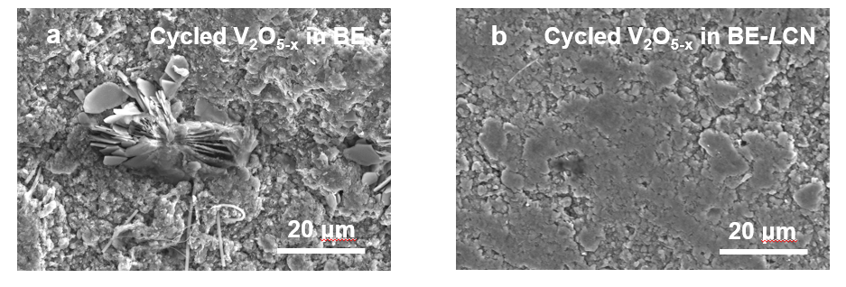
Fig. S31 The SEM images of the cycled V₂O_{5-x} cathodes in a BE and b BE-LCN.
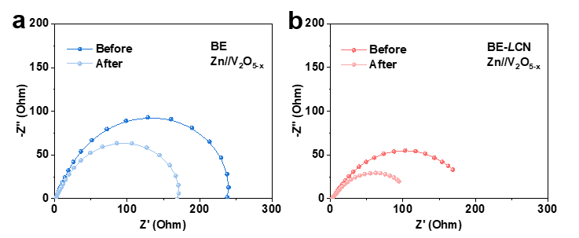
Fig. S32 EIS analysis of Zn//V₂O_{5-x} full cells in a BE and b BE-LCN before and after 50 cycles.
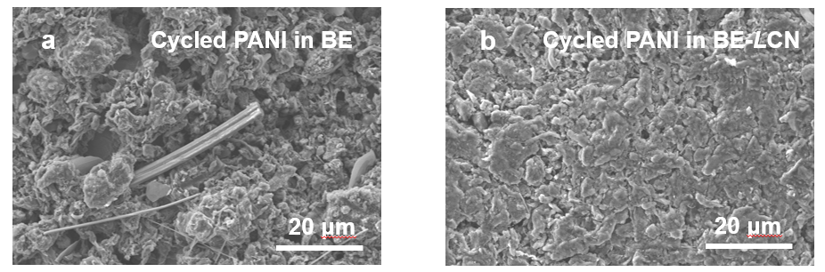
Fig. S33 The SEM images of the cycled PANI cathodes in a BE and b BE-LCN.
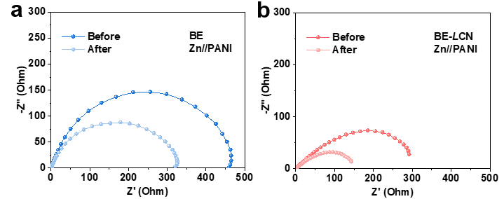
Fig. S34 EIS analysis of Zn//PANI full cells in a BE and b BE-LCN before and after 50 cycles.

Fig. S35 a The long-term cycling performances of Zn//V₂O_{5-x} full cells in BE and BE-LCN at 1 A g⁻¹. Capacity-voltage curves of Zn//V₂O_{5-x} full cells in b BE and c BE-LCN.

Fig. S36 a The long-term cycling performances of Zn//V₂O_{5-x} full cells in BE and BE-LCN at 10 A g⁻¹. Capacity-voltage curves of Zn//V₂O_{5-x} full cells in b BE and c BE-LCN.

Fig. S37 The long-term cycling performances of Zn//V₂O_{5-x} full cells in BE and BE-LCN at 0.5 A g⁻¹

Fig. S38 The long-term cycling performances of Zn//PANI full cells in BE and BE-LCN at 3 A g⁻¹.
S2 Supplementary Tables
Table S1 The N/P ratio of full cells
Type of cells | Zn thickness (cm) | Zn area (cm⁻²) | Negative Capacity (mAh) | Mass Loading of Cathode (mg) | Positive Capacity (mAh) | N/P Ratio
Coin | 0.002 | 1.13 | 13.23 | 5.64 | 3.32 | 3.98
Pouch | 0.005 | 14 | 409.84 | 99.96 | 58.88 | 6.96
The N/P ratio is calculated by the following equation:
Negative Capacity (mAh) = Zn thickness (cm) * ρ_{Zn} (g cm⁻³) * Theoretical specific capacity of Zn (mAh g⁻¹) * Area of the Zn anode
Positive Capacity (mAh) = Mass loading of cathode (g) * Theoretical specificcapacity of V₂O_{5-x} (mAh g⁻¹)
Where ρ_{Zn}, theoretical specific capacity of Zn and theoretical specific capacity of V₂O₅ are 7.14, 820 and 589, respectively.
Table S2 Performance comparison of symmetrical cells with different electrolyte additives between previous studies and this work
Electrolyte additive | Current density (mA cm⁻²) |  | Areal capacity (mAh cm⁻²) | Lifespan (h) | Reference
L-CN |  | 1 | 1 | 7000 | This work
L-CN |  | 5 | 5 | 2000 | This work
PEG-oSDE |  | 1 | 1 | 1400 | [S1]
TXA |  | 5 | 5 | 700 | [S2]
DA |  | 2 | 1 | 1000 | [S3]
SMD |  | 5 | 3 | 1400 | [S4]
Na-L |  | 2 | 1 | 1500 | [S5]
AS |  | 5 | 5 | 1300 | [S6]
PA |  | 2 | 2 | 1200 | [S7]
PNO |  | 5 | 5 | 1000 | [S8]

Table S3 DOD and cycle lifespan comparison of symmetrical cells between previous studies and this work
Electrolyte additive | Current density (mA cm⁻²) |  | Areal capacity (mAh cm⁻²) | DOD (%) | Lifespan (h) | Reference
L-CN |  | 11.7 | 11.7 | 40 | 7000 | This work
L-CN |  | 5 | 10 | 85.4 | 200 | This work
CoPcS₄ |  | 10 | 3 | 51.2 | 150 | [S9]
NHM |  | 6 | 6 | 60 | 400 | [S10]
CTP |  | 8.8 | 8.8 | 50 | 300 | [S11]
PN-ps coating |  | 2 | 20 | 68.3 | 400 | [S12]
AHRE |  | - | - | 60 | 300 | [S13]

Table S4 Performance comparison of full cells with different electrolyte additives between previous studies and this work
Electrolyte additive | Cathode materials | Current  (A g⁻¹) | Cycling performances | Reference
L-CN | V₂O_{5-x} | 1 | 500 cycles  95.2%  444 mAh g⁻¹ | This work
L-CN | V₂O_{5-x} | 10 | 4000 cycles  93.9% | This work
L-CN | PANI | 3 | 4000 cycles  86.3% | This work
LA | NH₄V₄O₁₀ | 5 | 2000 cycles  80.35% | [S14]
DP | NH₄V₄O₁₀ | 3 | 3000 cycles  80.3% | [S15]
10% Xos | ZnVO | 5 | 1000 cycles  82.9% | [S16]
Zn(BF₄)₂-AN | PANI | 1 | 2000 cycles  86.72% | [S17]
Glu | PANI | 1 | 1000 cycles  91% | [S18]
PCA-Zn | PANI | 1 | 2000 cycles  73.33% | [S19]
Zn(CF₃SO₃)₂ | MEG/PANI | 2 | 2000 cycles  72.7% | [S20]

Table S5 N/P ratio and performance comparison of full cells between previous studies and this work
Work | Cathode materials | Type of cells | Cycling performances | N/P ratio | Reference
L-CN | V₂O_{5-x} | coin | 500 cycles  1 A g⁻¹ | 3.98 | This work
L-CN | V₂O_{5-x} | pouch | 200 cycles  1 A g⁻¹ | 6.96 | This work
FCOF@Zn | MnO₂ | coin | 200 cycles  4 mA cm⁻² | 5 | [S21]
Sorbitol | CNF/MnO₂ | coin | 500 cycles  1 A g⁻¹ | 5.55 | [S22]
NH₄Ac/Et₄  NOTF | PANI | coin | 1000 cycles  1 A g⁻¹ | 5~6 | [S23]
FPCH-ZI/Zn | MnO₂ | coin | 600 cycles  0.5 A g⁻¹ | 7.3 | [S24]
Zinc-plated Cu substrate | MnO₂ | coin | 640 cycles  5 mA cm⁻² | 5 | [S25]
Supplementary References
- Z. Shi, M. Li, X. Fu, Y. Zhang, S. Jiao et al., Bimodal Block molecule with ether-type and hydroxyl-type oxygen stabilizes Zn anode in super-dilute electrolyte. Adv. Funct. Mater. 34(25), 2316427 (2024). https://doi.org/10.1002/adfm.202316427
- J. Yin, H. Liu, P. Li, X. Feng, M. Wang et al., Integrated electrolyte regulation strategy: Trace trifunctional tranexamic acid additive for highly reversible Zn metal anode and stable aqueous zinc ion battery. Energy Storage Mater. 59, 102800 (2023). https://doi.org/10.1016/j.ensm.2023.102800
- Y. Yang, Y. Li, Q. Zhu, B. Xu, Optimal molecular configuration of electrolyte additives enabling stabilization of zinc anodes. Adv. Funct. Mater. 34(32), 2316371 (2024). https://doi.org/10.1002/adfm.202316371
- S. Zheng, Y. Wang, B. Luo, L. Sun, G. Duan et al., In-situ formation of heterogeneous interfaces inducing surface crystallographic manipulation toward highly stable Zn anode. Chem. Eng. J. 473, 145313 (2023). https://doi.org/10.1016/j.cej.2023.145313
- Z. Hu, F. Zhang, A. Zhou, X. Hu, Q. Yan et al., Highly reversible Zn metal anodes enabled by increased nucleation overpotential. Nanomicro Lett. 15(1), 171 (2023). https://doi.org/10.1007/s40820-023-01136-z
- X. Ma, Q. Wang, X. Zhang, Y. Lin, F. Zhang et al., Highly reversible zinc anode enabled by a trace-amount additive with pH buffering capability. Energy Environ. Sci. 18(2), 982–990 (2025). https://doi.org/10.1039/d4ee04870a
- K. Wang, H. Zhan, X.-X. Liu, X. Sun, Uncovering required molecular properties for interface regulators and modification mechanisms for Zn anode in aqueous batteries. Adv. Funct. Mater. 35(16), 2418993 (2025). https://doi.org/10.1002/adfm.202418993
- Q. Kang, H. Liang, Z. Zhu, F. Xing, B. Zhu et al., Non-substituted aromatic pyridine N-oxide additives with an intrinsic N→O acceptor for ultra-long-life Zn||MnO₂ batteries. Angew. Chem. Int. Ed. 64(10), e202420183 (2025). https://doi.org/10.1002/anie.202420183
- Z. Fang, J. Li, L. Xiang, K. Liu, Y. Pan et al., Kinetic regulation of Zn(002) textured interfaces for highly reversible Zn–iodine batteries. Energy Storage Mater. 82, 104592 (2025). https://doi.org/10.1016/j.ensm.2025.104592
- L. You, S. Guo, Y. He, Y. Xie, S. Liang et al., Surface tension-derived electrical double layer modification enables practical zinc-ion pouch cells. Adv. Funct. Mater. 35(31), 2500780 (2025). https://doi.org/10.1002/adfm.202500780
- Z. Chen, Y. Liao, Z. Lu, G. Chen, H.M.A. Hassan et al., Amphiphilic interfacial environment reconfiguration unlocks long-life zinc-ion batteries with lean electrolytes and ultra-low N/P ratios. Angew. Chem. Int. Ed. 65(26), e4128996 (2026). https://doi.org/10.1002/anie.4128996
- Z. Zhang, G. Liao, Y. Lin, W. Du, Y. Zhang et al., Decoupled yet synergistic microdomains via in situ phase separation enabling ultra-stable zinc metal anodes. Adv. Energy Mater. e71136 (2026). https://doi.org/10.1002/aenm.71136
- X. Zhang, Q. Tang, H. Luo, Y. Xu, S. Miao et al., Hydrogen bond reconstruction maneuver in eutectic electrolyte enables ultralong-lifespan zinc-ion batteries. J. Am. Chem. Soc. 147(43), 39440–39451 (2025). https://doi.org/10.1021/jacs.5c12021
- R. Jiang, T. Naren, Y. Chen, Z. Chen, C. Zhang et al., Enhanced hydrogen bonding through strong water-locking additives for long-term cycling of zinc ion batteries. Adv. Funct. Mater. 34(49), 2411477 (2024). https://doi.org/10.1002/adfm.202411477
- M. Wu, Y. Sun, Z. Yang, S. Deng, H. Tong et al., Harnessing ion-dipole interactions for water-lean solvation chemistry: achieving high-stability Zn anodes in aqueous zinc-ion batteries. Angew. Chem. Int. Ed. 63(43), e202407439 (2024). https://doi.org/10.1002/anie.202407439
- W. Guo, L. Xu, Y. Su, L. Zhao, Y. Ding et al., Synchronous modulation of H-bond interaction and steric hindrance via bio-molecular additive screening in Zn batteries. Angew. Chem. Int. Ed. 64(5), e202417125 (2025). https://doi.org/10.1002/anie.202417125
- Z. Zha, D. Li, T. Sun, Q. Sun, J. Hou et al., Electrolyte design via cation-anion association regulation for high-rate and dendrite-free zinc metal batteries at low temperature. J. Am. Chem. Soc. 146(46), 31612–31623 (2024). https://doi.org/10.1021/jacs.4c09524
- Y. Chen, B. Yin, Y. Zeng, H. Wang, B.-B. Xie et al., Ion-dipole-interaction-manipulated bilateral interface chemistry for deep rechargeability and high redox activity of Zn-organic batteries. Chem 11(6), 102411 (2025). https://doi.org/10.1016/j.chempr.2025.102411
- M. Yang, J. Zhu, S. Bi, R. Wang, H. Wang et al., The construction of anion-induced solvation structures in low-concentration electrolyte for stable zinc anodes. Angew. Chem. Int. Ed. 63(15), e202400337 (2024). https://doi.org/10.1002/anie.202400337
- X. Liao, C. Pan, H. Yan, Y. Zhu, Y. Pan et al., Polyaniline-functionalized graphene composite cathode with enhanced Zn²⁺ storage performance for aqueous zinc-ion battery. Chem. Eng. J. 440, 135930 (2022). https://doi.org/10.1016/j.cej.2022.135930
- Z. Zhao, R. Wang, C. Peng, W. Chen, T. Wu et al., Horizontally arranged zinc platelet electrodeposits modulated by fluorinated covalent organic framework film for high-rate and durable aqueous zinc ion batteries. Nat. Commun. 12, 6606 (2021). https://doi.org/10.1038/s41467-021-26947-9
- Y. Quan, M. Yang, M. Chen, W. Zhou, X. Han et al., Electrolyte additive of sorbitol rendering aqueous zinc-ion batteries with dendrite-free behavior and good anti-freezing ability. Chem. Eng. J. 458, 141392 (2023). https://doi.org/10.1016/j.cej.2023.141392
- X. Zhao, N. Dong, M. Yan, H. Pan, Unraveling the interphasial chemistry for highly reversible aqueous Zn ion batteries. ACS Appl. Mater. Interfaces 15(3), 4053–4060 (2023). https://doi.org/10.1021/acsami.2c19022
- J.B. Park, C. Choi, J.H. Park, S. Yu, D.-W. Kim, Synergistic design of multifunctional interfacial Zn host toward practical Zn metal batteries. Adv. Energy Mater. 12(48), 2202937 (2022). https://doi.org/10.1002/aenm.202202937
- C. Xie, H. Ji, Q. Zhang, Z. Yang, C. Hu et al., High-index zinc facet exposure induced by preferentially orientated substrate for dendrite-free zinc anode. Adv. Energy Mater. 13(3), 2203203 (2023). https://doi.org/10.1002/aenm.202203203

