Supporting Information for
Surfactant-Derived Nitrogen-Bridged MoS₂/C Heterostructures for Robust Lithium-Ion Storage
Senchuan Huang^{1, #,} *, Kewei Pei^{1, #}, Yunyi Chen¹, Yangfei Cao^{2,} *, Jingwen Shangguan¹, Shiman He³, Junxia Meng⁴, and Shanqing Zhang^{1, 5,} *
¹ School of Chemical Engineering and Light Industry, Guangdong University of Technology, Guangzhou 510006, P. R. China
² School of Materials and Energy, Guangdong University of Technology, Guangzhou 510006, P. R. China
³ School of Materials Science and Engineering, Guangdong Provincial Key Laboratory of Advanced Energy Storage Materials, South China University of Technology, Guangzhou 510641, P. R. China
⁴ School of Physics and Electronics, Gannan Normal University, Ganzhou 341000, P. R. China
⁵ School of Environment and Science, Griﬃth University, Gold Coast, QLD 4222, Australia
# Senchuan Huang and Kewei Pei contribute to the work equally.
* Corresponding authors. E-mail: huangsch@gdut.edu.cn (Senchuan Huang); caoyf@gdut.edu.cn (Yangfei Cao); s.zhang@griffith.edu.au (Shanqing Zhang)
Supplementary Figures and Tables
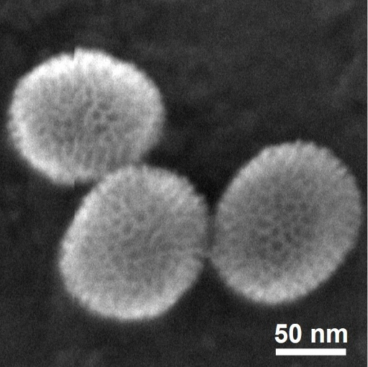
Fig. S1 FESEM image of mSiO₂@CTAB
Fig. S2 a Nitrogen adsorption–desorption isotherms and b corresponding pore size distribution curve of mSiO₂@CTAB
Fig. S3 FESEM images of SiO₂@MoS₂-N-C composites at different magnifications: a, b SiO₂@MoS₂-N-C₆₀₀, c, d SiO₂@MoS₂-N-C₇₀₀, and e, f SiO₂@MoS₂-N-C₈₀₀
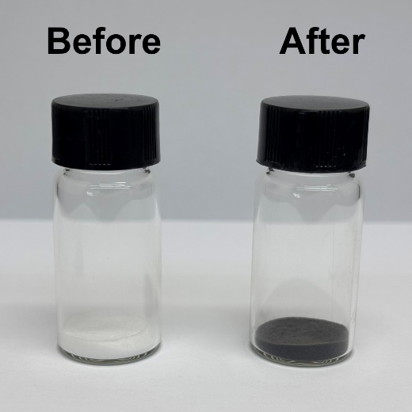
Fig. S4 Digital photographs of mSiO₂@CTAB before and after carbonization
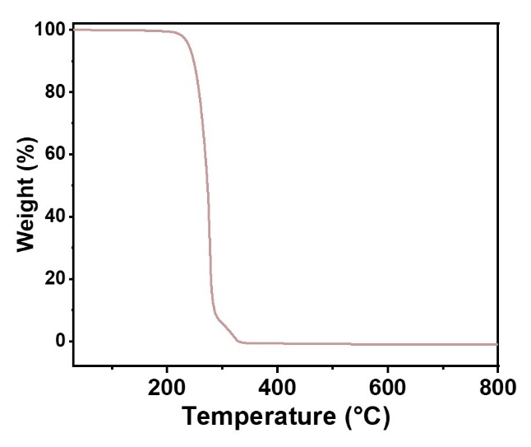
Fig. S5 TG curve of CTAB measured under Ar
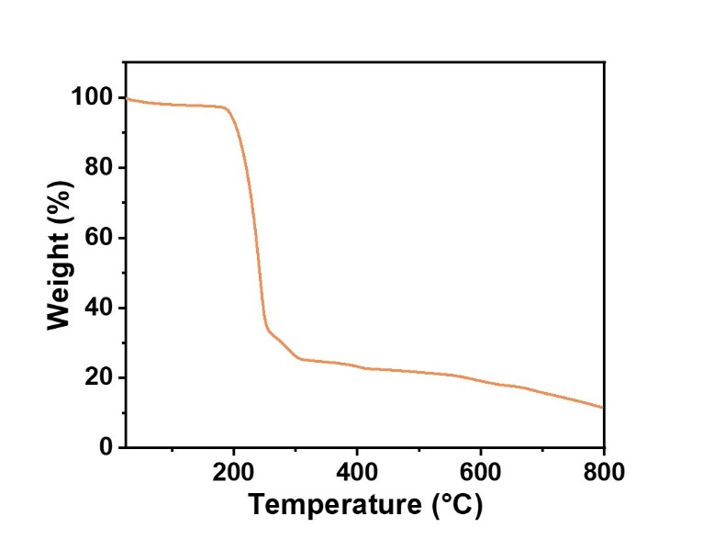
Fig. S6 TG curve of thiourea measured under Ar
Fig. S7 FESEM images of the MoS₂-N-C heterostructures synthesized at different temperatures: a MoS₂-N-C₆₀₀ and b MoS₂-N-C₈₀₀
Fig. S8 a TEM image and b SAED pattern of MoS₂-N-C₇₀₀
Fig. S9 FESEM images of commercial MoS₂ at different magnifications
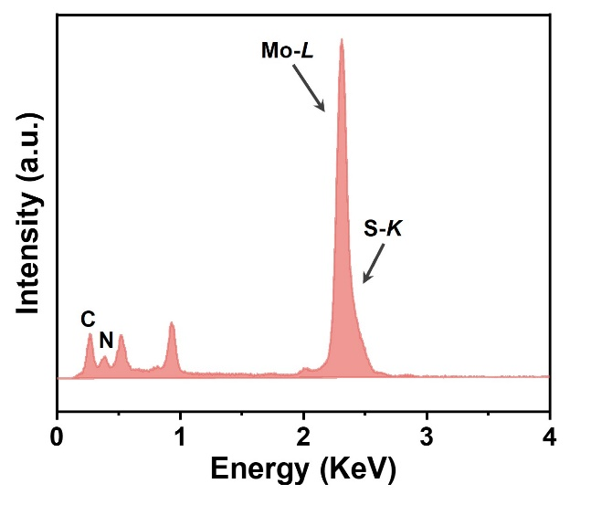
Fig. S10 EDS spectrum of MoS₂-N-C₇₀₀, showing the existence of N-dopants
Fig. S11 a TEM and b HRTEM images of commercial MoS₂
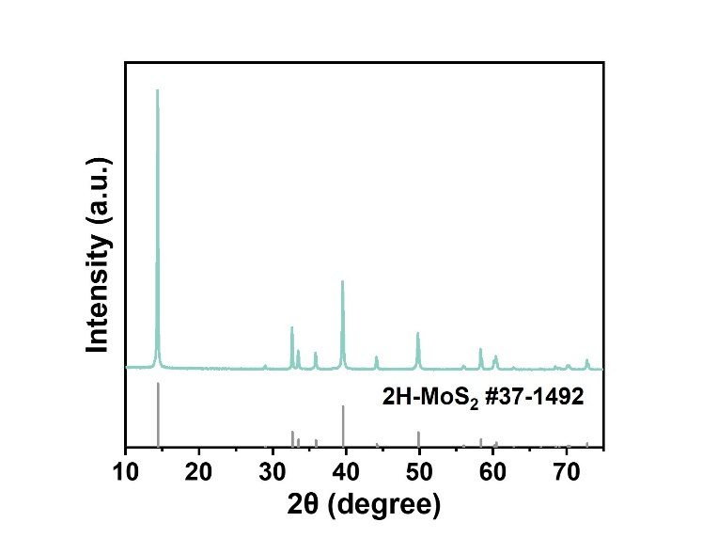
Fig. S12 XRD pattern of commercial MoS₂
Fig. S13 Full Raman spectra of MoS₂-N-C₆₀₀, MoS₂-N-C₇₀₀, and MoS₂-N-C₈₀₀
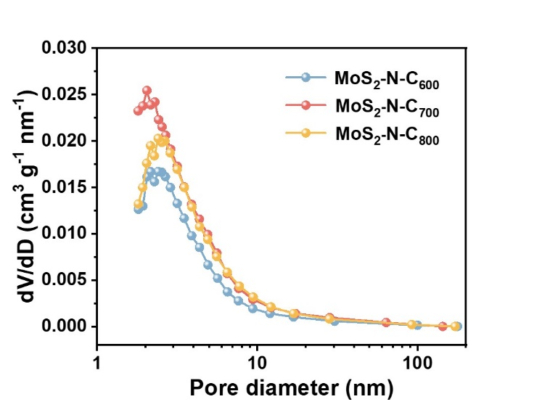
Fig. S14 Pore size distribution curves of MoS₂-N-C₆₀₀, MoS₂-N-C₇₀₀, and MoS₂-N-C₈₀₀
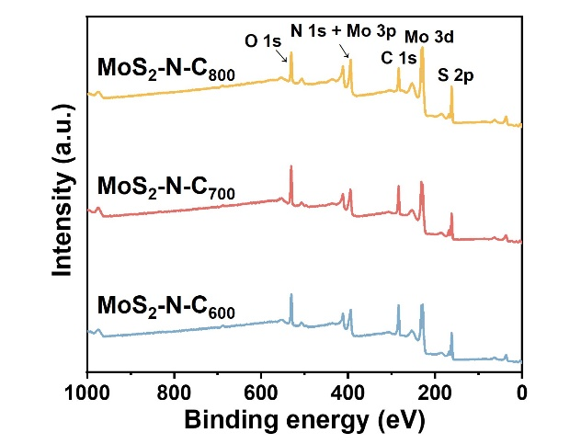
Fig. S15 XPS survey spectra of MoS₂-N-C₆₀₀, MoS₂-N-C₇₀₀, and MoS₂-N-C₈₀₀
Fig. S16 a Normalized XANES spectrum and b Fourier transformed k²-weighted EXAFS spectrum of Mo K-edge for MoS₂-N-C₇₀₀
Fig. S17 Structure characterization of Pristine MoS₂ control sample. a, b FESEM images at different magnifications, c XRD pattern, and d TG curves
Fig. S18 a N₂ adsorption-desorption isotherms and b-d Mo 3d, Mo 3p and S 2p spectra of Pristine MoS₂ control sample, respectively
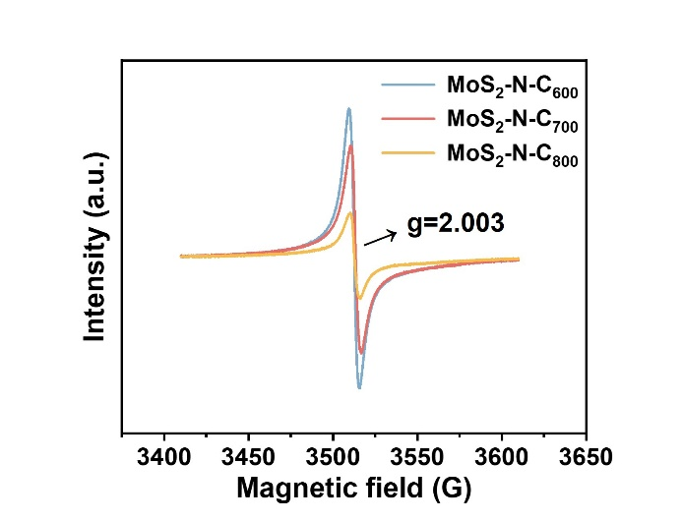
Fig. S19 EPR spectra of MoS₂-N-C₆₀₀, MoS₂-N-C₇₀₀, and MoS₂-N-C₈₀₀
Fig. S20 EPR tests of MoS₂-N-C₇₀₀ electrodes after different cycles at 0.5 A g⁻¹
Fig. S21 a N₂ absorption/desorption isotherms and b relative specific area of MoS₂-N-C₇₀₀ electrodes before cycling and after different cycles at 0.5 A g⁻¹
Fig. S22 a CV cures and b corresponding redox peak currents of MoS₂-N-C₇₀₀ electrodes after different cycles
Fig. S23 Deconvoluted XPS spectra of MoS₂-N-C₇₀₀ electrodes after different cycles at 0.5 A g⁻¹: a Mo 3d, and b N 1s + Mo 3p
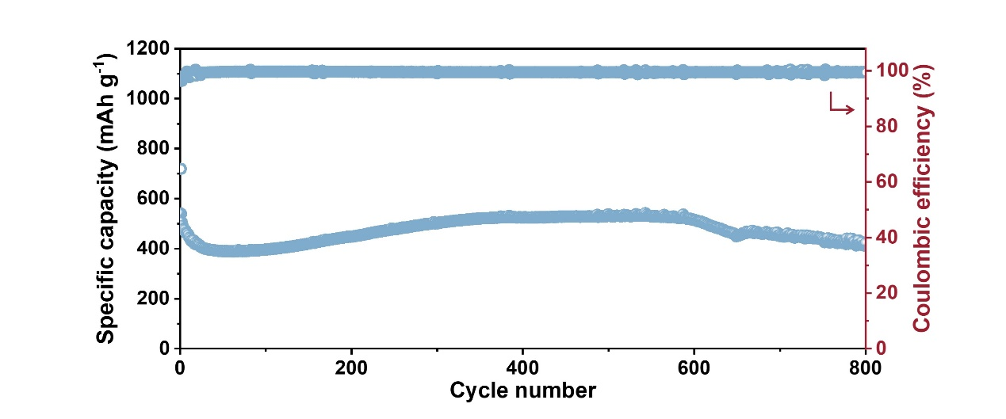
Fig. S24 Cycling stability of MoS₂-N-C₆₀₀ at 0.5 A g⁻¹
Fig. S25 Cycling stability of MoS₂-N-C₈₀₀ at 0.5 A g⁻¹
Fig. S26 a N₂ adsorption-desorption isotherms and b corresponding pore size distribution curve of MoS₂/NC control sample
Fig. S27 SEM images of MoS₂/NC control sample at different magnifications
Fig. S28 Cycling stability of MoS₂-N-C₇₀₀ at 2 A g⁻¹
Fig. S29 dQ/dV curves at various cycles of a MoS₂-N-C₆₀₀ and b MoS₂-N-C₈₀₀
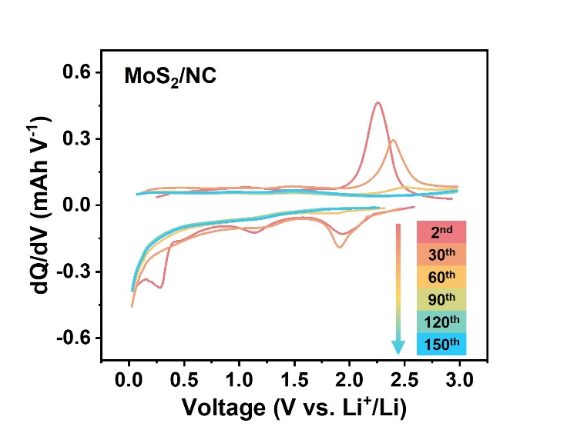
Fig. S30 dQ/dV curves of MoS₂/NC at various cycles
Fig. S31 First three CV curves at 0.1 mV s⁻¹ of a MoS₂-N-C₆₀₀ and b MoS₂-N-C₈₀₀
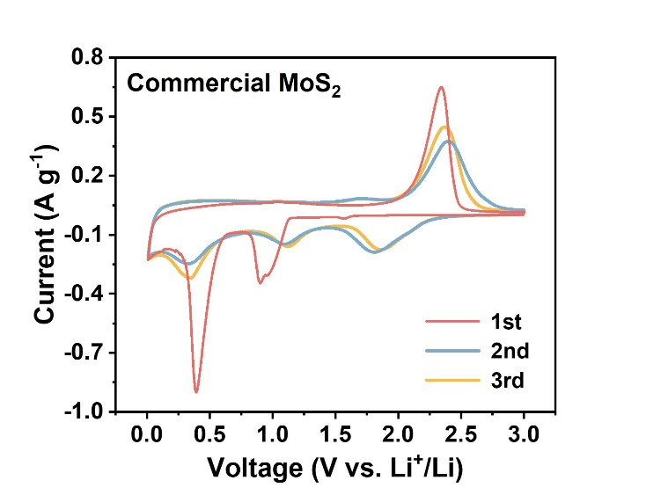
Fig. S32 First three CV curves at 0.1 mV s⁻¹ of commercial MoS₂
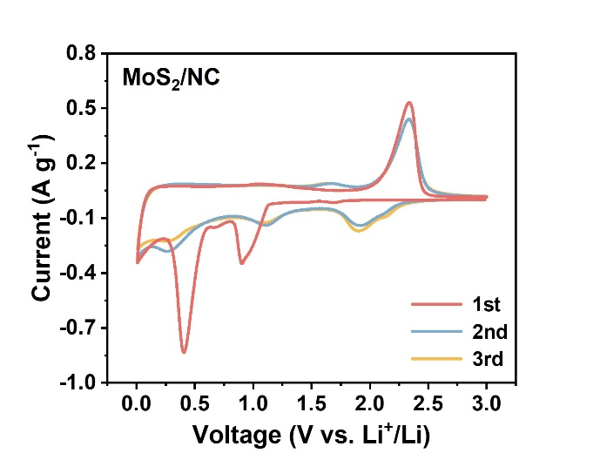
Fig. S33 First three CV curves at 0.1 mV s⁻¹ of MoS₂/NC
Fig. S34 First three GCD curves of a MoS₂-N-C₆₀₀ and b MoS₂-N-C₈₀₀ obtained at 0.1 A g⁻¹

Fig. S35 First three GCD curves of a commercial MoS₂ and b MoS₂/NC obtained at 0.1 A g⁻¹

Fig. S36 a Rate performance and b cycling stability at 0.5 A g⁻¹ of MoS₂-N-C₇₀₀ at a high mass loading of ~2.9 mg cm⁻²
Fig. S37 Rate performance of MoS₂-N-C₇₀₀, commercial MoS₂ and MoS₂/NC electrodes
Fig. S38 Deconvoluted N 1s XPS spectra for the MoS₂-N-C₇₀₀ electrode after discharging to 0.01 V at 0.1 A g⁻¹
Fig. S39 Nyquist plots of MoS₂-N-C₆₀₀, MoS₂-N-C₇₀₀ and MoS₂-N-C₈₀₀
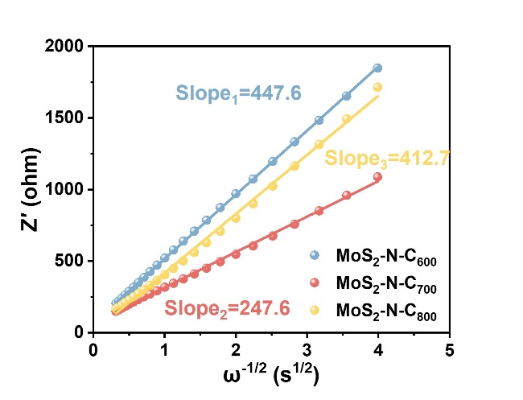
Fig. S40 Linear relationship between Z′ and 𝜔^{-1/2} of MoS₂-N-C₆₀₀, MoS₂-N-C₇₀₀, and MoS₂-N-C₈₀₀

Fig. S41 Nyquist plot of MoS₂/NC control sample
Fig. S42 a CV curves at scan rates from 0.2 to 1.0 mV s⁻¹, b linear fitting of the logarithmic relationship between peak current log(i) and scan rate log(v), c pseudocapacitive contribution at different scan rates, and d pseudocapacitive contribution at 1.0 mV s⁻¹ of MoS₂-N-C₆₀₀
Fig. S43 a CV curves at scan rates from 0.2 to 1.0 mV s⁻¹, b linear fitting of the logarithmic relationship between peak current log(i) and scan rate log(v), c pseudocapacitive contribution at different scan rates, and d pseudocapacitive contribution at 1.0 mV s⁻¹ of MoS₂-N-C₈₀₀
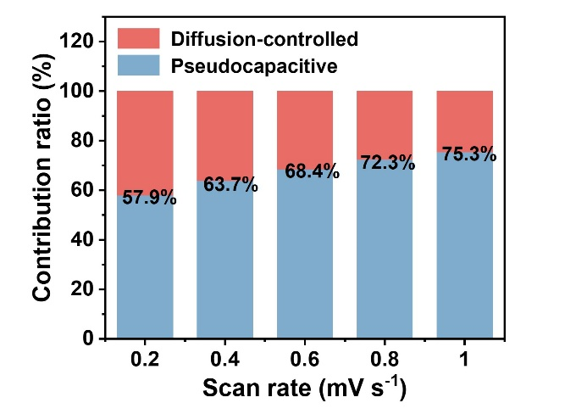
Fig. S44 Pseudocapacitive contribution of MoS₂-N-C₇₀₀ at different scan rates

Fig. S45 a CV curves at scan rates from 0.2 to 1.0 mV s⁻¹, b linear fitting of the logarithmic relationship between peak current log(i) and scan rate log(v), c pseudocapacitive contribution at different scan rates, and d pseudocapacitive contribution at 1.0 mV s⁻¹ of MoS₂/NC

Fig. S46 Equivalent circuits for EIS spectra fitting
Fig. S47 The trends of a R_{ct} and b D_{Li+} values obtained from in-situ EIS spectra during discharge and charge for MoS₂-N-C₇₀₀
Fig. S48 In-situ EIS spectra of MoS₂-N-C₆₀₀ during the 6th cycle: a discharge process and b charge process
Fig. S49 In-situ EIS spectra of MoS₂-N-C₈₀₀ during the 6th cycle: a discharge process and b charge process
Fig. S50 DRT plots of MoS₂-N-C₆₀₀ based on the EIS spectra: a discharge process and b charge process
Fig. S51 DRT plots of MoS₂-N-C₇₀₀ based on the EIS spectra: a discharge process and b charge process
Fig. S52 DRT plots of MoS₂-N-C₈₀₀ based on the EIS spectra: a discharge process and b charge process
Fig. S53 XRD pattern of the as-synthesized WS₂-N-C₇₀₀ heterostructure

Fig. S54 FESEM image of the as-synthesized WS₂-N-C₇₀₀ heterostructure
Fig. S55 Electrochemical performance of the as-synthesized WS₂-N-C₇₀₀ heterostructure for LIBs. a CV curves, b rate capability, c GCD profiles, and d cycling stability at 0.5A g⁻¹
Table S1 Quantitative analysis of different chemical states of S species obtained from the deconvoluted XPS spectra
Samples | Chemical states |  | Peak position (eV) | Relative percentage (%)
MoS₂-N-C₆₀₀ | Sulphate | 2p 1/2 | 169.7 | 16.8
MoS₂-N-C₆₀₀ | Sulphate | 2p 3/2 | 168.6 | 16.8
MoS₂-N-C₆₀₀ | C-S | 2p 1/2 | 165.2 | 10.2
MoS₂-N-C₆₀₀ | C-S | 2p 3/2 | 164.1 | 10.2
MoS₂-N-C₆₀₀ | Mo-S | 2p 1/2 | 163.5 | 73.0
MoS₂-N-C₆₀₀ | Mo-S | 2p 3/2 | 162.4 | 73.0
MoS₂-N-C₇₀₀ | Sulphate | 2p 1/2 | 169.8 | 19.8
MoS₂-N-C₇₀₀ | Sulphate | 2p 3/2 | 168.7 | 19.8
MoS₂-N-C₇₀₀ | C-S | 2p 1/2 | 165.2 | 6.0
MoS₂-N-C₇₀₀ | C-S | 2p 3/2 | 164.1 | 6.0
MoS₂-N-C₇₀₀ | Mo-S | 2p 1/2 | 163.5 | 74.2
MoS₂-N-C₇₀₀ | Mo-S | 2p 3/2 | 162.4 | 74.2
MoS₂-N-C₈₀₀ | Sulphate | 2p 1/2 | 169.9 | 12.4
MoS₂-N-C₈₀₀ | Sulphate | 2p 3/2 | 168.8 | 12.4
MoS₂-N-C₈₀₀ | C-S | 2p 1/2 | 165.2 | 2.6
MoS₂-N-C₈₀₀ | C-S | 2p 3/2 | 164.1 | 2.6
MoS₂-N-C₈₀₀ | Mo-S | 2p 1/2 | 163.6 | 85.0
MoS₂-N-C₈₀₀ | Mo-S | 2p 3/2 | 162.5 | 85.0
Table S2 Relative percentages of nitrogen species in the MoS₂-N-C heterostructures determined from the deconvoluted N 1s XPS spectra
Samples | Chemical states | Peak position (eV) | Relative percentage (%)
MoS₂-N-C₆₀₀ | Mo–N | 397.5 | 17.2
MoS₂-N-C₆₀₀ | Pyridinic N | 398.5 | 33.0
MoS₂-N-C₆₀₀ | Pyrrolic N | 399.9 | 30.4
MoS₂-N-C₆₀₀ | Graphitic N | 401.2 | 19.4
MoS₂-N-C₇₀₀ | Mo–N | 397.6 | 16.4
MoS₂-N-C₇₀₀ | Pyridinic N | 398.5 | 30.0
MoS₂-N-C₇₀₀ | Pyrrolic N | 399.8 | 30.4
MoS₂-N-C₇₀₀ | Graphitic N | 401.3 | 23.1
MoS₂-N-C₈₀₀ | Mo–N | 397.6 | 15.1
MoS₂-N-C₈₀₀ | Pyridinic N | 398.5 | 33.6
MoS₂-N-C₈₀₀ | Pyrrolic N | 399.8 | 26.1
MoS₂-N-C₈₀₀ | Graphitic N | 401.4 | 25.2
Table S3 Charge transfer resistance (R_{ct}) and Li⁺ diffusion coefficient (D_{Li+}) values obtained from fitting the EIS spectra
 | MoS₂-N-C₆₀₀ | MoS₂-N-C₇₀₀ | MoS₂-N-C₈₀₀
R_{ct} (ohm) | 106.7 | 77.1 | 83.1
D_{Li+} (10⁻¹⁴ cm² s⁻¹) | 1.2 | 3.8 | 1.4
Table S4 Cycling performance comparison of recent state-of-the-art MoS₂/C anodes for LIBs
Anode | Mass loading (mg cm⁻²) | Current density (A g⁻¹) | Cycle number | Capacity retention | Ref.
MoS₂-N-C₇₀₀ | 1.1~1.3 | 0.5 | 800 | ~100% | This work
MoS₂@C | ~2.0 | 1 | 100 | 21.7% | [S1]
NG@MoS₂@LS-C | ~3.1 | 0.1 | 100 | 55.5% | [S2]
B-MoS₂–GO | ~0.6 | 0.5 | 200 | 77.9% | [S3]
Ni-MoS₂/rGO | ~2.0 | 0.1 | 100 | 79.0% | [S4]
Co₃S₄/1T-MoS₂@NC | 1.0~1.1 | 1 | 250 | 75.7% | [S5]
1T/2H hybrid phase MoS₂-graphene | 2~3 | 0.18 | 100 | 90.0% | [S6]
MoS₂/C-3 | 1.6~2.1 | 1 | 1300 | 41.4% | [S7]
5% BN-G@MoS₂-50@50 | 0.57~0.85 | 1 | 500 | 85.6% | [S8]
SnS₂/MoS₂/DGS | ~2.0 | 0.2 | 200 | 96.9% | [S9]
Table S5 Comparisons of electrochemical performance of carbon-based LISCs reported previously
System | Voltage window (V) | Current density (A g⁻¹) | Energy density (Wh kg⁻¹) | Cycling performance | Ref.
MoS₂-N-C₇₀₀//AC | 0.5-4 | 0.1 | 175.0 | 1 A g⁻¹@10000 cycles@78.2% | This work
MC800//HC | 2-4 | 0.25 | 152.2 | 2 A g⁻¹@5000 cycles@80.0% | [S10]
Zn₈₀Co₂₀-PC//AC | 2-4 | 0.05 | 123.0 | 1 A g⁻¹@5000 cycles@90.0% | [S11]
CAC//NPC | 0.01-4 | 1 | 151.8 | 2 A g⁻¹@1600 cycles@87.0% | [S12]
NPC//AC | 2.0-4.2 | 0.1 | 112.0 | 1 A g-1@6000 cycles@72.0% | [S13]
CTK-1.0//CTK-1.0 | 0.1-4.2 | 0.1 | 137.6 | 2 A g⁻¹@3000 cycles@75.0% | [S14]
NP-HPC//NP-SC | 1-3.8 | 0.1 | 121.0 | 1 A g⁻¹@3000 cycles@80.2% | [S15]
PCNs-800//PCNs-800 | 1-4.2 | 0.1 | 112.0 | 1 A g⁻¹@9000 cycles@63.0% | [S16]
NHCM-12//NHCM-A | 0.1-4 | 0.1 | 162.0 | 1 A g⁻¹@5000 cycles@86.2% | [S17]
DGPC-1//AC | 2-4 | 0.1 | 103.4 | 5 A g⁻¹@5000 cycles@70.2% | [S18]
Supplementary References
- D. Li, G. Lin, Z. Huang, X. Tang, Z. Wu et al., Effect of different shell structure on lithium storage properties of MoS₂ anode. J. Electroanal. Chem. 905, 115972 (2022). https://doi.org/10.1016/j.jelechem.2021.115972
- J. Sun, Z. Xu, W. Wang, S. Sheng, S. Zhao et al., Preparation and electrochemical properties of mesoporous Carbon@ MoS₂ anode materials for lithium-ion batteries. Int. J. Electrochem. Sci. 21(3), 101294 (2026). https://doi.org/10.1016/j.ijoes.2026.101294
- H. Lu, B. Wu, Y. Zhang, T. Dong, Q. Duan et al., A simple and scalable method for preparing natural molybdenite-based MoS₂–graphene oxide composite anodes via ultrasonic exfoliation combined with a solvothermal process. J. Electron. Mater. 55(3), 2969–2987 (2026). https://doi.org/10.1007/s11664-026-12686-4
- S. Zhang, K. Qi, B. Du, G. Zhu, X. Liu et al., Reduced graphene oxide supported Ni-doped MoS₂ nanosheets with enhanced lithium-ion storage performance. J. Electroanal. Chem. 997, 119501 (2025). https://doi.org/10.1016/j.jelechem.2025.119501
- S.-C. Dong, R. Zeng, H. Zhang, S.-T. Zhang, P.-P. Chen et al., Enhancing stable and rapid Li⁺/Na⁺ storage performance via interface engineering of confining Co3S₄/1T-MoS₂ heterostructure on nitrogen-doped carbon. Electrochim. Acta 542, 147415 (2025). https://doi.org/10.1016/j.electacta.2025.147415
- K.Y. Jang, Y.A. Lee, S. Lim, S. Park, K.-N. Jung et al., Enhancing lithium-ion battery kinetics and stability leveraging hybrid 1T/2H MoS₂–graphene heterostructures. Chem. Eng. J. 520, 165803 (2025). https://doi.org/10.1016/j.cej.2025.165803
- L. Liu, W. Du, Q. Zhang, H. Jiang, Y. Zhang et al., Constructing hollow flower-like molybdenum disulfide nanospheres/carbon nanospheres as anode with enhanced diffusion kinetics for lithium storage. Adv. Compos. Hybrid Mater. 7(6), 195 (2024). https://doi.org/10.1007/s42114-024-01029-8
- B. Chandra Sekhar, A. Soliman, M. Arsalan, E.H. Alsharaeh, A 2D hybrid nanocomposite: a promising anode material for lithium-ion batteries at high temperature. Nanoscale Adv. 6(22), 5612–5624 (2024). https://doi.org/10.1039/d4na00424h
- W. Yu, B. Cui, J. Han, S. Zhu, X. Xu et al., In situ encapsulation of SnS(2)/MoS₂ heterojunctions by amphiphilic graphene for high-energy and ultrastable lithium-ion anodes. Adv. Sci. 11(36), 2405135 (2024). https://doi.org/10.1002/advs.202405135
- H. Liu, X. Zhang, C. Li, S. Zhao, Y. An et al., Self-templating synthesis of mesoporous carbon cathode materials for high-performance lithium-ion capacitors. ChemSusChem 18(3), e202401365 (2025). https://doi.org/10.1002/cssc.202401365
- Q. Tang, G. Chu, Y. Xie, C. Yang, F. Tang et al., Zn/Co bimetallic metal-organic framework derived carbon anode with enchanted rate capability for lithium-ion capacitors. Mater. Today Commun. 41, 110224 (2024). https://doi.org/10.1016/j.mtcomm.2024.110224
- Y. Yang, H. Du, A. Wang, C. Lu, D. Sun et al., Excellent capacitive storage performance of N-doped porous carbon derived from the orientation-guidance coupled with in-situ activation methodology. J. Colloid Interface Sci. 673, 657–668 (2024). https://doi.org/10.1016/j.jcis.2024.05.237
- H. Jing, M. Chen, X. Zhang, Y. Yang, X. Zheng et al., CO₂-derived nitrogen doped porous carbon as advanced anodes for lithium-ion capacitors. J. Alloys Compd. 983, 173937 (2024). https://doi.org/10.1016/j.jallcom.2024.173937
- J. Jiang, Q. Shen, Z. Chen, S. Wang, Nitrogen-doped porous carbon derived from coal for high-performance dual-carbon lithium-ion capacitors. Nanomaterials 13(18), 2525 (2023). https://doi.org/10.3390/nano13182525
- C. Cao, H. Hu, J. Duan, G. Zeng, X. Cai et al., Phytic acid mediated N, P Co-doped hierarchical porous carbon with boosting capacitive storage for dual carbon lithium-ion capacitor. Electrochim. Acta 470, 143310 (2023). https://doi.org/10.1016/j.electacta.2023.143310
- T. Qian, Y. Huang, M. Zhang, Z. Xia, H. Liu et al., Non-corrosive and low-cost synthesis of hierarchically porous carbon frameworks for high-performance lithium-ion capacitors. Carbon 173, 646–654 (2021). https://doi.org/10.1016/j.carbon.2020.11.051
- J. Jiang, J. Yuan, P. Nie, Q. Zhu, C. Chen et al., Hierarchical N-doped hollow carbon microspheres as advanced materials for high-performance lithium-ion capacitors. J. Mater. Chem. A 8(7), 3956–3966 (2020). https://doi.org/10.1039/c9ta08676e
- G. Zhang, K. Sun, Y. Liu, D. Wu, H. Zhu et al., Double reaction initiated self-assembly process fabricated hard carbon with high power capability for lithium ion capacitor anodes. Appl. Surf. Sci. 609, 155083 (2023). https://doi.org/10.1016/j.apsusc.2022.155083

